UNO Card Stack Simulation – C Program

Code :
#include <stdio.h>
#include <string.h>

#define SIZE 5

char stack[SIZE][20];
int top = -1;

void push(char card[]) {
if(top == SIZE - 1) {
printf("Draw Pile FULL! Cannot add card: %s\n", card);
} else {
top++;
strcpy(stack[top], card);
printf("Card Added: %s\n", card);
}
}

void pop() {
if(top == -1) {
printf("Draw Pile EMPTY! No card to draw.\n");
} else {
printf("Card Drawn: %s\n", stack[top]);
top--;
}
}

void display() {
if(top == -1) {
printf("Draw Pile is empty!\n");
} else {
printf("UNO Draw Pile (Top to Bottom):\n");
for(int i = top; i >= 0; i--) {
printf("%s\n", stack[i]);
}
}
}

int main() {
int choice;
char card[20];

printf("UNO CARD STACK SIMULATION\n");
printf("--------------------------\n");

while(1) {
printf("\n1. Add Card (Push)\n");
printf("2. Draw Card (Pop)\n");
printf("3. Show Pile (Display)\n");
printf("4. Exit\n");
printf("Enter choice: ");
scanf("%d", &choice);

switch(choice) {
case 1:
printf("Enter UNO card (e.g., Red 5): ");
scanf(" %[^\n]", card);
push(card);
break;

case 2:
pop();
break;

case 3:
display();
break;

case 4:
printf("Exiting...\n");
return 0;

default:
printf("Invalid choice\n");
}
}
}

Output :
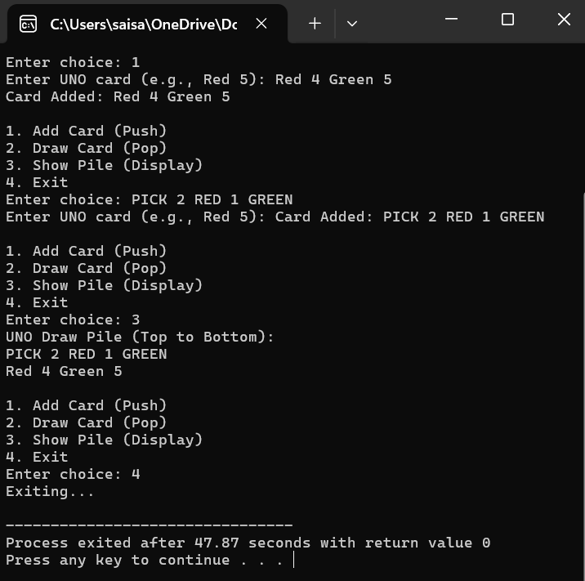

V. Vijaya Hasini
AP24110012089
Section:X

