**Interface Calculation:**

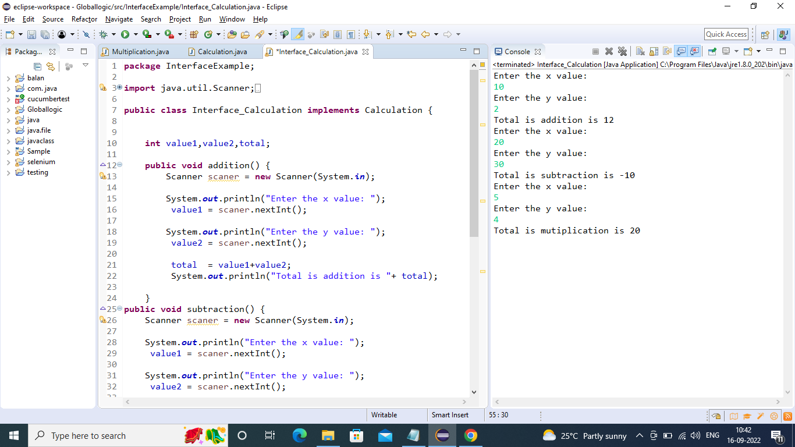

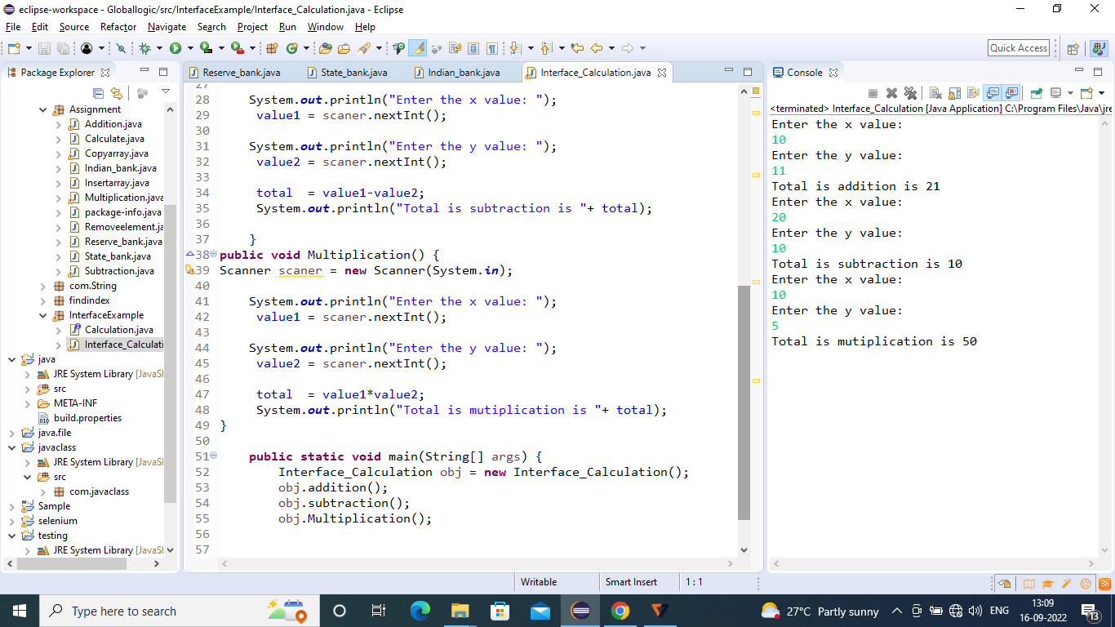

**Interface creating:**

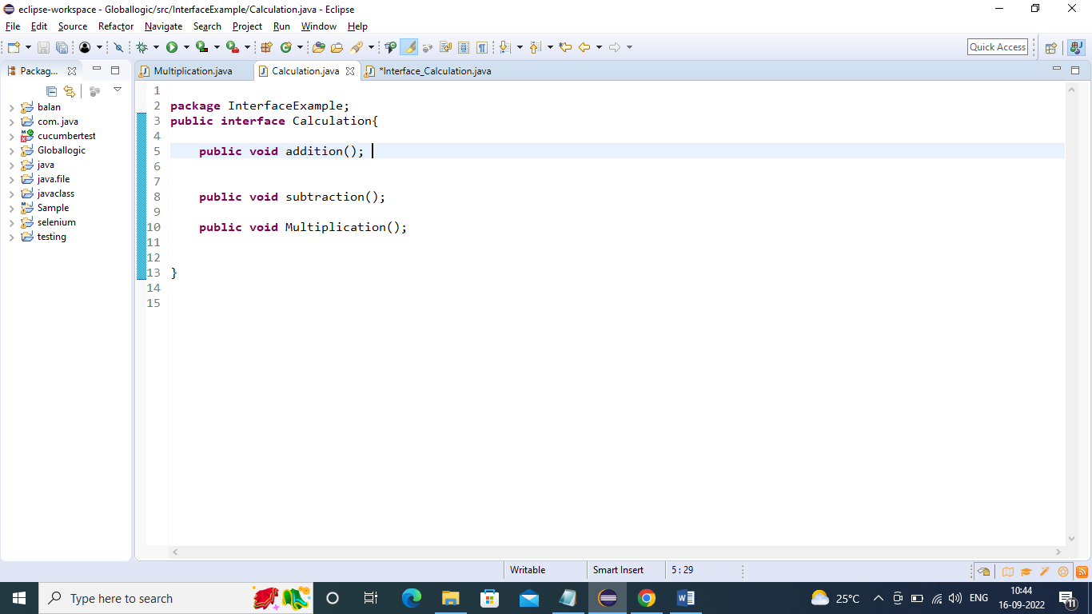

package InterfaceExample;

import java.util.Scanner;

import Assignment.Multiplication;

public class Interface_Calculation implements Calculation {

int value1,value2,total;

public void addition() {

Scanner scaner = new Scanner(System.in);

System.out.println("Enter the x value: ");

value1 = scaner.nextInt();

System.out.println("Enter the y value: ");

value2 = scaner.nextInt();

total = value1+value2;

System.out.println("Total is addition is "+ total);

}

public void subtraction() {

Scanner scaner = new Scanner(System.in);

System.out.println("Enter the x value: ");

value1 = scaner.nextInt();

System.out.println("Enter the y value: ");

value2 = scaner.nextInt();

total = value1-value2;

System.out.println("Total is subtraction is "+ total);

}

public void Multiplication() {

Scanner scaner = new Scanner(System.in)

System.out.println("Enter the x value: ");

value1 = scaner.nextInt();

System.out.println("Enter the y value: ");

value2 = scaner.nextInt();

total = value1*value2;

System.out.println("Total is mutiplication is "+ total);

}

public static void main(String[] args) {

Interface_Calculation obj = new Interface_Calculation();

obj.addition();

obj.subtraction();

obj.Multiplication();

}

}