**1) create a new array list, add some colors (string)**

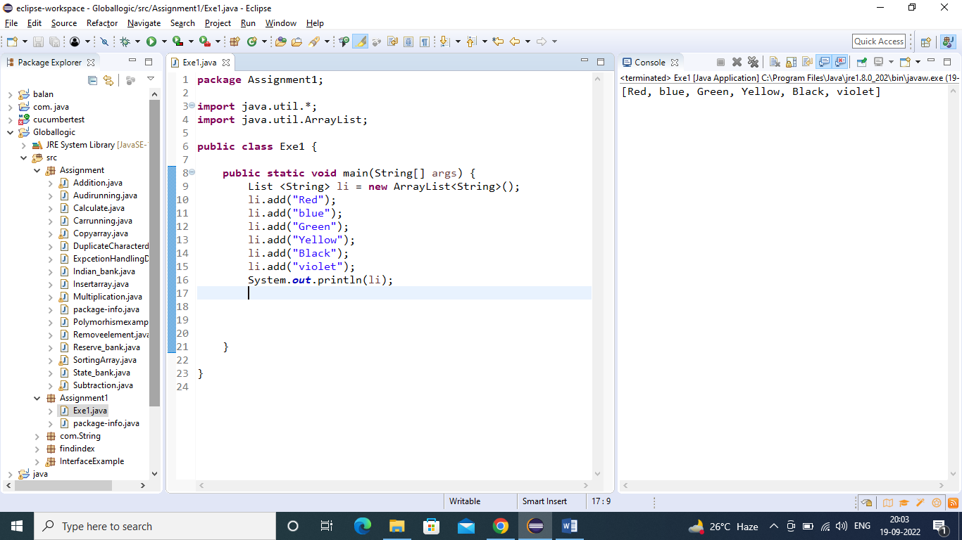

2)Iterate the list:

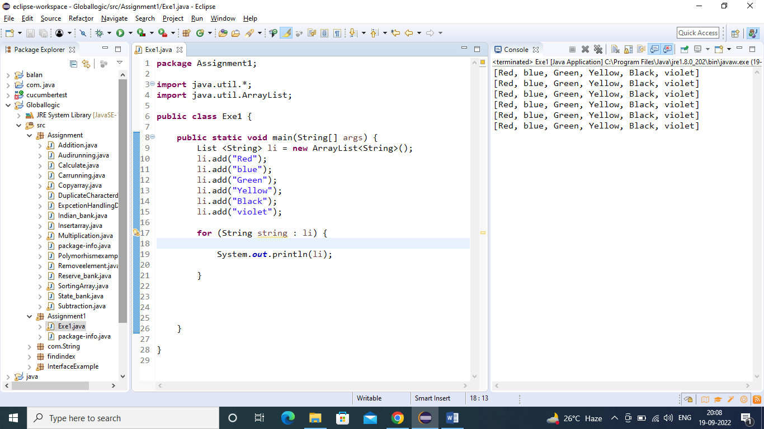

3)Insert an Element:

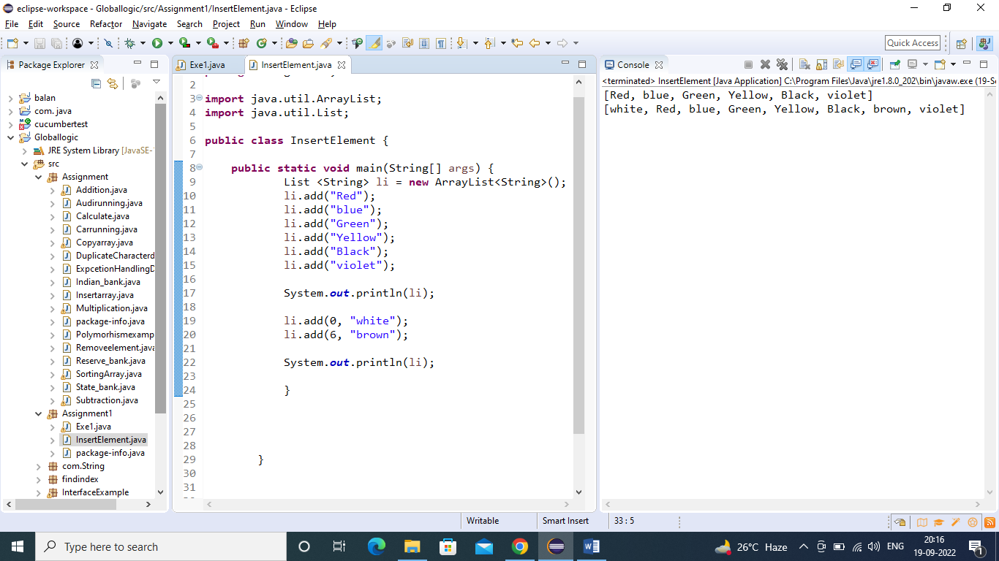

1)Linked List:

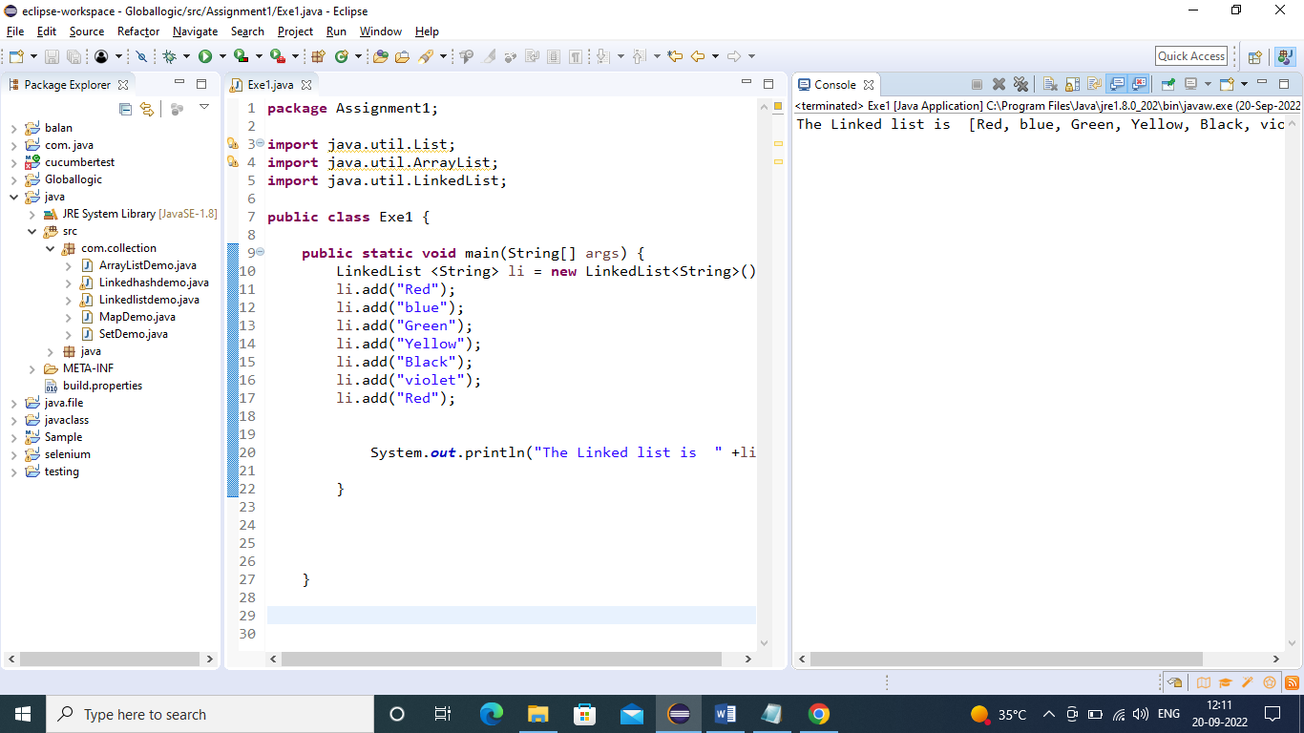

2)Iterate the element:

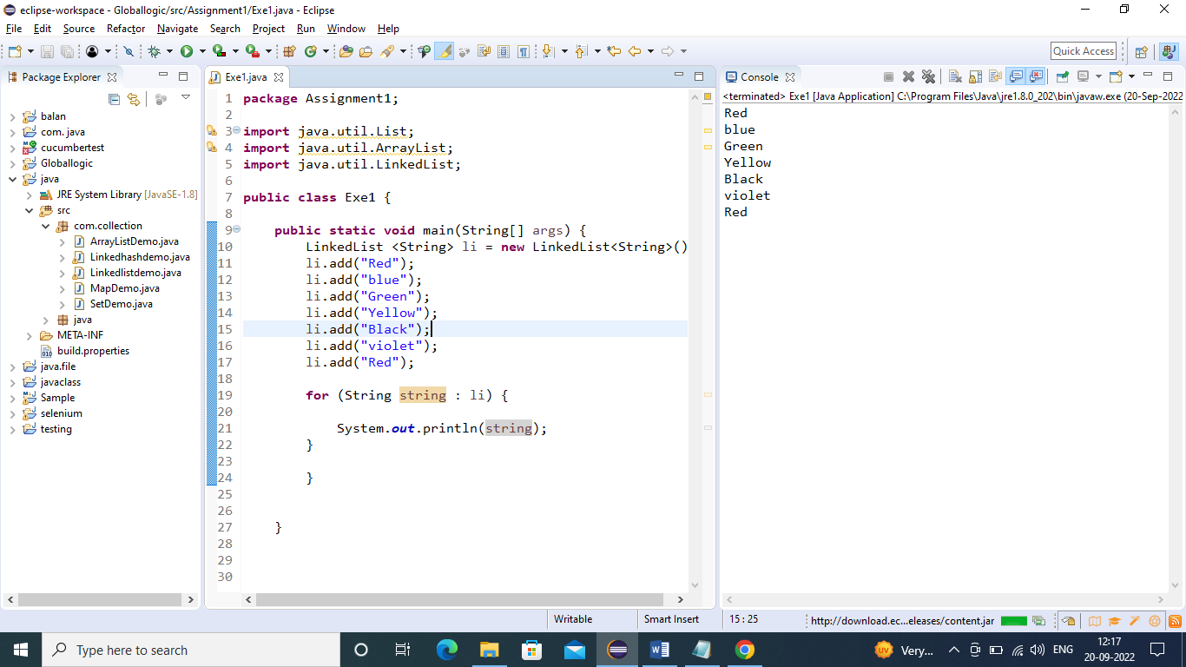

3)start from specific index:

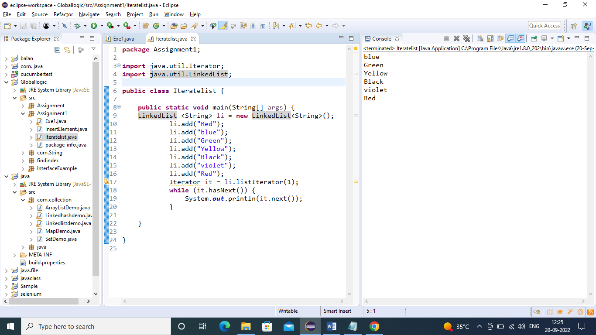

1)HashSet:

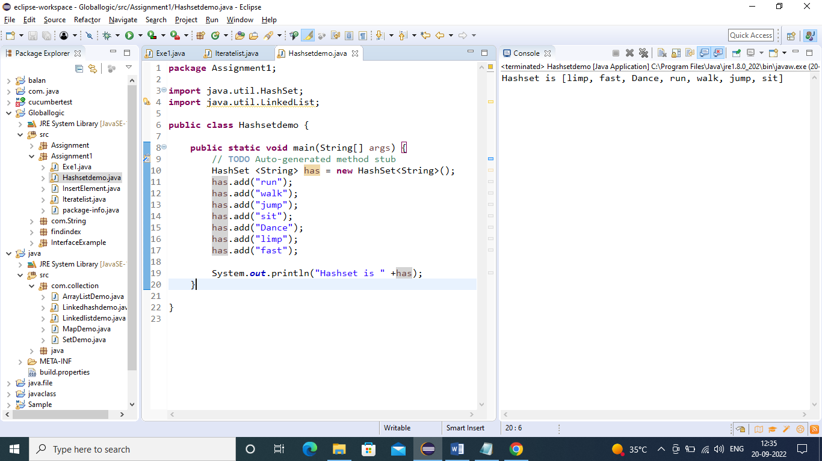

2)Iterate HASHSET:

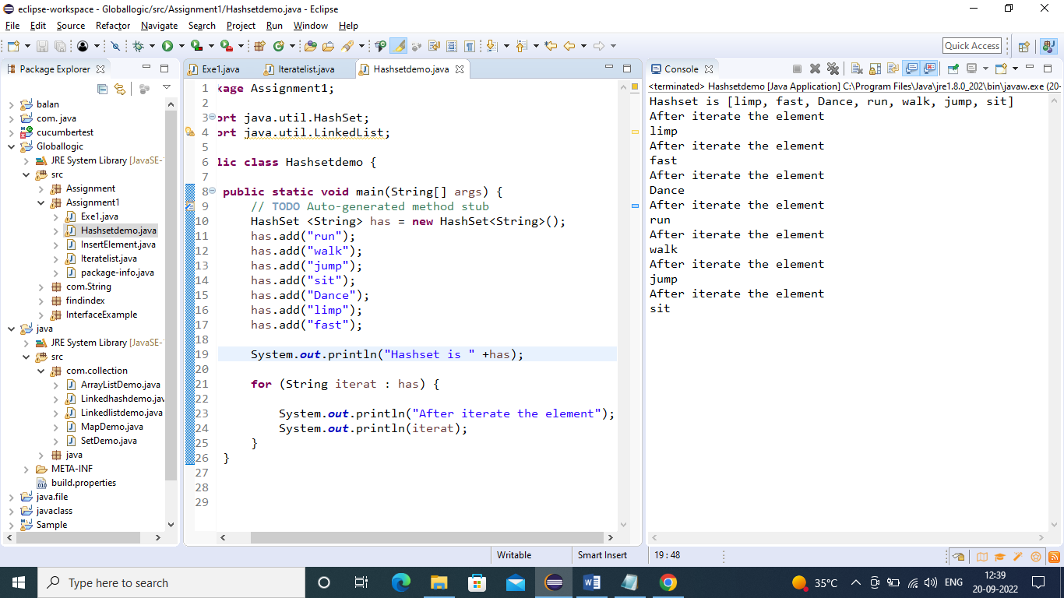

3)number of HashSet:

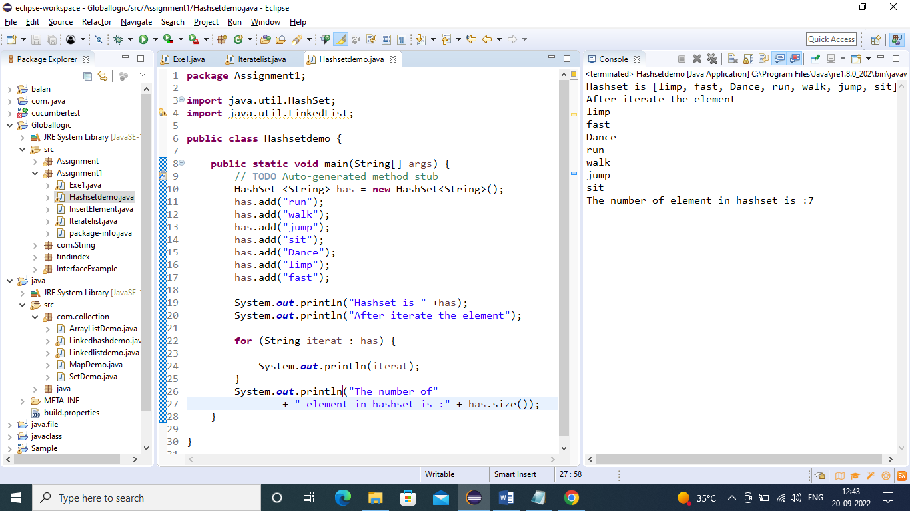

**1)TreeSet:**

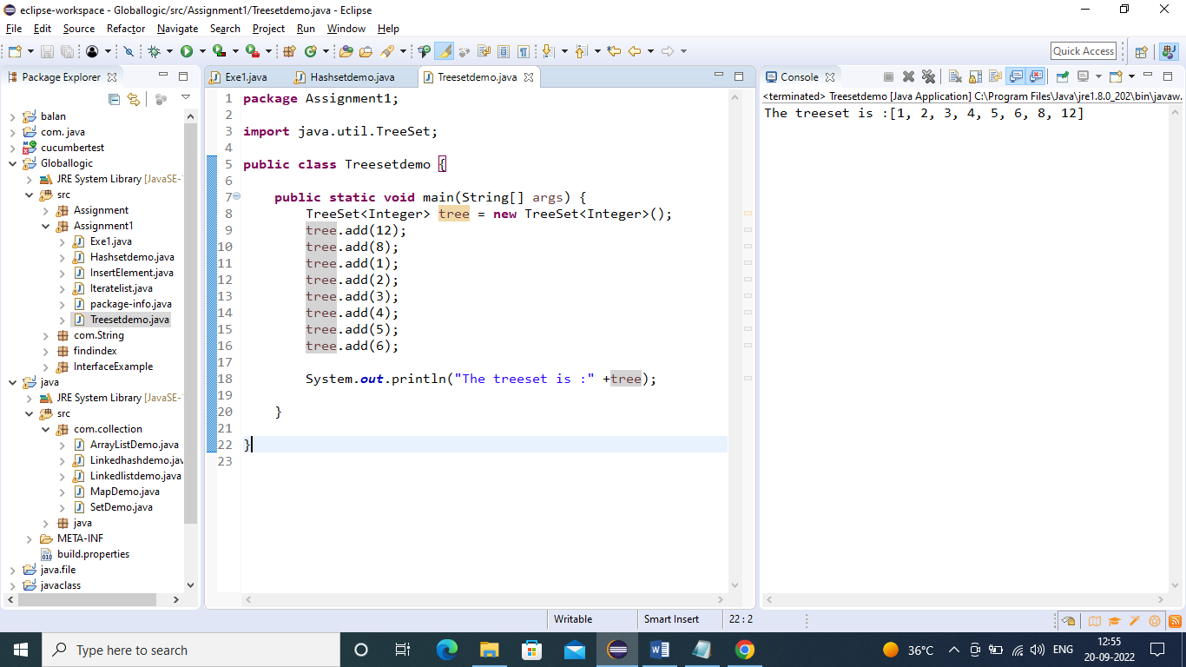

**2)Iterate Tree Set:**

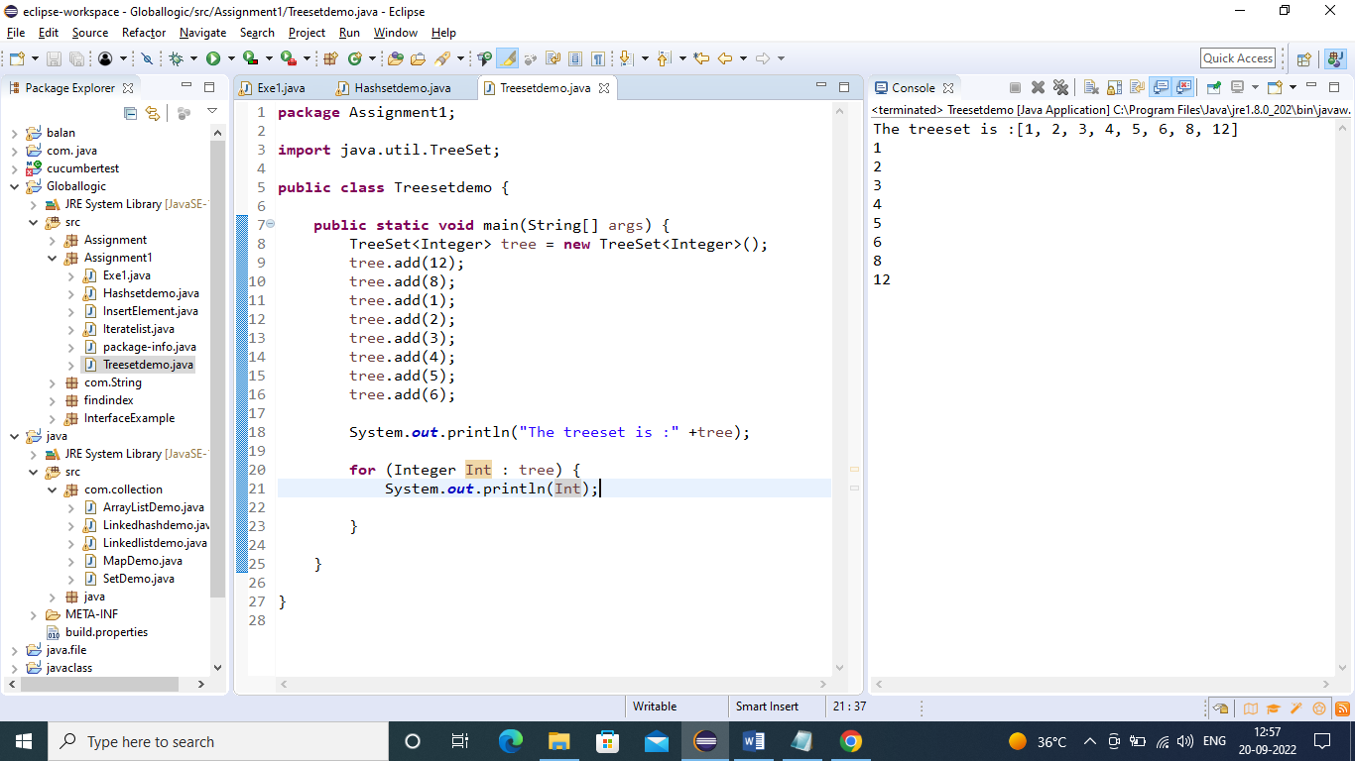

**3)Added all to another Tree:**

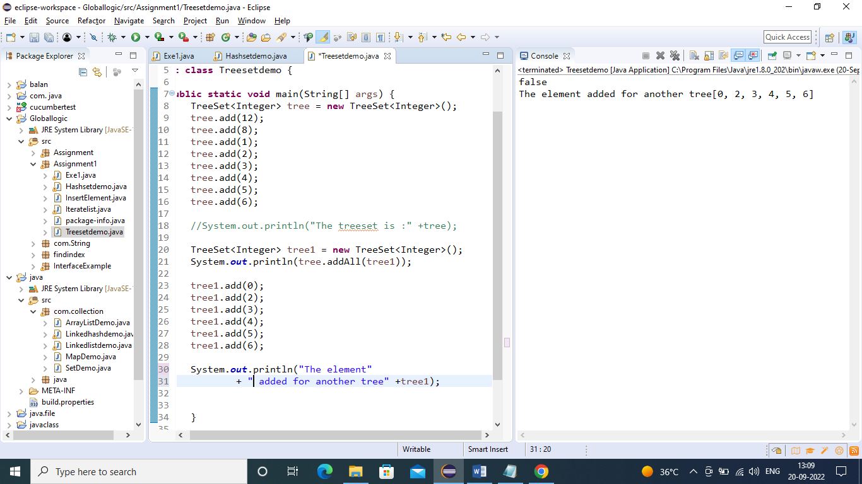

**1)priority Queue:**

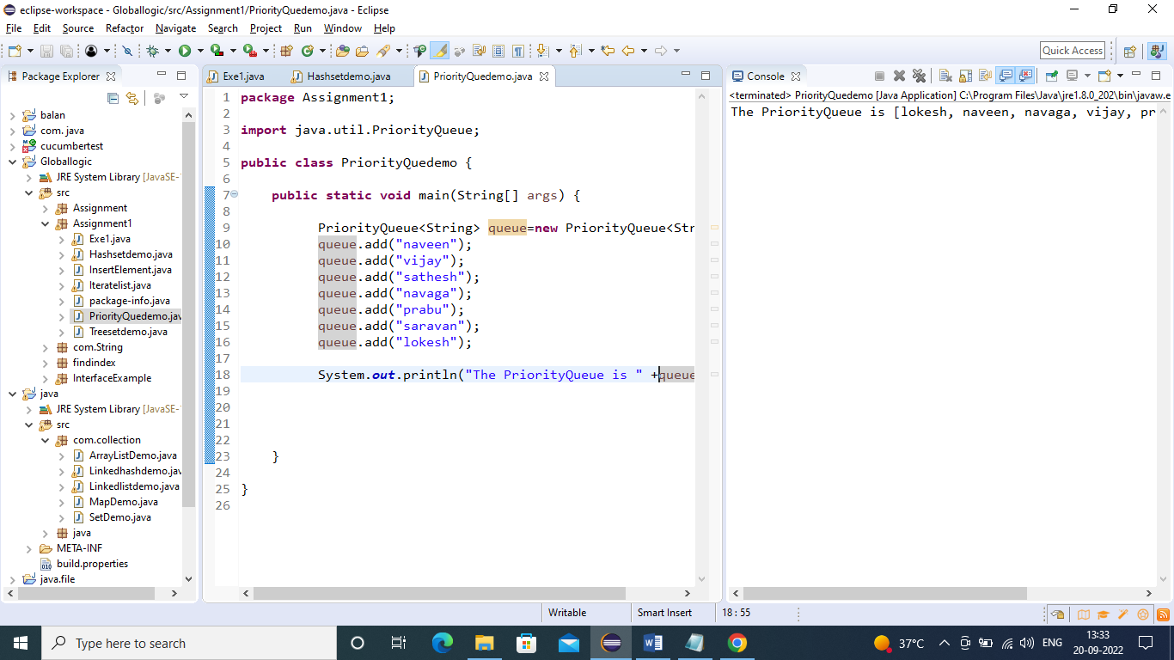

**2)Iterate priority:**

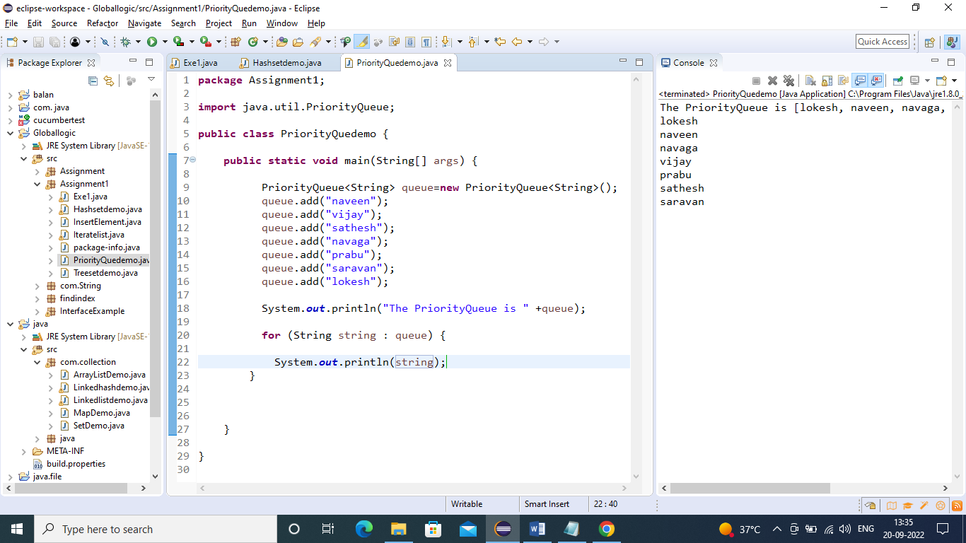

**3)Priority add all:**

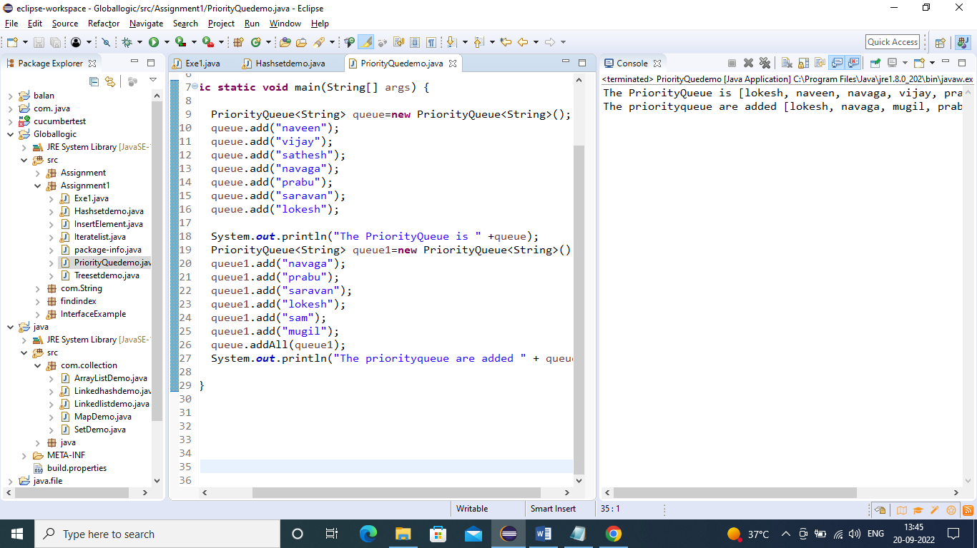

**1)Size of Map:**

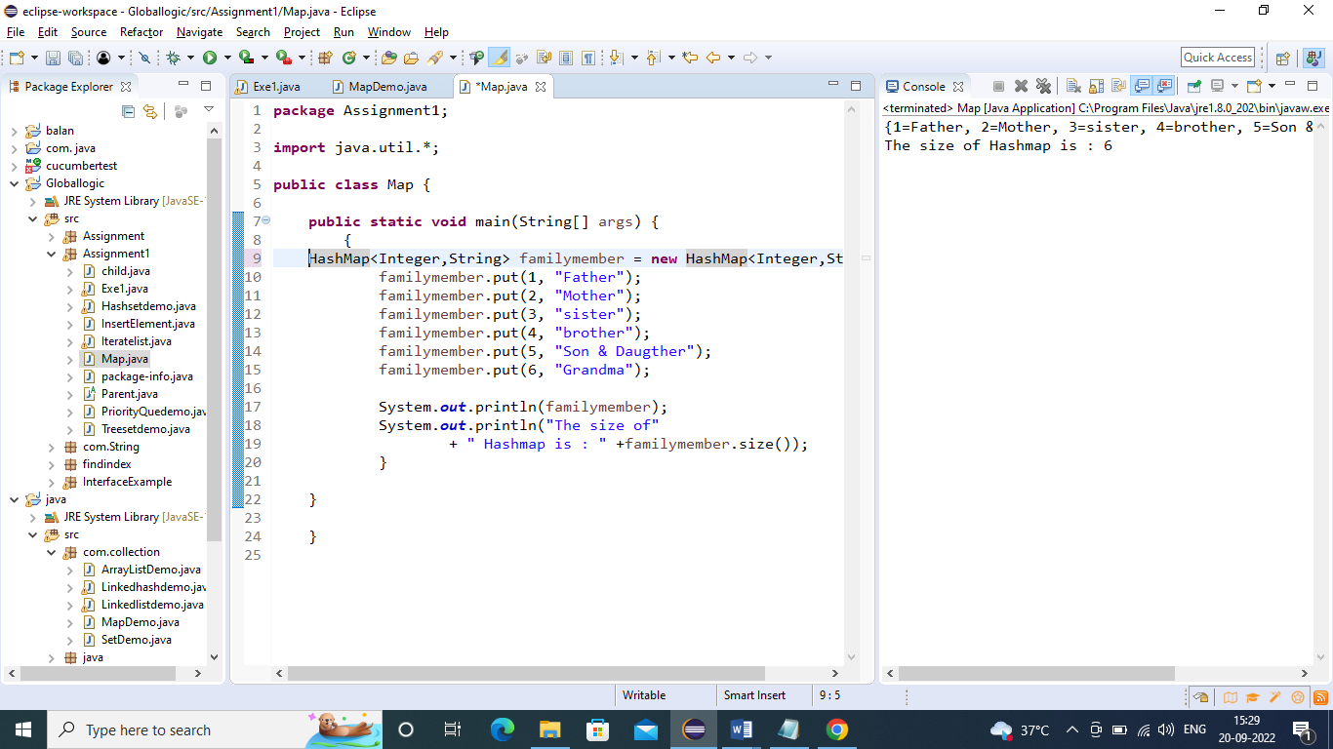

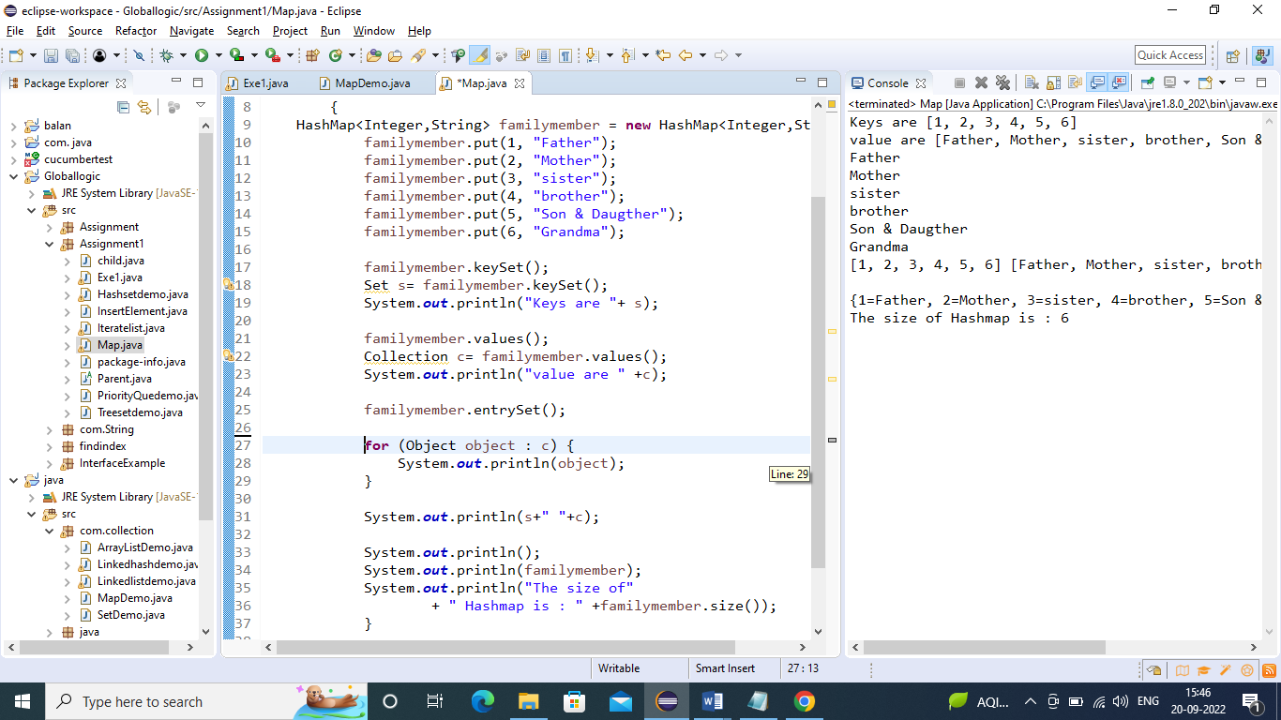

**Map Add all:**

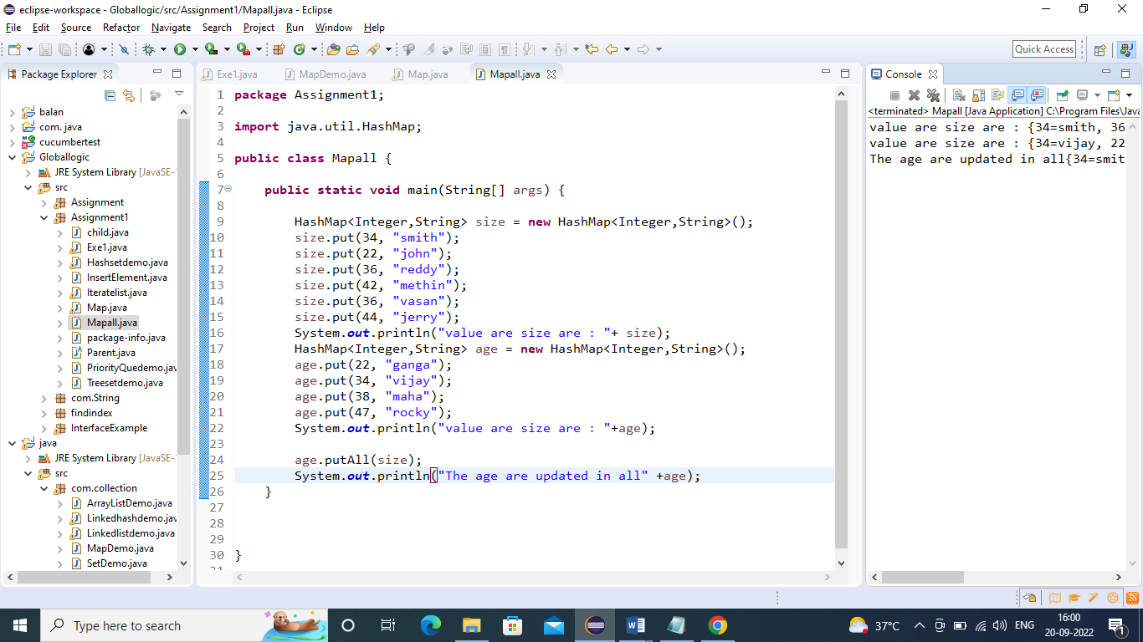

OutPut:value are size are : {34=smith, 36=vasan, 22=john, 42=methin, 44=jerry}

value are size are : {34=vijay, 22=ganga, 38=maha, 47=rocky}

The age are updated in all{34=smith, 36=vasan, 22=john, 38=maha, 42=methin, 44=jerry, 47=rocky}

**1)TreeMap-Iterate:**

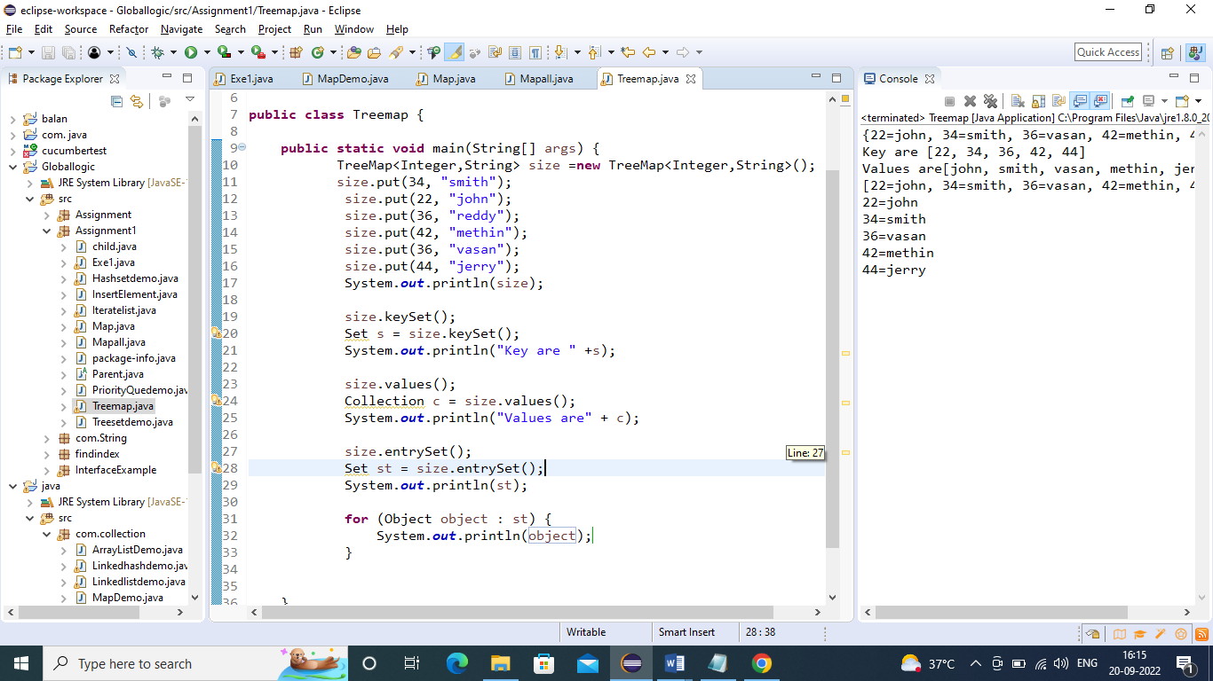

2)Copy to another Map:

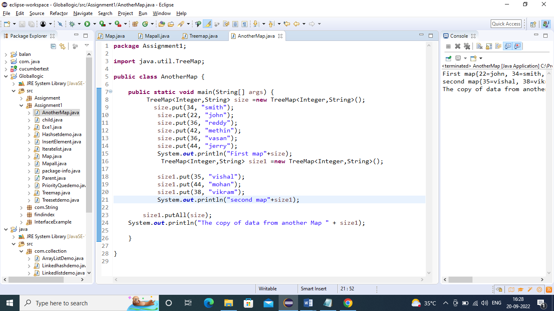

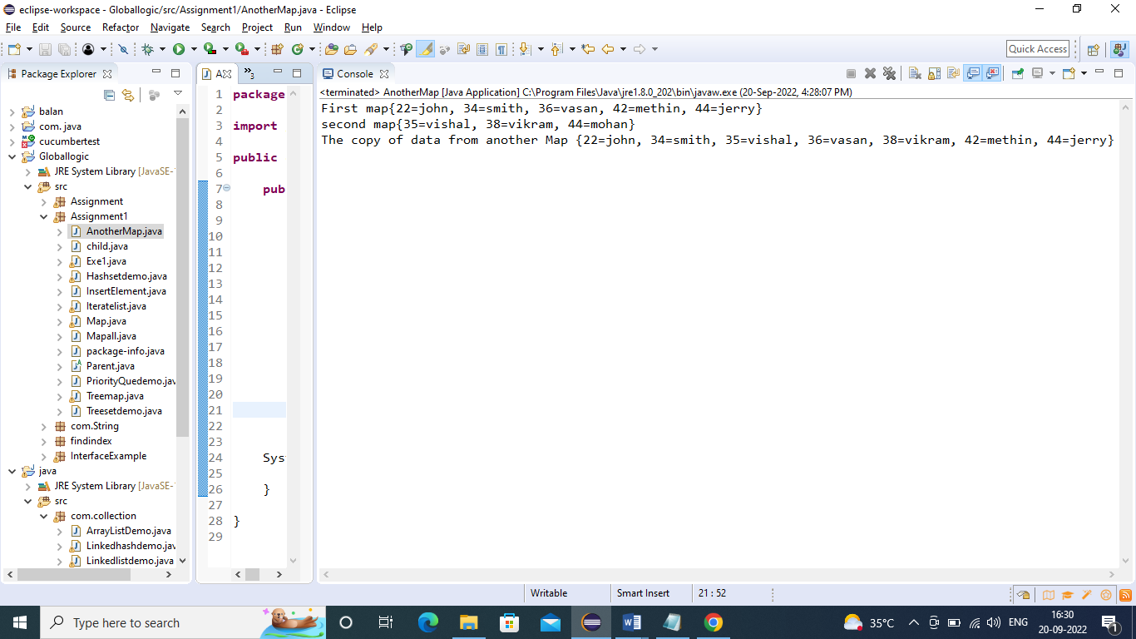

**3) checking the Key:**

