Here is a short note on how to use this app:

URL[: Knowledge management portal](http://10.153.156.105/)

Which redirects to login page:

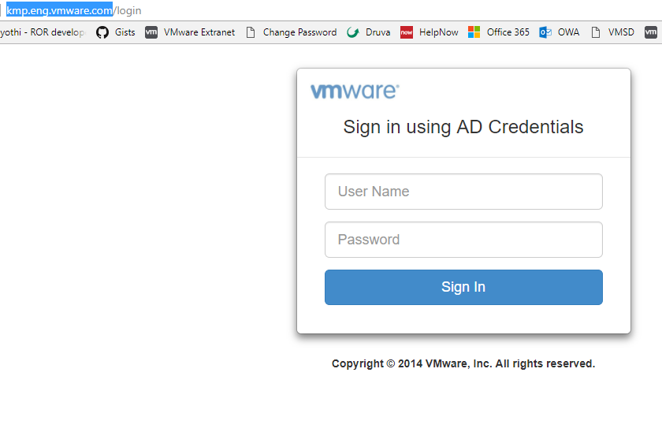

* Login with your AD credentials.
* Here is the listing page, which will list all the ideas/projects submitted.

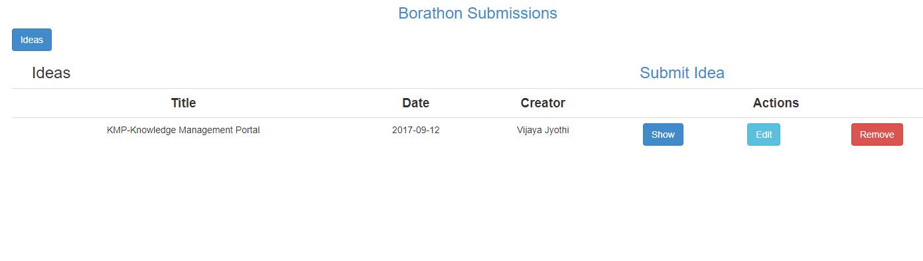

* Clicking on submit idea will redirect to :

