# **Self-Healing at SDDC**

## **Shivaprasad.A.V (**[**shivaprasada@vmware.com**](mailto:shivaprasada@vmware.com)**)**

# **1 Introduction**

Today building a Software Defined Datacenter has become easy, thanks to VMware technologies. VMware SDDC provides the complete software needed for building an Enterprise infrastructure that is flexible, easy to manage and easy to change for future needs. Among different outcomes from an SDDC, we are picking the below two outcomes which will drive and cater to the concept of Self-Healing at SDDC.

* Streamlined and Automated Data Center Operations – Drives ongoing operational efficiency and helps administrators spend more time on value-added projects
* High Availability and Resilient Infrastructure – Simplifies the architecture needed to support business continuity and automation of the disaster recovery process

With vRealize Operations, we know that it can monitor the complete SDDC infrastructure, Server Operating System, applications and more and alerting the administrator about the event and providing suggestion on the remediation action.

With vRealize Orchestrator, we can automate almost all data center operations covering complex IT processes by developing advance custom workflows that will provide complete end-to-end automated solutions. In addition, vRO has plugins for every other VMware products making this even more flexible to use across multiple products in the SDDC stack.

We combine the capabilities of both vRealize Operations for monitoring and alerting and vRealize Orchestrator for automating the data center operations. This combination helps the data center or the cloud admins to automate most of the remediation actions without any human intervention, ultimately reducing the RTO (recovery time objective).

## **1.1 Problem Description**

Today IT downtime costs organizations thousands of dollars per minute, in revenue and lost productivity, while also affecting customer experience and brand reputation.

In the event of disaster or any kind of downtime for any of the component in the SDDC stack, vRealize Operations would monitor and alert the admin, after which admin will have to take a necessary remediation action to fix the issue as quickly as possible.

With this approach there is always a time delay being added at different levels.

* Delay in alert notification.
* Delay in taking remediation action.
* Notification not being delivered for unknown reasons.

To overcome these issues, Automation helps reduce the time to resolution, the negative impacts on businesses and improve service availability.

vRealize operations provides a solution for Monitoring and Alerting of the complete SDDC stack, wouldn’t it be good if vROps also attempts to take certain remediation actions on the alert before it would even allow the administrator.

# **2 Executive summary**

An SDDC provides a unified platform for intelligent operations across physical hardware, virtualized environments, and cloud infrastructures, giving deep insight into all aspects of the data center, including compute, storage, and networking. With this information, IT conducts data-driven health monitoring, performance analysis, and capacity planning. At the core of SDDC intelligent operations are software tools that are inherently and deeply integrated into virtualized compute, storage, and network components of the infrastructure. By leveraging their unique position in software-defined infrastructure and native machine learning capabilities, these tools offer predictive analytics to IT operators, enabling proactive issue identification and resolution. Health alerts are presented proactively and include automated remediation for common issues.

Taking the automation to the next level by combining vRealize Operations (monitoring and alerting) and vRealize Orchestrator (Data center operations automation) and stitching the alerting and remediation action workflows to achieve automated remediation.

This approach would broadly cover the below:

* Engage the IT team for automating communication workflows and alerts
* Reduce the time to fix and automate manual, repetitive tasks
* Reduce the overall time to resolution even further by eliminating the time between receiving an alert and executing the remediation action.

The proposed approach will best utilize the integration of VMware products to work towards providing an end-to-end solution.

# **3 Proposal**

Leverage VMware vRealize Operation that offers increased flexibility to administrators by adding the concepts of symptoms, recommendations and actions to the product. As you might expect, symptoms are thresholds or characteristics that define when a problem may have occurred or additional guidance may be needed. Recommendations are a customizable way to define what that additional guidance might be – and actions allow you to automate and carry out that guidance.

Leverage VMware vRealize Orchestrator to Automate the Complex IT Processes: Build advanced customized workflows by stitching the existing default workflows, which come with the Solutions and workflow package.

vRealize Orchestrator integrates with other products in the vRealize Suite and vCloud Suite, this will add more flexibility to cover automation for complex usecases that will span across two or more products in the SDDC stack.

Our proposal is to define the advanced custom workflows by stitching the capabilities of vROps and vRO, which would to take automated remediation action for some of the common problems that are encountered in the data center without human intervention.

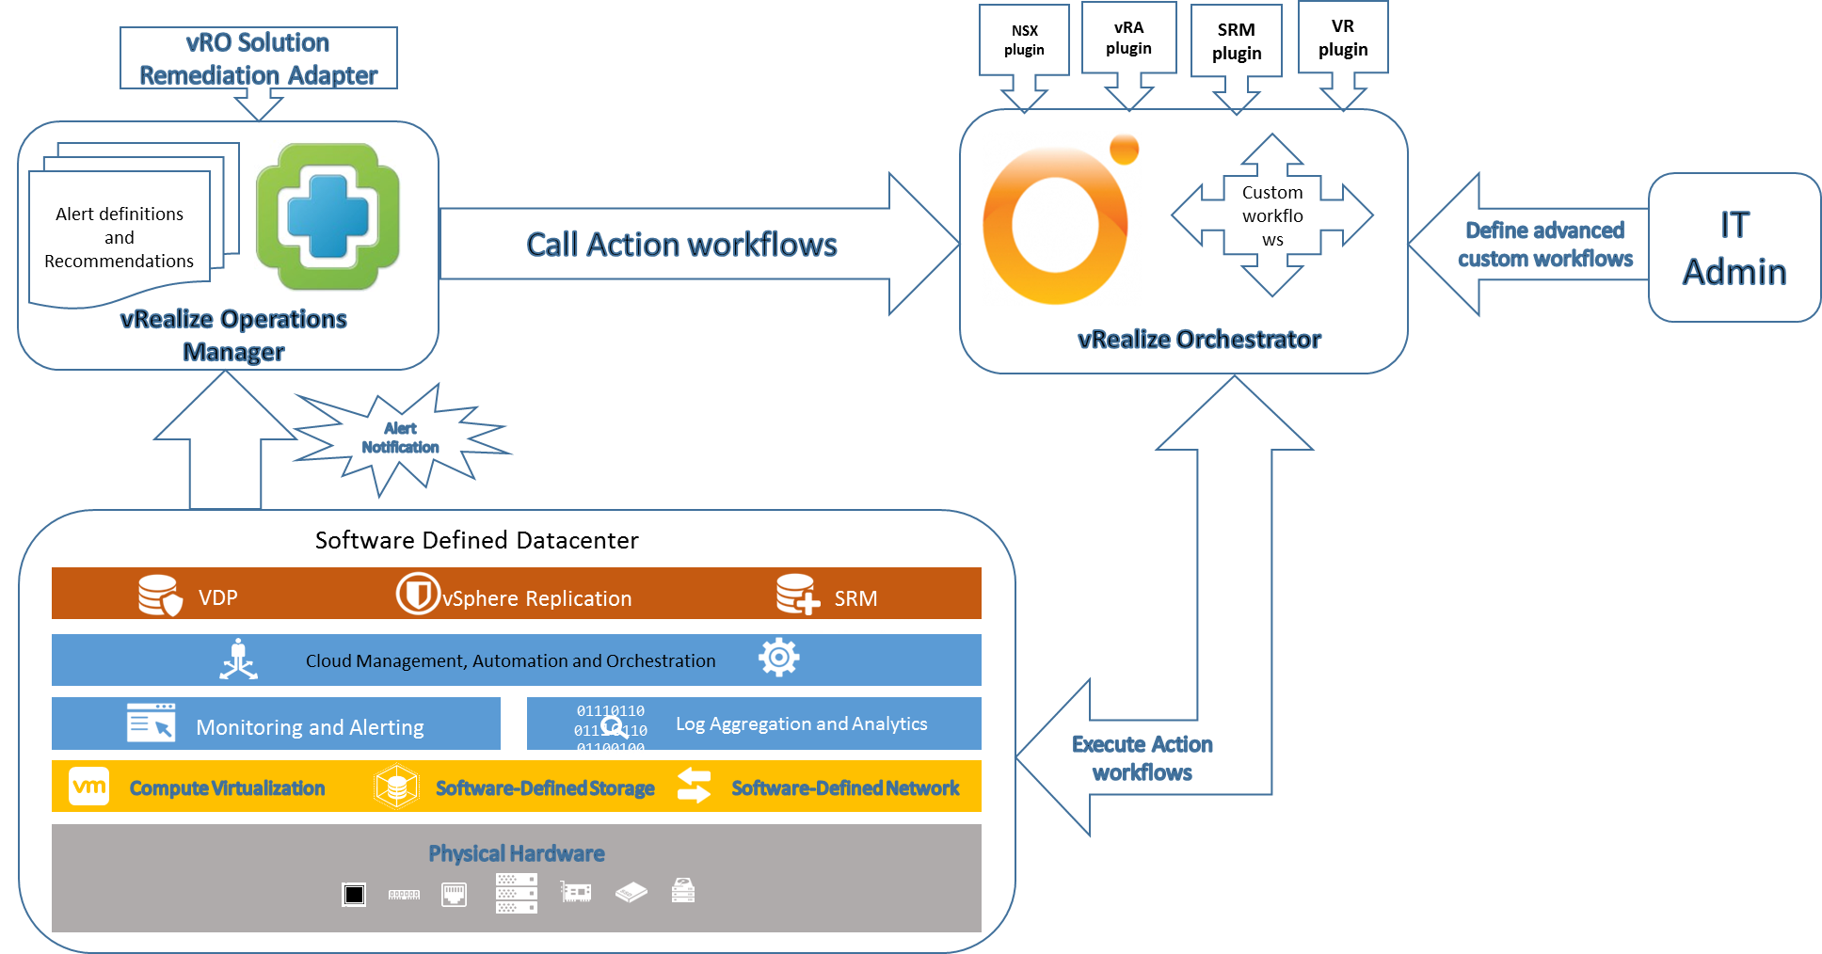

Above figure, demonstrate the flow:

1. vRealize Operations Manager will integrate with all the other SDDC components via Management packs.
2. Integrate the vROps with vRO via the solutions package.
3. IT Admin will define the custom alert definitions, with recommended actions.
4. IT Admin will define customized action workflows in vRealize orchestrator, which are specific to the alerts.
5. Once the alert is generated, this will be monitored by vROps and corresponding action workflow is triggered.

The proposal here is just to bring in the thought process of defining and automating the complex action workflows. This will become important when we actually define the real complex IT process where RTO is critical.

Action workflows can vary from simple workflow, where we monitor for CPU or Memory usage alerts on the Virtual Machine within the data center and trigger appropriate action workflow to increase the CPU or Memory.

To complex workflow like, the monitor the event specific to the disaster within the datacenter and trigger, the action workflows (DR workflows) that will cut across multiple products like say vRO-SRM-VC.

# **4 References**

* vRelaize Orchestrator [ <https://www.vmware.com/products/vrealize-orchestrator.html> ]
* vRealize Operations Manager [ <https://www.vmware.com/support/pubs/vrealize-operations-manager-pubs.html> ]
* vRealize Orchestrator Solution workflow package <https://blogs.vmware.com/management/2015/04/extending-vrealize-operations-actions-vrealize-orchestrator-solution-workflow-package.html> ]
* VMware SDDC [ <https://www.vmware.com/solutions/software-defined-datacenter/in-depth.html> ]