**EARLY PREDICTIONFOR CHRONIC KINDLY DIEASE DETECTION**

SYNOPSIS:

1.INTRODUCTION

1.1 OVERVIEW

1.2 PURPOSE

2.PROBLEM DEFINITION & DESIGN THINKING

2.1 EMPATHY MAP

2.2 IDEATION & BRAINSTORMING MAP

3.RESULT

4.ADVANTAGES & DISADVANTAGES

5.APPLICATIONS

6.CONCLUSION

7.FUTURE SCOPE

8.APPENDIX

1. **INTRODUCTION**

1.1 **OVERVIEW**

In the human body, the kidneys, two bean-shaped organs positioned under the ribs, play the important role of filtering wastes and toxic bodies from the blood. Chronic kidney disease (CKD) is a condition in which the human kidneys are damaged and unable to filter the blood in a proper way [[1](https://preview.hindawi.com/journals/jhe/2023/3553216/?msclkid=ed371c61cd881957575d7855c816a6d3&utm_source=bing&utm_medium=cpc&utm_campaign=HDW_MRKT_GBL_SUB_BNGA_PAI_DYNA_JOUR_X_PJ_GROUP3&utm_term=Electrical%20and%20Computer%20Engineering&utm_content=JOUR_X_PJ_GROUP3_JECE#B1)]. It is a nontransmissible disease that causes mortality of large numbers worldwide [[2](https://preview.hindawi.com/journals/jhe/2023/3553216/?msclkid=ed371c61cd881957575d7855c816a6d3&utm_source=bing&utm_medium=cpc&utm_campaign=HDW_MRKT_GBL_SUB_BNGA_PAI_DYNA_JOUR_X_PJ_GROUP3&utm_term=Electrical%20and%20Computer%20Engineering&utm_content=JOUR_X_PJ_GROUP3_JECE#B2), [3](https://preview.hindawi.com/journals/jhe/2023/3553216/?msclkid=ed371c61cd881957575d7855c816a6d3&utm_source=bing&utm_medium=cpc&utm_campaign=HDW_MRKT_GBL_SUB_BNGA_PAI_DYNA_JOUR_X_PJ_GROUP3&utm_term=Electrical%20and%20Computer%20Engineering&utm_content=JOUR_X_PJ_GROUP3_JECE#B3)] and is very expensive to properly detect and diagnose [[3](https://preview.hindawi.com/journals/jhe/2023/3553216/?msclkid=ed371c61cd881957575d7855c816a6d3&utm_source=bing&utm_medium=cpc&utm_campaign=HDW_MRKT_GBL_SUB_BNGA_PAI_DYNA_JOUR_X_PJ_GROUP3&utm_term=Electrical%20and%20Computer%20Engineering&utm_content=JOUR_X_PJ_GROUP3_JECE#B3)]. CKD is commonly destructive, expensive, onerous, and often risky; therefore, CKD patients often reach its chronic stages, especially in countries with limited resources [[4](https://preview.hindawi.com/journals/jhe/2023/3553216/?msclkid=ed371c61cd881957575d7855c816a6d3&utm_source=bing&utm_medium=cpc&utm_campaign=HDW_MRKT_GBL_SUB_BNGA_PAI_DYNA_JOUR_X_PJ_GROUP3&utm_term=Electrical%20and%20Computer%20Engineering&utm_content=JOUR_X_PJ_GROUP3_JECE#B4)]. Furthermore, CKD is a silent killer due to the lack of physical symptoms at the initial stage, but a steady loss of glomerular filtration rate (GFR) occurs over a period of time longer than three months [[5](https://preview.hindawi.com/journals/jhe/2023/3553216/?msclkid=ed371c61cd881957575d7855c816a6d3&utm_source=bing&utm_medium=cpc&utm_campaign=HDW_MRKT_GBL_SUB_BNGA_PAI_DYNA_JOUR_X_PJ_GROUP3&utm_term=Electrical%20and%20Computer%20Engineering&utm_content=JOUR_X_PJ_GROUP3_JECE#B5)]. The study of Bikbov et al. [[2](https://preview.hindawi.com/journals/jhe/2023/3553216/?msclkid=ed371c61cd881957575d7855c816a6d3&utm_source=bing&utm_medium=cpc&utm_campaign=HDW_MRKT_GBL_SUB_BNGA_PAI_DYNA_JOUR_X_PJ_GROUP3&utm_term=Electrical%20and%20Computer%20Engineering&utm_content=JOUR_X_PJ_GROUP3_JECE#B2)] reported that in 2016, the CKD-affected individuals reached above 752 million of which more than 335 million are males and 417 million are females. A total CKD-affected population exceeding 600 million in 112 countries cannot afford renal transplantation which leads to an annual mortality rate of over 1 million people due to kidney failure [[6](https://preview.hindawi.com/journals/jhe/2023/3553216/?msclkid=ed371c61cd881957575d7855c816a6d3&utm_source=bing&utm_medium=cpc&utm_campaign=HDW_MRKT_GBL_SUB_BNGA_PAI_DYNA_JOUR_X_PJ_GROUP3&utm_term=Electrical%20and%20Computer%20Engineering&utm_content=JOUR_X_PJ_GROUP3_JECE#B6)]. Similarly, due to CKD, the worldwide death rate of patients of any age increased by over 41% from 1990 to 2017, resulting in the mortality of 1.2 million in 2017 only [[7](https://preview.hindawi.com/journals/jhe/2023/3553216/?msclkid=ed371c61cd881957575d7855c816a6d3&utm_source=bing&utm_medium=cpc&utm_campaign=HDW_MRKT_GBL_SUB_BNGA_PAI_DYNA_JOUR_X_PJ_GROUP3&utm_term=Electrical%20and%20Computer%20Engineering&utm_content=JOUR_X_PJ_GROUP3_JECE#B7)].

CKD is a fatal disease if left undetected as it leads to renal failure, in the worst cases. However, the early diagnosis of CDK can significantly reduce the mortality rate. Moreover, if CKD is predicted early and correctly, it results in an increased probability of successful treatment and prolongs the patient’s life [[8](https://preview.hindawi.com/journals/jhe/2023/3553216/?msclkid=ed371c61cd881957575d7855c816a6d3&utm_source=bing&utm_medium=cpc&utm_campaign=HDW_MRKT_GBL_SUB_BNGA_PAI_DYNA_JOUR_X_PJ_GROUP3&utm_term=Electrical%20and%20Computer%20Engineering&utm_content=JOUR_X_PJ_GROUP3_JECE#B8)]. The stages of CKD are primarily based on the estimated GFR (eGFR) which is based on creatinine level, age, and race [[9](https://preview.hindawi.com/journals/jhe/2023/3553216/?msclkid=ed371c61cd881957575d7855c816a6d3&utm_source=bing&utm_medium=cpc&utm_campaign=HDW_MRKT_GBL_SUB_BNGA_PAI_DYNA_JOUR_X_PJ_GROUP3&utm_term=Electrical%20and%20Computer%20Engineering&utm_content=JOUR_X_PJ_GROUP3_JECE#B9)]. In this regard, an efficient prediction is more useful as it can save the lives of thousands of patients and prevent negative outcomes. ML techniques play a vital role to provide fast predictions depending on historical medical data; however, it has been challenging to determine which prediction model is more accurate in a short period [[10](https://preview.hindawi.com/journals/jhe/2023/3553216/?msclkid=ed371c61cd881957575d7855c816a6d3&utm_source=bing&utm_medium=cpc&utm_campaign=HDW_MRKT_GBL_SUB_BNGA_PAI_DYNA_JOUR_X_PJ_GROUP3&utm_term=Electrical%20and%20Computer%20Engineering&utm_content=JOUR_X_PJ_GROUP3_JECE#B10)]. The advances in ML, in addition to predictive analytics, provide promising results which in turn prove the capability of prediction in CKD and beyond [[11](https://preview.hindawi.com/journals/jhe/2023/3553216/?msclkid=ed371c61cd881957575d7855c816a6d3&utm_source=bing&utm_medium=cpc&utm_campaign=HDW_MRKT_GBL_SUB_BNGA_PAI_DYNA_JOUR_X_PJ_GROUP3&utm_term=Electrical%20and%20Computer%20Engineering&utm_content=JOUR_X_PJ_GROUP3_JECE#B11)]. The utilization of ML methods in nephrology enables the building of ML models to better detect the at-risk patients of CKD and better enhance their decision-making process, especially in primary care settings [[12](https://preview.hindawi.com/journals/jhe/2023/3553216/?msclkid=ed371c61cd881957575d7855c816a6d3&utm_source=bing&utm_medium=cpc&utm_campaign=HDW_MRKT_GBL_SUB_BNGA_PAI_DYNA_JOUR_X_PJ_GROUP3&utm_term=Electrical%20and%20Computer%20Engineering&utm_content=JOUR_X_PJ_GROUP3_JECE#B12)].

1. This paper is an attempt to assist physicians in detecting and diagnosing CKD patients using ML techniques, simultaneously reducing the cost of diagnosing through limiting the clinical tests which will be ideal for countries with limited resources. We have trained KNN, SVM, RF, and bagging on a dataset taken from the UCI repository. The dataset was preprocessed which entailed missing value imputation, feature selection, and features normalization. The socioeconomic aim of this paper is to lessen clinical expenses and accommodate early treatment plans by achieving accurate prediction using simple and inexpensive clinical tests.
2. The remainder of this study is organized as follows: Section [2](https://preview.hindawi.com/journals/jhe/2023/3553216/?msclkid=ed371c61cd881957575d7855c816a6d3&utm_source=bing&utm_medium=cpc&utm_campaign=HDW_MRKT_GBL_SUB_BNGA_PAI_DYNA_JOUR_X_PJ_GROUP3&utm_term=Electrical%20and%20Computer%20Engineering&utm_content=JOUR_X_PJ_GROUP3_JECE#sec2) discusses the previous work, while details of the methods used are discussed in Section [3](https://preview.hindawi.com/journals/jhe/2023/3553216/?msclkid=ed371c61cd881957575d7855c816a6d3&utm_source=bing&utm_medium=cpc&utm_campaign=HDW_MRKT_GBL_SUB_BNGA_PAI_DYNA_JOUR_X_PJ_GROUP3&utm_term=Electrical%20and%20Computer%20Engineering&utm_content=JOUR_X_PJ_GROUP3_JECE#sec3), followed by results and discussion in Section [4](https://preview.hindawi.com/journals/jhe/2023/3553216/?msclkid=ed371c61cd881957575d7855c816a6d3&utm_source=bing&utm_medium=cpc&utm_campaign=HDW_MRKT_GBL_SUB_BNGA_PAI_DYNA_JOUR_X_PJ_GROUP3&utm_term=Electrical%20and%20Computer%20Engineering&utm_content=JOUR_X_PJ_GROUP3_JECE#sec4); finally, Section [5](https://preview.hindawi.com/journals/jhe/2023/3553216/?msclkid=ed371c61cd881957575d7855c816a6d3&utm_source=bing&utm_medium=cpc&utm_campaign=HDW_MRKT_GBL_SUB_BNGA_PAI_DYNA_JOUR_X_PJ_GROUP3&utm_term=Electrical%20and%20Computer%20Engineering&utm_content=JOUR_X_PJ_GROUP3_JECE#sec5) concludes this study.

**1.2 PURPOSE**

**Chronic kidney disease** (**CKD**) is a type of [kidney disease](https://en.wikipedia.org/wiki/Kidney_disease) in which a gradual loss of [kidney function](https://en.wikipedia.org/wiki/Kidney_function) occurs over a period of months to years.[[2]](https://en.wikipedia.org/wiki/Chronic_kidney_disease#cite_note-NIH2017What-2)[[5]](https://en.wikipedia.org/wiki/Chronic_kidney_disease#cite_note-Hop2017-5) Initially generally no symptoms are seen, but later symptoms may include [leg swelling](https://en.wikipedia.org/wiki/Pedal_edema), feeling tired, [vomiting](https://en.wikipedia.org/wiki/Vomiting), loss of appetite, and [confusion](https://en.wikipedia.org/wiki/Confusion).[[2]](https://en.wikipedia.org/wiki/Chronic_kidney_disease#cite_note-NIH2017What-2) Complications can relate to hormonal dysfunction of the kidneys and include (in chronological order) [high blood pressure](https://en.wikipedia.org/wiki/Hypertension) (often related to activation of the [renin–angiotensin system](https://en.wikipedia.org/wiki/Renin%E2%80%93angiotensin_system) system), [bone disease](https://en.wikipedia.org/wiki/Renal_osteodystrophy), and [anemia](https://en.wikipedia.org/wiki/Anemia).[[3]](https://en.wikipedia.org/wiki/Chronic_kidney_disease#cite_note-Li2012-3)[[4]](https://en.wikipedia.org/wiki/Chronic_kidney_disease#cite_note-MP2017-4)[[10]](https://en.wikipedia.org/wiki/Chronic_kidney_disease#cite_note-Kid2009-10) Additionally CKD patients have markedly increased [cardiovascular](https://en.wikipedia.org/wiki/Cardiovascular_disease) complications with increased risks of [death](https://en.wikipedia.org/wiki/Death) and hospitalization.[[11]](https://en.wikipedia.org/wiki/Chronic_kidney_disease#cite_note-11)

Causes of chronic kidney disease include [diabetes](https://en.wikipedia.org/wiki/Diabetic_nephropathy), [high blood pressure](https://en.wikipedia.org/wiki/High_blood_pressure), [glomerulonephritis](https://en.wikipedia.org/wiki/Glomerulonephritis), and [polycystic kidney disease](https://en.wikipedia.org/wiki/Polycystic_kidney_disease).[[5]](https://en.wikipedia.org/wiki/Chronic_kidney_disease#cite_note-Hop2017-5)[[6]](https://en.wikipedia.org/wiki/Chronic_kidney_disease#cite_note-GBD2015De-6) Risk factors include a family history of chronic kidney disease.[[2]](https://en.wikipedia.org/wiki/Chronic_kidney_disease#cite_note-NIH2017What-2) Diagnosis is by [blood tests](https://en.wikipedia.org/wiki/Blood_tests) to measure the estimated [glomerular filtration rate](https://en.wikipedia.org/wiki/Glomerular_filtration_rate) (eGFR), and a [urine test](https://en.wikipedia.org/wiki/Urinalysis) to measure [albumin](https://en.wikipedia.org/wiki/Albumin).[[7]](https://en.wikipedia.org/wiki/Chronic_kidney_disease#cite_note-NIH2016Diag-7) [Ultrasound](https://en.wikipedia.org/wiki/Renal_ultrasound) or [kidney biopsy](https://en.wikipedia.org/wiki/Kidney_biopsy) may be performed to determine the underlying cause.[[5]](https://en.wikipedia.org/wiki/Chronic_kidney_disease#cite_note-Hop2017-5) Several severity-based staging systems are in use.[[12]](https://en.wikipedia.org/wiki/Chronic_kidney_disease#cite_note-12)[[13]](https://en.wikipedia.org/wiki/Chronic_kidney_disease#cite_note-Fer2018-13)

Screening at-risk people is recommended.[[7]](https://en.wikipedia.org/wiki/Chronic_kidney_disease#cite_note-NIH2016Diag-7) Initial treatments may include medications to lower blood pressure, blood sugar, and cholesterol.[[9]](https://en.wikipedia.org/wiki/Chronic_kidney_disease#cite_note-NIH2016Tx-9) [Angiotensin converting enzyme inhibitors](https://en.wikipedia.org/wiki/Angiotensin_converting_enzyme_inhibitor) (ACEIs) or [angiotensin II receptor antagonists](https://en.wikipedia.org/wiki/Angiotensin_II_receptor_antagonists) (ARBs) are generally first-line agents for blood pressure control, as they slow progression of the kidney disease and the risk of heart disease.[[14]](https://en.wikipedia.org/wiki/Chronic_kidney_disease#cite_note-Xie2015-14) [Loop diuretics](https://en.wikipedia.org/wiki/Loop_diuretic) may be used to control [edema](https://en.wikipedia.org/wiki/Edema) and, if needed, to further lower blood pressure.[[15]](https://en.wikipedia.org/wiki/Chronic_kidney_disease#cite_note-15)[[9]](https://en.wikipedia.org/wiki/Chronic_kidney_disease#cite_note-NIH2016Tx-9)[[16]](https://en.wikipedia.org/wiki/Chronic_kidney_disease#cite_note-16) [NSAIDs](https://en.wikipedia.org/wiki/NSAIDs) should be avoided.[[9]](https://en.wikipedia.org/wiki/Chronic_kidney_disease#cite_note-NIH2016Tx-9) Other recommended measures include staying active, and certain dietary changes such as a low-salt diet and the right amount of protein.[[9]](https://en.wikipedia.org/wiki/Chronic_kidney_disease#cite_note-NIH2016Tx-9)[[17]](https://en.wikipedia.org/wiki/Chronic_kidney_disease#cite_note-17) Treatments for anemia and bone disease may also be required.[[18]](https://en.wikipedia.org/wiki/Chronic_kidney_disease#cite_note-NIH2016Anemia-18)[[19]](https://en.wikipedia.org/wiki/Chronic_kidney_disease#cite_note-19) Severe disease requires [hemodialysis](https://en.wikipedia.org/wiki/Hemodialysis), [peritoneal dialysis](https://en.wikipedia.org/wiki/Peritoneal_dialysis), or a [kidney transplant](https://en.wikipedia.org/wiki/Kidney_transplant) for survival.[[8]](https://en.wikipedia.org/wiki/Chronic_kidney_disease#cite_note-NIH2017-8)

Chronic kidney disease affected 753 million people globally in 2016 - 417 million females and 336 million males.[[1]](https://en.wikipedia.org/wiki/Chronic_kidney_disease#cite_note-GBD2016Prev-1)[[20]](https://en.wikipedia.org/wiki/Chronic_kidney_disease#cite_note-Osteoblastogenesis_of_adipose-deriv-20) In 2015, it caused 1.2 million deaths, up from 409,000 in 1990.[[6]](https://en.wikipedia.org/wiki/Chronic_kidney_disease#cite_note-GBD2015De-6)[[21]](https://en.wikipedia.org/wiki/Chronic_kidney_disease#cite_note-GDB2013-21) The causes that contribute to the greatest number of deaths are high blood pressure at 550,000, followed by diabetes at 418,000, and glomerulonephritis at 238,000.[[6]](https://en.wikipedia.org/wiki/Chronic_kidney_disease#cite_note-GBD2015De-6)

**2.PROBLEM DEFINITION&DESIGN THINKING**

**2.1 EMPATHY MAP**

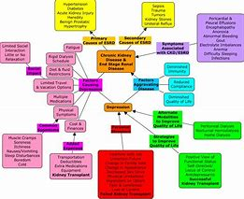

* 1. **IDEATION &BRAINSTORMING MAP**

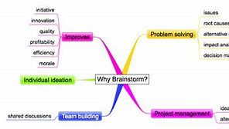

**3.RESULT**

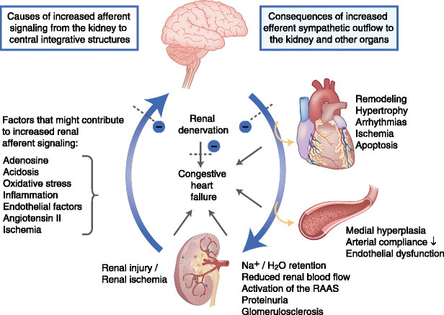

This project uses CKD parameters for predicting CKD parameters for predicting CKD disease which helps medical students. this project is an automation for chronic renal disease prediction and disease complication, type can be identified from the database in an affective and economically fast[1]tracked manner, which can be achieved by applying naive bayes algorithm and KNN. Input to the algorithm is CKD parameters and disease is predicted based upon old CKD patient data.

A. Criteria For Assessment

Accuracy of the proposed technology can be measured by employing certain parameters like Precision, Recall, F-Measure and Accuracy. All this  parameter can be measured by using the condition given below:

1. Accuracy: Accuracy is at the top priority in measuring performance and its a ratio perception that are correctly classified to the overall perception

Accuracy = T P + T N T P + F P + F N + T N   (6)

Equation 6 gives Accuracy, where total number of True-positive Classification is Given by TP, False-negative Classification is given by FN, True-negative Classification is given by TN, and False-positive Classification is given by FP.

2. Precision: Precision is the ratio of effectively expected observation that are positive to the overall positive observation.

Precision = T P T P + F P (7)

Equation 7 is used to find precision, where total number of True-positive Classification is Given by TP and False-positive Classification is given by FP.

3. Recall: It is a ration precisely expected observation that are positive to the observation in authentic class yes.

Recall = T P T P + F N (8)

Equation 8 is used to find recall, where total number of True-positive Classification is Given by TP and False-positive Classification is given by FP.

4. F-Measure: F-Measure is the average of Precision and Recall, it consider both false negative and false positives for its calculation. F-measure is more beneficial than accuracy, especially in the event where their is uneven distribution of class.

F − Measure = 2 (Recall ∗ Precision) / (Recall +  Precision )              (9)

Equation 9 is used to find F-measure.

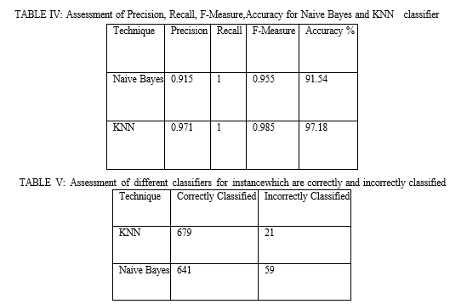

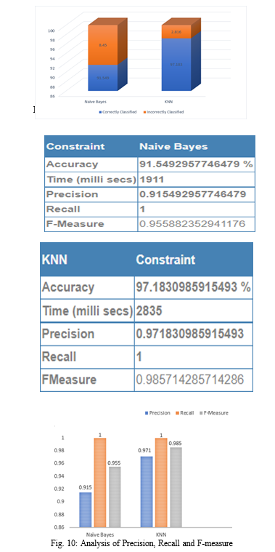

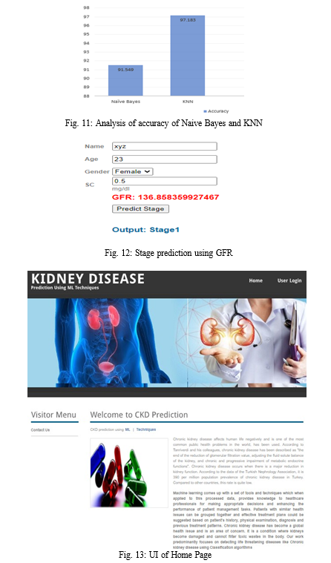

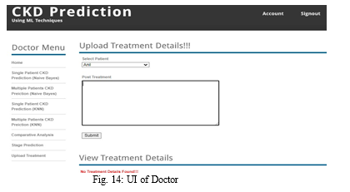

**4. ADVANTAGES&DISADVANTAGES**

**ADVANTAGES**

* It is readily available, so the patient doesn't need to wait.
* No chance of rejection.
* No need for major surgery.
* No need to take drugs, such as immuno-suppressants.

**DISADVANTAGE**

One of the most significant disadvantages of PD is that it’s required to be carried out every day, which may act as an inconvenience for some. Furthermore, by undergoing PD specifically, there may be a greater risk of developing peritonitis – an infection of the abdomen.

In some, quite rare instances, patients may experience scarring and thickening of the peritoneum. In order to prevent this, patients may have to change their treatment to hemodialysis.

**5. APPLICATIONS**

Artificial intelligence (AI) is considered as the next natural progression of traditional statistical techniques. Advances in analytical methods and infrastructure enable AI to be applied in health care. While AI applications are relatively common in fields like ophthalmology and cardiology, its use is scarcely reported in nephrology. We present the current status of AI in research toward kidney disease and discuss future pathways for AI. The clinical applications of AI in progression to end-stage kidney disease and dialysis can be broadly subdivided into three main topics: (a) predicting events in the future such as mortality and hospitalization; (b) providing treatment and decision aids such as automating drug prescription; and (c) identifying patterns such as phenotypical clusters and arteriovenous fistula aneurysm.

At present, the use of prediction models in treating patients with kidney disease is still in its infancy and further evidence is needed to identify its relative value. Policies and regulations need to be addressed before implementing AI solutions at the point of care in clinics. AI is not anticipated to replace the nephrologists’ medical decision-making, but instead assist them in providing optimal personalized care for their patients

Artificial intelligence (AI) is anticipated to transform health care through advancements in clinical decision support. Rapid advancements in computational power and improvements in statistical techniques ultimately enable AI to be leveraged to identify hidden interactions and patterns within large, complex, multi-level datasets.

AI has been suggested as the next natural progression of traditional statistical techniques (eg, logistic regression, linear regression, etc), and these analytical advancements can be applied to the practice of medicine.[1](https://onlinelibrary.wiley.com/doi/full/10.1111/sdi.12915#sdi12915-bib-0001), [2](https://onlinelibrary.wiley.com/doi/full/10.1111/sdi.12915#sdi12915-bib-0002) An AI-based “virtual coach” using a diverse set of inputs and algorithms may have the potential to aid in personalized medical guidance for patients.[3](https://onlinelibrary.wiley.com/doi/full/10.1111/sdi.12915#sdi12915-bib-0003) AI medical decision support tools for clinicians may also improve efficiency by optimizing routine workflows and aid them in the process of providing care.[4](https://onlinelibrary.wiley.com/doi/full/10.1111/sdi.12915#sdi12915-bib-0004)

In a recent bibliometric study on the global evolution of AI in health care and medicine, it is shown that clinical applications of AI are relatively common in fields like ophthalmology, oncology, and cardiology.[5](https://onlinelibrary.wiley.com/doi/full/10.1111/sdi.12915#sdi12915-bib-0005) However, the use of AI is scarcely reported in nephrology, despite attributes of large datasets[6](https://onlinelibrary.wiley.com/doi/full/10.1111/sdi.12915#sdi12915-bib-0006) and one of the highest disease burdens.[7](https://onlinelibrary.wiley.com/doi/full/10.1111/sdi.12915#sdi12915-bib-0007) In- center hemo dialysis (HD) is typically performed three times per week for 3-5 hours, thus amassing a large volume of clinical data captured in electronic medical records (EMR).

These large treatment datasets are ideal for AI applications. With advances in technology, remote treatment monitoring applications allow clinical data to be collected from patients dialyzing at home. Recently, it has also become possible to measure and store beat-to-beat hemodynamic and respiratory values during dialysis treatment.[8](https://onlinelibrary.wiley.com/doi/full/10.1111/sdi.12915#sdi12915-bib-0008) Furthermore, the emerging field of medical grade wearables is anticipated to yield even more robust data in all populations.[9](https://onlinelibrary.wiley.com/doi/full/10.1111/sdi.12915#sdi12915-bib-0009)

The aim of this review is to: (a) provide an overview of the AI application process in a clinical setting; (b) provide brief descriptions of select advanced Machine Learning (ML) algorithms; (c) present the current status of AI in research toward kidney disease and dialysis; and (d) explore future pathways for AI within the discipline of nephrology. This review focusses on the applications of AI in progression to end-stage kidney disease (ESKD) and dialysis omitting the unique acute kidney injury population.

There is no universal definition of AI, but central to most definitions is the ability of a learning system to mimic human behavior. As depicted in Figure [**1**](https://onlinelibrary.wiley.com/doi/full/10.1111/sdi.12915#sdi12915-fig-0001), AI is an umbrella term that brings together concepts from several fields such as computer science, statistics, algorithmic, ML, information retrieval, and data science at large.[10](https://onlinelibrary.wiley.com/doi/full/10.1111/sdi.12915#sdi12915-bib-0010) ML techniques are very powerful in their ability to detection hidden patterns in large datasets that are otherwise difficult to identify by traditional statistical techniques.

##### **6. Conclusion**

In this paper, we employed a web application which can predict CKD, a comparative analysis was performed between KNN and Naive Bayes algorithm, in which KNN yield a better result. From the result obtained it is observed that overall precision, F-measure, recall is 0.971, 0.985, 1 and accuracy is 97.18 percentage respectively.

This shows that KNN yields better result when compared with Naive Bayes. so medical practitioner can use KNN for prediction of CKD stage prediction is done by using GFR, depending on stage diet is recommended by the doctor and they can also upload patient’s treatment details. patients can access uploaded treatment and recommended diet by the doctor.

The proposed model uses a single algorithm to predict CKD, accuracy of the present work can be enhanced by using hybrid machine learning algorithms, which gives better accuracy compared with KNN algorithm. Along with this additional feature could be added to enhance our web application in future.

**7.FUTURE SCOPE**

The changing epidemiology of kidney failure is likely to present several challenges for the optimal management of these patients. For example, the ageing global population together with continuing increases in the prevalence of key risk factors for the development of kidney disease, such as diabetes mellitus and hypertension, mean that the incidence, prevalence and costs of kidney failure will continue to rise for the foreseeable future. This increased demand for KRT will undoubtedly lead to an increase in the uptake of haemodialysis, which will pose substantial economic challenges for health systems worldwide. Moreover, as growth in demand seems to be outpacing increases in KRT capacity, the number of deaths as a result of kidney failure is expected to rise dramatically (Fig. [1b](https://www.nature.com/articles/s41581-020-0315-4#Fig1)).

The same risk factors that drive the development of kidney disease will also increase the prevalence of multimorbidities within the dialysis population. These comorbidities will in turn require effective management in addition to the management of kidney failure per se[63](https://www.nature.com/articles/s41581-020-0315-4#ref-CR63) and will require technical innovations of dialysis procedures, as well as better evidence to guide the management of comorbidities in the dialysis population.

Finally, the particularly rapid increases in the incidence and prevalence of kidney failure among populations in LMICs will place considerable strain on the health systems of these countries. The associated increases in mortality resulting from a lack of access to KRT will create difficult choices for decision makers. Although LMIC should prioritize forms of KRT other than haemodialysis, some haemodialysis capacity will be required[11](https://www.nature.com/articles/s41581-020-0315-4#ref-CR11), for example, to manage patients with hypercatabolic acute kidney injury or refractory PD-associated peritonitis, which, once available, will inevitably increase the use of this modality

8.APPENDIX

SOURCE CODE

