Project Documentation

**Project Title:FitFlex:Your Personal Fitness Companion.**

# Introduction :

## "Get moving with FitFlex: Your Personal Fitness Companion, your ultimate partner in achieving fitness goals. FitFlex offers personalized workout plans, expert guidance, and tracking tools to help you stay motivated and focused on your journey to a healthier, stronger you. Whether you're a fitness enthusiast or just starting out, FitFlex provides flexible and adaptable solutions to fit your lifestyle and preferences. Join the FitFlex community today and start transforming your body and mind!"

## Project Title:Fitflex:Your Personal Fitness Companion

* + **Team ID :NM2025TMid33836**
  + **Team Leader:**  VIJAYAKANTH R Suthakar12067@gmail.com

## Team Members:

* + - - SARAVANAN T
    - [rajiulakhsmi@gmail.com](mailto:rajiulakhsmi@gmail.com)
    - VIJAYAKUMAR M [vijayk07379@gmail.com](mailto:vijayk07379@gmail.com)
    - ARUNKUMAR [arunkumaryuvarajaa@gmail.com](mailto:arunkumaryuvarajaa@gmail.com)

# Project Overview

* + **Purpose:** "The purpose of FitFlex is to empower individuals to achieve their fitness goals by providing personalized guidance, flexible workout plans, and supportive tools. We aim to help users develop sustainable habits, improve their overall well-being, and reach their full potential. By offering adaptable solutions and expert advice, FitFlex strives to make fitness accessible and enjoyable for everyone, regardless of fitness level or lifestyle."
  + Features:
    - Personalized Workout Plans
    - Exercise Library
    - Dynamic Search
* Customizable Workouts

# Architecture

* + **Frontend:** React.js with Bootstrap and Material UI
  + **Backend:** Node.js and Express.js managing server logic and API endpoints
  + **Database:** MongoDB stores user data, project information, applications, and chat messages

# Setup Instructions

* **Node.js and npm**:

Node.js is a powerful JavaScript runtime environment that allows you to run JavaScript code on the local environment. It provides a scalable and efficient platform for building network applications.

Install Node.js and npm on your development machine, as they are required to run JavaScript on the server-side.

* Download: <https://nodejs.org/en/download/>
* Installation instructions: <https://nodejs.org/en/download/package-manager/>

* **React.js**:

React.js is a popular JavaScript library for building user interfaces. It enables developers to create interactive and reusable UI components, making it easier to build dynamic and responsive web applications.

Install React.js, a JavaScript library for building user interfaces.

* Create a new React app:

npx create-react-app my-react-app

Replace my-react-app with your preferred project name.

* Navigate to the project directory:

cd my-react-app

* Running the React App:

With the React app created, you can now start the development server and see your React application in action.

* Start the development server:

npm start

This command launches the development server, and you can access your React app at http://localhost:3000 in your web browser.

* **HTML, CSS, and JavaScript**: Basic knowledge of HTML for creating the structure of your app, CSS for styling, and JavaScript for client-side interactivity is essential.

* **Version Control**: Use Git for version control, enabling collaboration and tracking changes throughout the development process. Platforms like GitHub or Bitbucket can host your repository.

 • Git: Download and installation instructions can be found at: <https://git-scm.com/downloads>

* **Development Environment**: Choose a code editor or Integrated Development Environment (IDE) that suits your preferences, such as Visual Studio Code, Sublime Text, or WebStorm.

# Folder Structure

SB-Works/

|-- client/ # React frontend

| components/ L pages/

| server/ # Node.js backend

| routes/

| models/

| controllers/

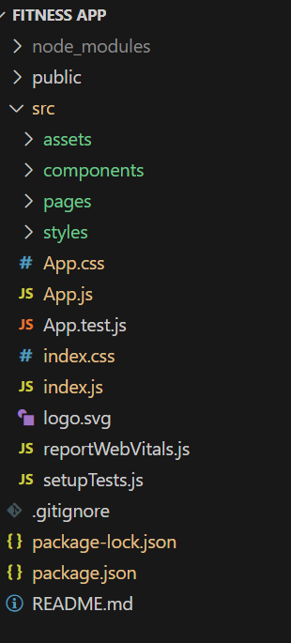

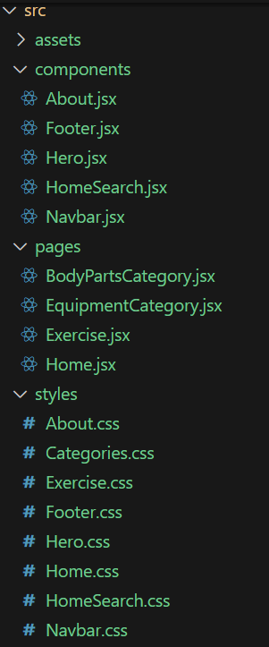

# Running the Application

## Frontend:

cd client npm start

**backend**

cd server npm start

* + **Access:** Visit [http://localhost:3000](http://localhost:3000/)

# API Documentation

## User:

* + - /api/user/register
    - /api/user/login

**Projects:**

/api/projects/create

/api/projects:id

Applications:/api/apply

# Authentication

* + User Registration
  + Login
  + Profile Management

# User Interface

* + Intuitive Interface
  + Dynamic Search
  + Visual Exercise Exploration
  + Customizable Workouts
  + 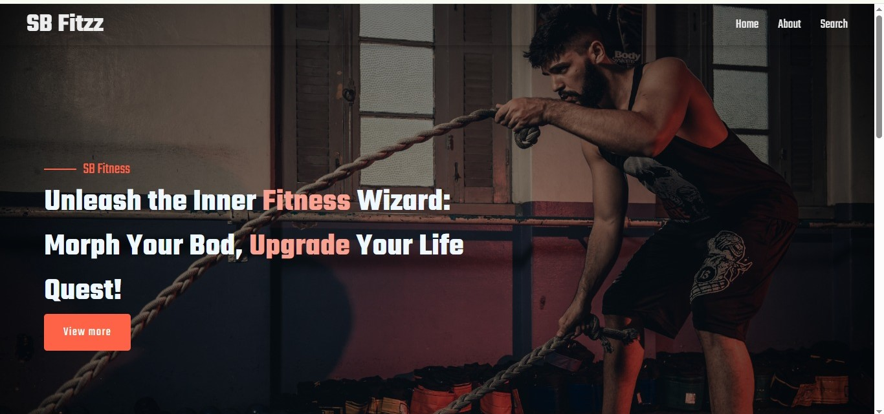
  + 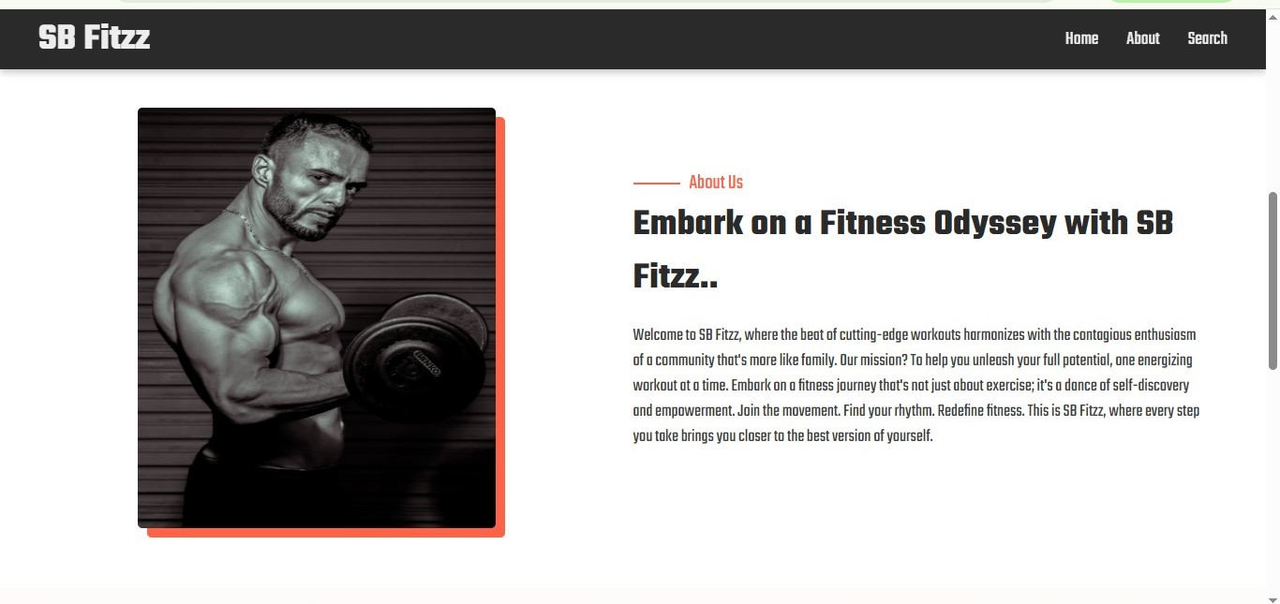
  + 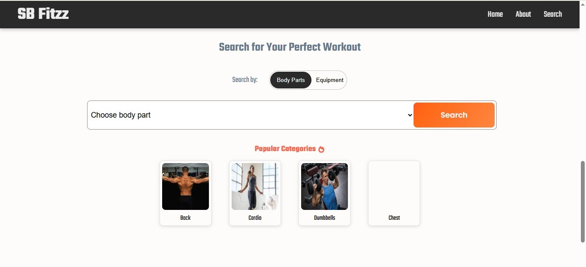

# Testing

* + Unit Testing
  + Topic Tracker
  + Integration Testing
  + User Interface (UI) Testing
  + Functional Testing

1. **Known Issues**
2. Data Privacy Concerns: Ensuring user data is protected and maintaining transparency in data usage is crucial, given the sensitive nature of fitness and health information.
3. Integration Challenges: FitFlex might face integration issues with various devices, wearables, or health apps, which could impact its functionality and user experience.
4. User Engagement: Maintaining user motivation and engagement over time can be a challenge, requiring continuous updates and innovative features.
5. Customization Limitations: Users may encounter limitations in customizing workout plans according to their specific needs, which could affect the app's effectiveness.
6. Technical Issues: Like any software, FitFlex might experience technical issues, such as bugs, crashes, or performance problems, which would need to be addressed promptly.
7. **Future Enhancements**
8. AI-powered workout recommendations
9. Integration with wearables
10. Progress tracking & analytics dashboard
11. Social features (leaderboards, friend challenges)
12. Expanded exercise library
13. Personalized notifications
14. Improved user interface
15. Scalable architecture for future growth