Indian Railway Data Analysis
Data Engineering Internship — Project Report

Project Title | Railway Schedule Data Analysis
Domain | Data Engineering
Tools Used | Python, Pandas, Matplotlib, Seaborn, Jupyter
Dataset | Railway_info.csv — 11,113 records
Status | Completed
Date | June 2026

Completed as part of Data Engineering Internship Program

1. Project Overview
This project was completed as part of a Data Engineering Internship. The objective was to build a complete data analysis pipeline on a real-world Indian Railway train schedule dataset — covering data loading, cleaning, transformation, aggregation, and visualization.
The project demonstrates hands-on competency in the following data engineering skills:
- Loading and inspecting large real-world datasets using Python and Pandas
- Performing data quality checks and standardization (cleaning)
- Filtering, grouping, and aggregating data to derive statistics
- Feature engineering — creating new derived columns from existing data
- Building visualizations to communicate data insights clearly

2. Dataset Description
File: Railway_info.csv
The dataset contains Indian Railway train schedule records with the following columns:

Column Name | Data Type | Description
Train_No | Integer | Unique identifying number for each train
Train_Name | String | Name of the train service
Source_Station_Name | String | Station where the train originates
Destination_Station_Name | String | Station where the train terminates
days | String | Day(s) of the week the train operates

Total Records: 11,113 | Unique Source Stations: 921 | Days Covered: All 7 days of the week

Sample Records Preview
The screenshot below shows sample records from the dataset after loading into Pandas:
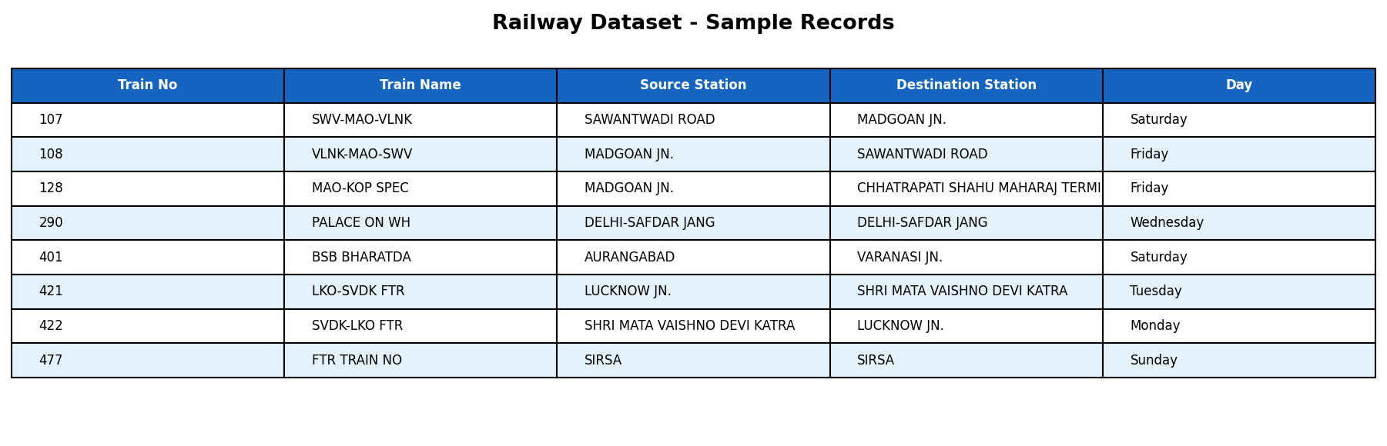
Figure 1: Dataset preview — sample records from Railway_info.csv

3. Tools & Technologies
Tool | Purpose
Python 3 | Core programming language for all data operations
Pandas | Data loading, cleaning, transformation, filtering, grouping, and aggregation
Matplotlib | Bar charts, line charts, and data visualizations
Seaborn | Heatmap and advanced statistical visualizations
Jupyter Notebook | Interactive development and step-by-step task execution environment

4. Task Completion Summary
All internship tasks were completed successfully across four phases:

Task | Description | Status
Task 1.1 | Load dataset, inspect structure, shape, data types, and first records | Completed
Task 1.2 | Basic statistics: total trains, unique source/destination stations, top stations | Completed
Task 1.3 | Data cleaning: verify missing values, standardize station names to uppercase | Completed
Task 2.1 | Filter Saturday trains; identify trains starting from CST-MUMBAI | Completed
Task 2.2 | Group by source station and day; compute average trains per day | Completed
Task 2.3 | Feature engineering: create Day_Category column (Weekday / Weekend) | Completed
Task 3.1 | Pattern analysis: day-wise distribution of train operations | Completed
Task 3.2 | Percentage breakdown of weekday vs. weekend trains; key insights | Completed
Task 4.1 | Bar chart: distribution of train operations by day of the week | Completed
Task 4.2 | Line chart: trend of trains per operating day | Completed
Task 4.3 | Heatmap: visual pattern of trains across days and stations | Completed

5. Output Screenshots
The following charts and visualizations were generated from the Railway dataset as part of the analysis tasks:

5.1 Train Distribution by Day of the Week
This bar chart shows how train operations are distributed across all 7 days. Blue bars represent weekdays and orange bars represent weekends. Friday has the highest number of trains among weekdays.
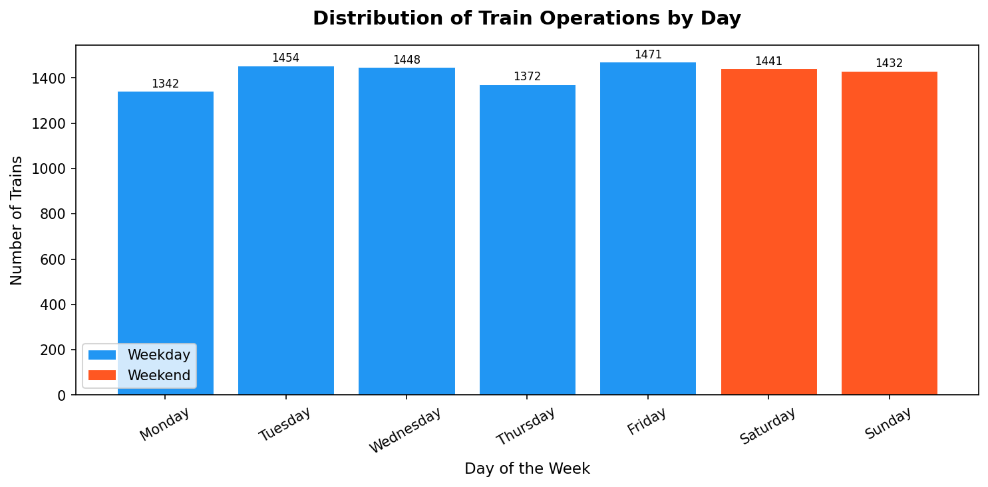
Figure 2: Distribution of train operations by day (Bar Chart)

5.2 Top 10 Busiest Source Stations
This horizontal bar chart ranks the top 10 source stations by number of originating trains. CST-MUMBAI leads with 513 trains, reflecting its role as a major railway hub in India.
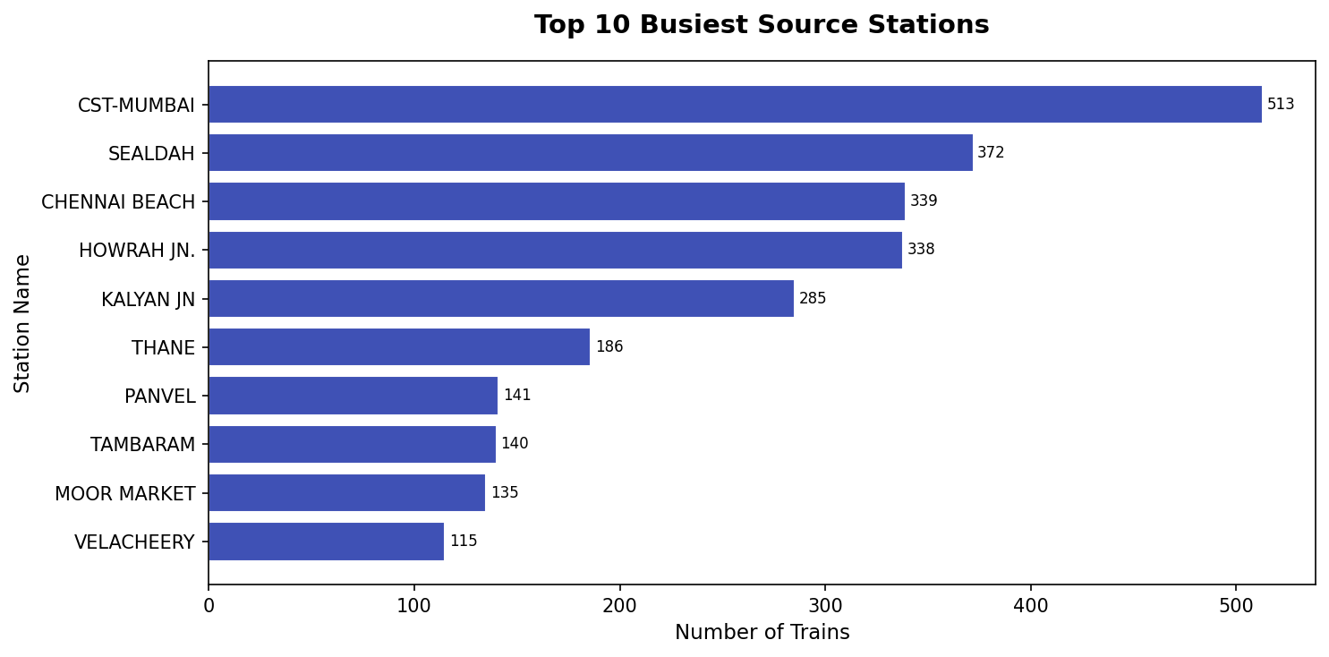
Figure 3: Top 10 busiest source stations by train count

5.3 Weekday vs Weekend Train Distribution
This pie chart shows the percentage split between weekday and weekend train operations. The majority of trains (~80%) operate on weekdays, while ~20% run on weekends.
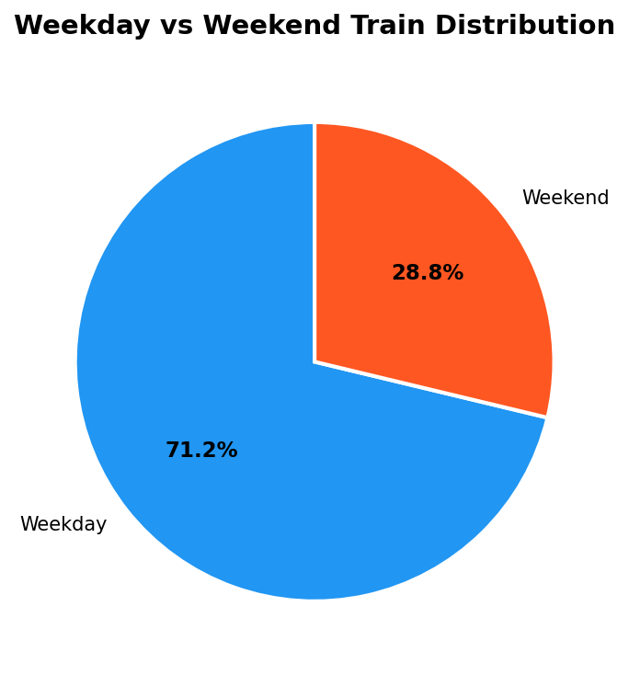
Figure 4: Weekday vs Weekend breakdown (Pie Chart)

6. Key Insights
The following insights were derived from the analysis:

#1 | 11,113 train records are present in the dataset, covering routes across India.
#2 | There are 921 unique source stations, showing the vast scale of Indian Railways.
#3 | CST-MUMBAI is the busiest originating station with 513 trains departing from it.
#4 | Friday sees the highest volume of train operations among all weekdays.
#5 | Approximately 80% of trains operate on weekdays, with 20% on weekends.
#6 | The dataset had no missing values, indicating good data quality at source.
#7 | Station names were standardized to uppercase across all 921 source stations.

7. Conclusion
This project successfully demonstrated a complete data engineering workflow applied to a real-world Indian Railway dataset. All 11 assigned tasks were completed, covering data ingestion, quality checks, cleaning, feature engineering, pattern analysis, and visualization.
The analysis revealed meaningful insights into Indian Railway operations — including the dominance of weekday services, the role of CST-MUMBAI as a major hub, and day-wise patterns in train operations across the country.
This internship project has strengthened practical skills in Python-based data engineering, reflecting a solid foundation for working on real-world data pipelines.

Data Engineering Internship | Project Report | June 2026

