**Finding homologs in the i5k@NAL Workspace** (02/2014)

All of the annotations that the i5k@NAL Workspace currently hosts are **provisional** annotations only. Because of the temporary nature of the genes, we do not have a search function that will allow you to find genes for your species by homolog name. To find homologs for the gene you are interested, we recommend using the Blast function. In this step-by-step tutorial, we’ll use the Blast function to find the ultrapiracle (usp) homolog in the Bed Bug, *Cimex lectularius*.

First, get a suitable homolog sequence. We’ll go to <http://flybase.org/> and type ‘usp’ in the search box.

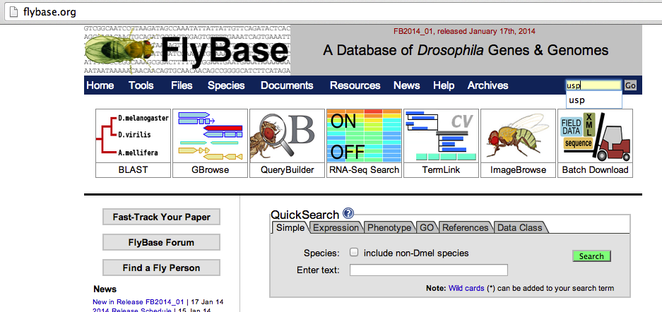

Then, on the right side of the page, in the drop-down menu above ‘Get FastA’, select ‘Translations’.

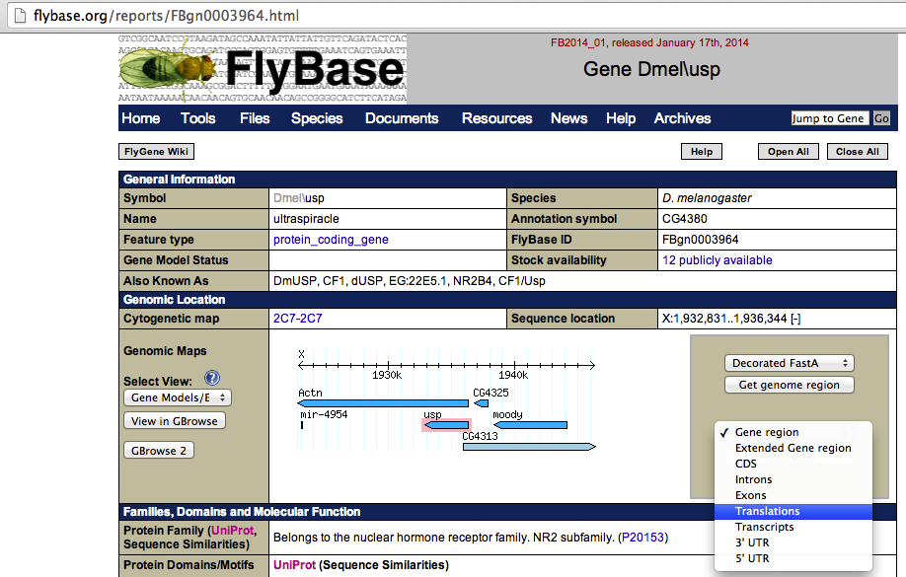

Copy one of the isoform sequences.

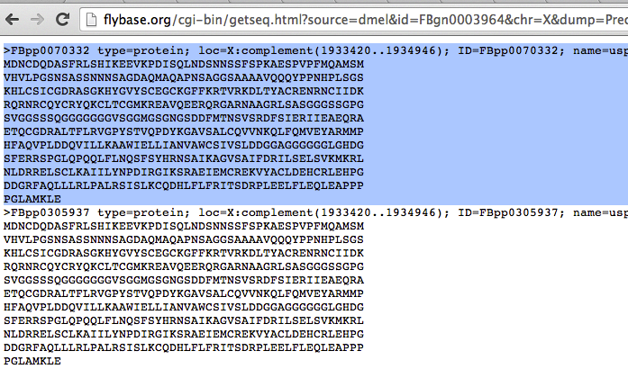

Go to the i5k@NAL homepage, and select ‘Tools -> Blast’ (http://i5k.nal.usda.gov/blastn).

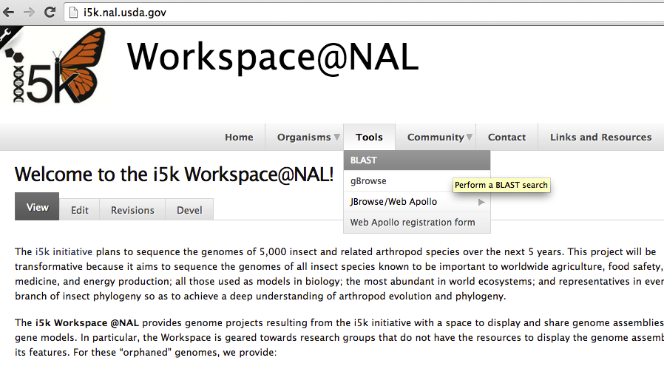

Paste the usp sequence into the Blast search window. Select ‘Cimex lectularius: Proteins’ from the Database drop-down menu. Because we are searching protein against protein, select ‘blastp’ from the Program drop-down menu. Hit ‘Search’.

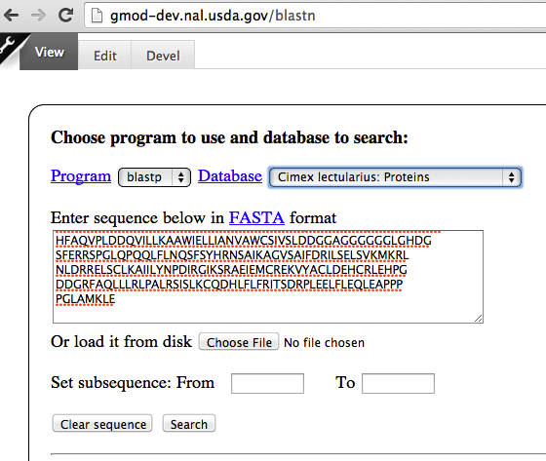

Find the protein sequence with the lowest e-value from the results page. Copy the protein sequence base name (e.g. CLEC005152) – this is the gene ID.

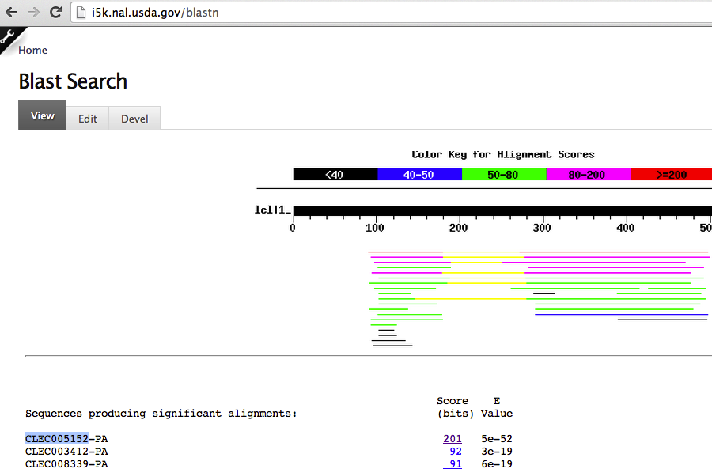

Go to ‘Search Genes’. Select ‘Bed bug’ from the Organism Common Name drop-down menu. Past the Gene ID into the ‘Gene ID’ box. Click ‘Show’. A table containing the link to the gene page will appear. (Alternatively, paste the Gene ID into the ‘Search’ box in the upper right corner).

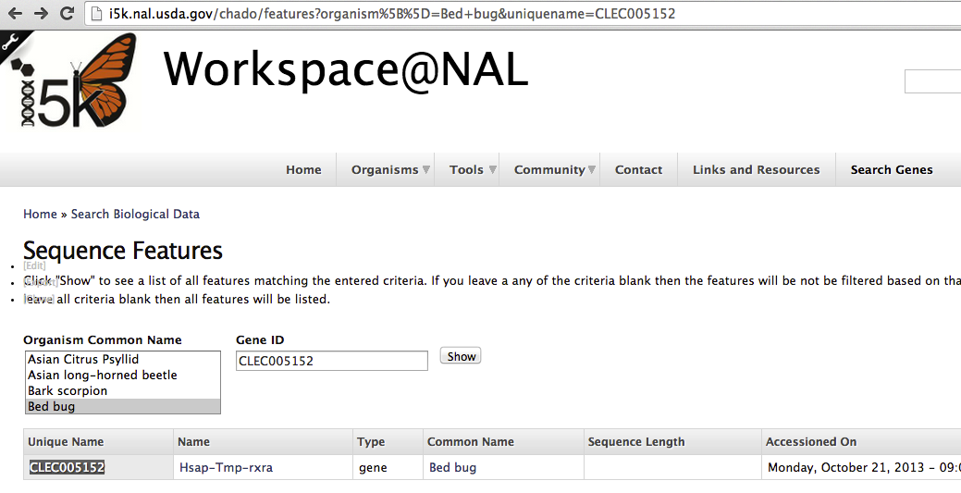

On the gene page, you will find relevant information about the gene – Its name and ID, scaffold location, mRNA sequence(s), homolog references, synonyms, the analysis the gene was generated from, and a JBrowse viewer. Web Apollo users can log in to annotate the gene if desired.

