Prerequisite:

1. Spring STS installed.
2. PostMan client Installed.
3. Git bash

Step 1 : Download or clone the following git repository.

Git link:

Step 2 : Go to the folder where git repository downloaded and unzip the following zip file

File Name :

Step 3 : launch the sts IDE and import the unzipped folder as mave project.

Step 4 : Build the maven project and run the DemoApplication.java

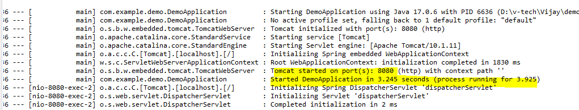

Step 5 : verify from post man client.

To get all the emp details.

GET : <http://localhost:8080/emp/>

Expected response be like :

[

    {

        "id": 100,

        "name": "keerthana",

        "sal": 0,

        "phone": 0,

        "gender": "F",

        "email": "abcd@gmail.com",

        "dept": "EC"

    },

    {

        "id": 101,

        "name": "Srusti",

        "sal": 0,

        "phone": 0,

        "gender": "F",

        "email": "abcde@gmail.com",

        "dept": "CS"

    },

    {

        "id": 102,

        "name": "Sowndarya",

        "sal": 0,

        "phone": 0,

        "gender": "F",

        "email": "abcdef@gmail.com",

        "dept": "Cs"

    },

    {

        "id": 103,

        "name": "Nithin",

        "sal": 0,

        "phone": 0,

        "gender": "M",

        "email": "abcd@gmail.com",

        "dept": "EC"

    },

    {

        "id": 104,

        "name": "Vijay",

        "sal": 0,

        "phone": 0,

        "gender": "M",

        "email": "abcd@gmail.com",

        "dept": "CS"

    }

]

To get particular the emp details by proving emp id

GET : <http://localhost:8080/emp/105>

{

    "id": 104,

    "name": "Vijay",

    "sal": 0,

    "phone": 0,

    "gender": "M",

    "email": "abcd@gmail.com",

    "dept": "CS"

}

Add new emp and provide the emp details in postman body section

POST : <http://localhost:8080/emp/>

EA: Looks employee addedd successfully please check by retrieving with emp id

example: {

        "id": 105,

        "name": "Kavitha",

        "sal": 0,

        "phone": 0,

        "gender": "F",

        "email": "abcd@gmail.com",

        "dept": "Computer Science"

    }

To update the details of existing employee

PUT : <http://localhost:8080/emp/>

Response : Update is completed

To Delete particular employee by providing the id

DELETE : http://localhost:8080/emp/105

Employee details are deleted