GEN AI Tools – Phase 2 – Week 1 Assignment - LangFlow Apr 29 2026

Build a test case reviewer using Langflow.
Your system should take a test case , create your own prompt template, review the test case for quality (completeness, clarity, and best practices),
and produce: List of issues Suggestions for improvement An improved version of the test case

Test case taken: SimpleTestCase.doc
Created Langflow with following components
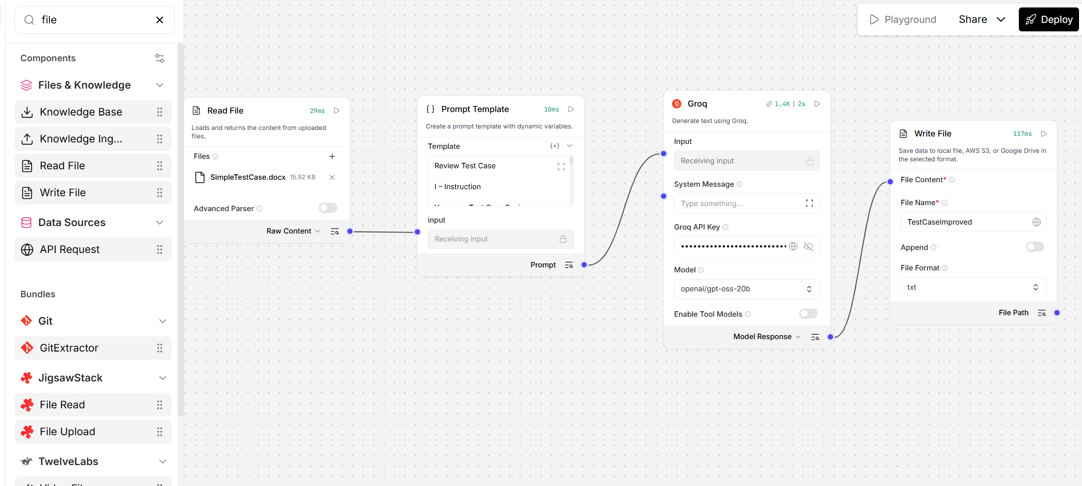

Read file : reads the SimpleTestCase.doc as input.
Prompt Template : takes {input} from Read File and given ICEPOT template
Groq – Prompt template output connected to Groq to connect to LLM and generate response
Write File – Groq output connected to Write file. This writes the suggestions and improvements and improved version of test case to file TestCaseImproved.txt
All files are uploaded in git

