Week 4 – Day 2 Apr 19 2026
Homework

Fine Tune any model , and use it with web-extension and verify the code produced according to training.
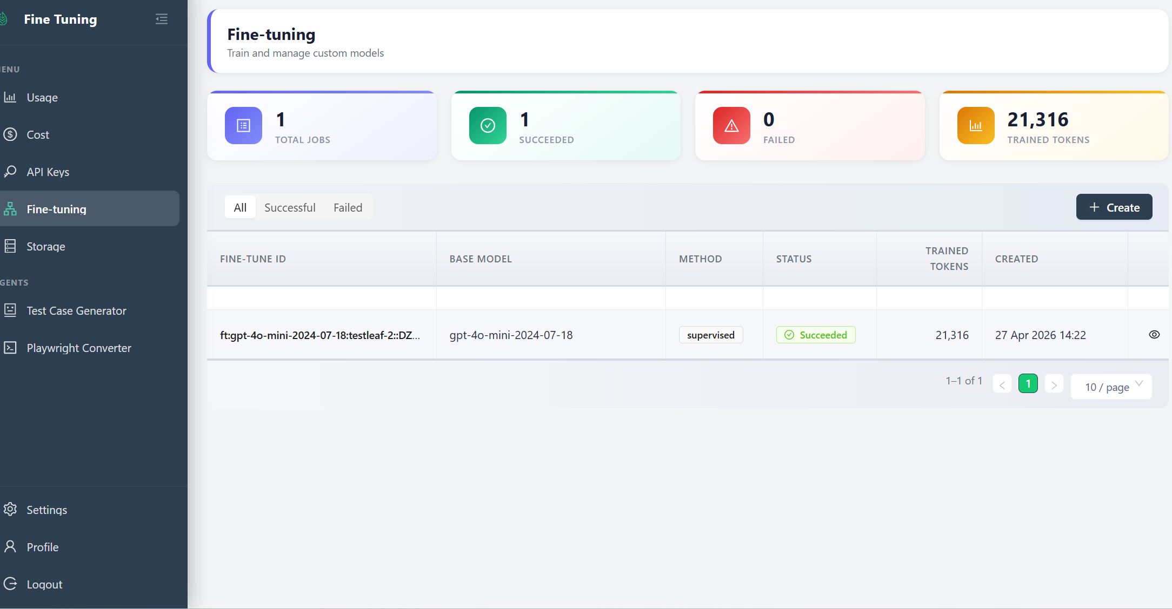

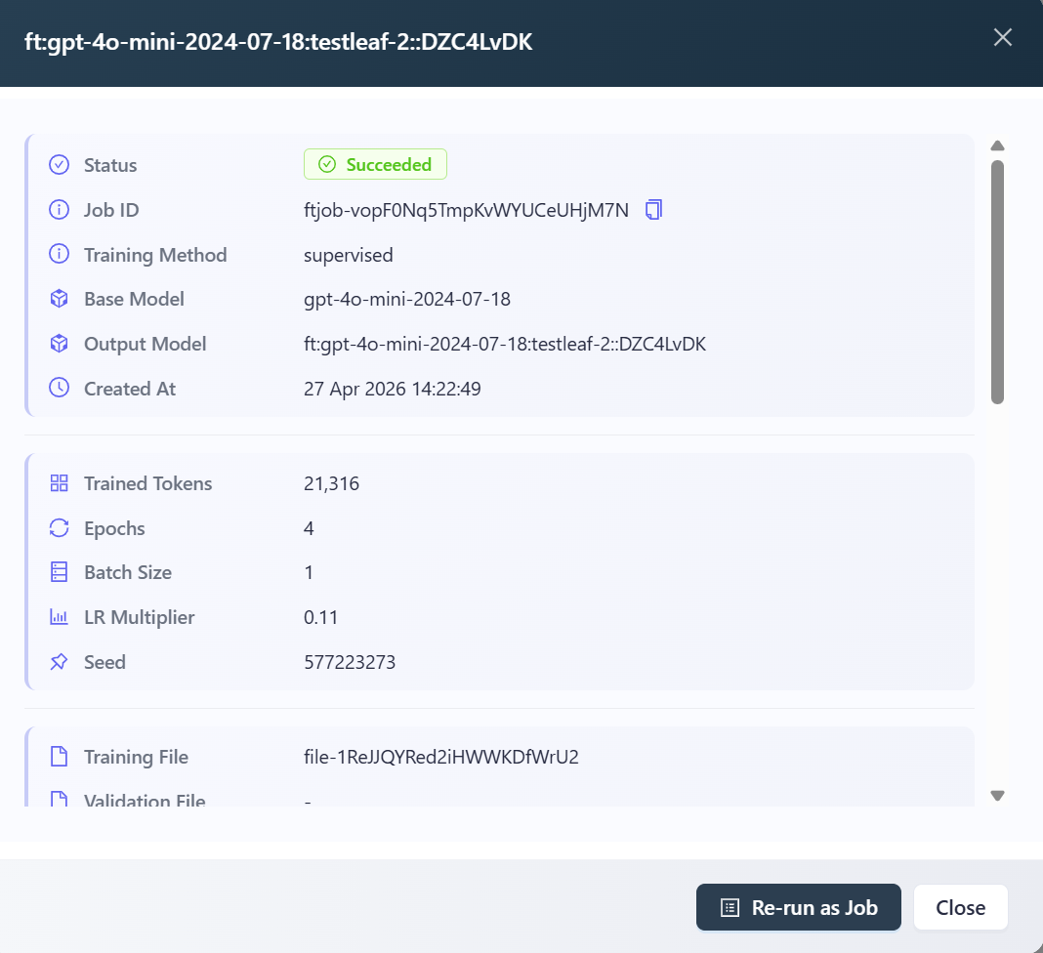

Finetuned Model ID :
ft:gpt-4o-mini-2024-07-18:testleaf-2::DZC4LvDK

Generate API KEY
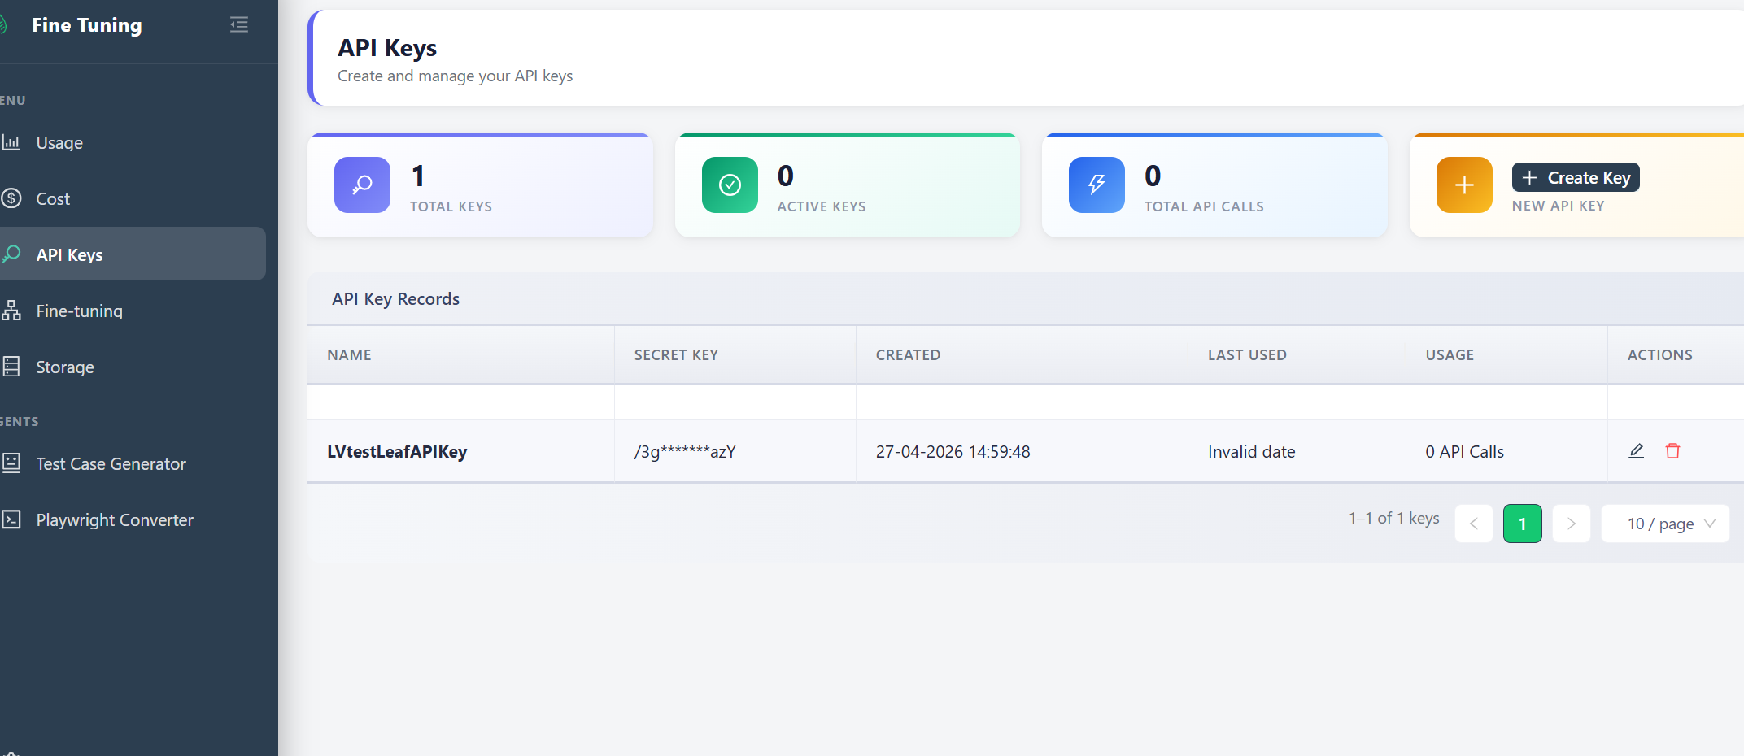

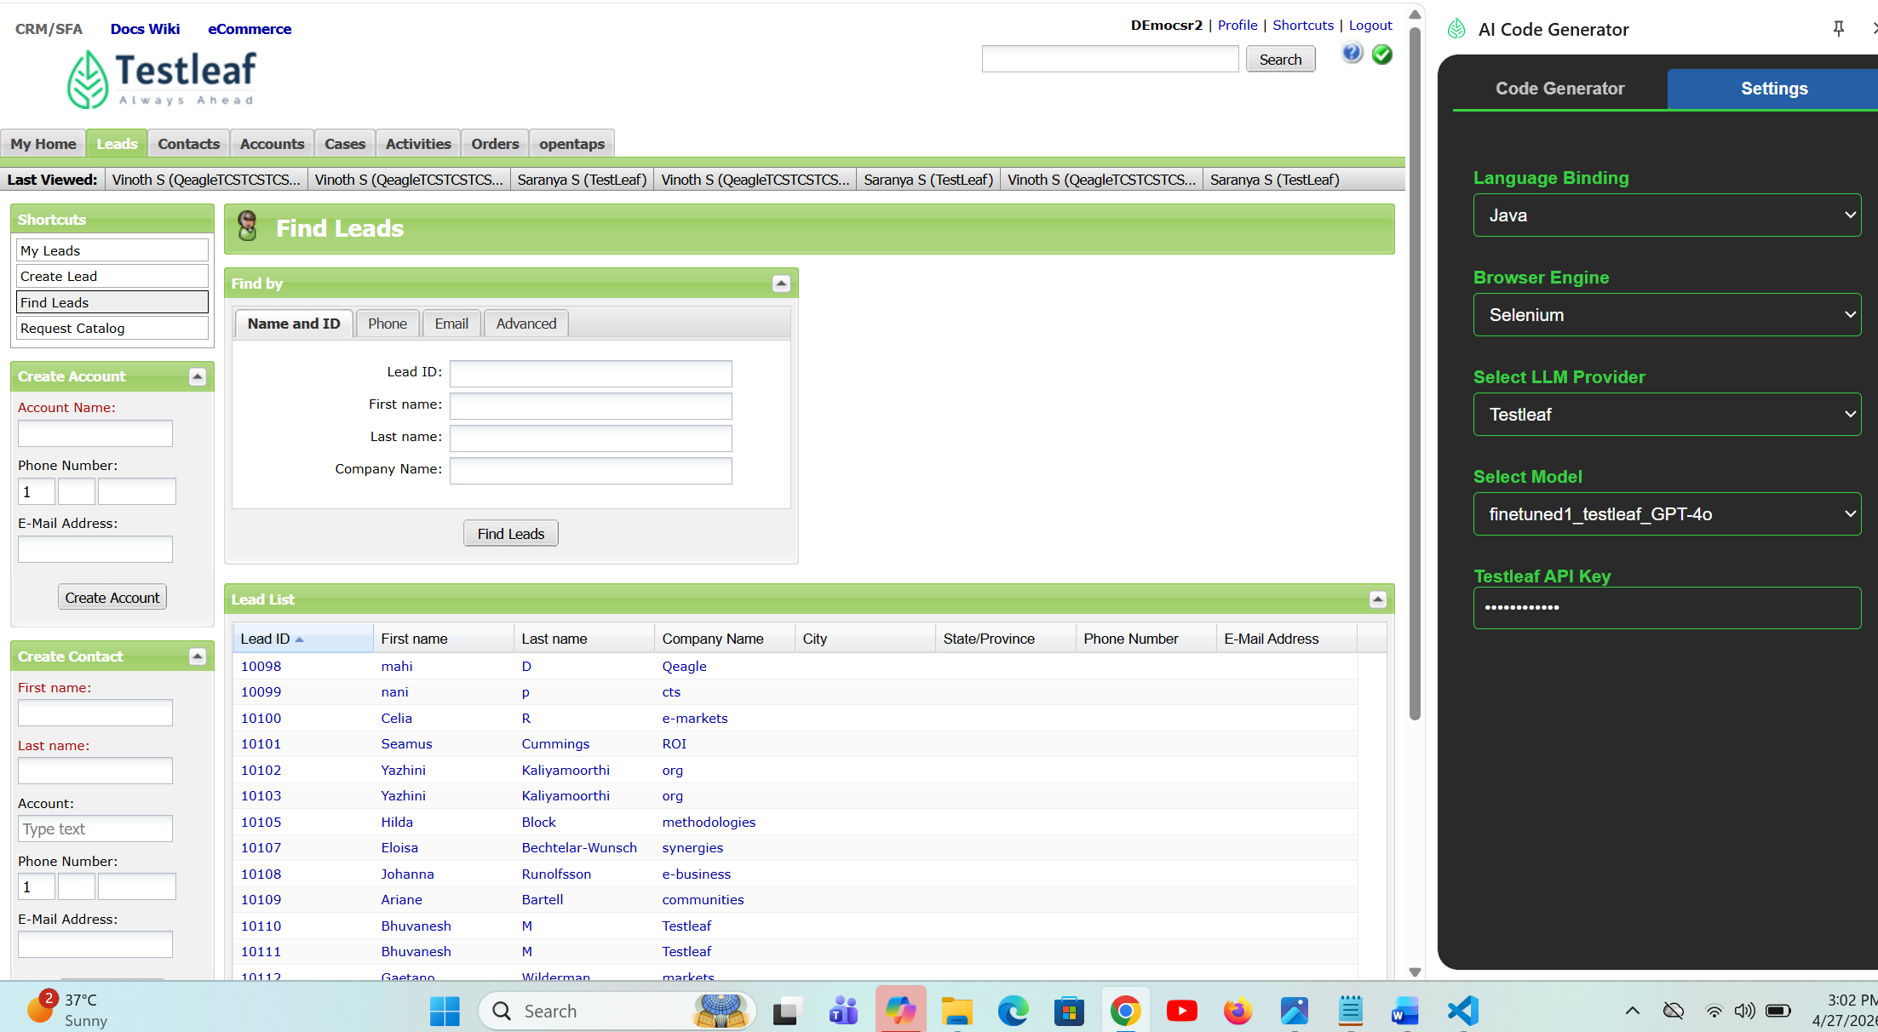

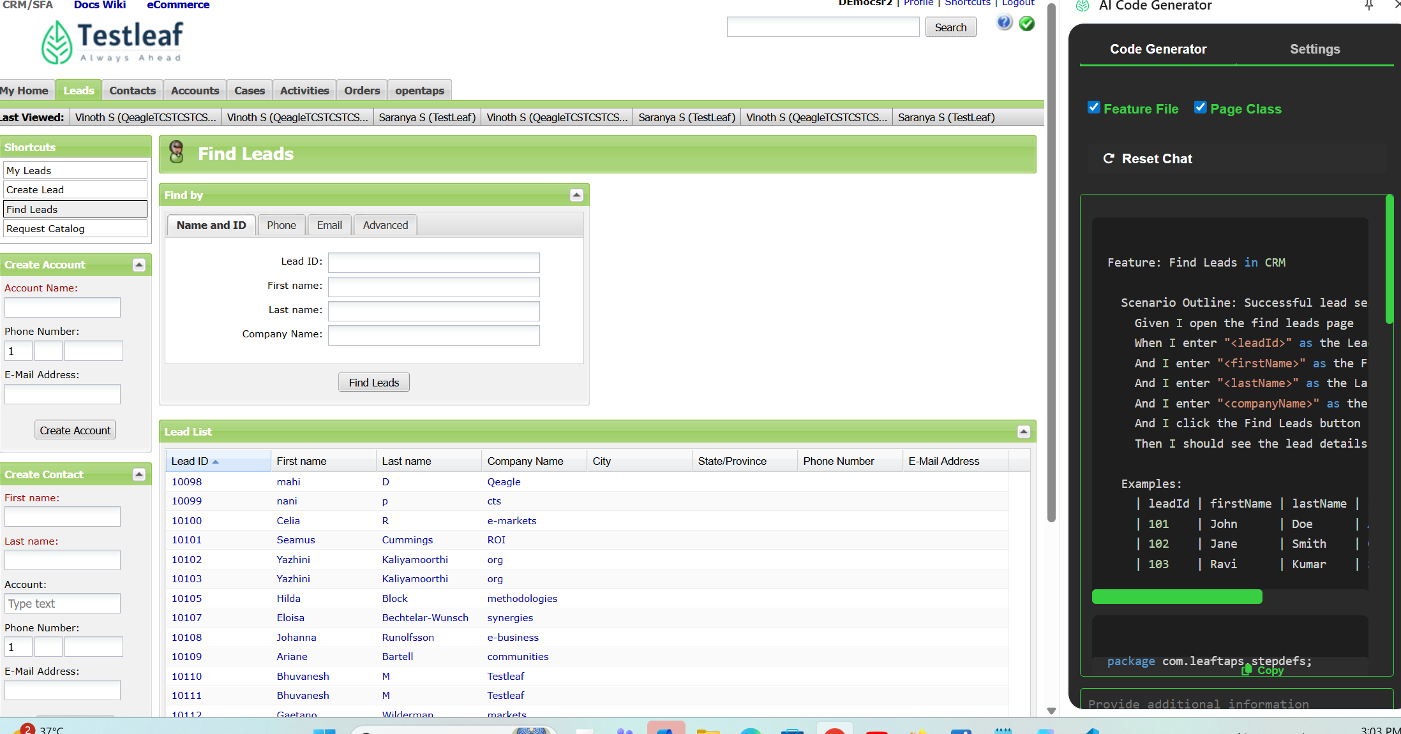

Generated Output
Feature: Find Leads in CRM

Scenario Outline: Successful lead search with valid details
Given I open the find leads page
When I enter "<leadId>" as the Lead ID
And I enter "<firstName>" as the First Name
And I enter "<lastName>" as the Last Name
And I enter "<companyName>" as the Company Name
And I click the Find Leads button
Then I should see the lead details for "<leadId>"

Examples:
| leadId | firstName | lastName | companyName |
| 101 | John | Doe | Acme Corp |
| 102 | Jane | Smith | Global Tech |
| 103 | Ravi | Kumar | South India Co |

package com.leaftaps.stepdefs;

import io.cucumber.java.en.*;
import org.openqa.selenium.*;
import org.openqa.selenium.chrome.ChromeDriver;
import org.openqa.selenium.support.ui.*;

public class FindLeadsStepDefinitions {
private WebDriver driver;
private WebDriverWait wait;

@io.cucumber.java.Before
public void setUp() {
System.setProperty("webdriver.chrome.driver", "path/to/chromedriver");
driver = new ChromeDriver();
wait = new WebDriverWait(driver, Duration.ofSeconds(10));
driver.manage().window().maximize();
}

@io.cucumber.java.After
public void tearDown() {
if (driver != null) driver.quit();
}

@Given("I open the find leads page")
public void openFindLeadsPage() {
driver.get("https://leaftaps.com/crmsfa/control/findLeads");
}

@When("I enter {string} as the Lead ID")
public void enterLeadId(String leadId) {
WebElement leadIdField = wait.until(ExpectedConditions.visibilityOfElementLocated(By.id("ext-gen246")));
leadIdField.sendKeys(leadId);
}

@When("I enter {string} as the First Name")
public void enterFirstName(String firstName) {
WebElement firstNameField = wait.until(ExpectedConditions.visibilityOfElementLocated(By.id("ext-gen248")));
firstNameField.sendKeys(firstName);
}

@When("I enter {string} as the Last Name")
public void enterLastName(String lastName) {
WebElement lastNameField = wait.until(ExpectedConditions.visibilityOfElementLocated(By.id("ext-gen250")));
lastNameField.sendKeys(lastName);
}

@When("I enter {string} as the Company Name")
public void enterCompanyName(String companyName) {
WebElement companyNameField = wait.until(ExpectedConditions.visibilityOfElementLocated(By.id("ext-gen252")));
companyNameField.sendKeys(companyName);
}

@When("I click the Find Leads button")
public void clickFindLeads() {
WebElement findLeadsButton = wait.until(ExpectedConditions.elementToBeClickable(By.id("ext-gen334")));
findLeadsButton.click();
}

@Then("I should see the lead details for {string}")
public void verifyLeadDetails(String leadId) {
WebElement leadDetails = wait.until(ExpectedConditions.visibilityOfElementLocated(By.xpath("//div[contains(text(),'" + leadId + "')]")));
assert leadDetails.isDisplayed();
}
}

