*Home Assignment*
Implement playwright/typescript with vibe coding
Note.AI Extension should be able to produce code in playwright/typescript combination.
Problem Statement:
Currently the AI Extension supports Selenium Java. Implement Playwright/typescript
In Browser, AI Extension should be able to generate Playwright/typescript
Solution
STEP 1
In VS Code: Load AI Extension folder
In VS Code ‘Ask’ AI Agent the following :
Analyze entire code base for generating selenium java (Feature file, Page class, Feature +Page class
VS Code Output from Copilot Chat
I understand now - you want me to analyze the entire JavaScript browser extension codebase. Let me examine all the key files to give you a comprehensive overview.

Read [](file:///c%3A/VijayaL/UdemyCourseEraTraining2022/TestLeaf/Week3Day1-%20files/ai-extension/src)

Read [](file:///c%3A/VijayaL/UdemyCourseEraTraining2022/TestLeaf/Week3Day1-%20files/ai-extension/manifest.json)

Read [](file:///c%3A/VijayaL/UdemyCourseEraTraining2022/TestLeaf/Week3Day1-%20files/ai-extension/panel.html#1-1), lines 1 to 100

Read [](file:///c%3A/VijayaL/UdemyCourseEraTraining2022/TestLeaf/Week3Day1-%20files/ai-extension/bg.js#1-1), lines 1 to 100

Read [](file:///c%3A/VijayaL/UdemyCourseEraTraining2022/TestLeaf/Week3Day1-%20files/ai-extension/src/scripts/chat.js#1-1), lines 1 to 150

Read [](file:///c%3A/VijayaL/UdemyCourseEraTraining2022/TestLeaf/Week3Day1-%20files/ai-extension/src/scripts/popup.js#1-1), lines 1 to 100

Read [](file:///c%3A/VijayaL/UdemyCourseEraTraining2022/TestLeaf/Week3Day1-%20files/ai-extension/src/content/content-script.js#1-1), lines 1 to 100

Read [](file:///c%3A/VijayaL/UdemyCourseEraTraining2022/TestLeaf/Week3Day1-%20files/ai-extension/src/scripts/prompts.js#1-1), lines 1 to 100

Read [](file:///c%3A/VijayaL/UdemyCourseEraTraining2022/TestLeaf/Week3Day1-%20files/ai-extension/src/scripts/api/openai-api.js)

Read [](file:///c%3A/VijayaL/UdemyCourseEraTraining2022/TestLeaf/Week3Day1-%20files/ai-extension/src/scripts/api/groq-api.js)

Read [](file:///c%3A/VijayaL/UdemyCourseEraTraining2022/TestLeaf/Week3Day1-%20files/ai-extension/src/scripts/chat.js#150-150), lines 150 to 300

Read [](file:///c%3A/VijayaL/UdemyCourseEraTraining2022/TestLeaf/Week3Day1-%20files/ai-extension/src/config/appConfig.js)

Read [](file:///c%3A/VijayaL/UdemyCourseEraTraining2022/TestLeaf/Week3Day1-%20files/ai-extension/src/scripts/chat.js#300-300), lines 300 to 500

Read [](file:///c%3A/VijayaL/UdemyCourseEraTraining2022/TestLeaf/Week3Day1-%20files/ai-extension/src/scripts/chat.js#500-500), lines 500 to 600

Read [](file:///c%3A/VijayaL/UdemyCourseEraTraining2022/TestLeaf/Week3Day1-%20files/ai-extension/src/scripts/chat.js#600-600), lines 600 to 700

Read [](file:///c%3A/VijayaL/UdemyCourseEraTraining2022/TestLeaf/Week3Day1-%20files/ai-extension/src/scripts/init-config.js)

Read [](file:///c%3A/VijayaL/UdemyCourseEraTraining2022/TestLeaf/Week3Day1-%20files/ai-extension/src/content/content.js#1-1), lines 1 to 100

Read [](file:///c%3A/VijayaL/UdemyCourseEraTraining2022/TestLeaf/Week3Day1-%20files/ai-extension/src/scripts/api/testleaf-api.js)

Read [](file:///c%3A/VijayaL/UdemyCourseEraTraining2022/TestLeaf/Week3Day1-%20files/ai-extension/src/content/content.js#100-100), lines 100 to 191

Read [](file:///c%3A/VijayaL/UdemyCourseEraTraining2022/TestLeaf/Week3Day1-%20files/ai-extension/src/scripts/prompts.js)

Now I have a complete picture. Let me create a comprehensive analysis document for you.

Created memory file [](file:///c%3A/Users/HP/AppData/Roaming/Code/User/workspaceStorage/59cdca612621c4be543bd6482744f346/GitHub.copilot-chat/memory-tool/memories/MTk0NjBjNzUtMWI5Yy00ODFmLTg1OTItNTkxNDBlYjA3MTAy/codebase-analysis.md)

## Complete Codebase Analysis - AI Code Generator Extension

I've analyzed your entire codebase. Here's a comprehensive breakdown:

### **Project Overview**
This is a **Chrome Extension (Manifest V3)** that generates Selenium Java test automation code using AI. It features:
- Interactive DOM element inspection
- AI-powered code generation (Cucumber feature files + Page Object classes)
- Support for 3 AI providers (OpenAI, Groq, TestLeaf)
- Real-time syntax highlighting for generated code

---

### **Architecture Diagram**

```
Chrome Extension (Manifest V3)
│
├─── Extension Icon Click
│ └──> bg.js (Service Worker)
│ └──> Opens side panel (panel.html)
│
├─── Side Panel (panel.html)
│ ├─ ChatUI (chat.js) - Main logic
│ └─ Settings Tab (API keys, language selection)
│
├─── Active Web Page
│ ├─ ElementInspector (content.js) - DOM selection
│ └─ Inspector Mode - Highlight & select elements
│
└─── AI APIs
├─ OpenAI
├─ Groq
└─ TestLeaf
```

---

### **Core Components**

#### **1. bg.js (Service Worker)**
- Opens side panel when icon clicked
- Receives DOM snippets from content script
- Stores selections in `chrome.storage.local`
- Acts as message relay hub

#### **2. chat.js (ChatUI Class)** - THE MAIN ENGINE
- Manages chat interface and messaging
- Orchestrates code generation workflow
- Integrates all 3 AI APIs
- Parses markdown + highlights code with Prism.js
- Handles DOM content, language selection, prompt generation

**Key workflow in sendMessage()**:
```
1. Get selected DOM content
2. Strip extra <option> elements
3. Retrieve active tab URL
4. Determine generation mode (Feature/Page/Both)
5. Get appropriate prompt template
6. Call AI API with templated prompt
7. Parse response (extract code blocks)
8. Display with syntax highlighting
9. Show token usage
```

#### **3. content.js (ElementInspector Class)**
- Provides interactive element selection
- Visual highlighting with `.genai-highlight` and `.genai-selected` classes
- Multi-element support using Set-based tracking
- Sends selected DOM to extension via `SELECTED_DOM_CONTENT` message

#### **4. prompts.js** - Code Generation Templates
Three main prompt modes:
1. **SELENIUM_JAVA_PAGE_ONLY** - Pure Page Object class
2. **CUCUMBER_ONLY** - Feature file only
3. **CUCUMBER_WITH_SELENIUM_JAVA_STEPS** - Feature + Step definitions combined

Each prompt includes:
- Instructions for AI model
- DOM context injection point
- Example output
- Persona and tone guidance

---

### **Code Generation Modes**

| Feature | Page | Combined | Output |
|---------|------|----------|--------|
| ✓ | ✗ | ✗ | Cucumber Feature File |
| ✗ | ✓ | ✗ | Java Page Object Class |
| ✓ | ✓ | ✓ | Feature + Step Definitions |

---

### **Data Flow**

```
Web Page DOM (User selects elements)
↓ [SELECTED_DOM_CONTENT message]
ElementInspector (content.js)
↓ [chrome.runtime.sendMessage]
Service Worker (bg.js)
↓ [Relay + store in chrome.storage.local]
Side Panel (panel.html) ChatUI
↓ [Build prompt with template variables]
AI API (OpenAI/Groq/TestLeaf)
↓ [Response with code blocks]
ChatUI.addMessage()
↓ [Markdown parsing + Prism highlighting]
User's Chat Display
↓ [Copy button allows extracting code]
```

---

### **Key Features**

**1. Multi-API Support**
- `OpenAIAPI` → api.openai.com
- `GroqAPI` → api.groq.com (temp: 0.2)
- `TestleafAPI` → api.testleaf.com (custom response format)

**2. Syntax Highlighting**
- marked.js converts markdown → HTML
- Prism.js highlights code blocks
- Language mapping: `feature` → `gherkin`

**3. Smart DOM Processing**
- Selects multiple elements (multi-select support)
- Strips extra `<option>` elements (limits to 3)
- Sends raw HTML to AI for context

**4. Storage Management**
- `chrome.storage.sync`: API keys, preferences
- `chrome.storage.local`: Temporary DOM snippets
- In-memory: Chat state in ChatUI instance

---

### **File Organization**

```
src/
├── config/ → Theme colors, app config
├── content/ → DOM inspection (content.js, content-script.js)
├── scripts/
│ ├── chat.js → Main ChatUI class
│ ├── popup.js → Settings & initialization
│ ├── prompts.js → Code generation templates
│ ├── tabs.js → Tab switching UI
│ ├── init-colors.js → Theme application
│ ├── init-config.js → Config setup
│ └── api/ → API integrations
│ ├── openai-api.js
│ ├── groq-api.js
│ └── testleaf-api.js
└── styles/ → CSS for panels and chat

lib/
├── marked/ → Markdown parser
├── prism/ → Syntax highlighter (supports Java, Gherkin, TypeScript)
└── css/ → Font Awesome icons
```

---

### **Important Methods**

| Class | Method | Purpose |
|-------|--------|---------|
| ChatUI | `sendMessage()` | Orchestrates code generation pipeline |
| ChatUI | `getPromptKeys()` | Determines generation mode from checkboxes |
| ChatUI | `parseMarkdown()` | Converts AI response to highlighted HTML |
| ElementInspector | `toggleInspector()` | Start/stop DOM selection mode |
| ElementInspector | `handleClick()` | Collect selected elements |
| GroqAPI/OpenAIAPI | `sendMessage()` | Call AI endpoint and parse response |

---

### **Sample Flow: Generate Feature + Page Class**

1. User selects both "Feature File" and "Page Class" checkboxes
2. User inspects DOM elements on the page
3. User clicks "Generate"
4. ChatUI calls `getPromptKeys('java', 'selenium')` → returns `['CUCUMBER_WITH_SELENIUM_JAVA_STEPS']`
5. `getPrompt()` fills template: `${domContent}` replaced with actual HTML
6. API called with combined prompt
7. Response contains both feature file (gherkin block) and step definitions (java block)
8. Both code blocks parsed, highlighted, and displayed
9. User copies code to their project

---

I've saved a detailed analysis document with all insights, patterns, and design details to your session memory for reference!

STEP 2
IN VS CODE prompt ‘ask’ agent
Go STEP BY STEP. ONCE UPON MY APPROVAL PROCEED WITH NEXT STEP
--Give me the files in which implementation is done

# STEP 1: Identify Implementation Files

Based on my codebase analysis, here are the **key implementation files** organized by functionality:

## **Core Implementation Files** (7 Critical Files)

### **1. Code Generation Engine**
- chat.js - **ChatUI class** (Main logic - ~700 lines)
- Code generation orchestration
- API integration
- Markdown parsing & syntax highlighting
- Chat UI management

### **2. Code Generation Prompts**
- prompts.js
- `SELENIUM_JAVA_PAGE_ONLY` prompt template
- `CUCUMBER_ONLY` prompt template
- `CUCUMBER_WITH_SELENIUM_JAVA_STEPS` prompt template
- `getPrompt()` function for template variable substitution

### **3. AI API Integrations** (3 files)
- openai-api.js - OpenAI integration
- groq-api.js - Groq integration
- testleaf-api.js - TestLeaf integration

### **4. DOM Inspection**
- content.js - **ElementInspector class**
- Element selection logic
- Visual highlighting
- DOM content extraction

### **5. Extension Communication**
- bg.js - Service Worker
- Message hub
- DOM content storage
- Side panel opening

### **6. UI & Initialization**
- panel.html - Side panel HTML
- Chat interface
- Settings tab
- Checkboxes for Feature/Page selection
- popup.js - Panel initialization & event handlers

---

## **Summary Table**

| File | Lines | Implementation Type | Purpose |
|------|-------|-------------------|---------|
| chat.js | ~700 | Business Logic | Code generation, API calls, UI |
| prompts.js | ~250 | Templates | AI prompts for all 3 modes |
| openai-api.js | ~50 | API Integration | OpenAI endpoint |
| groq-api.js | ~60 | API Integration | Groq endpoint |
| testleaf-api.js | ~50 | API Integration | TestLeaf endpoint |
| content.js | ~200 | DOM Logic | Element inspection & selection |
| bg.js | ~100 | Communication | Message relay & storage |
| popup.js | ~200+ | UI Logic | Settings & initialization |
| panel.html | ~80 | Markup | UI layout |

---

## **Your Turn**

✅ **Is this the breakdown you need?**

Or would you like me to:
- [ ] Show you the exact implementation details in each file?
- [ ] Explain the flow between these files?
- [ ] Show code snippets from each file?
- [ ] Something else?

**Please approve to proceed to the NEXT STEP.**

STEP 3
-- Proceed with Playwright TyprScript implementation

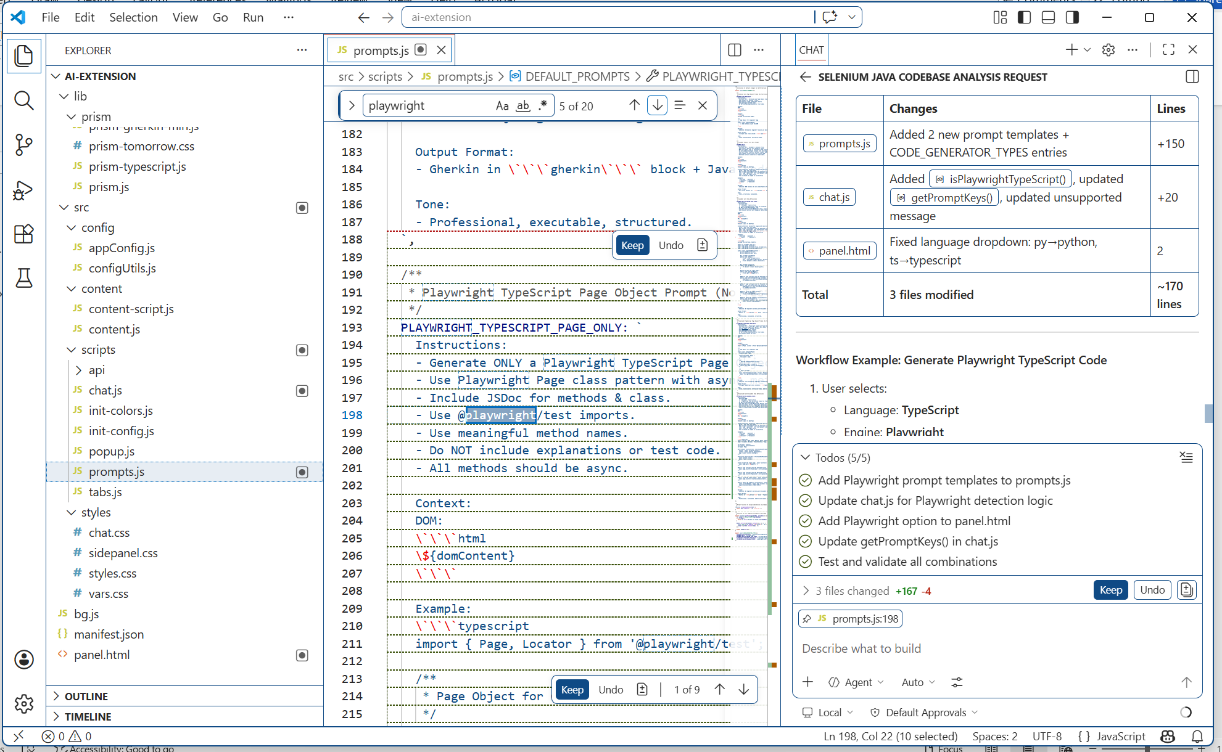

Output from AI extension
Feature: Login to OpenTaps

Scenario Outline: Successful login with valid credentials (South India users)
Given I open the login page
When I type "<username>" into the Username field
And I type "<password>" into the Password field
And I click the Login button
Then I should be logged in successfully

Examples:
| username | password |
| ramkumar | Rk@2023! |
| snehal | Snehal#1 |
| vijaykumar | Vj2023$ |
| anjali | Anjali!23 |
| karthik | Karthik#2023|

Feature: Login to OpenTaps

Scenario Outline: Successful login with valid credentials (South India users)
Given I open the login page
When I type "<username>" into the Username field
And I type "<password>" into the Password field
And I click the Login button
Then I should be logged in successfully

Examples:
| username | password |
| ramkumar | Rk@2023! |
| snehal | Snehal#1 |
| vijaykumar | Vj2023$ |
| anjali | Anjali!23 |
| karthik | Karthik#2023|

import { Given, When, Then, Before, After, ITestCaseHookParameter } from '@cucumber/cucumber';
import { expect, Browser, BrowserContext, Page, chromium } from '@playwright/test';

let browser: Browser;
let context: BrowserContext;
let page: Page;

/* ---------- Hooks ---------- */
Before(async function (this: ITestCaseHookParameter) {
// Launch a headless Chromium browser for each scenario
browser = await chromium.launch({ headless: true });
context = await browser.newContext();
page = await context.newPage();
});

After(async function (this: ITestCaseHookParameter) {
// Clean up after each scenario
await page.close();
await context.close();
await browser.close();
});

/* ---------- Step Definitions ---------- */
Given('I open the login page', async function () {
await page.goto('https://leaftaps.com/opentaps/control/main');
});

When('I type {string} into the Username field', async function (username: string) {
await page.locator('#username').fill(username);
});

When('I type {string} into the Password field', async function (password: string) {
await page.locator('#password').fill(password);
});

When('I click the Login button', async function () {
// The login button is an <input type="submit" value="Login">
await page.locator('input[value="Login"]').click();
});

Then('I should be logged in successfully', async function () {
// After a successful login OpenTaps shows a logout link.
// Adjust the selector if your application uses a different indicator.
const logoutVisible = await page.locator('a[href*="logout"]').first().isVisible();
expect(logoutVisible).toBeTruthy();
});

………………..
