**WEEK 5_ Microservices with Spring Boot 3 and Spring Cloud**

**Exercise 1: Creating Microservices for account and loan**

**Scenario:**

Design and implement two RESTful Spring Boot microservices — one to retrieve **account information** and another to retrieve **loan details** — each running independently on different ports, simulating a modular banking system architecture with separate responsibilities.

**CODE:**

**Account:**

**Pom.xml:**<project xmlns="http://maven.apache.org/POM/4.0.0"

xmlns:xsi="http://www.w3.org/2001/XMLSchema-instance"

xsi:schemaLocation="http://maven.apache.org/POM/4.0.0

http://maven.apache.org/xsd/maven-4.0.0.xsd">

<modelVersion>4.0.0</modelVersion>

<parent>

<groupId>org.springframework.boot</groupId>

<artifactId>spring-boot-starter-parent</artifactId>

<version>3.2.4</version>

<relativePath/>

</parent>

<groupId>com.cognizant</groupId>

<artifactId>account</artifactId>

<version>0.0.1-SNAPSHOT</version>

<name>account</name>

<description>Account Microservice</description>

<properties>

<java.version>17</java.version>

</properties>

<dependencies>

<dependency>

<groupId>org.springframework.boot</groupId>

<artifactId>spring-boot-starter-web</artifactId>

</dependency>

<dependency>

<groupId>org.springframework.boot</groupId>

<artifactId>spring-boot-devtools</artifactId>

<scope>runtime</scope>

</dependency>

</dependencies>

<build>

<plugins>

<plugin>

<groupId>org.springframework.boot</groupId>

<artifactId>spring-boot-maven-plugin</artifactId>

</plugin>

</plugins>

</build>

</project>

**OUTPUT:**

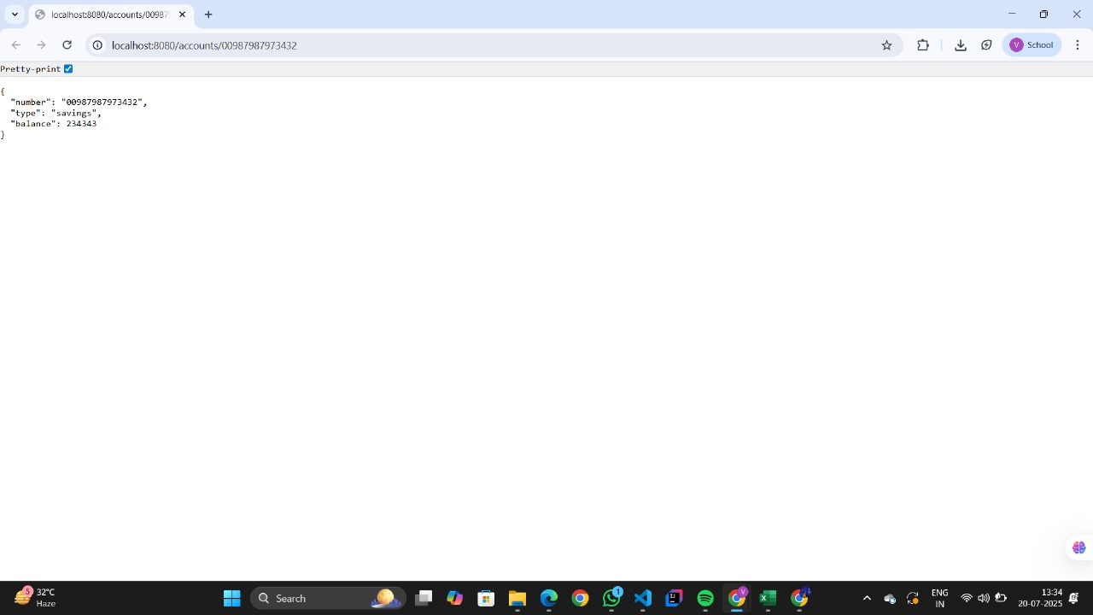

**LOAN:**

**Pom.xml:**

<project xmlns="http://maven.apache.org/POM/4.0.0"

xmlns:xsi="http://www.w3.org/2001/XMLSchema-instance"

xsi:schemaLocation="http://maven.apache.org/POM/4.0.0

http://maven.apache.org/xsd/maven-4.0.0.xsd">

<modelVersion>4.0.0</modelVersion>

<parent>

<groupId>org.springframework.boot</groupId>

<artifactId>spring-boot-starter-parent</artifactId>

<version>3.2.4</version>

<relativePath/>

</parent>

<groupId>com.cognizant</groupId>

<artifactId>loan</artifactId>

<version>0.0.1-SNAPSHOT</version>

<name>loan</name>

<description>Loan Microservice</description>

<properties>

<java.version>17</java.version>

</properties>

<dependencies>

<dependency>

<groupId>org.springframework.boot</groupId>

<artifactId>spring-boot-starter-web</artifactId>

</dependency>

<dependency>

<groupId>org.springframework.boot</groupId>

<artifactId>spring-boot-devtools</artifactId>

<scope>runtime</scope>

</dependency>

</dependencies>

<build>

<plugins>

<plugin>

<groupId>org.springframework.boot</groupId>

<artifactId>spring-boot-maven-plugin</artifactId>

</plugin>

</plugins>

</build>

</project>

**OUTPUT:**

