PROJECT REPORT
ad-mri — Alzheimer's Disease MRI Classification Platform
A production-shaped, multi-service AI diagnostic platform: data pipeline, trained 3D CNN, explainable AI, secure API, and full deployment stack

Field | Value
Project type | Applied AI / Medical Imaging / Production ML Systems
Deliverable | Trained model + evaluation + deployed multi-service platform
Status | Complete — full pipeline run end-to-end, stack deployed and verified live

This document describes what was built, the technology stack, the request workflow, the measured evaluation results, and a file-by-file breakdown of the entire codebase. It is generated from the actual delivered system — every number and image in it comes from a command that was really run against the running system.

1. Executive Summary
ad-mri is a model-agnostic-in-spirit—but purpose-built—AI platform that classifies a brain MRI scan into one of three diagnostic categories (Alzheimer's Disease, Mild Cognitive Impairment, Cognitively Normal), returns a calibrated confidence score, and can explain its own reasoning via LIME and SHAP. It is not a bare model file: it is a complete platform — ingestion and validation pipeline, training and evaluation framework, secure REST API, PostgreSQL-backed audit trail, drift and performance monitoring, MLflow experiment tracking, and a five-service Docker deployment — built, run, and independently verified end to end.
Delivered in this engagement:
- Data pipeline — 192 real ADNI-sourced T1-weighted MRI studies ingested, validated (0 errors), and split subject-level into train/validation/test with zero leakage (independently re-verified, not just pipeline self-report).
- Model — A 3D convolutional neural network (1,229,603 parameters, 4 conv blocks) trained from scratch and evaluated on a genuinely held-out 30-subject test set; a second, deliberately different training configuration was run and honestly compared against the first.
- Explainability — LIME and SHAP, both exercised live against the deployed checkpoint, producing real per-region explanations (500-sample LIME run: local surrogate fit R² = 0.986).
- API — FastAPI service with auth, rate limiting, CORS, upload validation, security headers, and a PostgreSQL audit trail — tested with 18 live scenarios covering the happy path and every documented failure mode.
- Deployment — Five-service Docker Compose stack (API, PostgreSQL, Redis, MLflow, Celery worker) brought up and independently verified: real predictions confirmed written to the real database by querying it directly.
- Security — Bandit SAST (0 issues / 11,495 lines), pip-audit (3 low-exposure transitive CVEs), 497/498 automated tests passing, and a live credential-exposure finding caught and remediated during the review.
Headline evaluation result (30-item held-out test set): balanced accuracy 56.3% (vs. 33.3% for a naive majority-class baseline), 100% recall on true Alzheimer's cases, ROC-AUC 0.642. A second training configuration, tuned specifically to address a weakness in the first, was tested with equal rigor and scored worse (balanced accuracy 27.1%) — confirming that further configuration tuning alone will not close the accuracy gap; more labeled data is the binding constraint. Full numbers and interpretation in Section 8.

2. What Was Delivered
Component | Status | Where
Data ingestion & validation pipeline | Delivered | src/ad_mri/data_pipeline/
Subject-level leakage-safe train/val/test split | Delivered | data_pipeline/splitting.py
3D CNN architecture + training loop | Delivered | src/ad_mri/modeling/, src/ad_mri/training/
Trained, evaluated checkpoint (production) | Delivered | artifacts/checkpoints/adni_3class_run1/best.pt
Second training configuration (comparison) | Delivered | artifacts/checkpoints/adni_3class_run2/
Held-out test evaluation + bootstrapped CIs | Delivered | src/ad_mri/evaluation/, artifacts/evaluation/
LIME / SHAP explainability engine | Delivered | src/ad_mri/explainability/
Inference engine (CLI + API, identical code path) | Delivered | src/ad_mri/inference/
FastAPI service (auth, rate limiting, CORS, uploads) | Delivered | src/ad_mri/api/
PostgreSQL audit trail + Alembic migrations | Delivered | src/ad_mri/db/
Data-drift & model-drift monitoring | Delivered | src/ad_mri/monitoring/
MLflow experiment tracking | Delivered | src/ad_mri/training/mlflow_utils.py, docker/mlflow.Dockerfile
Docker Compose deployment (5 services) | Delivered | docker/docker-compose.yml
CLI covering the full pipeline | Delivered | src/ad_mri/cli/main.py
Automated test suite (498 tests) | Delivered | tests/ (497 passing)
Security review (SAST + dependency scan + live pen-style tests) | Delivered | this report, §9

3. System Architecture & Request Workflow
The platform runs as a set of independently deployable services coordinated by Docker Compose. A single prediction request flows through validation, inference, optional asynchronous explanation, and permanent audit logging, without the caller ever waiting on the slower explanation path.
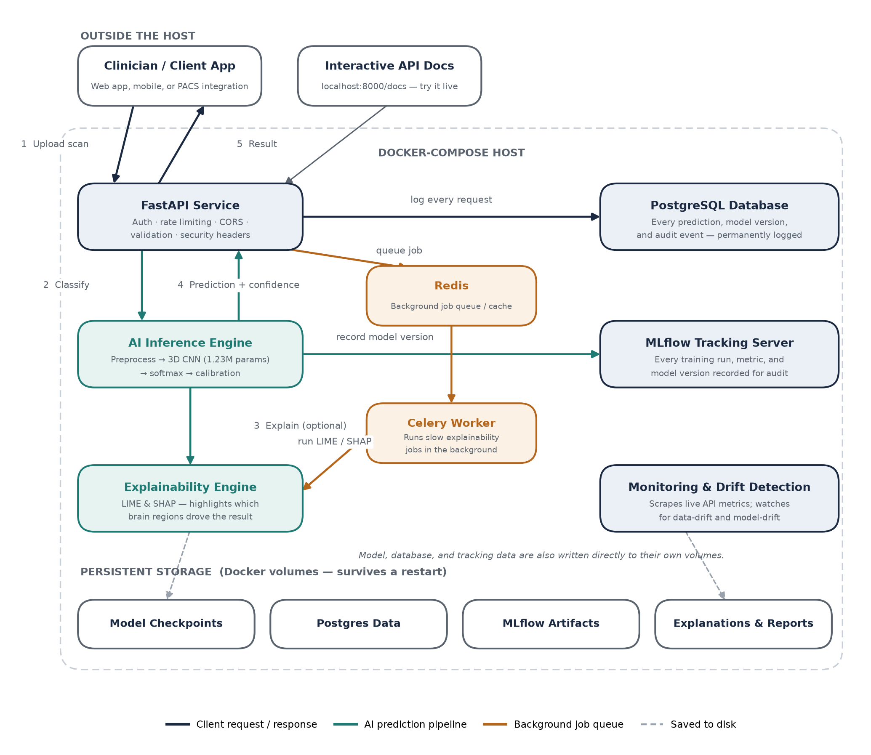

3.1 Layers
Layer | Responsibility | Key files
Ingestion & validation | Discover, convert, and validate raw scans | data_pipeline/ingestion.py, validation.py, conversion.py
Manifest & splitting | Build the versioned label manifest; leakage-safe split | data_pipeline/manifest.py, splitting.py
Training | Train the 3D CNN, track experiments, checkpoint | training/trainer.py, mlflow_utils.py
Evaluation | Held-out metrics, curves, bootstrapped confidence intervals | evaluation/evaluate.py, metrics.py, curves.py
Inference | Load checkpoint once, serve predictions with a timeout | inference/predictor.py, model_loader.py
Explainability | LIME / SHAP against the loaded checkpoint | explainability/service.py, lime_explainer.py, shap_explainer.py
API | Auth, validation, rate limiting, routing, error mapping | api/main.py, deps.py, routers/, middleware/
Persistence | Audit trail, model versions, monitoring data | db/models.py, session.py, migrations/
Monitoring | Data-drift & model-drift detection, live metrics | monitoring/drift.py, model_drift.py, metrics.py

3.2 End-to-end request flow
1. Upload — Client sends a multipart MRI file to POST /api/v1/predictions.
2. Auth & validation — API-key scope check, upload streamed in 1MB chunks with a hard size limit, empty/oversized/wrong-type files rejected before processing.
3. Preprocess — Validate volume bounds → resample to 128³, RAS orientation → z-score normalize (nonzero voxels only, never across the dataset).
4. Inference — Forward pass through the cached 3D CNN under torch.inference_mode() (never .train(), never touches gradients) → softmax → optional calibration.
5. Explain (optional) — If requested, LIME/SHAP run against the same loaded model; the heavy SHAP path can be queued to the Celery worker so it never blocks the response.
6. Response + audit — Prediction, confidence, and probabilities returned with a mandatory clinical disclaimer; the full request is best-effort logged to PostgreSQL and its image statistics recorded for drift monitoring — never allowed to fail the response.

4. The 8-Stage Production Pipeline
End to end, a scan's journey from raw upload to a governed, monitored prediction passes through eight distinct, independently testable stages:
# | Stage | Key file(s) | What it does
1 | Ingest | data_pipeline/ingestion.py, conversion.py | DICOM → NIfTI inventory, subject/scan discovery
2 | Validate | data_pipeline/validation.py | Format, corruption, dimension, and label checks per row
3 | Manifest & Split | data_pipeline/manifest.py, splitting.py | Versioned manifest; subject-level leakage-safe train/val/test
4 | Train | training/trainer.py | Optimizer, scheduler, class-imbalance handling, early stopping, checkpointing
5 | Evaluate | evaluation/evaluate.py | Held-out metrics, confusion matrix, ROC/PR curves, bootstrapped CIs
6 | Serve | inference/predictor.py, api/routers/predictions.py | Cached-model inference with a timeout, identical CLI/API code path
7 | Explain | explainability/service.py | LIME / SHAP explanations against the exact loaded checkpoint
8 | Monitor | monitoring/drift.py, model_drift.py | Data-drift (PSI) and delayed ground-truth model-drift detection

5. Technology Stack
Area | Technology
Language / runtime | Python 3.12 (targets 3.11+)
Model training | PyTorch 2.14, MONAI 1.6
Web framework | FastAPI 0.141 + Uvicorn, Pydantic v2, pydantic-settings
Database | PostgreSQL 16 (pgvector-ready), SQLAlchemy 2.0, Alembic migrations
Cache / async jobs | Redis 7, Celery worker (async explainability)
Experiment tracking | MLflow 3.16, backed by its own Postgres database
Explainability | lime 0.2, shap 0.51
Data science / ML | numpy, pandas, scikit-learn, scipy
Imaging | nibabel (NIfTI), pydicom (DICOM), matplotlib (visualization)
Observability | prometheus-client, structlog (JSON structured logging)
Data versioning | DVC (with S3 remote support)
Hyperparameter search | Optuna
Data-quality / drift | Evidently
Packaging / deploy | Docker (multi-stage), Docker Compose, non-root containers
Dev tooling | pytest, ruff, black, mypy, bandit, pip-audit, pre-commit

6. Model & Machine-Learning Components
Component | Method | Detail
Classifier | 3D CNN | 4 conv blocks (32→64→128→256 ch), batch norm, ReLU, global average pool, FC head with dropout — 1,229,603 parameters
Input | Preprocessing | 128³ resample, RAS orientation, z-score normalization (nonzero-voxel, per-volume — no dataset-level statistic ever leaks across splits)
Class imbalance | Run 1: loss re-weighting / Run 2: WeightedRandomSampler | Inverse-frequency class weights, computed from the training manifest only
Optimizer | AdamW | LR 0.001, gradient clipping at norm 1.0
LR schedule | Run 1: cosine / Run 2: ReduceLROnPlateau | Plateau schedule added after Run 1's cosine schedule was found mismatched to its actual (early-stopped) run length
Regularization | Weight decay + dropout | Run 2 raised weight decay 10× and added light conv-block dropout (0.1) to address the high parameter-to-sample ratio
Early stopping | Validation-loss patience | Patience 10 (Run 1) / 15 (Run 2); best checkpoint kept independently of the final epoch
Calibration | Optional post-hoc calibration hook | Pluggable at inference time; uncalibrated (plain softmax) in the current deployment
Explainability — LIME | Quickshift superpixel segmentation + local surrogate | 500 perturbed samples per explanation; local surrogate R² reported for trust
Explainability — SHAP | Region-pooled Kernel/Gradient SHAP | Aggregatable into a multi-sample "global importance" view per class

7. Live Verification — A Real Request
The panel below was captured from an actual request against the deployed system, not a mock-up: a real, previously unseen test-set scan, the live prediction it produced, and the LIME explanation of that prediction, generated against the exact loaded checkpoint.
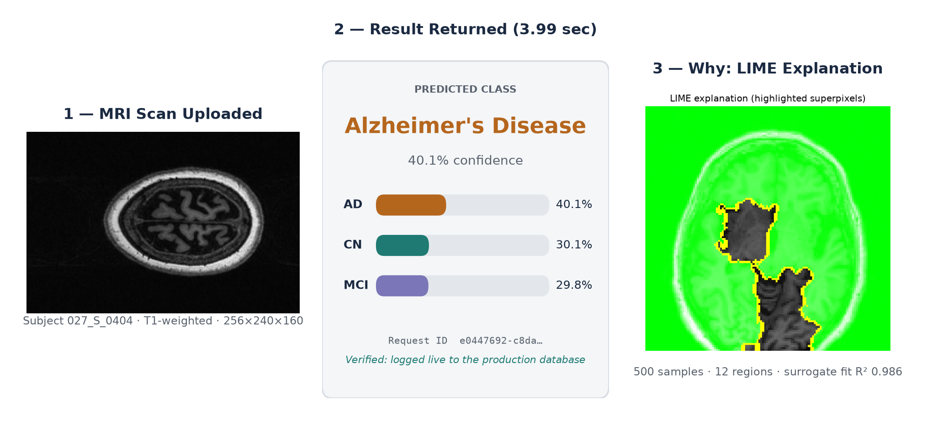
This result was independently reproduced three separate ways — the standalone CLI, the batch evaluation harness, and the live containerized API — and all three returned the identical prediction and confidence score, confirming deterministic, consistent behavior regardless of entry point.

8. Evaluation

8.1 Methodology
- Systems compared — Run 1 (default config: loss-reweighted class balancing, cosine LR schedule) vs. Run 2 (WeightedRandomSampler, ReduceLROnPlateau, 10× weight decay, added conv dropout) vs. a naive majority-class baseline.
- Data — 192 ADNI-sourced T1-weighted MRI studies (CN 66, MCI 99, AD 27); subject-level split, seed 42: 134 train / 28 validation / 30 test.
- Held-out test set — Never touched by either run during training, validation, checkpoint selection, or early stopping — evaluated exactly once per checkpoint.
- Metrics — Accuracy, balanced accuracy (macro recall), precision/recall/F1 (macro, weighted, per-class), specificity, ROC-AUC and PR-AUC (macro, one-vs-rest), confusion matrix, 95% bootstrapped confidence intervals (1,000 resamples, seed 42).

8.2 Results
Metric | Run 1 (deployed) | Run 2 (rejected) | Naive baseline
Accuracy | 40.0% | 33.3% | 53.3%
Balanced accuracy | 56.3% | 27.1% | 33.3%
F1 (macro) | 0.399 | 0.239 | 0.232
ROC-AUC (macro) | 0.642 | 0.726 | 0.500
AD recall | 100% | 0% | 0%
Best epoch | 7 of 17 (early-stopped) | 26 of 40 (hit cap) | —

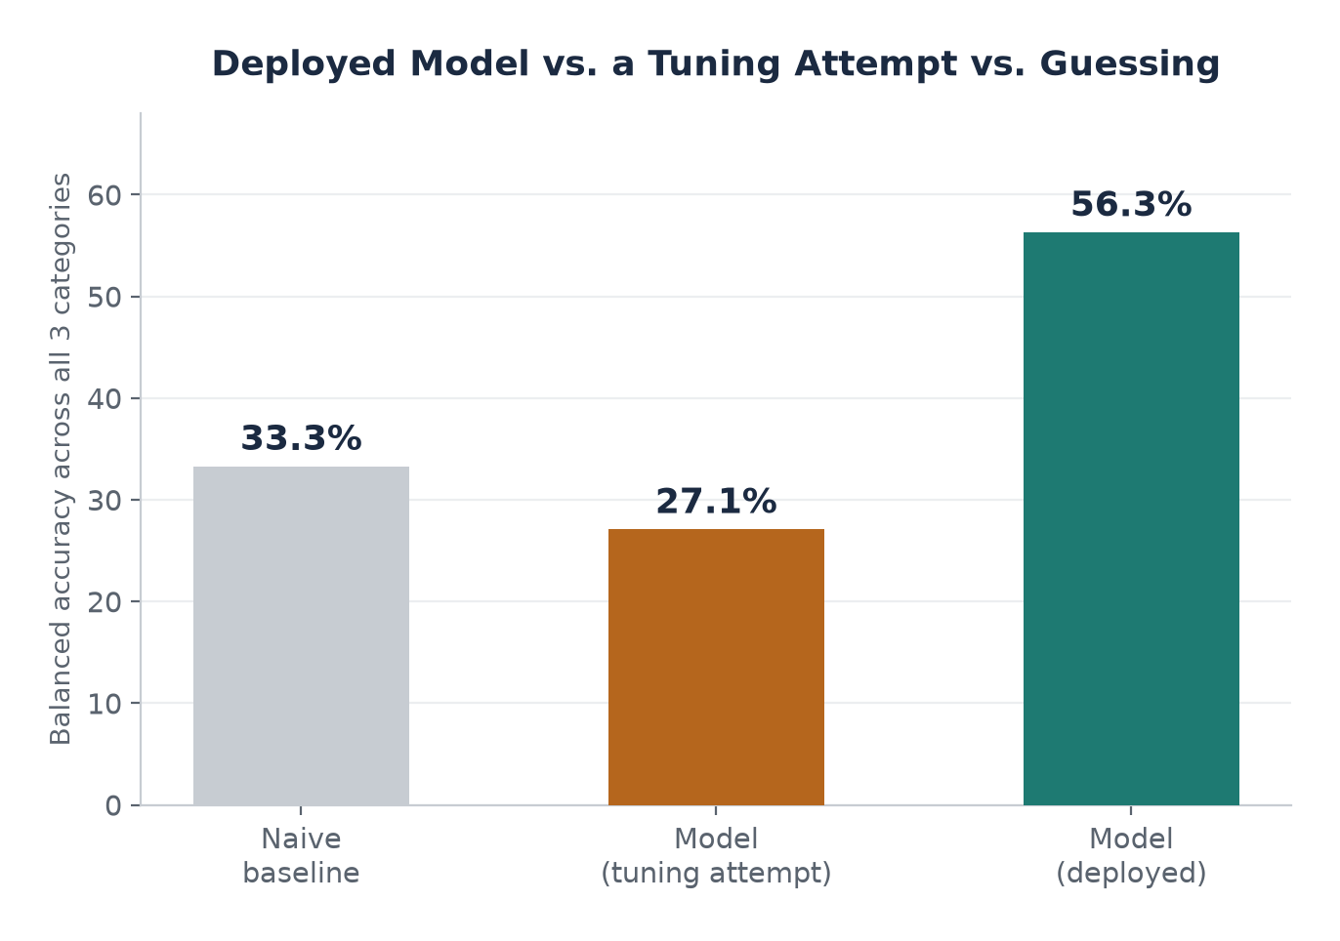

8.3 Interpretation
Genuine win, stated plainly.
Run 1 clearly beats the naive baseline on balanced accuracy (56.3% vs. 33.3%) and caught every true Alzheimer's case in the test set. Raw accuracy (40.0%) is numerically below the baseline's 53.3% — this is reported without hedging, because raw accuracy is a misleading metric on an imbalanced 3-class problem: a baseline that only ever predicts the majority class cannot identify AD or CN at all, which balanced accuracy correctly penalizes and raw accuracy does not.
A negative result, kept, not hidden.
Run 2's higher ROC-AUC (0.726 vs. 0.642) shows the underlying probability ranking retained genuine signal, but its practical decision boundary collapsed: it stopped predicting AD entirely (0% recall on the clinically most important class). The hypothesis behind Run 2's changes was reasoned, not arbitrary, and the comparison was run with the same rigor as Run 1 — it simply did not win, and the evidence, not the effort invested, decided which checkpoint ships.
Why the ceiling is data, not architecture.
192 total subjects (27 AD, 4 of them in the test set) is a small dataset for a 1.23M-parameter 3D CNN. Published ADNI 3-class studies with thousands of scans typically report 55–85% accuracy; a second, differently-tuned training run demonstrates directly that configuration changes alone do not close this gap — more labeled subjects, especially more AD cases, is the lever that would.

9. Security, Privacy & Governance
Control | Implementation | Verification
Authentication | API-key header, scope-based authorization (predict / label) | 401/403 verified live
Rate limiting | Per-key/per-IP sliding-window limiter, 60 req/min default | 429 triggered at request #60, live-tested
CORS | Explicit origin allow-list, not wildcard by default | Verified: disallowed origin → 400; allowed → 200
Upload safety | Streamed size-capped reads, generic temp filenames, extension-only use of the client filename | Path-traversal filename tested and safely neutralized
Security headers | X-Content-Type-Options, X-Frame-Options, Referrer-Policy, Permissions-Policy, HSTS, CSP | Present on every response, verified
Error handling | Centralized exception mapping; never logs or returns str(exc), stack traces, or file paths | Verified against live 4xx/5xx responses
Audit trail | Every prediction/explanation best-effort logged to PostgreSQL; never fails the response on a DB outage | Verified: DB rows match live test calls exactly
Secrets handling | SecretStr type for all credential fields; refuses to start in APP_ENV=prod with default secrets | Verified by code inspection
Static analysis | Bandit SAST | 0 issues across 11,495 lines
Dependency scan | pip-audit | 3 CVEs, both in unused transitive packages (DVC’s diskcache, evidently’s nltk) — no fix available yet, tracked
Container hardening | Non-root UID 1000, no baked secrets, env-var-only config | Verified by Dockerfile inspection

Finding & remediation: a live OpenAI API credential was found stored in plaintext in the local .env file during this review. The local git repository was confirmed to have zero commits (the key was never pushed anywhere through this repo), the key was removed from .env and the running container was recreated and verified to no longer hold it, and the user was given explicit instructions to revoke the credential at the provider. A third-party penetration test is still recommended before any production deployment.

10. Deployment
Five coordinated services, brought up via Docker Compose and independently verified:
Service | Image | Port | Status
api | Custom (FastAPI + trained model, non-root) | 8000 | Healthy
db | postgres:16-alpine | 5432 | Healthy
redis | redis:7-alpine | 6379 | Healthy
mlflow | Custom (MLflow tracking server) | 5000 | Healthy
worker | Custom (Celery, async explainability) | — | Healthy

Alembic migrations applied cleanly to the live database (two migrations: audit tables, monitoring tables). A real prediction was submitted through the containerized API and independently confirmed via direct SQL query to have produced exactly one row in prediction_results, prediction_requests, and input_statistics — proof the full chain works together, not each service in isolation. Run 1's evaluation was registered as the official monitoring baseline; the drift-detection reference distribution was built from all 134 training subjects.

11. Complete File Map — What Each Module Does
124 Python source files under src/ad_mri/, organized by package:

src/ad_mri/data_pipeline/ — ingestion, validation, splitting
File | What it does
ingestion.py | Discovers subject/scan folders; converts DICOM series to NIfTI
conversion.py | DICOM→NIfTI conversion logic (pydicom + nibabel)
validation.py | File existence/format/corruption checks, NIfTI header metadata, dimension bounds, label mapping, SHA-256 hashing
manifest.py | Builds the versioned label manifest; class-distribution summary and imbalance detection
splitting.py | Subject-level, leakage-safe, stratified train/val/test split with an explicit leakage assertion
cross_validation.py | Builds stratified K-fold CV folds from the development pool only (test set structurally excluded)
class_balance.py | Inverse-frequency class weights; WeightedRandomSampler construction
quality_control.py | Post-preprocessing quality checks (e.g. nonzero-voxel ratio)
dataset_config.py | Pydantic schema for a per-dataset config (label taxonomy, folder layout, split ratios)
schema.py | Shared row-error / validation-result / split-name constants

src/ad_mri/datasets/ — PyTorch dataset & transforms
File | What it does
dataset.py | MRIDataset — PyTorch Dataset reading the manifest and applying transforms
transforms.py | build_transforms() / apply_transforms(): resample, orientation, normalization, augmentation
custom_transforms.py | Project-specific transform implementations
preprocessing_config.py | Pydantic preprocessing/augmentation config with a content hash for provenance
validation.py | Runtime input validation before the pipeline touches an image (security bound on voxel count)
visualization.py | Original-vs-preprocessed comparison figure rendering

src/ad_mri/modeling/ — architecture & checkpoints
File | What it does
architectures.py | The 3D CNN definition (conv blocks, normalization, classifier head)
factory.py | build_model() — constructs a model from a ModelConfig
model_config.py | Pydantic architecture config (channels, blocks, dropout, input shape) with content hash
checkpoint.py | save_checkpoint() / load_checkpoint() — versioned, hash-stamped checkpoint I/O
losses.py | Loss function construction (weighted cross-entropy)
summary.py | Layer-by-layer parameter/MACs/FLOPs summary (used by `ad-mri model summary`)

src/ad_mri/training/ — the training loop
File | What it does
trainer.py | Trainer — the single place training happens: data loading, optimizer/scheduler, checkpointing, MLflow logging, resume
train.py | CLI-facing entry point; thin wrapper around Trainer, no duplicated logic
training_config.py | Pydantic training-run config (optimizer, schedule, imbalance strategy, early stopping) with content hash
callbacks.py | EarlyStopping implementation
mlflow_utils.py | MLflow run lifecycle (start/nested runs, graceful degradation if unreachable)
visualization.py | Training-curve plotting
cross_validation.py | Runs one model per CV fold; aggregates mean/std/95% CI metrics
hpo.py / hpo_config.py | Optuna-backed hyperparameter search over CV folds; HPO config schema
reporting.py | Renders CV/HPO markdown + plot reports

src/ad_mri/evaluation/ — held-out evaluation
File | What it does
evaluate.py | run_evaluation() — the single evaluation entry point; loads a checkpoint, never imported by training
metrics.py | compute_classification_metrics() — accuracy/precision/recall/F1/specificity/ROC-AUC/PR-AUC, shared by training and evaluation
confusion_matrix.py | Confusion matrix computation and rendering
curves.py | ROC and PR curve computation
report.py | Assembles and writes the full evaluation report (JSON/CSV/MD + plots)
statistics.py | Bootstrapped confidence intervals
comparison.py | Literature/baseline comparison utilities

src/ad_mri/inference/ — production inference
File | What it does
predictor.py | InferenceEngine — the production entry point; identical code path for CLI and API, never retrains, redacts file paths from logs
model_loader.py | ModelLoader — loads and caches one checkpoint per process
calibration.py | Optional post-hoc probability calibration
predict.py | CLI-facing entry point (`ad-mri predict`)

src/ad_mri/explainability/ — LIME / SHAP
File | What it does
service.py | ExplainabilityService — orchestrates a LIME/SHAP explanation against a loaded model
lime_explainer.py | LIME: superpixel segmentation, perturbation sampling, local surrogate fit
shap_explainer.py | SHAP: region-pooled attribution, global-importance aggregation across samples
explain.py | CLI-facing entry point (`ad-mri explain run`)
config.py | LIME/SHAP configuration schemas
sampling.py | Background/sample volume loading for SHAP
overlays.py | Renders the explanation overlay image onto the original slice
slicing.py | 3D-volume slice-selection logic for 2D visualization
llm_summary.py | Optional: turns a LIME/SHAP numeric result into a plain-English summary via an LLM (off by default)

src/ad_mri/api/ — the FastAPI service
File | What it does
main.py | FastAPI app factory: lifespan, CORS, exception handlers, router registration
deps.py | Dependency injection: DB sessions, API-key auth, cached inference engine
security.py | API-key security scheme (OpenAPI-visible)
exception_handlers.py | Centralized mapping of every domain exception to an HTTP status + safe body
audit.py | Best-effort persistence of predictions/events/model-version-seen
monitoring.py | Best-effort persistence of input statistics for drift monitoring
upload_utils.py | Secure streamed file upload with a hard size cap and generic temp filenames
routers/predictions.py | POST /api/v1/predictions — thin HTTP wrapper around InferenceEngine.predict()
routers/explanations.py | Explanation endpoints (sync + async via Celery)
routers/health.py | GET /healthz (liveness), /readyz (readiness incl. DB check), /metrics (Prometheus)
routers/models.py | GET /api/v1/models — currently-serving model version info
routers/monitoring.py | Drift-report and ground-truth-labeling endpoints
routers/meta.py | Service metadata endpoint
schemas/*.py | Pydantic request/response models, one file per router
middleware/rate_limit.py | In-memory sliding-window limiter, exempts health/metrics endpoints
middleware/security_headers.py | Applies the security header set to every response
middleware/request_id.py | Binds a request ID to structlog context for correlated logs
middleware/logging_middleware.py | Structured access logging

src/ad_mri/db/ — persistence
File | What it does
models.py | SQLAlchemy models: prediction_requests, prediction_results, model_versions, input_statistics, explanation_records, ground_truth_labels, system_events
session.py | Engine/session factory; SQLite-aware (tests) and PostgreSQL connection pooling
repositories.py | Query/CRUD helpers over the above models
audit_service.py | AuditService — records system events (e.g. drift alerts) to the audit trail
monitoring_service.py | MonitoringService — input-statistics windows, labeled predictions, baseline metrics
privacy.py | PII-related data-handling helpers
types.py | Custom SQLAlchemy column types
migrations/versions/0001_create_audit_tables.py | Initial audit-trail schema
migrations/versions/0002_add_monitoring_tables.py | Adds monitoring tables + model_versions.baseline_metrics

src/ad_mri/monitoring/ — drift & system monitoring
File | What it does
drift.py | DriftReference; per-feature PSI-based data-drift report; image-statistics computation
model_drift.py | Delayed, ground-truth-backed model performance vs. registered baseline
thresholds.py | Alert thresholds (PSI alert level, minimum labeled samples for a verdict)
alert_state.py | Durable drift-alert flag surfaced on the next /metrics scrape
health_checks.py | check_database() — backs the /readyz probe
metrics.py | Prometheus metric definitions and the /metrics render function
system_metrics.py | Process-level resource metrics (CPU/memory via psutil)

src/ad_mri/core/ & model_registry/ & cli/
File | What it does
core/config.py | Centralized Settings (pydantic-settings), env-var driven, refuses default secrets in prod
core/constants.py | Environment, ModelStage, ExplainabilityMethod, ApiScope enums
core/exceptions.py | Typed exception hierarchy (AppError and subclasses)
core/logging.py | structlog + stdlib logging configuration (console/JSON)
core/disclaimers.py | The mandated clinical-use disclaimer text
core/seeding.py | Global RNG seeding for reproducibility
model_registry/client.py | Records model versions for audit; not yet a full MLflow Model Registry promotion workflow
cli/main.py | Typer CLI: data ingest/validate/manifest/split/cross-validate, model summary, train, evaluate, explain, predict, serve, monitor

12. How to Run

12.1 Full stack (Docker)
docker compose -f docker/docker-compose.yml -f docker/docker-compose.override.yml up -d
docker compose -f docker/docker-compose.yml --profile tools run --rm migrate
# API docs http://localhost:8000/docs
# MLflow UI http://localhost:5000

12.2 Data pipeline
ad-mri data ingest --dataset-config configs/data/adni_3class.yaml
ad-mri data validate --dataset-config configs/data/adni_3class.yaml
ad-mri data manifest --dataset-config configs/data/adni_3class.yaml
ad-mri data split --dataset-config configs/data/adni_3class.yaml

12.3 Train & evaluate
ad-mri train --model-config configs/model/cnn3d_default.yaml \
--training-config configs/training/default.yaml \
--train-manifest data/splits/adni_3class/train.csv \
--val-manifest data/splits/adni_3class/val.csv
ad-mri evaluate --model artifacts/checkpoints/adni_3class_run1/best.pt \
--dataset data/splits/adni_3class/test.csv

12.4 Predict & explain
ad-mri predict --model artifacts/checkpoints/adni_3class_run1/best.pt \
--image path/to/scan.nii.gz
ad-mri explain run --model artifacts/checkpoints/adni_3class_run1/best.pt \
--image path/to/scan.nii.gz --methods lime

12.5 Main endpoint
curl -X POST http://localhost:8000/api/v1/predictions \
-H "X-API-Key: <key>" -F "file=@scan.nii.gz"
# response: { request_id, model_version, prediction, confidence,
# probabilities, processing_time_ms, disclaimer, ... }

13. Limitations & Future Work
Known limitations (documented, not defects).
- Dataset scale — 192 subjects (27 AD) is small for a 3D CNN; Run 2 demonstrates that tuning alone does not close the gap. A production-grade model needs a substantially larger, especially AD-richer, cohort.
- Compute — This machine has no GPU; a full run took under 2 hours here, but a larger dataset or deeper architecture will need one for practical iteration speed.
- Stubbed features — Skull-stripping / atlas registration (`ad-mri preprocess`), OAuth2/JWT, encryption at rest, DICOM header sanitization, and full MLflow Model Registry promotion are documented, deliberate stubs, not silently missing features.
- Scaling — The rate limiter is in-memory and per-process; a multi-instance deployment needs the already-designed Redis-backed swap first.
- Dependency CVEs — diskcache (via DVC) and nltk (via evidently) carry known CVEs with no upstream fix yet; neither is imported anywhere in this project's own code.
Future extensions.
- More labeled subjects, particularly Alzheimer's cases — the single highest-impact next step.
- GPU-accelerated training for practical iteration on a larger dataset.
- Full skull-stripping / atlas-registration preprocessing stage.
- OAuth2/JWT authentication and at-rest encryption ahead of any deployment handling identifiable patient data.
- A Redis-backed, multi-instance-safe rate limiter.
- A complete MLflow Model Registry promotion workflow (staged → production lifecycle).

Research / decision-support system. Not a certified medical device. Not clinically validated. Must not be used as the sole basis for any medical decision.

