Sales Data Analysis Project

🚀 Project Overview
This project focuses on analysing sales data using SQL by importing a CSV dataset into MySQL. The data was cleaned, transformed, and analysed to extract meaningful business insights that can support decision-making.
The goal of this project is to demonstrate practical SQL skills including data cleaning, aggregations, subqueries, business problem-solving and building an interactive dashboard using Power BI.

🛠 Tools & Technologies
* MySQL
* SQL (Subqueries, Aggregations, DDL, DQL, DML commands)
* Excel, Power Query
* MySQL Workbench
* Power BI

📂 Dataset
The dataset was imported from a CSV file into MySQL. It contains information related to:
* Customers
* Orders
* Revenue, Cost, Profit
* Sales Representatives & Managers
* Product Categories
* Country & Device Type
* Date

🧹 Data Cleaning
Before analysis, the dataset was cleaned by:
* Standardizing column names
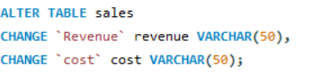
* Removing commas
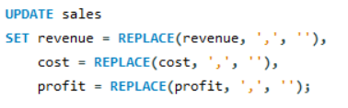
* Ensuring correct data types
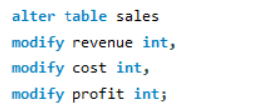

📈 Key Business Problems Solved
🔹 Advanced SQL Queries (Using Subqueries)

* Find top 5 customers whose total revenue is above average revenue
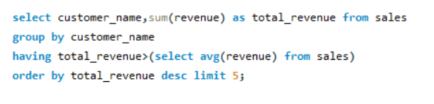
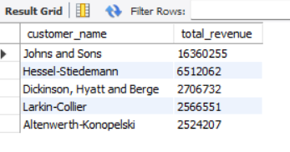
* Find the country with the highest total profit
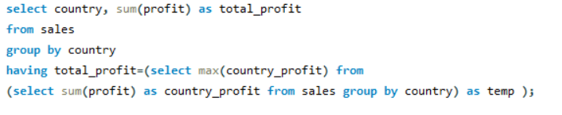

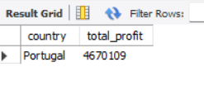
* Find sales representatives who generated more revenue than their manager’s average
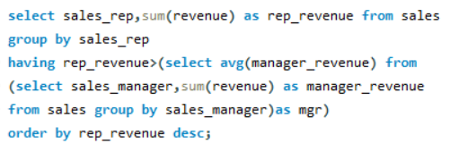
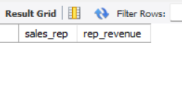
* Find top 3 categories by profit
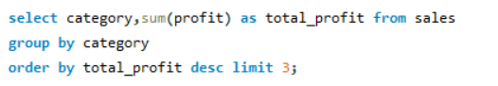

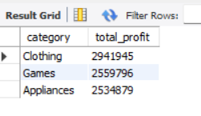
* Find top 5 orders where profit is higher than overall average profit
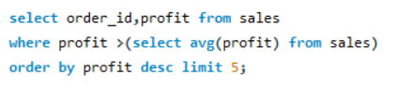

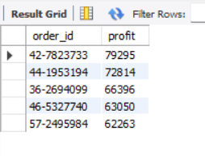

📊 KPI Metrics
* Total Cost
* Total Revenue
* Total Profit
* Total Orders
* Average Order Value (AOV)
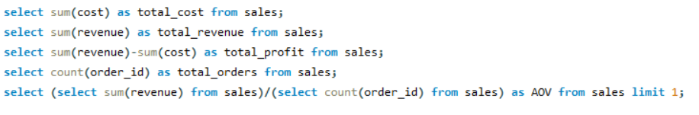
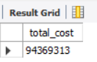 | 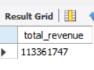 | 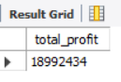
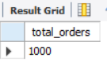 | 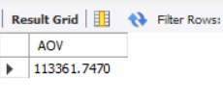

📌 Business Insights Breakdown

🌍 Country-Level Analysis
* Total Cost, Revenue, and Profit by Country

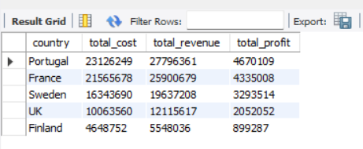

🛍 Category-Level Analysis
* Total Cost, Revenue, and Profit by Category

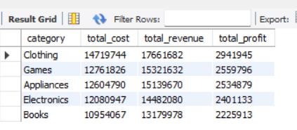

👨💼 Sales Hierarchy Analysis
* Total Cost, Revenue, and Profit by Sales Manager
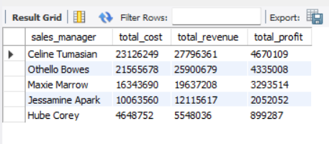
* Total Cost, Revenue, and Profit by Sales Representative
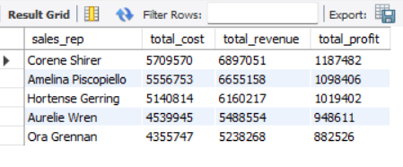
📱 Device-Based Analysis
* Total Cost, Revenue, and Profit by Device Type
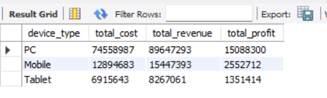

Next is to build a dashboard
What I usually do is first create the necessary views in MySQL that contain the insights I want to visualize.
Then, instead of connecting Power BI to the entire table, I connect it directly to those views.
This makes things much faster, improves performance, and keeps the whole workflow more efficient.
Dashboard:
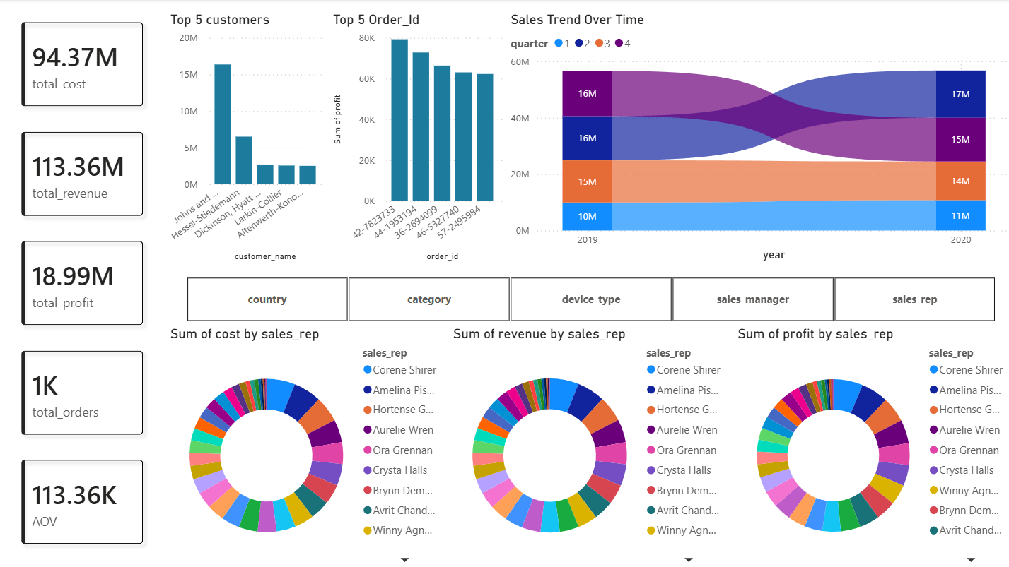

💡 Key Learnings
* Writing efficient SQL queries using subqueries and aggregations
* Creating VIEWs for efficient and better performance
* Connecting MySQL Database to Power BI
* Building interactive Dashboard
* Solving real-world business problems using data
* Understanding sales performance across multiple dimensions
* Building KPIs for business decision-making

📎 How to Run This Project
1. Import the CSV file into MySQL
2. Run the SQL queries provided in this document
3. Connect the database to Power BI then import necessary tables
4. Create a dashboard with suitable visuals

⭐ Future Improvements
* Going to add more advanced analytics (cohort analysis, customer segmentation)

🙌 Author:
Vijayalakshmi Konduru

