**UML-Diagrams (Eva Fashion World)**

1. **Activity Diagram.**

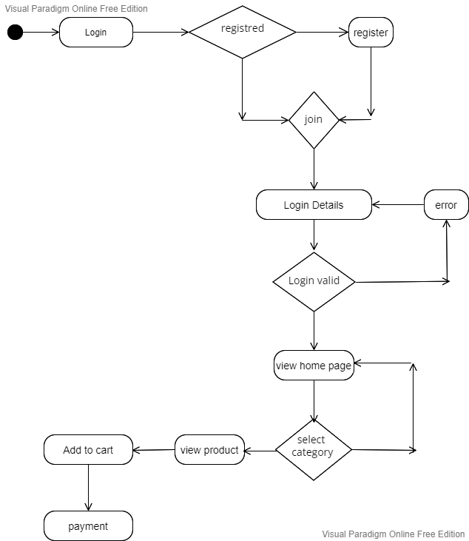

1. **UseCase Diagram.**

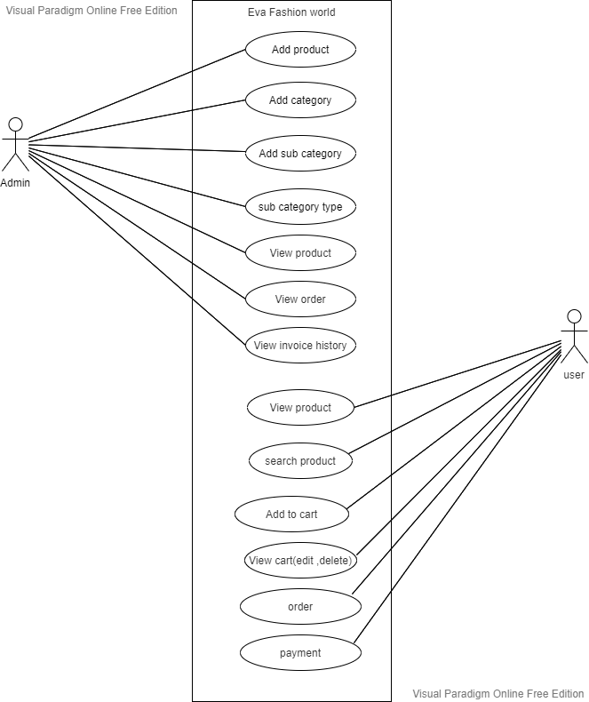

1. **Deployement Diagram**

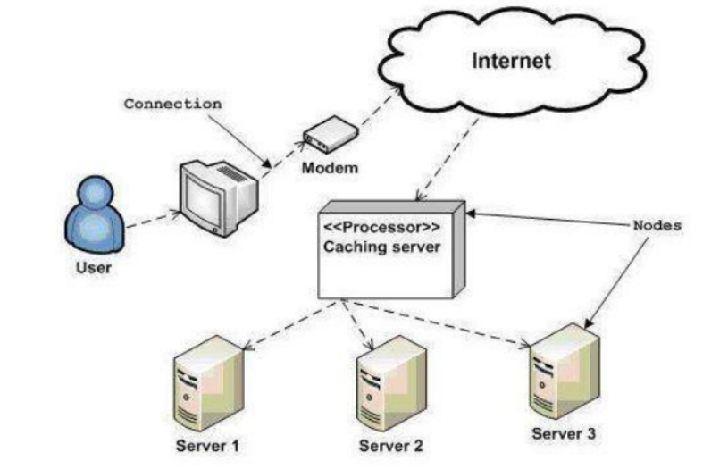

1. **Class Diagram**

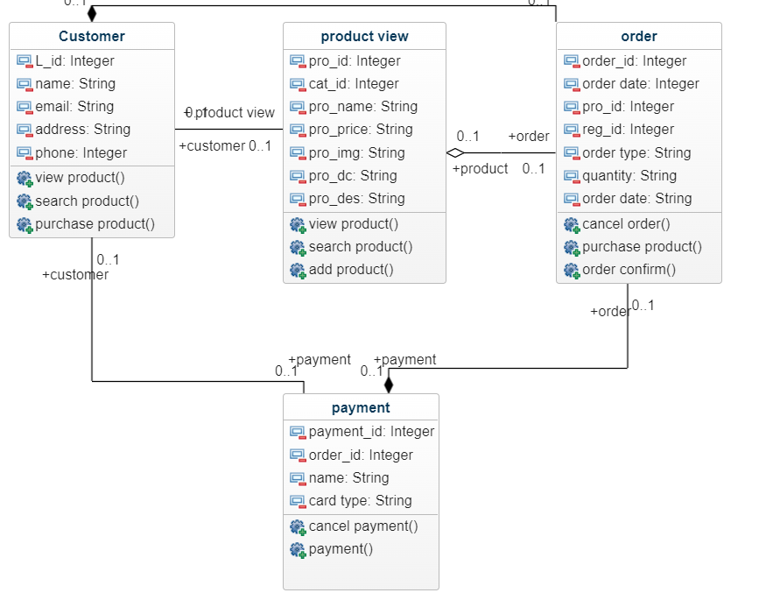

1. **Object Diagram**

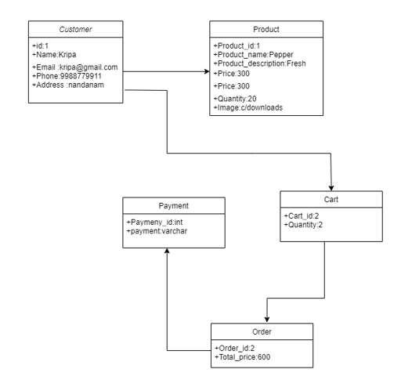

1. **State Diagram**

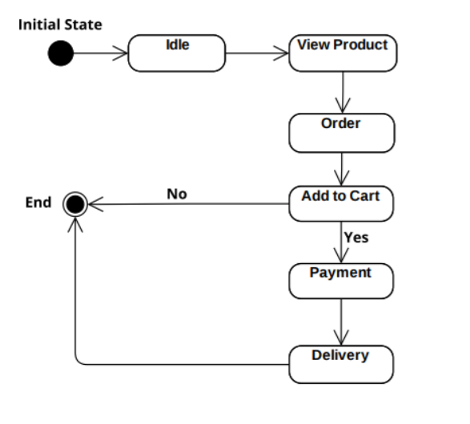

1. **Sequence Diagram**

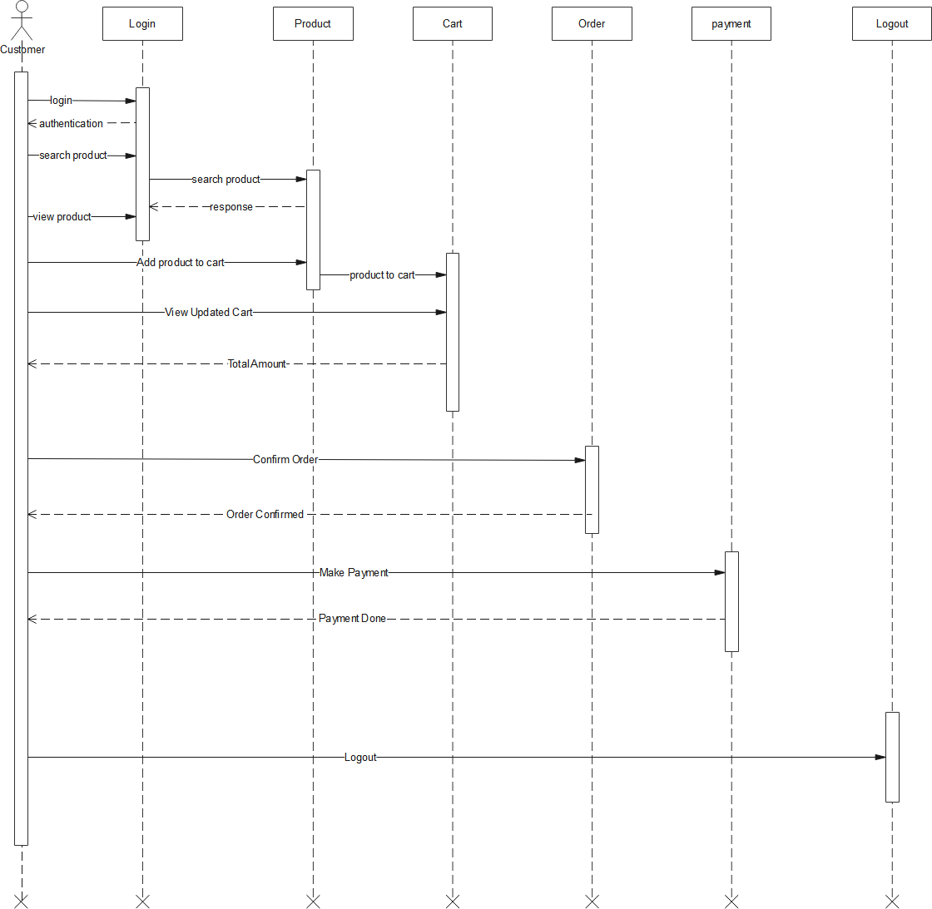

1. **Class Diagram**

