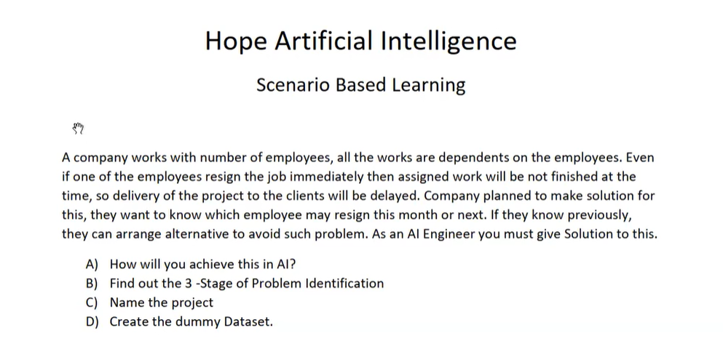

Employee Resignation Prediction System

A) How will you achieve this in AI?
- The Scenario defines the Employee Attrition Prediction.
- Collect the data: age, salary, Experience, performance, overtime, satisfaction, promotions, leave details.
- Prepare employee’s historical data.
- Train the model.
- Predict probability of resignation in the next 1-2 months.
- Create the dashboard and alerts for high-risk employees.

B) Three Stages of Problem Identification
- Stage 1: Domain Selection: Machine Learning
- Stage 2: Requirement and I/P & O/P are clear : Supervised learning
- Stage 3: Output is in category type : Classification

C) Project Name
- Employee Attrition Prediction and Retention System

D) Dummy Dataset Structure
- Fields:
- Employee_ID,
- Age,
- Department,
- Experience_Of_Years,
- Monthly_Salary,
- Job_Satisfaction,
- Performance_Rating,
- Overtime_Hours,
- Leave_Taken,
- Promotion_Last_2_Years,
- Attrition

