PRD Genie Capstone Submission Documentation
Vijayalaxmi 4th Nov 2026 TPM Role
GitHub Link: https://github.com/vijayalaxmireddy47/PRD-Genie

Problem Statement
Neuron Forge Technologies’ PMs/TPMs spend too much time turning meeting transcripts, briefs and stakeholder notes into PRDs, epics and user stories by hand. Each PM/TPM uses a different format, and requirements get lost in notes nobody re-reads, which causes delays, inconsistent tracking and slower time-to-market. The task is to build PRD Genie, a multi-agent AI assistant that extracts requirements, writes a standard-template PRD and breaks it into prioritised user stories, without inventing anything that wasn’t discussed. Neuron Forge has identified a significant bottleneck in its product management process which is listed below.

- PMs/TPMs spend a disproportionate amount of time gathering scope and requirements from meetings
- Translating discussions into structured PRDs, epics, and user stories is highly manual and iterative
- Different PMs/TPMs produce PRDs in different formats, making engineering estimation difficult
- Meeting transcripts and notes sit in documents nobody revisits valuable requirements get lost
- This leads to delays, inconsistent tracking, and slower time-to-market

Who it is for
- Primary users: PMs and TPMs, who write PRDs.
- Secondary users: engineering teams, who estimate from the PRDs and stories, and stakeholders, who answer clarification questions.

What PRD Genie must do
Core capabilities (all required):
- Requirement extraction: features, requirements, constraints, assumptions, stakeholders and deadlines, with stated items kept apart from ambiguous ones.
- PRD generation: overview, goals, personas, feature list, acceptance criteria, assumptions and open questions, following prd_template.md.
- Epic and user story breakdown: Epics, then Features, then User Stories, each with a priority of Must Have, Should Have or Nice to Have.

Ideation (pain points in Neuron Forge's PM workflow)
PMs/TPMs lose most time on four manual steps that sit between a meeting ending and engineering being able to estimate. Each map to one or more PRD Genie agents.
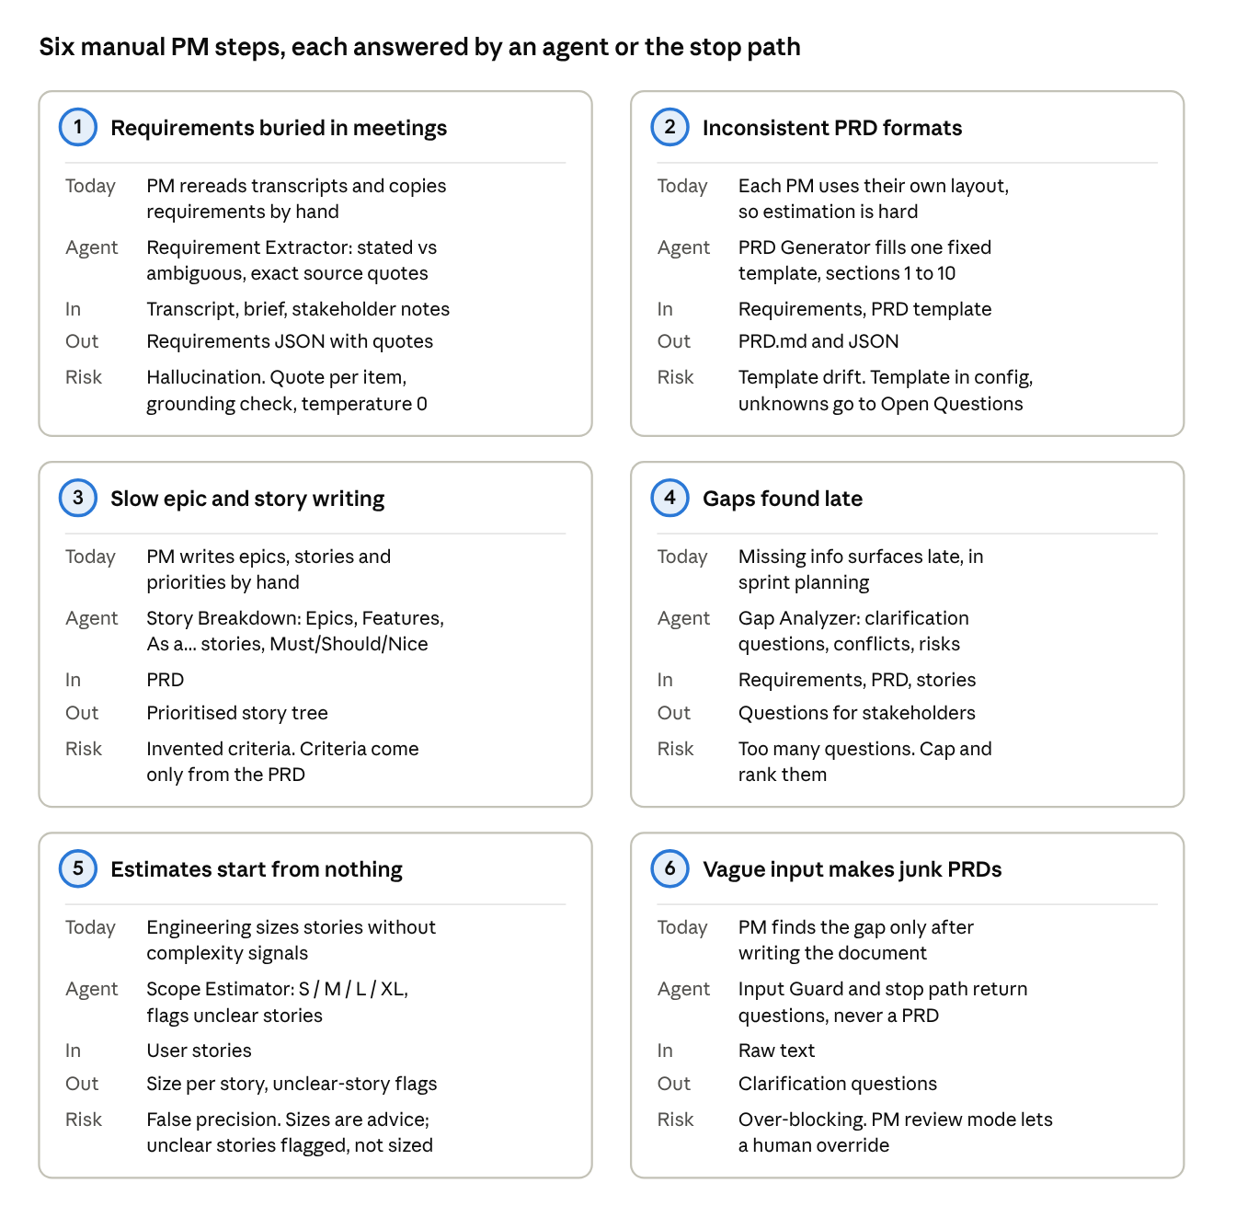
Program Charter
PRD Genie is a six-week program to give every Neuron Forge PM/TPM one consistent, evidence-backed path from meeting transcript to PRD and user stories, and to refuse to invent requirements when the input is thin. This charter sets out why the program exists, what it will and will not deliver, how success is measured, who decides, and how it rolls out.
1. Charter summary
- Program: PRD Genie, an AI-powered product documentation assistant.
- Company: Neuron Forge Technologies.
- Sponsor: Product and Innovation team.
- Program owner: AI PM/TPM, Product and Innovation team.
- Platform: n8n workflow, OpenAI LLM (configurable), Lang fuse observability.
- Duration: 6 weeks, from design to pilot.

2. Background and problem
Neuron Forge's product management process has a bottleneck between a meeting ending and engineering being able to estimate the work.
- PMs and TPMs spend a disproportionate amount of time gathering scope and requirements from meetings.
- Turning discussions into structured PRDs, epics and user stories is manual and iterative.
- Each PM writes PRDs in a different format, which makes engineering estimation difficult.
- Meeting transcripts and notes sit in documents nobody revisits, so valuable requirements are lost.
- The result is delays, inconsistent tracking and slower time to market.

3. Vision and mission
Vision: Meetings stop being a graveyard of lost requirements. Any PM/TPM pastes a transcript and gets a template-conformant PRD, prioritized stories and a list of open questions in minutes, with every requirement traceable to a quote.
Mission: Build and pilot a multi-agent workflow that extracts requirements, generates structured PRD, breaks it into epics and stories, surfaces gaps and estimates, and measures its own quality and cost.

4. Objectives
- Speed- Cut the time from meeting to first-draft PRD and stories from hours of manual work to minutes of generation plus PM review.
- Consistency- Produce every PRD from one template with ten fixed sections, so engineering can compare and estimate across teams.
- Grounding- Keep invented content out of the output: every requirement carries an exact source quote, and every number matches the input.
- Early risk visibility- Surface gaps, conflicts and dependencies at the start of planning rather than mid-sprint.
- Trust through measurement- Trace every run and keep a baseline test set (T1 to T12) that must pass before any change ships.

5. Scope
In scope
- Text inputs: meeting transcripts, product briefs and stakeholder notes.
- Requirement extraction separating stated from ambiguous items, with people, deadlines, conflicts and missing information.
- PRD generation against the standard 10-section template.
- Epic, feature and user story breakdown with Must, Should or Nice priority.
- Gap Analyzer and Scope Estimator running in parallel.
- PM review loop using the extract only and from extraction modes.
- Stop path for empty or insufficient input.
- Lang fuse tracing and the baseline evaluation harness.
Out of scope (future work)
- Audio recording and transcription.
- Direct sync to Jira, Notion or other tools.
- Version comparison of two transcripts.
- Fine-tuning a model and retrieval over past PRDs.
- Multi-language input.
- Final approval of a PRD: the PM remains accountable for what is published.

6. Deliverables
- n8n workflow JSON files (main workflow and evaluation harness).
- PRD template and prompt set.
- Baseline results for all 12 tests, with outputs.
- Lang fuse project with traces, cost and scores.
- Architecture diagram, slide deck, README and a 5-minute demo video.
- Pilot feedback summary and a go or no-go recommendation.

7. Success criteria
The program succeeds if all quality gates below are met at the end of week 5 and the pilot confirms the time saving in week 6. Targets marked proposed are for the sponsor to confirm.

Metric | Target | How measured
Baseline tests passed | 12 of 12 | Eval harness pass or fail report
Ungrounded requirements in output | 0 on the baseline set | Grounding check: every quote found in the source
Numbers altered (T1, T7) | 0 | Exact-match check
Vague or empty input that produces a PRD (T2, T5, T9) | 0 cases | Stop-path check
PRD template sections present | 10 of 10 | Structure check on T11
Stories in the standard format with priority | 100 percent (T12) | Format check on T12
Cost per full run | Under 0.05 USD (estimate 0.015) | Lang fuse cost per trace
PM time saved on first draft | Majority of drafting time (proposed) | Pilot PMs compare against their usual process
Pilot PM satisfaction | 4 or more out of 5 (proposed) | End-of-pilot survey

8. Stakeholders and governance

Stakeholder | Role | Involvement and decision rights
Product and Innovation team | Sponsor | Approves charter, scope changes and the go or no-go decision
AI PM/TPM (program owner) | Delivery owner | Designs and builds the workflow, owns evaluation results, reports status
Pilot PMs and TPMs | Primary users | Supply real transcripts, review outputs, give feedback in week 6
Engineering leads | Consumers of PRDs and stories | Confirm the template and story format are estimable
Design leads | Consumers of PRDs | Confirm personas and flows are captured
Security and legal | Approvers | Approve data handling for transcripts and the LLM account

The sponsor decides at each gate whether to continue. The program owner may change prompts and workflow design within scope without approval, but any change to scope, template sections or success targets goes to the sponsor.

9. Timeline and milestones
The plan runs 6 relative weeks in five phases, each ending in a gate that must be passed before the next phase starts. Calendar dates are set once the sponsor approves the charter.
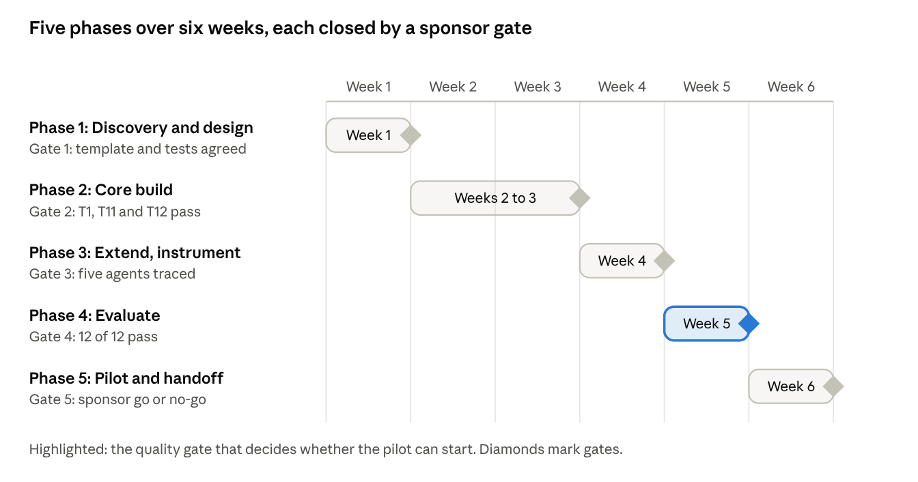
program roadmap · 5 phases, 5 gates, 6 weeks
- Phase 1, Discovery and design (week 1). Interview PMs about their current process, fix the 10-section PRD template, agree the evaluation set T1 to T12 and the pass rules. Gate 1: sponsor approves template and tests.
- Phase 2, Core build (weeks 2 to 3). Build the input guard, both routers, the Requirement Extractor, PRD Generator and Story Breakdown. Gate 2: T1, T11 and T12 pass end to end.
- Phase 3, Extend and instrument (week 4). Add Gap Analyzer and Scope Estimator in parallel, the PM review modes, Langfuse tracing and the grounding checks. Gate 3: all five agents traced and the parallel merge works.
- Phase 4, Evaluate (week 5). Run T1 to T12, tune prompts, rerun the full set after each change, review cost. Gate 4: 12 of 12 pass with zero ungrounded content.
- Phase 5, Pilot and handoff (week 6). Run two or three PMs on real meetings in review mode, collect feedback, finalize documentation and demo. Gate 5: sponsor go or no-go for team rollout.

10. Resources and budget
- People: one AI PM/TPM as program owner; two or three pilot PMs/TPMs for part of week 6; short reviews from one engineering lead, one design lead, and security and legal. Hours per person are for the sponsor to confirm.
- Platform and tools: n8n for the workflow, an OpenAI API account for the LLM, and a Langfuse project for tracing.
- Running cost: about 0.015 USD per full run and about 1.52 USD for 100 full runs a month, with the full baseline suite costing about 0.11 USD (estimates from the cost section; replace with Langfuse figures). Running cost is small next to people time, so the case for the program rests on hours saved.

11. Risk register
Risk | Likelihood and impact | Mitigation and fallback
The LLM invents requirements | Medium, high | Quote per requirement, grounding check, temperature 0, stop path. Fallback: PM review mode becomes mandatory for every run.
PMs over-trust generated PRDs | Medium, high | Open Questions section, PM review mode, visible AI-generated draft label, sampled human audits.
Sensitive meeting data sent to a third-party LLM | Medium, high | Approved API account, access control on the webhook, limited trace retention. Fallback: pause the pilot until security and legal approve.
Vague input produces a confident PRD | Medium, high | Input guard and After-Extraction router stop the run and return questions (T2, T5, T9).
Prompt changes cause silent regressions | Medium, medium | Rerun T1 to T12 after every change; any new failure blocks the change.
Model or price changes | Medium, medium | Model is a config setting; cost tracked per run in Langfuse.
PMs do not adopt the tool | Medium, medium | Involve pilot PMs from week 1, keep review mode simple, collect feedback early.
Template does not suit all teams | Low, medium | Agree with the template at Gate 1 with engineering and design; allow sponsor-approved changes later.

12. Assumptions, constraints and dependencies
- Assumptions: inputs are text, in English, and contain enough detail for at least some requirements; PMs will review output before it is shared.
- Constraints: six-week schedule; low-code platform; one LLM account; the PM stays accountable for the final PRD.
- Dependencies: access to an LLM API key, a Langfuse project, the sample inputs and PRD template, and approval from security and legal for pilot transcripts.

13. Communication and reporting
- A short-written status update to the sponsor at the end of each phase, with gate result, test pass count, cost to date, open risks and decisions needed.
- A demo to pilot PMs and engineering leads at the end of phase 3, to confirm the output is usable before evaluation begins.
- A final report at Gate 5 with baseline results, traces, cost, pilot feedback and a go or no-go recommendation.

14. Rollout plan
- Internal pilot (week 6). Two or three PMs run PRD Genie on real meetings in review mode (extract only, edit, from extraction). Exit when pilot feedback is collected and the baseline still passes 12 of 12.
- Team-wide release. Open to all PMs and TPMs after the sponsor's go decision, with a one-page how-to, the template and a feedback channel. Exit when the baseline stays at 12 of 12 and no ungrounded content is reported for the agreed period.
- Expansion. Add integrations (Jira, Notion), version comparison and retrieval over past PRDs, each as its own change approved by the sponsor.

Rollback: if a serious grounding failure or data issue appears, disable the webhook, return PMs to their manual process, and reopen the program at the last passed gate.

15. Change control
Changes to scope, template sections, success targets or the LLM provider are raised with the program owner, assessed for effect on schedule, cost and risk, and approved or rejected by the sponsor. Prompt and workflow tuning inside the approved scope does not need approval but must pass the baseline suite.

16. Approval and open items
- ☐ Sponsor approves vision, objectives, scope and success targets
- ☐ Engineering and design leads agree the PRD template
- ☐ Security and legal approve data handling for pilot transcripts
- ☐ Sponsor confirms people hours and calendar dates for the six weeks
- ☐ Sponsor confirms the proposed targets (time saved, satisfaction score)

Design and architecture
PRD Genie is a sequential pipeline of three core LLM agents, followed by two parallel extended agents, with two routers that can stop the run early and a human review loop at the front.

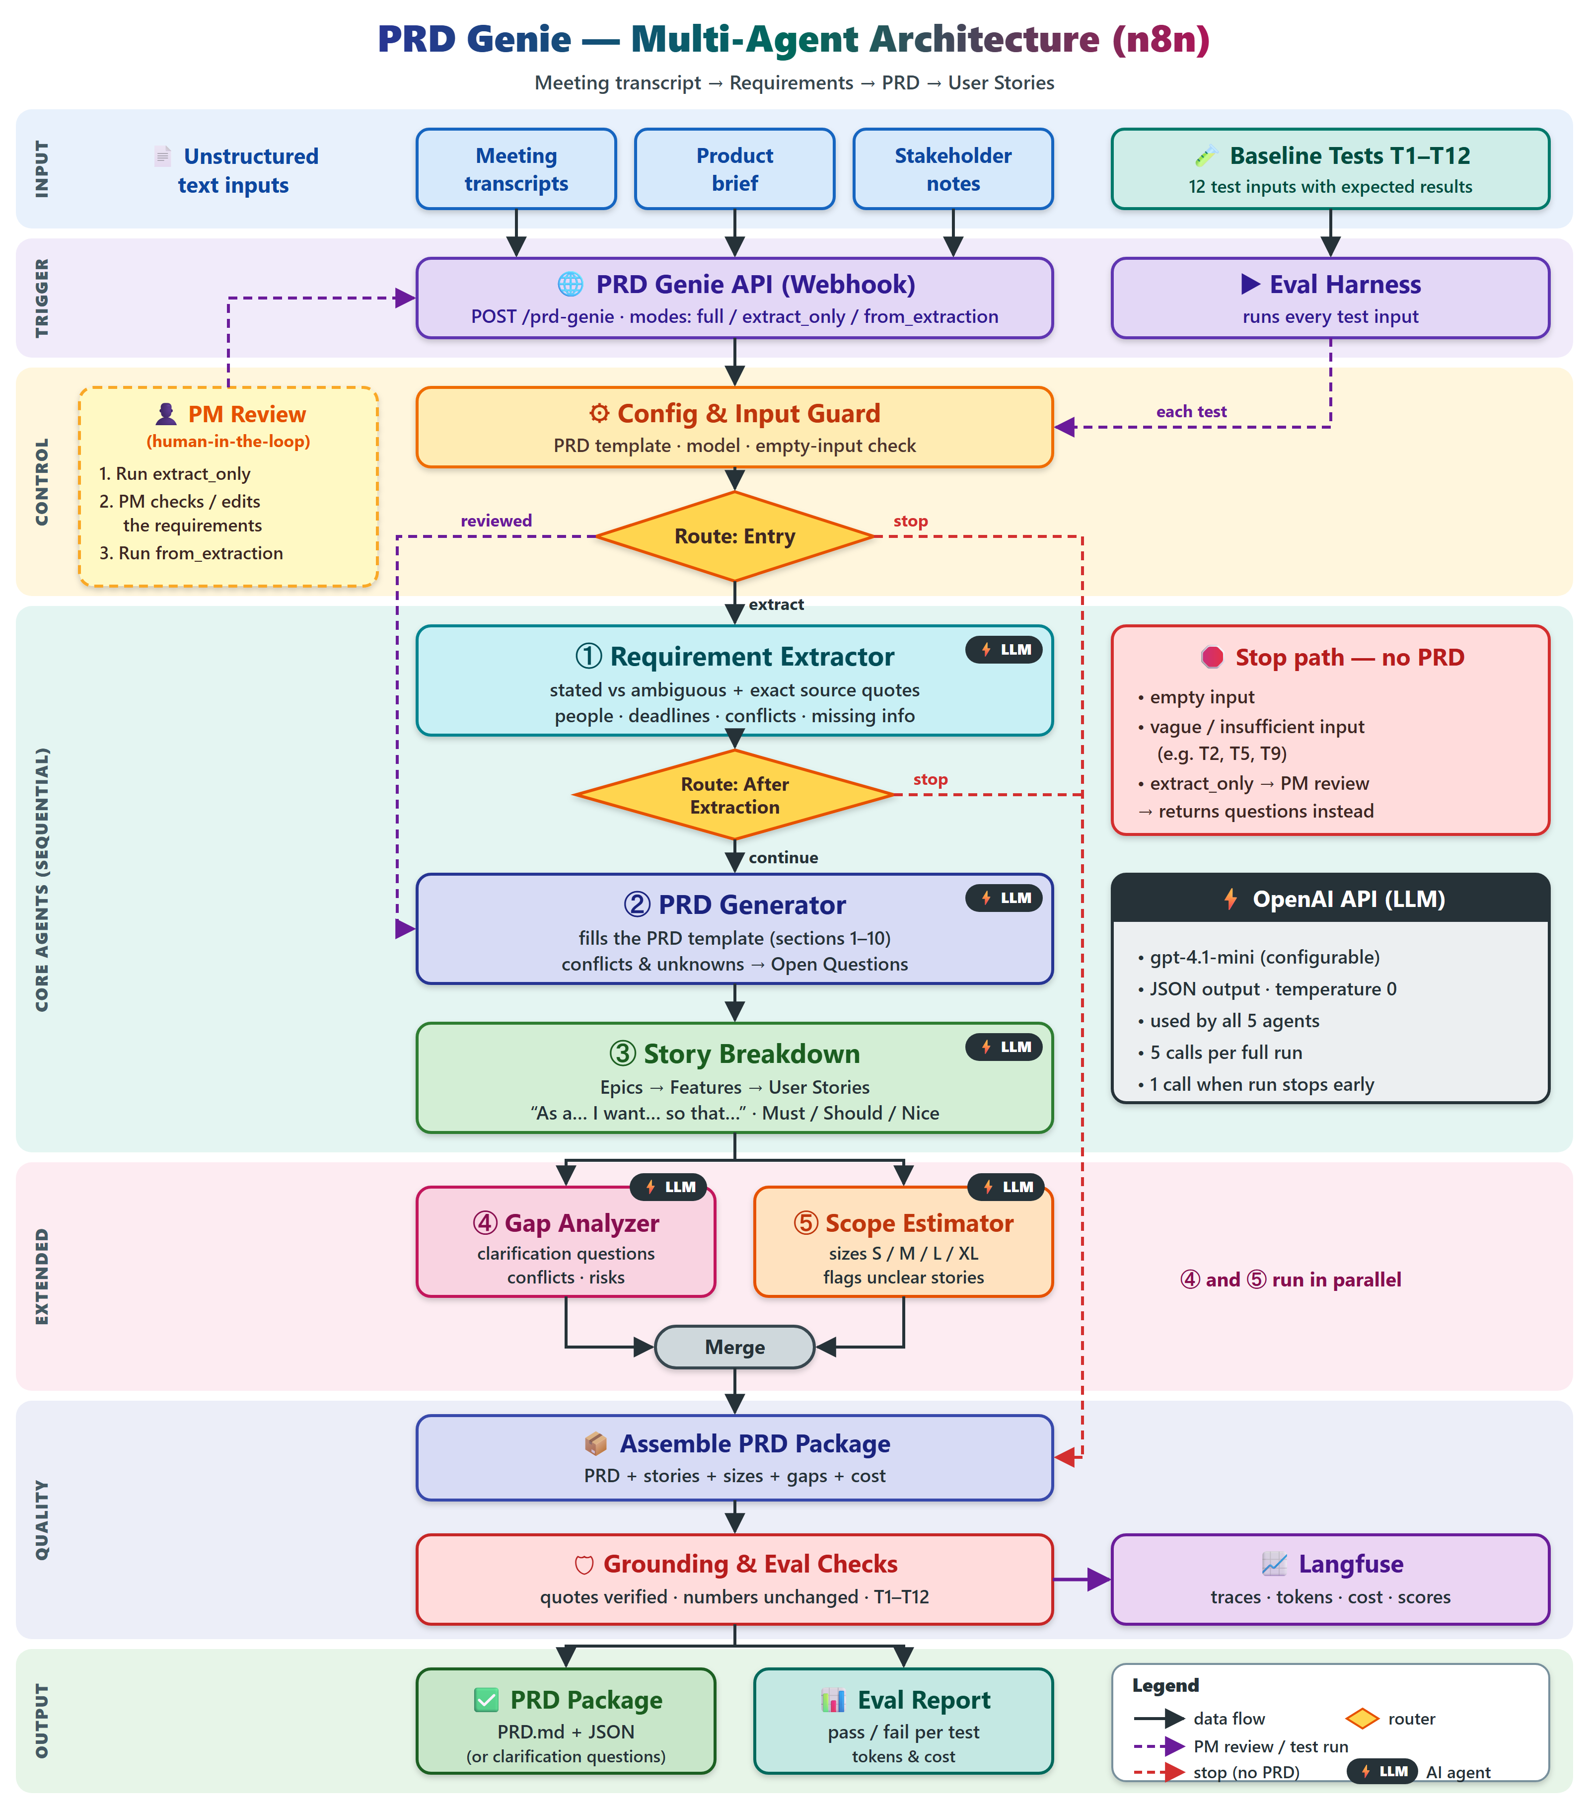

How to read the above architecture diagram. Workflows top to bottom through seven bands Input, Trigger, Control, Core Agents, Extended, Quality and Output.
- Input and trigger- Transcripts, briefs and notes arrive at the PRD Genie webhook (POST /prd-genie) with one of three modes: full, extract only or from extraction. The Eval Harness calls the same entry for each of the 12 baseline tests.
- Control- Config and Input Guard loads the PRD template, model name and runs the empty-input check. Route: Entry then sends the run to extraction (normal), straight to the PRD Generator (reviewed extraction from a PM) or to the stop path.
- Core agents- The Requirement Extractor separates stated from ambiguous requirements and attaches exact source quotes. Route: After Extraction stops the run if the input was insufficient otherwise, the PRD Generator fills template sections 1 to 10, sending conflicts and unknowns to Open Questions, and Story Breakdown produces Epics, Features and stories with Must, Should or Nice priority.
- Extended agents- Gap Analyzer (clarification questions, conflicts, risks) and Scope Estimator (S, M, L, XL and unclear-story flags) run in parallel, then merge.
- Quality- Assemble PRD Package combines PRD, sizes, gaps and cost. Grounding and Eval Checks verify quotes and numbers and report T1 to T12 results, and send traces, tokens, cost and scores to Langfuse.
- Output- A PRD Package (PRD.md plus JSON, or clarification questions when stopped) and an Eval Report (pass or fail per test, with tokens and cost).

Orchestration pattern and why
I selected a sequential pipeline with conditional routers and a parallel extension, matching the problem statement's recommendation. Every input goes through the same three dependent stages, and each stage needs the previous stage's structured output, so there is nothing to gain from a free-form planner.

Pattern | Used? | Reason
Sequential pipeline | Yes, the backbone | Fixed order: extract, then PRD, then stories. Each output is the next input, which also makes failures easy to localize in traces.
Router | Yes, lightweight | Two routers (Entry and After Extraction) decide to continue, skip extraction after PM review, or stop. They avoid building a PRD from empty or vague input (T2, T5, T9).
Parallel fan-out | Yes, after Story Breakdown | Gap Analyzer and Scope Estimator are independent of each other, so running them side by side cuts latency without changing results.
Hierarchical | No | Inputs are single documents, so splitting into subtasks adds cost and failure points without benefit. It becomes relevant for multi-document inputs later.

Tool rationale

Layer | Choice | Why
Workflow platform | n8n | Low-code, visual canvas, webhook trigger, native branching and merge nodes, exportable as JSON for the repo
LLM | OpenAI gpt-4.1-mini (configurable) | Low cost per call, JSON output mode, strong enough for extraction and generation at temperature 0
Ingestion | Webhook with plain-text body | Transcripts, briefs and notes are all text, so no parser is needed
Observability | Langfuse | Traces per run, token and cost tracking, and scores attached to each test
Output | Markdown plus JSON | Markdown is readable and diff-able; JSON feeds Jira, Notion or other tools later
Access | API key on the webhook and LLM credentials stored in n8n | Keeps the endpoint and the key off the public internet

Agent decisions

# | Agent | Responsibility | Key design decision
1 | Requirement Extractor | Stated versus ambiguous requirements, exact quotes, people, deadlines, conflicts, missing info | Quote required for every item, so anything without a quote is rejected by the grounding check
2 | PRD Generator | Fills template sections 1 to 10 | Unknowns and conflicts go to Open Questions, never filled with assumptions
3 | Story Breakdown | Epics, Features, 'As a... I want... so that...', priority | Acceptance criteria are copied from the PRD, never invented
4 | Gap Analyzer | Clarification questions, conflicts, risks | Runs after stories so it sees the full picture
5 | Scope Estimator | S, M, L, XL per story | Flags unclear stories instead of guessing a size

All five agents share one model setting, JSON output and temperature 0, so runs are repeatable and the evaluation compares like with like.

Human in the loop
The PM review loop uses the three modes. The PM runs extract only and gets the requirements and questions back, then edits or corrects them, and runs from extraction, which skips extraction and goes directly to the PRD Generator. The mistakes that matter most, such as a misread requirement, are caught before the PRD and stories are built on top of them. A vague input can never produce a PRD, because the stop path returns questions instead.

Implementation Run modes

Mode | Purpose | Path through the workflow | LLM calls
full | One-shot generation | Guard, Entry router, Extractor, After-Extraction router, PRD Generator, Story Breakdown, Gap Analyzer and Scope Estimator in parallel, Assemble, Checks | 5
extract only | PM review step | Guard, Extractor, then returns requirements and questions | 1
from extraction | After PM review | Guard, Entry router skips extraction, PRD Generator onward | 4
Any mode, vague input | Safety stop | Extractor flags insufficient input, router stops, Assemble returns questions | 1
Any mode, empty input | Safety stop | Input Guard stops before any LLM call | 0

Core capabilities
Requirement Extraction: Parses text and returns stated requirements, ambiguous items, constraints, assumptions, stakeholders, deadlines, conflicts and missing information. Every item carries the exact source quote. The agent returns a sufficient flag, and when it is false the router stops the run (T2, T5, T9).

PRD Generation: Fills the 10-section template. Required content includes overview, goals, personas, feature list, acceptance criteria, NFRs, assumptions and open questions. Only extracted requirements may appear, and conflicts and unknowns are written to Open Questions.

Epic and Story Breakdown: Groups features into Epics, write stories as 'As a [user], I want [goal] so that [benefit]', and assigns Must Have, Should Have or Nice to Have. Acceptance criteria are copied from the PRD, and each persona gets its own stories (T8).

Extended capabilities
- Gap Analyzer: lists missing information as clarification questions for stakeholders, plus conflicts and risks (T3, T6, T10).
- Scope Estimator: assigns S, M, L or XL per story from complexity signals and flags underspecified stories instead of sizing them.
- Human-in-the-loop: the extract only then from extraction loop described in the design section.

Prompt engineering approach
The prompts share five rules, which directly target baseline failures.
Stated versus ambiguous: Each requirement is classified, with the exact quote supporting it. No quote means it is not a requirement.
Do not add: The model may not add requirements, criteria or numbers that are not in the text, and must not use general knowledge about what a good product need (T1, T4).
Preserve numbers verbatim: Figures such as 10,000 users, 200ms p95 and Salesforce REST API v52 are copied as written, never rounded (T7).
Surface tensions, never resolve them: Contradictions and competing viewpoints are listed with who said what, with no favored side (T3, T6).
Say what is missing: When information is absent, the agent lists the question rather than assuming (T2, T5, T9, T10).

Data grounding
Grounding is enforced in code, not just by instruction. The Grounding and Eval Checks node confirm that each requirement's quote appears in the source text and that every number in the output appears in the input. Items that fail are flagged and counted as hallucination in the evaluation. This is the mechanism that answers the mandatory Data Grounding concept.

Deliverables for this part
- Exported workflow JSON from n8n (main workflow, plus the eval harness workflow if separate).
- Screenshots: a full run output, an extract only run, a stop-path run
Baseline test results (T1 to T12)
The 12 baseline inputs test one failure mode each: invented requirements, vague input, contradictions, altered numbers and empty input. Set each result from your run, and paste the real output beside it, because the rubric asks for all 12 inputs with outputs.

How each test is checked
The Eval Harness sends every input through the webhook. Automatic checks look for the expected keywords, confirm no extra requirements appear, and run the grounding check (quotes found in source, numbers unchanged). A test passes only if every 'must contain' item is present and no 'must not' rule is broken.

ID | Type | Input | Must contain | Must not | Result
T1 | Detailed | Filter reports by date range, category, status; load under 2 seconds; PM Sarah; deadline Q3 | Filter by date, category, status; 2-second load time; PM Sarah; Q3 deadline | Add requirements not in transcript | PASS
T2 | Vague | 'We need better reporting. Something like Competitor X.' | Flagged ambiguous; missing info (metrics, format, users) | Inventing specific requirements; generate a PRD | PASS
T3 | Contradictory | Auto-refresh every 5 seconds vs minimize API calls | Contradiction identified; flagged for stakeholder resolution | Silently pick one side | PASS
T4 | Detailed with AC | Export as PDF and CSV; PDF has company logo; CSV preserves formulas | Acceptance criteria verbatim; stories using them as criteria | Add extra criteria | PASS
T5 | Incomplete | 'Discussed dashboard... John mentioned real-time... budget TBD...' | Flagged insufficient; missing: which dashboard, what real-time, what budget | Fill gaps with assumptions | PASS
T6 | Multi-stakeholder | Engineering: microservices; Design: single-page app; PM: ship by March | All three viewpoints; tensions identified | Favour one view | PASS
T7 | Technical | 10,000 concurrent users; under 200ms at p95; Salesforce REST API v52 | Exact numbers; classified as NFRs | Round or change numbers | PASS
T8 | Persona-based | Admins bulk user management; End users simplified view; Auditors read-only with full history | 3 personas; separate stories for each | Merge into generic stories | PASS
T9 | Empty | 'Meeting happened. Notes: none.' | Flagged as no requirements extractable | Generate a PRD from nothing | PASS
T10 | Dependency | SSO needs the new auth service built by Team Alpha; ETA unknown | SSO feature; dependency on auth service and Team Alpha; unknown ETA as risk | Assume an ETA | PASS
T11 | PRD generation | PRD from T1 extraction | Template structure; all sections; only T1 requirements | Extra requirements | PASS
T12 | Story breakdown | User stories from T11 PRD | Epics and 'As a [user]' stories; priority suggestions | Stories with no priority | PASS

Expected stop-path behavior
T2, T5 and T9 must end at the stop path with questions and no PRD. These runs use a single LLM call, so token and cost numbers for them should be much lower than for a full run, and that is worth showing in the report.

Observability, cost analysis and evaluation strategy
A full PRD Genie run costs roughly 1.5 US cents with gpt-4.1-mini, and the full 12-test baseline costs roughly 11 cents, based on the token assumptions below. Replace these estimates with the real token and cost figures from Langfuse before submitting.

Observability with Langfuse
Each run creates one Langfuse trace, with one span per agent so you can see where a failure began. The Grounding and Eval Checks node sends the data shown in the diagram: traces, tokens, cost and scores.

Tracked item | What it shows | Used for
Trace per run (mode, test ID) | Full path through routers and agents | Debugging; showing the stop path for T2, T5, T9
Span per agent | Prompt, output, latency, tokens | Finding which agent introduced an error
Tokens and cost per trace | Spend for each run | Cost analysis below
Score: grounding | Share of quotes found in the source | Hallucination tracking
Score: numbers unchanged | Pass or fail on exact figures | T1, T7
Score: test result | Pass or fail per T1 to T12 | Eval report and regression runs

Cost analysis
Pricing used: gpt-4.1-mini at 0.40 USD per 1M input tokens and 1.60 USD per 1M output tokens, per the OpenAI model page . The model name is a config setting, so a newer model is a one-line change.

Run type | LLM calls | Assumed input tokens | Assumed output tokens | Cost (USD)
Full run | 5 | 14,000 | 6,000 | 0.0152
Early stop (T2, Tmodel’s) | 1 | 2,000 | 400 | 0.0014
Baseline suite (7 full runs, 3 stops; T11 and T12 reuse T1's run) | 38 | 104,000 | 43,200 | 0.111
100 full runs per month | 500 | 1,400,000 | 600,000 | 1.52

Assumptions
a 1,500-token transcript, a 500-token prompt, and each later agent receiving the previous outputs. Input tokens are the larger share of tokens, but output tokens are the larger share of cost (0.0096 of 0.0152 USD per full run), so shorter JSON outputs save the most. The stop path saves about 90 percent of the cost of a full run, which is why the guard and routers matter for cost as well as quality.
Levers to reduce costs if needed
cache the PRD template and prompts, cap output length per agent, send only the needed fields between agents, and run Gap Analyzer and Scope Estimator on a smaller model.

Evaluation strategy
Evaluation has three layers, from cheapest to most expensive.
Deterministic checks on every run. Required keywords present, quotes found in source, numbers unchanged, template sections present, stop path taken for empty or vague input. These cost nothing and run inside the workflow.
Baseline regression suite. T1 to T12 re-run after every prompt or model change; any new failure blocks the change.
Human review. PM/TPMs spot-check a sample of real PRDs against the transcript each week during the pilot, which catches subtle errors the keyword checks cannot see.

Hallucination definition
A requirement, number, criterion or name in the output that does not appear in the source. Tracked as ungrounded requirements per run (target 0), numbers altered per run (target 0) and invented criteria per run (target 0).

Known limits of the checks
Keyword matching can pass a bad output that happens to contain the right words, and a quote check cannot detect a requirement that was misinterpreted but correctly quoted. This is why PM review and sampling stay in the process.

Improvement plan
- Fix any remaining baseline failure by tightening the relevant prompt rule, then rerun all 12 tests, not only the failed one.
- Grow the test set beyond 12, using real PM transcripts (with consent) and adversarial cases such as long meetings, mixed topics and sarcasm.
- Add the version comparison capability so a changed transcript shows new, modified and dropped requirements.
- Add retrieval of the PRD template and past PRDs, so style and terminology stay consistent.
- Consider fine-tuning the extractor only if prompt changes plateau on stated-versus-assumed errors.
- Add integrations (Jira, Notion) after the pilot confirms the output is trusted.

Risks of AI-generated PRDs

Risk | What goes wrong | Mitigation | Where it is handled
Plausible invention | A fluent PRD contains a requirement nobody asked for, and readers tend to trust polished documents | Exact source quotes, grounding checks, an Open Questions section | Requirement Extractor, Grounding and Eval Checks
Automation bias | PMs skim and approve without checking | PM review mode, a visible “AI-generated draft” label, sampled human audits | extract only then from extraction loop
False resolution | Conflicting stakeholder views are merged into one tidy requirement, hiding a decision someone should make | Conflicts are listed with who said what, never resolved by the model | Requirement Extractor, PRD Generator (Open Questions)
Missing context | Decisions made outside the meeting never reach the transcript | The Gap Analyzer lists what is not in the text as clarification questions | Gap Analyzer
Confidential data | Transcripts may include customer or personnel information | Approved LLM account, access control on the webhook, limited trace retention | Config and Input Guard, Langfuse settings
Overconfident estimates | Sizes look more certain than they are | Sizes are suggestions; unclear stories are flagged, not sized | Scope Estimator

Connection to evaluation skills
The capstone shows that evaluation is part of the design, not a final step. The stop path, the quote requirement and the numeric check exist because the baseline set named those failure modes first. Deterministic checks catch the cheap errors, regression runs protect against prompt changes, and human review covers what keyword checks cannot see. The main lesson: a test only helps if its pass condition is written before the prompt is tuned, and a passing keyword check is not proof the output is right.

