E-commerce Application on IBM Cloud Foundry

PHASE 3: DEVELOPMENT PART 1

In this part we will begin building our project.

Begin building the artisanal e-commerce platform on IBM Cloud

Foundry.

Design the platform layout and create a database to store product

information.

CREATE AN ACCOUNT ON IBM CLOUD

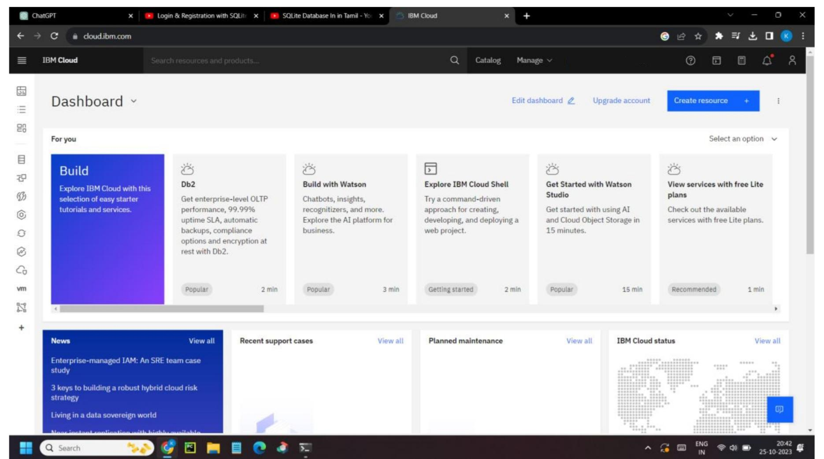

DESIGN THE PLATFORM LAYOUT

Step 1: Create a Home Page.

The Home Page is the first point of contact for visitors. It should include:

• A prominent and appealing hero image or slideshow.

• Clear navigation menus for categories and featured products.

• A search bar.

• Customer reviews or testimonials.

• Promotions, featured products, or deals.

• A call-to-action button to start shopping.

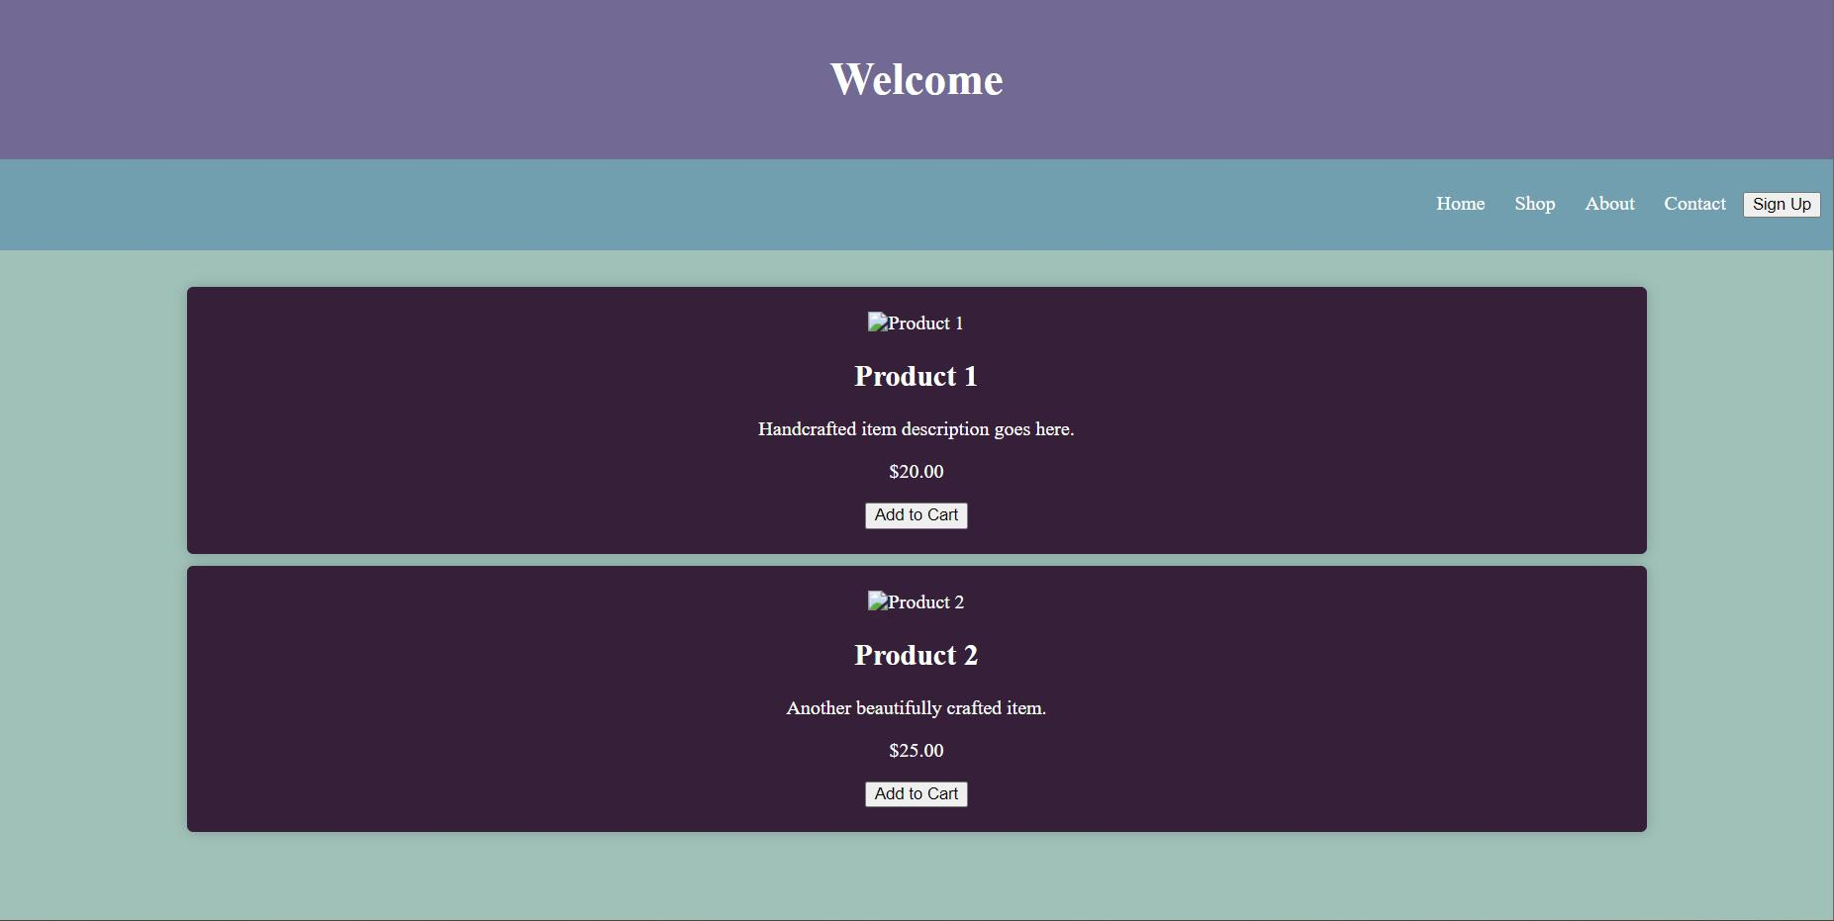

Step 2: Design Product Description Pages

Product Description Pages should provide detailed information. Include:

• High-quality product images (with zoom functionality).

• Product title, price, and a concise description.

• Product variations (e.g., size and color).

• Customer reviews and ratings.

• Include an “Add to Cart” or “Buy Now” button on each product

Listing.

• Shipping and return information.

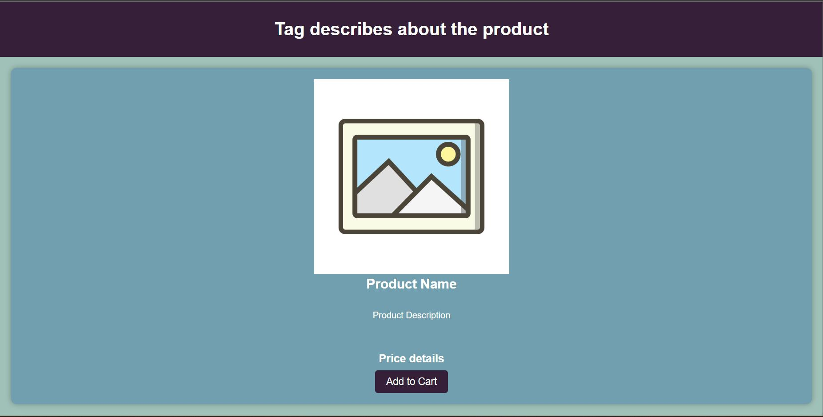

**Step 3 : USER LOGIN PAGE**

A login/sign-up page for a website typically consists of several key components that provide users with the means to authenticate and create accounts.

Sign-Up Form:

• Full Name: A field for users to enter their full name.

• Email: A field for users to enter their email address.

• Password: A field for users to create and confirm their password.

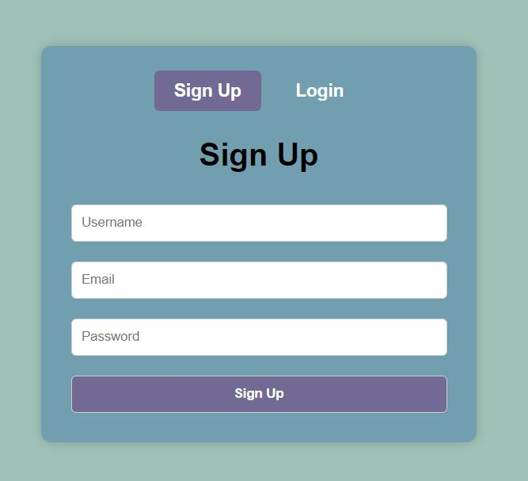

CREATE A DATABASE TO STORE PRODUCT

INFORMATION

Certainly! If you want to create a SQLite database and execute these commands from the command line, follow these steps:

1. Open a command prompt or terminal window.
2. Launch SQLite by typing:

```

Sqlite3 your_database_name.db

```

Replace `your_database_name.db` with the desired name for your SQLite database file.

1. Once inside the SQLite shell, you can enter the SQL commands one by one:

```sql

**CREATE TABLE USING DATABASE**

CREATE TABLE product (

product_id INTEGER PRIMARY KEY AUTOINCREMENT,

product_name TEXT NOT NULL,

product_price REAL,

product_description TEXT,

stock INTEGER,

image_url TEXT

);

INSERT INTO product (product_name,product_price, product_description,stock, image_url)

VALUES

('Hand-Painted Ceramic Mug',150,'A beautifully hand-painted ceramic mugwith intricate designs and vibrant colors.', 40, 'mug_image.jpg'),

('Handwoven Bohemian Throw Blanket',750,'A cozy, handwoven throw blanket featuring a bohemian-inspired design, made from soft, natural materials.',10,'blanket_image.url'),

('Wooden Hand-Carved Jewelry Box',450, 'This elegant jewelry box is meticulously hand-carved from wood and features multiple compartments for storing your treasures.', 30, 'jewelry_box_image.jpg'),

('Handcrafted Leather Wallet',250, 'A high-quality leather wallet handcrafted with precision, featuring card slots, a bill compartment, and a coin pocket.', 80,'wallet_image.jpg'),

('Wooden Hand-Carved Jewelry Box',500, 'This elegant jewelry box is meticulously hand-carved from wood and features multiple compartmentsfor storing your treasures.', 30, 'jewelry_box_image.jpg');

