INTERNET PROGRAMMING LAB | EXPERIMENT 05
Online Flight Reservation System
AIM
To develop a responsive flight reservation webpage that searches sample flights, allows flight selection, captures passenger details, and demonstrates booking status, ticket printing, cancellation, feedback, and an admin report.
TOOLS REQUIRED
HTML5, CSS3, JavaScript, Notepad, and a web browser.
CODE
<!DOCTYPE html>
<html lang="en">
<head>
<meta charset="UTF-8">
<meta name="viewport" content="width=device-width, initial-scale=1.0">
<title>SkyBook - Flight Reservation</title>
<style>
* { box-sizing: border-box; }
body { margin: 0; font-family: Arial, sans-serif; background: #f2f6fc; color: #23334d; }
header { padding: 28px 18px; text-align: center; color: white; background: linear-gradient(120deg,#123b70,#2676b8); }
nav { padding: 12px; text-align: center; background: #0d2b50; }
nav a { color: white; text-decoration: none; margin: 0 10px; }
main { max-width: 950px; margin: 24px auto; padding: 0 16px; }
.panel, .flight, .ticket { background: white; padding: 18px; border-radius: 12px; margin-bottom: 16px; box-shadow: 0 4px 14px #dce5f1; }
.fields { display: grid; grid-template-columns: repeat(auto-fit,minmax(160px,1fr)); gap: 12px; }
label { display: block; font-weight: bold; margin: 8px 0 5px; }
input, select, textarea { width: 100%; padding: 11px; border: 1px solid #c5d1e0; border-radius: 7px; }
button { border: 0; padding: 11px 15px; background: #2676b8; color: white; border-radius: 7px; cursor: pointer; margin-top: 10px; }
button:hover { background: #174f87; }
.flight { display: flex; justify-content: space-between; align-items: center; gap: 12px; flex-wrap: wrap; }
.flight h3 { margin: 0 0 8px; color: #174f87; }
.muted { color: #65758a; font-size: 14px; }
#message { font-weight: bold; color: #13764a; }
footer { text-align: center; padding: 18px; color: #65758a; }
</style>
</head>
<body>
<header><h1>SkyBook</h1><p>Search, book, and manage your flights</p></header>
<nav><a href="#search">Search Flights</a><a href="#myticket">My Ticket</a><a href="#feedback">Feedback</a><a href="#admin">Admin Report</a></nav>
<main>
<section class="panel" id="search">
<h2>Search Flights</h2>
<div class="fields">
<div><label for="from">From</label><input id="from" placeholder="Chennai"></div>
<div><label for="to">Destination</label><input id="to" placeholder="Delhi"></div>
<div><label for="date">Travel date</label><input id="date" type="date"></div>
<div><label for="classType">Class</label><select id="classType"><option>Economy</option><option>Business</option><option>First Class</option></select></div>
</div>
<button onclick="searchFlights()">Search Flights</button>
<p class="muted">Demo inventory only. Availability is not connected to airline systems.</p>
</section>
<h2>Available Sample Flights</h2>
<section id="flightList">
<article class="flight" data-from="chennai" data-to="delhi">
<div><h3>SkyAir SA 101</h3><p>Chennai → Delhi | 08:30 AM</p><p>Seats shown: 18</p></div>
<div><strong>₹5,200</strong><br><button onclick="bookFlight('SkyAir SA 101')">Select Flight</button></div>
</article>
<article class="flight" data-from="chennai" data-to="mumbai">
<div><h3>BlueWings BW 220</h3><p>Chennai → Mumbai | 11:15 AM</p><p>Seats shown: 12</p></div>
<div><strong>₹4,100</strong><br><button onclick="bookFlight('BlueWings BW 220')">Select Flight</button></div>
</article>
<article class="flight" data-from="hyderabad" data-to="bengaluru">
<div><h3>CloudJet CJ 315</h3><p>Hyderabad → Bengaluru | 06:45 PM</p><p>Seats shown: 9</p></div>
<div><strong>₹2,800</strong><br><button onclick="bookFlight('CloudJet CJ 315')">Select Flight</button></div>
</article>
</section>
<section class="panel">
<h2>Passenger and Payment Details</h2>
<div class="fields">
<div><label for="passenger">Passenger name</label><input id="passenger" placeholder="Full name"></div>
<div><label for="email">Email</label><input id="email" type="email" placeholder="name@example.com"></div>
<div><label for="seat">Seat</label><select id="seat"><option>12A</option><option>12B</option><option>14C</option><option>18D</option></select></div>
</div>
<label for="payment">Payment method (demo)</label>
<select id="payment"><option>UPI (demo)</option><option>Credit/Debit Card (demo)</option><option>Net Banking (demo)</option></select>
<button onclick="confirmBooking()">Confirm Demo Booking</button>
<p class="muted">Do not enter real payment details. This page does not process payments.</p>
<p id="message"></p>
</section>
<section class="panel" id="myticket">
<h2>My Ticket / Booking Status</h2>
<input id="ticketSearch" placeholder="Enter demo booking reference">
<button onclick="viewTicket()">View Booking</button>
<button onclick="cancelTicket()">Cancel Demo Ticket</button>
<button onclick="printTicket()">Print Ticket</button>
<div id="ticketDetails" class="ticket">No demo ticket created yet.</div>
</section>
<section class="panel" id="feedback">
<h2>Customer Feedback</h2>
<textarea id="feedbackText" placeholder="Write your feedback"></textarea>
<button onclick="sendFeedback()">Submit Feedback</button>
<p id="feedbackResult"></p>
</section>
<section class="panel" id="admin">
<h2>Admin Report (Demo)</h2>
<p id="report">Demo bookings this session: 0</p>
<button onclick="showReport()">Refresh Report</button>
</section>
</main>
<footer>SkyBook | IP Lab Experiment 5</footer>
<script>
let selectedFlight = "";
let booking = null;
function searchFlights() {
const from = document.getElementById("from").value.trim().toLowerCase();
const to = document.getElementById("to").value.trim().toLowerCase();
if (!from || !to) { document.getElementById("message").textContent = "Enter source and destination."; return; }
let count = 0;
document.querySelectorAll(".flight").forEach(f => {
const match = f.dataset.from === from && f.dataset.to === to;
f.style.display = match ? "flex" : "none";
if (match) count++;
});
document.getElementById("message").textContent = count ? count + " sample flight(s) found." : "No sample flights found for this route.";
}
function bookFlight(name) {
selectedFlight = name;
document.getElementById("message").textContent = name + " selected. Enter passenger details below.";
document.getElementById("passenger").focus();
}
function confirmBooking() {
const passenger = document.getElementById("passenger").value.trim();
const email = document.getElementById("email").value.trim();
if (!selectedFlight) { document.getElementById("message").textContent = "Please select a flight first."; return; }
if (!passenger || !email) { document.getElementById("message").textContent = "Enter passenger name and email."; return; }
booking = { ref: "SB" + Math.floor(100000 + Math.random() * 900000), passenger, email,
flight: selectedFlight, seat: document.getElementById("seat").value, status: "Confirmed (demo)" };
document.getElementById("ticketSearch").value = booking.ref;
document.getElementById("message").textContent = "Demo booking created. No payment was processed and no email was sent.";
viewTicket(); showReport();
}
function viewTicket() {
const ref = document.getElementById("ticketSearch").value.trim();
const box = document.getElementById("ticketDetails");
if (!booking || ref !== booking.ref) { box.textContent = "Booking reference not found in this session."; return; }
box.innerHTML = "<h3>SkyBook E-Ticket (Demo)</h3><p>Reference: " + booking.ref +
"</p><p>Passenger: " + booking.passenger + "</p><p>Email: " + booking.email +
"</p><p>Flight: " + booking.flight + "</p><p>Seat: " + booking.seat +
"</p><p>Status: " + booking.status + "</p>";
}
function cancelTicket() {
if (!booking || document.getElementById("ticketSearch").value.trim() !== booking.ref) {
document.getElementById("message").textContent = "Enter a valid demo booking reference."; return;
}
booking.status = "Cancelled (demo)";
viewTicket(); showReport();
document.getElementById("message").textContent = "Demo ticket cancelled. No real reservation or refund was made.";
}
function printTicket() { window.print(); }
function sendFeedback() {
const text = document.getElementById("feedbackText").value.trim();
document.getElementById("feedbackResult").textContent = text ? "Thank you. Feedback recorded for this demo session." : "Please enter feedback.";
}
function showReport() {
document.getElementById("report").textContent = "Demo bookings this session: " + (booking ? 1 : 0) +
(booking ? " | Latest status: " + booking.status : "");
}
</script>
</body>
</html>

WEBSITE SCREENSHOT
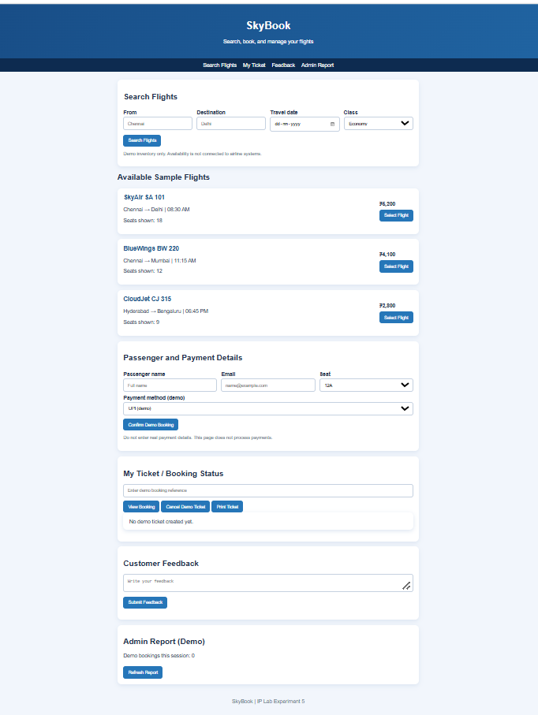
RESULT
Thus, the Online Flight Reservation webpage was created successfully, and sample flight search, demo booking, ticket status, cancellation, printing, feedback, and report features were tested.

