IP LAB | EXPERIMENT 02
Hotel Room Booking System

AIM
To create a hotel room booking webpage that displays room options and checks booking dates before showing a confirmation message.
TOOLS REQUIRED
HTML5, CSS3, JavaScript, Notepad, and a web browser.
CODE
<!DOCTYPE html>
<html lang="en">
<head>
<meta charset="UTF-8">
<meta name="viewport" content="width=device-width, initial-scale=1.0">
<title>BlueSky Hotel</title>
<style>
body { margin: 0; font-family: Arial, sans-serif; background: #f3f8fc; color: #23354d; }
header { background: linear-gradient(120deg,#146c94,#19a7ce); color: white; text-align: center; padding: 28px; }
main { max-width: 900px; margin: 25px auto; padding: 18px; }
.rooms { display: grid; grid-template-columns: repeat(auto-fit,minmax(190px,1fr)); gap: 15px; }
.room, form { background: white; padding: 18px; border-radius: 12px; box-shadow: 0 4px 14px #dbe7ef; }
.room h3 { color: #146c94; }
form { margin-top: 22px; display: grid; gap: 12px; }
label { font-weight: bold; }
input, select { width: 100%; box-sizing: border-box; padding: 10px; border: 1px solid #bdcbd7; border-radius: 7px; }
button { background: #146c94; color: white; padding: 12px; border: 0; border-radius: 7px; cursor: pointer; }
#result { font-weight: bold; color: #146c45; }
footer { text-align: center; padding: 16px; color: #66788a; }
</style>
</head>
<body>
<header>
<h1>BlueSky Hotel</h1>
<p>Comfortable stays, simple booking</p>
</header>
<main>
<h2>Available Room Types</h2>
<section class="rooms">
<div class="room"><h3>Standard</h3><p>One comfortable room</p><strong>₹1,500 / night</strong></div>
<div class="room"><h3>Deluxe</h3><p>Extra space and comfort</p><strong>₹2,500 / night</strong></div>
<div class="room"><h3>Suite</h3><p>Premium room experience</p><strong>₹4,000 / night</strong></div>
<div class="room"><h3>Family</h3><p>Suitable for families</p><strong>₹3,200 / night</strong></div>
</section>
<h2>Book a Room</h2>
<form id="bookingForm">
<label for="guest">Guest name</label>
<input id="guest" required placeholder="Enter your name">
<label for="roomType">Room type</label>
<select id="roomType"><option>Standard</option><option>Deluxe</option><option>Suite</option><option>Family</option></select>
<label for="checkin">Check-in date</label>
<input id="checkin" type="date" required>
<label for="checkout">Check-out date</label>
<input id="checkout" type="date" required>
<button type="submit">Confirm Booking</button>
<p id="result"></p>
</form>
</main>
<footer>BlueSky Hotel | IP Lab Experiment 2</footer>
<script>
document.getElementById("bookingForm").addEventListener("submit", function(event) {
event.preventDefault();
const guest = document.getElementById("guest").value.trim();
const checkin = document.getElementById("checkin").value;
const checkout = document.getElementById("checkout").value;
if (checkout <= checkin) {
document.getElementById("result").style.color = "#c0392b";
document.getElementById("result").textContent = "Check-out must be after check-in.";
return;
}
document.getElementById("result").style.color = "#146c45";
document.getElementById("result").textContent =
"Demo booking confirmed for " + guest + " (" +
document.getElementById("roomType").value + ").";
});
</script>
</body>
</html>

WEBSITE SCREENSHOT
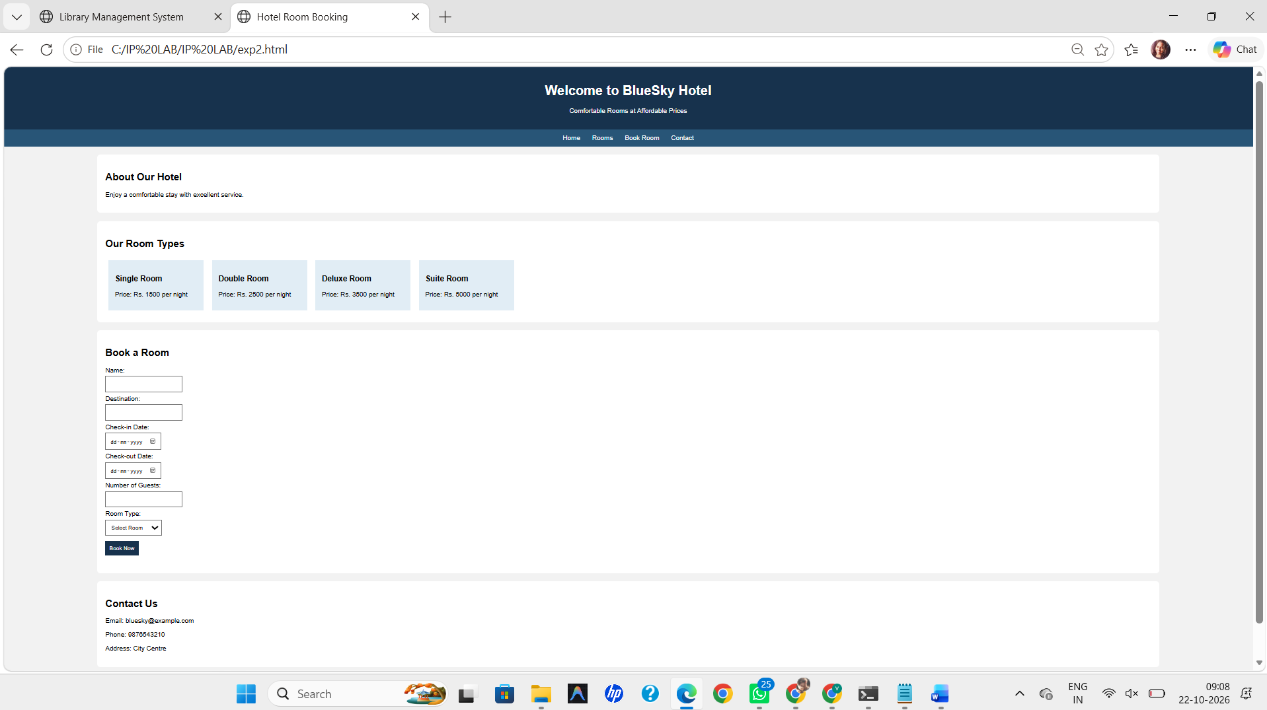RESULT
Thus, the Hotel Room Booking webpage was created successfully, and the booking form validated the check-in and check-out dates.

