IP LAB | EXPERIMENT 03
Online Bus Ticket Booking System

AIM
To develop a basic bus ticket booking webpage that searches sample buses by route and date and displays a demo booking confirmation.
TOOLS REQUIRED
HTML5, CSS3, JavaScript, Notepad, and a web browser.
CODE
<!DOCTYPE html>
<html lang="en">
<head>
<meta charset="UTF-8">
<meta name="viewport" content="width=device-width, initial-scale=1.0">
<title>EasyBus</title>
<style>
body { margin: 0; font-family: Arial, sans-serif; background: #f4f7fb; color: #26354b; }
header { background: #173f5f; color: white; text-align: center; padding: 26px; }
main { max-width: 900px; margin: 25px auto; padding: 18px; }
.search, .bus { background: white; padding: 18px; border-radius: 12px; margin-bottom: 15px; box-shadow: 0 4px 12px #dfe6ef; }
.search { display: grid; grid-template-columns: repeat(auto-fit,minmax(150px,1fr)); gap: 12px; }
input { padding: 11px; border: 1px solid #c3cfdd; border-radius: 7px; width: 100%; box-sizing: border-box; }
button { padding: 11px 16px; border: 0; border-radius: 7px; background: #ed553b; color: white; cursor: pointer; }
.bus { display: flex; justify-content: space-between; align-items: center; gap: 12px; flex-wrap: wrap; }
.bus h3 { margin: 0 0 8px; color: #173f5f; }
#message { font-weight: bold; color: #157347; }
footer { text-align: center; padding: 16px; color: #66788a; }
</style>
</head>
<body>
<header><h1>EasyBus</h1><p>Book your journey in a few simple steps</p></header>
<main>
<h2>Find a Bus</h2>
<section class="search">
<input id="from" placeholder="From city" required>
<input id="to" placeholder="To city" required>
<input id="travelDate" type="date" required>
<button onclick="searchBuses()">Search Buses</button>
</section>
<h2>Sample Buses</h2>
<section id="busList">
<article class="bus" data-from="chennai" data-to="bengaluru">
<div><h3>City Express</h3><p>Chennai → Bengaluru | 08:00 AM</p><p>Seats available: 18</p></div>
<div><strong>₹650</strong><br><button onclick="bookBus('City Express')">Book</button></div>
</article>
<article class="bus" data-from="hyderabad" data-to="vijayawada">
<div><h3>Green Travels</h3><p>Hyderabad → Vijayawada | 09:30 PM</p><p>Seats available: 12</p></div>
<div><strong>₹500</strong><br><button onclick="bookBus('Green Travels')">Book</button></div>
</article>
<article class="bus" data-from="chennai" data-to="hyderabad">
<div><h3>Night Rider</h3><p>Chennai → Hyderabad | 10:00 PM</p><p>Seats available: 9</p></div>
<div><strong>₹900</strong><br><button onclick="bookBus('Night Rider')">Book</button></div>
</article>
</section>
<p id="message"></p>
<h2>Comments</h2>
<input id="comment" placeholder="Write a short comment">
<button onclick="addComment()">Submit Comment</button>
<p id="commentResult"></p>
</main>
<footer>EasyBus | IP Lab Experiment 3</footer>
<script>
function searchBuses() {
const from = document.getElementById("from").value.trim().toLowerCase();
const to = document.getElementById("to").value.trim().toLowerCase();
if (!from || !to) {
document.getElementById("message").textContent = "Enter both source and destination.";
return;
}
let count = 0;
document.querySelectorAll(".bus").forEach(bus => {
const match = bus.dataset.from === from && bus.dataset.to === to;
bus.style.display = match ? "flex" : "none";
if (match) count++;
});
document.getElementById("message").textContent =
count ? count + " bus(es) found. Select Book to continue." : "No sample buses found for this route.";
}
function bookBus(name) {
document.getElementById("message").textContent =
"Demo booking request created for " + name + ". No payment was processed.";
}
function addComment() {
const comment = document.getElementById("comment").value.trim();
document.getElementById("commentResult").textContent =
comment ? "Comment added for this demo session: " + comment : "Please enter a comment.";
}
</script>
</body>
</html>

WEBSITE SCREENSHOT
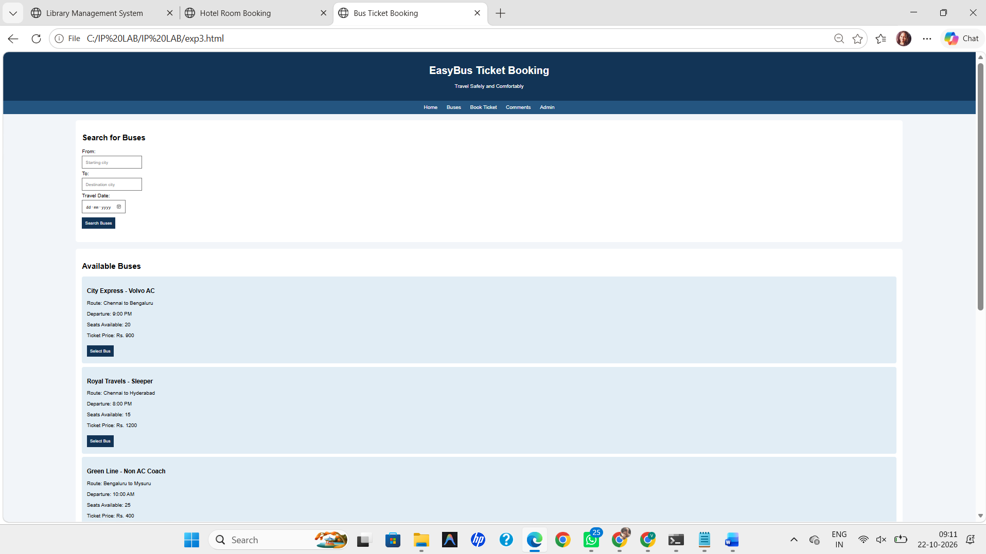
RESULT
Thus, the Online Bus Ticket Booking webpage was created successfully, and route search and demo booking confirmation were tested.

