EXPERIMENT 7
ONLINE BEAUTY PARLOUR APPOINTMENT BOOKING SYSTEM

1. Aim
To design and develop a responsive website for booking beauty parlour appointments, managing reservations, and providing customer and staff facilities.

2. Tools Required
HTML, CSS, JavaScript, Web Browser, Notepad

3. Code
Save the following code as beauty_bliss.html and open it in a web browser.
<!DOCTYPE html>
<html lang="en">
<head>
<meta charset="UTF-8">
<meta name="viewport" content="width=device-width, initial-scale=1.0">
<title>Beauty Bliss - Appointment Booking</title>
<style>
*{box-sizing:border-box} body{margin:0;font-family:Arial,sans-serif;background:#fff5f8;color:#333}
header{background:#8e3565;color:white;text-align:center;padding:25px} header h1{margin:0}
nav{background:#632448;padding:13px;text-align:center} nav a{color:white;text-decoration:none;margin:12px;font-weight:bold}
.container{max-width:1000px;margin:25px auto;padding:15px}
.card{background:white;padding:22px;margin-bottom:22px;border-radius:12px;box-shadow:0 3px 12px #ddd}
h2{color:#8e3565}
input,select,textarea,button{width:100%;padding:11px;margin:7px 0;border:1px solid #ccc;border-radius:6px}
button{background:#8e3565;color:white;border:0;cursor:pointer;font-weight:bold} button:hover{background:#632448}
.grid{display:grid;grid-template-columns:repeat(auto-fit,minmax(220px,1fr));gap:15px}
.service{background:#fff0f6;padding:15px;border-radius:9px;text-align:center}
table{width:100%;border-collapse:collapse} th,td{padding:10px;border:1px solid #ddd;text-align:left}
th{background:#8e3565;color:white} footer{text-align:center;background:#632448;color:white;padding:18px}
.small{font-size:13px;color:#666}
</style>
</head>
<body>
<header><h1>Beauty Bliss Parlour</h1><p>Your Beauty, Our Passion</p></header>
<nav><a href="#services">Services</a><a href="#booking">Book Appointment</a><a href="#customer">My Appointments</a><a href="#staff">Staff Panel</a></nav>
<div class="container">
<section class="card" id="services"><h2>Our Beauty Services</h2><div class="grid">
<div class="service"><h3>Hair Styling</h3><p>₹500 onwards</p></div><div class="service"><h3>Facial</h3><p>₹800 onwards</p></div>
<div class="service"><h3>Makeup</h3><p>₹1500 onwards</p></div><div class="service"><h3>Manicure</h3><p>₹400 onwards</p></div>
</div></section>
<section class="card" id="booking"><h2>Book an Appointment</h2><form id="bookingForm">
<label>Customer Name</label><input id="name" required placeholder="Enter your name">
<label>Email Address</label><input id="email" type="email" required placeholder="Enter your email">
<label>Phone Number</label><input id="phone" required placeholder="Enter your phone number">
<label>Select Service</label><select id="service" required><option value="">Choose a service</option><option>Hair Styling</option><option>Facial</option><option>Makeup</option><option>Manicure</option></select>
<label>Appointment Date</label><input id="date" type="date" required>
<label>Appointment Time</label><select id="time" required><option value="">Choose a time</option><option>10:00 AM</option><option>11:00 AM</option><option>12:00 PM</option><option>02:00 PM</option><option>03:00 PM</option><option>04:00 PM</option></select>
<label>Payment Option</label><select id="payment"><option>Pay at Parlour</option><option>Full Payment (Demo)</option><option>Deposit Payment (Demo)</option></select>
<button type="submit">Book Appointment</button></form><p class="small">Demo only: online payment is not processed.</p><p id="message"></p></section>
<section class="card" id="customer"><h2>My Appointments</h2><p>Enter your email to view or cancel your appointments.</p>
<input id="searchEmail" type="email" placeholder="Your email address"><button onclick="showCustomer()">View Appointments</button><div id="customerAppointments"></div></section>
<section class="card" id="feedback"><h2>Customer Feedback</h2><form id="feedbackForm"><input id="feedbackName" required placeholder="Your name">
<select id="rating"><option>5 - Excellent</option><option>4 - Very Good</option><option>3 - Good</option><option>2 - Fair</option><option>1 - Poor</option></select>
<textarea id="comments" required placeholder="Write your feedback"></textarea><button>Submit Feedback</button></form><p id="feedbackMessage"></p></section>
<section class="card" id="staff"><h2>Staff / Manager Panel</h2><p>View all appointments booked in this browser.</p><button onclick="showStaff()">Refresh Reservations</button><div id="staffAppointments"></div></section>
</div><footer><p>Beauty Bliss Parlour | Appointment Booking System</p></footer>
<script>
let appointments = [];
const dateInput = document.getElementById("date");
dateInput.min = new Date().toISOString().split("T")[0];
document.getElementById("bookingForm").addEventListener("submit", function(e){
e.preventDefault(); const date=dateInput.value; const time=document.getElementById("time").value;
const email=document.getElementById("email").value.trim().toLowerCase();
if(date < new Date().toISOString().split("T")[0]){alert("Please select a future date.");return;}
if(appointments.some(a=>a.date===date&&a.time===time)){alert("This time slot is already booked. Please select another time.");return;}
const appointment={id:Date.now(),name:document.getElementById("name").value,email,phone:document.getElementById("phone").value,
service:document.getElementById("service").value,date,time,payment:document.getElementById("payment").value,status:"Confirmed"};
appointments.push(appointment);
document.getElementById("message").textContent="Appointment booked successfully! Your booking ID is "+appointment.id+".";
this.reset(); dateInput.min=new Date().toISOString().split("T")[0];
});
function showCustomer(){
const email=document.getElementById("searchEmail").value.trim().toLowerCase();
const list=appointments.filter(a=>a.email===email); const output=document.getElementById("customerAppointments");
if(!list.length){output.innerHTML="<p>No appointments found for this email.</p>";return;}
output.innerHTML=list.map(a=>`<div class="service"><h3>${a.service}</h3><p>${a.date} at ${a.time}</p><p>Status: ${a.status}</p>
${a.status==="Confirmed"?`<button onclick="cancelAppointment(${a.id})">Cancel Appointment</button>`:""}</div>`).join("");
}
function cancelAppointment(id){const item=appointments.find(a=>a.id===id);if(item){item.status="Cancelled";showCustomer();}}
function showStaff(){
const output=document.getElementById("staffAppointments");
if(!appointments.length){output.innerHTML="<p>No reservations have been made yet.</p>";return;}
output.innerHTML=`<table><tr><th>Customer</th><th>Service</th><th>Date</th><th>Time</th><th>Contact</th><th>Status</th></tr>`+
appointments.map(a=>`<tr><td>${a.name}</td><td>${a.service}</td><td>${a.date}</td><td>${a.time}</td><td>${a.phone}</td><td>${a.status}</td></tr>`).join("")+"</table>";
}
document.getElementById("feedbackForm").addEventListener("submit",function(e){e.preventDefault();
document.getElementById("feedbackMessage").textContent="Thank you, "+document.getElementById("feedbackName").value+"! Your feedback has been submitted for this demo.";this.reset();});
</script>
</body>
</html>

4. Website Output
Screenshot of the Website:

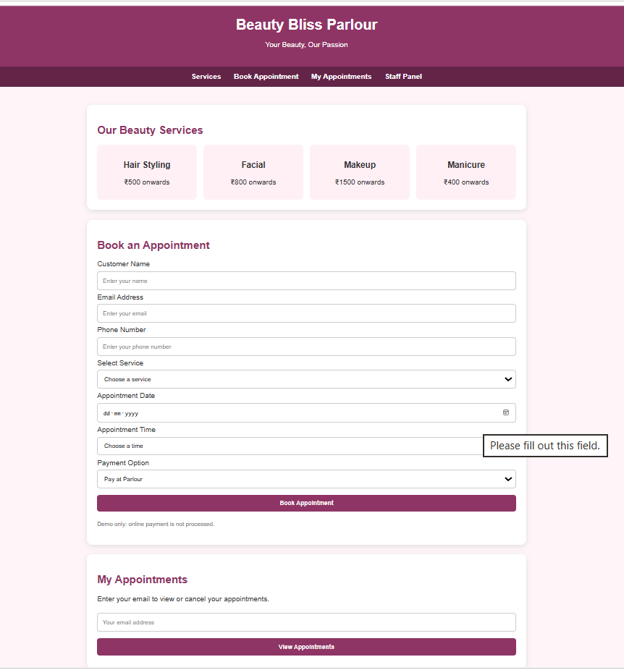5. Result
Thus, the Online Beauty Parlour Appointment Booking System website was designed and developed successfully. It provides appointment booking, reservation management, customer details, feedback, and payment-related demonstration features.

