IP LAB | EXPERIMENT 04
Online Train Reservation System

AIM
To create a simple train reservation webpage that searches sample trains, generates a demo PNR, checks PNR status, and demonstrates ticket cancellation.
TOOLS REQUIRED
HTML5, CSS3, JavaScript, Notepad, and a web browser.
CODE
<!DOCTYPE html>
<html lang="en">
<head>
<meta charset="UTF-8">
<meta name="viewport" content="width=device-width, initial-scale=1.0">
<title>RailConnect</title>
<style>
body { margin: 0; font-family: Arial, sans-serif; background: #f3f6fb; color: #26344b; }
header { background: linear-gradient(120deg,#513783,#2874a6); color: white; padding: 26px; text-align: center; }
main { max-width: 900px; margin: 25px auto; padding: 18px; }
.panel, .train { background: white; padding: 18px; border-radius: 12px; margin-bottom: 16px; box-shadow: 0 4px 12px #dce4ef; }
.fields { display: grid; grid-template-columns: repeat(auto-fit,minmax(160px,1fr)); gap: 12px; }
input, select { width: 100%; box-sizing: border-box; padding: 11px; border: 1px solid #c5cedb; border-radius: 7px; margin-top: 5px; }
label { font-weight: bold; }
button { padding: 11px 16px; border: 0; border-radius: 7px; background: #513783; color: white; cursor: pointer; margin-top: 10px; }
.train { display: flex; justify-content: space-between; align-items: center; flex-wrap: wrap; gap: 12px; }
.train h3 { margin: 0 0 7px; color: #513783; }
#result { font-weight: bold; color: #157347; }
footer { text-align: center; padding: 16px; color: #66788a; }
</style>
</head>
<body>
<header><h1>RailConnect</h1><p>Simple online train reservation demo</p></header>
<main>
<section class="panel">
<h2>Search Trains</h2>
<div class="fields">
<div><label for="source">From</label><input id="source" placeholder="Chennai"></div>
<div><label for="destination">To</label><input id="destination" placeholder="Bengaluru"></div>
<div><label for="journeyDate">Journey date</label><input id="journeyDate" type="date"></div>
</div>
<button onclick="searchTrains()">Search Trains</button>
</section>
<h2>Sample Trains</h2>
<section id="trains">
<article class="train" data-from="chennai" data-to="bengaluru">
<div><h3>12608 - Lalbagh Express</h3><p>Chennai → Bengaluru | Sleeper / AC</p><p>Seats shown: 24</p></div>
<button onclick="bookTicket('12608 - Lalbagh Express')">Book Ticket</button>
</article>
<article class="train" data-from="hyderabad" data-to="vijayawada">
<div><h3>12714 - Satavahana Express</h3><p>Hyderabad → Vijayawada | Sleeper / AC</p><p>Seats shown: 16</p></div>
<button onclick="bookTicket('12714 - Satavahana Express')">Book Ticket</button>
</article>
<article class="train" data-from="chennai" data-to="hyderabad">
<div><h3>12603 - Charminar Express</h3><p>Chennai → Hyderabad | Sleeper / AC</p><p>Seats shown: 10</p></div>
<button onclick="bookTicket('12603 - Charminar Express')">Book Ticket</button>
</article>
</section>
<section class="panel">
<h2>PNR Status / Cancellation</h2>
<div class="fields">
<input id="pnrInput" placeholder="Enter demo PNR">
<button onclick="checkPNR()">Check Status</button>
<button onclick="cancelTicket()">Cancel Demo Ticket</button>
</div>
<p id="result">No demo ticket booked yet.</p>
</section>
</main>
<footer>RailConnect | IP Lab Experiment 4</footer>
<script>
let currentPNR = "";
let ticketStatus = "Not booked";
function searchTrains() {
const from = document.getElementById("source").value.trim().toLowerCase();
const to = document.getElementById("destination").value.trim().toLowerCase();
if (!from || !to) {
document.getElementById("result").textContent = "Enter source and destination to search.";
return;
}
let count = 0;
document.querySelectorAll(".train").forEach(train => {
const match = train.dataset.from === from && train.dataset.to === to;
train.style.display = match ? "flex" : "none";
if (match) count++;
});
document.getElementById("result").textContent =
count ? count + " sample train(s) found." : "No sample trains found for this route.";
}
function bookTicket(trainName) {
currentPNR = String(Math.floor(1000000000 + Math.random() * 9000000000));
ticketStatus = "Confirmed (demo)";
document.getElementById("pnrInput").value = currentPNR;
document.getElementById("result").textContent =
"Demo ticket booked on " + trainName + ". PNR: " + currentPNR;
}
function checkPNR() {
const entered = document.getElementById("pnrInput").value.trim();
document.getElementById("result").textContent =
entered && entered === currentPNR ? "PNR " + currentPNR + ": " + ticketStatus :
"PNR not found in this demo session.";
}
function cancelTicket() {
const entered = document.getElementById("pnrInput").value.trim();
if (entered && entered === currentPNR && ticketStatus !== "Cancelled") {
ticketStatus = "Cancelled (demo)";
document.getElementById("result").textContent =
"Demo ticket cancelled. No real booking or refund was processed.";
} else {
document.getElementById("result").textContent = "Book a demo ticket and enter its PNR first.";
}
}
</script>
</body>
</html>

WEBSITE SCREENSHOT
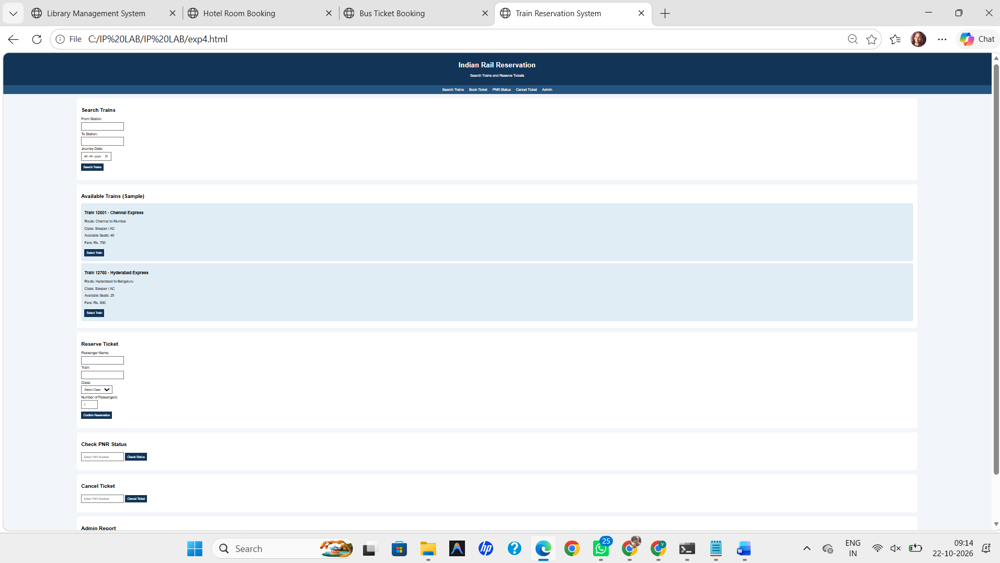
RESULT
Thus, the Online Train Reservation webpage was created successfully, and sample train search, PNR status, and cancellation features were tested.

