EXPERIMENT 10
STYLEHUB ONLINE FASHION SHOPPING SYSTEM

1. Aim
To design and develop an online fashion shopping system that enables customers to browse clothing, footwear, and accessories by category, search for products, select sizes, manage a cart and wishlist, and view demo orders. The administrator can manage product details and review customer checkout information.

2. Tools Required
HTML, CSS, JavaScript, Web Browser, Notepad

3. Code
Save the following source code as stylehub.html and open it in a web browser.
<!DOCTYPE html>
<html lang="en">
<head>
<meta charset="UTF-8">
<meta name="viewport" content="width=device-width, initial-scale=1.0">
<title>StyleHub Fashion Store</title>
<style>
*{box-sizing:border-box}
body{margin:0;font-family:Arial,sans-serif;background:#fff8f4;color:#342d2b}
header{background:#7b2945;color:white;text-align:center;padding:24px}
nav{background:#4e1b2d;padding:13px;text-align:center}
nav a{color:white;text-decoration:none;margin:10px;font-weight:bold}
.container{max-width:1100px;margin:22px auto;padding:15px}
section{background:white;padding:20px;margin-bottom:20px;border-radius:9px;box-shadow:0 2px 8px #eadde0}
h2{color:#7b2945}
.grid{display:grid;grid-template-columns:repeat(auto-fit,minmax(210px,1fr));gap:14px}
.product{border:1px solid #eadde0;border-radius:8px;padding:14px;background:#fffdfc}
input,select,textarea,button{width:100%;padding:10px;margin:6px 0;border:1px solid #d8c8cd;border-radius:5px}
button{background:#9b3658;color:white;border:0;cursor:pointer;font-weight:bold}
button:hover{background:#4e1b2d}
.price{font-weight:bold;color:#9b3658}
table{width:100%;border-collapse:collapse;margin-top:10px}
th,td{border:1px solid #eadde0;padding:9px;text-align:left}
th{background:#7b2945;color:white}
footer{text-align:center;background:#4e1b2d;color:white;padding:16px}
.small{font-size:12px;color:#76666b}
</style>
</head>
<body>
<header><h1>StyleHub</h1><p>Find Your Style. Wear Your Confidence.</p></header>
<nav><a href="#categories">Categories</a><a href="#products">Shop</a><a href="#wishlist">Wishlist</a><a href="#cart">Cart</a><a href="#orders">Orders</a><a href="#admin">Admin</a></nav>
<div class="container">
<section id="categories"><h2>Shop by Category</h2><div class="grid">
<div class="product"><h3>Women</h3><p>Dresses, tops and ethnic wear</p></div><div class="product"><h3>Men</h3><p>Shirts, trousers and casual wear</p></div>
<div class="product"><h3>Kids</h3><p>Comfortable everyday outfits</p></div><div class="product"><h3>Footwear & Accessories</h3><p>Shoes, bags and accessories</p></div>
<div class="product"><h3>Formal Wear</h3><p>Office and special occasion outfits</p></div><div class="product"><h3>Seasonal Collection</h3><p>Fresh looks for the season</p></div>
</div></section>
<section><h2>Customer Login / Registration</h2><form id="loginForm">
<input id="customerName" required placeholder="Full name"><input id="customerEmail" type="email" required placeholder="Email address"><button type="submit">Sign In / Register</button></form><p id="loginMessage" class="small"></p></section>
<section id="products"><h2>Fashion Catalogue</h2><input id="search" placeholder="Search clothing, footwear or accessories..." oninput="displayProducts()">
<select id="categoryFilter" onchange="displayProducts()"><option value="All">All Categories</option><option>Women</option><option>Men</option><option>Kids</option><option>Footwear & Accessories</option><option>Formal Wear</option><option>Seasonal Collection</option></select>
<div id="productList" class="grid"></div></section>
<section id="wishlist"><h2>My Wishlist</h2><div id="wishlistList"></div></section>
<section id="cart"><h2>Shopping Cart</h2><div id="cartList"></div><p id="cartTotal"></p><button onclick="checkout()">Checkout</button><p id="checkoutMessage" class="small"></p></section>
<section id="orders"><h2>Order Status and History</h2><input id="orderEmail" type="email" placeholder="Enter your registered email"><button onclick="showOrders()">View Order History</button><div id="orderList"></div></section>
<section id="admin"><h2>Administrator Panel</h2><p class="small">Demo admin tools: add products, update prices/descriptions, remove products, and view checkout customers.</p>
<form id="addProductForm"><input id="newName" required placeholder="Product name">
<select id="newCategory"><option>Women</option><option>Men</option><option>Kids</option><option>Footwear & Accessories</option><option>Formal Wear</option><option>Seasonal Collection</option></select>
<input id="newPrice" type="number" min="1" required placeholder="Price (₹)"><textarea id="newDescription" required placeholder="Product description"></textarea><button type="submit">Add Product</button></form>
<div id="adminProducts"></div><h3>Customer Checkout Details</h3><button onclick="showCustomers()">View Customers</button><div id="customerList"></div></section>
</div><footer>StyleHub | Online Fashion Store</footer>
<script>
let products=[
{id:1,name:"Floral Summer Dress",category:"Women",price:1799,description:"Lightweight floral dress for casual outings.",sizes:"S, M, L, XL",stock:10},
{id:2,name:"Classic Cotton Shirt",category:"Men",price:1299,description:"Everyday cotton shirt with a comfortable fit.",sizes:"S, M, L, XL",stock:12},
{id:3,name:"Kids Printed T-Shirt",category:"Kids",price:499,description:"Soft printed T-shirt for everyday play.",sizes:"2-3Y, 4-5Y, 6-7Y",stock:15},
{id:4,name:"Everyday Sneakers",category:"Footwear & Accessories",price:2199,description:"Versatile sneakers for daily wear.",sizes:"6, 7, 8, 9, 10",stock:7},
{id:5,name:"Formal Blazer",category:"Formal Wear",price:3499,description:"Smart blazer suitable for office and events.",sizes:"S, M, L, XL",stock:5},
{id:6,name:"Seasonal Hoodie",category:"Seasonal Collection",price:1599,description:"Warm casual hoodie for cooler weather.",sizes:"S, M, L, XL",stock:8}
];
let cart=[],wishlist=[],orders=[],customers=[],signedInCustomer=null;
function money(n){return "₹"+Number(n).toLocaleString("en-IN")}
function displayProducts(){
const q=document.getElementById("search").value.toLowerCase(),cat=document.getElementById("categoryFilter").value;
const list=products.filter(p=>(cat==="All"||p.category===cat)&&(p.name+" "+p.description+" "+p.category).toLowerCase().includes(q));
document.getElementById("productList").innerHTML=list.map(p=>`<div class="product"><h3>${p.name}</h3><p>${p.category}</p><p>${p.description}</p><p><b>Available sizes:</b> ${p.sizes||"Standard"}</p><p class="price">${money(p.price)}</p><p>Stock: ${p.stock}</p><button onclick="addToCart(${p.id})" ${p.stock===0?"disabled":""}>Add to Cart</button><button onclick="toggleWishlist(${p.id})">Add to Wishlist</button></div>`).join("")||"<p>No matching products found.</p>";
displayAdminProducts();displayWishlist();
}
document.getElementById("loginForm").addEventListener("submit",e=>{
e.preventDefault();signedInCustomer={name:document.getElementById("customerName").value.trim(),email:document.getElementById("customerEmail").value.trim().toLowerCase()};
if(!customers.some(c=>c.email===signedInCustomer.email))customers.push({...signedInCustomer});
document.getElementById("loginMessage").textContent="Signed in for this demo as "+signedInCustomer.name+".";
document.getElementById("orderEmail").value=signedInCustomer.email;
});
function addToCart(id){const p=products.find(p=>p.id===id),item=cart.find(i=>i.id===id);if(!p||p.stock<1)return alert("This item is unavailable.");if(item){if(item.qty>=p.stock)return alert("No more stock available.");item.qty++;}else cart.push({id,qty:1});displayCart();}
function displayCart(){
const out=document.getElementById("cartList");if(!cart.length){out.innerHTML="<p>Your cart is empty.</p>";document.getElementById("cartTotal").textContent="";return;}
out.innerHTML=cart.map(i=>{const p=products.find(p=>p.id===i.id);return `<div class="product"><b>${p.name}</b> — ${money(p.price)} each<p>Size: ${i.size||"Not selected"}</p><label>Size</label><select onchange="updateSize(${i.id},this.value)"><option value="">Choose size</option>${(p.sizes||"Standard").split(", ").map(s=>`<option ${i.size===s?"selected":""}>${s}</option>`).join("")}</select><label>Quantity</label><input type="number" min="1" max="${p.stock}" value="${i.qty}" onchange="updateQty(${i.id},this.value)"><button onclick="removeFromCart(${i.id})">Remove</button></div>`}).join("");
document.getElementById("cartTotal").textContent="Total: "+money(cart.reduce((s,i)=>s+products.find(p=>p.id===i.id).price*i.qty,0));
}
function updateSize(id,size){const item=cart.find(i=>i.id===id);if(item){item.size=size;displayCart();}}
function updateQty(id,value){const item=cart.find(i=>i.id===id),p=products.find(p=>p.id===id);if(!item)return;let qty=parseInt(value,10);if(!Number.isFinite(qty)||qty<1)qty=1;if(qty>p.stock){alert("Quantity adjusted to available stock.");qty=p.stock;}item.qty=qty;displayCart();}
function removeFromCart(id){cart=cart.filter(i=>i.id!==id);displayCart();}
function toggleWishlist(id){if(wishlist.includes(id))wishlist=wishlist.filter(x=>x!==id);else wishlist.push(id);displayWishlist();}
function displayWishlist(){const out=document.getElementById("wishlistList");out.innerHTML=wishlist.length?wishlist.map(id=>{const p=products.find(p=>p.id===id);return p?`<div class="product"><b>${p.name}</b> — ${money(p.price)}<button onclick="addToCart(${id})">Add to Cart</button><button onclick="toggleWishlist(${id})">Remove from Wishlist</button></div>`:""}).join(""):"<p>Your wishlist is empty.</p>";}
function checkout(){
if(!signedInCustomer)return alert("Please sign in or register before checkout.");if(!cart.length)return alert("Your cart is empty.");
if(cart.some(i=>!i.size))return alert("Please select a size for each item in your cart.");
for(const i of cart){const p=products.find(p=>p.id===i.id);if(!p||p.stock<i.qty)return alert("Stock changed. Please review your cart.");}
const total=cart.reduce((s,i)=>s+products.find(p=>p.id===i.id).price*i.qty,0);
const order={id:"SH"+Date.now(),name:signedInCustomer.name,email:signedInCustomer.email,items:cart.map(i=>{const p=products.find(p=>p.id===i.id);return {name:p.name,qty:i.qty,size:i.size,price:p.price};}),total,status:"Order Placed",date:new Date().toLocaleDateString()};
cart.forEach(i=>products.find(p=>p.id===i.id).stock-=i.qty);orders.push(order);cart=[];displayCart();displayProducts();
document.getElementById("checkoutMessage").textContent="Demo checkout successful. Order ID: "+order.id+". Payment is not processed.";
}
function showOrders(){const email=document.getElementById("orderEmail").value.trim().toLowerCase(),list=orders.filter(o=>o.email===email),out=document.getElementById("orderList");
out.innerHTML=list.length?list.map(o=>`<div class="product"><h3>${o.id}</h3><p>${o.date} | ${o.status}</p><p>${o.items.map(i=>i.name+" ("+i.size+") × "+i.qty).join(", ")}</p><p>Total: ${money(o.total)}</p></div>`).join(""):"<p>No orders found for this email.</p>";}
document.getElementById("addProductForm").addEventListener("submit",e=>{e.preventDefault();products.push({id:Date.now(),name:document.getElementById("newName").value.trim(),category:document.getElementById("newCategory").value,price:Number(document.getElementById("newPrice").value),description:document.getElementById("newDescription").value.trim(),sizes:"S, M, L, XL",stock:10});e.target.reset();displayProducts();alert("Product added to this demo catalogue.");});
function displayAdminProducts(){const out=document.getElementById("adminProducts");if(!out)return;out.innerHTML=products.map(p=>`<div class="product"><b>${p.name}</b> (${p.category})<p>Current price: ${money(p.price)}</p><input id="price-${p.id}" type="number" min="1" value="${p.price}" aria-label="New price"><textarea id="desc-${p.id}" aria-label="New description">${p.description}</textarea><button onclick="updateProduct(${p.id})">Update Price / Description</button><button onclick="deleteProduct(${p.id})">Remove Product</button></div>`).join("");}
function updateProduct(id){const p=products.find(p=>p.id===id);if(!p)return;const price=Number(document.getElementById("price-"+id).value),desc=document.getElementById("desc-"+id).value.trim();if(price<=0||!desc)return alert("Enter a valid price and description.");p.price=price;p.description=desc;displayProducts();}
function deleteProduct(id){products=products.filter(p=>p.id!==id);cart=cart.filter(i=>i.id!==id);wishlist=wishlist.filter(x=>x!==id);displayProducts();displayCart();}
function showCustomers(){const out=document.getElementById("customerList");out.innerHTML=customers.length?`<table><tr><th>Name</th><th>Email</th><th>Orders</th></tr>`+customers.map(c=>`<tr><td>${c.name}</td><td>${c.email}</td><td>${orders.filter(o=>o.email===c.email).length}</td></tr>`).join("")+"</table>":"<p>No customer records yet.</p>";}
displayProducts();displayCart();
</script>
</body>
</html>

4. Website Output
Screenshot of the Website:
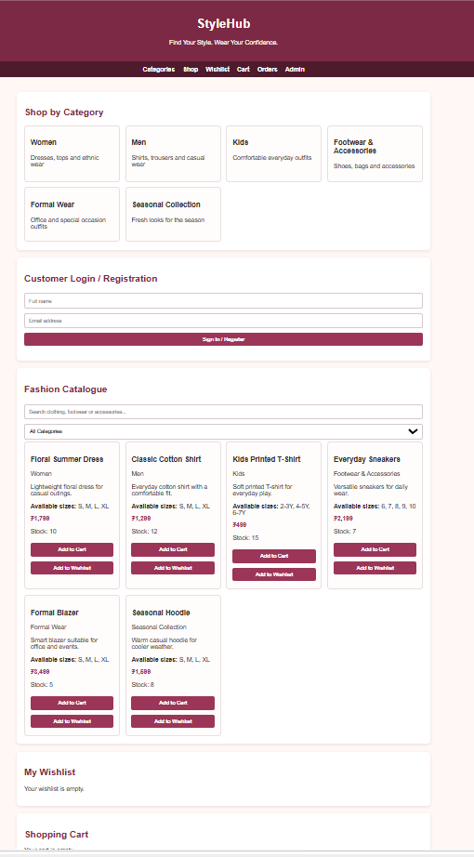

5. Result
Thus, the StyleHub Online Fashion Shopping System was designed and developed successfully. It provides categorized fashion products, product search, size selection, cart management, wishlist features, demo checkout, order history, and administrator product management.

