IP LAB | EXPERIMENT 01
Library Management System

AIM
To design a simple Library Management System webpage that displays books and allows users to search the available book list.
TOOLS REQUIRED
HTML5, CSS3, JavaScript, Notepad, and a web browser.
CODE
<!DOCTYPE html>
<html lang="en">
<head>
<meta charset="UTF-8">
<meta name="viewport" content="width=device-width, initial-scale=1.0">
<title>LibraryHub</title>
<style>
body { margin: 0; font-family: Arial, sans-serif; background: #f2f5fb; color: #24324a; }
header { background: #243b6b; color: white; padding: 24px; text-align: center; }
nav { background: #172747; padding: 12px; text-align: center; }
nav a { color: white; margin: 0 14px; text-decoration: none; }
main { max-width: 900px; margin: 28px auto; padding: 20px; }
.search { display: flex; gap: 10px; margin-bottom: 20px; }
input { flex: 1; padding: 12px; border: 1px solid #bbc6d8; border-radius: 8px; }
button { padding: 12px 18px; border: 0; border-radius: 8px; background: #3867c8; color: white; cursor: pointer; }
.books { display: grid; grid-template-columns: repeat(auto-fit,minmax(200px,1fr)); gap: 16px; }
.book { background: white; padding: 18px; border-radius: 12px; box-shadow: 0 4px 12px #dce3ef; }
.book h3 { color: #243b6b; margin-top: 0; }
footer { text-align: center; padding: 18px; color: #65728a; }
</style>
</head>
<body>
<header>
<h1>LibraryHub</h1>
<p>Discover your next favourite book</p>
</header>
<nav>
<a href="#">Home</a><a href="#books">Books</a><a href="#about">About</a>
</nav>
<main>
<h2>Search Books</h2>
<div class="search">
<input id="searchBox" type="text" placeholder="Enter a book title or author">
<button onclick="searchBooks()">Search</button>
</div>
<section class="books" id="books">
<article class="book"><h3>Wings of Fire</h3><p>Author: A. P. J. Abdul Kalam</p><p>Category: Biography</p></article>
<article class="book"><h3>Clean Code</h3><p>Author: Robert C. Martin</p><p>Category: Programming</p></article>
<article class="book"><h3>The Alchemist</h3><p>Author: Paulo Coelho</p><p>Category: Fiction</p></article>
<article class="book"><h3>Introduction to Algorithms</h3><p>Author: Cormen et al.</p><p>Category: Computer Science</p></article>
</section>
<p id="message"></p>
<section id="about"><h2>About the Library</h2><p>A simple demo page to explore the available books.</p></section>
</main>
<footer>LibraryHub | IP Lab Experiment 1</footer>
<script>
function searchBooks() {
const query = document.getElementById("searchBox").value.toLowerCase().trim();
const books = document.querySelectorAll(".book");
let found = 0;
books.forEach(book => {
const match = book.textContent.toLowerCase().includes(query);
book.style.display = match ? "block" : "none";
if (match) found++;
});
document.getElementById("message").textContent =
found ? found + " book(s) found." : "No matching books found.";
}
</script>
</body>
</html>
WEBSITE SCREENSHOT
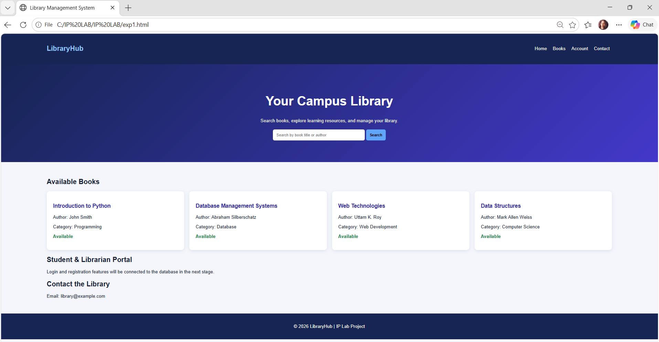
RESULT
Thus, the Library Management System webpage was created successfully, and the book search feature was tested in the browser.

