EXPERIMENT 8
MEDCARE HOSPITAL APPOINTMENT BOOKING SYSTEM

1. Aim
To design and develop a hospital appointment booking website that allows patients to search for doctors, schedule appointments, and manage their medical visit details.

2. Tools Required
HTML, CSS, JavaScript, Web Browser, Notepad

3. Code
Save the following code as medcare_hospital.html and open it in a web browser.
<!DOCTYPE html>
<html lang="en">
<head>
<meta charset="UTF-8">
<meta name="viewport" content="width=device-width, initial-scale=1.0">
<title>MedCare Hospital Appointment System</title>
<style>
*{box-sizing:border-box} body{margin:0;font-family:Arial,sans-serif;background:#f0f7fb;color:#263746}
header{background:#087e8b;color:white;padding:25px;text-align:center} header h1{margin:0}
nav{background:#075b68;padding:14px;text-align:center} nav a{color:white;text-decoration:none;margin:10px;font-weight:bold}
.container{max-width:1050px;margin:25px auto;padding:15px}
.card{background:white;padding:22px;margin-bottom:22px;border-radius:10px;box-shadow:0 3px 12px #d5e4e9}
h2{color:#087e8b}.grid{display:grid;grid-template-columns:repeat(auto-fit,minmax(220px,1fr));gap:15px}
.doctor{background:#eaf7fa;padding:15px;border-radius:9px}
input,select,textarea,button{width:100%;padding:11px;margin:7px 0;border:1px solid #cbd8dc;border-radius:5px}
button{background:#087e8b;color:white;border:0;cursor:pointer;font-weight:bold} button:hover{background:#075b68}
table{width:100%;border-collapse:collapse} th,td{padding:10px;border:1px solid #d5e0e3;text-align:left}
th{background:#087e8b;color:white} footer{background:#075b68;color:white;text-align:center;padding:18px}
.small{font-size:13px;color:#61757c}
</style>
</head>
<body>
<header><h1>MedCare Hospital</h1><p>Your Health, Our Priority</p></header>
<nav><a href="#doctors">Find Doctors</a><a href="#booking">Book Appointment</a><a href="#patient">Patient Portal</a><a href="#hospitals">Hospitals</a><a href="#admin">Admin</a></nav>
<div class="container">
<section class="card"><h2>Welcome to MedCare</h2><p>Find qualified doctors, check available specialties, and book your hospital appointments easily.</p></section>
<section class="card" id="doctors"><h2>Search Doctors</h2><input id="search" placeholder="Search by doctor name, specialty, or location" oninput="filterDoctors()"><div id="doctorList" class="grid"></div></section>
<section class="card" id="booking"><h2>Book a Hospital Appointment</h2><form id="bookingForm">
<label>Patient Name</label><input id="patientName" required placeholder="Enter patient name">
<label>Email Address</label><input id="patientEmail" type="email" required placeholder="Enter email address">
<label>Phone Number</label><input id="patientPhone" required placeholder="Enter phone number">
<label>Select Doctor</label><select id="doctorSelect" required><option value="">Choose a doctor</option></select>
<label>Appointment Date</label><input id="appointmentDate" type="date" required>
<label>Appointment Time</label><select id="appointmentTime" required><option value="">Select time</option><option>09:00 AM</option><option>10:00 AM</option><option>11:00 AM</option><option>12:00 PM</option><option>02:00 PM</option><option>03:00 PM</option><option>04:00 PM</option></select>
<label>Reason for Visit</label><textarea id="reason" required placeholder="Briefly describe the reason for your visit"></textarea>
<button type="submit">Confirm Appointment</button></form><p id="bookingMessage"></p><p class="small">This demonstration does not send real email or SMS reminders.</p></section>
<section class="card" id="patient"><h2>Patient Portal</h2><p>Enter your registered email to view your appointment history.</p><input id="portalEmail" type="email" placeholder="Enter patient email"><button onclick="showPatientAppointments()">View My Appointments</button><div id="patientHistory"></div></section>
<section class="card" id="hospitals"><h2>Hospital Information</h2><div class="grid">
<div class="doctor"><h3>MedCare Central Hospital</h3><p>Location: City Centre</p><p>Departments: General Medicine, Cardiology</p></div>
<div class="doctor"><h3>MedCare Health Clinic</h3><p>Location: North City</p><p>Departments: Pediatrics, Dermatology</p></div>
<div class="doctor"><h3>MedCare Specialty Hospital</h3><p>Location: South City</p><p>Departments: Orthopedics, Neurology</p></div>
</div><p class="small">Sample hospital locations for demonstration only.</p></section>
<section class="card" id="checkin"><h2>Patient Check-in Form</h2><form id="checkinForm"><input id="checkinName" required placeholder="Patient name"><input id="checkinId" required placeholder="Appointment ID"><button type="submit">Check In</button></form><p id="checkinMessage"></p></section>
<section class="card" id="reviews"><h2>Patient Feedback</h2><form id="reviewForm"><input id="reviewName" required placeholder="Your name">
<select id="reviewRating"><option>5 - Excellent</option><option>4 - Very Good</option><option>3 - Good</option><option>2 - Fair</option><option>1 - Poor</option></select>
<textarea id="reviewText" required placeholder="Write your feedback"></textarea><button>Submit Review</button></form><p id="reviewMessage"></p></section>
<section class="card" id="admin"><h2>Administrator Dashboard</h2><p>View appointments recorded during this browser session.</p><button onclick="showAllAppointments()">View All Appointments</button><div id="adminList"></div></section>
</div><footer><p>MedCare Hospital | Online Appointment Booking System</p></footer>
<script>
const doctors=[
{name:"Dr. Ananya Rao",specialty:"Cardiology",location:"City Centre"},
{name:"Dr. Rahul Kumar",specialty:"General Medicine",location:"City Centre"},
{name:"Dr. Priya Sharma",specialty:"Pediatrics",location:"North City"},
{name:"Dr. Kiran Reddy",specialty:"Dermatology",location:"North City"},
{name:"Dr. Sneha Patel",specialty:"Orthopedics",location:"South City"},
{name:"Dr. Arjun Verma",specialty:"Neurology",location:"South City"}];
let appointments=[];
const dateInput=document.getElementById("appointmentDate");dateInput.min=new Date().toISOString().split("T")[0];
function loadDoctors(){
document.getElementById("doctorList").innerHTML=doctors.map(d=>`<div class="doctor"><h3>${d.name}</h3><p>Specialty: ${d.specialty}</p><p>Location: ${d.location}</p><button onclick="selectDoctor('${d.name}')">Book This Doctor</button></div>`).join("");
document.getElementById("doctorSelect").innerHTML='<option value="">Choose a doctor</option>'+doctors.map(d=>`<option value="${d.name}">${d.name} - ${d.specialty}</option>`).join("");
}
function filterDoctors(){
const query=document.getElementById("search").value.toLowerCase();
const filtered=doctors.filter(d=>(d.name+" "+d.specialty+" "+d.location).toLowerCase().includes(query));
document.getElementById("doctorList").innerHTML=filtered.length?filtered.map(d=>`<div class="doctor"><h3>${d.name}</h3><p>Specialty: ${d.specialty}</p><p>Location: ${d.location}</p><button onclick="selectDoctor('${d.name}')">Book This Doctor</button></div>`).join(""):"<p>No doctors found.</p>";
}
function selectDoctor(name){document.getElementById("doctorSelect").value=name;document.getElementById("booking").scrollIntoView({behavior:"smooth"});}
document.getElementById("bookingForm").addEventListener("submit",function(e){
e.preventDefault();const date=dateInput.value,time=document.getElementById("appointmentTime").value,doctor=document.getElementById("doctorSelect").value;
if(date<new Date().toISOString().split("T")[0]){alert("Please select today or a future date.");return;}
if(appointments.some(a=>a.doctor===doctor&&a.date===date&&a.time===time&&a.status==="Booked")){alert("This doctor already has an appointment at that time. Choose another slot.");return;}
const appointment={id:"MC"+Date.now(),name:document.getElementById("patientName").value,email:document.getElementById("patientEmail").value.trim().toLowerCase(),phone:document.getElementById("patientPhone").value,doctor,date,time,reason:document.getElementById("reason").value,status:"Booked"};
appointments.push(appointment);document.getElementById("bookingMessage").textContent="Appointment booked successfully! Your appointment ID is "+appointment.id;this.reset();
});
function showPatientAppointments(){
const email=document.getElementById("portalEmail").value.trim().toLowerCase(),list=appointments.filter(a=>a.email===email),output=document.getElementById("patientHistory");
if(!list.length){output.innerHTML="<p>No appointments found for this email.</p>";return;}
output.innerHTML=list.map(a=>`<div class="doctor"><h3>${a.doctor}</h3><p>Appointment ID: ${a.id}</p><p>Date: ${a.date} | Time: ${a.time}</p><p>Status: ${a.status}</p>${a.status==="Booked"?`<button onclick="cancelAppointment('${a.id}')">Cancel Appointment</button>`:""}</div>`).join("");
}
function cancelAppointment(id){const item=appointments.find(a=>a.id===id);if(item){item.status="Cancelled";showPatientAppointments();}}
function showAllAppointments(){
const output=document.getElementById("adminList");if(!appointments.length){output.innerHTML="<p>No appointments have been booked yet.</p>";return;}
output.innerHTML=`<table><tr><th>ID</th><th>Patient</th><th>Doctor</th><th>Date</th><th>Time</th><th>Phone</th><th>Status</th></tr>`+
appointments.map(a=>`<tr><td>${a.id}</td><td>${a.name}</td><td>${a.doctor}</td><td>${a.date}</td><td>${a.time}</td><td>${a.phone}</td><td>${a.status}</td></tr>`).join("")+"</table>";
}
document.getElementById("checkinForm").addEventListener("submit",function(e){e.preventDefault();const id=document.getElementById("checkinId").value.trim(),item=appointments.find(a=>a.id===id&&a.status==="Booked");
document.getElementById("checkinMessage").textContent=item?"Check-in successful for "+item.name+".":"Appointment not found. Please check the appointment ID.";this.reset();});
document.getElementById("reviewForm").addEventListener("submit",function(e){e.preventDefault();document.getElementById("reviewMessage").textContent="Thank you, "+document.getElementById("reviewName").value+"! Your feedback has been submitted.";this.reset();});
loadDoctors();
</script>
</body>
</html>

4. Website Output
Screenshot of the Website:
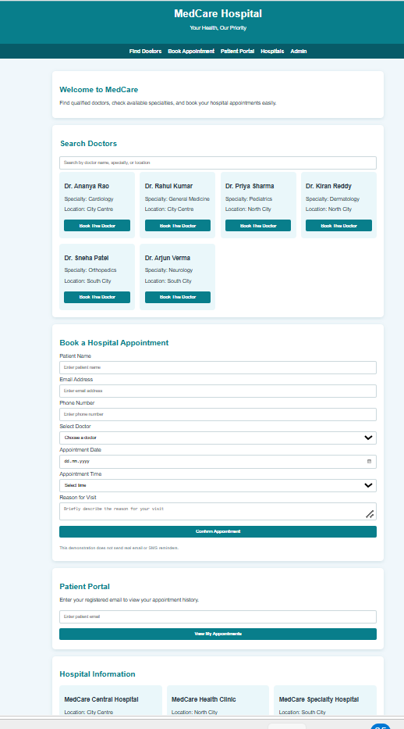

5. Result
Thus, the MedCare Hospital Appointment Booking System website was designed and developed successfully. It provides doctor search, patient registration, appointment scheduling, appointment management, hospital information, and patient feedback features.

