# The Battle of Neighborhood

(Coursera Capstone Project – Exploring Restaurants in London)

# Problem description & Introduction

The basis of this study is to help a small group of investors planning to open their first Indian restaurant expansion in London. Being that London is the most populated city in England, and continually ranks as an important global city based on a high quality of living, the choice to expand into the neighbor of the north market was an easy selection for the investing group. However, with limited knowledge of the London market, the groups of investors have selected us to assist in the selection of which areas of London will facilitate a launch of their brewery / restaurant expansion.

They are interested in building in an area that meets the following criteria:

1. A neighborhood with an average to above average total population

2. above average populations of 25–40-year-old male and female professionals

3. A high concentration of the population having secondary education

4. Average to above average median net household incomes

With these criteria given by the investing group, based on previous success in other markets, the objective is to locate and recommend to the investors, the target audience, which neighborhood(s) of London will be the best choice to start their international growth plan. The information gained will assist in choosing the right location by providing data about the population of each neighborhood, in addition to other established venues present in these areas.

Additionally, this information could be of interest to other potential investors looking to open a new restaurant or entertainment venue in London.

# Description of the Data

For this project we need the following data:

London City data that contains list Ward name(Boroughs), Ward codes along with their latitude and longitude.

**Data source:** https://opendata.camden.gov.uk/resource/tr8t-gqz7.json

**Description:** This data set contains the Postal code information of entire England. And we will use this data set to explore various neighborhoods of London city.

Indian restaurants in each neighborhood of London city.

**Data source:** Foursquare API

**Description:** By using this API we will get all the venues in each neighborhood. We can filter these venues to get only Indian restaurants.

**GeoSpace data**

**Data source:** https://data.london.gov.uk/download/statistical-gis-boundary-files-london/9ba8c833-6370-4b11-abdc-314aa020d5e0/statistical-gis-boundaries-london.zip

**Description:** By using this geo space data we will get the London Borough boundaries that will help us visualize follium map.

# Methodology

In the below section, we will direct our efforts detecting on the areas of London that have Indian restaurants. Also, we will particularly concentrate on the areas which have more number of South Asian populations with less number of Indian restaurants.

In first step we have collected the required **data: location and type (category) of every restaurant. We have also identified Indian restaurants** (according to Foursquare categorization).

Second step in our analysis will be calculation and exploration of '**restaurant ratings**, **Likes** and **Tips** across different areas of London - we will use **Bar, pie charts along with maps** to identify a few promising areas which has Indian resturants in general and focus our attention on those areas.

In third and final step we will focus on most promising areas and identify the location which has highest and least population of South Asian countries and map them.

Initially using the data source (<https://opendata.camden.gov.uk/resource/tr8t-gqz7.json>), we will do required cleansing and renaming the columns to identify the neighborhoods of London which has latitudes and longitude information of each Borough and the corresponding neighborhood as shown below.

Based on the data it is being identified that **Barnet** Borough has more number of Neighborhoods, followed by **Lambeth**. On the other hand, **Southwark and Tower Hamlets** has the least number of neighborhoods in London.

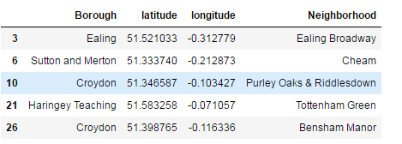

After identifying the boroughs and neighborhood, we will be proceeding with Identifying the restaurants present in the concerned localities with the help of Four square API.

Using FourSquare API, we would be identifying the venue details using explore function in the API and identify only Indian restaurants located in those borough and neighborhood as show below.

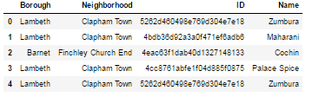

It is being identified that Harrow Borough has the maximum number of Indian restaurants. Correspondingly, we find that there is equal number of Indian restaurants present in 5 neighborhoods i.e. **Wall End,Hillside,Greenhill,Edgware,East Ham North** which has 6 Indian restaurants in their localities.

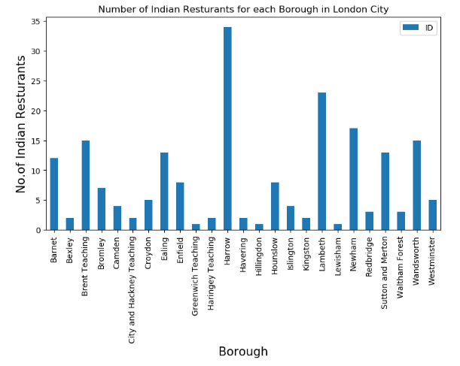

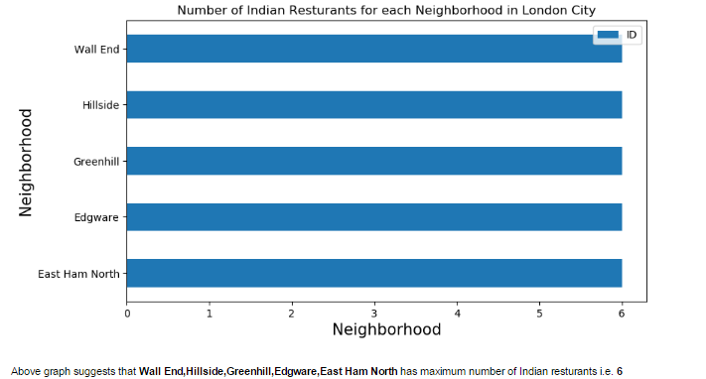

Now with the help of Venue details and restaurants names, let’s identify the ratings, likes and tips of each and every restaurant present in those neighborhoods.

It is identified that, **Dishoom** is the most popular restaurant among the people which has average rating of 9.3 and located in West End neighborhood of Westminster which has almost 1600 plus likes and 300 plus tips. Below pie chart explains the popular Indian restaurants in London.

Also, based on the ratings, West End neighborhood tops as the best neighborhood among popular Indian Restaurants. Whereas, based on the Likes, Cochin, Dipali Indian Restaurant, Taste of Lahore tops with 15.38% each as one of the most popular Indian Restaurants in the London.

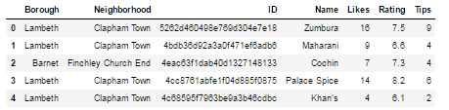

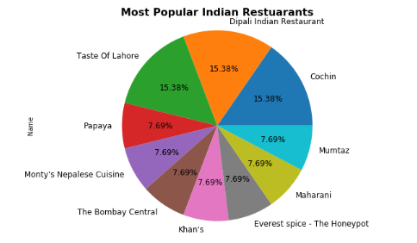

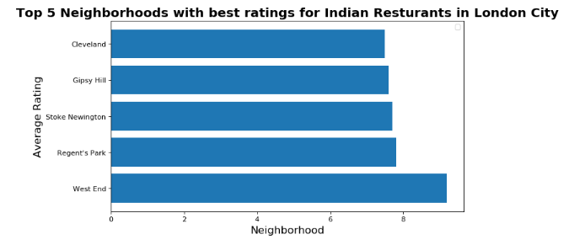

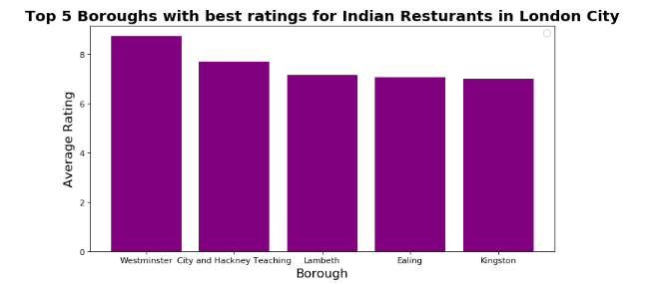

After this analysis, we would like to do the analysis of the data based on the South Asian population present in those localities. This would help us to identify the place which is highly populated with Indian people and also restaurants popularity. This is one of the aspect which would help us to judge to open the restaurant in that particular locality or not.

As shown below, we have extracted the data of South Asian population ( i.e. India, Pakistan,Srilanka and Bhutan ) present in those neighborhoods. Based on the ratings, we merged the data with the highest and least favorite restaurants and identified the corresponding population present in those localities.

**Note :** Here the population is present in millions count.

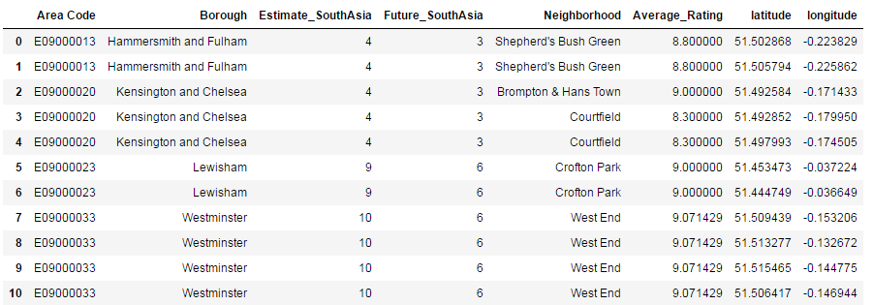

Based on the above statistics, **South Asian population is more in Newshaw with the neighborhood as Forest Gate South but the Average rating for the Indian restaurants is at the bottom of 6.1 respectively**.

Image 1 below shows the West End, Westminster borough has the top most Indian restaurant with rating as 9.2.

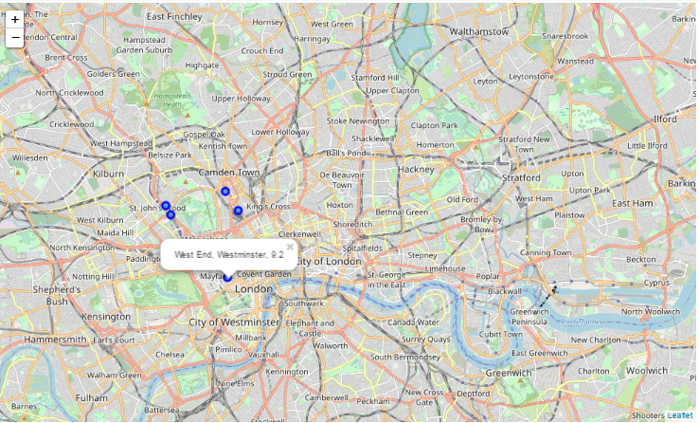

Image 2 shows the,Forest Gate South of Newshaw borough,which has rating as 6.1 and have more Indian population which would be feasible for the new restaurants to establish or expand their business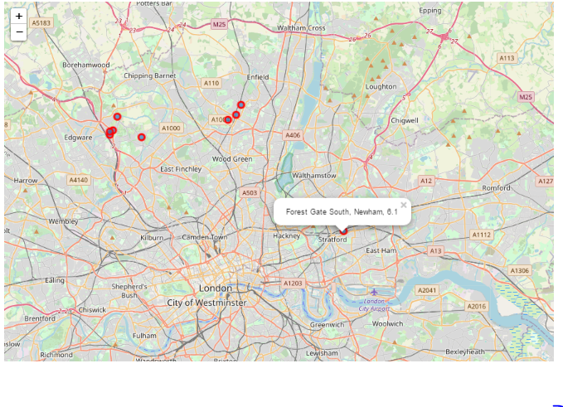

# Results and Discussion

Our analysis shows that although there is a great number of restaurants in London , there are a few Indian restaurants which are present in highly populated localities and neighborhoods. Highest concentration of restaurants was detected in Westend of Windmister borough, so we focused our attention to areas like Newshaw borough with the neighborhood as Forest Gate South.

Based on the above statistics, South Asian population is more in Newshaw with the neighborhood as Forest Gate South but the Average rating for the Indian restaurants is at the bottom of 6.1 respectively.

On the other hand, even though the South Asian population is predominately and comparatively less in WestMinster and other borough's but those localities has some of the best Indian restaurants

Result of all this is shows that the least rated neighborhoods has the new potential Indian restaurants which are yet to be rated by the reviewers. However, as the area is densely populated than other zones, chances are more likely that restaurant would receive better profits if basic necessities and requirements of the people met within the budget. Recommended zones should therefore be considered only as a starting point for more detailed analysis which could eventually result in location which has not only no nearby competition but also other factors taken into account and all other relevant conditions met.

# Conclusion

Purpose of this project was to identify London particularly Indian restaurants in order to aid stakeholders in narrowing down the search for optimal location for a new Indian restaurant. By calculating existing restaurant ratings and population density in different neighborhoods from Foursquare data we have first identified general boroughs that justify further analysis , and then generated extensive collection of locations which satisfy some basic requirements regarding existing nearby restaurants.

Final decision on optimal restaurant location will be made by stakeholders based on specific characteristics of neighborhoods and locations in every recommended zone, taking into consideration additional factors like attractiveness of each location (proximity to park or water), levels of noise / proximity to major roads, real estate availability, prices, social and economic dynamics of every neighborhood etc.