Create an employee table

create table employee(emp_id int,emp_name varchar(30),Department varchar(50),Salary int,City varchar(70));

1.Display all records

  - INSERT INTO employee
  - (emp_id, emp_name, department, salary, city)
  - VALUES
  - (1, 'Arun', 'IT', 35000, 'Karur'),
  - (2, 'Kavin', 'HR', 30000, 'Chennai'),
  - (3, 'Rahul', 'Finance', 40000, 'Coimbatore'),
  - (4, 'Sunil','Analyst',40000,'Chennai');
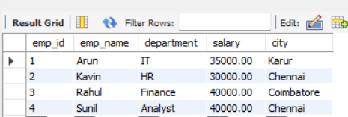

2.Display only name and salary

  - SELECT emp_name, salary
  - FROM employee;
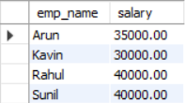

3.salary greaterthen 50000

  - FROM employee
  - WHERE salary > 50000;

No results found

4. Employees belonging to IT department
  - SELECT *
  - FROM employee
  - WHERE department = 'IT';
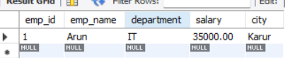

5. Employees whose city is Chennai
  - SELECT *
  - FROM employee
  - WHERE city = 'Chennai';


6. Salary between 40,000 and 60,000
  - SELECT *
  - FROM employee
  - WHERE salary BETWEEN 40000 AND 60000;
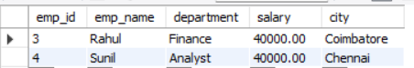

7. Employee names starting with 'A'
  - SELECT *
  - FROM employee
  - WHERE emp_name LIKE 'A%';


8. Display distinct departments
  - SELECT DISTINCT department
  - FROM employee;
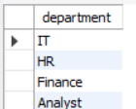

9. Employees whose City is NULL
  - SELECT *
  - FROM employee
  - WHERE city IS NULL;


10. Find total salary
  - SELECT SUM(salary) AS total_salary
  - FROM employee;
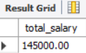

11. Average salary of IT department
  - SELECT AVG(salary) AS average_salary
  - FROM employee
  - WHERE department = 'IT';
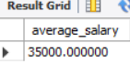

12. Count employees in each department using GROUP BY
  - SELECT department, COUNT(*) AS employee_count
  - FROM employee
  - GROUP BY department;
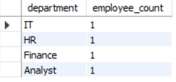

13. Employees whose salary is greater than the average salary

Nested subquery:
  - SELECT *
  - FROM employee
  - WHERE salary > (
  - SELECT AVG(salary)
  - FROM employee
  - );
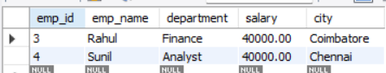

14. Insert a new employee record
  - INSERT INTO employee
  - (emp_id, emp_name, department, salary, city)
  - VALUES
  - (105, 'Vijay', 'IT', 45000, 'Chennai');
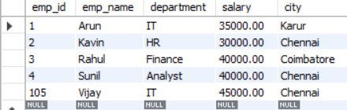

15. Update salary of employee with EmpID = 105 to 48000
  - UPDATE employee
  - SET salary = 48000
  - WHERE emp_id = 105;
