Table of Contents

AI-Driven Late Delivery Risk Prediction and Explainable Insights System for Logistics

Cover Page
AI-Driven Late Delivery Risk Prediction and Explainable Insights System for Logistics
A project report submitted in partial fulfilment of the requirements for the degree of
M.Sc (Data Science)
Chandigarh University
Submitted by: Vijay Anand E
Roll No.: O23MSD110005
Under the guidance of: Aamir Ahmed Khan – Manager
September 2026

Acknowledgement
I would like to express my sincere gratitude to my project guide Aamir Ahmed Khan for the guidance, encouragement and constructive feedback provided throughout this project.
Vijay Anand E
O23MSD110005

Certificate from Guide (Annexure A)
This is to certify that this project entitled “AI-Driven Late Delivery Risk Prediction and Explainable Insights System for Logistics” submitted in partial fulfillment of the degree of M.Sc (Data Science) to Chandigarh University done by Mr. Vijay Anand E, Roll No. O23MSD110005 is an authentic work carried out by him under my guidance. The matter embodied in this project work has not been submitted earlier for award of any degree or diploma to the best of my knowledge and belief.
Signature of the student | Signature of the Guide
 | 

Synopsis

1. Title of the Project
AI-Driven Late Delivery Risk Prediction and Explainable Insights System for Logistics

2. Statement of the Problem
In order fulfilment, a delivery that arrives after its scheduled date affects customer satisfaction and creates follow-up work for the logistics team. In the dataset used for this project, the DataCo Smart Supply Chain dataset, 57.3% of the 172,762 shipped order items were flagged as late (late_delivery_risk = 1). When the risk of a late delivery is known only after shipping, the business can do little except react.
The problem I address is to estimate, at the moment an order is placed, the probability that an order item will be delivered late. The estimate must use only information that is available at that moment. For each prediction, the system must also explain in plain language which order characteristics raised or lowered the risk, so that an operations user can understand and act on it.

3. Why this Topic was Chosen
I chose this topic because I work in the shipping and logistics industry, in a commercial and analytics role. Delivery reliability is a regular subject in that work, and a delay is usually known only after it has happened, when little can be done except react. I wanted to find out whether the risk of a late delivery can be estimated at the time an order is placed, using only the information available at that moment. A public supply chain dataset allowed me to study this question without using any company data. The topic also matches the direction I want my career to take, which is building AI applications that business users can understand and act on.
From a technical point of view, the topic combines several parts of the Data Science and AI curriculum in one end-to-end system:
- data preparation on a real, large dataset: 180,519 raw rows and 53 columns
- supervised classification with a baseline and a tree-based model
- evaluation with business-oriented metrics
- model explainability with SHAP
- a secure, role-based web application backed by a relational database
The topic also raises a practical issue that is common in industry: data leakage. The raw dataset contains several columns recorded after shipping, such as the actual shipping days and the delivery status, which would make a model look far better than it could be in real use. Designing the system so that these columns are never used was a central part of the work.

4. Objective and Scope of the Project
Objectives
- Prepare the DataCo dataset for modelling. This means removing orders that never shipped, excluding every column recorded after shipping or delivery, and producing a clean, documented table.
- Train and compare a logistic regression baseline and a tree-based model (scikit-learn HistGradientBoostingClassifier) to predict late delivery risk. The comparison also includes two simple reference baselines.
- Choose a decision threshold that matches the business priority of catching late deliveries. I use recall as the main metric and set a target of at least 80% recall.
- Explain the model globally (which features matter overall) and locally (the top five reasons behind a single order’s risk) using SHAP.
- Deliver the model to end users through a Streamlit web application with the following parts:
  - a login screen
  - a risk dashboard
  - a single-order risk checker
  - batch CSV scoring
- The application enforces role-based access: an admin sees all regions and an analyst sees only an assigned region.
- Store users, orders and predictions in a SQLite database. Passwords are stored as salted hashes, and every query is parameterized.
- Verify the system with automated tests (pytest) and document the results.
Scope. The project is a minimum viable, locally running system. It covers one dataset, one binary target, two main models, SHAP explanations, a SQLite database and a Streamlit application with two roles. It does not include demand forecasting, real-time integration with a live order system, external APIs or large language models. Everything runs on a single machine.
Benefit to the end user. An operations analyst can enter a new order, or upload a file of orders, and immediately see three things: the probability of late delivery, a High or Low risk level, and the main factors behind the prediction. This supports early action, for example choosing a different shipping mode or informing the customer.

5. Methodology (including a summary of the project)
The project follows a standard supervised machine learning workflow, implemented as separate Python modules in src/ and a Streamlit application in app.py.
- Data preparation (src/data_prep.py).
  - I load the raw file DataCoSupplyChainDataset.csv (Windows-1252 encoding, 180,519 rows, 53 columns). Its orders date from 1 January 2015 to 31 January 2018.
  - I remove 7,754 rows whose order status is CANCELED or SUSPECTED_FRAUD: these orders never shipped, so their “not late” label is meaningless.
  - I drop the leakage columns (actual shipping days, delivery status, shipping date, order status), the profit columns (their timing is uncertain), personal data, identifier codes and redundant columns.
  - After tidying the text, renaming the columns and removing three rows with invalid state values, the clean table has 172,762 order items, 22 columns and 62,894 orders, with no missing values.
- Feature engineering (src/features.py).
  - The model uses 20 features: 14 categorical order-time attributes, 3 date parts derived from the order date (month, weekday, quarter) and 3 numeric attributes (product price, quantity, discount rate).
  - I excluded the scheduled shipping days because they map one-to-one to the shipping mode.
  - Categories seen fewer than 500 times in training are grouped as “infrequent”.
  - All preprocessing is inside a scikit-learn Pipeline, so it is fitted on training data only.
- Model training and selection (src/train.py).
  - The data is split 80/20 with a stratified split grouped by order, so no order appears in both the training set and the test set. This gives 138,209 training items (50,315 orders) and 34,553 test items (12,579 orders).
  - I trained four candidates:
    - an “always late” baseline
    - a shipping-mode-only baseline
    - logistic regression
    - HistGradientBoostingClassifier
  - The gradient boosting model was tuned with a grid of 8 settings, evaluated by order-grouped 5-fold cross-validation on ROC-AUC.
- Threshold tuning.
  - Missing a late delivery is more costly than a false alarm, so I chose the decision threshold on out-of-fold training predictions. It is the highest threshold that still gives at least 80% recall: 0.397.
  - On the untouched test set, the tuned model reaches:
    - recall 0.795
    - precision 0.633
    - F1 0.705
    - ROC-AUC 0.732
- Explainability (src/explain.py).
  - I use SHAP’s PermutationExplainer on the predicted probability, with 100 training rows as background.
  - It produces a global importance chart and, for any single order, the top five factors in percentage points of risk.
- Database (src/db.py) and application (app.py).
  - A SQLite database stores users, orders and predictions.
  - The Streamlit application provides the login, dashboard, single-order checker and batch scoring screens, with admin and analyst roles.
- Testing. The modules and the application logic are tested with pytest.
Process description. Information flows from the raw CSV file through data preparation to the clean dataset. The clean dataset is used to train and save the model and to build the database. The application reads the database and the saved model to serve users, and each user sees only the data their role permits. This flow is shown in the Data Flow Diagrams (Level 0 and Level 1, reports/figures/diagrams/dfd_level0.png and dfd_level1.png) and in the ML pipeline flowchart (reports/figures/diagrams/ml_pipeline.png).
The software was developed with the assistance of an AI coding assistant (Claude Code). I reviewed all code, and every significant AI-assisted task is recorded in docs/ai-use-log.md.

6. Hardware and Software Used
Hardware: Apple MacBook Air (M1 chip, 8 GB RAM) running macOS (kernel Darwin 27.0.0). No GPU is required; all training and scoring run on the CPU.
Software:
Software | Version | Purpose
Python | 3.12.6 | Programming language
pandas | 3.0.6 | Data loading and cleaning
numpy | 2.5.3 | Numerical arrays
scikit-learn | 1.9.1 | Pipelines, logistic regression, HistGradientBoostingClassifier, cross-validation, metrics, threshold
shap | 0.52.0 | Model explanations
matplotlib | 3.11.2 | Charts and figures
joblib | 1.6.0 | Saving and loading the model
SQLite (Python sqlite3) | standard library | Database
Streamlit | 1.64.0 | Web application
pytest | 9.1.1 | Automated testing
Jupyter | 7.6.3 | Exploratory data analysis notebook
No external APIs or large language models are used by the system itself.

7. Testing Technologies Used
I used pytest for automated testing, together with Streamlit’s built-in testing tool (streamlit.testing.v1.AppTest), which runs the real application and logs in through its login form.
The test suite contains 107 tests, and all 107 pass. The tests cover:
- data preparation, including checks that no leakage column survives
- feature engineering, including handling of unseen categories
- training utilities, including that no order appears in both the training and test sets, and the threshold rule
- the SHAP explanation code
- the database layer, including password hashing, SQL-injection attempts and region filtering
- the application’s upload validation and role-based access control
Tests use small hand-made data and temporary databases so that project data is never modified. During testing, two defects were found and fixed:
- the upload check accepted an infinite price
- a failed batch of predictions was not rolled back
The full list is in docs/test-report.md.

8. Resources and Limitations
Resources. - The public DataCo Smart Supply Chain dataset from Kaggle. - A single personal computer. - Open-source Python libraries.
No proprietary data or paid services were required.
Limitations. - The model is dominated by shipping mode. A baseline that uses only the shipping mode reaches a test ROC-AUC of 0.739, which is practically the same as the full model’s 0.732. In the global SHAP analysis, shipping mode has a mean effect of about 22 percentage points, and every other feature has an effect below about 2 points. In this dataset every First Class item is labelled late (26,512 of 26,512), which suggests the label depends strongly on how the scheduled delivery time is set for each mode. - There are many false alarms. At the chosen threshold, precision is 0.633, so about 37% of orders flagged as High risk are in fact delivered on time. - The data is historical and has gaps. It covers January 2015 to January 2018, and some regions have months with no orders at all. For example, Central America has none from June 2015 to December 2016. - The system is local only. It is not connected to a live order system; new orders are entered by hand or uploaded as CSV files. - The dashboard’s predictions include training orders. Its figures are therefore more favourable than they would be on new orders. - Explanations are slow. One explanation takes about 3 seconds.

9. Contribution of the Project
The project contributes a complete, reproducible and leakage-aware pipeline for late delivery risk. It runs from the raw data to a working application in which every prediction comes with a plain-language explanation.
Its main contributions are:
- A documented separation between features known at order time and information recorded after shipping, enforced in code and checked by tests.
- A decision threshold chosen on training data only and justified by the business priority of catching late deliveries.
- A finding of practical value: in this dataset, the shipping mode alone carries almost all of the predictive signal. This tells a logistics team where process improvements would have the most effect.
- A secure, role-based application: hashed passwords, parameterized SQL, and region-level access for analysts.

10. Conclusion
In this project I built an end-to-end system that predicts, at order time, the risk that an order item will be delivered late. On the test set it catches about 80% of late items (recall 0.795) and explains each prediction with SHAP.
The main strengths of the approach are:
- careful exclusion of information that would not be available at order time
- a threshold chosen for the business goal rather than the default of 0.5
- an explanation method that I verified to be correct for this model; the tree-specific SHAP method gave values that did not add up for its categorical splits, so I used the model-agnostic permutation method with an additivity check
- a working, tested application with role-based access
What I consider most valuable is that the system reports its own limits. The baselines show that most of the predictive signal comes from the shipping mode, and the report states this plainly instead of presenting the model as more powerful than it is. I also consider the leakage controls and the verified explanations to be the parts that would matter most if the system were used with real orders.

1. Objective and Scope of the Project

1.1 Objective
The objective of this project is to build a system that predicts the risk of late delivery for an order item at the time the order is placed, and explains that prediction. The specific objectives are:
- Leakage-free data. Prepare a clean dataset from the DataCo Smart Supply Chain data that contains only information known when the order is placed. In particular, it excludes the actual shipping days, the delivery status, the shipping date and the order status.
- Predictive model. Train a logistic regression baseline and a HistGradientBoostingClassifier model, compare them with two reference baselines, and select a model using order-grouped cross-validation.
- Business-aligned decision rule. Treat recall on late deliveries as the primary metric, and choose the decision threshold on training data so that at least 80% of late deliveries are flagged. The resulting threshold is 0.397.
- Explainability. Provide global feature importance and a per-order explanation listing the top five factors in percentage points of risk.
- Secure application. Provide a Streamlit application with login, a risk dashboard, a single-order risk checker and batch CSV scoring. It has two roles: an admin sees all regions and an analyst sees only an assigned region. It stores data in SQLite, keeps passwords as salted hashes and uses parameterized queries.
- Verification. Test all modules and the application logic with pytest and report the results.

1.2 Scope
In scope:
- One dataset (DataCo Smart Supply Chain, Kaggle) and one binary target, late_delivery_risk (late = 1, on time = 0), predicted per order item.
- Two main models (logistic regression and HistGradientBoosting), plus the “always late” and shipping-mode-only baselines for reference.
- Metrics: precision, recall, F1, ROC-AUC and the confusion matrix.
- SHAP global and local explanations.
- A SQLite database with three tables (users, orders, predictions).
- A Streamlit application with two roles (admin, analyst) and four screens (login, dashboard, order risk checker, batch scoring).
- Automated tests with pytest, and project documentation (data dictionary, diagrams, test report, user manual).
Out of scope:
- Demand forecasting or time-series prediction.
- Integration with live order-management or carrier systems.
- External APIs, cloud deployment and large language models in the product.
- Automatic retraining or monitoring of the model in production.

1.3 How the System Helps the End User
The intended users are logistics operations staff:
- An analyst is responsible for one region; in the demo setup the analyst is assigned Central America.
- An admin oversees all regions.
With the system, a user can:
- See the risk picture on the dashboard. It shows the actual late rate, the share of orders predicted as High risk, monthly trends, the late rate by shipping mode, and the 20 highest-risk order items.
- Check a new order before it ships. The user enters its details and receives the probability of late delivery, a High or Low risk level, and the top five reasons.
- Score many orders at once. The user uploads a CSV file, which is validated before scoring, and downloads the results.
Because an analyst can only see and score orders for their own region, the system also supports data separation between teams.

2. Theoretical Background

2.1 Late Delivery Risk in Logistics
In order fulfilment, each order has a scheduled delivery time. The scheduled time usually depends on the shipping mode chosen by the customer: in this dataset, Same Day, First Class, Second Class or Standard Class. A delivery is late when the actual shipping time exceeds the scheduled time. Late deliveries reduce customer satisfaction and can lead to extra support contacts, refunds or lost repeat business.
In the DataCo dataset, this outcome is recorded in the column Late_delivery_risk, which I renamed to late_delivery_risk. Its value is 1 if the item was delivered late and 0 otherwise. After cleaning, 57.3% of the 172,762 order items are labelled late. The late rate differs strongly by shipping mode:
Shipping mode | Order items | Late rate
First Class | 26,512 | 100.0%
Second Class | 33,806 | 79.8%
Same Day | 9,293 | 47.9%
Standard Class | 103,151 | 39.8%
Data leakage occurs when a model is trained with information that would not be available at prediction time. It makes the model appear more accurate than it can be in practice [6]. In this problem, the actual shipping days, the delivery status, the shipping date and the order status are all recorded after the order ships. They would reveal the outcome, so I excluded all of them.

2.2 Binary Classification
Predicting late delivery risk is a binary classification task. For each order item with features x, the model estimates the probability p = P(y = 1 | x) that the item will be late. A class label is then obtained by comparing p with a decision threshold t: predict “late” if p ≥ t, and “on time” otherwise. The model is learned from labelled historical examples (supervised learning).
To estimate how the model will behave on new orders, the data is split into a training set and a test set. In this dataset one order can contain several items that share the same customer, date and destination. If items of one order appeared in both sets, the test score would be optimistic. For this reason I used a stratified, group-wise split:
- It keeps every order entirely in one set.
- It keeps the late rate similar in both sets: 57.3% in each.
Hyperparameters were tuned with k-fold cross-validation (k = 5), using the same grouping by order.

2.3 Logistic Regression
Logistic regression is a linear model for binary classification [2], [6]. It computes a weighted sum of the input features and passes it through the logistic (sigmoid) function:
p = 1 / (1 + e^-(b0 + b1·x1 + … + bk·xk))
The coefficients b are learned by maximising the likelihood of the training labels. Logistic regression is fast and interpretable, and it is a standard baseline. Because it is linear, the inputs need preparation:
- categorical features are one-hot encoded, one binary column per category
- numeric features are standardised to zero mean and unit variance
In this project, logistic regression reached a cross-validated ROC-AUC of 0.742 and a test ROC-AUC of 0.731.

2.4 Gradient Boosting and HistGradientBoostingClassifier
Gradient boosting builds an ensemble of decision trees one after another. Each new tree is fitted to correct the errors of the ensemble built so far, and the final prediction is the sum of all trees’ outputs, converted to a probability [6].
scikit-learn’s HistGradientBoostingClassifier is an efficient implementation. It first groups each numeric feature into at most 255 bins (histograms), which makes finding the best split much faster on large datasets [2], [6]. It also supports categorical features natively: a split can send any subset of categories to the left or the right branch, so one-hot encoding is not needed.
In this project:
- Each categorical feature was converted to a single integer code (ordinal encoding) and marked as categorical.
- The model was tuned over learning rate (0.05, 0.1), maximum leaf nodes (15, 31) and number of iterations (200, 400). The selected setting was learning rate 0.1, 15 leaf nodes and 200 iterations.
- Its cross-validated ROC-AUC was 0.740 (standard deviation 0.005), within the cross-validation variation of logistic regression’s 0.742. I kept the tree-based model as the final model.

2.5 Evaluation Metrics: Precision, Recall, F1 and ROC-AUC
With “late” as the positive class, each prediction on the test set falls into one of four groups:
- true positives (TP): late items predicted late
- false positives (FP): on-time items predicted late
- true negatives (TN): on-time items predicted on time
- false negatives (FN): late items predicted on time
These four counts form the confusion matrix. For the final model on the test set of 34,553 items, it is:
 | Predicted on time | Predicted late
Actually on time | 5,631 (TN) | 9,127 (FP)
Actually late | 4,062 (FN) | 15,733 (TP)
From these counts:
- Precision = TP / (TP + FP) is the share of items flagged late that are actually late: 15,733 / 24,860 = 0.633.
- Recall = TP / (TP + FN) is the share of late items that the model catches: 15,733 / 19,795 = 0.795.
- F1 score = 2 · precision · recall / (precision + recall) balances the two: 0.705.
- ROC-AUC is the area under the Receiver Operating Characteristic curve, which plots the true positive rate against the false positive rate at every possible threshold. It equals the probability that a randomly chosen late item receives a higher predicted risk than a randomly chosen on-time item. A value of 0.5 means no ranking ability, and 1.0 means perfect ranking. It does not depend on the chosen threshold. The final model’s test ROC-AUC is 0.732.
Metric that matters most for the business. Missing a late delivery (a false negative) means no early action is taken and the customer experiences the delay. A false alarm (a false positive) costs some extra attention from the operations team. I therefore treat recall on late deliveries as the primary metric, while reporting precision so that the cost of false alarms stays visible.

2.6 Choice of Decision Threshold
Most classifiers use a default threshold of 0.5. The default is not optimal when the costs of the two kinds of error differ. Lowering the threshold flags more items as late: recall rises and precision falls.
I chose the threshold on the training data only, so that the test set stays untouched:
- I generated out-of-fold predictions using the order-grouped 5-fold cross-validation. Every training item then has a predicted probability from a model that did not see it.
- I selected the highest threshold at which out-of-fold recall is at least 80%, which is 0.397.
The model is saved with this threshold fixed (scikit-learn’s FixedThresholdClassifier). On the test set it gives recall 0.795, just below the 0.80 target, which is expected when a threshold is transferred to new data. With the default threshold of 0.5, the same model reached recall 0.574 and precision 0.833 (reports/model_comparison.csv).

2.7 SHAP Explanations
SHAP (SHapley Additive exPlanations) explains an individual prediction by assigning each feature a contribution. The method is based on Shapley values from cooperative game theory [3]. The contributions are additive: the average prediction over a background sample (the baseline), plus the sum of all feature contributions, equals the model’s prediction for that order.
- Global explanation: the mean absolute SHAP value of each feature over many orders shows which features matter most overall.
- Local explanation: the SHAP values of one order show which features raised or lowered that order’s risk, and by how much.
In this project I explain the predicted probability of late delivery, so every contribution is expressed in percentage points of risk. I used SHAP’s PermutationExplainer, with 100 training rows as background and a fixed random seed (42).
I did not use the faster TreeExplainer. In testing, it gave values that did not add up to the model’s output for HistGradientBoostingClassifier’s native categorical splits, off by up to 3 log-odds. The PermutationExplainer only calls the model’s prediction function, so it is correct for any model. The code checks the additivity property on every explanation.
Over 500 test order items, the global analysis shows:
- shipping mode has by far the largest effect, a mean of about 22 percentage points
- every other feature has a mean effect below about 2 points; the next largest are order state and order country

2.8 Role-Based Access Control and Password Security
Role-based access control (RBAC) grants permissions to roles instead of individual users; each user is assigned a role. This system has two roles:
- Admin: can view and score orders from all regions.
- Analyst: is assigned one region and can view and score only orders from that region.
Access is decided by the user’s role, not by the text of the region field. The region filter is applied inside the database query, so an analyst’s screens never receive other regions’ data. Batch files that contain rows from another region are rejected.
Password storage. Passwords are never stored in plain text. Each password is hashed with scrypt, a deliberately slow and memory-hard key-derivation function [12], using a random 16-byte salt per user. The stored value holds only the salt and the hash. At login, the entered password is hashed again with the stored salt, and the two hashes are compared in constant time. Two further measures protect the login:
- An unknown username triggers the same amount of hashing work as a wrong password, so response time does not reveal which usernames exist.
- All database queries use parameterized statements, so user input cannot change the SQL (protection against SQL injection).

3. Definition of Problem

3.1 Background
A logistics operation receives orders that differ in shipping mode, destination, product and customer. Some orders will be delivered later than scheduled. In the DataCo dataset this is the majority: 57.3% of the 172,762 shipped order items. Without a prediction, the operations team learns about a late delivery only after it has happened.

3.2 Problem Statement
Given the information available when an order is placed, the task is to estimate for each order item the probability that it will be delivered late. The system must:
- classify the item as High or Low risk
- explain which of the order’s characteristics drove the estimate
- make this available securely to users according to their role and region
Formally, the task is supervised binary classification:
- Unit of prediction: one order item. The final dataset has 172,762 items belonging to 62,894 orders.
- Target: late_delivery_risk, 1 = late and 0 = on time.
- Inputs: 20 features known at order time:
  - 14 categorical: payment type, shipping mode, customer segment, customer country/state/city, market, order region/country/state/city, category, department and product
  - 3 date parts from the order date: month, weekday and quarter
  - 3 numeric: product price, quantity and discount rate
- Excluded inputs: everything recorded after shipping or delivery (actual shipping days, delivery status, shipping date, order status), profit columns whose timing is uncertain, identifiers and personal data.
- Output: a probability between 0 and 1, a risk level (High if the probability is at least 0.397, otherwise Low), and the top five contributing factors.

3.3 Requirements Derived from the Problem
- No leakage. Only order-time features may be used, and no order may appear in both the training and the test data.
- Catch most late deliveries. Recall on late items is the primary metric, with a target of at least 80%, chosen on training data only.
- Explainability. Every single-order prediction must come with its main reasons, in terms a non-specialist can read.
- Security. Users log in; passwords are stored as salted hashes; analysts see only their own region; SQL queries are parameterized; uploaded files are validated before scoring.
- Usability. Users need a dashboard view, a way to check one new order, and a way to score a file of orders.
- Local operation. The system runs on a single machine without external services.

3.4 Challenges Identified
- Leakage-prone raw data. Several attractive columns are recorded after shipping and had to be identified and removed.
- Related rows. Multiple items belong to the same order, which required grouped splitting and grouped cross-validation.
- High-cardinality categories. There are, for example, 3,585 order cities and 118 products; categories seen fewer than 500 times in training were grouped.
- A dominant feature. Shipping mode alone carries most of the signal, and the late label is 100% for First Class. This limits how much the other features can add.
- Explanation correctness. The fast tree-specific SHAP method was not correct for this model’s categorical splits, so a slower model-agnostic method with an additivity check was required.

Part 2: System Analysis, Design, Planning and Implementation

4. System Analysis and Design vis-a-vis User Requirements

4.1 Users and Their Requirements
The system has two kinds of users, both from logistics operations:
- Analyst: responsible for one region. In the demo setup the analyst is assigned Central America, the largest region, with 27,174 order items.
- Admin: oversees all regions.
The analyst needs to see the late-delivery picture for their own region, check the risk of a new order before it ships, understand why an order is risky, and score a file of orders at once. The admin needs the same functions for any region. Both must log in, and neither may see more than their role allows.
From these needs and the project scope, I derived the requirements below. Each one is traced to the part of the system that meets it.
Table 4.1: Functional requirements
ID | Requirement | Met by
FR1 | Users log in with a username and password; wrong credentials are rejected | app.py show_login, src/db.py verify_user
FR2 | A risk dashboard shows KPIs, trends and the highest-risk orders for the user’s allowed regions | app.py show_dashboard, src/db.py get_orders, get_predictions
FR3 | A user can describe one new order and get the probability of late delivery, a risk level and the top 5 reasons | app.py show_checker, score, src/explain.py explain_order
FR4 | A user can upload a CSV of orders, have it validated, see the scores and download them | app.py show_batch, validate_upload, score
FR5 | Admins see all regions; analysts see and score only their own region | src/db.py get_orders, get_predictions (filter by role in SQL); app.py validate_upload (region check)
FR6 | Predictions for stored orders are saved in the database | app.py ensure_predictions, src/db.py save_predictions
FR7 | The data can be rebuilt and the model retrained from the raw dataset with documented commands | python -m src.data_prep, src.train, src.explain, src.db; docs/setup.md
Table 4.2: Non-functional requirements
ID | Requirement | How it is met
NFR1 | No data leakage: only information known when the order is placed is used | Leakage columns are dropped in src/data_prep.py; the feature list in src/features.py excludes IDs, the target and scheduled_shipping_days; the split is grouped by order; tests FE-04, DP-02 and DP-19 check this
NFR2 | Business-aligned decisions: catch most late deliveries | Threshold chosen for out-of-fold recall of at least 0.80 (0.397); test recall 0.795
NFR3 | Explainability: every single-order prediction comes with readable reasons | SHAP PermutationExplainer; reasons in percentage points; additivity checked in code
NFR4 | Security | scrypt password hashes with a random salt, constant-time comparison, a dummy hash for unknown users, parameterized SQL, role-based filtering, upload validation
NFR5 | Local operation: no external services | All components run on one machine; no external APIs or LLMs
NFR6 | Usability: clear screens and messages | Linked drop-downs, plain-language error messages, the same login error for every failure, a sample CSV (docs/sample_batch.csv)
NFR7 | Testability and maintainability | 107 automated pytest tests; pinned library versions in requirements.txt; one module per concern
NFR8 | Performance acceptable on a laptop | Scoring all 172,762 stored orders took about 0.9 s and one SHAP explanation about 3 s (measured on 2026-09-28)

4.2 Analysis of the Existing Situation
Without the system, late deliveries are known only after they happen: the delivery status and the actual shipping days are recorded after shipping. The raw dataset contains exactly these after-the-fact columns. Using them would produce a model that looks very accurate but cannot be used at order time. The analysis therefore had two parts:
- Separate the information available when an order is placed from the information recorded later.
- Design a system that works only with the first.
The column-by-column analysis of all 53 raw columns is in the data dictionary (Annexure 2). In summary:
Classification | Columns
Model features (19 raw columns, giving 20 features after the date parts are derived) | 19
Target | 1
Keys (not features) | 2
Excluded as leakage | 4
Excluded as leakage with uncertain timing (the profit columns) | 3
Dropped as personal data | 8
Dropped as redundant IDs | 7
Dropped as duplicates | 5
Dropped as carrying no information | 4

4.3 System Architecture
The system is organised in four layers plus a set of offline build scripts (Figure 1).
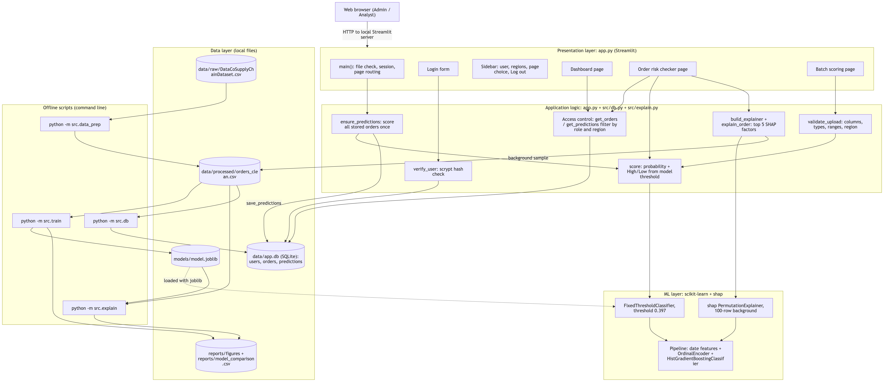
Figure 1: System architecture
- Presentation layer (app.py, Streamlit): the login form, a sidebar (user, role, regions, page choice, Log out) and three pages: Dashboard, Order risk checker and Batch scoring.
- Application logic:
  - authentication (verify_user, check_password)
  - access control (get_orders, get_predictions, and the region check in validate_upload)
  - upload validation (validate_upload)
  - scoring (score, ensure_predictions)
  - the SHAP explainer (build_explainer, explain_order)
- ML layer: the saved model models/model.joblib. It is a FixedThresholdClassifier with threshold 0.397, wrapping the frozen scikit-learn pipeline (date features, ordinal encoding, HistGradientBoostingClassifier). The SHAP PermutationExplainer uses 100 training rows as background.
- Data layer:
  - the SQLite database data/app.db (users, orders, predictions)
  - the clean CSV data/processed/orders_clean.csv
  - the model file
  - the figures and comparison table in reports/
- Offline scripts: python -m src.data_prep, src.train, src.explain and src.db build the data, model, figures and database. Each has a main() function and is run from the project root.
Design decisions:
Decision | Reason
Separate modules for data preparation, features, training, explanation and database | Each can be run, reviewed and tested on its own
All preprocessing inside the scikit-learn Pipeline | It is fitted on training data only and applied identically at prediction time
The model saved with its threshold (FixedThresholdClassifier) | The application uses exactly the decision rule chosen during training
The region filter applied inside the SQL query and decided by role | An analyst’s screens never receive other regions’ data
One database connection per request | SQLite connections cannot be shared across Streamlit’s threads
A fresh SHAP explainer for each explanation | The same order always gets the same explanation; building one takes about 0.02 s

4.4 Data Design
The database design is shown in the ERD (section 10.2, Figure 14). It has three tables:
- users: unique username, salted password hash, role (admin or analyst), region.
- orders: the clean order items, with order_item_id as the primary key and an index on order_region.
- predictions: probability, risk level and timestamp. A foreign key links each prediction to its order.
order_item_id is used as the key rather than order_id, because one order can contain several items; 172,762 items belong to 62,894 orders. The detailed data dictionary is Annexure 2.

4.5 Screen Design
The four screens (login, dashboard, order risk checker, batch scoring) and their inputs and outputs are described with screenshots in section 10.4.

5. System Planning (PERT Chart)

5.1 Planning Approach
I planned the project as a sequence of activities, one module at a time, following a day-by-day plan (docs/claude-code-playbook.md) for the window Sunday 27 September to Monday 5 October 2026. For each activity I estimated three durations in days: optimistic (o), most likely (m) and pessimistic (p). From these I computed the PERT expected time:
te = (o + 4m + p) / 6
I then derived the earliest and latest start and finish times, the slack of each activity and the critical path.
Figure 2: PERT chart (critical activities highlighted)
Table 5.1: PERT activities (source: docs/diagrams/pert.md; durations are estimates in days)
ID | Activity | Predecessors | o | m | p | te | Slack | Critical
A | Project setup and requirements checklist | - | 0.25 | 0.5 | 1 | 0.54 | 0.00 | Yes
B | Download and profile the dataset, classify columns | A | 0.25 | 0.5 | 1 | 0.54 | 0.00 | Yes
C | Data preparation, code review, data dictionary | B | 0.5 | 1 | 1.5 | 1.00 | 0.00 | Yes
D | EDA notebook (7 charts) | C | 0.25 | 0.5 | 1 | 0.54 | 0.00 | Yes
E | Feature engineering and leakage review | D | 0.25 | 0.5 | 1 | 0.54 | 0.00 | Yes
F | Model training and review | E | 0.5 | 1 | 1.5 | 1.00 | 0.00 | Yes
G | SHAP explanations | F | 0.25 | 0.5 | 1.5 | 0.63 | 0.00 | Yes
H | SQLite database | C | 0.25 | 0.5 | 1 | 0.54 | 2.17 | No
I | Review of explanation and database modules, ERD | G, H | 0.25 | 0.25 | 0.5 | 0.29 | 0.00 | Yes
J | Streamlit application | I | 0.5 | 1 | 1.5 | 1.00 | 0.00 | Yes
K | Tests and test report | J | 0.5 | 1 | 1.5 | 1.00 | 0.00 | Yes
L | Fix reported defects, re-run tests | K | 0.25 | 0.5 | 1 | 0.54 | 0.00 | Yes
M | Documentation: DFD, architecture, ML pipeline, PERT, user manual, hardware/software | L | 0.25 | 0.5 | 1 | 0.54 | 0.00 | Yes
N | Update requirements checklist | M | 0.1 | 0.25 | 0.5 | 0.27 | 0.00 | Yes
O | Update README | L | 0.1 | 0.25 | 0.5 | 0.27 | 0.81 | No
P | Viva practice | M | 0.25 | 0.5 | 1 | 0.54 | 0.27 | No
Q | Final code review | L | 0.25 | 0.25 | 0.5 | 0.29 | 0.79 | No
R | Review report draft against the checklist | N | 0.25 | 0.5 | 1 | 0.54 | 0.00 | Yes
S | Fresh clone test | O, Q | 0.1 | 0.25 | 0.5 | 0.27 | 0.79 | No
T | Upload soft copy, final submission | P, R, S | 0.1 | 0.1 | 0.25 | 0.13 | 0.00 | Yes
Critical path: A → B → C → D → E → F → G → I → J → K → L → M → N → R → T, with an expected length of 9.10 days. The planned window was 9 calendar days, so the plan had no slack on the critical path.
Two dependencies are worth explaining:
- H has slack of 2.17 days. The database only needs the clean data (C), not the model.
- E follows D. The decision to exclude scheduled_shipping_days from the features came from the EDA: it maps one-to-one to the shipping mode.

5.2 Planned versus Actual Progress
Work went faster than planned. According to docs/ai-use-log.md:
- Activities A to F: finished on 27 September.
- Activities G to K: finished on 28 September. The model was also re-run in the project environment with the pinned library versions that day.
- Activity L (defect fixes): 30 September.
- Activities M, N, O and S: 30 September. These are the documentation, the checklist, the README and the fresh clone test.
The submission date was later moved forward from 5 October 2026 to the end of September 2026. The PERT chart above shows the original plan. The remaining activities were:
- viva practice (P)
- the final code review (Q)
- the review of this report against the checklist (R)
- submission (T)
Activities P, Q, R and T were completed in September 2026.

6. Process Logic of Each Module
Figure 3 shows the complete process, from the raw data to the application. The leakage-control steps are highlighted. This section describes the logic of each module in the order in which the process runs; it also serves as the description of the process involved.
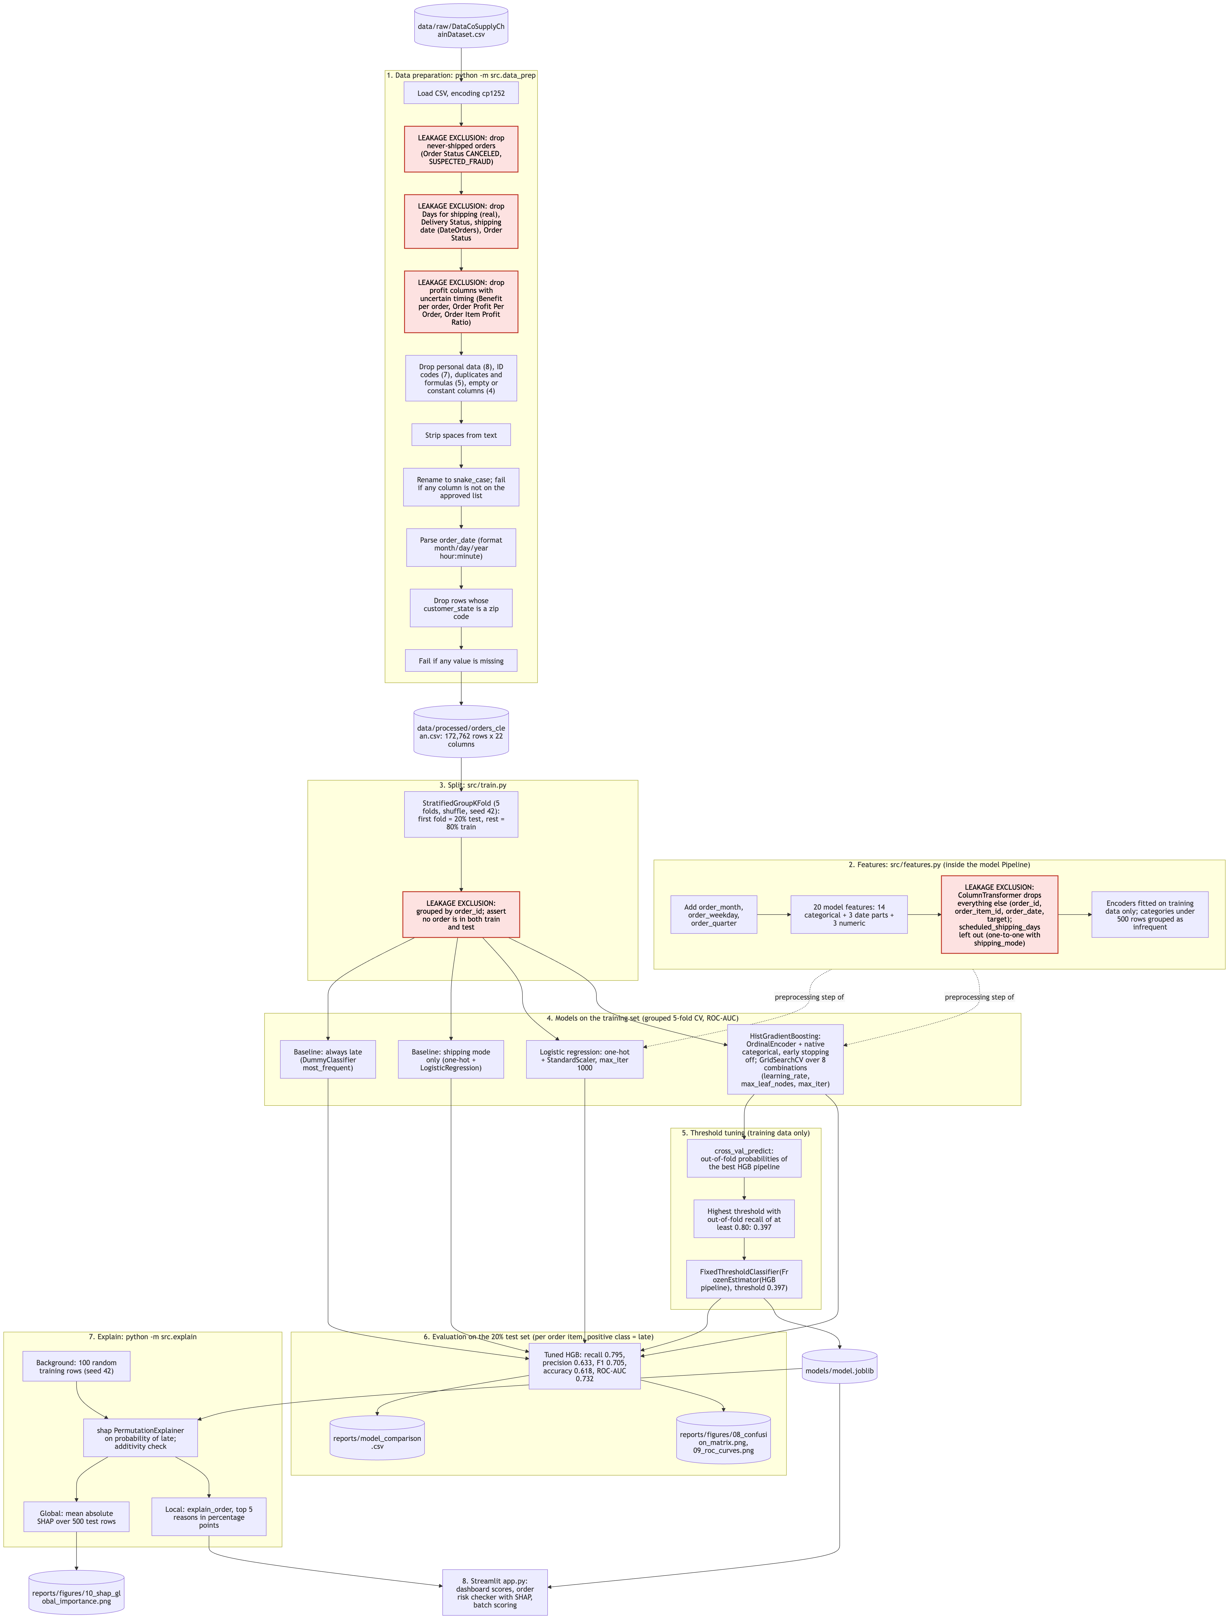
Figure 3: ML pipeline flow

6.1 Data Preparation (src/data_prep.py)
Input: data/raw/DataCoSupplyChainDataset.csv, which has 180,519 rows and 53 columns and is Windows-1252 encoded.
Output: data/processed/orders_clean.csv, which has 172,762 rows, 22 columns and no missing values.
Steps:
- Load the file with the cp1252 encoding. Latin-1 would garble place names such as “Šiauliai”.
- Remove orders that never shipped. These are the 7,754 rows whose order status is CANCELED or SUSPECTED_FRAUD; their “not late” label is meaningless.
- Drop columns. The script checks that every expected column is present before dropping anything. It drops:
  - 4 leakage columns: actual shipping days, delivery status, shipping date, order status
  - 3 profit columns whose timing is uncertain
  - 8 personal-data or precise-location columns
  - 7 redundant identifier codes
  - 5 duplicate or formula columns
  - 4 columns that carry no information
- Strip spaces from all text values.
- Rename the columns to snake_case. The script stops with an error if any column is not on the approved list, so a leakage column cannot slip through.
- Remove the 3 rows whose customer state is a zip code; these rows are shifted in the source.
- Parse the order date with the explicit format month/day/year hour:minute.
- Check for missing values. The script stops if any value is missing.
- Save the clean CSV.
Exploratory data analysis (notebooks/01_eda.ipynb, Figures 4 to 10). The EDA shows that the late rate is almost the same across most dimensions:
- Markets: from 56.8% (Africa) to 57.7% (Europe).
- Customer segments: from 57.1% to 57.6%.
- Order months: from 56.7% to 58.0%.
- Product categories with at least 500 items: from 56.0% to 61.2%.
- Order regions: from 51.6% (Canada) to 60.1% (Central Africa).
Only the shipping mode separates the classes clearly. Its late rates are:
Shipping mode | Late rate
First Class | 100%
Second Class | 79.8%
Same Day | 47.9%
Standard Class | 39.8%
The scheduled shipping days map one-to-one to the shipping mode: 0 days for Same Day, 1 for First Class, 2 for Second Class and 4 for Standard Class.
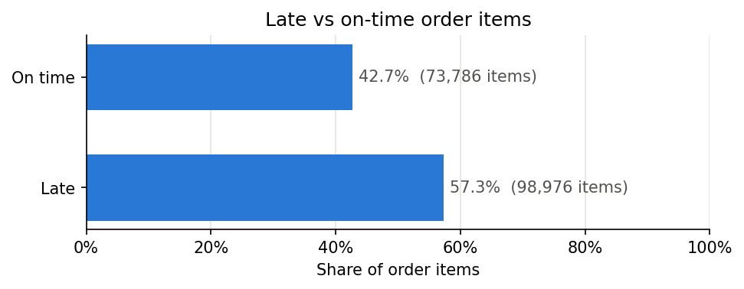
Figure 4: Overall late delivery rate
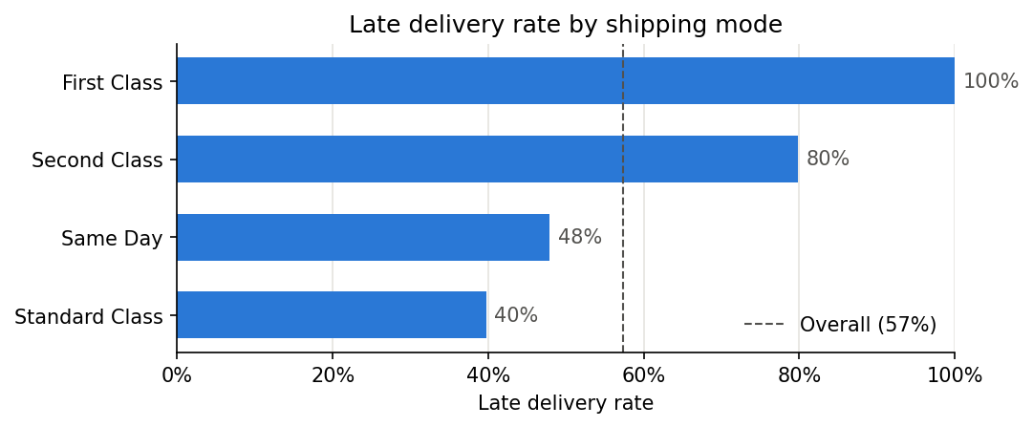
Figure 5: Late rate by shipping mode
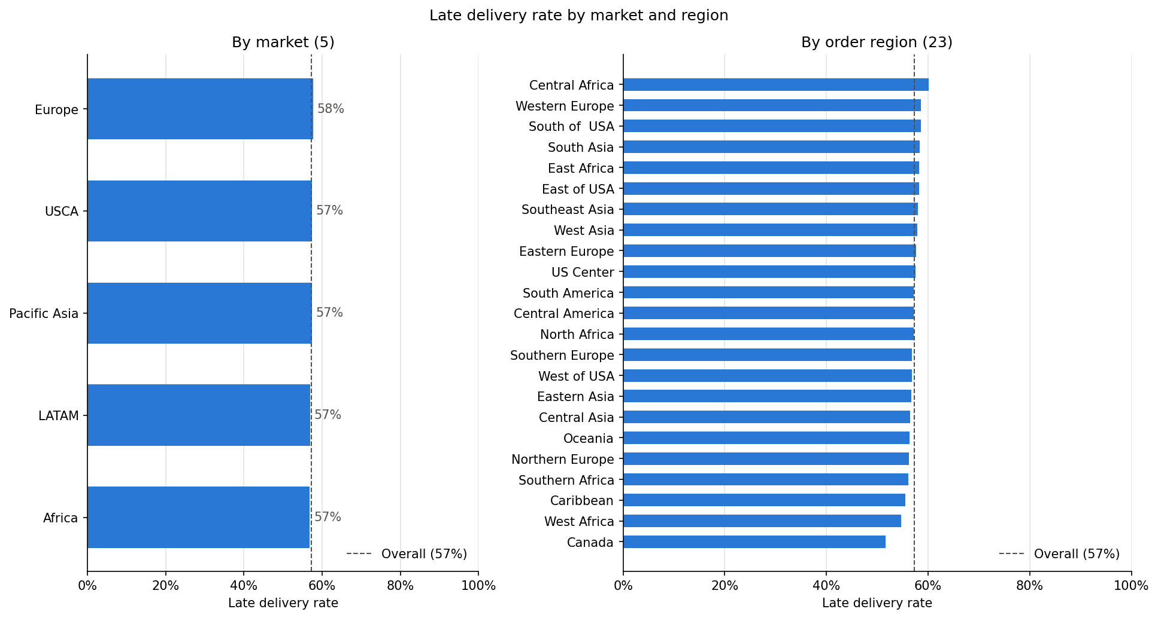
Figure 6: Late rate by market and region
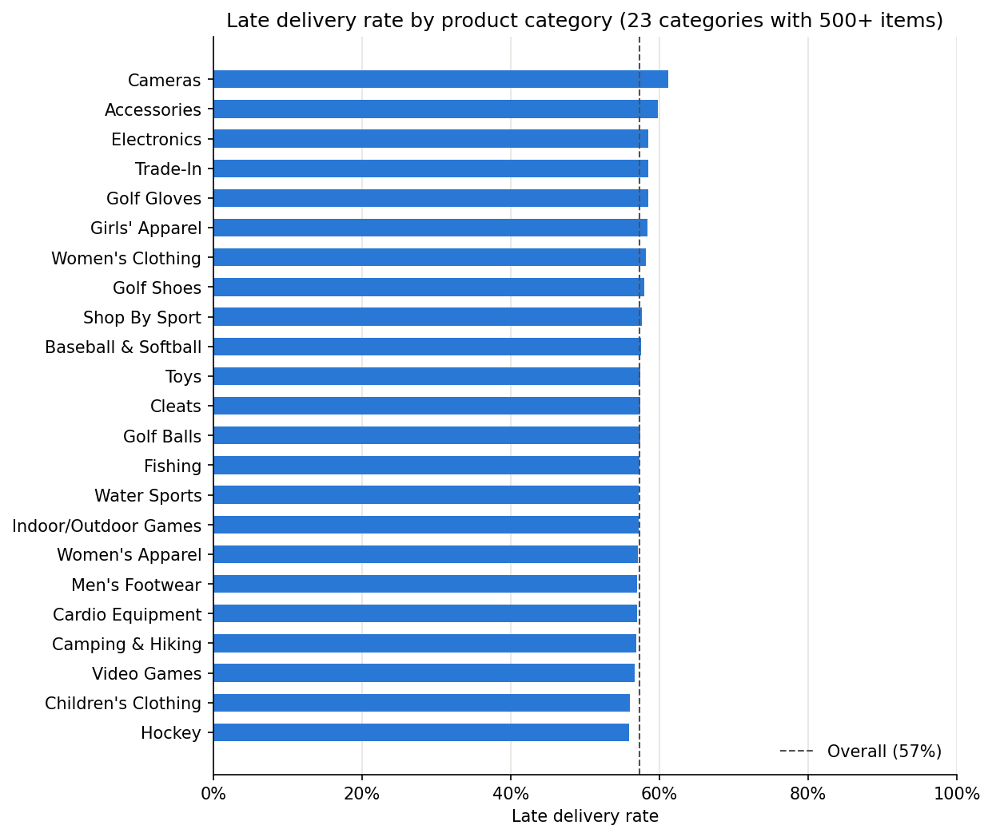
Figure 7: Late rate by product category
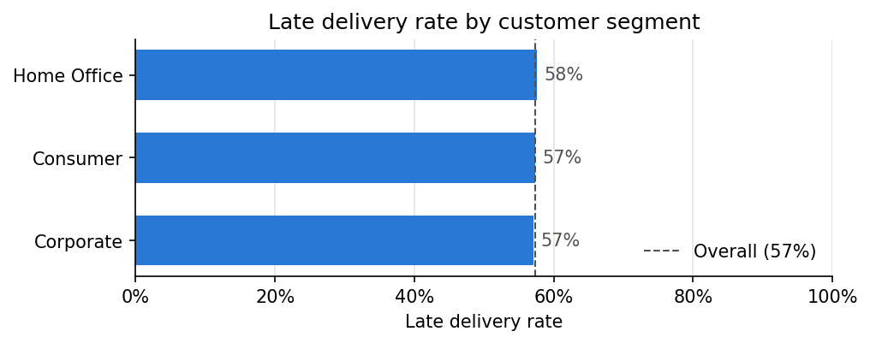
Figure 8: Late rate by customer segment
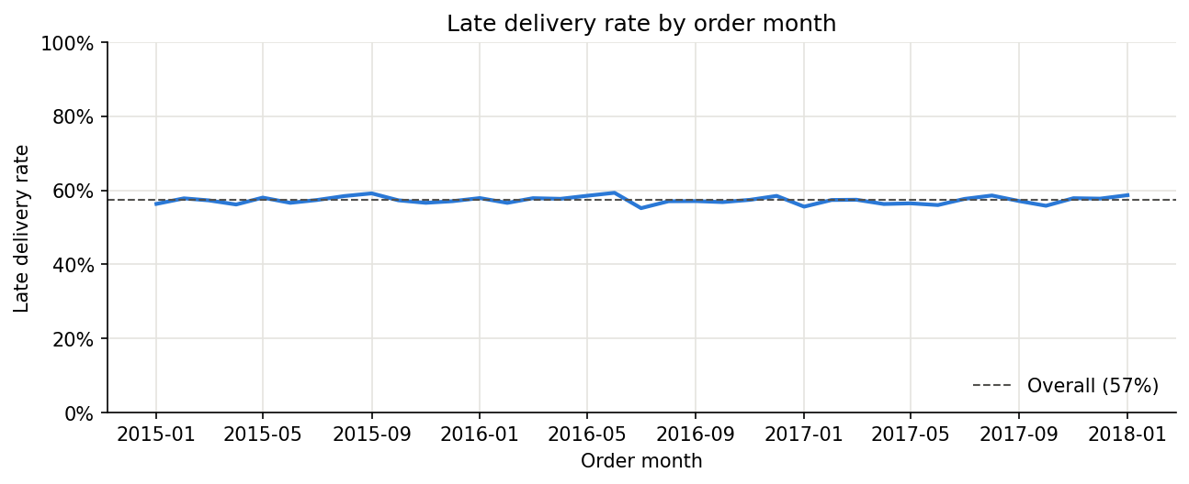
Figure 9: Late rate by order month
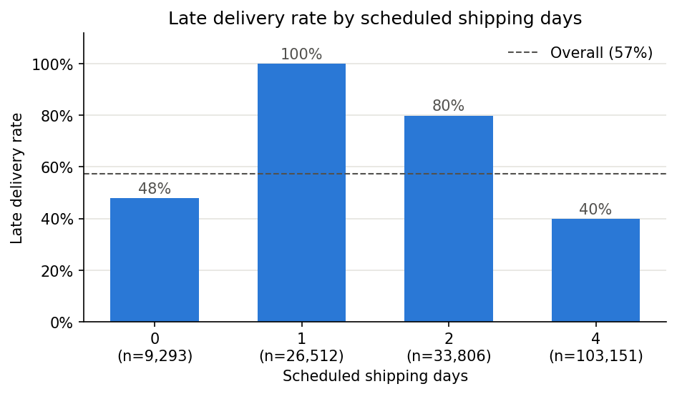
Figure 10: Late rate by scheduled shipping days

6.2 Feature Engineering (src/features.py)
Input: clean order items. Output: a preprocessing step for each model type. It is not fitted here; it is fitted inside the model pipeline on training data only.
Steps:
- add_date_features adds order_month, order_weekday (0 = Monday) and order_quarter from the order date. These date parts are treated as categories, because month 12 is not “more” than month 1.
- get_feature_lists returns the 20 model features:
  - 14 categorical: payment type, shipping mode, customer segment, customer country, state and city, market, order region, country, state and city, category, department, product
  - 3 date parts
  - 3 numeric: product price, quantity, discount rate
- scheduled_shipping_days is left out because it is one-to-one with the shipping mode.
- build_preprocessor prepares the features differently for each model:
  - Logistic regression: one-hot encoding of the categories, plus scaling of the numbers to zero mean and unit variance.
  - HistGradientBoosting: one integer code per category (ordinal encoding), read by the model’s native categorical support, with the numbers passed through unchanged.
- In both cases, categories seen fewer than 500 times in training are grouped as “infrequent”. This keeps high-cardinality columns small (for example, 3,585 order cities) and below HistGradientBoosting’s limit of 255 categories per feature. A category not seen in training is encoded as -1, which the tree model treats as missing.
- remainder="drop" removes every other column (order ID, order item ID, order date, target), so none of them can reach the model.

6.3 Model Training and Selection (src/train.py)
Input: clean order items. Outputs: - models/model.joblib - reports/model_comparison.csv - reports/figures/08_confusion_matrix.png and 09_roc_curves.png
Steps:
- Split. split_train_test uses StratifiedGroupKFold (5 folds, shuffled, seed 42) grouped by order_id. It takes the first fold as the 20% test set and asserts that no order is in both sets. The result is 138,209 training items and 34,553 test items, both with a late rate of 57.3%.
- Baselines:
  - “always late” (DummyClassifier predicting the most frequent class)
  - “shipping mode only” (one-hot shipping mode plus logistic regression)
- Logistic regression: the one-hot and scaling preprocessor, with max_iter=1000.
- HistGradientBoosting: the ordinal preprocessor and native categorical features.
  - Early stopping is switched off, because it would hold out a random 10% of training rows that is not grouped by order. The number of iterations is tuned instead.
  - GridSearchCV tries 8 combinations: learning rate 0.05 or 0.1, maximum leaf nodes 15 or 31, and 200 or 400 iterations. It uses order-grouped 5-fold CV on ROC-AUC.
  - Selected: learning rate 0.1, 15 leaf nodes, 200 iterations.
- Cross-validated scores: every candidate is scored with the same grouped 5-fold CV (ROC-AUC mean and standard deviation).
- Threshold. choose_threshold computes out-of-fold probabilities of the tuned pipeline with cross_val_predict. It picks the highest threshold at which recall is at least 0.80 (TARGET_RECALL), which is 0.397. The script stops with an error if no threshold reaches the target.
- Save. The pipeline is frozen (FrozenEstimator) and wrapped in FixedThresholdClassifier with this threshold, then saved with joblib.
- Evaluate every model on the test set: accuracy, precision, recall, F1, ROC-AUC. The script saves the comparison table, the confusion matrix and the ROC curves. The results are in section 8.

6.4 Explanation (src/explain.py)
Input: the saved model and clean order items. Outputs: reports/figures/10_shap_global_importance.png, and plain-language reasons for any single order.
Steps:
- load_pipeline takes the inner pipeline from the saved model (model.estimator_.estimator).
- build_explainer creates a shap.PermutationExplainer on the predicted probability of “late”. It uses an Independent masker over 100 training rows and seed 42.
- shap_values_for computes the SHAP values. It then checks additivity: the baseline plus the sum of the SHAP values must equal the predicted probability, within 1e-6. It raises an error otherwise.
- explain_order sorts one order’s contributions by size and keeps the top 5, dropping features with an effect of exactly zero. It then writes each one as a sentence, for example: “Shipping mode ‘First Class’ increased risk by 41.8 percentage points”.
  - Month, weekday and quarter are shown as names, such as “January” or “Q1”.
  - A value that was grouped as rare in training is flagged as such.
- save_global_summary plots the mean absolute SHAP value per feature over 500 test items.

6.5 Database (src/db.py)
Input: the clean CSV and, optionally, the environment variables for the demo passwords. Output: data/app.db.
Logic:
- init_db creates the three tables with their constraints:
  - unique username
  - role CHECK (admin or analyst)
  - probability CHECK (between 0 and 1)
  - foreign key from predictions to orders
  - an index on order_region
- get_connection switches on foreign-key enforcement.
- load_orders clears predictions and orders, then inserts all 172,762 clean rows.
- Passwords:
  - hash_password creates a random 16-byte salt and stores salt$hash, computed with scrypt (n = 2^14, r = 8, p = 1).
  - check_password re-hashes with the stored salt and compares in constant time (hmac.compare_digest).
  - verify_user checks unknown usernames against a dummy hash, so the response time does not reveal which usernames exist.
- create_demo_users adds admin (all regions) and analyst (Central America) if they are missing. The passwords come from environment variables, and the script prints a warning when the defaults are used.
- get_orders and get_predictions return every region for the admin role. For any other role they add WHERE order_region = ?. Access is decided by role, so a non-admin whose region is “All” sees nothing.
- save_predictions inserts many predictions in one transaction. If any row fails, the whole batch is rolled back.
- Every query uses ? placeholders; no SQL is built from user input.

6.6 Application (app.py)
Startup: main checks that the clean CSV, the model and the database exist. If any is missing, it names the missing files and lists the commands to build them. It then shows the login form, or the pages if a user is logged in.
Login: show_login calls verify_user. On success the user record (username, role, region) is stored in the Streamlit session. On failure the page shows “Wrong username or password.”
One-time scoring: ensure_predictions runs after login. If the predictions table is empty, for example after a fresh database build, it scores all stored orders and saves them with save_predictions.
Dashboard (show_dashboard): - It loads the user’s orders and predictions through the role-filtered queries. - Admins can narrow the view to one region. - It shows four KPIs, monthly order items and late rate (missing months appear as gaps), the actual late rate against the predicted risk by shipping mode, and the 20 highest-risk items. - A caption notes that the predictions include training orders.
Order risk checker (show_checker): - The drop-downs are linked (region → country → state → city, and so on), so only realistic combinations can be chosen. The market is derived from the region. - On Check risk, the order is scored. The page shows: - the probability and the High/Low level, where High means a probability of at least 0.397 - the background average - the top 5 SHAP reasons, from a freshly built explainer
Batch scoring (show_batch, validate_upload): 1. The uploaded CSV is read. 2. The 18 required columns must be present and the file must not be empty. 3. The late_delivery_risk column is dropped if present. 4. Dates and numbers are converted. Infinite numbers count as invalid. 5. The file is rejected if any of the following is true: - a value is missing or invalid - a quantity is not a whole number of at least 1 - a price is negative - a discount is outside 0 to 1 - for an analyst, a row is outside their region 6. Valid files are scored. The results are shown sorted by risk and offered as a CSV download. They are not saved.
Caching and connections: the model and the SHAP background sample are loaded once per application process. Orders are cached per role and region. Each database read opens and closes its own connection.

7. Methodology Adopted, System Implementation and Details of Hardware and Software

7.1 Methodology Adopted
I followed an iterative, module-by-module method with a review step after each module:
- Plan. Before each task, write a short plan and confirm the approach.
- Build. Write the module and run it on the real data in the project environment.
- Review. A code review looks for bugs, data leakage, security issues and readability. I decided which findings to fix, and the fixes were applied before moving on.
- Test. Add automated tests, and turn every defect found into a test.
- Record. Record the task, the tool used and what I reviewed or changed in docs/ai-use-log.md.
The modelling itself follows the standard supervised-learning process:
- data understanding and preparation
- exploratory analysis
- feature engineering
- a grouped train/test split
- baselines
- model training with cross-validation
- threshold selection
- evaluation on an untouched test set
- explanation
- deployment in an application
Development was assisted by an AI coding assistant, Claude Code. It was used for writing and reviewing code, for writing tests, and for documentation (diagrams, data dictionary, test report, user manual). I reviewed and ran all code and made the design decisions, including the leakage-free feature list, the model choice and the threshold. Every significant AI-assisted task is recorded in docs/ai-use-log.md.
Several rules governed the project, recorded in the project instructions (CLAUDE.md):
- use only features known at order time
- store passwords only as hashes
- use parameterized SQL only
- validate uploaded files
- add no library without approval
- run everything locally

7.2 System Implementation
Code organisation:
File | Lines | Purpose
src/data_prep.py | 201 | Cleaning and leakage removal
src/features.py | 93 | Feature list and preprocessing
src/train.py | 239 | Split, models, threshold, evaluation
src/explain.py | 166 | SHAP explanations
src/db.py | 256 | SQLite database
app.py | 349 | Streamlit application
tests/ | – | 107 pytest tests
The full code is in the code annexure.
Build and run commands (from the project root; full guide in docs/setup.md):
- python3.12 -m venv .venv, then .venv/bin/pip install -r requirements.txt
- Place DataCoSupplyChainDataset.csv in data/raw/
- .venv/bin/python -m src.data_prep
- .venv/bin/python -m src.train
- .venv/bin/python -m src.explain (optional; global SHAP figure)
- .venv/bin/python -m src.db
- .venv/bin/streamlit run app.py, which opens at http://localhost:8501
- .venv/bin/python -m pytest
Implementation verification: fresh clone test. On 30 September 2026 I cloned the repository into an empty folder and followed docs/setup.md exactly: new virtual environment, package installation, dataset, the four build scripts, the tests and the application. The results were:
- Data preparation: a clean CSV byte-identical to the original.
- Training: about 4 minutes, with the same threshold (0.397) and a model comparison table identical to the original.
- Tests: the first run showed that 3 login tests could not run on a freshly built database. They opened the database read-only, but the application saves its predictions at the first login. The tests were changed to use a private copy of the database, after which all 107 tests passed.
- Application: it started, and the first login scored and saved all 172,762 orders.
Run times measured during the fresh clone test (on the development machine):
Step | Time
Package installation | about 25 s
Data preparation | about 10 s
Training | about 4 min
Global SHAP explanation | about 2.5 min
Database build | a few seconds
Test suite | about 11–16 s

7.3 Hardware Used
Item | Details
Machine | Apple MacBook Air (M1)
Operating system | macOS (kernel Darwin 27.0.0)
Processor | Apple M1
Memory | 8 GB
Storage | Not recorded
GPU | Not used; all training and scoring run on the CPU
Minimum and recommended requirements are estimates, not measured values. They are listed in docs/hardware-software.md: at least a 64-bit dual-core CPU, 4 GB RAM and 2 GB free disk; a quad-core CPU and 8 GB RAM or more are recommended.

7.4 Software Used
Software | Version | Purpose
macOS | Darwin 27.0.0 | Operating system
Python | 3.12.6 | Programming language
pandas | 3.0.6 | Data loading, cleaning and filtering
NumPy | 2.5.3 | Numerical arrays
scikit-learn | 1.9.1 | Pipeline, encoders, LogisticRegression, HistGradientBoostingClassifier, StratifiedGroupKFold, GridSearchCV, FixedThresholdClassifier, metrics
SHAP | 0.52.0 | PermutationExplainer for global and local explanations
Matplotlib | 3.11.2 | Charts saved to reports/figures/
joblib | 1.6.0 | Saving and loading the model
SQLite (Python sqlite3) | standard library | Database
Streamlit | 1.64.0 | Web application; AppTest for application tests
pytest | 9.1.1 | Automated testing
Jupyter | 7.6.3 | EDA notebook
Git | Not recorded | Version control
Claude Code | Not recorded | AI coding assistant used during development (not part of the product)
pandoc | 3.12 | Converting the report from Markdown to Word (not part of the product)
All product software is free and open source. Package versions are pinned in requirements.txt. No external APIs or large language models are used by the system.

Part 3: Results, Life Cycle, Manual and Annexures

8. System Maintenance and Evaluation

8.1 Model Comparison
All models were trained on the same 138,209 training order items (50,315 orders) and evaluated on the same untouched test set of 34,553 order items (12,579 orders). The split was grouped by order, so no order appears in both sets. The cross-validation (CV) columns come from order-grouped 5-fold cross-validation on the training set. The other columns are measured on the test set, with “late” as the positive class.
Table 8.1: Model comparison (source: reports/model_comparison.csv)
Model | CV ROC-AUC (± std) | Accuracy | Precision | Recall | F1 | Test ROC-AUC
Always late (baseline) | 0.500 (± 0.000) | 0.573 | 0.573 | 1.000 | 0.728 | 0.500
Shipping mode only (baseline) | 0.742 (± 0.004) | 0.695 | 0.883 | 0.539 | 0.670 | 0.739
Logistic regression | 0.742 (± 0.005) | 0.694 | 0.859 | 0.557 | 0.676 | 0.731
HistGradientBoosting (threshold 0.5) | 0.740 (± 0.005) | 0.690 | 0.833 | 0.574 | 0.679 | 0.732
HistGradientBoosting, tuned threshold 0.397 (final model) | 0.740 (± 0.005) | 0.618 | 0.633 | 0.795 | 0.705 | 0.732
The CSV file labels the last model “threshold 0.40” because it rounds to two decimals; the exact saved threshold is 0.397.
Four observations follow from this table:
- All three learned models rank orders almost equally well. Their CV ROC-AUC values (0.740 to 0.742) differ by less than one standard deviation (0.005).
- The shipping-mode-only baseline ranks as well as the full models (test ROC-AUC 0.739). Almost all of the predictive signal in this dataset comes from the shipping mode (see section 8.4).
- The “always late” baseline has recall 1.0 but no ranking ability (ROC-AUC 0.5). Recall on its own is therefore not enough to judge a model.
- At the default threshold of 0.5, every learned model misses more than 40% of late deliveries (recall 0.539 to 0.574).
I kept HistGradientBoostingClassifier as the final model even though its CV ROC-AUC is not higher than logistic regression’s. The two models rank orders equally well, so the choice rests on other properties. The project plan set logistic regression as the baseline and a tree-based model as the candidate final model. I kept the tree-based model for three reasons. First, it handles categorical features natively, without one-hot encoding. Second, it can learn interactions between features, for example between shipping mode and region, without my having to construct them by hand, so it is better placed to benefit if the system is retrained on data that carries more signal. Third, at the default threshold it had slightly higher recall (0.574 against 0.557) and F1 (0.679 against 0.676) on the test set, although these differences are small. On this dataset logistic regression would have been an equally valid choice, and it is simpler to explain.
The tree model was tuned over 8 combinations: - learning rate 0.05 or 0.1 - maximum leaf nodes 15 or 31 - 200 or 400 iterations
The selected setting was learning rate 0.1, 15 leaf nodes and 200 iterations.

8.2 Chosen Threshold and Why
For this business, a missed late delivery (false negative) is more costly than a false alarm (false positive). A missed late delivery means no early action and a disappointed customer, while a false alarm only costs some extra attention from the operations team. I therefore treated recall on late deliveries as the primary metric and set a target of at least 80% recall.
I chose the threshold without using the test set:
- I computed out-of-fold predicted probabilities for every training item with order-grouped 5-fold cross-validation.
- I selected the highest threshold whose out-of-fold recall was at least 0.80. This is 0.397. Taking the highest such threshold keeps as many true on-time orders as possible out of the “High” group.
- I saved the model with this threshold fixed (FixedThresholdClassifier wrapping the frozen pipeline) in models/model.joblib.
On the test set, the tuned threshold raises recall from 0.574 to 0.795 and F1 from 0.679 to 0.705. Precision falls from 0.833 to 0.633. Test recall is slightly below the 0.80 target, which is expected when a threshold chosen on training data is applied to new data. In the application, an order is labelled High risk when its predicted probability is at least 0.397 and Low otherwise.

8.3 Confusion Matrix
Table 8.2: Confusion matrix of the final model on the test set (34,553 order items)
 | Predicted on time | Predicted late
Actually on time (14,758) | 5,631 (true negatives) | 9,127 (false positives)
Actually late (19,795) | 4,062 (false negatives) | 15,733 (true positives)
- Late deliveries caught: 15,733 of 19,795, which is 79.5% (recall).
- Late deliveries missed: 4,062, which is 20.5%.
- Flags that were correct: of the 24,860 items flagged High risk, 15,733 were actually late, which is 63.3% (precision).
- False alarms: the other 9,127 flagged items, 36.7%, were delivered on time.
The figure is reports/figures/08_confusion_matrix.png (Figure 11), and the ROC curves of the models are in reports/figures/09_roc_curves.png (Figure 12).
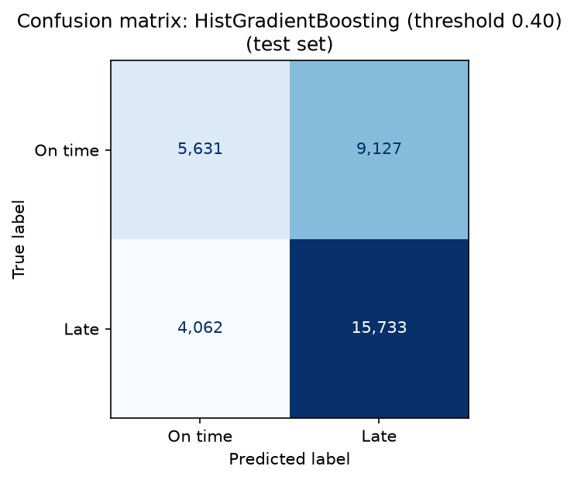
Figure 11: Confusion matrix of the final model
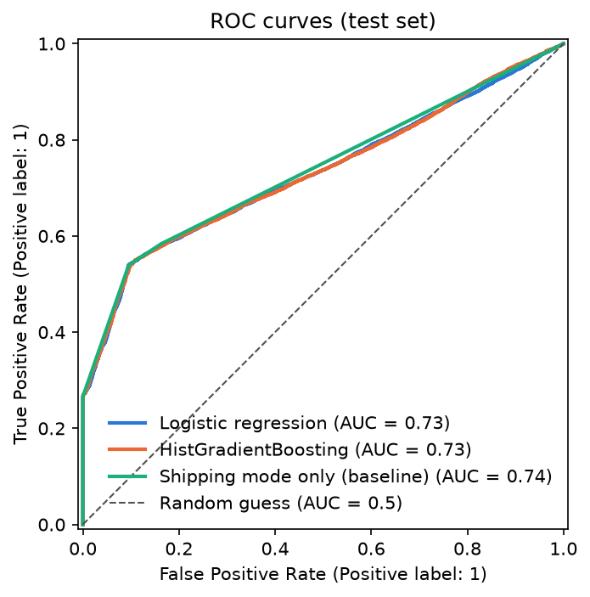
Figure 12: ROC curves of the models

8.4 SHAP Findings
Method. I used SHAP’s PermutationExplainer on the predicted probability of “late”, with 100 training rows as background and seed 42. The code checks on every call that the baseline plus all SHAP values equals the model’s predicted probability.
Global importance. Figure 13 (reports/figures/10_shap_global_importance.png) shows the mean absolute SHAP value per feature over 500 test order items.
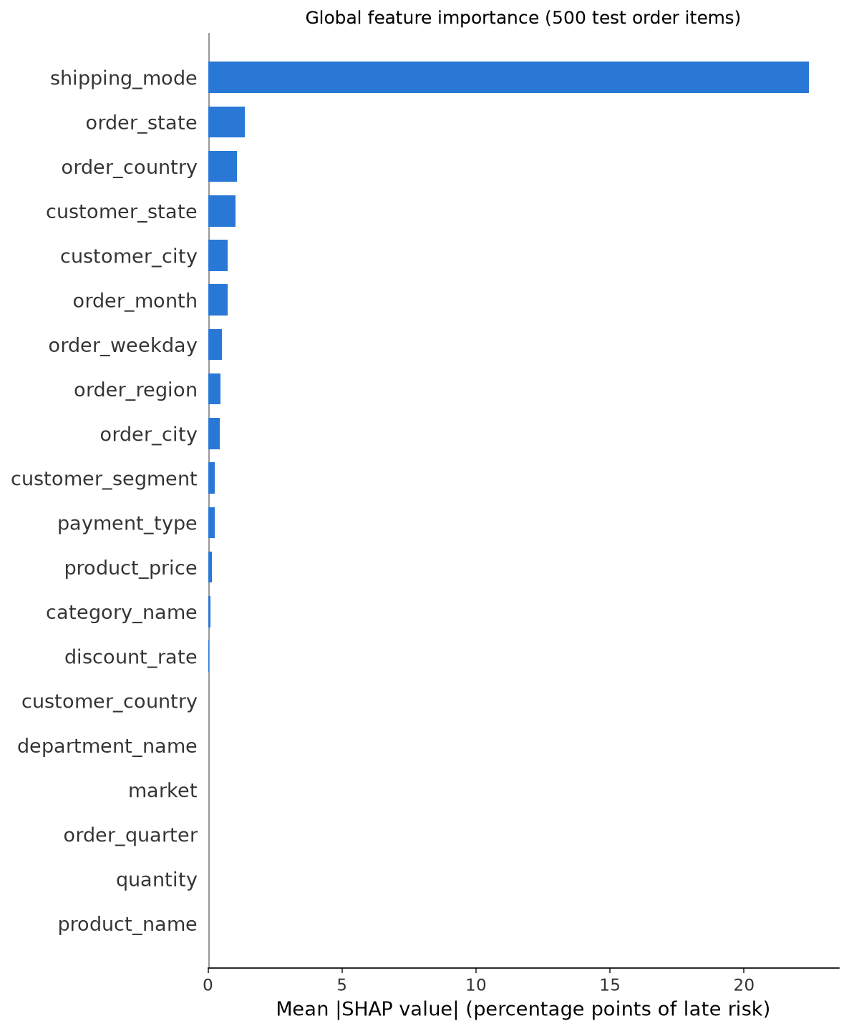
Figure 13: Global SHAP feature importance
- Shipping mode dominates, with a mean effect of about 22 percentage points of late risk.
- The next features are order state, order country, customer state, customer city and order month. Each has a mean effect below about 1.5 percentage points.
- Several features have almost no effect, including quantity, product name, market, order quarter, department name and customer country.
This matches the data itself:
Shipping mode | Late rate
First Class | 100% (26,512 of 26,512 items)
Second Class | 79.8%
Same Day | 47.9%
Standard Class | 39.8%
The label appears to depend mainly on how the scheduled delivery time is set for each shipping mode.
Local explanations. In the application, the order risk checker lists the top five factors of a single order in plain language. One order I checked in the running application on 2026-09-28 was a First Class order to Belize:
- Predicted risk: 100.0%, High, against an average of 57.5% for the background sample.
- Top factor: “Shipping mode ‘First Class’ increased risk by 41.8 percentage points”.
- Other four factors: each changed the risk by 0.4 percentage points or less.
Why not TreeExplainer. SHAP’s faster TreeExplainer produced values that did not add up to the model’s output for HistGradientBoostingClassifier’s native categorical splits, off by up to 3 log-odds. I therefore used the model-agnostic PermutationExplainer. Its cost is speed: about 3 seconds per explained order.
Repeatability. SHAP applies the random seed once, when the explainer is built. The application therefore builds a new explainer for each request, which takes about 0.02 seconds, so the same order always receives the same explanation. A test checks this (EX-02).

8.5 System Maintenance
Task | How | When
Retrain the model | Put the new DataCo-format file in data/raw/, then run src.data_prep, src.train, src.explain and src.db in order (see docs/setup.md). Training re-tunes the hyperparameters and re-chooses the threshold on out-of-fold predictions. | When new order data is available, or when monitoring shows recall falling
Check the model after retraining | Compare the new reports/model_comparison.csv with Table 8.1. Confirm recall on the test set is still close to 0.80, and that the shipping-mode baseline is not better than the model. | After every retraining
Run the tests | .venv/bin/python -m pytest (107 tests) | After any code or library change
Rebuild the database | .venv/bin/python -m src.db. This reloads the orders and clears the saved predictions, which the application recomputes at the next login. Existing users are kept. | After new data or a new model
Back up | Copy data/app.db, models/model.joblib and data/processed/orders_clean.csv while the application is stopped. These files are git-ignored. | Before each retraining or database rebuild
Library versions | Versions are pinned in requirements.txt. One test helper uses a private Streamlit attribute and works only with the pinned Streamlit 1.64.0; it must be re-checked if Streamlit is upgraded. | Before any upgrade
Leakage control | Any new column must be classified as known at order time or recorded later before it is used. Tests fail if a leakage column appears in the clean data or in the feature list. | Whenever the data source changes

9. Cost and Benefit Analysis
This analysis is qualitative. No cost or savings figures were measured in this project.

9.1 Costs
Cost item | Description | Amount
Software | All software used is free and open source: Python, pandas, numpy, scikit-learn, shap, matplotlib, joblib, Streamlit, pytest and SQLite. No licences were bought. | No cost
Data | The DataCo Smart Supply Chain dataset was downloaded from Kaggle. | No cost (free download)
Hardware | One existing personal computer; no GPU and no server. | Existing equipment; no new cost
Development effort | Design, coding, testing and documentation | Not recorded
AI coding assistant | Claude Code was used for development assistance (see section 7.1) | Not included in this analysis
Operation | The system runs locally; there are no hosting or API costs | No hosting or API cost
Maintenance | Periodic retraining, testing and backups (section 8.5) | Not estimated

9.2 Benefits
Benefit | How the system provides it
Early warning of late deliveries | The final model flags about 80% of late items at the time the order is placed (test recall 0.795), before shipping.
Explainable decisions | Every single-order prediction comes with its top five factors, so staff can see why an order is at risk, not just that it is.
Actionable insight | The analysis shows that shipping mode drives almost all of the risk. This points process improvements at how delivery times are scheduled for each mode.
Faster review of many orders | Batch CSV scoring validates and scores a whole file of orders and returns a downloadable result.
Data separation and security | Analysts see only their own region; passwords are hashed; SQL is parameterized; uploads are validated.
Low running cost | The system uses only open-source software and runs on one local machine without external services.
Monetary benefit | For example, fewer customer complaints or refunds from late deliveries handled in advance

9.3 Trade-offs
The chosen threshold favours catching late deliveries over precision. About 37% of orders flagged High risk (9,127 of 24,860 in the test set) are in fact delivered on time. Whether this is worthwhile depends on the cost of reviewing a flagged order compared with the cost of a missed late delivery. These unit costs were not available for this project. With those two costs, the threshold could be re-chosen to minimise total cost instead of targeting 80% recall.

10. Detailed Life Cycle of the Project

10.1 Life Cycle Phases
The project followed an iterative, module-by-module life cycle. Each module was written, run, reviewed and tested before the next one was started. The dates below are from docs/ai-use-log.md, and the planned schedule is in the PERT chart (section 5).
Phase | Work done | Output | Date(s)
1. Requirement analysis | Project scope and rules defined; university guidelines turned into a requirements checklist | CLAUDE.md, docs/requirements-checklist.md | 2026-09-27
2. Environment setup | Git repository, folder structure, Python virtual environment. The tree model was changed to scikit-learn’s HistGradientBoostingClassifier after XGBoost and LightGBM needed an extra system library. | .gitignore, requirements.txt | 2026-09-27
3. Data understanding | Profiling of all 53 raw columns (types, missing values, class balance) and classification of each column as known at order time, leakage, or drop | docs/data-dictionary.md | 2026-09-27
4. Data preparation | src/data_prep.py written, reviewed and corrected | data/processed/orders_clean.csv (172,762 × 22) | 2026-09-27
5. Exploratory data analysis | Seven late-rate charts | notebooks/01_eda.ipynb, figures 01 to 07 | 2026-09-27
6. Feature engineering | Date parts, final list of 20 features, preprocessing for each model type | src/features.py | 2026-09-27
7. Model training and evaluation | Grouped split, baselines, logistic regression, tuned HistGradientBoosting, threshold tuning, comparison table and figures; re-run in the project environment with the pinned library versions | src/train.py, models/model.joblib, figures 08 and 09 | 2026-09-27 to 2026-09-28
8. Explainability | SHAP method chosen after testing showed that TreeExplainer was incorrect for this model; global figure and local explanations | src/explain.py, figure 10 | 2026-09-28
9. Database design | SQLite schema, password hashing, region filtering; ERD | src/db.py, docs/diagrams/erd.md | 2026-09-28
10. Application development | Streamlit application with login, dashboard, risk checker and batch scoring | app.py | 2026-09-28
11. Testing | 107 automated tests; two defects found and fixed | tests/, docs/test-report.md | 2026-09-28 to 2026-09-30
12. Documentation | DFD, architecture, ML pipeline and PERT diagrams; user manual; hardware and software list; setup guide | docs/, reports/figures/diagrams/ | 2026-09-30
13. Deployment and submission | Local installation as described in docs/setup.md; report and soft copy submitted | This report, source code | September 2026
Code review was built into the cycle. A review was carried out after each module (data preparation, training, explanation, database), and the fixes I accepted were applied before moving on. All of this is recorded in docs/ai-use-log.md.

10.2 Entity Relationship Diagram (ERD)
Figure 14: ERD of the SQLite database (reports/figures/diagrams/erd.png)
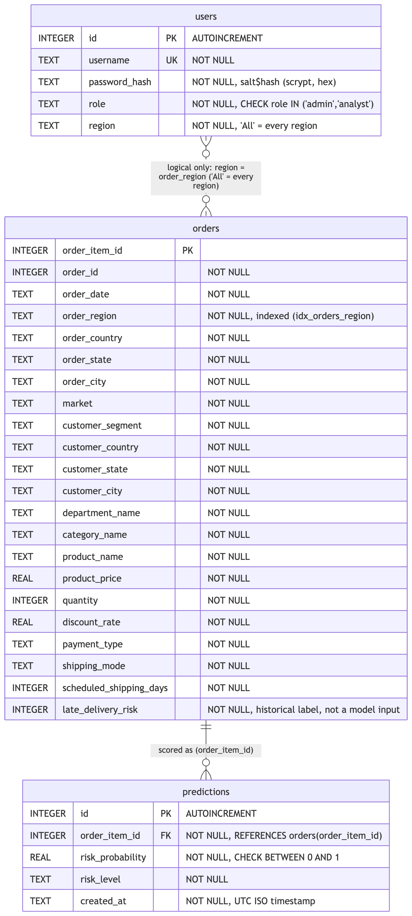
The database data/app.db has three tables:
- users (id, username, password_hash, role, region). The username is unique, and the role must be admin or analyst.
- orders (order_item_id as primary key, plus the 21 other columns of the clean dataset). There is an index on order_region.
- predictions (id, order_item_id, risk_probability, risk_level, created_at). order_item_id is a foreign key to orders, and the probability must be between 0 and 1.
One order item can have zero or more predictions. The link between users.region and orders.order_region is logical only; it is enforced in the query code.

10.3 Data Flow Diagrams (DFD)
Figure 15: DFD Level 0 (context diagram) (reports/figures/diagrams/dfd_level0.png)
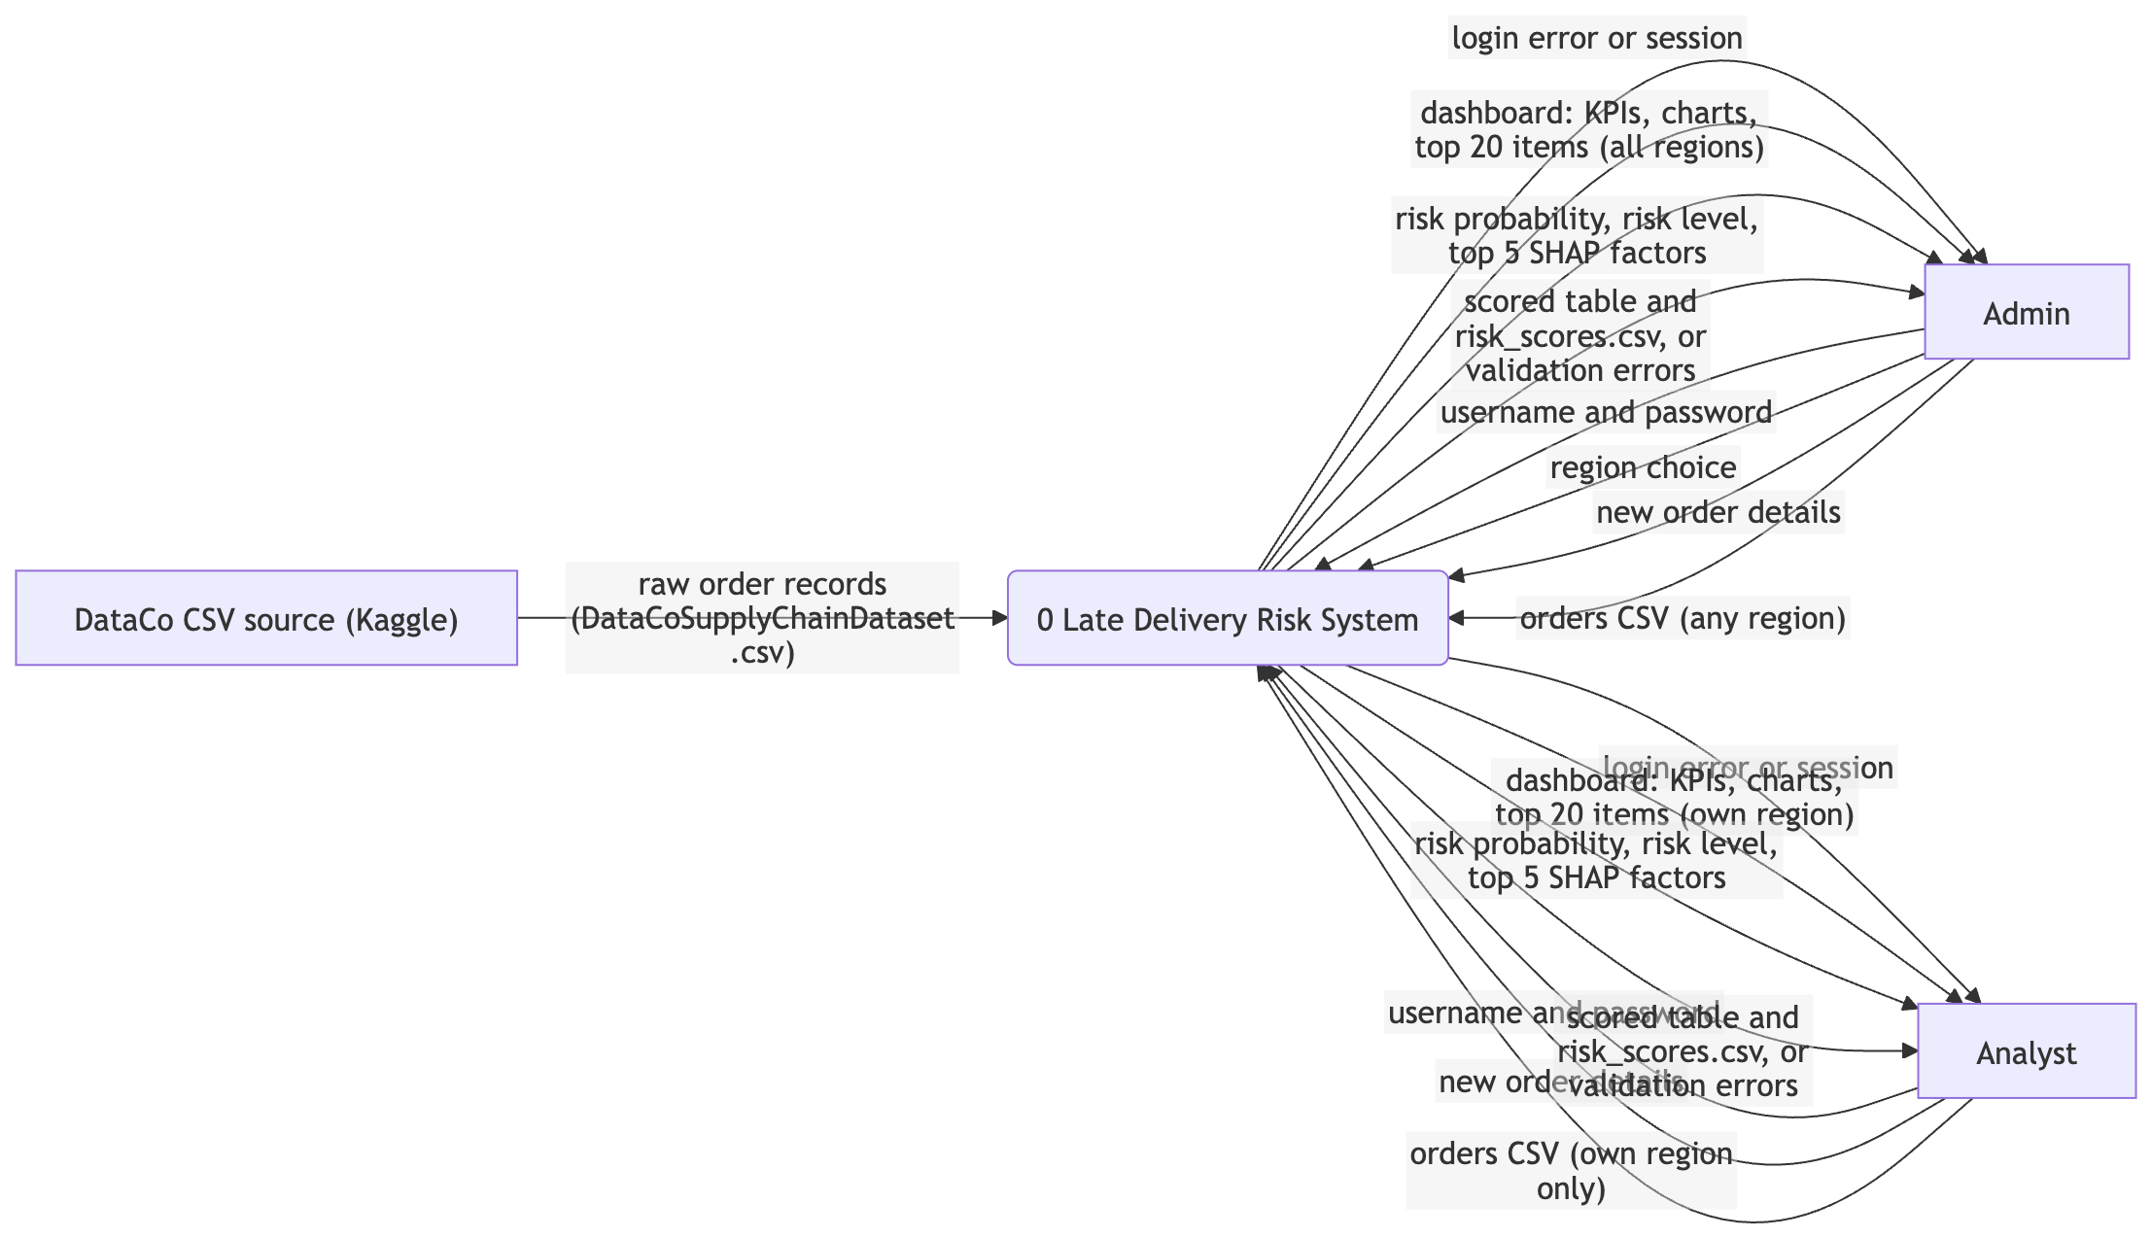
Figure 16: DFD Level 1 (reports/figures/diagrams/dfd_level1.png)
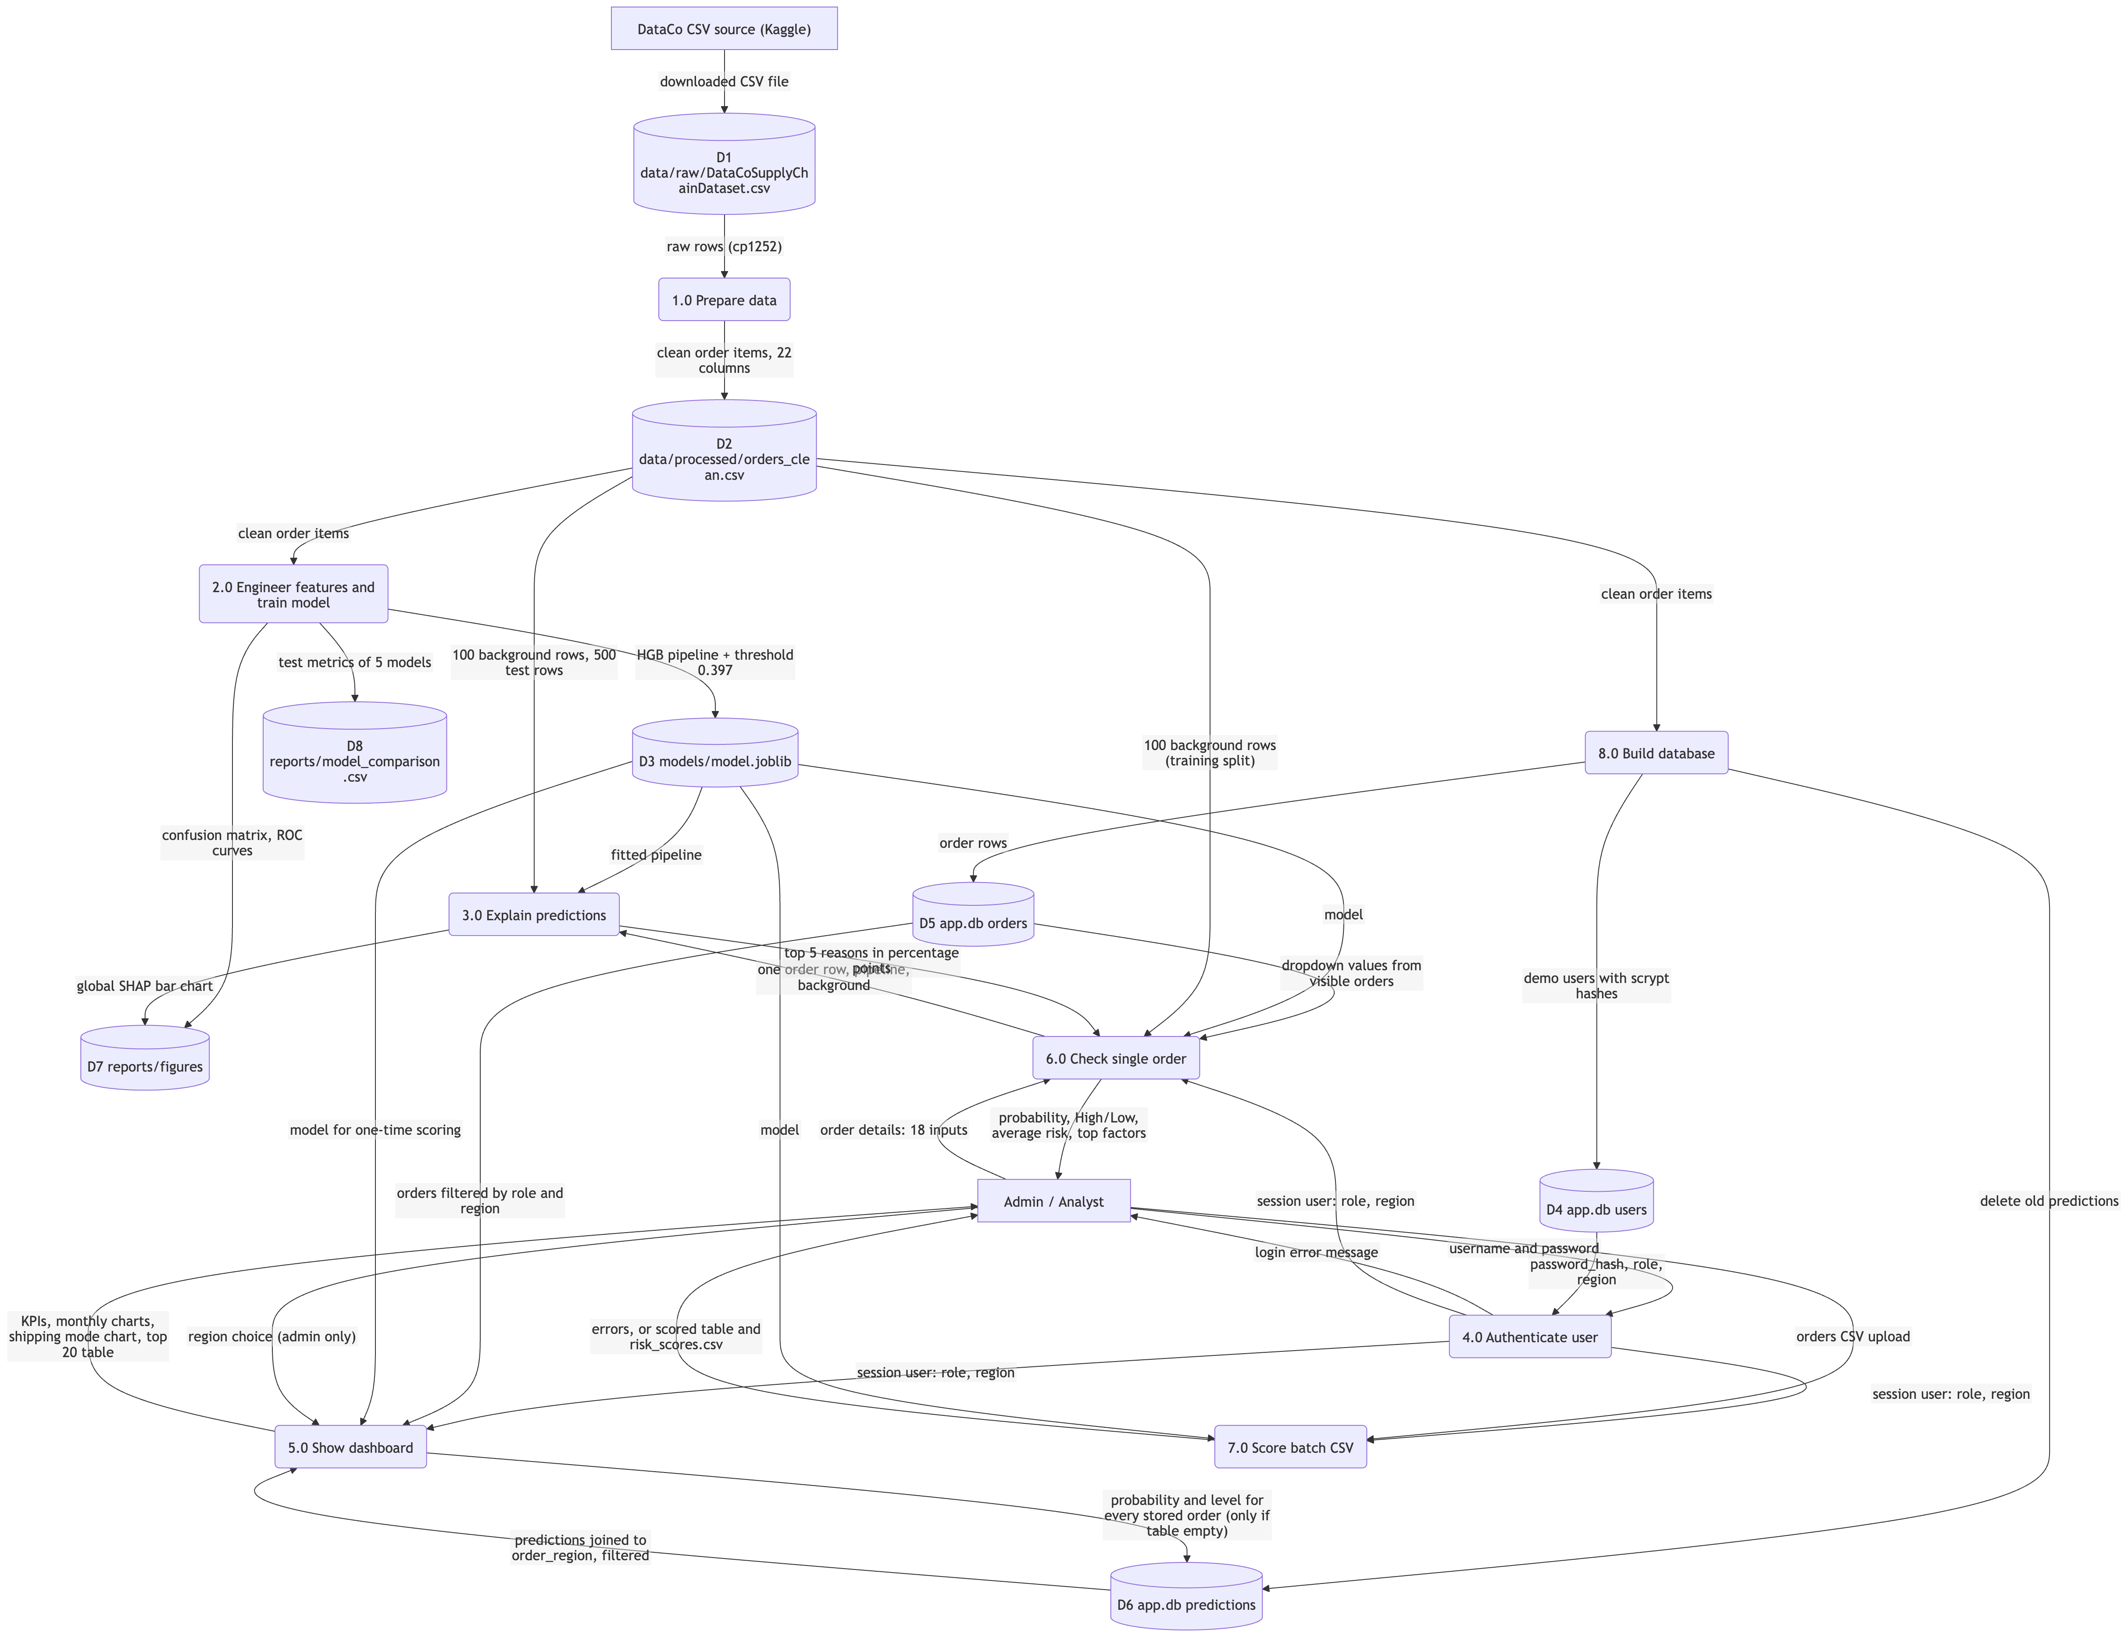
At Level 0, the system exchanges data with three external entities:
- the DataCo CSV source, which provides the raw order records
- the admin
- the analyst
Admins and analysts send login details, order details and CSV files, and receive dashboards, risk scores, explanations and scored files.
Level 1 breaks the system into eight processes:
- prepare data
- engineer features and train the model
- explain predictions
- authenticate the user
- show the dashboard
- check a single order
- score a batch CSV
- build the database
These processes read and write eight data stores: the raw CSV, the clean CSV, the model file, the users, orders and predictions tables, the figures, and the model comparison table.
The system architecture and the ML pipeline flow are shown in sections 4.3 and 6 (Figures 1 and 3).

10.4 Input and Output Screen Design
The application has four screens and a sidebar. The screenshots below go in reports/figures/screenshots/.
Figure 17: Login screen (input)
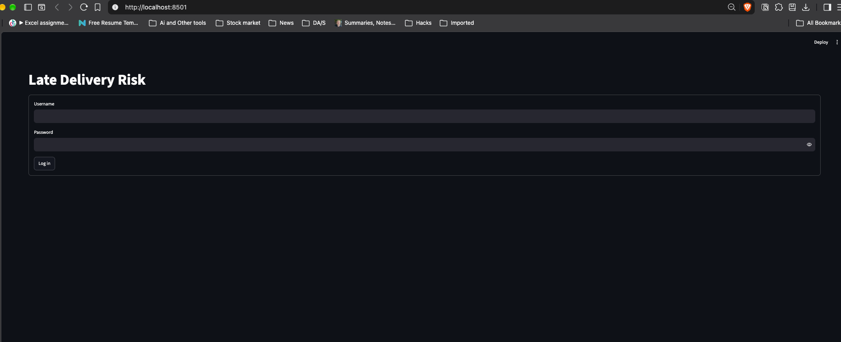
- Inputs: Username, Password (hidden) and a Log in button.
- Output on failure: “Wrong username or password.” The same message is shown for an unknown user and for a wrong password.
Figure 18: Risk dashboard, admin view (output)
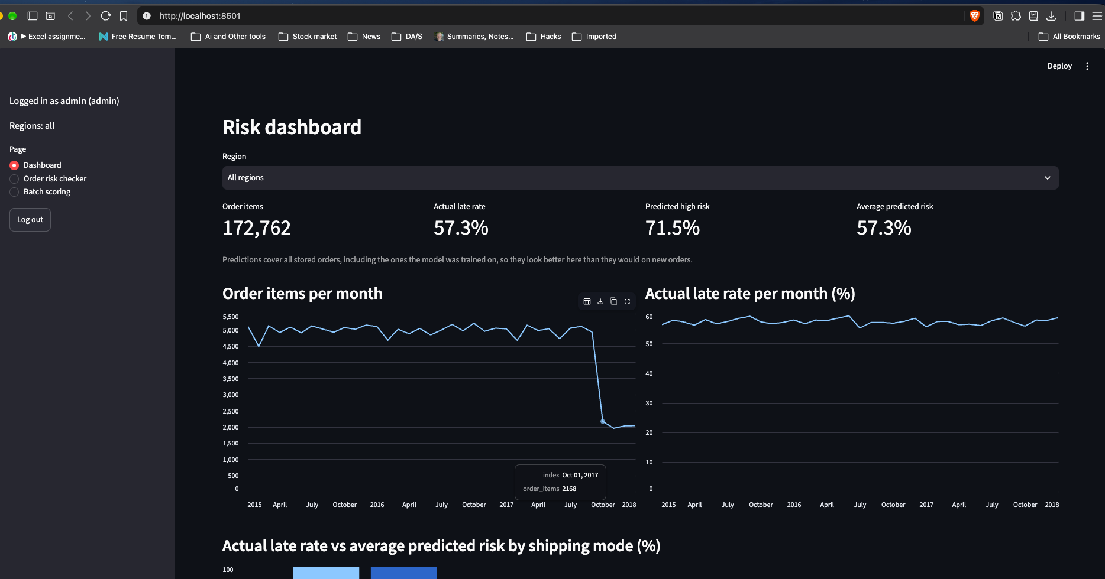
Figure 19: Risk dashboard, analyst view (output)
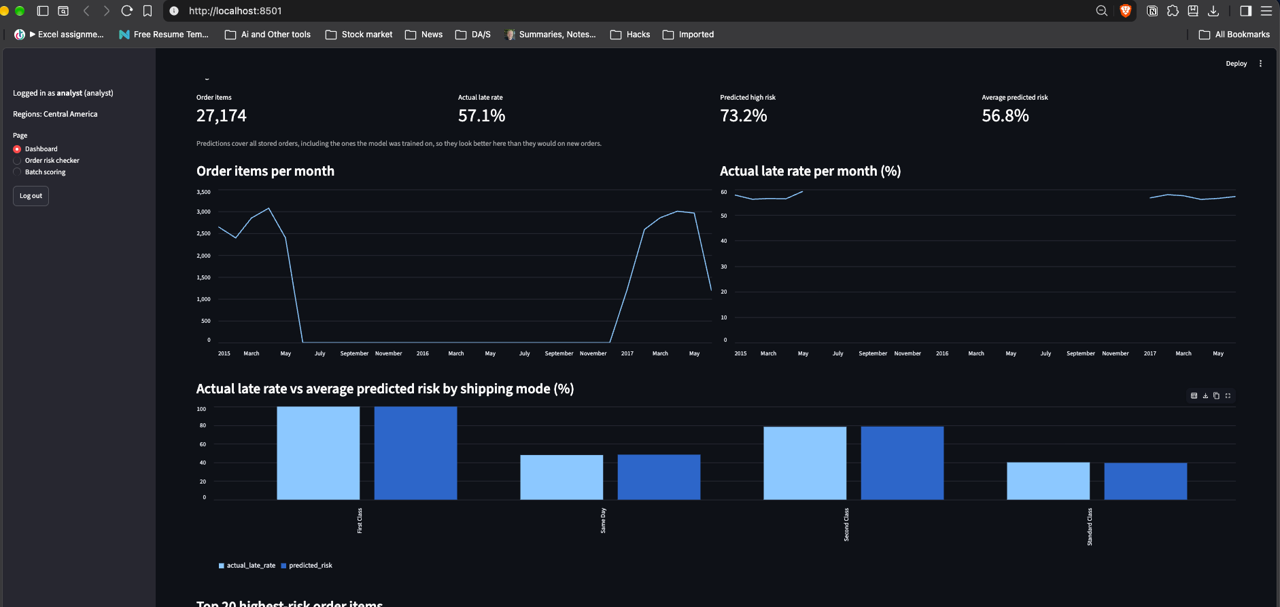
The dashboard shows:
- Four KPIs: order items, actual late rate, predicted high risk, and average predicted risk.
- Two monthly line charts: order items per month, and the actual late rate per month. Months without orders appear as gaps.
- A bar chart: actual late rate against average predicted risk by shipping mode.
- A table: the 20 highest-risk order items.
The two roles see different data:
- Admin: has a Region drop-down (“All regions” or one region). In the running application on 2026-09-28, the admin’s all-regions view showed 172,762 order items, an actual late rate of 57.3%, 71.5% predicted high risk and an average predicted risk of 57.3%.
- Analyst: sees only “Region: Central America”. The same day, the analyst’s view showed 27,174 order items, an actual late rate of 57.1%, 73.2% predicted high risk and an average predicted risk of 56.8%.
Figure 20: Order risk checker (input and output)
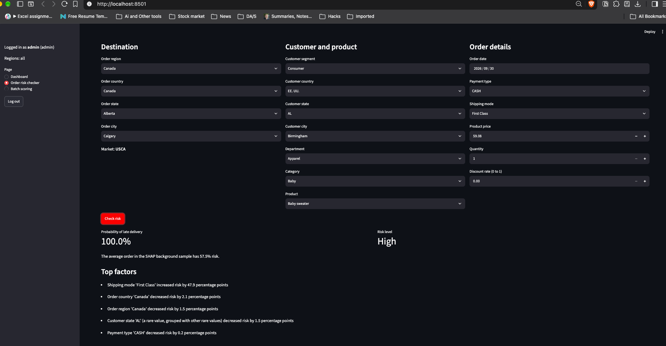
- Inputs: linked drop-downs, in three groups:
  - Destination: order region, then country, state and city (the market is shown automatically)
  - Customer and product: segment; customer country, state and city; department, then category and product
  - Order details: order date, payment type, shipping mode, product price, quantity and discount rate
- Action: a Check risk button.
- Outputs:
  - the probability of late delivery
  - the risk level (High or Low)
  - the average risk of the background sample
  - the top five factors, in percentage points
Figure 21: Batch scoring (input and output)
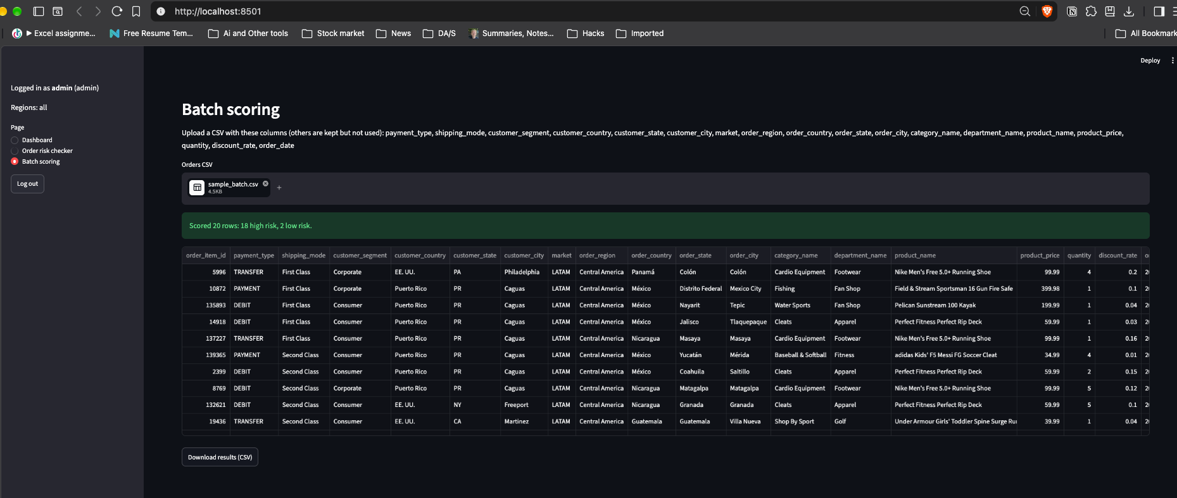
- Input: a CSV file with the 18 required columns. docs/sample_batch.csv is a 20-row example that passes validation.
- Output: either a list of validation errors, or:
  - a summary line (“Scored N rows: H high risk, L low risk.”)
  - the scored table sorted by risk
  - a Download results (CSV) button that saves risk_scores.csv
The sidebar shows the logged-in user and role, the region access, the page choice (Dashboard, Order risk checker, Batch scoring) and a Log out button.

10.5 Methodology Used for Testing
I used pytest for automated testing, and Streamlit’s AppTest (streamlit.testing.v1) to run the real application and log in through its login form. The testing approach was:
- Unit tests for each function, using small hand-made data. They cover data preparation steps, feature engineering, training utilities, database functions and upload validation.
- Data-quality tests on the real clean dataset: no leakage columns, no missing values, unique order item IDs and a binary target.
- Leakage tests:
  - no leakage, target or ID column is in the feature list
  - no order appears in both the training and test sets
- Security tests:
  - passwords are stored only as salted hashes
  - wrong passwords and SQL-injection usernames are rejected
  - analysts see only their own region, including an analyst whose region text is “All”
  - uploads with rows from another region are rejected
- Integration tests with AppTest: the real application is logged into as the demo analyst and admin. The database is opened read-only, so tests cannot change it.
- Negative tests: invalid inputs must raise errors or be rejected. Examples are missing columns, invalid dates, text prices, quantities of 0 or 2.5, discounts outside 0 to 1, infinite prices, unknown order items and out-of-range probabilities.
- Test isolation: tests use temporary files and databases (pytest tmp_path) and never write to project data, models or figures. The full model training is not run in the tests because it is too slow; its functions are tested on small synthetic data.
When a test revealed a defect, the test was first kept as an expected failure with the reason recorded. After the fix, it became a normal passing test.

10.6 Test Report
The full test report, with one row per test, is in docs/test-report.md. Summary of the final run on 2026-09-30:
Table 10.1: Test summary
Module | Test file | Tests | Passed
src/data_prep.py | tests/test_data_prep.py | 19 | 19
src/features.py | tests/test_features.py | 10 | 10
src/train.py | tests/test_train.py | 14 | 14
src/db.py | tests/test_db.py | 37 | 37
src/explain.py | tests/test_explain.py | 3 | 3
app.py (validation, scoring, access control) | tests/test_app_logic.py | 24 | 24
Total |  | 107 | 107
pytest result: 107 passed, 3 warnings in 13.69s. The warnings come from inside the shap library, not from project code.
Defects found and fixed:
ID | Defect | Fix | Verified by
KI-1 | The batch upload accepted a product price of “inf” (infinity) and scored the row. | Infinite values in numeric columns are treated as invalid, so the file is rejected. | AP-15
KI-2 | If saving a batch of predictions failed part-way, the rows saved before the error stayed pending and could be committed later. | The batch insert runs in a transaction that is rolled back on error. | DB-35
Checked manually, not by automated tests:
- the file-upload widget and the download button
- the visual rendering of the charts
- the full order-risk-checker flow in the browser
- the Log out button
- a full model training run
The application was checked by hand in the running Streamlit app on 2026-09-28.

11. User / Operational Manual (Summary)
The full manual is docs/user-manual.md. This section summarises it.
Installation and start. Follow docs/setup.md from the project root:
- Create the virtual environment and install requirements.txt.
- Place the dataset in data/raw/.
- Run src.data_prep, src.train and src.db with .venv/bin/python.
- Start the application with .venv/bin/streamlit run app.py. It opens at http://localhost:8501.
If a required file is missing, the application names it and lists the commands to run.
Logging in. The demo accounts are admin, which sees all regions, and analyst, which sees Central America. Their default passwords apply only to local demos and can be replaced with the environment variables DEMO_ADMIN_PASSWORD and DEMO_ANALYST_PASSWORD when the database is built.
Using the screens.
- Dashboard: read the KPIs and trends. Admins can choose a region.
- Order risk checker: describe a new order and press Check risk. The explanation takes about 3 seconds.
- Batch scoring: upload a CSV with the 18 required columns and download the results. Batch results are not saved in the database.
Access rights.
Capability | Admin | Analyst
Dashboard data | All regions | Own region only (filtered in the SQL query)
Region selector | Yes | No
Risk checker choices | All orders | Own-region orders only
Batch scoring | Any region | Own region only; otherwise the file is rejected
User management in the app | No | No
Security controls.
- salted scrypt password hashes
- constant-time password comparison
- the same error message for an unknown user and a wrong password
- role-based filtering inside the SQL queries
- parameterized SQL only
- database constraints (unique username, allowed roles, probability between 0 and 1, foreign keys)
- validation of uploaded files
- local-only operation
The system does not have account lockout, a password-change screen or a login audit log.
Backup. The application has no built-in backup. Stop the application and copy data/app.db, models/model.joblib and data/processed/orders_clean.csv to a backup folder. These files are git-ignored. To restore, copy them back and restart the application.
Troubleshooting. The manual explains each message the user can see:
- missing files
- a wrong username or password
- a rejected upload and its reasons
- a file that cannot be read
- gaps in the monthly charts
- a slow first page after a database rebuild

12. Limitations and Future Scope

12.1 Limitations
- The model is dominated by shipping mode. The full model (test ROC-AUC 0.732) does not rank orders better than a baseline that uses only the shipping mode (0.739). Every First Class item is labelled late (26,512 of 26,512), so the label mostly reflects how delivery times are scheduled for each mode.
- There are many false alarms. At the chosen threshold, precision is 0.633: about 37% of High-risk flags are on-time deliveries.
- The data is historical and has gaps. It covers January 2015 to January 2018, and some regions have months without orders. For example, Central America has none from June 2015 to December 2016.
- The dashboard’s predictions include training orders. Its predicted-risk figures are therefore more favourable than they would be on new orders. The dashboard shows a caption saying so.
- The system is local and single-user in practice. It is not connected to a live order system. If two sessions open the application at the same moment on a freshly built database, the one-time scoring could run twice.
- Explanations are slow. One explanation takes about 3 seconds, because the correct method (PermutationExplainer) is slower than the tree-specific one.
- User management is limited. There is no screen for adding users or changing passwords, and there is no account lockout or audit log.
- Some rare values are treated as missing. Categories seen fewer than 500 times in training are grouped, and a value never seen in training is treated as missing by the tree model. The explanation text does not yet flag the unseen case.

12.2 Future Scope
The following are proposals. None of them is implemented.
- Add features that describe delays beyond the shipping mode. Examples are carrier, warehouse or origin, and distance, collected at order time, to increase the model’s signal.
- Use cost-based thresholds. With real costs for a missed late delivery and a false alarm, choose the threshold that minimises total expected cost.
- Calibrate probabilities and add more risk levels. Calibrate the predicted probabilities and consider three risk levels (Low, Medium, High) once a second cut-off can be justified.
- Monitor and retrain. Track recall and the late rate on new orders, and retrain automatically when they drift.
- Integrate with order systems. Score orders directly from an order-management system instead of through CSV upload.
- Strengthen security and administration. Add account lockout, a password-change screen, a user-management screen for admins, and an audit log.
- Speed up explanations. Cache explanations for repeated orders, or use a faster exact method if one becomes available for native categorical splits.
- Serve more users. Move from SQLite to a server database and deploy the application for multiple concurrent users.

13. Conclusion
In this project I built a complete, locally running system that predicts, at the time an order is placed, the risk that an order item will be delivered late, and explains each prediction.
- Data: starting from 180,519 raw rows and 53 columns, I produced a clean dataset of 172,762 order items. It contains only information known at order time, with every post-shipping column excluded and the exclusion checked by tests.
- Model: a HistGradientBoosting model with a threshold of 0.397, chosen on training data only, catches 79.5% of late deliveries in the untouched test set, with precision 0.633 and ROC-AUC 0.732.
- Explanations: SHAP explanations, verified to add up to the model’s output, show that shipping mode is by far the most important factor. This finding is useful in itself for the business.
- Application: the Streamlit application makes the model usable for two roles, with hashed passwords, parameterized SQL, region-level access and validated uploads.
- Testing: 107 automated tests pass, and the two defects they found were fixed.
The main strengths of the work are the systematic prevention of data leakage, the business-driven threshold, the correctness check on the explanations, and the tested role-based application. The most important lesson for me was that a model’s score means little until I know where the signal comes from. Comparing the models against simple baselines showed that shipping mode alone explains most of the result, and checking each column against the time at which it becomes known kept leaked information out of the model. I also learned to choose a decision threshold from the business cost of each type of error instead of accepting the default, and to test an explanation method before trusting it. What makes the system stand out, in my view, is that every prediction comes with a reason in plain language and that each user sees only the data their role allows.

Annexures

Annexure 1: Brief Background of the Organization
NA. The project was not developed for an organization. It is an academic project that uses a public dataset.

Annexure 2: Data Dictionary
Type is given as Numeric, Alpha, Date or Binary, as the university format requires. “Length” is the maximum text length in the raw data (before spaces were stripped) for Alpha fields, or the storage size in the SQLite database for numbers (8 bytes for SQLite INTEGER and REAL values). “Alias” is the original column name in the raw dataset. The full classification of all 53 raw columns, including excluded and dropped columns and the reasons, is in docs/data-dictionary.md.

A2.1 Orders (clean dataset data/processed/orders_clean.csv and table orders)
# | Data name | Alias (raw column) | Length (size) | Type | Role
1 | order_item_id | Order Item Id | 8 bytes | Numeric (integer) | Key (primary key), not a feature
2 | order_id | Order Id | 8 bytes | Numeric (integer) | Key, used to group the split; not a feature
3 | order_date | order date (DateOrders) | 16 characters (raw text) | Date | Feature (month, weekday, quarter derived)
4 | order_region | Order Region | 15 | Alpha | Feature; also used for access control
5 | order_country | Order Country | 31 | Alpha | Feature
6 | order_state | Order State | 36 | Alpha | Feature
7 | order_city | Order City | 35 | Alpha | Feature
8 | market | Market | 12 | Alpha | Feature
9 | customer_segment | Customer Segment | 11 | Alpha | Feature
10 | customer_country | Customer Country | 11 | Alpha | Feature
11 | customer_state | Customer State | 5 | Alpha | Feature
12 | customer_city | Customer City | 20 | Alpha | Feature
13 | department_name | Department Name | 18 | Alpha | Feature
14 | category_name | Category Name | 20 | Alpha | Feature
15 | product_name | Product Name | 45 | Alpha | Feature
16 | product_price | Order Item Product Price | 8 bytes | Numeric (decimal) | Feature
17 | quantity | Order Item Quantity | 8 bytes | Numeric (integer) | Feature
18 | discount_rate | Order Item Discount Rate | 8 bytes | Numeric (decimal) | Feature
19 | payment_type | Type | 8 | Alpha | Feature
20 | shipping_mode | Shipping Mode | 14 | Alpha | Feature
21 | scheduled_shipping_days | Days for shipment (scheduled) | 8 bytes | Numeric (integer) | Kept, but not a model input (one-to-one with shipping_mode)
22 | late_delivery_risk | Late_delivery_risk | 8 bytes | Binary (0/1) | Target (historical outcome; never a model input)
Derived model features (not stored): order_month (Numeric, 1 to 12), order_weekday (Numeric, 0 = Monday to 6), order_quarter (Numeric, 1 to 4). All three are treated as categories by the model.

A2.2 Table users
# | Data name | Alias | Length (size) | Type | Description
1 | id | NA | 8 bytes | Numeric (integer) | Primary key, auto-increment
2 | username | NA | NA (variable text) | Alpha | Unique login name
3 | password_hash | NA | 161 characters (32 hex characters of salt + “$” + 128 hex characters of hash) | Alpha | Salted scrypt hash; never the plain password
4 | role | NA | NA (variable text) | Alpha | admin or analyst (database CHECK)
5 | region | NA | NA (variable text) | Alpha | All for admin, or one order region

A2.3 Table predictions
# | Data name | Alias | Length (size) | Type | Description
1 | id | NA | 8 bytes | Numeric (integer) | Primary key, auto-increment
2 | order_item_id | NA | 8 bytes | Numeric (integer) | Foreign key to orders.order_item_id
3 | risk_probability | NA | 8 bytes | Numeric (decimal) | Predicted probability of late delivery, 0 to 1 (database CHECK)
4 | risk_level | NA | NA (variable text) | Alpha | High (probability ≥ 0.397) or Low
5 | created_at | NA | 32 characters | Date (text, UTC ISO 8601) | Time the prediction was saved

Annexure 3: List of Abbreviations, Figures and Tables

A3.1 Abbreviations
Abbreviation | Meaning
AI | Artificial Intelligence
API | Application Programming Interface
AUC | Area Under the Curve
CSV | Comma-Separated Values
CV | Cross-Validation
DFD | Data Flow Diagram
ERD | Entity Relationship Diagram
FK | Foreign Key
FN / FP | False Negative / False Positive
GPU | Graphics Processing Unit
HGB | HistGradientBoosting (scikit-learn HistGradientBoostingClassifier)
KPI | Key Performance Indicator
LLM | Large Language Model
ML | Machine Learning
PERT | Program Evaluation and Review Technique
PK | Primary Key
RBAC | Role-Based Access Control
ROC | Receiver Operating Characteristic
SHAP | SHapley Additive exPlanations
SQL | Structured Query Language
TN / TP | True Negative / True Positive
UTC | Coordinated Universal Time
venv | Python virtual environment

A3.2 List of Figures
Figure | Title | File
1 | System architecture | reports/figures/diagrams/architecture.png
2 | PERT chart | reports/figures/diagrams/pert.png
3 | ML pipeline flow | reports/figures/diagrams/ml_pipeline.png
4 | Overall late delivery rate | reports/figures/01_late_rate_overall.png
5 | Late rate by shipping mode | reports/figures/02_late_rate_by_shipping_mode.png
6 | Late rate by market and region | reports/figures/03_late_rate_by_market_region.png
7 | Late rate by product category | reports/figures/04_late_rate_by_category.png
8 | Late rate by customer segment | reports/figures/05_late_rate_by_customer_segment.png
9 | Late rate by order month | reports/figures/06_late_rate_by_order_month.png
10 | Late rate by scheduled shipping days | reports/figures/07_late_rate_by_scheduled_days.png
11 | Confusion matrix of the final model | reports/figures/08_confusion_matrix.png
12 | ROC curves of the models | reports/figures/09_roc_curves.png
13 | Global SHAP feature importance | reports/figures/10_shap_global_importance.png
14 | Entity Relationship Diagram | reports/figures/diagrams/erd.png
15 | DFD Level 0 | reports/figures/diagrams/dfd_level0.png
16 | DFD Level 1 | reports/figures/diagrams/dfd_level1.png
17 | Login screen | reports/figures/screenshots/login.png
18 | Risk dashboard, admin view | reports/figures/screenshots/dashboard_admin.png
19 | Risk dashboard, analyst view | reports/figures/screenshots/dashboard_analyst.png
20 | Order risk checker | reports/figures/screenshots/risk_checker.png
21 | Batch scoring | reports/figures/screenshots/batch_scoring.png

A3.3 List of Tables
Tables shown with a dash are not numbered in the text; they are identified by their location.
Table | Title | Location
– | Software used (synopsis) | Part 1, Synopsis section 6
– | Late rate by shipping mode | Part 1, section 2.1
– | Confusion matrix (theory example) | Part 1, section 2.5
4.1 | Functional requirements | Part 2, section 4.1
4.2 | Non-functional requirements | Part 2, section 4.1
– | Column classification summary | Part 2, section 4.2
– | Design decisions | Part 2, section 4.3
5.1 | PERT activities | Part 2, section 5.1
– | Code organisation | Part 2, section 7.2
– | Hardware used | Part 2, section 7.3
– | Software used | Part 2, section 7.4
8.1 | Model comparison | Part 3, section 8.1
8.2 | Confusion matrix of the final model | Part 3, section 8.3
– | System maintenance tasks | Part 3, section 8.5
– | Costs and benefits | Part 3, section 9
– | Life cycle phases | Part 3, section 10.1
10.1 | Test summary | Part 3, section 10.6
– | Access rights | Part 3, section 11
– | Data dictionary tables A2.1 to A2.3 | Annexure 2

Annexure 4: References

Bibliography
[1] F. Constante, F. Silva and A. Pereira, “DataCo SMART SUPPLY CHAIN FOR BIG DATA ANALYSIS”, Mendeley Data, Version 5, 2019. DOI: 10.17632/8gx2fvg2k6.5. The copy used in this project was downloaded from Kaggle (“DataCo Smart Supply Chain for Big Data Analysis”).
[2] F. Pedregosa, G. Varoquaux, A. Gramfort, V. Michel, B. Thirion, O. Grisel, M. Blondel, P. Prettenhofer, R. Weiss, V. Dubourg, J. Vanderplas, A. Passos, D. Cournapeau, M. Brucher, M. Perrot and É. Duchesnay, “Scikit-learn: Machine Learning in Python”, Journal of Machine Learning Research, vol. 12, 2011, pp. 2825–2830.
[3] S. M. Lundberg and S.-I. Lee, “A Unified Approach to Interpreting Model Predictions”, Advances in Neural Information Processing Systems 30 (NIPS 2017), 2017, pp. 4765–4774.

Websites (library documentation)
All websites were accessed in September 2026.
[4] pandas documentation, version 3.0.6. https://pandas.pydata.org/docs/
[5] NumPy documentation, version 2.5.3. https://numpy.org/doc/
[6] scikit-learn documentation, version 1.9.1. https://scikit-learn.org/stable/ The relevant pages are the user guide sections on logistic regression, histogram-based gradient boosting and common pitfalls (data leakage), and the reference pages for HistGradientBoostingClassifier, FixedThresholdClassifier, StratifiedGroupKFold and GridSearchCV.
[7] SHAP documentation, version 0.52.0. https://shap.readthedocs.io/ The relevant page is PermutationExplainer.
[8] Matplotlib documentation, version 3.11.2. https://matplotlib.org/stable/
[9] joblib documentation, version 1.6.0. https://joblib.readthedocs.io/
[10] Streamlit documentation, version 1.64.0. https://docs.streamlit.io/ The relevant pages include streamlit.testing.v1.AppTest.
[11] pytest documentation, version 9.1.1. https://docs.pytest.org/
[12] Python standard library documentation, Python 3.12: sqlite3, hashlib.scrypt and hmac.compare_digest. https://docs.python.org/3.12/library/

Annexure 5: Soft Copy of the Project
https://github.com/vijayanand0502-hue/ai-commercial-insights-logistics

Annexure 6: Guide Details
Item | Details
Guide name | Aamir Ahmed Khan
Full address | 114 Heeranagar A, near 200 feet bypass, ajmer road, Jaipur - 302021, Rajasthan
Qualification | M.Tech,MBA
Mobile | 96023 25939
Email | aamir.ahmed.khan@maersk.com

Annexure 7: Certificate from Guide (Annexure A format)
CERTIFICATE FROM GUIDE
This is to certify that this project entitled “AI-Driven Late Delivery Risk Prediction and Explainable Insights System for Logistics” submitted in partial fulfillment of the degree of M.Sc (Data Science) to Chandigarh University done by Mr. Vijay Anand E, Roll No. O23MSD110005 is an authentic work carried out by him under my guidance. The matter embodied in this project’
work has not been submitted earlier for award of any degree or diploma to the best of my knowledge and belief.
Signature of the student | Signature of the Guide

Annexure: Printout of the Code
The source code below is copied automatically from the project files, one block per file.

src/__init__.py
src/__init__.py is empty (it only marks src as a Python package).

src/data_prep.py
201 lines.
"""Data preparation for the late delivery risk project.
Loads the raw DataCo Smart Supply Chain CSV, removes orders that never shipped,
drops leakage, personal-data and redundant columns, tidies text and column names,
parses the order date, checks for missing values, and saves a clean CSV.
Run from the project root: python -m src.data_prep
"""
from pathlib import Path
import pandas as pd
PROJECT_ROOT = Path(__file__).resolve().parent.parent
RAW_FILE = PROJECT_ROOT / "data" / "raw" / "DataCoSupplyChainDataset.csv"
PROCESSED_FILE = PROJECT_ROOT / "data" / "processed" / "orders_clean.csv"
# The file is Windows-1252, not UTF-8; latin-1 would garble names like "Šiauliai".
RAW_ENCODING = "cp1252"
# Cancelled and suspected-fraud orders never shipped, so their "not late" label is meaningless.
NEVER_SHIPPED_STATUSES = ["CANCELED", "SUSPECTED_FRAUD"]
# Recorded after shipping or delivery; using them would leak the outcome.
LEAKAGE_COLUMNS = [
"Days for shipping (real)",
"Delivery Status",
"shipping date (DateOrders)",
"Order Status",
]
# Profit may include costs known only after delivery; excluded because the timing is uncertain.
UNCERTAIN_TIMING_COLUMNS = [
"Benefit per order",
"Order Profit Per Order",
"Order Item Profit Ratio",
]
# Personal data or precise locations; city, state and region already describe location.
PERSONAL_COLUMNS = [
"Customer Fname",
"Customer Lname",
"Customer Street",
"Customer Zipcode",
"Customer Email",
"Customer Password",
"Latitude",
"Longitude",
]
# Numeric codes that duplicate a name column (or each other) and carry no extra meaning.
IDENTIFIER_COLUMNS = [
"Customer Id",
"Order Customer Id",
"Product Card Id",
"Order Item Cardprod Id",
"Category Id",
"Product Category Id",
"Department Id",
]
# Exact copies or exact formulas of columns we keep.
DUPLICATE_COLUMNS = [
"Product Price", # same as Order Item Product Price
"Sales per customer", # same as Order Item Total
"Sales", # equals price x quantity
"Order Item Total", # equals price x quantity - discount
"Order Item Discount", # equals price x quantity x discount rate
]
# Empty, mostly empty, constant, or a URL.
NO_INFORMATION_COLUMNS = [
"Product Description", # 100% missing
"Order Zipcode", # 86% missing
"Product Status", # always 0
"Product Image", # image URL
]
# Every column we keep, with a short snake_case name that is easy to use in code and SQL.
KEEP_AND_RENAME = {
"Order Id": "order_id", # database key and split group, not a feature
"Order Item Id": "order_item_id", # database key, not a feature
"Late_delivery_risk": "late_delivery_risk", # target
"Type": "payment_type",
"Days for shipment (scheduled)": "scheduled_shipping_days",
"Shipping Mode": "shipping_mode",
"order date (DateOrders)": "order_date",
"Customer Segment": "customer_segment",
"Customer Country": "customer_country",
"Customer State": "customer_state",
"Customer City": "customer_city",
"Market": "market",
"Order Region": "order_region",
"Order Country": "order_country",
"Order State": "order_state",
"Order City": "order_city",
"Category Name": "category_name",
"Department Name": "department_name",
"Product Name": "product_name",
"Order Item Product Price": "product_price",
"Order Item Quantity": "quantity",
"Order Item Discount Rate": "discount_rate",
}
def load_raw(path=RAW_FILE):
"""Read the raw DataCo CSV with the correct encoding."""
return pd.read_csv(path, encoding=RAW_ENCODING)
def drop_rows_and_columns(df):
"""Remove never-shipped orders, then drop every approved column."""
# Filter rows first, because Order Status is itself dropped below.
df = df[~df["Order Status"].isin(NEVER_SHIPPED_STATUSES)]
columns_to_drop = (
LEAKAGE_COLUMNS
+ UNCERTAIN_TIMING_COLUMNS
+ PERSONAL_COLUMNS
+ IDENTIFIER_COLUMNS
+ DUPLICATE_COLUMNS
+ NO_INFORMATION_COLUMNS
)
return df.drop(columns=columns_to_drop)
def strip_text(df):
"""Remove leading/trailing spaces so 'Oceania ' and 'Oceania' are one category."""
df = df.copy()
for column in df.select_dtypes(include=["object", "string"]).columns:
df[column] = df[column].str.strip()
return df
def rename_columns(df):
"""Rename kept columns to snake_case; fail if a column is unreviewed or missing."""
unexpected = set(df.columns) - set(KEEP_AND_RENAME)
if unexpected:
# Guards against a column slipping into the features without a leakage review.
raise ValueError(f"Columns not in the approved list: {sorted(unexpected)}")
missing = set(KEEP_AND_RENAME) - set(df.columns)
if missing:
# rename() would silently skip these, so fail here instead of later.
raise ValueError(f"Approved columns missing from the data: {sorted(missing)}")
return df.rename(columns=KEEP_AND_RENAME)
def drop_bad_states(df):
"""Drop rows whose customer_state is a zip code (shifted rows in the raw file)."""
# Their other columns may be shifted too, so we drop them rather than guess the state.
return df[~df["customer_state"].str.isdigit()]
def parse_dates(df):
"""Convert order_date from text like '1/31/2018 22:56' to a datetime."""
df = df.copy()
# An explicit format is faster and fails loudly on unexpected values.
df["order_date"] = pd.to_datetime(df["order_date"], format="%m/%d/%Y %H:%M")
return df
def check_missing(df):
"""Fail if any value is missing (none are expected)."""
# All columns that had gaps were dropped above, so silently dropping rows would hide a problem.
missing_counts = df.isna().sum()
if missing_counts.any():
raise ValueError(f"Unexpected missing values:\n{missing_counts[missing_counts > 0]}")
def save_processed(df, path=PROCESSED_FILE):
"""Save the clean data as a UTF-8 CSV in data/processed/."""
path.parent.mkdir(parents=True, exist_ok=True)
df.to_csv(path, index=False)
def load_processed(path=PROCESSED_FILE):
"""Read the clean CSV; CSV stores dates as text, so order_date is parsed again here."""
return pd.read_csv(path, parse_dates=["order_date"])
def main():
"""Run the full preparation pipeline and print row counts at each step."""
df = load_raw()
print(f"Loaded: {len(df):,} rows, {df.shape[1]} columns")
df = drop_rows_and_columns(df)
print(f"After drops: {len(df):,} rows, {df.shape[1]} columns")
df = rename_columns(strip_text(df))
df = parse_dates(df)
rows_before = len(df)
df = drop_bad_states(df)
print(f"Bad-state rows removed: {rows_before - len(df)}")
check_missing(df)
save_processed(df)
print(f"Saved: {len(df):,} rows, {df.shape[1]} columns -> {PROCESSED_FILE}")
if __name__ == "__main__":
main()

src/db.py
256 lines.
"""SQLite database for the late delivery risk app.
Three tables:
users login accounts with a salted scrypt password hash, a role and a region
orders the cleaned order items from data/processed/orders_clean.csv
predictions model scores saved by the app, linked to orders by order_item_id
Every query uses "?" placeholders, never string formatting, so user input
cannot change the SQL (no SQL injection).
Run from the project root: python -m src.db
"""
import hashlib
import hmac
import os
import sqlite3
from datetime import datetime, timezone
from pathlib import Path
import pandas as pd
from src.data_prep import PROCESSED_FILE
PROJECT_ROOT = Path(__file__).resolve().parent.parent
DB_FILE = PROJECT_ROOT / "data" / "app.db"
# An admin's region is stored as ALL_REGIONS and means "no region filter".
ALL_REGIONS = "All"
# Largest order_region by row count (27,174 of 172,762 rows).
ANALYST_REGION = "Central America"
# scrypt settings: n = CPU/memory cost, r = block size, p = parallelism.
# These are the commonly recommended interactive-login values (about 16 MB of memory per hash).
SCRYPT_N = 2**14
SCRYPT_R = 8
SCRYPT_P = 1
SALT_BYTES = 16
SCHEMA = """
CREATE TABLE IF NOT EXISTS users (
id INTEGER PRIMARY KEY AUTOINCREMENT,
username TEXT NOT NULL UNIQUE,
password_hash TEXT NOT NULL,
role TEXT NOT NULL CHECK (role IN ('admin', 'analyst')),
region TEXT NOT NULL
);
CREATE TABLE IF NOT EXISTS orders (
order_item_id INTEGER PRIMARY KEY,
order_id INTEGER NOT NULL,
order_date TEXT NOT NULL,
order_region TEXT NOT NULL,
order_country TEXT NOT NULL,
order_state TEXT NOT NULL,
order_city TEXT NOT NULL,
market TEXT NOT NULL,
customer_segment TEXT NOT NULL,
customer_country TEXT NOT NULL,
customer_state TEXT NOT NULL,
customer_city TEXT NOT NULL,
department_name TEXT NOT NULL,
category_name TEXT NOT NULL,
product_name TEXT NOT NULL,
product_price REAL NOT NULL,
quantity INTEGER NOT NULL,
discount_rate REAL NOT NULL,
payment_type TEXT NOT NULL,
shipping_mode TEXT NOT NULL,
scheduled_shipping_days INTEGER NOT NULL,
late_delivery_risk INTEGER NOT NULL
);
CREATE INDEX IF NOT EXISTS idx_orders_region ON orders (order_region);
CREATE TABLE IF NOT EXISTS predictions (
id INTEGER PRIMARY KEY AUTOINCREMENT,
order_item_id INTEGER NOT NULL REFERENCES orders (order_item_id),
risk_probability REAL NOT NULL CHECK (risk_probability BETWEEN 0 AND 1),
risk_level TEXT NOT NULL,
created_at TEXT NOT NULL
);
"""
def get_connection(path=DB_FILE):
"""Open the database. SQLite only enforces foreign keys when this pragma is on."""
conn = sqlite3.connect(path)
conn.execute("PRAGMA foreign_keys = ON")
return conn
def init_db(conn):
"""Create the tables if they do not exist yet."""
conn.executescript(SCHEMA)
conn.commit()
# ---------- passwords ----------
def hash_password(password):
"""Return 'salt$hash' (both hex). A new random salt per user means equal passwords get different hashes."""
salt = os.urandom(SALT_BYTES)
digest = hashlib.scrypt(password.encode("utf-8"), salt=salt, n=SCRYPT_N, r=SCRYPT_R, p=SCRYPT_P)
return f"{salt.hex()}${digest.hex()}"
def check_password(password, stored_hash):
"""Re-hash the password with the stored salt and compare in constant time."""
salt_hex, digest_hex = stored_hash.split("$")
digest = hashlib.scrypt(
password.encode("utf-8"), salt=bytes.fromhex(salt_hex), n=SCRYPT_N, r=SCRYPT_R, p=SCRYPT_P
)
return hmac.compare_digest(digest.hex(), digest_hex)
# Checked against when the username does not exist, so an unknown user takes as long as a wrong password
# and response time does not reveal which usernames exist.
DUMMY_HASH = hash_password("not-a-real-password")
# ---------- users ----------
def add_user(conn, username, password, role, region):
"""Insert a new user. Raises sqlite3.IntegrityError if the username exists or the role is invalid."""
conn.execute(
"INSERT INTO users (username, password_hash, role, region) VALUES (?, ?, ?, ?)",
(username, hash_password(password), role, region),
)
conn.commit()
def verify_user(conn, username, password):
"""Return {'username', 'role', 'region'} if the login is correct, otherwise None."""
row = conn.execute(
"SELECT username, password_hash, role, region FROM users WHERE username = ?",
(username,),
).fetchone()
if row is None:
check_password(password, DUMMY_HASH) # same work as a real check; result ignored
return None
if not check_password(password, row[1]):
return None
return {"username": row[0], "role": row[2], "region": row[3]}
def create_demo_users(conn):
"""Add the admin and analyst demo accounts if they are missing. Passwords come from env vars."""
demo_users = [
("admin", "DEMO_ADMIN_PASSWORD", "admin123", "admin", ALL_REGIONS),
("analyst", "DEMO_ANALYST_PASSWORD", "analyst123", "analyst", ANALYST_REGION),
]
for username, env_var, default_password, role, region in demo_users:
exists = conn.execute("SELECT 1 FROM users WHERE username = ?", (username,)).fetchone()
if exists:
continue
password = os.environ.get(env_var)
if password is None:
print(f"Warning: {env_var} is not set; '{username}' gets the default demo password (docs/setup.md)")
password = default_password
add_user(conn, username, password, role, region)
# ---------- orders ----------
def load_orders(conn, csv_path=PROCESSED_FILE):
"""Replace the orders table contents with the processed CSV. Returns the number of rows loaded."""
df = pd.read_csv(csv_path)
conn.execute("DELETE FROM predictions") # predictions point at orders, so clear them first
conn.execute("DELETE FROM orders")
# to_sql with if_exists="append" keeps our schema and inserts with placeholders.
df.to_sql("orders", conn, if_exists="append", index=False)
conn.commit()
return len(df)
def get_orders(conn, role, region):
"""Return orders as a DataFrame. Admins see every region; anyone else only their own region.
Access is decided by role, not by the region text, so a non-admin with region 'All' sees nothing.
order_date is parsed to a datetime because the date features (month, weekday, quarter) need it.
"""
if role == "admin":
return pd.read_sql_query("SELECT * FROM orders", conn, parse_dates=["order_date"])
return pd.read_sql_query(
"SELECT * FROM orders WHERE order_region = ?", conn, params=(region,), parse_dates=["order_date"]
)
# ---------- predictions ----------
def save_prediction(conn, order_item_id, risk_probability, risk_level):
"""Store one model score with a UTC timestamp."""
conn.execute(
"INSERT INTO predictions (order_item_id, risk_probability, risk_level, created_at) "
"VALUES (?, ?, ?, ?)",
(int(order_item_id), float(risk_probability), risk_level, datetime.now(timezone.utc).isoformat()),
)
conn.commit()
def save_predictions(conn, order_item_ids, risk_probabilities, risk_levels):
"""Store many model scores in one transaction: all rows are saved, or none if any row fails."""
created_at = datetime.now(timezone.utc).isoformat()
rows = [
(int(item_id), float(prob), level, created_at)
for item_id, prob, level in zip(order_item_ids, risk_probabilities, risk_levels)
]
# "with conn" commits if the block succeeds and rolls back if it raises, so a failed batch
# leaves no half-saved rows behind on this connection.
with conn:
conn.executemany(
"INSERT INTO predictions (order_item_id, risk_probability, risk_level, created_at) "
"VALUES (?, ?, ?, ?)",
rows,
)
def count_predictions(conn):
"""Return how many predictions are stored."""
return conn.execute("SELECT COUNT(*) FROM predictions").fetchone()[0]
def get_predictions(conn, role, region):
"""Return saved predictions joined to their order's region, filtered the same way as get_orders."""
query = (
"SELECT p.id, p.order_item_id, o.order_region, p.risk_probability, p.risk_level, p.created_at "
"FROM predictions p JOIN orders o ON o.order_item_id = p.order_item_id"
)
if role == "admin":
return pd.read_sql_query(query, conn)
return pd.read_sql_query(query + " WHERE o.order_region = ?", conn, params=(region,))
def main():
"""Build data/app.db: create tables, load orders, add demo users, print row counts."""
conn = get_connection()
init_db(conn)
n_orders = load_orders(conn)
create_demo_users(conn)
n_users = conn.execute("SELECT COUNT(*) FROM users").fetchone()[0]
n_analyst = conn.execute(
"SELECT COUNT(*) FROM orders WHERE order_region = ?", (ANALYST_REGION,)
).fetchone()[0]
conn.close()
print(f"Database: {DB_FILE}")
print(f"Orders loaded: {n_orders:,}")
print(f"Users: {n_users}")
print(f"Analyst region: {ANALYST_REGION} ({n_analyst:,} orders)")
if __name__ == "__main__":
main()

src/explain.py
166 lines.
"""SHAP explanations for the late delivery risk model.
Global: which features matter most overall (bar chart of mean |SHAP| on test orders).
Local: the top factors behind one order item's risk, in plain language.
SHAP values here explain the predicted probability of "late": the baseline is the
average risk over a background sample, and each value is a push in percentage points.
Why PermutationExplainer, not TreeExplainer: shap's TreeExplainer does not read
HistGradientBoosting's native categorical splits correctly (its values did not add
up to the model output, off by up to 3 log-odds). PermutationExplainer only calls the
model's predict function, so it is correct for any model; additivity is checked below.
Run from the project root: python -m src.explain
"""
import calendar
from pathlib import Path
import joblib
import matplotlib.pyplot as plt
import numpy as np
import pandas as pd
import shap
from src.data_prep import load_processed
from src.features import add_date_features, get_feature_lists
from src.train import MODEL_FILE, TARGET, split_train_test
PROJECT_ROOT = Path(__file__).resolve().parent.parent
GLOBAL_FIGURE = PROJECT_ROOT / "reports" / "figures" / "10_shap_global_importance.png"
BACKGROUND_SIZE = 100 # training rows that define the "average order" baseline
GLOBAL_SAMPLE_SIZE = 500 # test rows for the global plot (about 0.3 s per row)
RANDOM_STATE = 42
def load_pipeline(path=MODEL_FILE):
"""Load the saved model and return the inner preprocessing + HGB pipeline."""
model = joblib.load(path)
# Saved model = FixedThresholdClassifier(FrozenEstimator(pipeline)); SHAP needs the pipeline.
return model.estimator_.estimator
def build_explainer(pipeline, background_orders):
"""Create a PermutationExplainer on the probability of "late".
`background_orders` are rows in the clean-CSV format, normally a sample of training data.
"""
prep, model = pipeline.named_steps["prep"], pipeline.named_steps["model"]
background = prep.transform(background_orders)
columns = background.columns
def predict_late(encoded):
# shap passes plain arrays; restore column names so the model sees what it was trained on.
return model.predict_proba(pd.DataFrame(encoded, columns=columns))[:, 1]
# shap applies the seed once, here in the constructor (np.random.seed, which also resets numpy's global
# random state). A fresh explainer is repeatable; reusing one gives slightly different explanations per call.
return shap.PermutationExplainer(predict_late, shap.maskers.Independent(background), seed=RANDOM_STATE)
def shap_values_for(orders, pipeline, explainer):
"""Return (encoded features, SHAP values, baseline) for rows in the clean-CSV format."""
encoded = pipeline.named_steps["prep"].transform(orders)
explanation = explainer(encoded, silent=True)
values, baseline = explanation.values, explanation.base_values
# Additivity: baseline + SHAP values must equal the model's predicted probability.
predicted = pipeline.named_steps["model"].predict_proba(encoded)[:, 1]
if not np.allclose(baseline + values.sum(axis=1), predicted, atol=1e-6):
raise RuntimeError("SHAP values do not add up to the model's prediction")
return encoded, values, baseline
def format_value(feature, value):
"""Show a feature's original value in a readable form."""
if feature == "order_month":
return calendar.month_name[int(value)]
if feature == "order_weekday":
return calendar.day_name[int(value)]
if feature == "order_quarter":
return f"Q{int(value)}"
if feature == "discount_rate":
return f"{value:.0%}"
if feature == "product_price":
return f"{value:.2f}"
return str(value)
def rare_values(pipeline):
"""Return {feature: set of values} that the encoder merged into one "infrequent" group."""
encoder = pipeline.named_steps["prep"].named_steps["columns"].named_transformers_["categorical"]
return {
feature: set(infrequent) if infrequent is not None else set()
for feature, infrequent in zip(encoder.feature_names_in_, encoder.infrequent_categories_)
}
def explain_order(order, pipeline, explainer, top_n=5):
"""Return up to top_n plain-language reasons for one order item's risk.
`order` is a one-row DataFrame in the clean-CSV format. Features with a SHAP
value of exactly 0 had no effect and are left out.
"""
if len(order) != 1:
raise ValueError(f"explain_order expects one row, got {len(order)}")
encoded, values, _ = shap_values_for(order, pipeline, explainer)
# Original values (not the encoded codes) are shown to the user.
original = add_date_features(order).iloc[0]
contributions = sorted(zip(encoded.columns, values[0]), key=lambda pair: abs(pair[1]), reverse=True)
categorical, _ = get_feature_lists()
rare = rare_values(pipeline)
reasons = []
for feature, shap_value in contributions[:top_n]:
if shap_value == 0:
continue
label = feature.replace("_", " ").capitalize()
value = format_value(feature, original[feature])
if feature in categorical:
value = f"'{value}'"
# The model only saw "a rare value" here, not this specific one.
if original[feature] in rare.get(feature, set()):
value += " (a rare value, grouped with other rare values)"
direction = "increased" if shap_value > 0 else "decreased"
reasons.append(f"{label} {value} {direction} risk by {abs(shap_value) * 100:.1f} percentage points")
return reasons
def save_global_summary(orders, pipeline, explainer, path=GLOBAL_FIGURE):
"""Save a bar chart of mean |SHAP| per feature (global importance)."""
encoded, values, _ = shap_values_for(orders, pipeline, explainer)
shap.summary_plot(values * 100, encoded, plot_type="bar", color="#2a78d6",
max_display=len(encoded.columns), show=False)
plt.title(f"Global feature importance ({len(orders):,} test order items)")
plt.xlabel("Mean |SHAP value| (percentage points of late risk)")
path.parent.mkdir(parents=True, exist_ok=True)
plt.savefig(path, dpi=150, bbox_inches="tight")
plt.close()
def main():
"""Save the global plot and print explanations for one example order per shipping mode."""
pipeline = load_pipeline()
train, test = split_train_test(load_processed())
background = train.drop(columns=[TARGET]).sample(BACKGROUND_SIZE, random_state=RANDOM_STATE)
explainer = build_explainer(pipeline, background)
sample = test.drop(columns=[TARGET]).sample(GLOBAL_SAMPLE_SIZE, random_state=RANDOM_STATE)
save_global_summary(sample, pipeline, explainer)
print(f"Saved global SHAP plot -> {GLOBAL_FIGURE}")
for _, example in sample.groupby("shipping_mode").head(1).iterrows():
order = example.to_frame().T.astype(sample.dtypes.to_dict())
_, _, baseline = shap_values_for(order, pipeline, explainer)
risk = pipeline.predict_proba(order)[0, 1]
print(f"\nOrder item {order['order_item_id'].iloc[0]} ({order['shipping_mode'].iloc[0]}): "
f"risk {risk:.0%} vs average {baseline[0]:.0%}")
for reason in explain_order(order, pipeline, explainer):
print(f" - {reason}")
if __name__ == "__main__":
main()

src/features.py
93 lines.
"""Feature engineering for the late delivery risk model.
Adds date parts from order_date, lists the final model inputs, and builds the
preprocessing step for each model type. Everything is a scikit-learn step, so it
is fitted inside the model Pipeline on training data only.
Usage in train.py: Pipeline([("prep", build_preprocessor("logistic")), ("model", ...)])
"""
from sklearn.compose import ColumnTransformer
from sklearn.pipeline import Pipeline
from sklearn.preprocessing import FunctionTransformer, OneHotEncoder, OrdinalEncoder, StandardScaler
# All known when the order is placed (see docs/data-dictionary.md).
# scheduled_shipping_days is left out: it maps one-to-one to shipping_mode (EDA charts 2 and 7).
CATEGORICAL_FEATURES = [
"payment_type",
"shipping_mode",
"customer_segment",
"customer_country",
"customer_state",
"customer_city",
"market",
"order_region",
"order_country",
"order_state",
"order_city",
"category_name",
"department_name",
"product_name",
]
# Treated as categories: month 12 is not "more" than month 1.
DATE_FEATURES = ["order_month", "order_weekday", "order_quarter"]
NUMERIC_FEATURES = ["product_price", "quantity", "discount_rate"]
# Categories seen fewer times than this in training are merged into one "infrequent" group.
# Keeps high-cardinality columns (e.g. 3,585 order cities) small and avoids noisy rare values.
# It also keeps every column under HistGradientBoosting's limit of 255 categories per feature
# (the largest is 57 today); recheck this if the dataset changes.
MIN_CATEGORY_COUNT = 500
def add_date_features(df):
"""Add month, weekday (0 = Monday) and quarter from order_date."""
df = df.copy()
df["order_month"] = df["order_date"].dt.month
df["order_weekday"] = df["order_date"].dt.weekday
df["order_quarter"] = df["order_date"].dt.quarter
return df
def get_feature_lists():
"""Return (categorical, numeric) model input names; categorical includes the date parts."""
return CATEGORICAL_FEATURES + DATE_FEATURES, NUMERIC_FEATURES
def build_preprocessor(model_type):
"""Build the unfitted preprocessing step for "logistic" or "tree" models.
logistic: one-hot categories and scale numbers (a linear model needs both).
tree: one integer code per category (read by HistGradientBoosting's native
categorical support) and raw numbers, so each feature stays one column.
"""
categorical, numeric = get_feature_lists()
if model_type == "logistic":
encoder = OneHotEncoder(handle_unknown="infrequent_if_exist", min_frequency=MIN_CATEGORY_COUNT)
numeric_step = StandardScaler()
elif model_type == "tree":
# Unseen categories become -1, which HistGradientBoosting treats as missing.
encoder = OrdinalEncoder(
handle_unknown="use_encoded_value", unknown_value=-1, min_frequency=MIN_CATEGORY_COUNT
)
numeric_step = "passthrough"
else:
raise ValueError(f"model_type must be 'logistic' or 'tree', got {model_type!r}")
# remainder="drop" removes everything else: order_id, order_item_id, order_date and the target.
columns = ColumnTransformer(
[("categorical", encoder, categorical), ("numeric", numeric_step, numeric)],
remainder="drop",
verbose_feature_names_out=False,
)
if model_type == "tree":
# Keep column names so the model can be told which columns are categorical by name.
columns.set_output(transform="pandas")
return Pipeline([
("date_features", FunctionTransformer(add_date_features)),
("columns", columns),
])

src/train.py
239 lines.
"""Train and compare the late delivery risk models.
Splits the clean data 80/20 (stratified on the target, grouped by order), trains two
baselines, a logistic regression and a lightly tuned HistGradientBoosting model,
tunes the decision threshold on out-of-fold training predictions, reports all
metrics on the test set, saves figures and the comparison table, and saves the
HistGradientBoosting pipeline with its tuned threshold.
Each row is one order item, so all metrics count order items, not orders.
Run from the project root: python -m src.train
"""
from pathlib import Path
import joblib
import matplotlib.pyplot as plt
import pandas as pd
from sklearn.compose import ColumnTransformer
from sklearn.dummy import DummyClassifier
from sklearn.ensemble import HistGradientBoostingClassifier
from sklearn.frozen import FrozenEstimator
from sklearn.linear_model import LogisticRegression
from sklearn.metrics import (
ConfusionMatrixDisplay,
RocCurveDisplay,
accuracy_score,
f1_score,
precision_recall_curve,
precision_score,
recall_score,
roc_auc_score,
)
from sklearn.model_selection import (
FixedThresholdClassifier,
GridSearchCV,
StratifiedGroupKFold,
cross_val_predict,
cross_val_score,
)
from sklearn.pipeline import Pipeline
from sklearn.preprocessing import OneHotEncoder
from src.data_prep import load_processed
from src.features import build_preprocessor, get_feature_lists
PROJECT_ROOT = Path(__file__).resolve().parent.parent
MODEL_FILE = PROJECT_ROOT / "models" / "model.joblib"
FIGURES_DIR = PROJECT_ROOT / "reports" / "figures"
COMPARISON_FILE = PROJECT_ROOT / "reports" / "model_comparison.csv"
TARGET = "late_delivery_risk"
GROUP = "order_id"
RANDOM_STATE = 42
CV_FOLDS = 5
# Small grid: 2 x 2 x 2 = 8 combinations, each scored with 5-fold CV.
TREE_PARAM_GRID = {
"model__learning_rate": [0.05, 0.1],
"model__max_leaf_nodes": [15, 31],
"model__max_iter": [200, 400],
}
# Recall on "late" matters most: pick the highest threshold that still catches 80% of late items.
TARGET_RECALL = 0.80
MAJORITY = "Always late (baseline)"
SHIPPING_ONLY = "Shipping mode only (baseline)"
LOGISTIC = "Logistic regression"
TREE = "HistGradientBoosting"
ROC_COLORS = {LOGISTIC: "#2a78d6", TREE: "#eb6834", SHIPPING_ONLY: "#1baf7a"}
def make_group_folds(n_splits):
"""Folds that keep the late/on-time ratio and never split one order's items across folds."""
return StratifiedGroupKFold(n_splits=n_splits, shuffle=True, random_state=RANDOM_STATE)
def split_train_test(df):
"""80/20 split: take one of 5 stratified, order-grouped folds as the test set."""
train_idx, test_idx = next(make_group_folds(5).split(df, df[TARGET], groups=df[GROUP]))
train, test = df.iloc[train_idx], df.iloc[test_idx]
# No order may appear on both sides, or its items would leak from train into test.
assert set(train[GROUP]).isdisjoint(test[GROUP])
return train, test
def build_majority_baseline():
"""Baseline: predict the most common class ("late") for every item."""
return DummyClassifier(strategy="most_frequent")
def build_shipping_mode_baseline():
"""Baseline: logistic regression on shipping_mode alone (learns the late rate per mode)."""
prep = ColumnTransformer([("mode", OneHotEncoder(handle_unknown="ignore"), ["shipping_mode"])])
return Pipeline([("prep", prep), ("model", LogisticRegression())])
def build_logistic_pipeline():
"""Baseline: one-hot + scaling, then logistic regression."""
return Pipeline([
("prep", build_preprocessor("logistic")),
("model", LogisticRegression(max_iter=1000)),
])
def build_tree_pipeline():
"""Tree model: integer category codes, then HistGradientBoosting with native categorical support."""
categorical, _ = get_feature_lists()
model = HistGradientBoostingClassifier(
categorical_features=categorical,
# Early stopping would hold out a random (not order-grouped) 10% of training rows; max_iter is tuned instead.
early_stopping=False,
random_state=RANDOM_STATE,
)
return Pipeline([("prep", build_preprocessor("tree")), ("model", model)])
def choose_threshold(pipeline, X_train, y_train, groups, cv):
"""Pick the highest threshold whose out-of-fold recall on training data is >= TARGET_RECALL.
Each training item is scored by a model that did not see it, so the test set is never used.
"""
oof_prob = cross_val_predict(pipeline, X_train, y_train, groups=groups, cv=cv,
method="predict_proba")[:, 1]
_, recall, thresholds = precision_recall_curve(y_train, oof_prob)
# recall has one more value than thresholds; recall falls as the threshold rises.
meets_target = thresholds[recall[:-1] >= TARGET_RECALL]
if len(meets_target) == 0:
raise ValueError(f"No threshold reaches out-of-fold recall {TARGET_RECALL:.0%}")
return meets_target.max()
def evaluate(pipeline, X_test, y_test):
"""Return test-set metrics, treating 'late' (1) as the positive class."""
y_prob = pipeline.predict_proba(X_test)[:, 1]
y_pred = pipeline.predict(X_test) # threshold 0.5, or the tuned one for the saved model
return {
"accuracy": accuracy_score(y_test, y_pred),
"precision": precision_score(y_test, y_pred),
"recall": recall_score(y_test, y_pred),
"f1": f1_score(y_test, y_pred),
"roc_auc": roc_auc_score(y_test, y_prob),
}
def save_confusion_matrix(model, title, X_test, y_test):
"""Save the confusion matrix of one model to reports/figures/."""
fig, ax = plt.subplots(figsize=(4.5, 4))
ConfusionMatrixDisplay.from_estimator(
model, X_test, y_test, display_labels=["On time", "Late"],
cmap="Blues", colorbar=False, values_format=",", ax=ax,
)
ax.set_title(title)
fig.savefig(FIGURES_DIR / "08_confusion_matrix.png", dpi=150, bbox_inches="tight")
plt.close(fig)
def save_roc_curves(pipelines, X_test, y_test):
"""Save ROC curves of all models on one chart to reports/figures/."""
fig, ax = plt.subplots(figsize=(5.5, 5))
for name, color in ROC_COLORS.items():
RocCurveDisplay.from_estimator(pipelines[name], X_test, y_test, name=name,
curve_kwargs={"color": color, "linewidth": 2}, ax=ax)
ax.plot([0, 1], [0, 1], color="#52514e", linestyle="--", linewidth=1, label="Random guess (AUC = 0.5)")
ax.set_title("ROC curves (test set)")
ax.legend(loc="lower right", frameon=False)
fig.savefig(FIGURES_DIR / "09_roc_curves.png", dpi=150, bbox_inches="tight")
plt.close(fig)
def main():
"""Split, train two baselines and two models, tune the HGB threshold, compare, save everything."""
df = load_processed()
train, test = split_train_test(df)
# The target is removed from X explicitly; the preprocessor also drops ID and date columns.
X_train, y_train = train.drop(columns=[TARGET]), train[TARGET]
X_test, y_test = test.drop(columns=[TARGET]), test[TARGET]
groups = train[GROUP]
print(f"Train: {len(train):,} rows ({y_train.mean():.1%} late) "
f"Test: {len(test):,} rows ({y_test.mean():.1%} late)")
# Same CV folds for every model, built from training data only.
cv = make_group_folds(CV_FOLDS)
pipelines = {
MAJORITY: build_majority_baseline(),
SHIPPING_ONLY: build_shipping_mode_baseline(),
LOGISTIC: build_logistic_pipeline(),
}
cv_mean, cv_std = {}, {}
for name, pipeline in pipelines.items():
scores = cross_val_score(pipeline, X_train, y_train, groups=groups, cv=cv, scoring="roc_auc")
cv_mean[name], cv_std[name] = scores.mean(), scores.std()
pipeline.fit(X_train, y_train)
search = GridSearchCV(build_tree_pipeline(), TREE_PARAM_GRID, cv=cv, scoring="roc_auc")
search.fit(X_train, y_train, groups=groups) # refits the best settings on all training data
pipelines[TREE] = search.best_estimator_
cv_mean[TREE] = search.best_score_
cv_std[TREE] = search.cv_results_["std_test_score"][search.best_index_]
print(f"{TREE} best settings: {search.best_params_}")
# HistGradientBoosting is saved even though its CV ROC-AUC ties with logistic regression
# (the gap is far smaller than the fold-to-fold spread): it keeps one column per
# feature, so SHAP explanations map directly to features like shipping_mode.
threshold = choose_threshold(pipelines[TREE], X_train, y_train, groups, cv)
# FrozenEstimator stops FixedThresholdClassifier from retraining the already fitted pipeline.
final_model = FixedThresholdClassifier(
FrozenEstimator(pipelines[TREE]), threshold=threshold, response_method="predict_proba"
).fit(X_train, y_train)
tuned_name = f"{TREE} (threshold {threshold:.2f})"
print(f"Tuned threshold (out-of-fold recall >= {TARGET_RECALL:.0%}): {threshold:.3f}")
rows = {}
for name, pipeline in pipelines.items():
rows[name] = {"cv_roc_auc": cv_mean[name], "cv_roc_auc_std": cv_std[name],
**evaluate(pipeline, X_test, y_test)}
rows[tuned_name] = {"cv_roc_auc": cv_mean[TREE], "cv_roc_auc_std": cv_std[TREE],
**evaluate(final_model, X_test, y_test)}
comparison = pd.DataFrame(rows).T.round(3)
print("\nTest-set comparison (per order item, positive class = late, threshold 0.5 unless stated):")
print(comparison.to_string())
print("Note: the tuned row repeats the HGB ROC-AUC values because ROC-AUC does not depend on the threshold.")
COMPARISON_FILE.parent.mkdir(parents=True, exist_ok=True)
comparison.to_csv(COMPARISON_FILE, index_label="model")
FIGURES_DIR.mkdir(parents=True, exist_ok=True)
save_confusion_matrix(final_model, f"Confusion matrix: {tuned_name}\n(test set)", X_test, y_test)
save_roc_curves(pipelines, X_test, y_test)
MODEL_FILE.parent.mkdir(parents=True, exist_ok=True)
joblib.dump(final_model, MODEL_FILE)
print(f"\nSaved {tuned_name} -> {MODEL_FILE}")
if __name__ == "__main__":
main()

app.py
349 lines.
"""Streamlit app for late delivery risk.
Screens: login, risk dashboard, single-order risk checker (with SHAP reasons) and
batch CSV scoring. Admins see every region; analysts only see their own region.
Run from the project root (after python -m src.db): .venv/bin/streamlit run app.py
"""
from datetime import date
import joblib
import numpy as np
import pandas as pd
import streamlit as st
from src import db
from src.data_prep import PROCESSED_FILE, load_processed
from src.explain import BACKGROUND_SIZE, RANDOM_STATE, build_explainer, explain_order
from src.features import CATEGORICAL_FEATURES, NUMERIC_FEATURES
from src.train import MODEL_FILE, TARGET, split_train_test
# The raw columns the model needs; date parts are made from order_date inside the pipeline.
MODEL_INPUTS = CATEGORICAL_FEATURES + NUMERIC_FEATURES + ["order_date"]
HIGH, LOW = "High", "Low"
TOP_ORDERS = 20
st.set_page_config(page_title="Late Delivery Risk", layout="wide")
# ---------- loading (cached once per app process) ----------
@st.cache_resource
def load_model():
"""The saved model: HGB pipeline wrapped with its tuned threshold (0.397)."""
return joblib.load(MODEL_FILE)
@st.cache_data
def load_background():
"""The 100 training rows SHAP compares against (same sample as src/explain.py)."""
train, _ = split_train_test(load_processed())
return train.drop(columns=[TARGET]).sample(BACKGROUND_SIZE, random_state=RANDOM_STATE)
@st.cache_data
def load_orders_for(role, region):
"""Orders this user may see. Cached per (role, region), so users never share each other's rows."""
conn = db.get_connection() # one connection per call: SQLite connections can't be shared across threads
try:
return db.get_orders(conn, role, region)
finally:
conn.close()
def load_predictions_for(role, region):
conn = db.get_connection()
try:
return db.get_predictions(conn, role, region)
finally:
conn.close()
def score(model, orders):
"""Return (probability of late, risk level) for each row. The level uses the model's own threshold."""
probabilities = model.predict_proba(orders[MODEL_INPUTS])[:, 1]
levels = [HIGH if late == 1 else LOW for late in model.predict(orders[MODEL_INPUTS])]
return probabilities, levels
def ensure_predictions(model):
"""Score every stored order once and save the results (again after the database is rebuilt)."""
conn = db.get_connection()
try:
if db.count_predictions(conn) == 0:
orders = load_orders_for("admin", db.ALL_REGIONS)
probabilities, levels = score(model, orders)
db.save_predictions(conn, orders["order_item_id"], probabilities, levels)
finally:
conn.close()
# ---------- login ----------
def show_login():
st.title("Late Delivery Risk")
with st.form("login"):
username = st.text_input("Username")
password = st.text_input("Password", type="password")
submitted = st.form_submit_button("Log in")
if submitted:
conn = db.get_connection()
try:
user = db.verify_user(conn, username, password)
finally:
conn.close()
if user is None:
st.error("Wrong username or password.") # same message for both, so usernames are not revealed
else:
st.session_state["user"] = user
st.rerun()
# ---------- dashboard ----------
def show_dashboard(user):
st.header("Risk dashboard")
orders = load_orders_for(user["role"], user["region"])
predictions = load_predictions_for(user["role"], user["region"])
# Admins can narrow down to one region; an analyst's data is already limited by the SQL query.
if user["role"] == "admin":
choice = st.selectbox("Region", ["All regions"] + sorted(orders["order_region"].unique()))
if choice != "All regions":
orders = orders[orders["order_region"] == choice]
predictions = predictions[predictions["order_region"] == choice]
else:
st.write(f"Region: **{user['region']}**")
data = orders.merge(predictions[["order_item_id", "risk_probability", "risk_level"]], on="order_item_id")
col1, col2, col3, col4 = st.columns(4)
col1.metric("Order items", f"{len(data):,}")
col2.metric("Actual late rate", f"{data['late_delivery_risk'].mean():.1%}")
col3.metric("Predicted high risk", f"{(data['risk_level'] == HIGH).mean():.1%}")
col4.metric("Average predicted risk", f"{data['risk_probability'].mean():.1%}")
st.caption(
"Predictions cover all stored orders, including the ones the model was trained on, "
"so they look better here than they would on new orders."
)
month = data["order_date"].dt.to_period("M").dt.to_timestamp()
monthly = data.groupby(month).agg(
order_items=("order_item_id", "count"),
late_rate=("late_delivery_risk", "mean"),
)
# Some regions have months with no orders at all; list them explicitly so the charts show the gap
# (0 order items, blank late rate) instead of drawing a straight line across it.
all_months = pd.date_range(monthly.index.min(), monthly.index.max(), freq="MS")
monthly = monthly.reindex(all_months)
monthly["order_items"] = monthly["order_items"].fillna(0)
left, right = st.columns(2)
left.subheader("Order items per month")
left.line_chart(monthly["order_items"])
right.subheader("Actual late rate per month (%)")
right.line_chart(monthly["late_rate"] * 100)
st.subheader("Actual late rate vs average predicted risk by shipping mode (%)")
by_mode = data.groupby("shipping_mode").agg(
actual_late_rate=("late_delivery_risk", "mean"),
predicted_risk=("risk_probability", "mean"),
)
st.bar_chart(by_mode * 100, stack=False)
st.subheader(f"Top {TOP_ORDERS} highest-risk order items")
top = data.nlargest(TOP_ORDERS, "risk_probability")
table = top[["order_item_id", "order_date", "order_region", "order_country", "shipping_mode", "product_name"]].copy()
table["risk (%)"] = (top["risk_probability"] * 100).round(1)
table["actually late"] = top["late_delivery_risk"].map({1: "Yes", 0: "No"})
st.dataframe(table, hide_index=True)
# ---------- single-order risk checker ----------
def pick(container, label, rows, column):
"""Select box with the values of `column` that appear in `rows`."""
return container.selectbox(label, sorted(rows[column].unique()))
def show_checker(user, model):
st.header("Order risk checker")
st.write("Describe a new order. Each list only offers values that fit the choices above it.")
orders = load_orders_for(user["role"], user["region"])
left, middle, right = st.columns(3)
left.subheader("Destination")
order_region = pick(left, "Order region", orders, "order_region")
in_region = orders[orders["order_region"] == order_region]
order_country = pick(left, "Order country", in_region, "order_country")
in_country = in_region[in_region["order_country"] == order_country]
order_state = pick(left, "Order state", in_country, "order_state")
order_city = pick(left, "Order city", in_country[in_country["order_state"] == order_state], "order_city")
market = in_region["market"].iloc[0] # each region belongs to exactly one market
left.write(f"Market: **{market}**")
middle.subheader("Customer and product")
customer_segment = pick(middle, "Customer segment", orders, "customer_segment")
customer_country = pick(middle, "Customer country", orders, "customer_country")
in_customer_country = orders[orders["customer_country"] == customer_country]
customer_state = pick(middle, "Customer state", in_customer_country, "customer_state")
customer_city = pick(
middle, "Customer city",
in_customer_country[in_customer_country["customer_state"] == customer_state], "customer_city",
)
department_name = pick(middle, "Department", orders, "department_name")
in_department = orders[orders["department_name"] == department_name]
category_name = pick(middle, "Category", in_department, "category_name")
in_category = in_department[in_department["category_name"] == category_name]
product_name = pick(middle, "Product", in_category, "product_name")
right.subheader("Order details")
order_date = right.date_input("Order date", value=date.today())
payment_type = pick(right, "Payment type", orders, "payment_type")
shipping_mode = pick(right, "Shipping mode", orders, "shipping_mode")
usual_price = float(in_category.loc[in_category["product_name"] == product_name, "product_price"].median())
product_price = right.number_input("Product price", min_value=0.0, value=usual_price, step=1.0)
quantity = right.number_input("Quantity", min_value=1, max_value=100, value=1, step=1)
discount_rate = right.number_input("Discount rate (0 to 1)", min_value=0.0, max_value=1.0, value=0.0, step=0.01)
if not st.button("Check risk", type="primary"):
return
order = pd.DataFrame([{
"payment_type": payment_type, "shipping_mode": shipping_mode,
"customer_segment": customer_segment, "customer_country": customer_country,
"customer_state": customer_state, "customer_city": customer_city,
"market": market, "order_region": order_region, "order_country": order_country,
"order_state": order_state, "order_city": order_city,
"category_name": category_name, "department_name": department_name, "product_name": product_name,
"product_price": float(product_price), "quantity": int(quantity), "discount_rate": float(discount_rate),
"order_date": pd.Timestamp(order_date),
}])
probabilities, levels = score(model, order)
pipeline = model.estimator_.estimator # FixedThresholdClassifier(FrozenEstimator(pipeline))
background = load_background()
average_risk = pipeline.predict_proba(background)[:, 1].mean()
col1, col2 = st.columns(2)
col1.metric("Probability of late delivery", f"{probabilities[0]:.1%}")
col2.metric("Risk level", levels[0])
st.write(f"The average order in the SHAP background sample has {average_risk:.1%} risk.")
# A fresh explainer for every request: shap seeds its random orderings once, in the constructor,
# so only a new explainer gives the same explanation for the same order every time (builds in ~0.02 s).
with st.spinner("Explaining the prediction (a few seconds)..."):
explainer = build_explainer(pipeline, background)
reasons = explain_order(order, pipeline, explainer, top_n=5)
st.subheader("Top factors")
for reason in reasons:
st.write(f"- {reason}")
# ---------- batch CSV scoring ----------
def validate_upload(df, role, region):
"""Check and convert an uploaded file. Returns (clean rows, []) or (None, list of error messages)."""
missing = [column for column in MODEL_INPUTS if column not in df.columns]
if missing:
return None, [f"Missing columns: {', '.join(missing)}"]
if df.empty:
return None, ["The file has no rows."]
# Drop the actual outcome if it is present, so it can never reach the model.
clean = df.drop(columns=[TARGET], errors="ignore").copy()
clean["order_date"] = pd.to_datetime(clean["order_date"], errors="coerce")
for column in NUMERIC_FEATURES:
# "inf" parses as a number, so infinite values are turned into missing ones and reported below.
clean[column] = pd.to_numeric(clean[column], errors="coerce").replace([np.inf, -np.inf], np.nan)
for column in CATEGORICAL_FEATURES:
text = clean[column].astype("string").str.strip()
clean[column] = text.mask(text == "")
errors = []
invalid = clean[MODEL_INPUTS].isna().sum()
for column, count in invalid[invalid > 0].items():
errors.append(f"{column}: {count} missing or invalid values")
if (clean["quantity"] < 1).any() or (clean["quantity"] % 1 != 0).any():
errors.append("quantity: must be a whole number of at least 1")
if (clean["product_price"] < 0).any():
errors.append("product_price: must not be negative")
if ((clean["discount_rate"] < 0) | (clean["discount_rate"] > 1)).any():
errors.append("discount_rate: must be between 0 and 1")
if role != "admin":
outside = (clean["order_region"] != region).sum()
if outside:
errors.append(f"order_region: {outside} rows are outside your region ({region})")
if errors:
return None, errors
clean[CATEGORICAL_FEATURES] = clean[CATEGORICAL_FEATURES].astype(str)
clean["quantity"] = clean["quantity"].astype(int)
return clean, []
def show_batch(user, model):
st.header("Batch scoring")
st.write(f"Upload a CSV with these columns (others are kept but not used): {', '.join(MODEL_INPUTS)}")
uploaded = st.file_uploader("Orders CSV", type="csv")
if uploaded is None:
return
try:
df = pd.read_csv(uploaded)
except (pd.errors.ParserError, pd.errors.EmptyDataError, UnicodeDecodeError) as error:
st.error(f"Could not read the file: {error}")
return
clean, errors = validate_upload(df, user["role"], user["region"])
if errors:
st.error("The file was not scored:\n\n" + "\n".join(f"- {message}" for message in errors))
return
clean["risk_probability"], clean["risk_level"] = score(model, clean)
clean = clean.sort_values("risk_probability", ascending=False)
high = (clean["risk_level"] == HIGH).sum()
st.success(f"Scored {len(clean):,} rows: {high:,} high risk, {len(clean) - high:,} low risk.")
st.dataframe(clean, hide_index=True)
st.download_button(
"Download results (CSV)", clean.to_csv(index=False), file_name="risk_scores.csv", mime="text/csv"
)
# ---------- main ----------
def main():
# The checker also needs the processed CSV (SHAP background), so all three files are checked here.
missing = [str(path) for path in (PROCESSED_FILE, MODEL_FILE, db.DB_FILE) if not path.exists()]
if missing:
st.error(
f"Missing: {', '.join(missing)}. From the project root run, in order: "
"`.venv/bin/python -m src.data_prep`, `.venv/bin/python -m src.train`, "
"`.venv/bin/python -m src.db` (see docs/setup.md)."
)
st.stop()
if "user" not in st.session_state:
show_login()
return
user = st.session_state["user"]
model = load_model()
ensure_predictions(model)
with st.sidebar:
st.write(f"Logged in as **{user['username']}** ({user['role']})")
st.write("Regions: " + ("all" if user["role"] == "admin" else user["region"]))
page = st.radio("Page", ["Dashboard", "Order risk checker", "Batch scoring"])
if st.button("Log out"):
del st.session_state["user"]
st.rerun()
if page == "Dashboard":
show_dashboard(user)
elif page == "Order risk checker":
show_checker(user, model)
else:
show_batch(user, model)
main()

