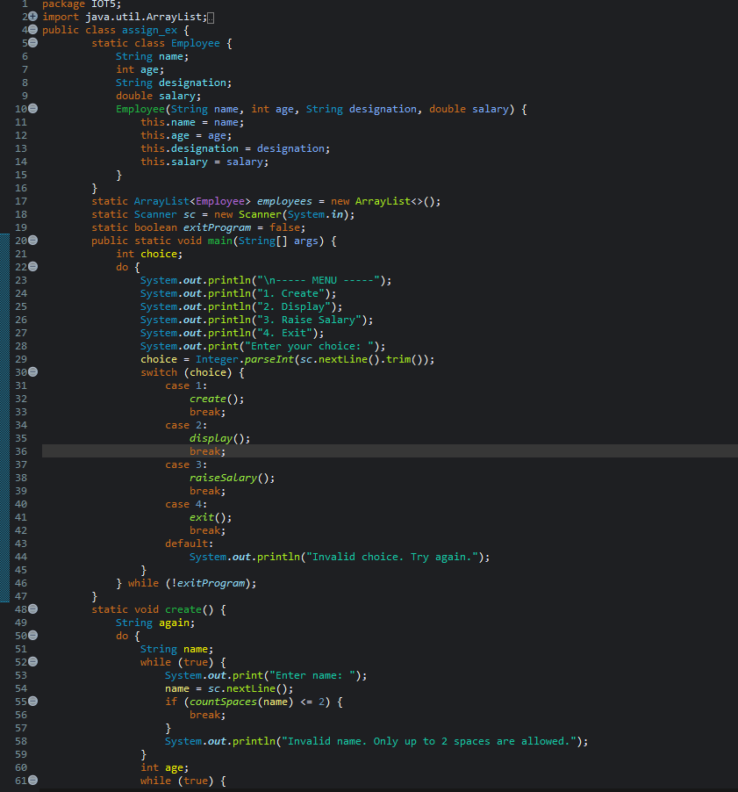
Screenshot 1 – Employee Management Menu and Setup
Explanation:
ArrayList<Employee> employees creates a list to store multiple Employee objects.
new ArrayList<>() creates an empty ArrayList where employees can be added dynamically.
Scanner sc = new Scanner(System.in) is used to take input from the user through the keyboard.
boolean exitProgram = false controls the exit condition and initially keeps the program running.

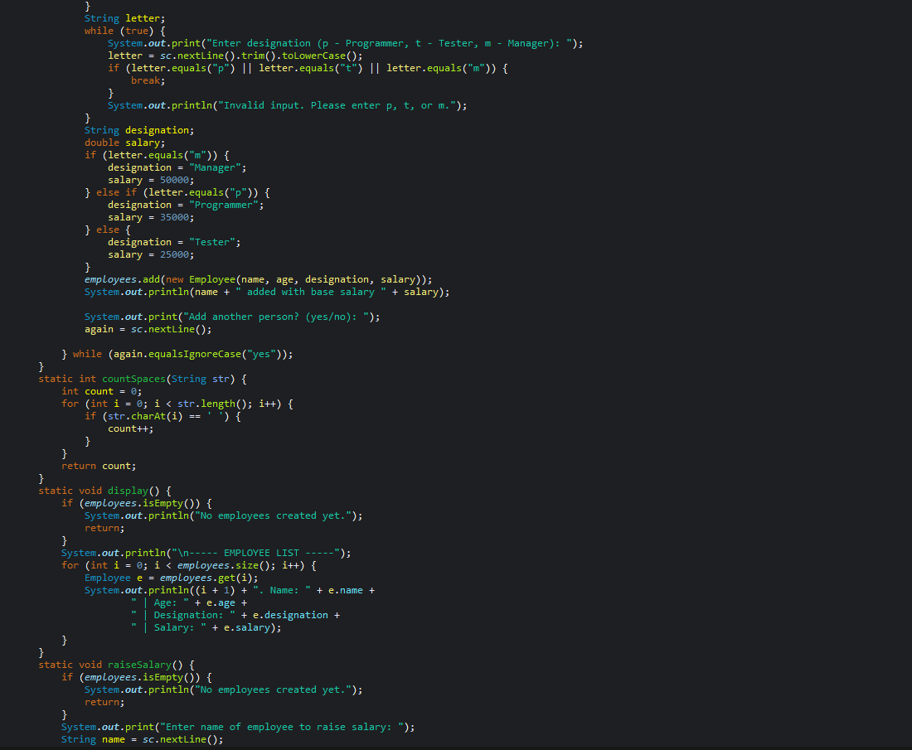

Screenshot 2 – Employee Creation and Input Validation
Explanation:
Case 3 calls raiseSalary() to increase an employee's salary, while Case 4 calls exit() to terminate the program.
The do-while loop keeps displaying the menu until exitProgram becomes true.
The create() method takes employee details such as name and age and validates the entered values.
It allows a name with a maximum of 2 spaces and accepts an age only between 18 and 60; invalid input is rejected and asked again.

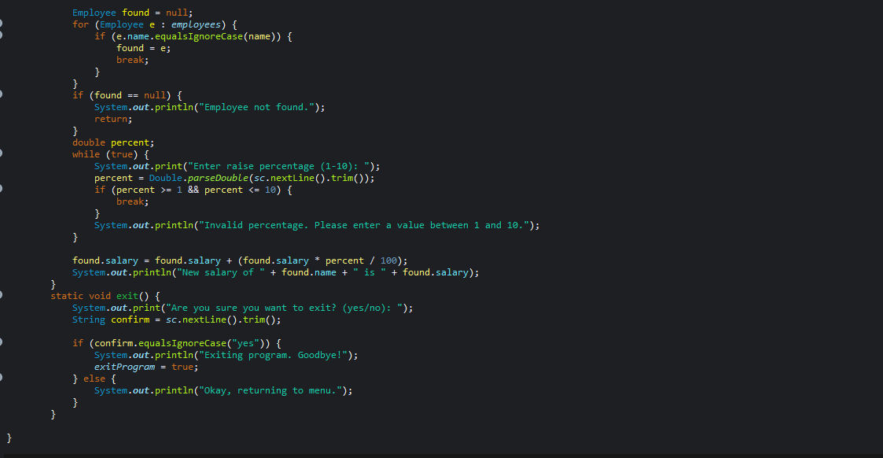
Screenshot 3 – Designation, Salary Assignment and Space Counting
Explanation:
The program searches for the employee by name using equalsIgnoreCase() and stores the matching employee in found; if not found, it displays an error message.
It asks the user to enter a salary raise percentage between 1 and 10 and keeps asking until a valid value is entered.
The employee's salary is increased using the formula salary + (salary * percent / 100).
The exit() method asks for confirmation; if the user enters yes, exitProgram becomes true and the program terminates, otherwise it returns to the menu.

OUTPUT-
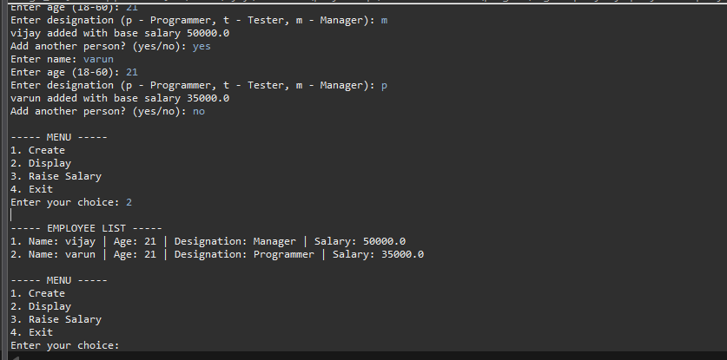

Explanation
- The program first creates employee records by taking name, age, designation, and salary.
- Two employees were added:
  - vijay → Manager → ₹50,000
  - varun → Programmer → ₹35,000
- When you select option 2 (Display), the program prints all employee details.
- After displaying, the menu appears again so you can choose another operation.
- The available options are:
  - Create – Add an employee
  - Display – Show employee details
  - Raise Salary – Increase an employee's salary
  - Exit – Stop the program

