Pwd: stands for present working directory.The pwd Linux command prints the current working directory path, starting from the root ( / ). Use the pwd command to find your way in the Linux file system structure maze or to pass the working directory in a Bash script.
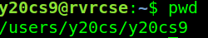

cd: stands for change directory command. It is used to change current working directory.
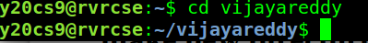

mkdir : stands for make new directories.The mkdir command in Linux/Unix allows users to create or make new directories. mkdir stands for “make directory.” With mkdir , you can also set permissions, create multiple directories (folders) at once, and much more.

ls:The ls command takes the location of a directory and prints all the files and directories within the location. It can also print additional file information like file permissions, file ownership, file size, etc.

rmdir: rmdir command is used remove empty directories from the filesystem in Linux. The rmdir command removes each and every directory specified in the command line only if these directories are empty. So if the specified directory has some directories or files in it then this cannot be removed by rmdir command.
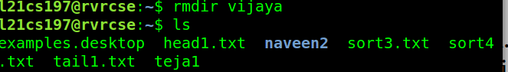

du: To utilize the basic usage of the du command, simply open a terminal window, type du, and hit Enter. The output displays each directory's disk usage and path, along with the total disk usage of the parent directory.

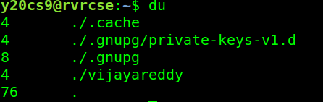

grep commands:

1. Case insensitive search : The -i option enables to search for a string case insensitively in the given file.
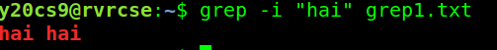

2. Displaying the count of number of matches : We can find the number of lines that matches the given string/pattern

3. Display the file names that matches the pattern : We can just display the files that contains the given string/pattern.

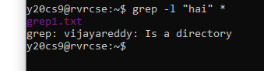
4. Checking for the whole words in a file : By default, grep matches the given string/pattern even if it is found as a substring in a file. The -w option to grep makes it match only the whole words.
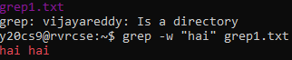
5. Displaying only the matched pattern : By default, grep displays the entire line which has the matched string. We can make the grep to display only the matched string by using the -o option.

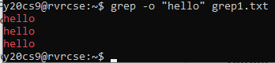

6. Show line number while displaying the output using grep -n : To show the line number of file with the line matched.
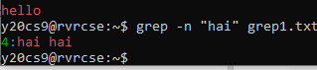

7. Inverting the pattern match : You can display the lines that are not matched with the specified search string pattern using the -v option.

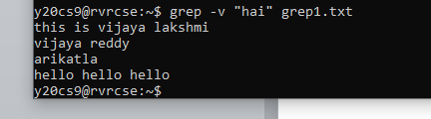

8. Matching the lines that start with a string : The ^ regular expression pattern specifies the start of a line. This can be used in grep to match the lines which start with the given string or pattern.

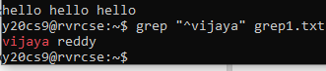

9. Matching the lines that end with a string : The $ regular expression pattern specifies the end of a line. This can be used in grep to match the lines which end with the given string or pattern.

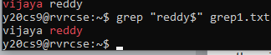

cat : To create a new file, use the cat command followed by the redirection operator ( > ) and the name of the file you want to create.
