Accessing Individual Fields :
The first field of the current line may be accessed by $1, the second by $2, and so forth. $0 stands for the entire line. The built-in variable NF is equal to the number of fields in the current line. In the following example, I ran a simple awk program on the text file “float” to insert the number of fields into each line:

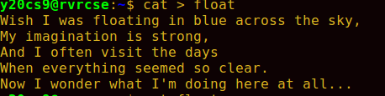

display:
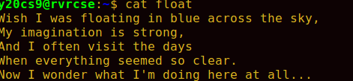

awk '{ print NF, $0 }' float:
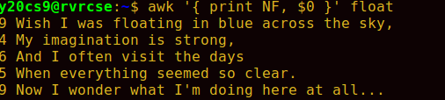

awk ‘{print NF}’ float:

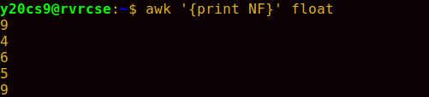
awk ‘{print $0}’ float :

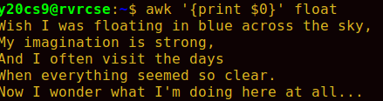

example:

awk ‘{print $1}’ float:
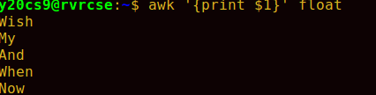

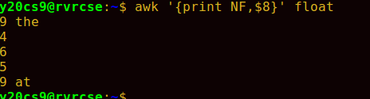

BEGIN and END :
The special condition BEGIN is triggered before the first line is read, and the special condition END is triggered after the last line has been read. When expressions are listed in a print statement, no space is placed between them, and a newline is printed by default. The built-in variable FILENAME is equal to the name of the input file. In the following example, I ran a program that displayed the first, third, and last fields of every line:

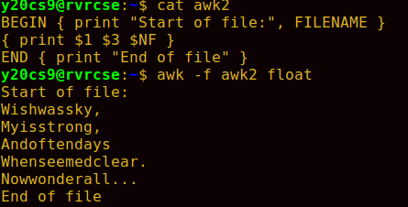

operators:
and &&:
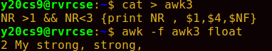

or || :

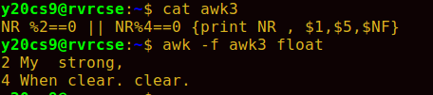

!=:

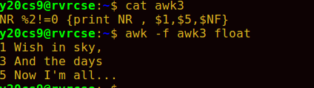

> =:

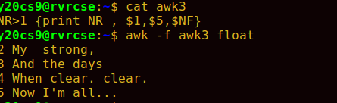

variables:
awk supports user-defined variables. There is no need to declare a variable. A variable’s initial value is a null string or zero, depending on how you use the variable.

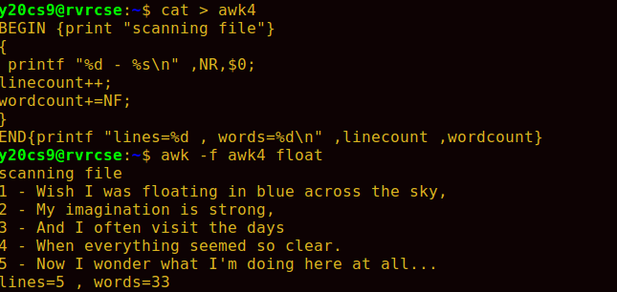

Control Structures:
awk supports most of the standard C control structures. In the following example, I printed the fields in each line backward:

