Models🡪TBIModel.edmx 🡪 TBIModel.tt🡪Person.cs

public int ID { get; set; }

[Required(ErrorMessage = "Last Name is Required")]

[StringLength(25)]

public string LastName { get; set; }

[Required(ErrorMessage = "First Name is Required")]

[StringLength(25)]

public string FirstName { get; set; }

[Range(1, 125, ErrorMessage = "Age Should be min 1 and max 125")]

[Required]

public Nullable<int> Age { get; set; }

[Required(ErrorMessage = "Email is Required")]

[RegularExpression(@"^([a-zA-Z0-9_\-\.]+)@((\[[0-9]{1,3}" +

@"\.[0-9]{1,3}\.[0-9]{1,3}\.)|(([a-zA-Z0-9\-]+\" +

@".)+))([a-zA-Z]{2,4}|[0-9]{1,3})(\]?)$",

ErrorMessage = "Email is not valid")]

public string Email { get; set; }

[StringLength(25)]

public string City { get; set; }

public string State { get; set; }

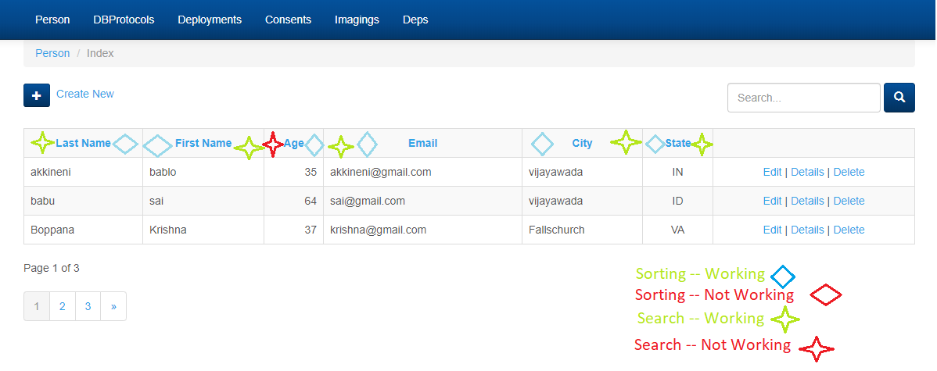

-------------------------------------------------------------------------------------

Models🡪TBIModel.edmx 🡪 TBIModel.tt🡪DBProtocol.cs

public int DBProtocolID { get; set; }

public Nullable<int> StudyID { get; set; }

public int ID { get; set; }

[DataType(DataType.Date)]

public Nullable<System.DateTime> DateofConsent { get; set; }

[Required(ErrorMessage = "The Type of Participant is Required")]

public string TypeofParticipant { get; set; }

public bool Withdraw { get; set; }

[DataType(DataType.Date)]

public Nullable<System.DateTime> DateofWithdraw { get; set; }

[StringLength(250)]

public string WithdrawComments { get; set; }

public virtual Person Person { get; set; }

-------------------------------------------------------------------------------------

Models🡪TBIModel.edmx 🡪 TBIModel.tt🡪Deployment.cs

public int DeploymentID { get; set; }

public int ID { get; set; }

public int DepID { get; set; }

[Required]

public string Month { get; set; }

public string Year { get; set; }

[StringLength(30)]

public string Duration { get; set; }

[StringLength(30)]

public string Location { get; set; }

[Required]

public System.DateTime InjuryDate { get; set; }

public System.DateTime DateComment { get; set; }

[Required]

public string OIFOEF { get; set; }

[Required]

public string InjuryType { get; set; }

[StringLength(30)]

public string IType { get; set; }

public bool Loc { get; set; }

[StringLength(30)]

public string LocDuration { get; set; }

[StringLength(30)]

public string PTA { get; set; }

[StringLength(30)]

public string PTADuration { get; set; }

public bool AOC { get; set; }

[StringLength(30)]

public string AOCDuration { get; set; }

[StringLength(30)]

public string MostSignificant { get; set; }

[StringLength(250)]

public string SiteOfInjury { get; set; }

[StringLength(250)]

public string Background { get; set; }

public virtual Person Person { get; set; }

-------------------------------------------------------------------------------------

Models🡪TBIModel.edmx 🡪 TBIModel.tt🡪.cs

-------------------------------------------------------------------------------------

Models🡪TBIModel.edmx 🡪 TBIModel.tt🡪.cs

-------------------------------------------------------------------------------------

Models🡪TBIModel.edmx 🡪 TBIModel.tt🡪.cs