NIP Project — Submission Template
Pega Platform project · This document is your complete submission
Read this before you start:
1. Fill in Section 1 completely. The Pega application name must follow the format NIP-[Project]-[YourName].
2. Create a new Operator in Pega with your full name and log in as that operator before taking any screenshot.
3. When you create your test case, enter YOUR FULL NAME in the Issue Description (Vehicle) or Movie Name (Movie) field.
4. Complete only the section for your chosen project. Delete the other project section.
5. Paste one screenshot per user story (10 total). Follow the screenshot rules in your selected project section.
6. Answer every question in Sections 3 and 4 in your own words.
7. Save the file using this format: ProjectName_FirstName_LastName.docx. Use VehicleService or MovieTicket as the ProjectName. Examples: VehicleService_Ravi_Kumar.docx or MovieTicket_Ravi_Kumar.docx.

Section 1 — Your Details
Full Name | Vijayasri chekuri
Email ID (registered on NIP) | 23891a6672@vignanits.ac.in
Phone Number | 6300182898
College Name | Vignan institute of technology and science
Course (e.g. IT, CS) | CSE(AIML)
State | Telangana
Project Chosen (Vehicle Service OR Movie Ticket Booking) | Movie Ticket Booking
Pega Application Name (e.g. NIP-VehicleService-YourName) | NIP-MovieTicket-vijayasri chekuri
Case Type Name (exact) | Movie Ticket Request
Pega Instance URL | https://tgqoduoz.pegaacademy.net/prweb/app/nip--movie-ticket-vijayasri-chekuri/
Operator Name (created in Pega with your full name) | Vijayasri Chekuri

Section 2A — Vehicle Service Management Application
Complete this section only if you selected this project. Delete the other project section before submitting.

Screenshot rules — IMPORTANT before you start:
1. Name your Pega application as: NIP-VehicleService-YourName OR NIP-MovieTicket-YourName
2. Create a new Operator in Pega with your full name (Security → Operators) and log in as that operator.
3. When you create your test case, enter YOUR FULL NAME in the Issue Description (Vehicle) or Movie Name (Movie) field.
4. The logged-in operator name must be visible in every screenshot wherever the Pega interface displays it.
5. The student's full name must be visible in all running-case screenshots.
6. Configuration screenshots must clearly show the relevant application or rule name.
Screenshots that do not show these will not be accepted.

US-001 — Submit Vehicle Service Request
What is expected:
Case created, customer submits Vehicle ID, Vehicle Model, Issue Description. Validation applied.
Screenshot — paste your screenshot below this line:
[ Paste screenshot here - follow the screenshot rules above ]

What I built for this (1–2 lines in your own words):
[ Type here ]

US-002 — Perform Vehicle Inspection
What is expected:
Inspection stage with Service Advisor step. Inspection Notes and Condition Rating captured.
Screenshot — paste your screenshot below this line:
[ Paste screenshot here - follow the screenshot rules above ]

What I built for this (1–2 lines in your own words):
[ Type here ]

US-003 — Generate Service Estimate
What is expected:
Labor Cost and Parts Cost captured. Total Cost calculated automatically by declare expression.
Screenshot — paste your screenshot below this line:
[ Paste screenshot here - follow the screenshot rules above ]

What I built for this (1–2 lines in your own words):
[ Type here ]

US-004 — Approve Service Estimate
What is expected:
Approval stage assigned to Customer. Approval Status captured. Flow branches on approve/reject.
Screenshot — paste your screenshot below this line:
[ Paste screenshot here - follow the screenshot rules above ]

What I built for this (1–2 lines in your own words):
[ Type here ]

US-005 — Maintain Vehicle Data
What is expected:
Reusable Vehicle data object created with Vehicle ID, Model, Type — linked to case.
Screenshot — paste your screenshot below this line:
[ Paste screenshot here - follow the screenshot rules above ]

What I built for this (1–2 lines in your own words):
[ Type here ]

US-006 — Review Service Estimate
What is expected:
Approval screen shows Labor Cost, Parts Cost and Total Cost clearly to the Customer persona.
Screenshot — paste your screenshot below this line:
[ Paste screenshot here - follow the screenshot rules above ]

What I built for this (1–2 lines in your own words):
[ Type here ]

US-007 — Auto Assign Technician
What is expected:
Service Execution stage with routing to HeavyVehicleQueue or LightVehicleQueue. Assigned Technician and Service Status properties maintained.
Screenshot — paste your screenshot below this line:
[ Paste screenshot here - follow the screenshot rules above ]

What I built for this (1–2 lines in your own words):
[ Type here ]

US-008 — Notify Service Completion
What is expected:
Correspondence rule created and triggered on case resolution. Email includes case and vehicle details.
Screenshot — paste your screenshot below this line:
[ Paste screenshot here - follow the screenshot rules above ]

What I built for this (1–2 lines in your own words):
[ Type here ]

US-009 — Define Service SLA
What is expected:
SLA configured on the case type. Goal: 2 days. Deadline: 3 days. Priority increases on breach.
Screenshot — paste your screenshot below this line:
[ Paste screenshot here - follow the screenshot rules above ]

What I built for this (1–2 lines in your own words):
[ Type here ]

US-010 — Route by Vehicle Type
What is expected:
Routing rule or Decision Table routes to HeavyVehicleQueue or LightVehicleQueue based on Vehicle Type property.
Screenshot — paste your screenshot below this line:
[ Paste screenshot here - follow the screenshot rules above ]

What I built for this (1–2 lines in your own words):
[ Type here ]

Section 2B — Movie Ticket Booking Management Application
Complete this section only if you selected this project. Delete the other project section before submitting.

Screenshot rules — IMPORTANT before you start:
1. Name your Pega application as: NIP-VehicleService-YourName OR NIP-MovieTicket-YourName
2. Create a new Operator in Pega with your full name (Security → Operators) and log in as that operator.
3. When you create your test case, enter YOUR FULL NAME in the Issue Description (Vehicle) or Movie Name (Movie) field.
4. The logged-in operator name must be visible in every screenshot wherever the Pega interface displays it.
5. The student's full name must be visible in all running-case screenshots.
6. Configuration screenshots must clearly show the relevant application or rule name.
Screenshots that do not show these will not be accepted.

US-001 — Submit Movie Ticket Request
What is expected:
Case created, customer submits Movie Name, Show Date, Show Time, Number of Tickets. Validation applied.
Screenshot — paste your screenshot below this line:
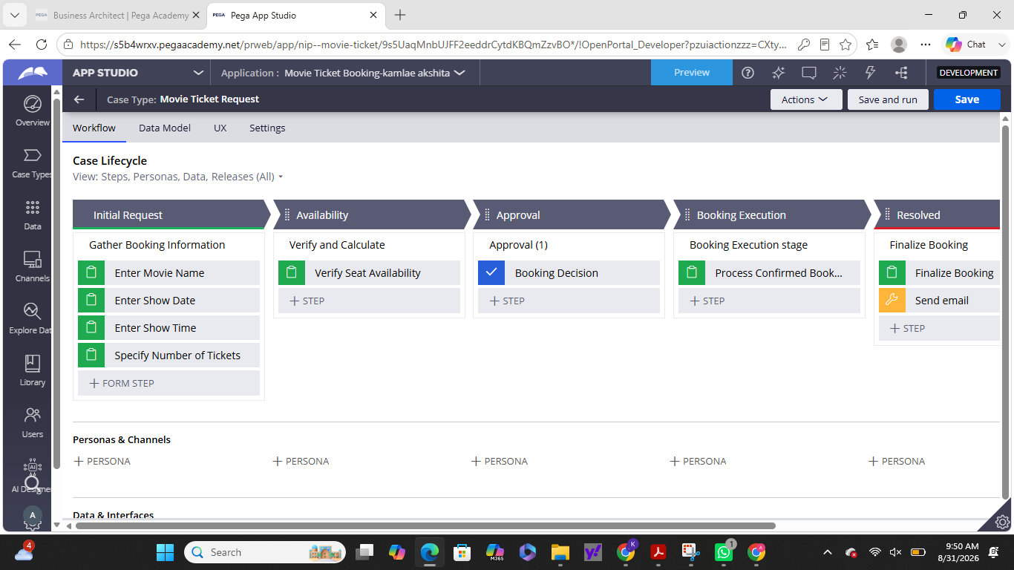

What I built for this (1–2 lines in your own words):
I created the Movie Ticket Request case with an initial form to capture Movie Name, Show Date, Show Time, and Number of Tickets, with the required validation applied to the booking inputs.

US-002 — Check Show Availability
What is expected:
Availability stage. Seat Availability Status and Available Seats Count captured. Booking proceeds only if available.
Screenshot — paste your screenshot below this line:
[ Paste screenshot here - follow the screenshot rules above ]
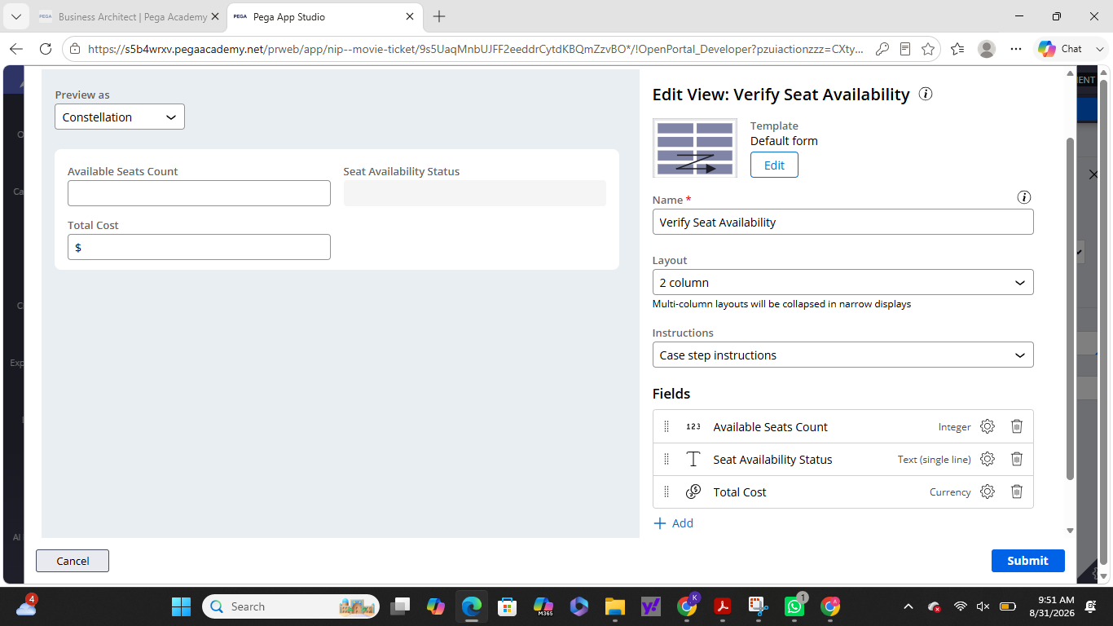

What I built for this (1–2 lines in your own words):
I created an Availability stage with a Verify Seat Availability step to capture the Seat Availability Status and Available Seats Count, allowing the booking process to continue when seats are available.

US-003 — Calculate Booking Cost
What is expected:
Total Cost calculated automatically from Ticket Price and Number of Tickets using a business rule.
Screenshot — paste your screenshot below this line:
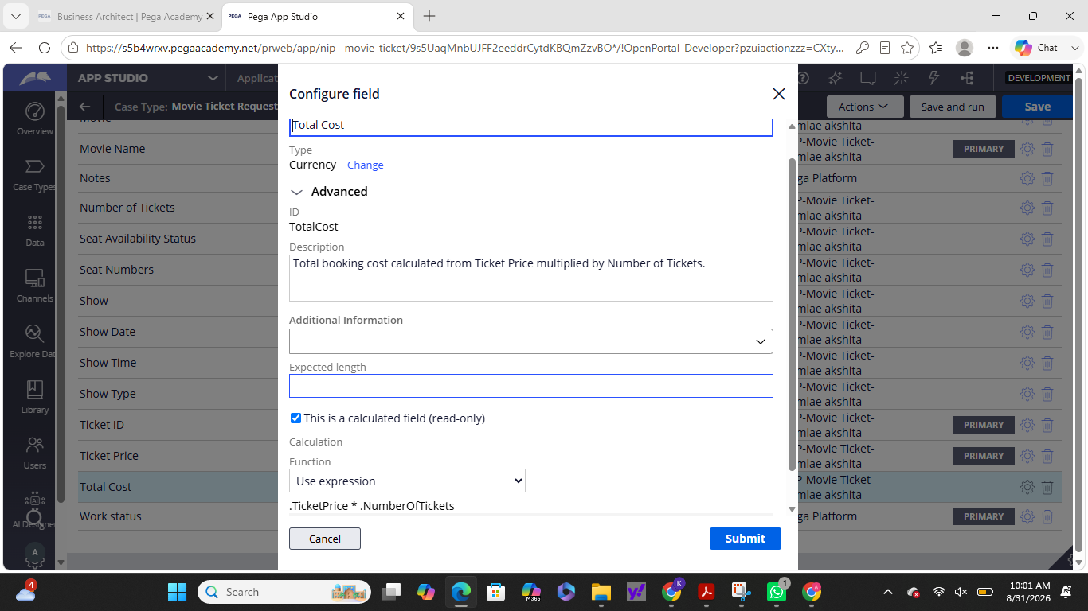

What I built for this (1–2 lines in your own words):
I configured Total Cost as a calculated, read-only field that automatically calculates the booking cost using Ticket Price × Number of Tickets.

US-004 — Confirm Booking Request
What is expected:
Approval stage assigned to Customer. Booking Status captured. Flow branches on confirm/cancel.
Screenshot — paste your screenshot below this line:
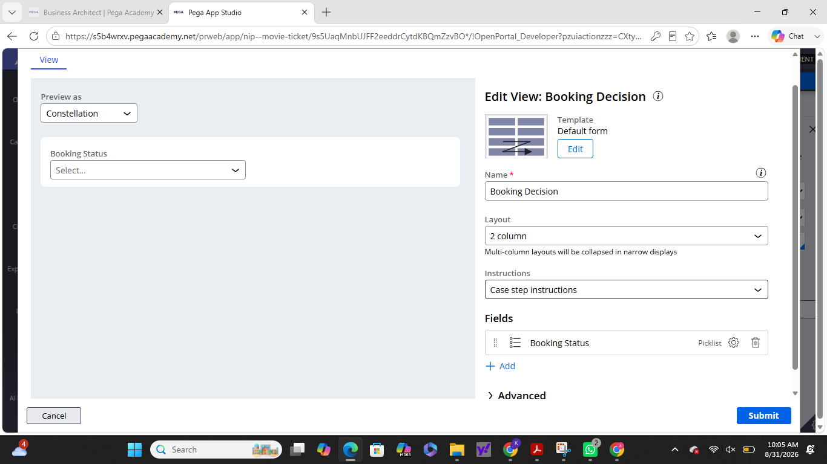

What I built for this (1–2 lines in your own words):
I created an Approval stage with a Booking Decision step where the customer can confirm or cancel the booking, and the Booking Status field captures the decision.

US-005 — Maintain Movie and Show Data
What is expected:
Reusable Movie and Show data objects created with Movie Name, Genre, Show Date, Show Time, Seat Capacity — linked to case.
Screenshot — paste your screenshot below this line:
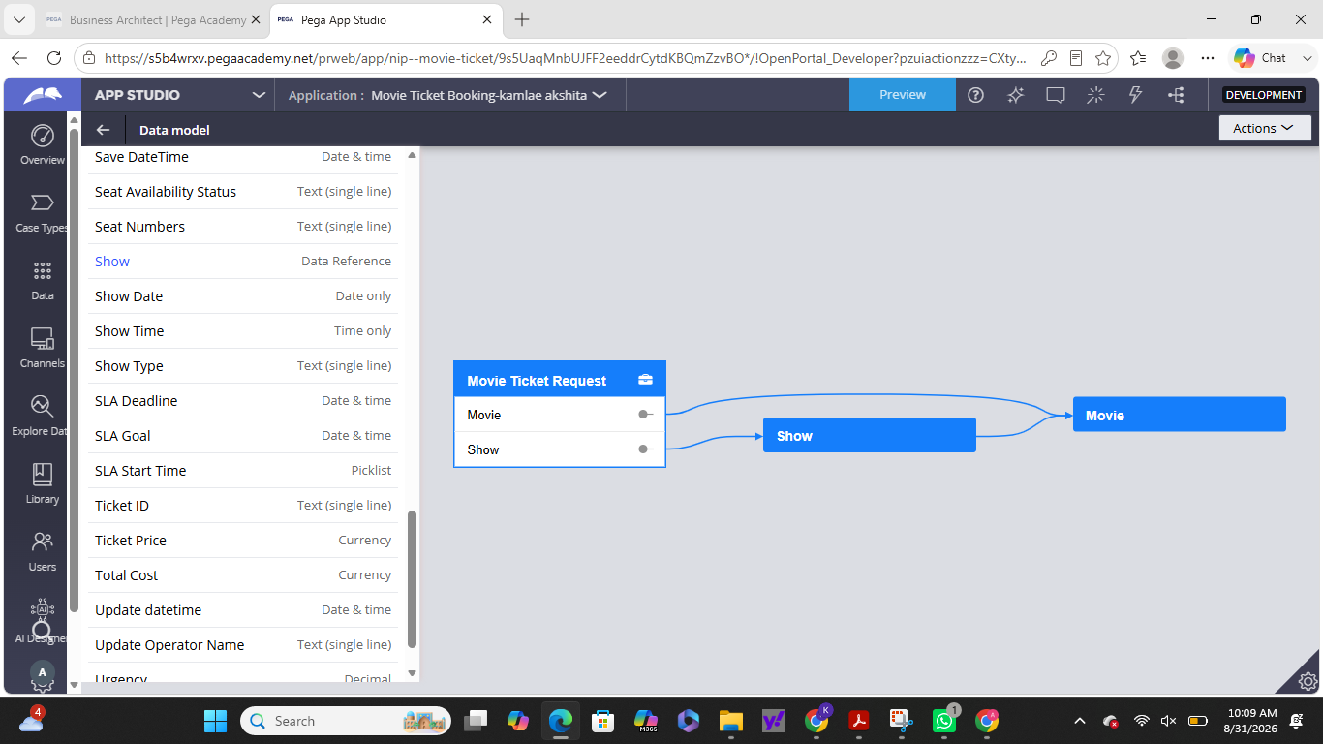

What I built for this (1–2 lines in your own words):
I created reusable Movie and Show data objects and linked them to the Movie Ticket Request case. The Movie object includes Movie Name and Genre, while the Show object includes Show Date, Show Time, and Seat Capacity.

US-006 — Review Booking Details
What is expected:
Confirmation screen shows Movie Name, Show Timing, Number of Tickets and Total Cost clearly.
Screenshot — paste your screenshot below this line:
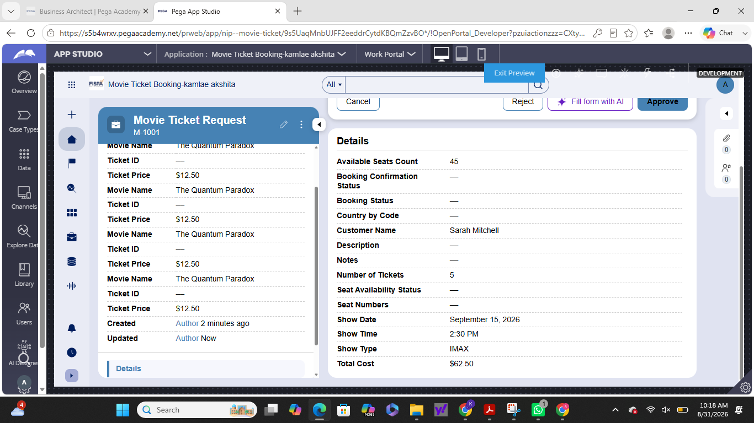

What I built for this (1–2 lines in your own words):
I configured the Booking Decision screen so the customer can review the Movie Name, Show Timing, Number of Tickets, and Total Cost before confirming the booking.

US-007 — Process Ticket Booking
What is expected:
Booking Execution stage. Seat Numbers, Ticket ID and Booking Confirmation Status maintained.
Screenshot — paste your screenshot below this line:
[ Paste screenshot here - follow the screenshot rules above ]

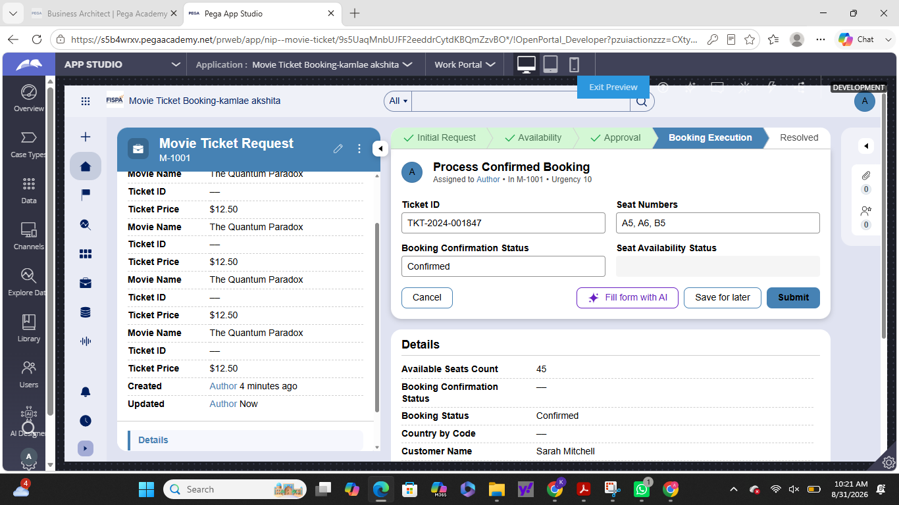

What I built for this (1–2 lines in your own words):
I created the Booking Execution stage with a ProcessBooking Data Transform to maintain the Booking Confirmation Status, Seat Numbers, and Ticket ID during ticket processing.

US-008 — Notify Booking Confirmation
What is expected:
Correspondence rule triggered on case resolution. Email includes movie, show, seat and cost details.
Screenshot — paste your screenshot below this line:
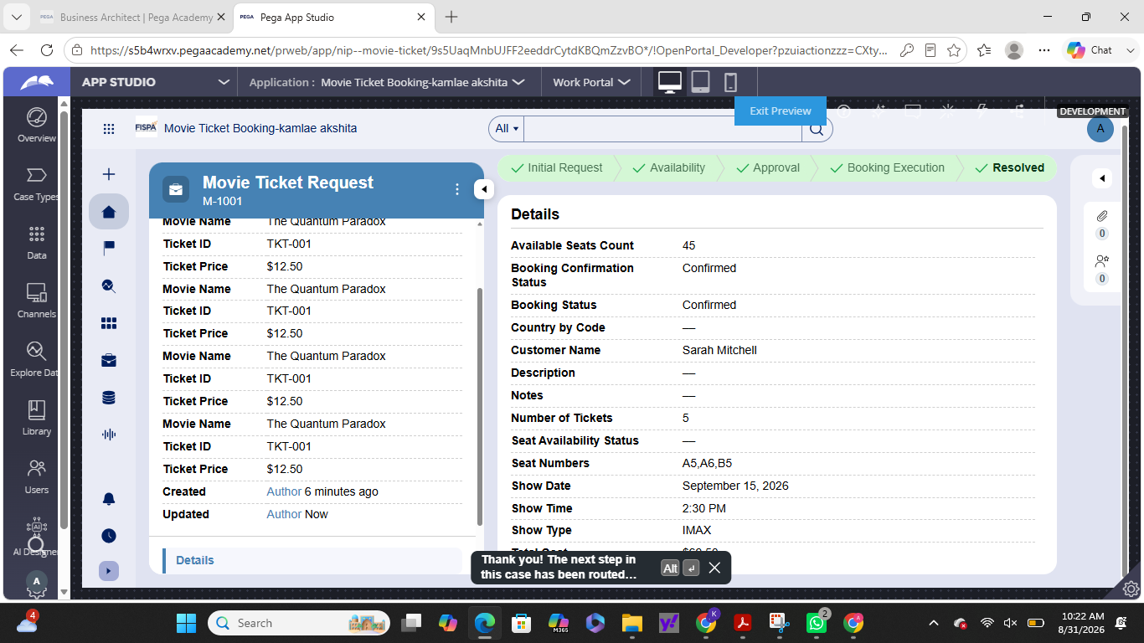

What I built for this (1–2 lines in your own words):
I configured a Send email step to notify the Customer when the booking is confirmed, with the message containing the movie, show date and time, seat numbers, number of tickets, and total cost.

US-009 — Define Booking SLA
What is expected:
SLA configured on the case type. Goal: 1 day. Deadline: 2 days. Priority increases on breach.
Screenshot — paste your screenshot below this line:
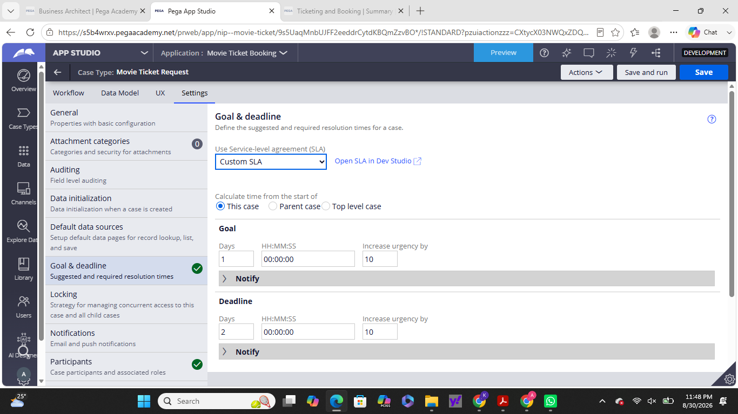

What I built for this (1–2 lines in your own words):
I configured a 1-day Goal and 2-day Deadline SLA on the Movie Ticket Request case, with the case priority increasing when the deadline is breached.

US-010 — Route by Show Type
What is expected:
Routing rule or Decision Table routes to PremiumShowQueue or StandardShowQueue based on Show Type property.
Screenshot — paste your screenshot below this line:
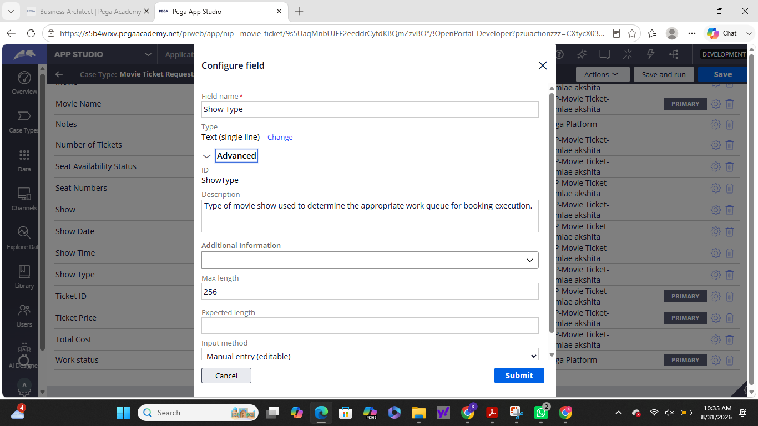

What I built for this (1–2 lines in your own words):
I created the Show Type property in the Movie Ticket Request case to support routing based on the type of movie show.

Section 3 — About Your Application
These answers are checked against your screenshots. Write exactly what is in your application.

Q1. List your stages in the order they appear in your case lifecycle.
Stage names in order, separated by commas.
Initial Request, Availability, Approval, Booking Execution, Resolved

Q2. Name the data object(s) you created and the properties inside them.
Data object name and its properties.
Movie: Movie Name, Genre
Show: Movie, Show Date, Show Time, Seat Capacity

Q3. What is the exact name and type of the rule you used to calculate Total Cost?
Provide:
• Rule Name
• Rule Type
• Properties used in the calculation
• Formula used
[ Type here ]
Rule/Field Name: TotalCost
Type: Currency — Calculated; Read-only
Properties used: Ticket Price, Number of Tickets
Formula: Ticket Price × Number of Tickets

Section 4 — Your Understanding
Short, honest and specific answers score well.

Q4. What did Blueprint generate for you, and what did you add or change yourself afterwards?
Be specific about what was already there and what you built or modified on top.
Blueprint generated the basic application structure, Movie Ticket Request case type, data objects, fields, and initial workflow. I then configured and customized the case lifecycle, availability checking, Total Cost calculation, customer approval, booking execution, SLA, work-queue routing, and confirmation email.

Q5. Was there anything Blueprint created that you had to correct or configure further? Describe one example.
A real example from your own work.
Yes. I had to configure the ProcessBooking Data Transform further so that booking confirmation details such as Booking Confirmation Status, Seat Numbers, and Ticket ID could be maintained correctly during booking execution.

Q6. Explain your case flow from creation to resolution, in order.
What happens first, who does what, when the case closes.
The customer creates a Movie Ticket Request and enters the movie and show details. The system checks seat availability and calculates the Total Cost. The customer then reviews and confirms or cancels the booking. If confirmed, the case moves to Booking Execution, where the booking is processed, seats are allocated, and the Ticket ID and booking status are updated. Finally, the customer receives a confirmation notification and the case is resolved.

Q7. Pick two design choices you made in your application and explain why you made them.
For each design choice, provide:
• What you implemented
• Why you chose that approach
• What benefit it provides to the application
1. Total Cost as a calculated field: I used Ticket Price and Number of Tickets to automatically calculate Total Cost. This reduces manual calculation and ensures accurate pricing.
2. Separate Availability and Approval stages: I separated availability checking from customer confirmation so that seats are verified first and the customer only confirms a booking that can actually proceed. This makes the case flow clear and prevents invalid bookings.

Q8. What was the hardest part, and how exactly did you fix it?
Specific and honest. A real challenge scores much better than a generic answer.
The hardest part was troubleshooting the confirmation email in the Approval flow. During testing, the generated Send Confirmation Emails step produced an UnresolvedAssemblyError / NullPointerException. I identified the generated email step as the issue and reviewed its configuration and booking properties to determine what needed further configuration.

Q9. If the approval step was only needed when Total Cost is above a certain amount, what would you change in your application?
Explain what you would change and where. You do not need to build this.
I would add a condition before the Approval stage based on Total Cost. If Total Cost is above the defined threshold, the case would proceed to Approval. If it is below the threshold, the case would skip Approval and continue directly to the next stage.

Q10. List three exact rule names from your application that you personally created or modified.
Include the rule name and rule type for each one (for example: CalculateTotalCost - Declare Expression).
1. ProcessBooking — Data Transform
2. Total Cost — Calculated Field / Business Rule
3. Verify Seat Availability — User Action
Q11. List all personas used in your application.
List the persona names exactly as they appear in your application.
Customer
Booking Agent

Q12. List all work queues used in your application and explain when each one is used.
For each work queue, provide its exact name and the condition or type of work routed to it.
PremiumShowQueue — Used for premium or special show bookings.
StandardShowQueue — Used for all other show bookings.

Before You Submit — Check These
Read through once before uploading.
1. Section 1 filled in. Application named as NIP-[Project]-[YourName]. Names match the actual application.
2. New Operator created in Pega with my full name. I logged in as that operator for all screenshots.
3. Only my chosen project section remains — the other project section is deleted.
4. All 10 user story screenshots are pasted and follow the operator, running-case, application, and rule-name evidence requirements.
5. Every question in Sections 3 and 4, including Q10, Q11, and Q12, is answered in my own words.
6. This file is named using the required format: ProjectName_FirstName_LastName.docx (for example, VehicleService_Ravi_Kumar.docx or MovieTicket_Ravi_Kumar.docx) and uploaded as required.

