Overview
In this lab you will learn how to set up an HTTP global load balancer and how load balancing can help scale your applications on Google Compute Engine.
Here is a diagram of all of the elements of an HTTP/HTTPS load balancer setup. This is what you will build in this lab:
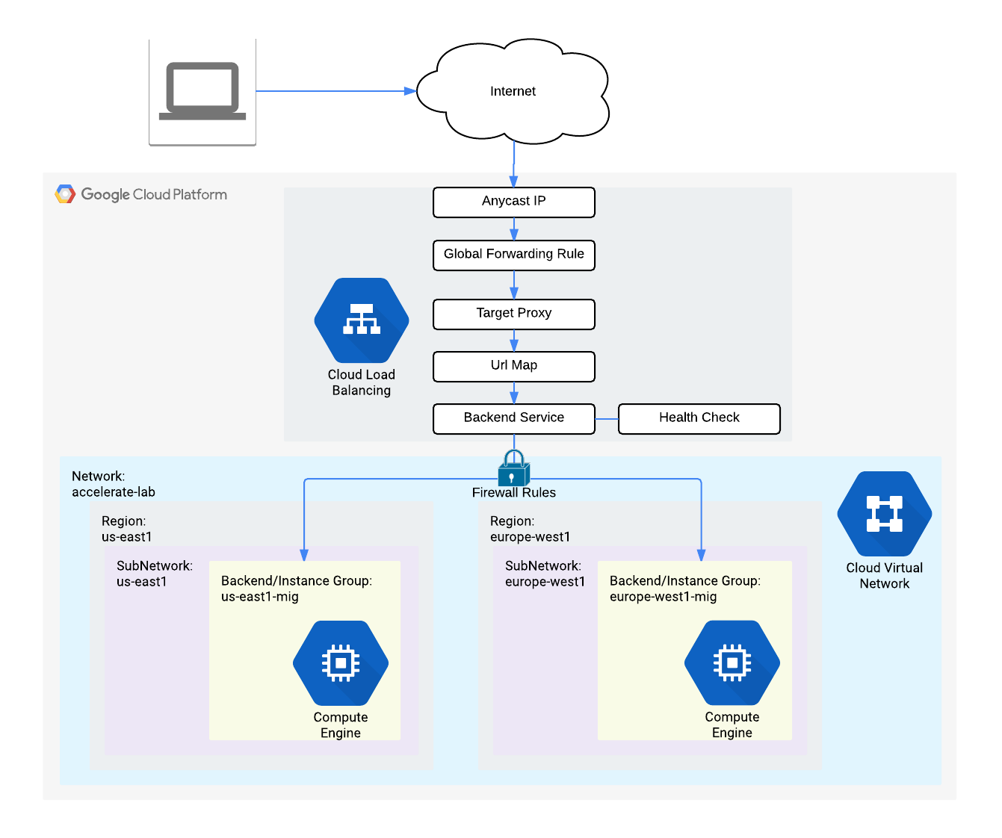
We will build this system starting with creating and opening access to the target Backends working towards the Global Forwarding Rule (following the arrows backwards).
This is accomplished in 3 steps:
- Add an HTTP firewall rule allowing network access to the Backend VM instances
- Create Managed Instance Groups with the VM instance configurations
- Create the HTTP Load Balancer with backends to route requests to available instances

What you'll learn
- How to set up up basic firewalling to secure your networks
- How to set up a global HTTP Load Balancer with Managed Instance Groups to automatically scale your resources up and down based on request load
- How to test and monitor your HTTP Load Balancer setup

Prerequisites
- Basic knowledge of Google Compute Engine (for example from the GCP Essentials Quest)
- Basic networking and TCP/IP knowledge
- Basic Unix/Linux command line knowledge
Important: Unless you are in the free trial, you may incur some costs for the virtual machines set up in this lab and the network transfer done for the performance testing. Make sure that you delete all resources (or delete the project) when you finish the code lab.
Also important: In this codelab we'll use open source tools to accomplish some network administration tasks, but bear in mind there are many such tools available and the best one for you will be a function of your needs and preferences.

Setup and Requirements

Qwiklabs setup

Before you click the Start Lab button
Read these instructions. Labs are timed and you cannot pause them. The timer, which starts when you click Start Lab, shows how long Cloud resources will be made available to you.
This Qwiklabs hands-on lab lets you do the lab activities yourself in a real cloud environment, not in a simulation or demo environment. It does so by giving you new, temporary credentials that you use to sign in and access the Google Cloud Platform for the duration of the lab.

What you need
To complete this lab, you need:
- Access to a standard internet browser (Chrome browser recommended).
- Time to complete the lab.
Note: If you already have your own personal GCP account or project, do not use it for this lab.

How to start your lab and sign in to the Console
- Click the Start Lab button. If you need to pay for the lab, a pop-up opens for you to select your payment method. On the left is a panel populated with the temporary credentials that you must use for this lab.
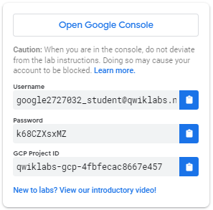
- Copy the username, and then click Open Google Console. The lab spins up resources, and then opens another tab that shows the Choose an account page.
Tip: Open the tabs in separate windows, side-by-side.
- On the Choose an account page, click Use Another Account.
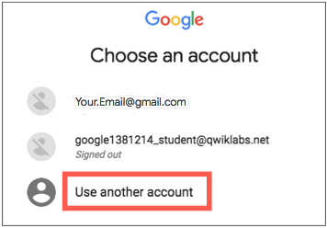
- The Sign in page opens. Paste the username that you copied from the Connection Details panel. Then copy and paste the password.
Important: You must use the credentials from the Connection Details panel. Do not use your Qwiklabs credentials. If you have your own GCP account, do not use it for this lab (avoids incurring charges).
- Click through the subsequent pages:
  - Accept the terms and conditions.
  - Do not add recovery options or two-factor authentication (because this is a temporary account).
  - Do not sign up for free trials.
After a few moments, the GCP console opens in this tab.
Note: You can view the menu with a list of GCP Products and Services by clicking the Navigation menu at the top-left, next to “Google Cloud Platform”. 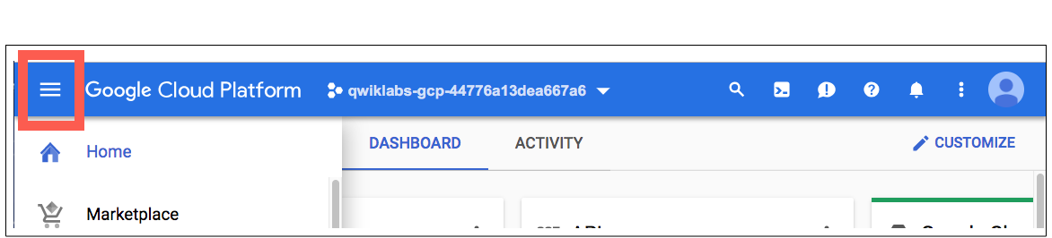

Activate Google Cloud Shell
Google Cloud Shell is a virtual machine that is loaded with development tools. It offers a persistent 5GB home directory and runs on the Google Cloud. Google Cloud Shell provides command-line access to your GCP resources.
- In GCP console, on the top right toolbar, click the Open Cloud Shell button.
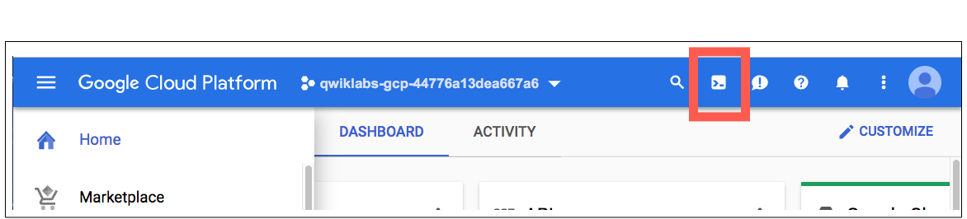
- In the dialog box that opens, click START CLOUD SHELL:
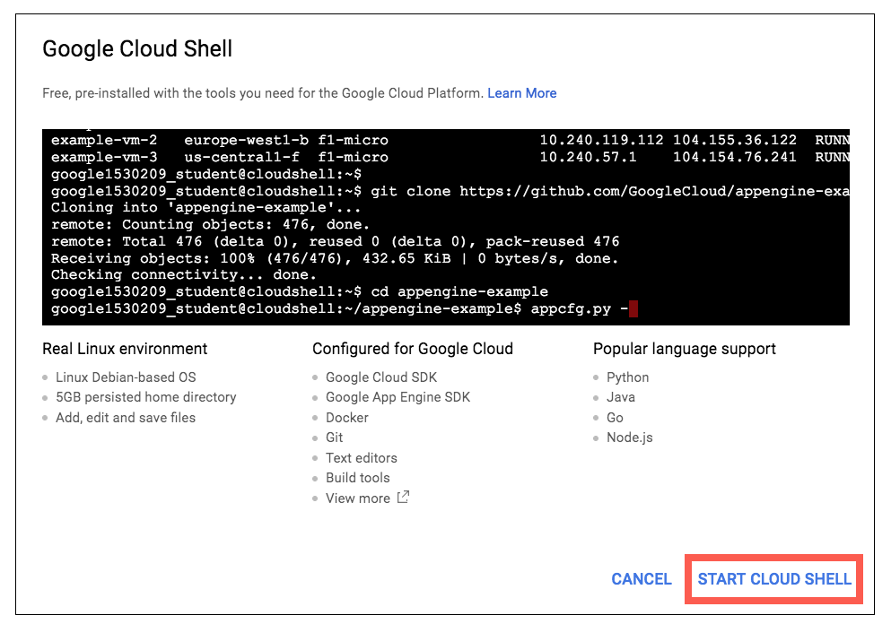
You can click "START CLOUD SHELL" immediately when the dialog box opens.
It takes a few moments to provision and connect to the environment. When you are connected, you are already authenticated, and the project is set to your PROJECT_ID. For example:
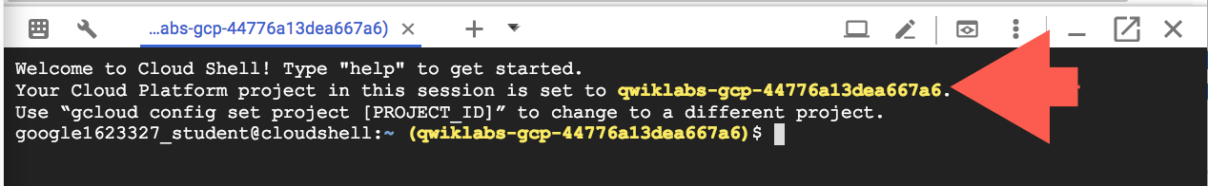
gcloud is the command-line tool for Google Cloud Platform. It comes pre-installed on Cloud Shell and supports tab-completion.
You can list the active account name with this command:
gcloud auth list
Output:
Credentialed accounts:
- <myaccount>@<mydomain>.com (active)
Example output:
Credentialed accounts:
- google1623327_student@qwiklabs.net
You can list the project ID with this command:
gcloud config list project
Output:
[core]
project = <project_ID>
Example output:
[core]
project = qwiklabs-gcp-44776a13dea667a6
Full documentation of gcloud is available on Google Cloud gcloud Overview.

Command output
Credentialed accounts:
- <myaccount>@<mydomain>.com (active)
Note: gcloud is the powerful and unified command-line tool for Google Cloud Platform. Full documentation is available from https://cloud.google.com/sdk/gcloud. It comes pre-installed on Cloud Shell and you will surely enjoy its support for tab-completion.
gcloud config list project

Command output
[core]
project = <PROJECT_ID>
If for some reason the project is not set, simply issue the following command :
gcloud config set project <PROJECT_ID>
Looking for you PROJECT_ID? It's the ID you used in the setup steps. You can find it in the console dashboard any time:
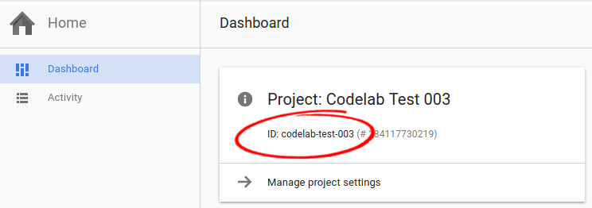
Note: When you run gcloud on your own local machine, the config settings are persisted across sessions. When in Cloud Shell, you may need to set this for every new session or reconnection.

Create a network and HTTP firewall rule
To work in a clean environment, we will run all the commands in a new "auto subnet" network called httplb. You can create this with Cloud Shell or in the Console. Instructions for Cloud Shell will be presented first. If you prefer to use the Console, scroll down to "Create with Console".

Create in Cloud Shell
Run the following command in Cloud Shell:
gcloud compute networks create httplb --subnet-mode=auto
Now open the firewall to allow HTTP Internet requests. We will apply the firewall rule to VM instances using a tag that is attached to the load balanced VM instances.
Instance TagsTags are used by networks and firewalls to apply certain firewall rules to tagged VM instances. For example, if there are several instances that perform the same task, such as serving a large website, you can tag these instances with a shared word or term and then use that tag to allow HTTP access to those instances with a firewall rule. Tags are also reflected in the metadata server, so you can use them for applications running on your instances.
To open the Network firewall, you need to supply the following information:
Field | Value | Comments
Source IP range or tags | 0.0.0.0/0 | We will open the firewall for any IP address from the Internet.
Destination protocol and port | tcp:80 | Only HTTP
Destination tags | www | The tag we select
Network | httplb | The default network
Existing HTTP ruleIn the default network, a rule to allow HTTP traffic for the tag http-server already exists. We create a similar rule here to show how the firewall can be opened in any network
Run the following command to open the firewall:
gcloud compute firewall-rules create httplb-allow-http \
--allow tcp:80 --network httplb --source-ranges 0.0.0.0/0 \
--target-tags www

Create with Cloud Console
Remember: If you just created a network using the Console, do not do the same exercise using Cloud Shell.
Navigate to VPC Networks via the Menu then click on Create VPC network. Then:
- Name the network httplb
- Change Subnets type to automatic
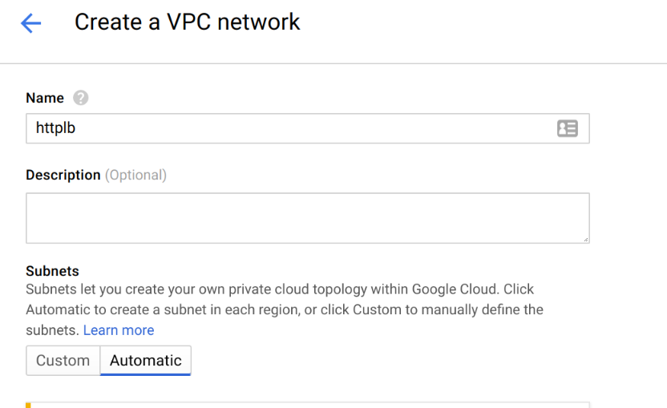
Click Create.

Click on httplb network:
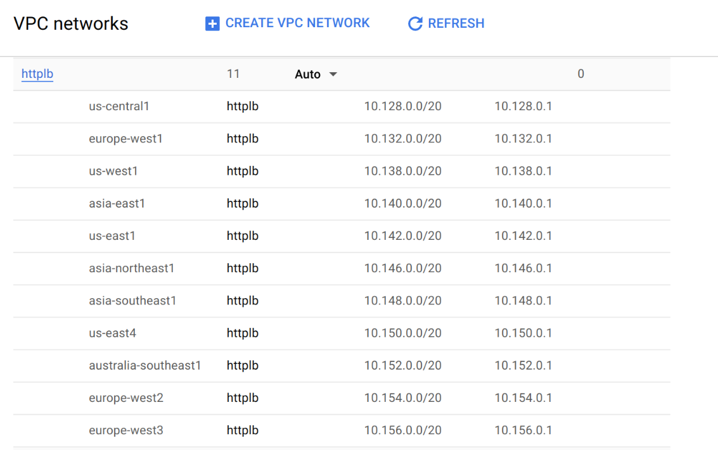
Click Add Firewall Rule: 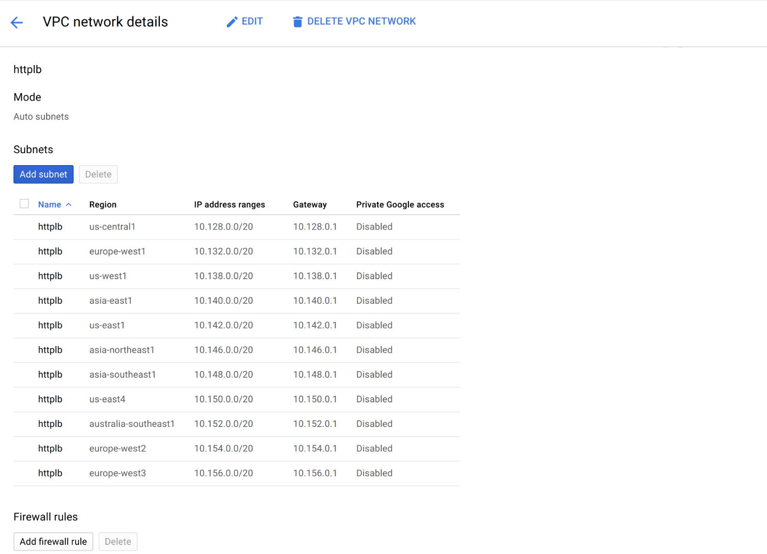
Enter the following info to your firewall:
Field | Value | Comments
Name | httplb-allow-http | New rule name
Source IP ranges | 0.0.0.0/0 | We will open the firewall for any IP address from the Internet.
Allowed protocols and ports | tcp:80 | Only HTTP
Target tags | www | The tag we created
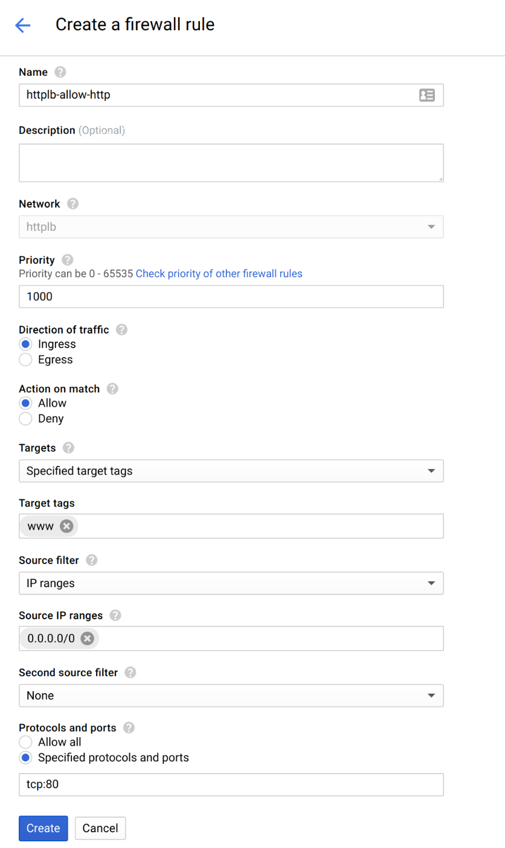
Click Create and wait until the command succeeds.
Now continue creating the globally load balanced web service.
What about those Routes I see in the Network console?GCP Networking uses Routes to direct packets between subnetworks and to the Internet.
Whenever a subnetwork is created (or pre-created) in your Network, routes are automatically created in each region to allow packets to route between subnetworks. These cannot be modified.
Additional routes can be created to send traffic to an instance, a VPN gateway, or default internet gateway. These can be modified to tailor the desired network architecture.
Routes and Firewalls work together to ensure your traffic gets where it needs to go.

Create Managed Instance Groups
You need to set up Managed Instance Groups which include the patterns for backend resources used by the HTTP Load Balancer. First you will create Instance Templates, which define the configuration for VMs to be created for each region. Then, for the backend in each region, you will create a Managed Instance Group that references an Instance Template.
Managed Instance groups can be Zonal or Regional in scope. For this lab exercise you will be creating two regional Managed Instance Groups, one in us-east1 and the other in europe-west1. Use the gcloud command line tool to create the templates.
In this section, a pre-created startup script, gs://cloudnet-lab/startup.sh, will be referenced upon instance creation. This startup script installs and enables web server capabilities which will be used to simulate a web application.

Create instance templates
You'll use gcloud to create us-east1-template with this configuration.
Field | Value | Comments
Machine type | Default (1 vCPU)
Boot disk | Default (10 GB standard persistent disk)
Image | Default (Debian GNU/Linux 9)
Identity and API access | Default
Firewall | Allow HTTP traffic | By adding the previously opened http-server tag
Metadata | Key: startup-script-url  Value:  gs://cloudnet-lab/startup.sh
Networking | Network: httplb  Subnetwork: us-east1  External IP: Default (Ephemeral)
Run this gcloud command to create the instance template:
gcloud compute instance-templates create "us-east1-template" \
--metadata "startup-script-url=gs://cloudnet-lab/startup.sh" \
--region "us-east1" \
--tags "www" \
--network "httplb"
Next you'll create a similar instance template for europe-west1 replacing the name, region, and subnetwork fields:
gcloud compute instance-templates create "europe-west1-template" \
--metadata "startup-script-url=gs://cloudnet-lab/startup.sh" \
--region "europe-west1" \
--tags "www" \
--network "httplb"
Verify that the instance templates were created successfully:
gcloud compute instance-templates list
Output should look like this:
NAME MACHINE_TYPE PREEMPTIBLE CREATION_TIMESTAMP
europe-west1-template n1-standard-1 2017-01-03T11:43:25.053-08:00
Us-east1-template n1-standard-1 2017-01-03T11:36:25.494-08:00

Create Managed Instance Groups
Now that you have the instance templates defined, it's time to create our regional Managed Instance Groups for the us-east1 and europe-west1 regions. Use the Cloud Console for this configuration.
Click on Navigation menu > Compute Engine > Instance Groups, then click Create Instance Group.
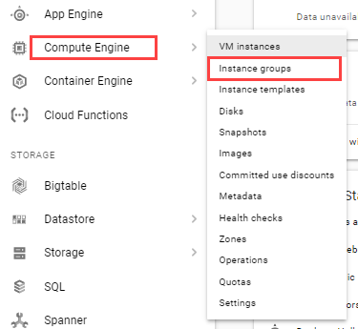
Configure your us-east1 instance group with the following:
Field | Value | Comments
Name | us-east1-mig
Location | Multi-zone
Region | us-east1
Instance template | us-east1-template | Select the template created earlier
Autoscaling | On
Autoscale based on | HTTP load balancing usage
Target load balancing usage | 100%
Minimum Number of Instances | 1 | Default
Maximum Number of Instances | 2 | Down from default of 10
Cool Down Period | 45 seconds | Down from default of 60
Autohealing | No health check | Leave default settings
Autoscaling: Dynamically creates or deletes VMs to meet the instance group target. The setting of 80% means that the autoscaler will kick in when operating at 80% of the HTTP(S) Load Balancer's balancing mode setting. This can be based on connection rate or CPU utilization.
Cool-down period: How long to wait before collecting information from a new instance. This should be at least the time it takes to initialize the instance. Given the startup-script, you're going to wait 45 seconds.
Autohealing: This is disabled in the lab, but would allow for a health-check on each VM in the instance group. If the health-check fails, GCE will automatically attempt to restart the instance.
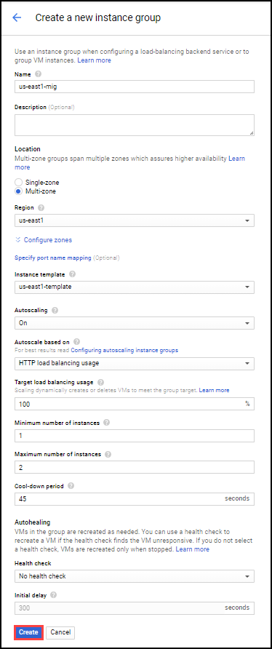
Click Create and accept the error. You will configure the HTTP load-balancing in a future step.
Now create a 2nd instance group in the europe-west1 region. This instance group will function as failover capacity for us-east and will use slightly different settings.
Click Create Instance Group at the top of the page. Use the following configuration:
Field | Value | Comments
Name | europe-west1-mig
Location | Multi-zone
Region | europe-west1
Instance Template | europe-west1-template | Select the template created earlier
Autoscaling | Off
Number of Instances | 3 | Default
Autohealing | No health check | Leave default settings
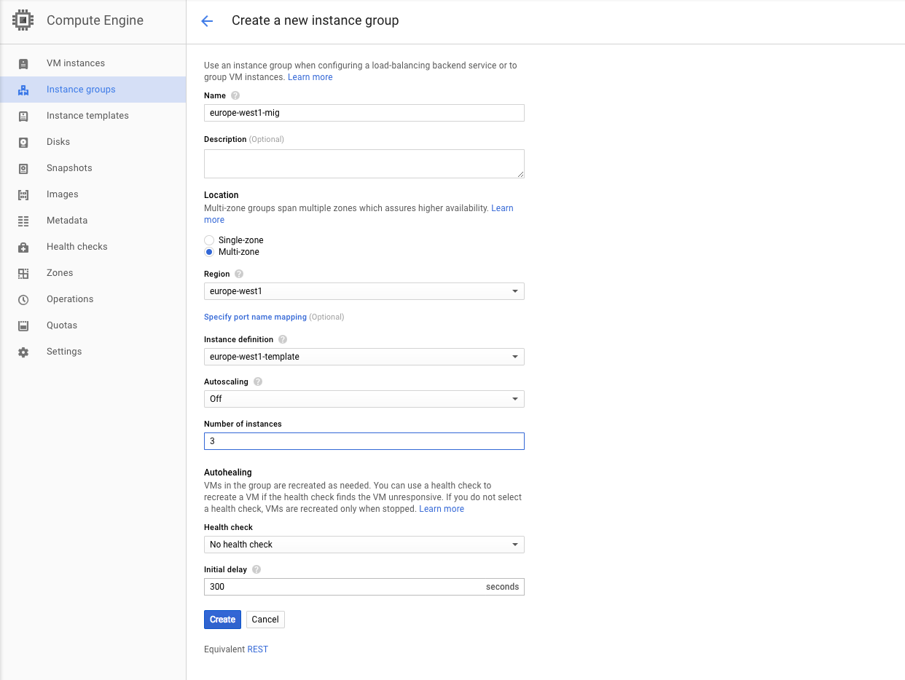
When you're done, click Create.
Verify that the instance groups were successfully created, enter the following command in Cloud Shell:
gcloud compute instance-groups list
The output should look like this:
NAME LOCATION SCOPE NETWORK MANAGED INSTANCES
europe-west1-mig europe-west1 region httplb Yes 3
Us-east1-mig us-east1 region httplb Yes 1

Verify Web Server Functionality
Each instance is configured to run an Apache web server with a simple PHP script that renders:
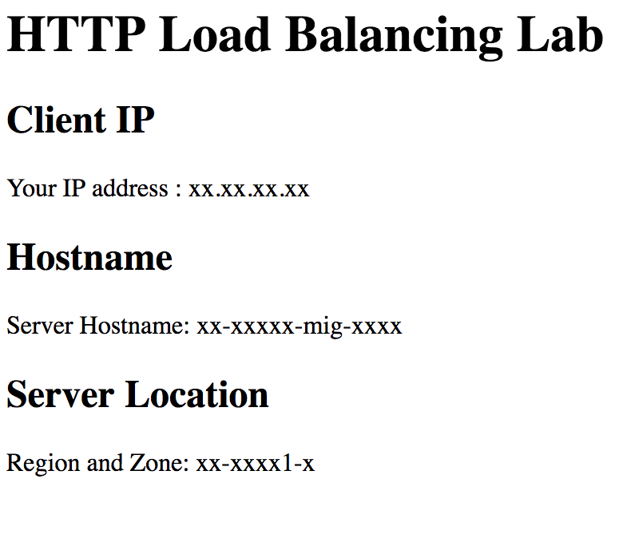

Validate functionality in the Console
To check your web servers are functioning correctly, go to Navigation menu > Compute Engine > VM instances. Ensure that your new instances have been created according to their instance group definitions.
Let's make sure the server is running. On the VM instances page select an instance created by your instance group and click its External (public) IP. Or, in your browser, navigate to http://<External IP>.

Create HTTP Load Balancer
Now that your Managed Instance Groups is defined, it's time to create your HTTP Load Balancer. The HTTP Load Balancer is a distributed global solution capable of distributing load across several regions. In this lab, use us-east1 and europe-west1 instance groups as backends. You will use the Cloud Console for our configuration.
In the Console, click on Navigation menu > Network Services > Load balancing and select Create Load Balancer in the work pane.
Note: In this lab you will be creating an HTTP Load Balancer. This works by reserving an Anycast IP Address that is advertised globally at Google's Points-of-Presence throughout the world. A Layer 7 load balancer is a proxy, and terminates the client session as close to the user as possible and can look into HTTP header information and requests to intelligently route them to the desired backend.
Although the HTTP(S) Load Balancer can terminate encrypted traffic (HTTPS), you will be using HTTP in this exercise.
Google Cloud Platform also has several load balancing offerings which operate at different layers in the OSI model. The HTTP(S) load balancer differs from the TCP/UDP load balancer, which is a regional solution that makes load balancing decisions on IP address (L3) and/or port (L4) information. This does not terminate the client's session and routes requests directly to the backend instance.
In the HTTP(S) Load Balancing tile, click Start configuration.
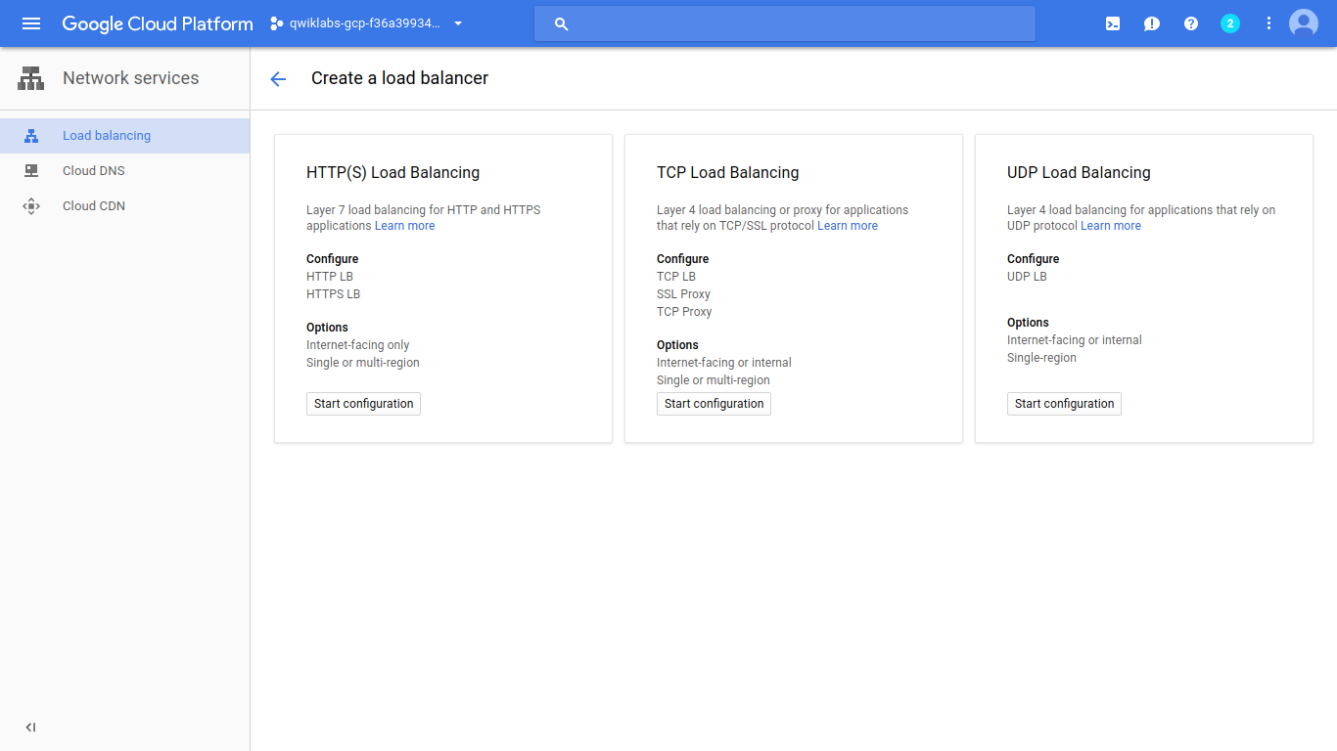
Name your HTTP Load Balancer my-gclb.

Backend configuration
Next, click Backend Configuration. In the new Backend Configuration section, click Create or select backend services or buckets > Backend Services > Create a backend service. This is where we associate the previously created instance groups with load balancing policies.
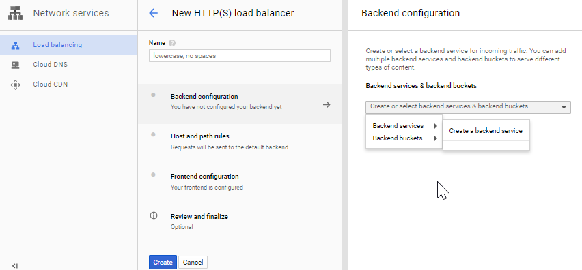
Configure your Backend service with two backends (one for us-east1 and one for europe-west1). Click on the pencil icon to name this Backend service and use these common configuration defaults:
Field | Value
Name | my-backend-service
Protocol | HTTP
Named Port | http
Timeout | 30 seconds
Under the New Backend section, configure:
Field | Value
Instance Group | us-east1-mig
Port number | 80
Balancing mode | Rate
Maximum RPS | 50 RPS per instance
Capacity | 100%
Verify your settings.
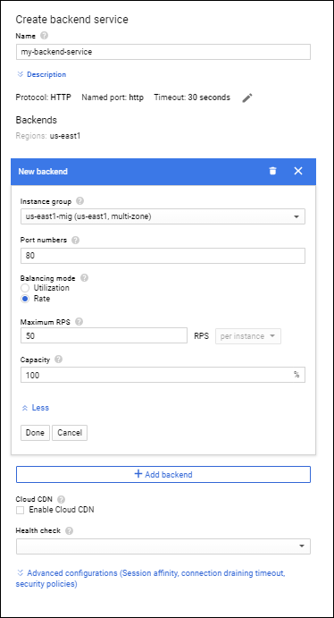
Click + Add backend button. In the next step we will be adding the europe-west1-mig backend into the same backend service.
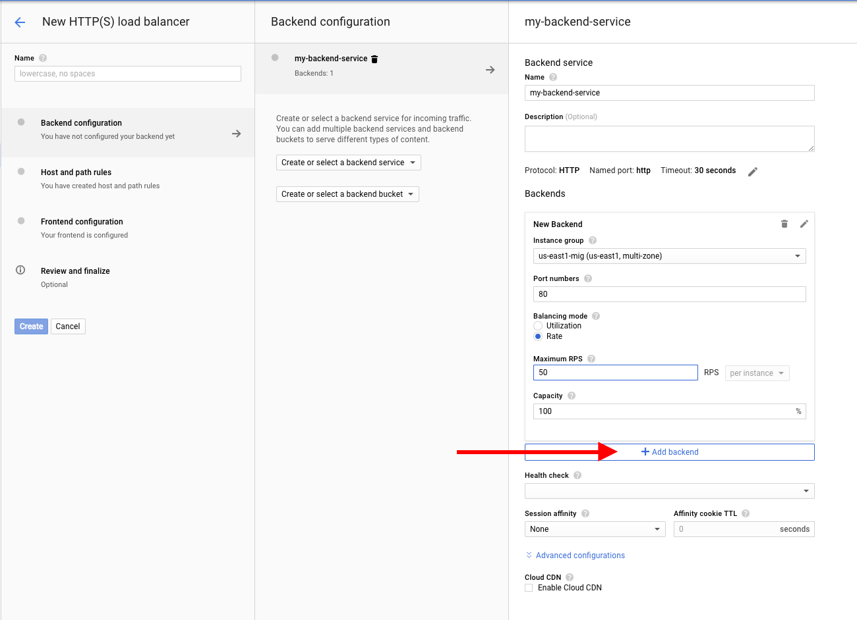
A new box appears where you can add the europe-west1-mig to the Backend service.
Note: You do not need to edit the Backend service Name, Description, Protocol, Named port, or Timeout again since you're adding two backends into the same Backend service.
Under the New Backend section, configure:
Field | Value
Instance Group | europe-west1-mig
Port number | 80
Balancing mode | Utilization
Maximum CPU utilization | 80%
Capacity | 100%
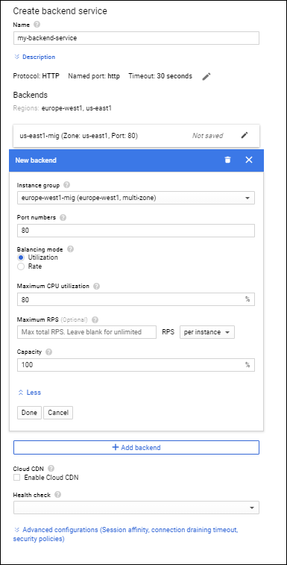
The last step for the Backend configuration is to associate a Health check.

Associate a Health Check
The health check will actively poll instances to ensure they are healthy. If an instance fails the health check the instance will be removed from the pool of available servers. Since you're load balancing HTTP, create a new simple health check.
Under Health check, use the drop down and select "Create Another Health Check" A dialog box will appear. Configure it this way:
Field | Value | Comment
Name | my-http-hc
Protocol | HTTP
Port | 80
Request path | / | Default
Health Criteria | Check interval: 5 seconds  Healthy threshold: 2 consecutive successes  Timeout: 5 seconds  Unhealthy threshold: 2 consecutive failures | Leave defaults
Verify your settings and click Save and Continue.
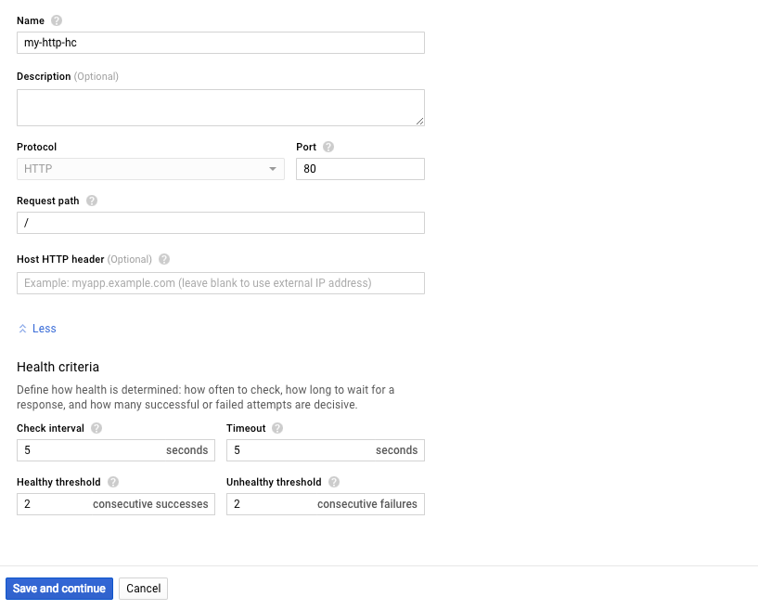
Click Create to complete the Backend configuration.
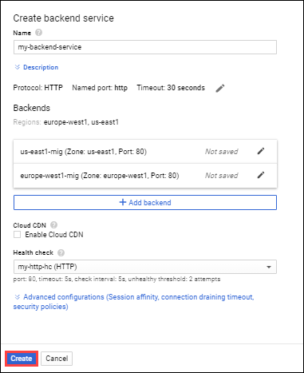

Host and path rules
Host and path rules allow you to direct traffic to Backends based on matching a host or path.
Click Host and path rules.
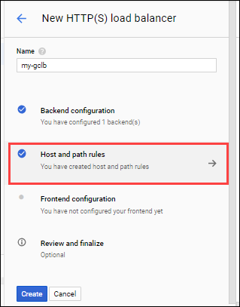
For this lab we will not add any host or path rules.
The Host and path rules is a very powerful feature. This gives administrators the power to direct traffic to specific Backend services (or storage buckets) based on the requested URL. Since we only have 1 Backend service, we will leave the default to send all requests to your Backend Service created earlier, "my-backend-service".

Frontend configuration
The Frontend configuration allows for an administrator to specify how the client traffic will be terminated at the HTTP(S) Load Balancer.
Click Frontend Configuration.
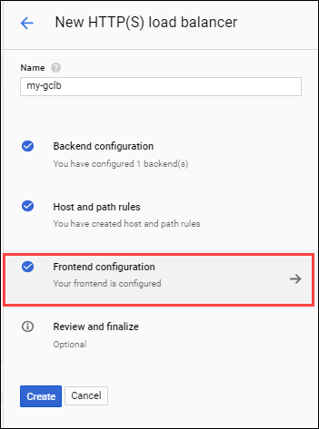
For this lab leave the defaults for:
Field | Value
Protocol | HTTP
IP | Ephemeral
Port | 80
If you were terminating HTTPS traffic (port 443), this is where you would need to import an SSL certificate. This also allows for terminating HTTP traffic on port 8080, and/or assigning the HTTP(S) load balancer a static reserved public IP address.
Click Done.

Review and finalize
Time to review your configuration! Select Review and finalize. Make sure you have 3 check marks next to your Backend configuration, Host and path rules, and Frontend configuration sections.
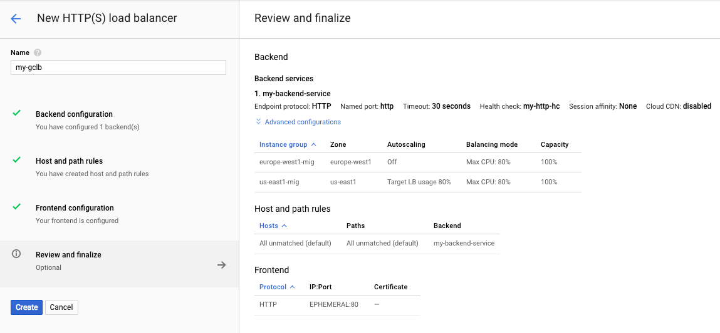
Once verified, click Create.

Testing and Monitoring
Put your freshly created HTTP Load Balancer to work. In this exercise you will be using Siege testing software to show several key features of the HTTP Load Balancer.
You'll need the public IP address for your HTTP Load Balancer. To get it, click on Navigation menu > Network Services > Load Balancing, then click on the load balancer you just created.
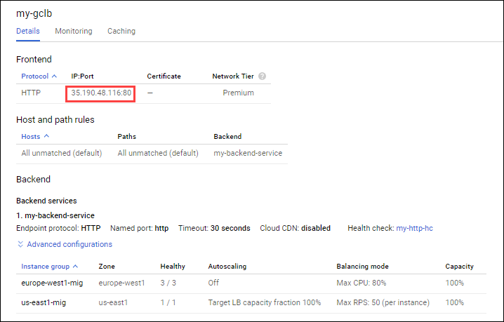
One of the key differentiators for the HTTP(S) load balancer is its global profile. The IP address is advertised throughout the world via Anycast and allows for global backend services. Enterprises can take this IP and create a simple DNS A (host) record for global delivery of their services.
To make sure the Load Balancer is up, launch your browser to the public IP (IP:Port) address.
Important: The HTTP Load Balancer might take a couple of minutes until it is accessible. You get error messages in the meantime (404 or 502).
Note the Client IP address. Why is this different than when you connected directly to your instance?
This is because the HTTP(S) Load Balancer terminates the client session at a Google Front End (GFE) which resides at a Point-of-Presence closest to the user. The GFE then originates a session to the backend instance chosen, so the IP address observed at the backend is that of the GFE which comes from a range of 130.211.0.0/22. This is important as you will need to ensure this source IP range is permitted through the Google Cloud Firewall. (We added a firewall rule for HTTP with 0.0.0.0/0 in this case.)
The HTTP(S) Load Balancer is capable of inserting an X-Forwarded-For HTML header which will identify the original client IP.

Using Siege to Simulate Load
For this exercise you will need to create a new VM in the us-west1 region. This instance will be configured with Siege. Siege works by simulating HTTP requests to a target, which will be the public IP address of your HTTP Load Balancer.
In Cloud Shell create a new VM named "siege" in the httplb network with the following commands:
gcloud compute instances create siege --network httplb --tags ssh --zone us-west1-c \
--metadata startup-script="apt-get -y install siege"
And create a firewall rule:
gcloud compute firewall-rules create httplb-allow-ssh \
--allow tcp:22 --network httplb --source-ranges 0.0.0.0/0 \
--target-tags ssh
SSH to your Siege instance by navigating to the VM instances page and clicking the SSH button in the Console next to the siege name.
Once your SSH session is connected, navigate back to your HTTP(S) Load Balancer in the Console (Home > Network Services > Load balancing). Select your load balancer and show the ‘Monitoring' tab.
Now select the backend you created in the backend drop down and notice the monitoring view expands to include the backends: 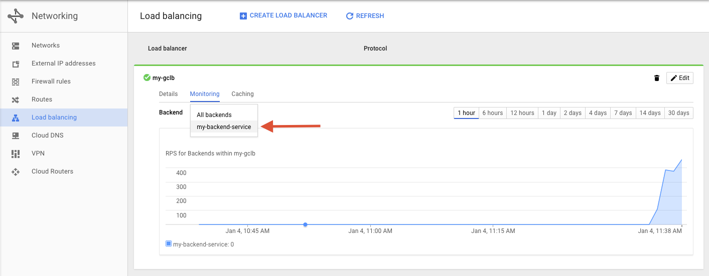
Next, simulate 250 concurrent users in Siege by running the following command in your Siege instance:
siege -c 250 http://<http-loadbalancer-ip>
Output should look like this:
** SIEGE 3.0.8
** Preparing 250 concurrent users for battle.
The server is now under siege...
Navigate back to the monitoring page for your load balancer in the Cloud Console. What do you expect to see? Watch for a few minutes while Siege continues to run.
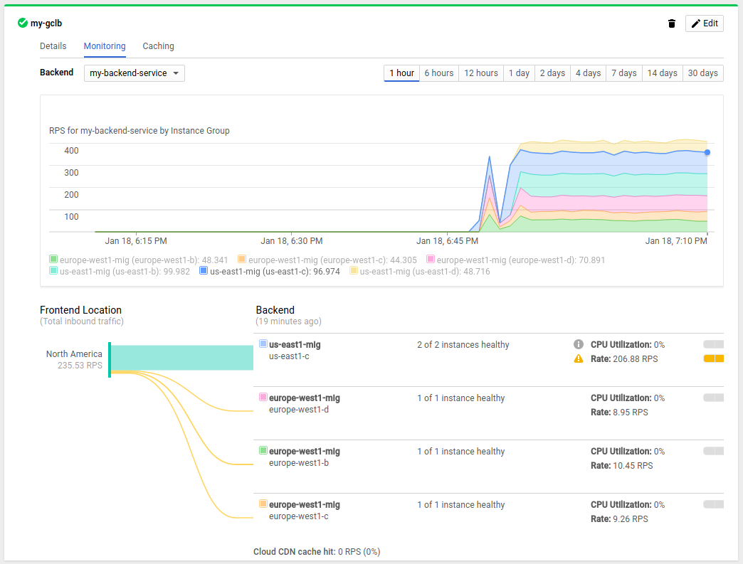
You previously created a backend service consisting of two backends (us-east1 and europe-west1). Since you're originating requests from an instance in us-west1, the HTTP load balancer will terminate the client session at a Point of Presence closest to the client. These requests will then be routed to the closest backend which is us-east1.
Since us-east1 was configured as a Managed Instance Group of 1 with a balancing mode of rate (50 requests per second), you should see traffic overflow to your backend in europe-west1. The latter backend is configured with a balancing mode of CPU utilization up to 80%.
Because an auto-scaler was associated with the us-east1 instance group, and the requests are greater than 50 request per second, the auto-scaler will scale up and build 4 additional instances in us-east1 to handle capacity (max 5 configured). This will take some time as the additional instances are subject to a cooldown period of 45 seconds + the time it takes to pass the HTTP Load Balancer health check.
You can view the instances spinning up in the Cloud Console under Compute Engine > VM Instances.
Once the instances in us-east1 are scaled up and healthy, you will see load transition back to us-east1, away from europe-west1.
Despite the relatively low load, this exercise shows the global nature of the HTTP load balancer, which is capable of handling millions of RPS. No advanced DNS configuration was necessary to achieve this!
Navigate back to your SSH session to your w1-vm and stop Siege with Crtl+c. Observe the output from the Siege program.
Was the HTTP load balancer able to serve every request?

Congratulations!

What we've covered
- How to set up up basic firewalling to secure your networks
- How to set up a global HTTP Load Balancer with Managed Instance Groups to automatically scale your resources up and down based on request load
- How to test and monitor your HTTP Load Balancer setup

