INITIAL MODEL:
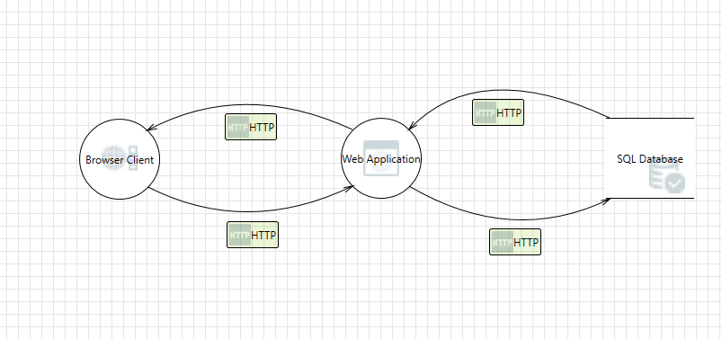
The model has a browser client, web application and SQL Database which has http transfers in bi-directional.
Threat List:

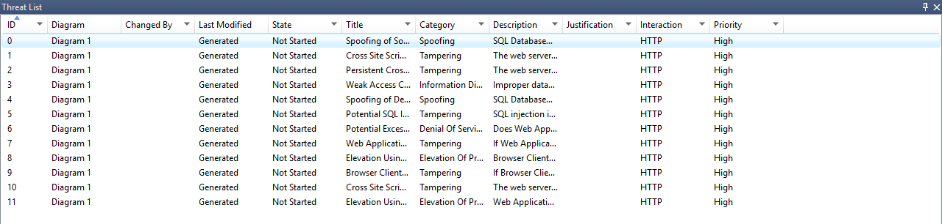

Now remove the “HTTP flow from database to web application” & observe the threats listed. Is anything missing?
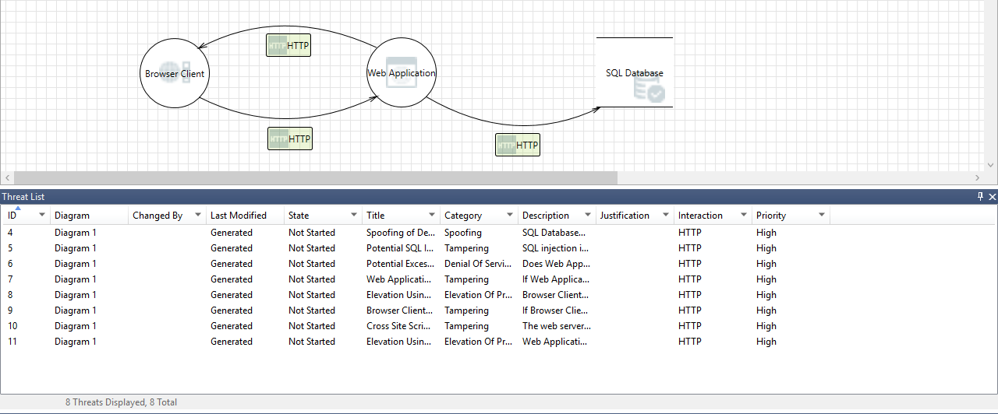
Ans: There are few threats missing. They are persistent cross site scripting, spoofing, weak access control.
UNDONE THE PREVIOUS CHANGES:
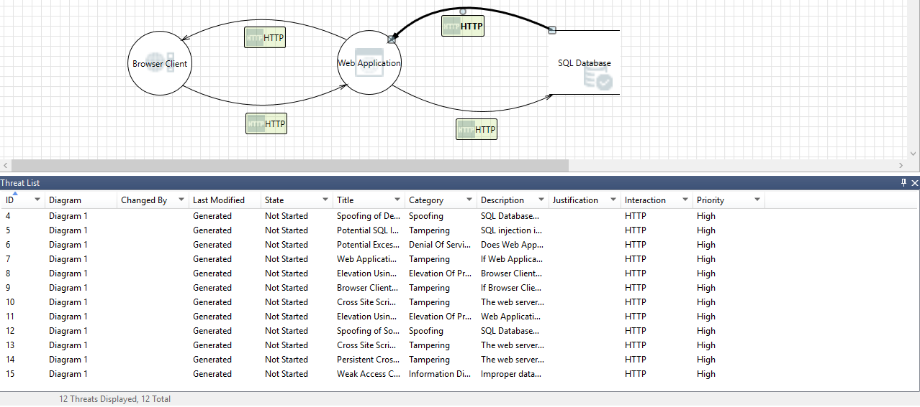
Removed Database from web app to DB:

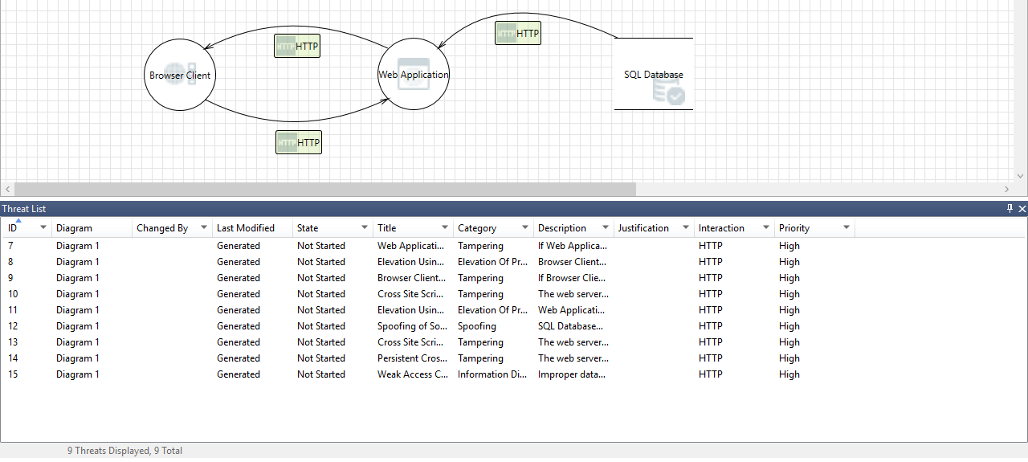
Ans: Few threats have been added once we removed the http from web application to SQL Database. They are as follows:
- Spoofing of database (spoofing)
- Potential SQL Injection (tampering)
- Potential excessive resource consumption (Denial of service)
Undone the previous changes:
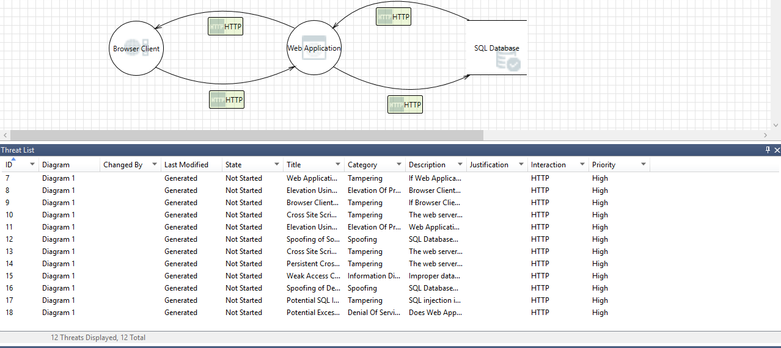
Remove web app to browser:

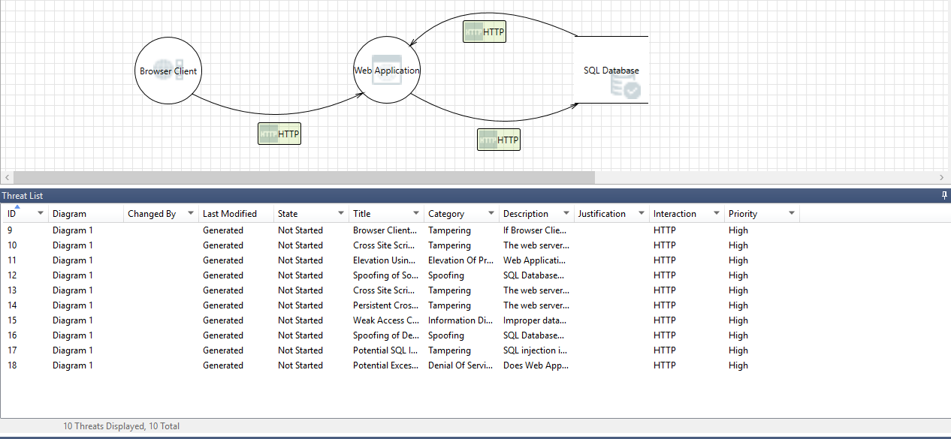

Ans:
Threats removed:
- Browser client process memory tampered (Tampering)
- Elevation using impersonation (Elevation of privilege)

Undo the previous changes:
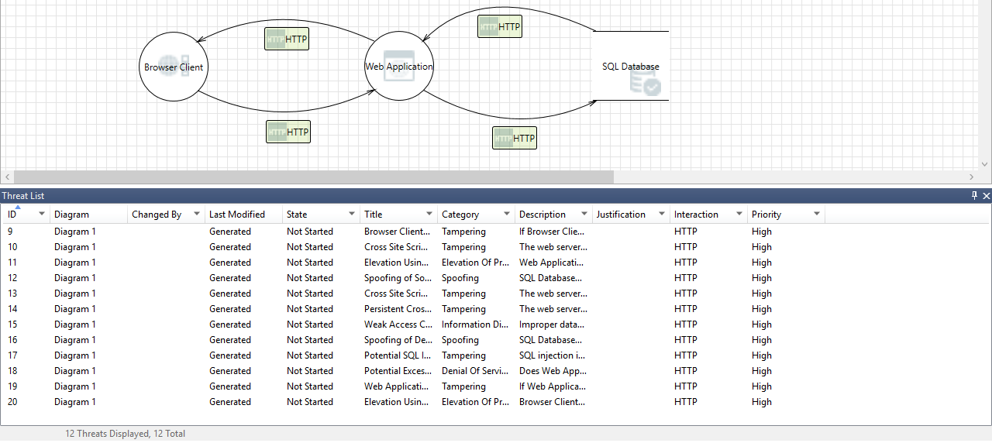

Remove browser to web app:
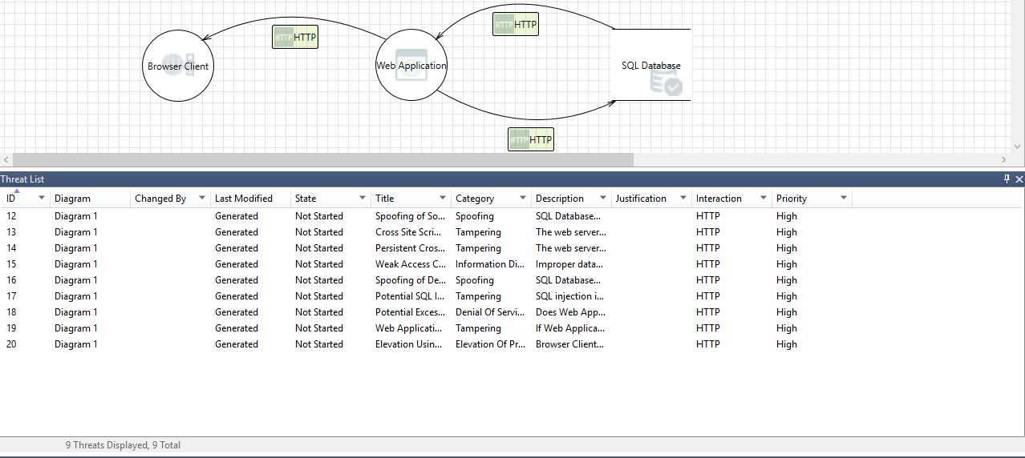
Undo previous changes:
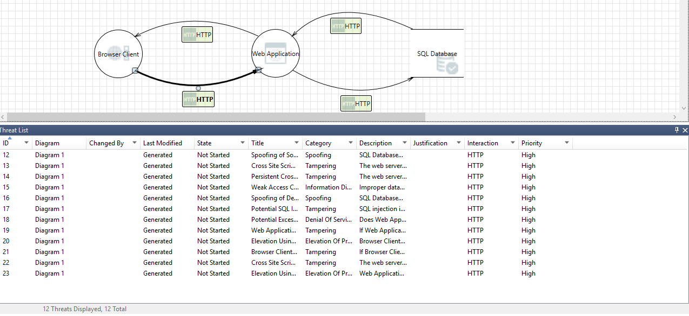

Add a Trust Boundary (CorpNet) that surrounds Web Application & Database. Now observe the threats. Do you see “Data flow sniffing” threat?
Ans: Yes, we can see the data flow sniffing threat.

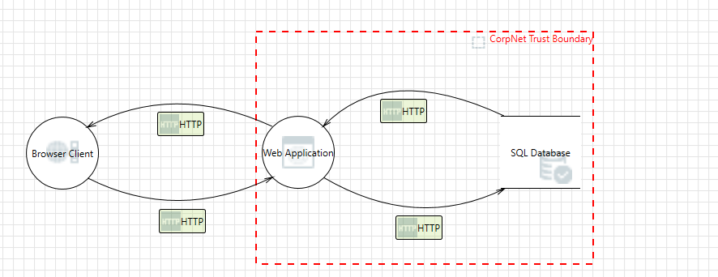
Threat list:
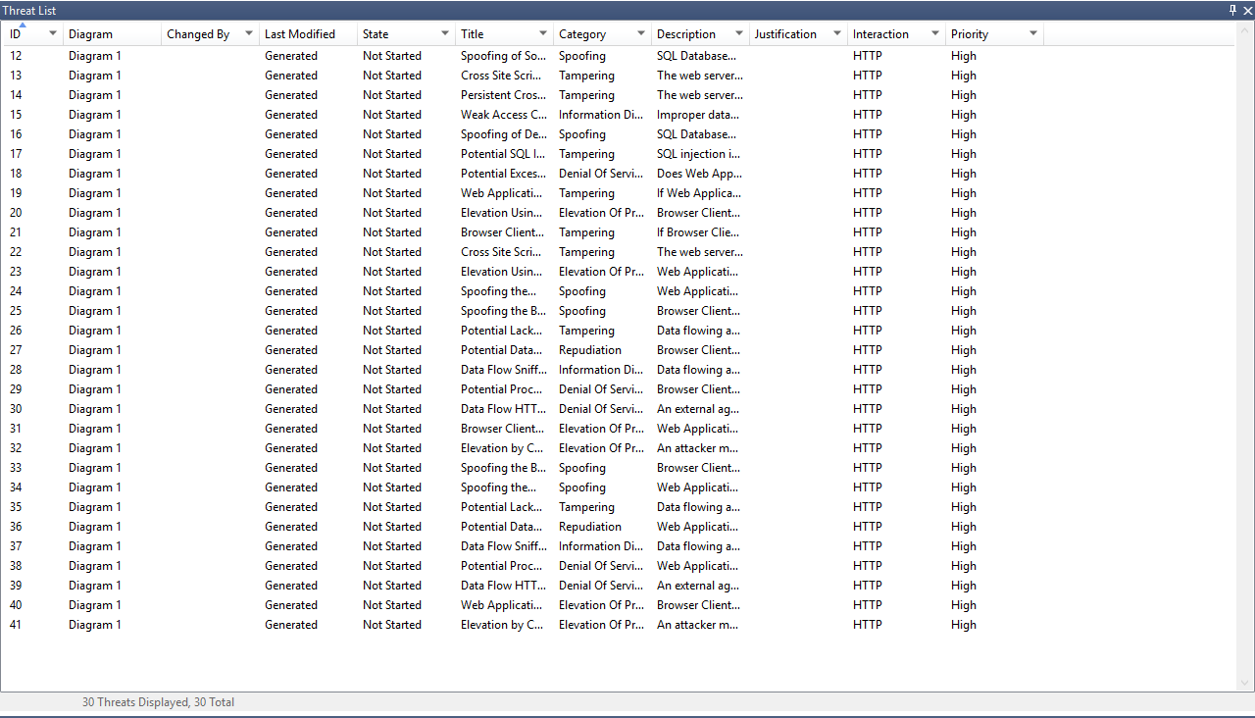
Now replace the HTTP flow from browser to web application with a HTTPS flow. Do you still see the “Data flow sniffing” threat?

Ans: Yes, I can see the data flow sniffing threat.

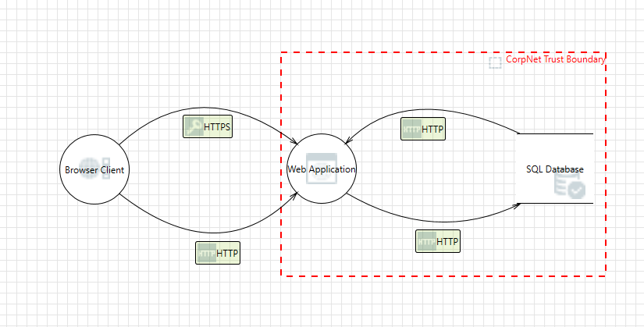
Threat file:
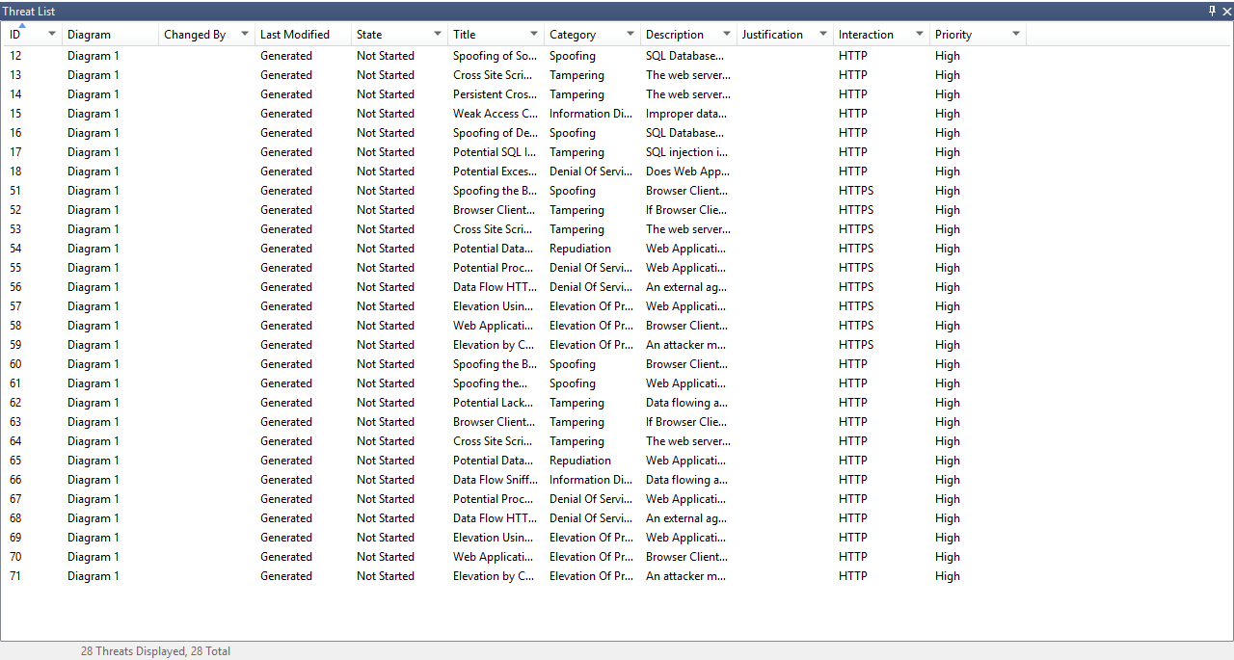

Types of threats and their desired properties:
- Spoofing: Authenticity
- Tampering: Integrity
- Information disclosure: Confidentiality

- Denial of service: Availability
- Elevation of privilege: Authorization

