BigQuery: Qwik Start - Command Line
30 minutesFree

Rate Lab

GSP071

Overview
Storing and querying massive datasets can be time consuming and expensive without the right hardware and infrastructure. Google BigQuery is a serverless, highly scalable cloud data warehouse that solves this problem by enabling super-fast SQL queries using the processing power of Google's infrastructure. Simply move your data into BigQuery and let us handle the hard work. You can control access to both the project and your data based on your business needs, such as giving others the ability to view or query your data.
You can access BigQuery by using the Console, Web UI or a command-line tool using a variety of client libraries such as Java, .NET, or Python. There are also a variety of solution providers that you can use to interact with BigQuery.
This hands-on lab shows you how to use bq, the python-based command line tool for BigQuery, to query public tables and load sample data into BigQuery.

Setup and Requirements

Qwiklabs setup

Before you click the Start Lab button
Read these instructions. Labs are timed and you cannot pause them. The timer, which starts when you click Start Lab, shows how long Cloud resources will be made available to you.
This Qwiklabs hands-on lab lets you do the lab activities yourself in a real cloud environment, not in a simulation or demo environment. It does so by giving you new, temporary credentials that you use to sign in and access the Google Cloud Platform for the duration of the lab.

What you need
To complete this lab, you need:
- Access to a standard internet browser (Chrome browser recommended).
- Time to complete the lab.
Note: If you already have your own personal GCP account or project, do not use it for this lab.

Google Cloud Platform Console

How to start your lab and sign in to the Console
- Click the Start Lab button. If you need to pay for the lab, a pop-up opens for you to select your payment method. On the left is a panel populated with the temporary credentials that you must use for this lab.
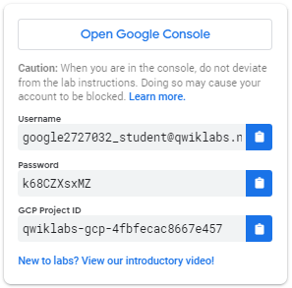
- Copy the username, and then click Open Google Console. The lab spins up resources, and then opens another tab that shows the Choose an account page.
Tip: Open the tabs in separate windows, side-by-side.
- On the Choose an account page, click Use Another Account.
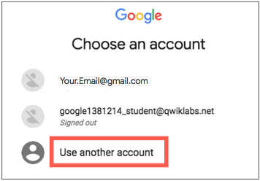
- The Sign in page opens. Paste the username that you copied from the Connection Details panel. Then copy and paste the password.
Important: You must use the credentials from the Connection Details panel. Do not use your Qwiklabs credentials. If you have your own GCP account, do not use it for this lab (avoids incurring charges).
- Click through the subsequent pages:
  - Accept the terms and conditions.
  - Do not add recovery options or two-factor authentication (because this is a temporary account).
  - Do not sign up for free trials.
After a few moments, the GCP console opens in this tab.
Note: You can view the menu with a list of GCP Products and Services by clicking the Navigation menu at the top-left, next to “Google Cloud Platform”. 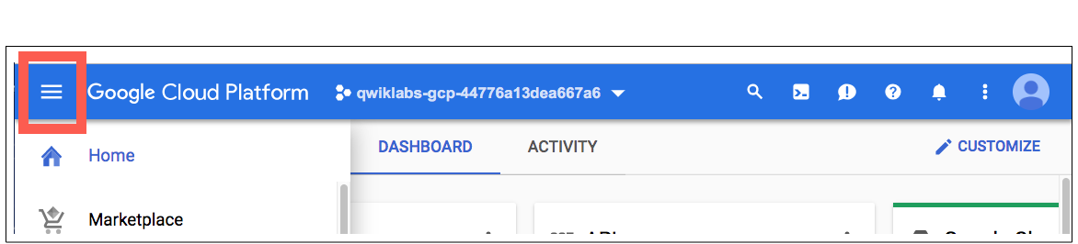

Activate Google Cloud Shell
Google Cloud Shell is a virtual machine that is loaded with development tools. It offers a persistent 5GB home directory and runs on the Google Cloud. Google Cloud Shell provides command-line access to your GCP resources.
- In GCP console, on the top right toolbar, click the Open Cloud Shell button.
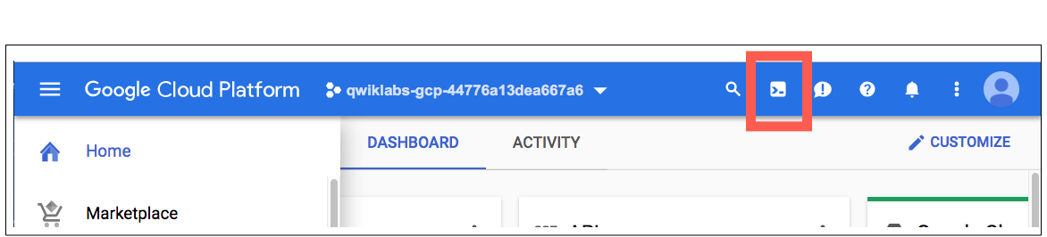
- In the dialog box that opens, click START CLOUD SHELL:
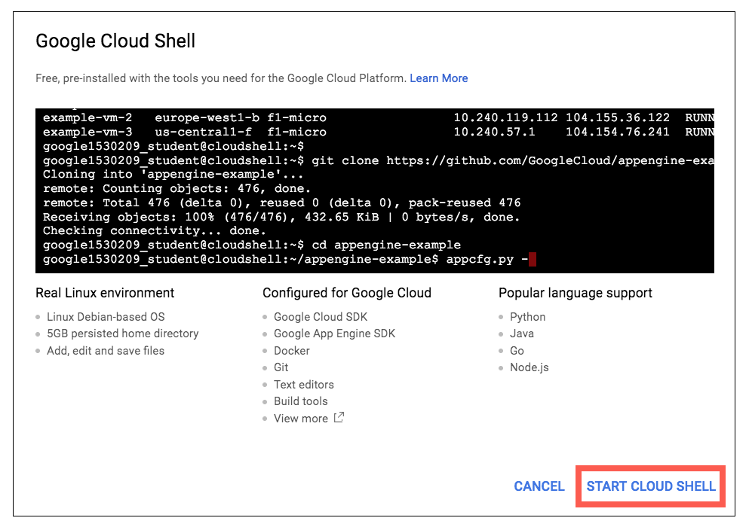
You can click "START CLOUD SHELL" immediately when the dialog box opens.
It takes a few moments to provision and connect to the environment. When you are connected, you are already authenticated, and the project is set to your PROJECT_ID. For example:
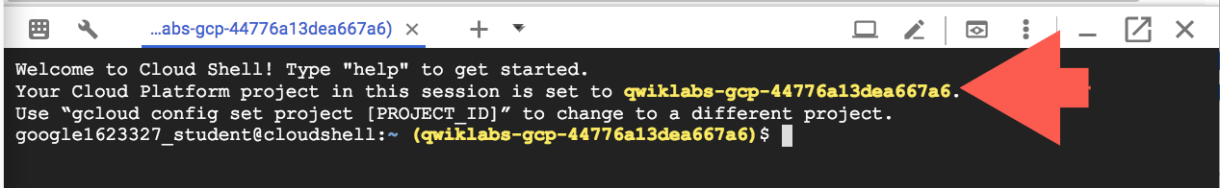
gcloud is the command-line tool for Google Cloud Platform. It comes pre-installed on Cloud Shell and supports tab-completion.
You can list the active account name with this command:
gcloud auth list
Output:
Credentialed accounts:
- <myaccount>@<mydomain>.com (active)
Example output:
Credentialed accounts:
- google1623327_student@qwiklabs.net
You can list the project ID with this command:
gcloud config list project
Output:
[core]
project = <project_ID>
Example output:
[core]
project = qwiklabs-gcp-44776a13dea667a6
Full documentation of gcloud is available on Google Cloud gcloud Overview.

Examine a table
BigQuery offers a number of sample tables that you can run queries against. In this lab you'll run queries against the shakespeare table, which contains an entry for every word in every play.
To examine the schema the Shakespeare table in the samples dataset, run:
bq show bigquery-public-data:samples.shakespeare
In this command you're doing the following:
- bq to invoke the BigQuery command line tool
- show is the action
- then you're listing the name of the project:public dataset.table in BigQuery that you want to see.
Output:
Last modified Schema Total Rows Total Bytes Expiration Time Partitioning Clustered Fields Labels
----------------- ------------------------------------ ------------ ------------- ------------ ------------------- ------------------ --------
14 Mar 13:16:45 |- word: string (required) 164656 6432064
|- word_count: integer (required)
|- corpus: string (required)
|- corpus_date: integer (required)

Run the help command
When you include a command name with the help commands, you get information about that specific command. For example, the following call to bq help retrieves information about the query command.
bq help query
To see a list of all of the commands bq uses, run just bq help.

Run a query
Now you'll run a query to see how many times the substring "raisin" appears in Shakespeare's works.
To run a query, run the command bq query "[SQL_STATEMENT]".
- Escape any quotation marks inside the [SQL_STATEMENT] with a \ mark, or
- Use a different quotation mark type than the surrounding marks (" versus ').
Run the following standard SQL query in Cloud Shell to count the number of times that the substring "raisin" appears in all of Shakespeare's works:
bq query --use_legacy_sql=false \
'SELECT
word,
SUM(word_count) AS count
FROM
`bigquery-public-data`.samples.shakespeare
WHERE
word LIKE "%raisin%"
GROUP BY
word'
In this command:
- --use_legacy_sql=false makes standard SQL the default query syntax
Output:
Waiting on job_e19 ... (0s) Current status: DONE
+---------------+-------+
| word | count |
+---------------+-------+
| praising | 8 |
| Praising | 4 |
| raising | 5 |
| dispraising | 2 |
| dispraisingly | 1 |
| raisins | 1 |
The table demonstrates that although the actual word raisin doesn't appear, the letters appear in order in several of Shakespeare's works.

Test Completed Task
Click Check my progress to verify your performed task. If you have successfully run query against public dataset, you will see an assessment score.
Run a query (dataset: samples, table: shakespeare, substring: raisin)
Check my progress
If you search for a word that isn't in Shakespeare's works, no results are returned.
Run following search for "huzzah", returns no matches:
bq query --use_legacy_sql=false \
'SELECT
word
FROM
`bigquery-public-data`.samples.shakespeare
WHERE
word = "huzzah"'

Test Completed Task
Click Check my progress to verify your performed task. If you have successfully run query against public dataset, you will see an assessment score.
Run a query (dataset: samples, table: shakespeare, substring: huzzah)
Check my progress

Create a new table
Now create your own table. Every table is stored inside a dataset. A dataset is a group of resources, such as tables and views.

Create a new dataset
Use the bq ls command to list any existing databsets in your project:
bq ls
You will be brought back to the command line since there aren't any datasets in your project yet.
Run bq ls and the bigquery-public-data Project ID to list the datasets in that specific project, followed by a colon (:).
bq ls bigquery-public-data:
Output:
datasetId
-----------------------------
austin_311
austin_bikeshare
austin_crime
austin_incidents
austin_waste
baseball
bitcoin_blockchain
bls
census_bureau_construction
census_bureau_international
census_bureau_usa
census_utility
chicago_crime
...
Now create a dataset. A dataset name can be up to 1,024 characters long, and consist of A-Z, a-z, 0-9, and the underscore, but it cannot start with a number or underscore, or have spaces.
Use the bq mk command to create a new dataset named babynames in your Qwiklabs project:
bq mk babynames
Sample output:
Dataset 'qwiklabs-gcp-ba3466847fe3cec0:babynames' successfully created.

Test Completed Task
Click Check my progress to verify your performed task. If you have successfully created BigQuery dataset with name as babynames, you will see an assessment score.
Create a new dataset (name: babynames)
Check my progress
Run bq ls to confirm that the dataset now appears as part of your project:
bq ls
Sample output:
datasetId
-------------
babynames

Upload the dataset
Before you can build the table, you need to add the dataset to your project. The custom data file you'll use contains approximately 7 MB of data about popular baby names, provided by the US Social Security Administration.
Run this command to add the baby names zip file to your project, using the URL for the data file:
wget http://www.ssa.gov/OACT/babynames/names.zip
List the file:
ls
You can see the name of the file added to your project.
Now unzip the file:
unzip names.zip
That's a pretty big list of text files! List the files again:
ls
The bq load command creates or updates a table and loads data in a single step.
You will use the bq load command to load your source file into a new table called names2010 in the babynames dataset you just created. By default, this runs synchronously, and will take a few seconds to complete.
The bq load arguments you'll be running are:
datasetID: babynames
tableID: names2010
source: yob2010.txt
schema: name:string,gender:string,count:integer
Create your table:
bq load babynames.names2010 yob2010.txt name:string,gender:string,count:integer
Sample output:
Waiting on job_4f0c0878f6184119abfdae05f5194e65 ... (35s) Current status: DONE

Test Completed Task
Click Check my progress to verify your performed task. If you have successfully load data into dataset table, you will see an assessment score.
Load the data into a new table
Check my progress
Run bq ls and babynames to confirm that the table now appears your dataset:
bq ls babynames
Output:
tableId Type
----------- -------
names2010 TABLE
Run bq show and your dataset.table to see the schema:
bq show babynames.names2010
Output:
Last modified Schema Total Rows Total Bytes Expiration Time Partitioning Clustered Fields Labels
----------------- ------------------- ------------ ------------- ----------------- ------------------- ------------------ --------
13 Aug 14:37:34 |- name: string 34073 654482 12 Oct 14:37:34
|- gender: string
|- count: integer
By default, when you load data, BigQuery expects UTF-8 encoded data. If you have data that is in ISO-8859-1 (or Latin-1) encoding and are having problems with your loaded data, you can tell BigQuery to treat your data as Latin-1 explicitly, using the -E flag. For more information, see Character Encodings.

Run queries
Now you're ready to query the data and return some interesting results.
Run the following command to return the top 5 most popular girls names:
bq query "SELECT name,count FROM babynames.names2010 WHERE gender = 'F' ORDER BY count DESC LIMIT 5"
Output:
Waiting on job_58c0f5ca52764ef1902eba611b71c651 ... (0s) Current status: DONE
+----------+-------+
| name | count |
+----------+-------+
| Isabella | 22913 |
| Sophia | 20643 |
| Emma | 17345 |
| Olivia | 17028 |
| Ava | 15433 |
+----------+-------+
Run the following command to see the top 5 most unusual boys names.
bq query "SELECT name,count FROM babynames.names2010 WHERE gender = 'M' ORDER BY count ASC LIMIT 5"
Note: The minimum count is 5 because the source data omits names with fewer than 5 occurrences.
Output:
Waiting on job_556ba2e5aad340a7b2818c3e3280b7a3 ... (1s) Current status: DONE
+----------+-------+
| name | count |
+----------+-------+
| Aaqib | 5 |
| Aaidan | 5 |
| Aadhavan | 5 |
| Aarian | 5 |
| Aamarion | 5 |
+----------+-------+

Test Completed Task
Click Check my progress to verify your performed task. If you have successfully run query against custom dataset, you will see an assessment score.
Run queries against your dataset table
Check my progress

Test your Understanding
Below are multiple choice questions to reinforce your understanding of this lab's concepts. Answer them to the best of your abilities.
You can access BigQuery using:
GLib
GStreamer
checkBigQuery REST API
checkWeb UI
checkCommand line tool
Submit
Which CLI tool is used to interact with BigQuery service?
gcloud
gsutil
compute
checkbq
Submit

Clean up
Run the bq rm command to remove the babynames dataset with the -r flag to delete all tables in the dataset.
bq rm -r babynames
Confirm the delete command by typing "y".

Test Completed Task
Click Check my progress to verify your performed task. If you have successfully removed babynames dataset, you will see an assessment score.
Remove the babynames dataset
Check my progress

Congratulations!
Now you can use the command line with BigQuery to manipulate data.

