Bigtable: Qwik Start - Command Line
30 minutes1 Credit

Rate Lab

GSP099
Cloud Bigtable is Google's NoSQL Big Data database service. It's the same database that powers many core Google services, including Search, Analytics, Maps, and Gmail. Bigtable is designed to handle massive workloads at consistent low latency and high throughput, so it's a great choice for both operational and analytical applications, including IoT, user analytics, and financial data analysis.
In this lab you'll learn how to use the cbt command line to connect to a Cloud Bigtable instance, perform basic administrative tasks, and read and write data in a table.

Setup and Requirements

Qwiklabs setup

Before you click the Start Lab button
Read these instructions. Labs are timed and you cannot pause them. The timer, which starts when you click Start Lab, shows how long Cloud resources will be made available to you.
This Qwiklabs hands-on lab lets you do the lab activities yourself in a real cloud environment, not in a simulation or demo environment. It does so by giving you new, temporary credentials that you use to sign in and access the Google Cloud Platform for the duration of the lab.

What you need
To complete this lab, you need:
- Access to a standard internet browser (Chrome browser recommended).
- Time to complete the lab.
Note: If you already have your own personal GCP account or project, do not use it for this lab.

Google Cloud Platform Console

How to start your lab and sign in to the Console
- Click the Start Lab button. If you need to pay for the lab, a pop-up opens for you to select your payment method. On the left is a panel populated with the temporary credentials that you must use for this lab.
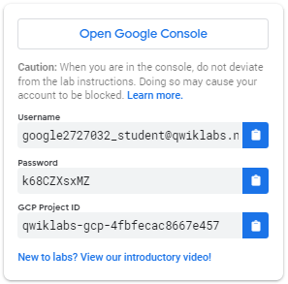
- Copy the username, and then click Open Google Console. The lab spins up resources, and then opens another tab that shows the Choose an account page.
Tip: Open the tabs in separate windows, side-by-side.
- On the Choose an account page, click Use Another Account.
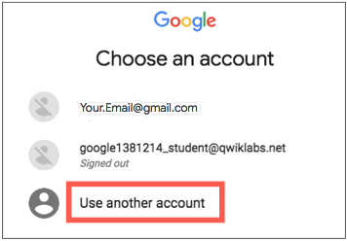
- The Sign in page opens. Paste the username that you copied from the Connection Details panel. Then copy and paste the password.
Important: You must use the credentials from the Connection Details panel. Do not use your Qwiklabs credentials. If you have your own GCP account, do not use it for this lab (avoids incurring charges).
- Click through the subsequent pages:
  - Accept the terms and conditions.
  - Do not add recovery options or two-factor authentication (because this is a temporary account).
  - Do not sign up for free trials.
After a few moments, the GCP console opens in this tab.
Note: You can view the menu with a list of GCP Products and Services by clicking the Navigation menu at the top-left, next to “Google Cloud Platform”. 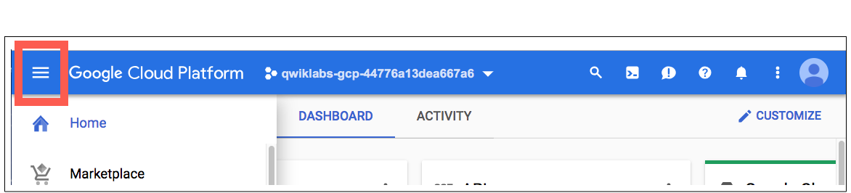

Cloud Shell

Activate Google Cloud Shell
Google Cloud Shell is a virtual machine that is loaded with development tools. It offers a persistent 5GB home directory and runs on the Google Cloud. Google Cloud Shell provides command-line access to your GCP resources.
- In GCP console, on the top right toolbar, click the Open Cloud Shell button.
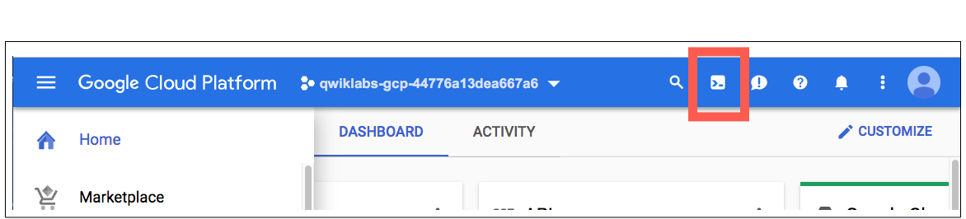
- In the dialog box that opens, click START CLOUD SHELL:
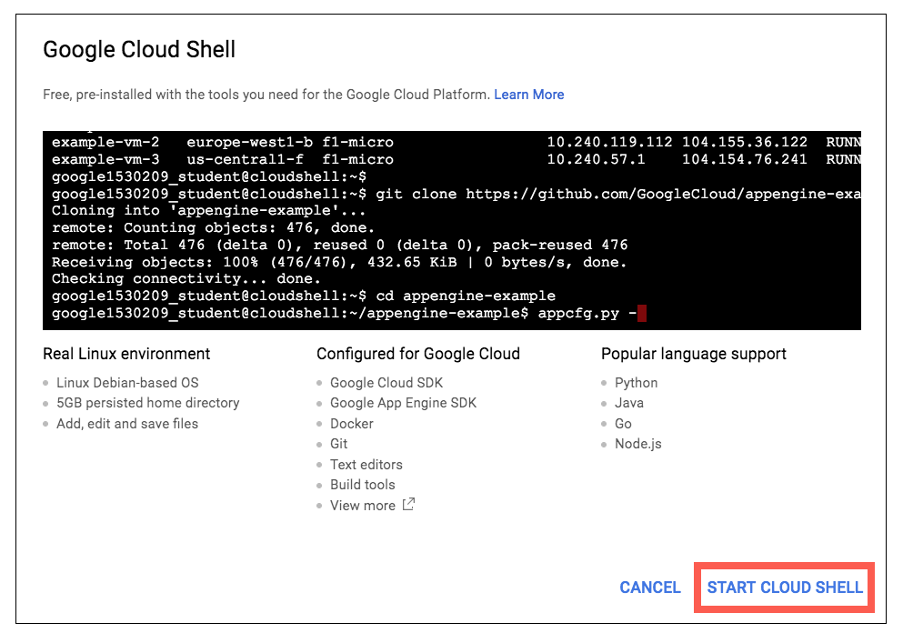
You can click "START CLOUD SHELL" immediately when the dialog box opens.
It takes a few moments to provision and connect to the environment. When you are connected, you are already authenticated, and the project is set to your PROJECT_ID. For example:
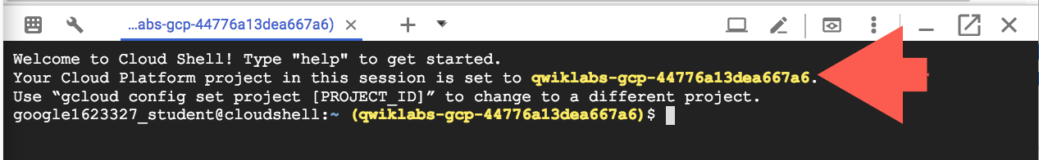
gcloud is the command-line tool for Google Cloud Platform. It comes pre-installed on Cloud Shell and supports tab-completion.
You can list the active account name with this command:
gcloud auth list
Output:
Credentialed accounts:
- <myaccount>@<mydomain>.com (active)
Example output:
Credentialed accounts:
- google1623327_student@qwiklabs.net
You can list the project ID with this command:
gcloud config list project
Output:
[core]
project = <project_ID>
Example output:
[core]
project = qwiklabs-gcp-44776a13dea667a6
Full documentation of gcloud is available on Google Cloud gcloud Overview.

Create a Cloud Bigtable instance
In the GCP Console, go to Navigation menu menu, click on Bigtable in the Storage section, then click Create instance.
Fill in the fields for your instance as follows:
Name: Quickstart instance
Instance type: Development
Region: us-east1
Zone: us-east1-c
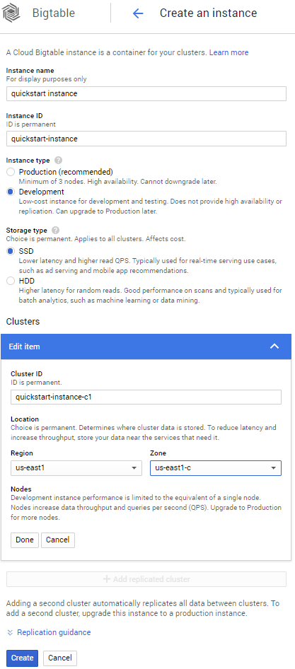
Click Done and then Create to create the instance.

Connect to your instance
In Cloud Shell, configure cbt to use your project and instance by modifying the .cbtrc file, replacing [PROJECT_ID] with your Qwiklabs-provisioned GCP project ID. You can copy this from the Qwiklabs lab start page:
echo project = [PROJECT_ID] > ~/.cbtrc
echo instance = quickstart-instance >> ~/.cbtrc
Now you're ready to use the cbt command.
Click Check my progress to verify the objective.
Create a Cloud BigTable instance
Check my progress

Read and Write Data
Cloud Bigtable stores data in tables, which contain rows. Each row is identified by a row key.
Data in a row is organized into column families, or groups of columns. A column qualifier identifies a single column within a column family.
A cell is the intersection of a row and a column. Each cell can contain multiple versions of a value.
Create a table named my-table.
cbt createtable my-table
List your tables:
cbt ls
The command displays output similar to the following:
my-table
Add one column family named cf1:
cbt createfamily my-table cf1
List your column families:
cbt ls my-table
The command displays output similar to the following:
Family Name GC Policy
----------- ---------
cf1 <never>
Click Check my progress to verify the objective.
Create a table
Check my progress
Put the value test-value in the row r1, using the column family cf1 and the column qualifier c1:
cbt set my-table r1 cf1:c1=test-value
Use the cbt read command to read the data you added to the table:
cbt read my-table
The shell displays output similar to the following:
----------------------------------------
r1
cf1:c1 @ 2016/10/31-15:05:38.840000
"test-value"
Delete the table my-table:
cbt deletetable my-table
Click Check my progress to verify the objective.
Delete the table
Check my progress
You have now used the cbt command line to access Bigtable.

Congratulations!

