Datastore: Qwik Start
30 minutesFree

Rate Lab

GSP131

Overview
This hands-on lab will show you how to store and query data in Google Cloud Datastore using the Google Cloud Platform.

Setup

Before you click the Start Lab button
Read these instructions. Labs are timed and you cannot pause them. The timer, which starts when you click Start Lab, shows how long Cloud resources will be made available to you.
This Qwiklabs hands-on lab lets you do the lab activities yourself in a real cloud environment, not in a simulation or demo environment. It does so by giving you new, temporary credentials that you use to sign in and access the Google Cloud Platform for the duration of the lab.

What you need
To complete this lab, you need:
- Access to a standard internet browser (Chrome browser recommended).
- Time to complete the lab.
Note: If you already have your own personal GCP account or project, do not use it for this lab.

How to start your lab and sign in to the Console
- Click the Start Lab button. If you need to pay for the lab, a pop-up opens for you to select your payment method. On the left is a panel populated with the temporary credentials that you must use for this lab.
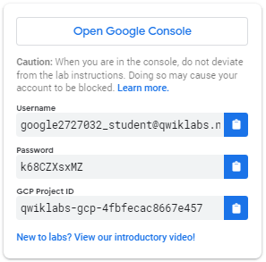
- Copy the username, and then click Open Google Console. The lab spins up resources, and then opens another tab that shows the Choose an account page.
Tip: Open the tabs in separate windows, side-by-side.
- On the Choose an account page, click Use Another Account.
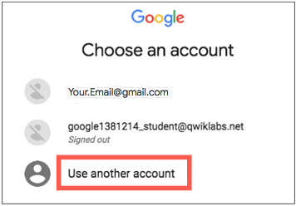
- The Sign in page opens. Paste the username that you copied from the Connection Details panel. Then copy and paste the password.
Important: You must use the credentials from the Connection Details panel. Do not use your Qwiklabs credentials. If you have your own GCP account, do not use it for this lab (avoids incurring charges).
- Click through the subsequent pages:
  - Accept the terms and conditions.
  - Do not add recovery options or two-factor authentication (because this is a temporary account).
  - Do not sign up for free trials.
After a few moments, the GCP console opens in this tab.
Note: You can view the menu with a list of GCP Products and Services by clicking the Navigation menu at the top-left, next to “Google Cloud Platform”. 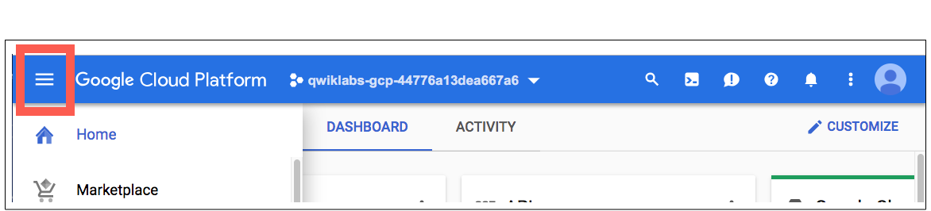

Store data
In left menu on the Console, Storage section, go to Datastore > Entities.
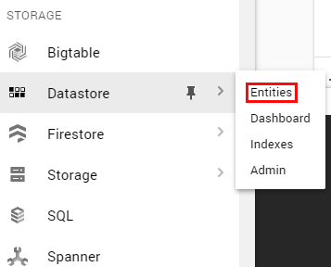
Under the Datastore mode column, click Select Datastore Mode.
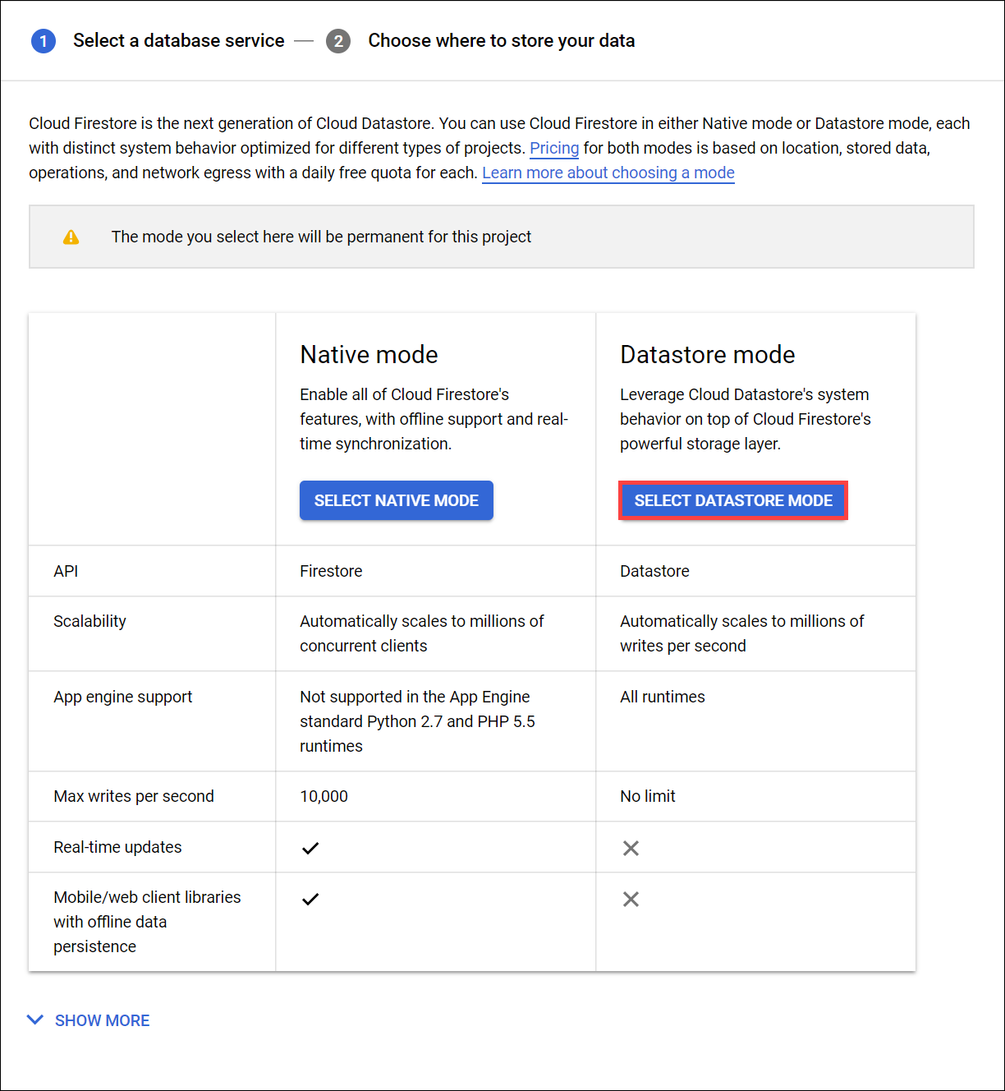
Now choose where you'll create your database. Use the dropdown menu to select a location:
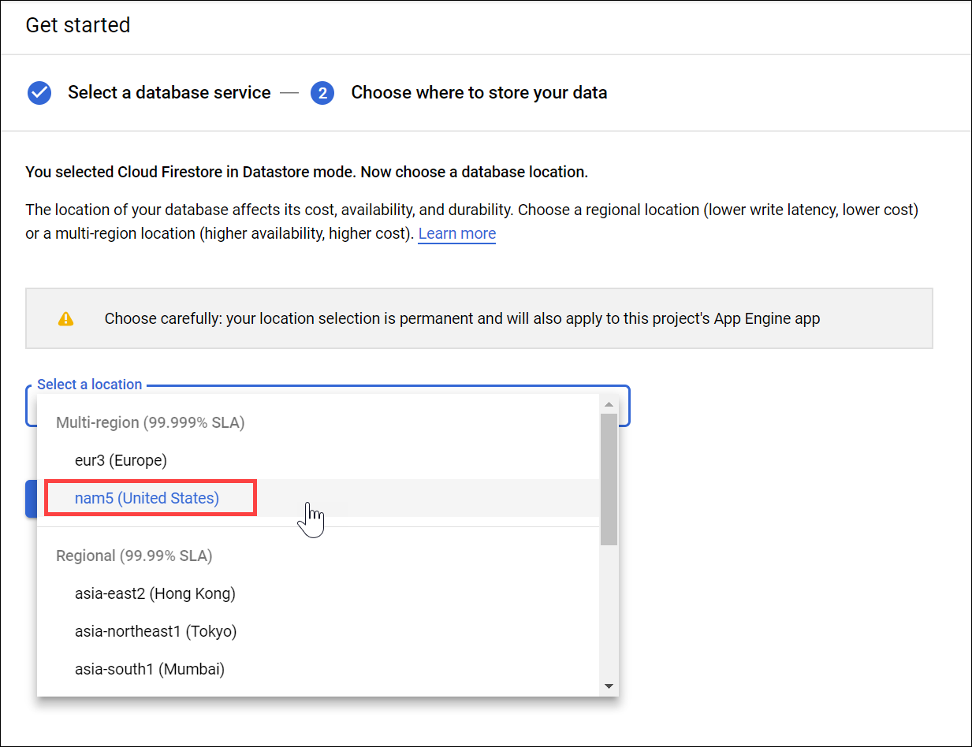
The location applies to both Cloud Datastore and App Engine for your Google Cloud Platform project. You cannot change the location after it has been saved.
Click Create database.
Click Create Entity.
On the Create an entity page, use [default] for Namespace.
Type Task for Kind.
Under Properties use the Add property button to add these properties, and click Done after each one:
Name | Type | Value | Indexed
description | String | Learn Google Cloud Datastore | ✕
created | Date and time | (today's date) | ✓
done | Boolean | False | ✓
Your creation page should now look like this:
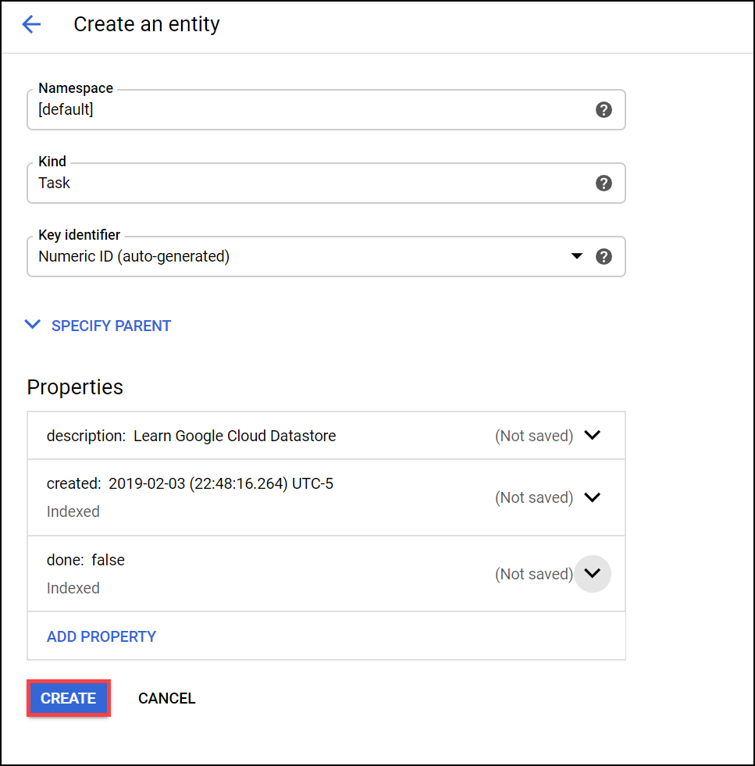
Click Create. The console displays the Task entity that you just created.
You just stored data in Cloud Datastore!

Test Completed Task
Click Check my progress to verify your performed task. If you have completed the task successfully you will granted with an assessment score.
Create Entity.
Check my progress

Run a query
Cloud Datastore supports querying data by kind or by Google Query Language (GQL); the instructions below walk you through the steps of doing both.

Run kind queries
- Click Query by kind.
- Select Task as the kind.
The query results show the Task entity that you created.
Next, add a query filter to restrict the results to entities that meet specific criteria:
- Click Filter entities tab.
- In the dropdown lists, select done, is a boolean, and that is false.
- Click Apply filters. The results show the Task entity that you created, since its done value is false. 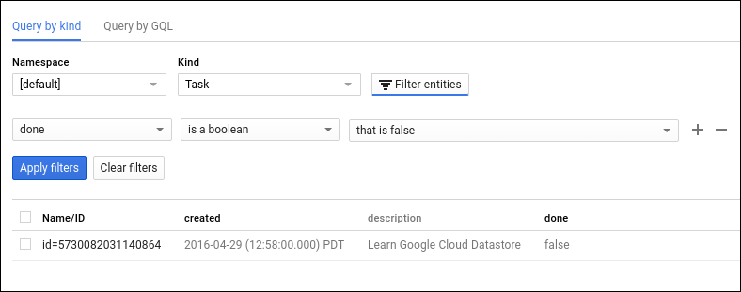
- Now try a query of done, is a boolean, and that is true then Apply filters. The results do not include the Task entity that you created, because its done value is not true.

Run GQL queries
- Click the Query by GQL tab.
- In the query box add the following:
SELECT * FROM Task
Note that Task is case sensitive.
- Click Run query.
The query results show the Task entity that you created.
Tip: The GQL query editor supports autocompletion for kinds: When you need to type a kind name, press Ctrl+Space to see a list of the available kinds. Up to 300 alphabetically sorted kinds can appear in the list. For better matches of kinds, type one or more characters.
Now add a query filter to restrict the results to entities that meet specific criteria:
Run this query:
SELECT * FROM Task WHERE done=false
Note that Task and done are case sensitive. The results show the Task entity that you created, since its done value is false. 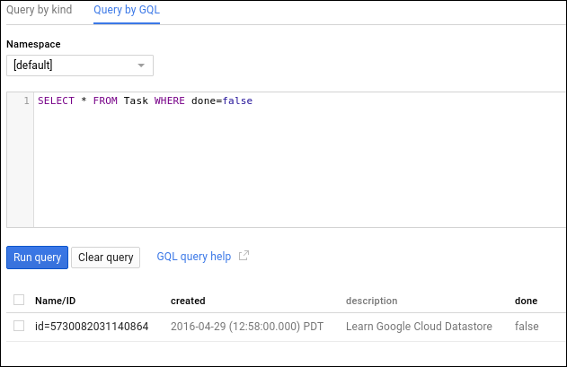
Now run this query:
SELECT * FROM Task WHERE done=true
The results do not include the Task entity that you created, because its done value is not true.

Test your Understanding
Below are multiple-choice questions to reinforce your understanding of this lab's concepts. Answer them to the best of your abilities.
Google Cloud Datastore is a NoSQL document database built for automatic scaling, high performance, and ease of application development.
True

False
Cloud Datastore is a relational database, and it is an effective storage solution for analytic data.
True

False

Congratulations!

