- Create a custom VPC (vpc_) with one subnet each in 2 regions. (Naming format: subnet1- and subnet2-) (4 marks)
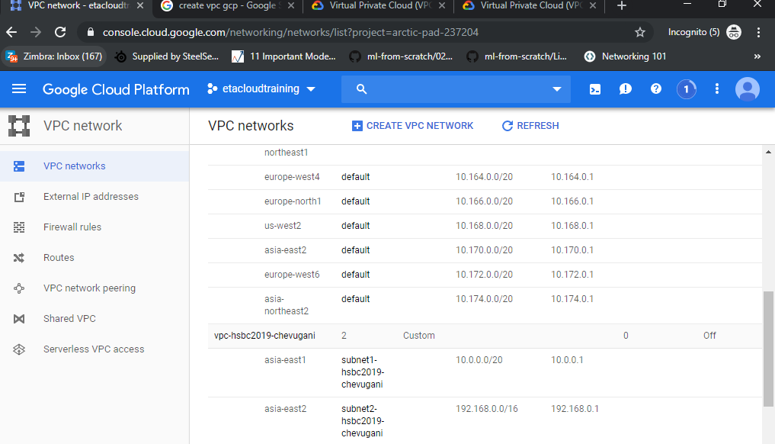

- Choose an appropriate IP CIDR range for each of the subnets.
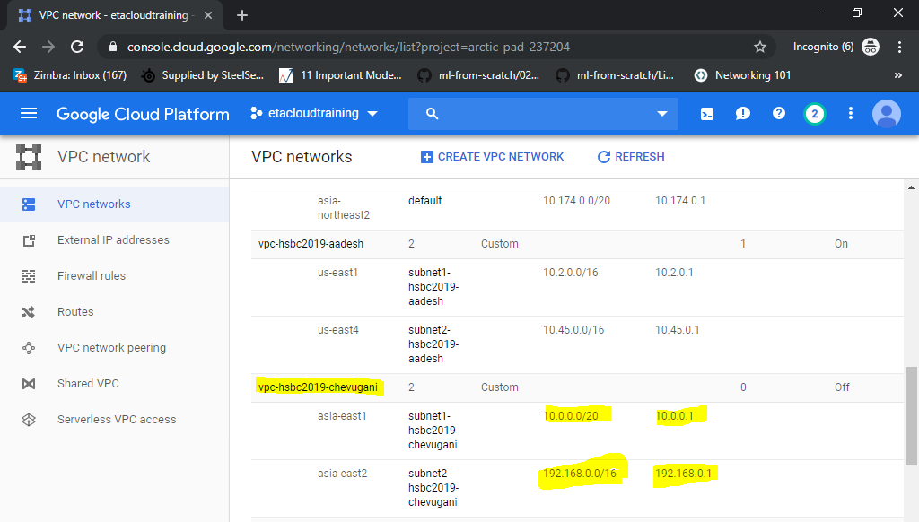

- Create one instance in each of these subnets. (Naming format: instance-subnet1- and instance-subnet2- ) (4 marks)
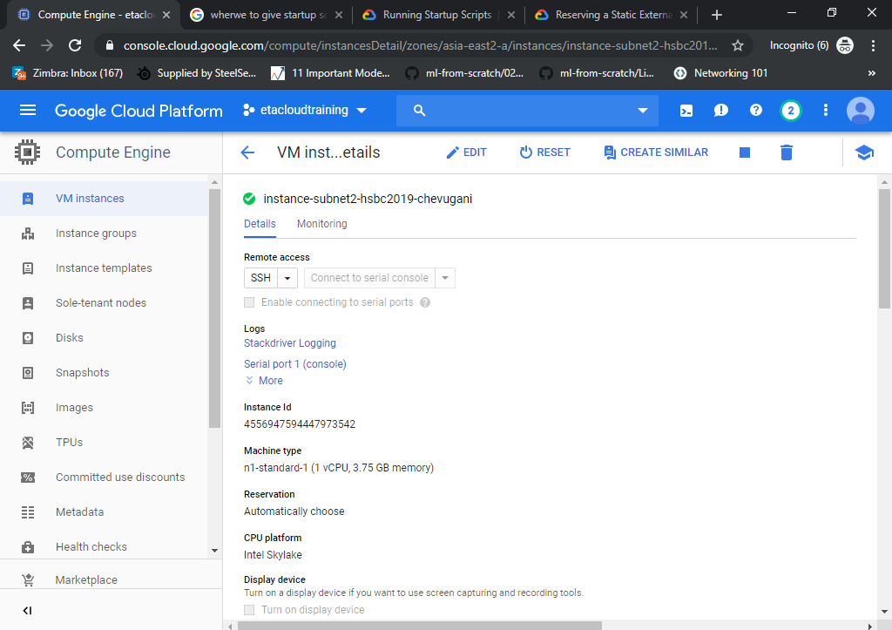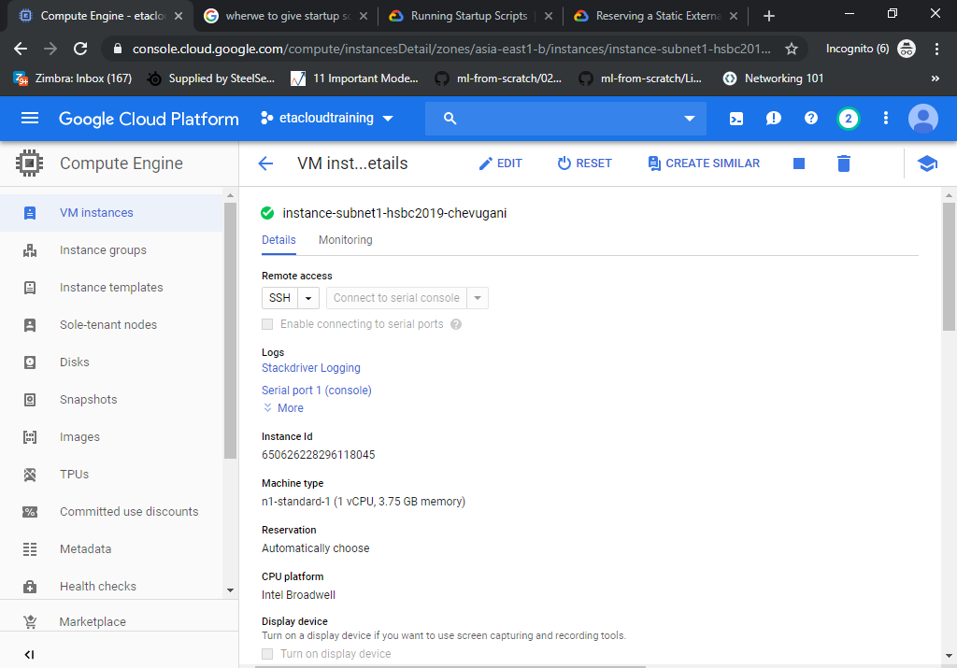

- Give below startup script for the instances. Check for both instances, the Welcome page is appearing with the correct instance host name.
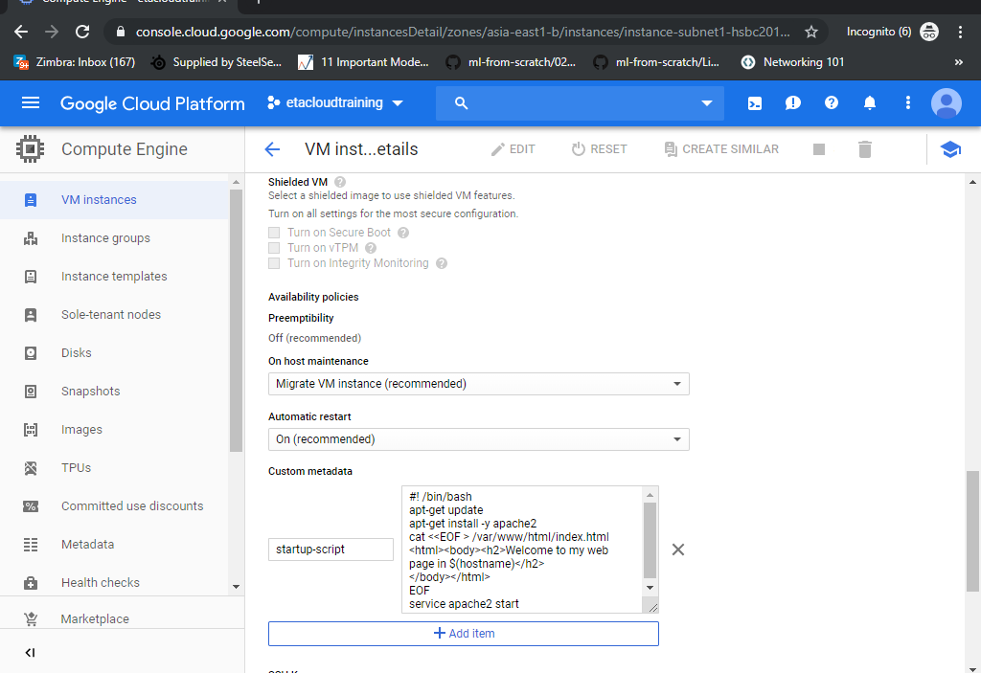

- For the second instance instance-subnet2-, associate a static IP address. Restart the instance and check for the IP address.
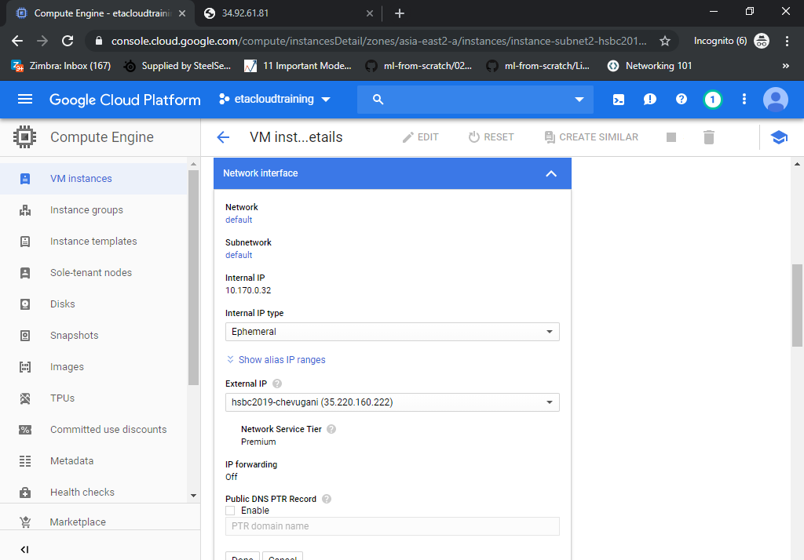
2)
a) Create an instance template with the below startup script: (Template name: migt-)
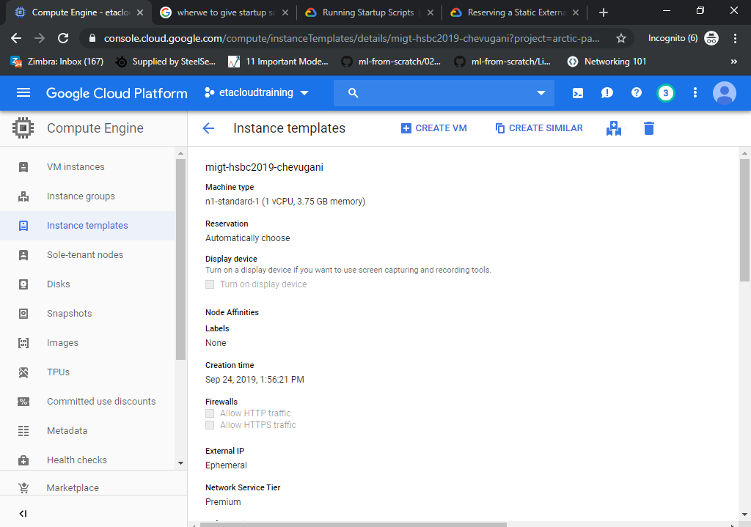
b) Create a Managed Instance group with the above Instance template. (Managed Instance Group name: mig-)
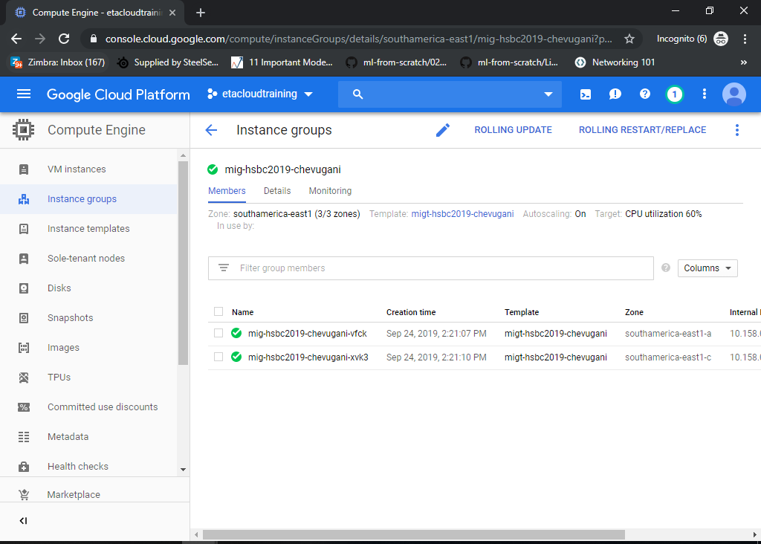

c) Enable AutoScaling in multiple zones- Scaling should scale within the limits: Min 2 and Max 4 VMs.
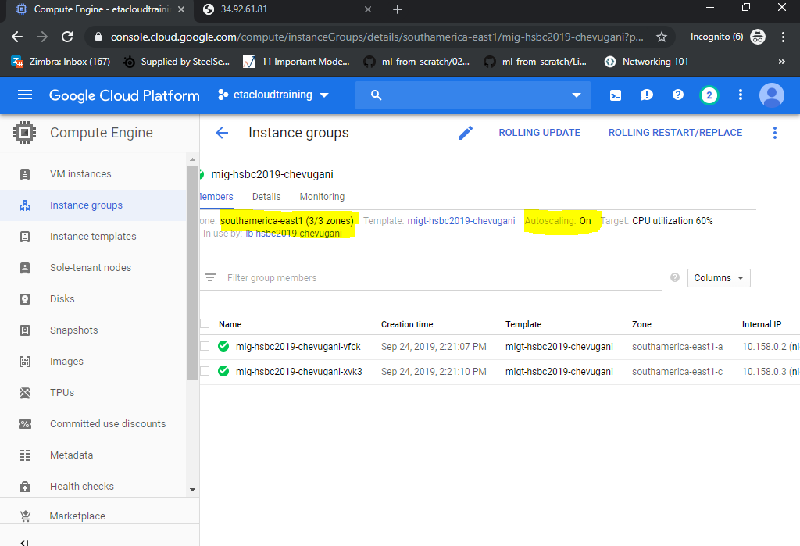

d) Create an HTTP(S) Load Balancer ‘lb-’and configure the backend to the above Managed Instance Group. (4 marks)
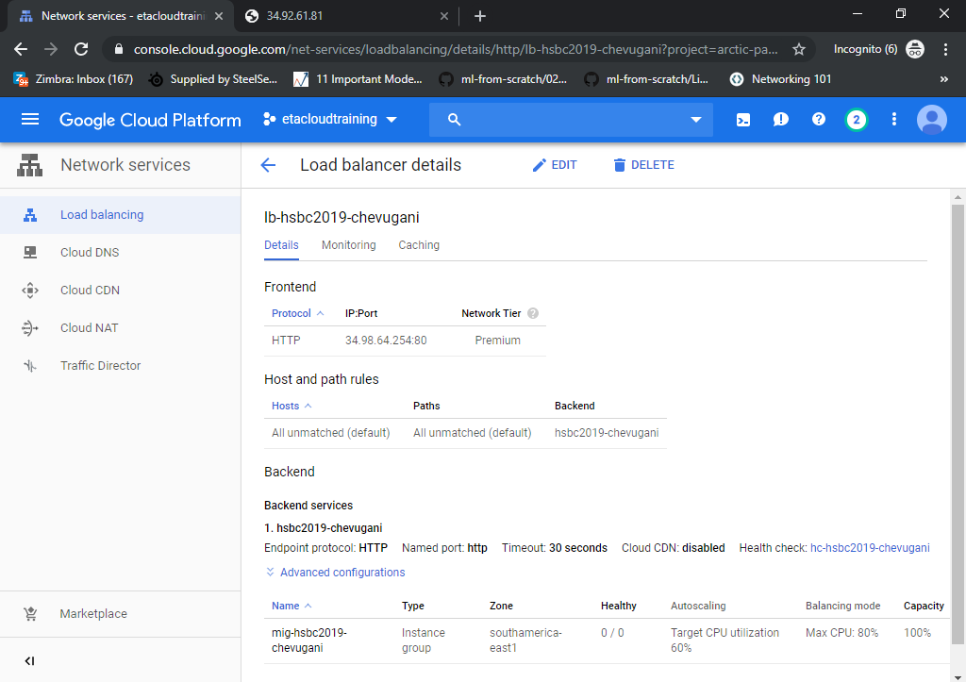

e) Access the application hosted through the public IP address of the Load balancer (2 marks)
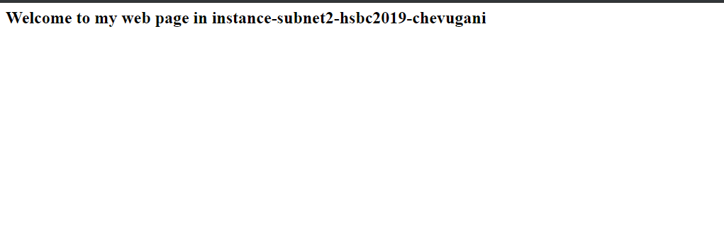
3) Cloud Functions:
a) Create a Cloud storage bucket called “bucket-” and upload any sample file into it.
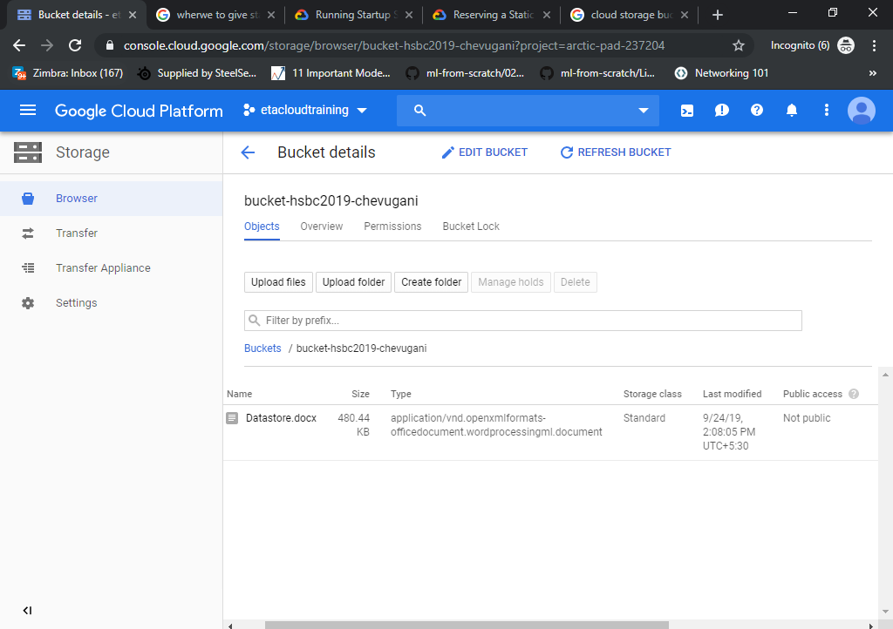

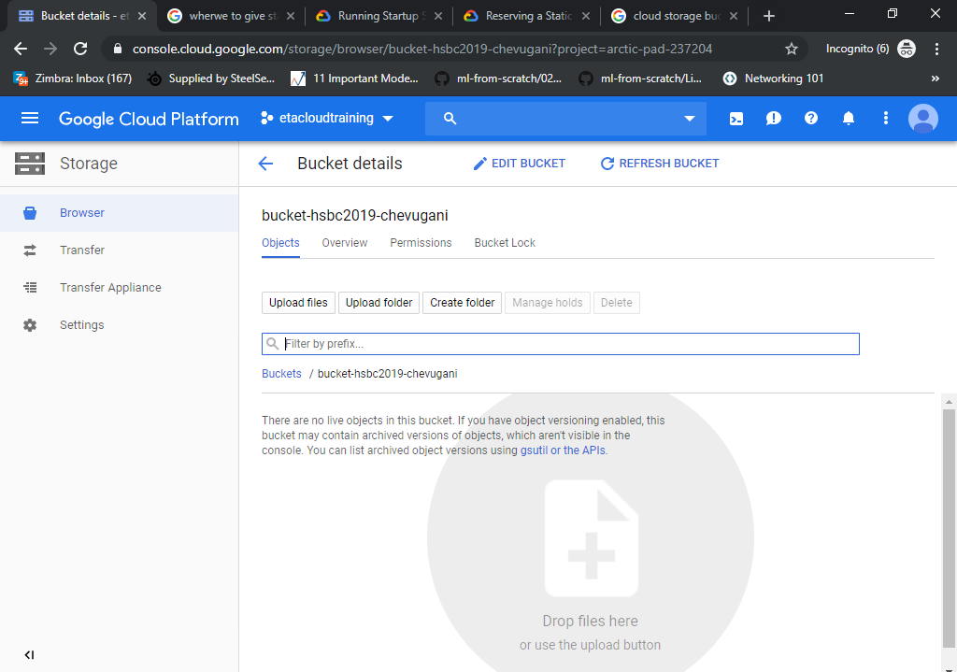

b) Make the sample file publically available and access the file over the URL. (3 marks)
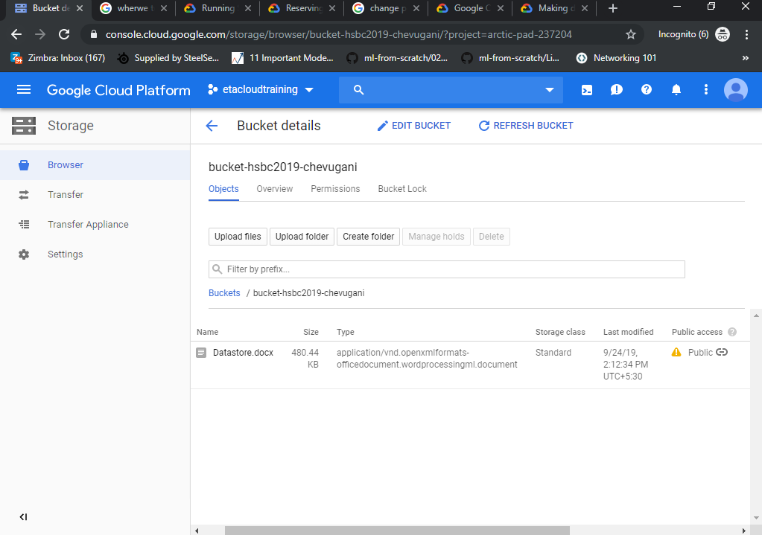
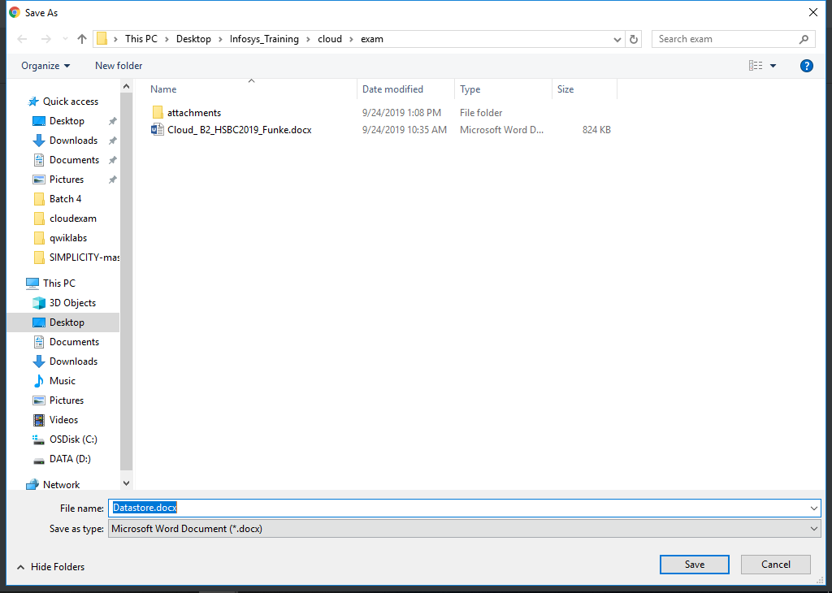

c) Create a cloud function which generates logs when the file in the above bucket is deleted. (3 marks)
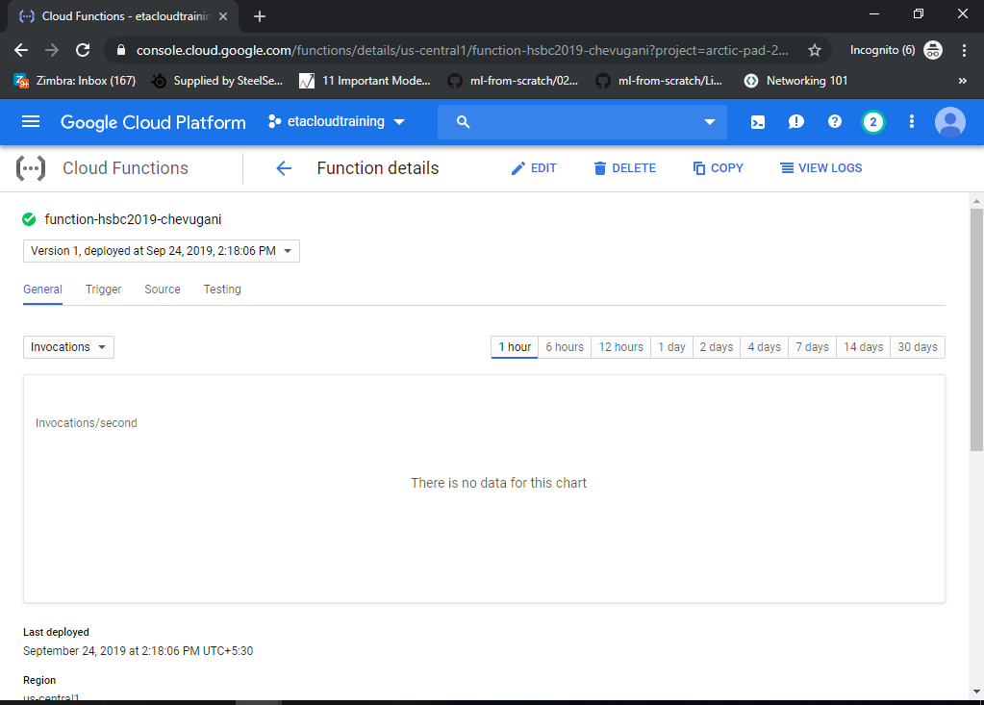
d) Upload a file into this bucket again and observe the logs and take a screenshot. Delete this second file as well to observe the logs and take a snapshot. (3 marks)
