**AIM**: To designPush Down Automata to represent the language L ={W/W belongs to (a+b)* and na(w)>nb(w) where na(w)=Number of a’s in w, nb(w)=Number of b’s in w.

**DIAGRAM:**

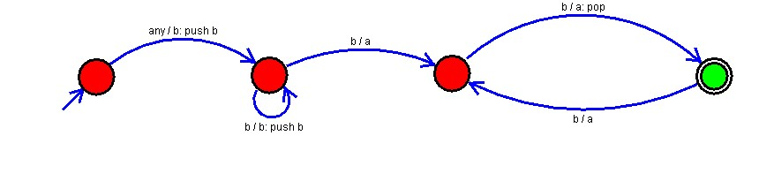

**RESULT:**

Hence the string is accepted.