

DEPARTMENT OF ELECTRONICS AND COMMUNICATION ENGINEERING

LABORATORY MANUAL

MACHINE LEARNING LAB
(SKILL ENHANCEMENT COURSE)
Regulations : ACETR23 Course Code : 231EC6S01 Semester : VI

Submitted by:
Student Name :
Roll Number :
Section :

Aditya Nagar, ADB Road, Surampalem, Kakinada District, Andhra Pradesh, Inida-533437



DEPARTMENT OF ELECTRONICS AND COMMUNICATION ENGINEERING
MACHINE LEARNING LAB
LIST OF EXPERIMENTS

B. Tech –VI SEMESTER (ECE) Regulation: ACETR23

- To implement Ordinary Least Squares (OLS) method to find the best-fit line for a given set of data using Simple Linear Regression.
- For a given set of training data examples implement and demonstrate Exploring the data, fitting and evaluating the model.
- Write a program for Dimensionality reduction PCA using iris data set.
- Write a program for Decision tree using iris data set.
- Write a program to implement Binary classification with logistic regression and finding performance metrics.
- Train Naïve Bayes, decision trees, KNN, SVM algorithms with scikit-learn. Measure accuracy, precision, recall, F1-Score, ROCAUC.
- Train Clustering with the K-Means algorithm using suitable data set.
- Write a program to implement Classifying handwritten digits.
- Write a program to Classifying characters in natural images.
- Training Bagging, Boosting, Random Forest, with scikit-learn.

List of Augmented Experiments:
(Any two of the following experiments can be performed)
- Extracting features from categorical variables, text, and pixel intensities.
- Train Clustering with the K-Means algorithm.
- Predict Stock market trends using LSTM.
- Detecting faces from images.

MACHINE LEARNING LAB
INDEX

S. NO | DATE | NAME OF THE EXPERIMENT | PAGE NUMBER | REMARKS

S. NO | DATE | NAME OF THE EXPERIMENT | PAGE NUMBER | REMARKS

Expt. No: 01 Date:

AIM: To implement Ordinary Least Squares (OLS) method to find the best-fit line for a given set of data using Simple Linear Regression.
- Objectives

  - To execute Python code in Google Colab or Anaconda for implementing simple linear regression.
  - To model the linear relationship between the input and output variables.

  - To visualize the dataset and best-fit regression line using plotting libraries like Matplotlib.

Required Software

  - Google Colab or Anaconda

Theory and Background:

Simple Linear Regression is a fundamental supervised machine learning technique used to model the relationship between two continuous variables: one independent variable (predictor) and one dependent variable (response). The purpose of this method is to determine a mathematical function that best describes how changes in the predictor variable affect the response variable.
The regression model assumes a linear relationship and is represented by the equation:

𝑦 = 𝑚𝑥 + 𝑐
where:

𝑦= predicted output , 𝑥= input value, 𝑚= slope of the regression line and 𝑐= y-intercept

To find the optimal values of 𝑚and 𝑐, the Ordinary Least Squares (OLS) method is used. OLS minimizes the sum of squared errors (differences) between observed values and predicted values. The cost function for OLS is given by:
𝑛
𝐽(𝑚, 𝑐) = ∑(𝑦_{𝑖} − (𝑚𝑥_{𝑖} + 𝑐))²
𝑖=1
where 𝑛 is the total number of data points.

The slope (𝑚) and intercept (𝑐) are calculated using the following formulas:

𝑚 =
𝑛∑𝑥𝑦 − (∑𝑥)(∑𝑦)

𝑛∑𝑥² − (∑𝑥)²

𝑐 =
∑𝑦 − 𝑚∑𝑥

𝑛

Once the regression line is obtained, the model can be used to make predictions and analyze relationships in data. Model performance is commonly evaluated using metrics such as Mean Squared Error (MSE) and the coefficient of determination (𝑅²).
Simple Linear Regression using OLS provides an essential foundation for understanding more advanced regression and machine learning models.

Procedure:

- Import necessary Python libraries and load the dataset.
- Split the dataset into training and testing sets.
- Apply the OLS method by creating and fitting a Linear Regression model.
- Predict the output values using the trained model.
- Evaluate the model performance and plot the data points with the best-fit regression line.

Program:
import numpy as np #
# Ordinary Least Squares Function #
def ols_linear_regression(x, y): x = np.array(x)
y = np.array(y)

# Calculate means x_mean = np.mean(x) y_mean = np.mean(y)

# Calculate slope (m)
numerator = np.sum((x - x_mean) * (y - y_mean)) denominator = np.sum((x - x_mean) ** 2)
m = numerator / denominator

return m * x + c # Test prediction
# Calculate intercept (c) c = y_mean - m * x_mean
return m, c
#
# Example Usage
#
# Sample data points
x = [1, 2, 3, 4, 5, 6, 7, 8, 9, | 10, 11, 12, 13, | 14, | 15, | 16, | 17, | 18, | 19,
20]
y = [2, 3, 5, 6, 5, 6, 8, 7, 9, | 11, 9, 7, 8, 9, | 12, | 13, | 15, | 17, | 18, | 11]
# Compute OLS best-fit line
m, c = ols_linear_regression(x, | y)
print("Slope (m):", m)
print("Intercept (c):", c)
# Predicting values def predict(x):

print("Prediction for x = 6:", predict(6))

Output:
Slope (m): 0.6533834586466165
Intercept (c): 2.189473684210528
Prediction for x = 6: 6.109774436090227

import matplotlib.pyplot as plt # Plot points
plt.scatter(x, y, label="Data Points")

# Plot best-fit line
x_line = np.linspace(min(x), max(x), 100) y_line = m * x_line + c

plt.plot(x_line, y_line, label="Best Fit Line", linewidth=2) plt.xlabel("X")
plt.ylabel("Y") plt.legend() plt.show()

Output Plot:
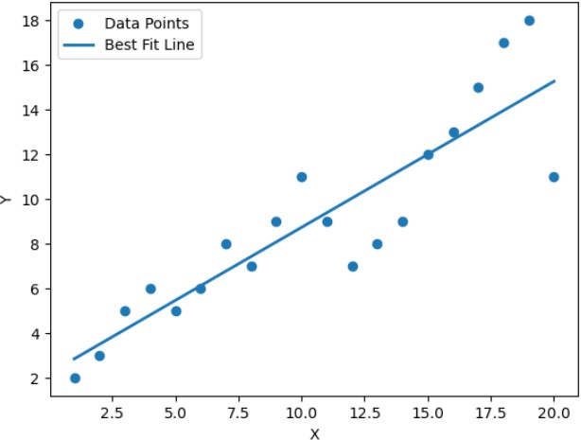

PRECAUTIONS:

- Check and remove missing or invalid data before running the code.
- Ensure the variables have a linear relationship for accurate results.

RESULT:

Expt. No: 02 Date:

AIM: For a given set of training data examples implement and demonstrate Exploring the data, fitting and evaluating the model.
- Objectives

  - To explore and preprocess the given training dataset to understand its structure, patterns, and feature characteristics.
  - To apply an appropriate machine learning algorithm to fit a predictive model using the prepared data.
  - To evaluate the trained model using suitable performance metrics such as accuracy, precision, recall, or confusion matrix.
  - To interpret the model results and assess its effectiveness in predicting outcomes based on input features.

Required Software

  - Google Colab or Anaconda

Theory and Background

Machine learning involves training a model using labeled data so it can learn patterns and make predictions on new unseen data. The process typically includes three main steps: exploring the data, fitting the model, and evaluating performance.
Data exploration helps identify feature relationships, detect missing values, and understand the dataset through statistical summaries and visualizations. After preprocessing, a suitable machine learning algorithm is applied to fit a model to the training data. Finally, evaluation metrics such as accuracy, precision, recall, and confusion matrix are used to measure how well the model performs and generalizes to new data.

Procedure:

  - Import libraries, load the dataset, and explore it using summary statistics and visualizations.
  - Split the dataset into training and testing sets using train_test_split().
  - Select a suitable machine learning model and train (fit) it using the training data.
  - Evaluate the model using appropriate metrics such as accuracy, precision, recall.
  - Visualize and interpret the results to understand the model’s performance.

Program:

import pandas as pd import numpy as np
import matplotlib.pyplot as plt import seaborn as sns

from sklearn.model_selection import train_test_split, cross_val_score,
KFold
from sklearn.preprocessing import StandardScaler, OneHotEncoder from sklearn.compose import ColumnTransformer
from sklearn.pipeline import Pipeline
from sklearn.linear_model import LinearRegression
from sklearn.metrics import mean_squared_error, mean_absolute_error, r2_score

#
# 1. LOAD DATASET #
df = pd.read_csv("Global_Mobile_Prices_2025_Extended.csv")

print("\nDataset Shape:", df.shape) print("\nFirst 5 Rows:") display(df.head())

print("\nDataset Info:") display(df.info())

print("\nMissing Values:") print(df.isna().sum())

Output:

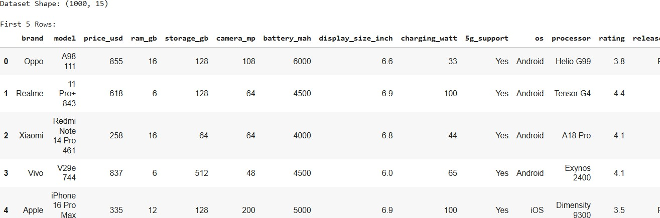

#
# 2. DATA EXPLORATION (EDA) #

# Summary Statistics print("\nSummary Statistics:") display(df.describe(include='all'))

# Distribution of target variable plt.figure(figsize=(6,4)) sns.histplot(df["price_usd"], kde=True) plt.title("Distribution of Phone Prices") plt.show()

# Correlation Heatmap plt.figure(figsize=(10,6))
numeric_df = df.select_dtypes(include=[np.number]) sns.heatmap(numeric_df.corr(), annot=False, cmap="coolwarm") plt.title("Correlation Heatmap")
plt.show()

# Price vs RAM plt.figure(figsize=(6,4))
sns.scatterplot(x="ram_gb", y="price_usd", data=df) plt.title("Price vs RAM")
plt.show()

# Brand-wise average price plt.figure(figsize=(10,4))
df.groupby("brand")["price_usd"].mean().sort_values().plot(kind="bar") plt.title("Average Price per Brand")
plt.ylabel("USD") plt.show()

Output:

  - Summary Statistics
  - Distribution of target variable
  - Correlation Heatmap
  - Price vs RAM
  - Brand-wise average price

#
# 3. PREPROCESSING #

df_clean = df.copy()

# Simplify categorical column "5g_support" df_clean["5g_support"] = df_clean["5g_support"].str.lower().map({"yes":1, "no":0})

# Drop columns not used for prediction
df_clean = df_clean.drop(columns=["model", "processor", "release_month"])

target = "price_usd"
X = df_clean.drop(columns=[target]) y = df_clean[target]

# Categorical and numeric columns categorical_features = ["brand", "os"] numeric_features = [c for c in X.columns if c not in categorical_features]

print("\nNumeric Features:", numeric_features) print("Categorical Features:", categorical_features)

# Preprocessing pipeline preprocessor = ColumnTransformer([
('num', StandardScaler(), numeric_features),
('cat', OneHotEncoder(drop='first', sparse_output=False), categorical_features)
])

Output:

Numeric Features: ['ram_gb', 'storage_gb', 'camera_mp', 'battery_mah', 'display_size_inch', 'charging_watt', '5g_support', 'rating', 'year'] Categorical Features: ['brand', 'os']

#
# 4. TRAIN-TEST SPLIT #
X_train, X_test, y_train, y_test = train_test_split( X, y, test_size=0.2, random_state=42
)
print("\nTraining Size:", X_train.shape) print("Testing Size:", X_test.shape)

Output

Training Size: (800, 11)
Testing Size: (200, 11)

#
# 5. FITTING THE MODEL #
model = Pipeline([
('preprocessor', preprocessor), ('regressor', LinearRegression())
])

model.fit(X_train, y_train) print("\nModel Fitted Successfully.") Output:
Model Fitted Successfully. #
# 6. MODEL EVALUATION #

# Predictions
train_pred = model.predict(X_train) test_pred = model.predict(X_test)

# Metrics function
def metrics(y_true, y_pred):
mse = mean_squared_error(y_true, y_pred) rmse = np.sqrt(mse)
mae = mean_absolute_error(y_true, y_pred) r2 = r2_score(y_true, y_pred)
return mse, rmse, mae, r2

mse_train, rmse_train, mae_train, r2_train = metrics(y_train, train_pred)
mse_test, rmse_test, mae_test, r2_test = metrics(y_test, test_pred)

print("\n--- Training Performance ---") print("MSE:", mse_train) print("RMSE:", rmse_train) print("MAE:", mae_train)
print("R²:", r2_train)

print("\n--- Testing Performance ---") print("MSE:", mse_test) print("RMSE:", rmse_test) print("MAE:", mae_test)
print("R²:", r2_test)

# Cross-validation
kf = KFold(n_splits=5, shuffle=True, random_state=42) cv_scores = cross_val_score(model, X, y, scoring='r2', cv=kf)

print("\nCross-validation R² scores:", cv_scores) print("Mean R²:", cv_scores.mean())

Output:

--- Training Performance --- MSE: 166800.8720538385
RMSE: 408.4126247483524
MAE: 354.121501762002
R²: 0.008346649594522249
--- Testing Performance --- MSE: 179044.09022986892
RMSE: 423.1360185919758
MAE: 366.39142772448906
R²: -0.031572841711634325

Cross-validation R² scores: [-0.03157284 -0.05867022 -0.02447081 -
0.03496524 -0.0500125 ]
Mean R²: -0.039938325063730275

PRECAUTIONS:

- Ensure the dataset is cleaned properly, removing missing or incorrect values before model training.
- Avoid data leakage by separating training and testing data correctly.

RESULT:

Expt. No:03 Date:

AIM: Write a program for Dimensionality reduction PCA using iris data set.

Objectives

  - To apply Principal Component Analysis (PCA) for reducing the dimensionality of the Iris dataset while preserving maximum variance.
  - To visualize the reduced feature space and evaluate how well PCA separates the different Iris flower species.

Required Software

  - Google Colab or Anaconda

Theory and Background

Principal Component Analysis (PCA) is a statistical technique used for dimensionality reduction while preserving the maximum variability present in the data. It transforms the original correlated features into a new set of uncorrelated variables called principal components. These components are ordered such that the first component captures the highest variance, followed by the second, and so on.
PCA works by standardizing the data, computing the covariance matrix, and then extracting eigenvalues and eigenvectors. The eigenvectors form the principal components, and the eigenvalues indicate how much variance each component explains. PCA helps reduce redundancy, simplifies visualization, improves computational efficiency, and sometimes enhances model performance. However, the transformed features may lose interpretability and the method is effective mainly for linear data relationships.

Procedure:

  - Import necessary libraries, load the Iris dataset, and preprocess the data (standardize features).
  - Apply Principal Component Analysis (PCA) to reduce dimensions while retaining maximum variance.
  - Fit the PCA model and transform the original dataset into reduced principal components.

Program:

import pandas as pd import numpy as np
import matplotlib.pyplot as plt
from mpl_toolkits.mplot3d import Axes3D
from sklearn.preprocessing import StandardScaler from sklearn.decomposition import PCA

#
# 1) LOAD IRIS CSV FILE

#
df = pd.read_csv("Iris.csv") print("File Loaded Successfully!") print(df.head())
print("Shape:", df.shape)

# If last column contains species labels feature_columns = df.columns[:-1] label_column = df.columns[-1]

X = df[feature_columns].values y = df[label_column].values

print("\nFeatures:", feature_columns.tolist()) print("Target Column:", label_column) print("Unique Classes:", np.unique(y))

Output:
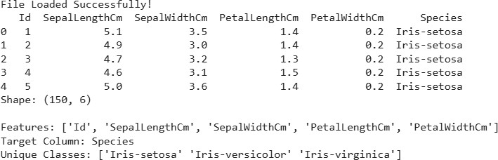

#
# 2) STANDARDIZE THE FEATURES #
scaler = StandardScaler() X_scaled = scaler.fit_transform(X) print(X_scaled.shape) print(X_scaled[:5])

Output:
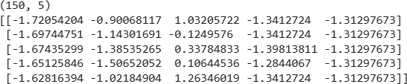

#
# 3) APPLY PCA (reduce to 2 components) #
pca2 = PCA(n_components=2)
X_pca2 = pca2.fit_transform(X_scaled)

print("\nExplained Variance Ratio (2 Components):") print(pca2.explained_variance_ratio_)

Output

Explained Variance Ratio (2 Components): [0.7470533 0.18435257]

print("Total variance explained:", pca2.explained_variance_ratio_.sum())

Output
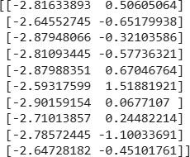
Total variance explained: 0.9314058689070457 print(X_pca2[:10]) # first 10 rows

#
# 4) 2D PCA SCATTER PLOT #
plt.figure(figsize=(8,6)) for species in np.unique(y):
plt.scatter(
X_pca2[y == species, 0], X_pca2[y == species, 1], label=species,
s=60
)

plt.xlabel("Principal Component 1")
plt.ylabel("Principal Component 2") plt.title("PCA on Iris Dataset (2D)") plt.legend()
plt.grid(True) plt.tight_layout() plt.show()

Output Plot:
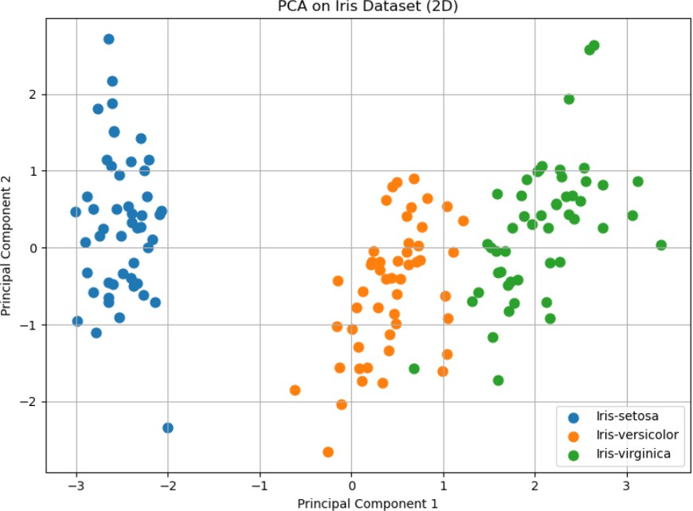

PRECAUTIONS:

- Ensure that the dataset is standardized or normalized, as PCA is sensitive to feature scale.
- Remove or handle missing values and outliers, as they can distort the variance structure.
- Choose the number of principal components carefully based on the explained variance ratio

RESULT:

Expt. No: 04 Date:

AIM: Write a program for Decision tree using iris data set.

Objectives

  - To build a Decision Tree classifier using the Iris dataset for species prediction based on features.
  - To evaluate the performance of the Decision Tree model using accuracy and visualization of the tree structure.

Required Software

  - Google Colab or Anaconda

Theory and Background:

A Decision Tree is a supervised machine learning algorithm used for both classification and regression tasks. It works by splitting the dataset into smaller subsets based on feature values, forming a tree-like structure of decisions. Each internal node represents a feature-based condition, branches represent outcomes of the condition, and leaf nodes represent the final class labels.

Decision Trees use measures such as Gini Impurity or Entropy (Information Gain) to select the best feature for splitting. The goal is to create pure nodes where samples belong to a single class. Decision Trees are easy to interpret, require little data preprocessing, and can model nonlinear relationships. However, they may overfit the data if not controlled using pruning techniques or depth limitations.

Procedure:

  - Import required libraries and load the Iris dataset.
  - Split the dataset into training and testing sets using train_test_split().
  - Create a Decision Tree classifier and train (fit) it using the training data.
  - Predict the class labels for the test set and compare with actual labels.
  - Evaluate model performance using accuracy, confusion matrix, and classification report.

Program:

import pandas as pd import numpy as np
import matplotlib.pyplot as plt import seaborn as sns
import joblib

from sklearn.model_selection import train_test_split
from sklearn.tree import DecisionTreeClassifier, plot_tree from sklearn.preprocessing import LabelEncoder
from sklearn.metrics import accuracy_score, classification_report, confusion_matrix

#
# 1) Load data #
df = pd.read_csv("Iris.csv")

# If file contains an Id column (common Kaggle variant), drop it if "Id" in df.columns:
df = df.drop(columns=["Id"])

# Feature / label
feature_cols = df.columns[:-1].tolist() label_col = df.columns[-1]
X = df[feature_cols].values y = df[label_col].values

# Encode labels to integers le = LabelEncoder()
y_enc = le.fit_transform(y) class_names = le.classes_

print("Loaded Iris data shape:", df.shape) print("Features:", feature_cols) print("Classes:", class_names)

Output:
Loaded Iris data shape: (150, 5)
Features: ['SepalLengthCm', 'SepalWidthCm', 'PetalLengthCm', 'PetalWidthCm']
Classes: ['Iris-setosa' 'Iris-versicolor' 'Iris-virginica'] df.info()

Output:
<class 'pandas.core.frame.DataFrame'> RangeIndex: 150 entries, 0 to 149 Data columns (total 5 columns):
# |  | Column | Non-Null Count |  | Dtype
0 |  | SepalLengthCm | 150 non-null |  | float64
1 |  | SepalWidthCm | 150 non-null |  | float64
2 |  | PetalLengthCm | 150 non-null |  | float64
3 |  | PetalWidthCm | 150 non-null |  | float64
4 |  | Species | 150 non-null |  | object
dtypes: float64(4), object(1) memory usage: 6.0+ KB

df.describe()
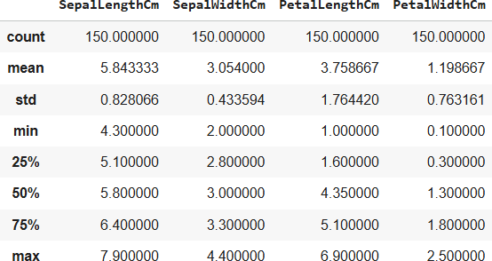

df.isnull().sum()

Output:
SepalLengthCm 0
SepalWidthCm 0
PetalLengthCm 0
PetalWidthCm 0
Species 0
dtype: int64

print(y_enc[:10])

Output:
[0 0 0 0 0 0 0 0 0 0]

print("Unique encoded classes:", np.unique(y_enc))

Output:
Unique encoded classes: [0 1 2]

#
# 2) Train/test split #
X_train, X_test, y_train, y_test = train_test_split(X, y_enc, test_size=0.2, random_state=42, stratify=y_enc)
print("Train shape:", X_train.shape, "Test shape:", X_test.shape)

Output:
Train shape: (120, 4) Test shape: (30, 4) #
# 3) Train Decision Tree #
clf = DecisionTreeClassifier(random_state=42) clf.fit(X_train, y_train)
print("\nTrained Decision Tree classifier.")

Output:
Trained Decision Tree classifier. #
# 4) Predict & Evaluate #
y_pred = clf.predict(X_test)
acc = accuracy_score(y_test, y_pred) print(f"\nTest Accuracy: {acc:.4f}\n")

print("Classification Report:")
print(classification_report(y_test, y_pred, target_names=class_names))

Output

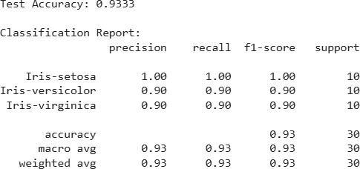

# Confusion matrix
cm = confusion_matrix(y_test, y_pred) plt.figure(figsize=(6,4))
sns.heatmap(cm, annot=True, fmt="d", cmap="Blues", xticklabels=class_names, yticklabels=class_names)
plt.xlabel("Predicted") plt.ylabel("Actual") plt.title("Confusion Matrix") plt.tight_layout() plt.show()

Output Plot:

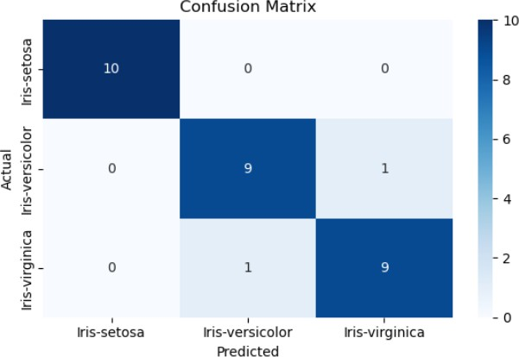

from sklearn.ensemble import BaggingClassifier from sklearn.tree import DecisionTreeClassifier
from sklearn.metrics import accuracy_score, classification_report, confusion_matrix

# Base model: Decision Tree
base_model = DecisionTreeClassifier(random_state=42)

# Bagging Classifier bag_clf = BaggingClassifier(
estimator=base_model,
n_estimators=50, # number of trees max_samples=0.8, # % of data per tree bootstrap=True, # With replacement random_state=42
)

# Train the model bag_clf.fit(X_train, y_train)

# Test prediction
y_pred_bag = bag_clf.predict(X_test)

# Evaluation
print("Bagging Classifier Accuracy:", accuracy_score(y_test, y_pred_bag))
print("\nClassification Report:") print(classification_report(y_test, y_pred_bag)) print("Confusion Matrix:") print(confusion_matrix(y_test, y_pred_bag))

Output :
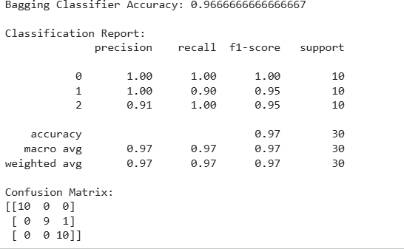

from sklearn.ensemble import AdaBoostClassifier from sklearn.tree import DecisionTreeClassifier
from sklearn.metrics import accuracy_score, classification_report, confusion_matrix

# Weak/base learner: shallow decision tree
base_dt = DecisionTreeClassifier(max_depth=1, random_state=42)

# AdaBoost classifier ada_clf = AdaBoostClassifier(
estimator=base_dt, # use 'base_estimator=base_dt' in older sklearn versions
n_estimators=50, learning_rate=1.0, random_state=42
)

# Train
ada_clf.fit(X_train, y_train)

# Predict
y_pred_ada = ada_clf.predict(X_test)

# Evaluate
print("AdaBoost Accuracy:", accuracy_score(y_test, y_pred_ada))

print("\nClassification Report (AdaBoost):") print(classification_report(y_test, y_pred_ada))

print("Confusion Matrix (AdaBoost):") print(confusion_matrix(y_test, y_pred_ada))

Output:
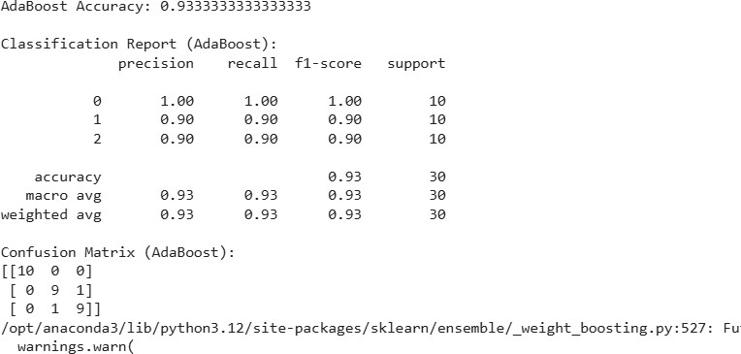

from sklearn.ensemble import RandomForestClassifier
from sklearn.metrics import accuracy_score, classification_report, confusion_matrix

# 1. Create the model
rf_clf = RandomForestClassifier( n_estimators=100, # number of trees
max_depth=None, # let trees expand fully (you can tune this) random_state=42
)

# 2. Train the model rf_clf.fit(X_train, y_train)

# 3. Predict on test data y_pred_rf = rf_clf.predict(X_test)

# 4. Evaluate the model
print("Random Forest Accuracy:", accuracy_score(y_test, y_pred_rf))

print("\nClassification Report (Random Forest):") print(classification_report(y_test, y_pred_rf))

print("Confusion Matrix (Random Forest):") print(confusion_matrix(y_test, y_pred_rf))

Output:
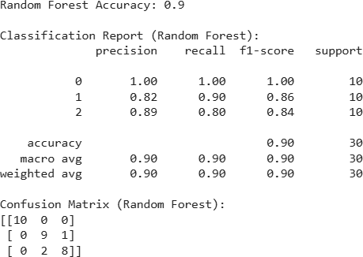

PRECAUTIONS:

- Ensure the dataset is properly cleaned, with no missing or incorrect values before training the model.
- Split the dataset into training and testing sets to correctly evaluate model performance.

RESULT:

Expt. No: 05 Date:

AIM: Write a program to implement Binary classification with logistic regression and finding performance metrics.

Objectives

  - To implement a binary classification model using Logistic Regression on a given dataset.
  - To evaluate the performance of the classifier using metrics such as accuracy, confusion matrix, precision, recall, and F1-score.

Required Software

  - Google Colab or Anaconda

Theory and Background

Logistic Regression is a supervised machine learning algorithm used primarily for binary classification problems. Unlike linear regression, which predicts continuous values, logistic regression predicts the probability that a given input belongs to one of two classes.

The model uses a logistic (sigmoid) function to map linear combinations of input features into a probability value between 0 and 1:

where 𝑧 = 𝑤₁𝑥₁ + 𝑤₂𝑥₂+. . . +𝑏.
1
𝜎(𝑧) = 1 + 𝑒−𝑧

If the predicted probability is above a threshold (commonly 0.5), the model assigns the label 1, otherwise 0.

Logistic Regression uses maximum likelihood estimation (MLE) to find optimal weights that best separate the classes. It is widely used because it is simple, fast, interpretable, and effective for linearly separable data. However, it may not perform well when class boundaries are highly nonlinear or overlapping.

Procedure:

- Import necessary libraries and load the dataset.
- Split the dataset into training and testing sets using train_test_split().
- Train a Logistic Regression model on the training data.
- Predict the class labels and probabilities for the test data.
- Evaluate the model using performance metrics like accuracy, precision, recall, F1- score, ROC-AUC, and confusion matrix.

Program:

import numpy as np import pandas as pd
import matplotlib.pyplot as plt import seaborn as sns

from sklearn.model_selection import train_test_split from sklearn.preprocessing import StandardScaler from sklearn.linear_model import LogisticRegression from sklearn.metrics import (
accuracy_score, precision_score, recall_score, f1_score, confusion_matrix, classification_report, roc_auc_score, roc_curve, precision_recall_curve, auc
)

%matplotlib inline sns.set_style('whitegrid') plt.style.use("fivethirtyeight")

# 1. Load data
data = pd.read_csv(r"D:\Python\advertising.csv")

# Rename target to remove spaces
data.rename(columns={'Clicked on Ad': 'Clicked_on_Ad'}, inplace=True) target_col = "Clicked_on_Ad"

print(data.head()) print(data.columns)

Output:
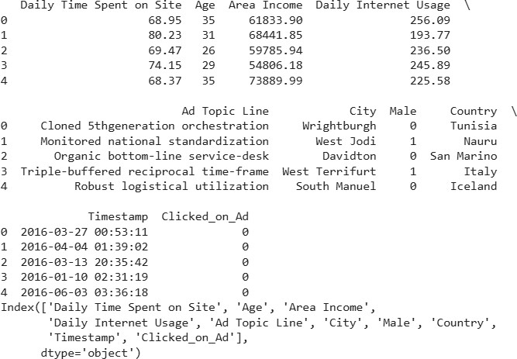

# 2. Drop non-numeric / text columns not used for model drop_cols = []
for col in ["Ad Topic Line", "Ad_Topic_Line", "City", "Country", "Timestamp", "Ad_ID", "User_ID", "ID"]:
if col in data.columns: drop_cols.append(col)
print("Dropping columns:", drop_cols) df_model = data.drop(columns=drop_cols) Output:
Dropping columns: ['Ad Topic Line', 'City', 'Country', 'Timestamp'] # 3. Separate features and target
X = df_model.drop(columns=[target_col])
y = df_model[target_col]

print("X shape:", X.shape) print("y value counts:") print(y.value_counts())

Output:
X shape: (1000, 5) y value counts: Clicked_on_Ad
0 500
1 500
Name: count, dtype: int64

# 4. Train–test split
X_train, X_test, y_train, y_test = train_test_split( X, y,
test_size=0.2, random_state=42, stratify=y
)
# 5. Scale features scaler = StandardScaler()
X_train_scaled = scaler.fit_transform(X_train) X_test_scaled = scaler.transform(X_test)

# 6. Train logistic regression
log_reg = LogisticRegression(solver='liblinear', random_state=42) log_reg.fit(X_train_scaled, y_train)

# 7. Predictions and probabilities y_pred = log_reg.predict(X_test_scaled)
y_prob = log_reg.predict_proba(X_test_scaled)[:, 1]

# 8. Metrics
acc = accuracy_score(y_test, y_pred) prec = precision_score(y_test, y_pred) rec = recall_score(y_test, y_pred)
f1 = f1_score(y_test, y_pred)
roc_auc = roc_auc_score(y_test, y_prob)

print("\n=== Test Set Performance ===") print(f"Accuracy : {acc:.4f}") print(f"Precision: {prec:.4f}") print(f"Recall : {rec:.4f}")
print(f"F1-score : {f1:.4f}") print(f"ROC AUC : {roc_auc:.4f}")

print("\nClassification Report:") print(classification_report(y_test, y_pred))
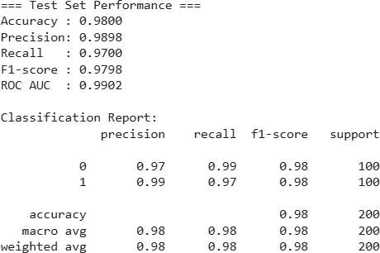

# 9. Confusion matrix
cm = confusion_matrix(y_test, y_pred) plt.figure(figsize=(5,4))
sns.heatmap(cm, annot=True, fmt='d', cmap='Blues', xticklabels=['Pred 0','Pred 1'],
yticklabels=['True 0','True 1']) plt.xlabel("Predicted") plt.ylabel("Actual")
plt.title("Confusion Matrix") plt.tight_layout() plt.show()

Output Plot:

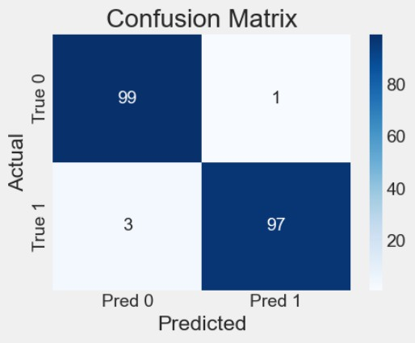

# 10. ROC curve
fpr, tpr, _ = roc_curve(y_test, y_prob) plt.figure(figsize=(6,5))
plt.plot(fpr, tpr, label=f"AUC = {roc_auc:.3f}") plt.plot([0,1],[0,1],'--', color='gray') plt.xlabel("False Positive Rate") plt.ylabel("True Positive Rate")
plt.title("ROC Curve") plt.legend() plt.grid(True) plt.show()

Output Plot:
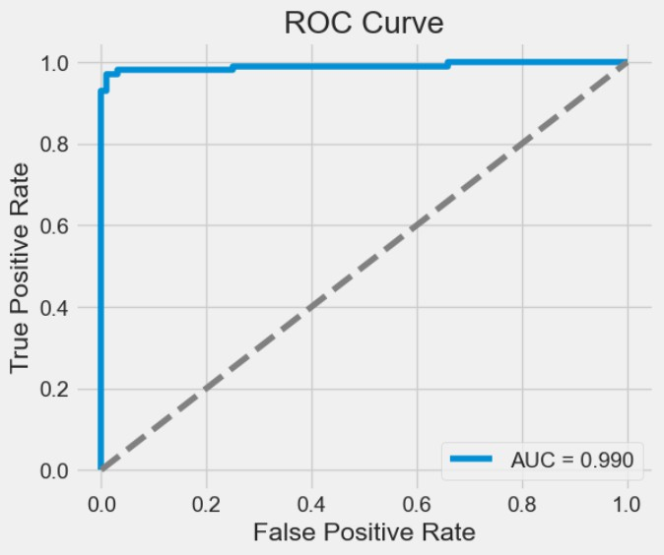

PRECAUTIONS:

- Ensure the dataset is properly scaled or normalized, as logistic regression can be sensitive to feature magnitude.
- Handle class imbalance using techniques like oversampling, undersampling, or class weights to avoid biased predictions.
- Remove unnecessary or highly correlated features to prevent multicollinearity, which may affect model performance.
- Use appropriate performance metrics beyond accuracy, especially when classes are imbalanced (e.g., precision, recall, F1-score).

RESULT:

Expt. No:06 Date:

AIM: Train Naïve Bayes, decision trees, KNN, SVM algorithms with scikit-learn. Measure accuracy, precision, recall, F1-Score, ROCAUC.

Objectives

  - To train and compare multiple machine learning classification algorithms such as Naïve Bayes, Decision Tree, K-Nearest Neighbors (KNN), and Support Vector Machine (SVM) using the Scikit-learn library.
  - To evaluate and analyze the performance of each classifier using key performance metrics including Accuracy, Precision, Recall, F1-Score, and ROC-AUC score.
  - To identify the most effective model for the given dataset based on quantitative evaluation results.
  - To understand how different ML algorithms behave on the same dataset and demonstrate the importance of performance evaluation in model select

Required Software

  - Google Colab or Anaconda

Theory and Background

Machine learning classification algorithms are used to categorize data into predefined classes based on patterns learned from training data. Different algorithms use different learning approaches:

  - Naïve Bayes is a probabilistic classifier based on Bayes’ theorem with the assumption that features are independent. It is fast, simple, and works well for text classification and high-dimensional data.
  - Decision Tree is a rule-based model that splits data using feature conditions to create a tree structure. It is easy to interpret but can overfit if not pruned.
  - K-Nearest Neighbors (KNN) is a distance-based classifier that predicts a label based on the majority class among the nearest data points. It is simple but computationally expensive for large datasets.
  - Support Vector Machine (SVM) finds the optimal boundary (hyperplane) that maximally separates classes. It performs well in high-dimensional spaces and with complex decision boundaries.

To evaluate these models, performance metrics such as Accuracy, Precision, Recall, F1- Score, and ROC-AUC are used to measure how well the classifiers generalize to unseen data.

Procedure:

  - Import libraries and load the dataset, separating features and target.
  - Split the dataset into training and testing sets using train_test_split().
  - Train multiple classifiers: Naïve Bayes, Decision Tree, KNN, and SVM.
  - Predict class labels and probabilities for the test set.
  - Evaluate performance using accuracy, precision, recall, F1-score, and ROC-AUC.

Program:

import pandas as pd import numpy as np
from sklearn.model_selection import train_test_split from sklearn.preprocessing import StandardScaler from sklearn.metrics import (
accuracy_score, precision_score, recall_score, f1_score, roc_auc_score, classification_report,
confusion_matrix, roc_curve, precision_recall_curve, auc
)
# LOAD DATA
df = pd.read_csv(r"D:\Python\diabetes.csv") # <--- YOU ALREADY UPLOADED THIS FILE

print("Dataset Shape:", df.shape) print(df.head())

print("\nClass distribution (Outcome):") print(df["Outcome"].value_counts())

Output:
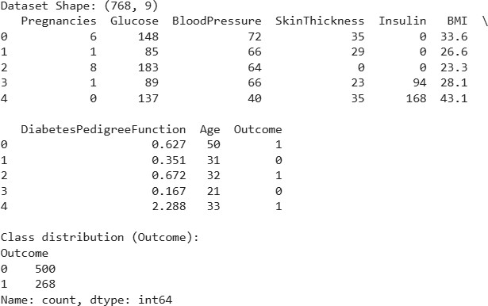

# FEATURES / TARGET
X = df.drop(columns=['Outcome']) y = df['Outcome'
# TRAIN / TEST SPLIT
X_train, X_test, y_train, y_test = train_test_split( X, y, test_size=0.2, random_state=42, stratify=y
)
# ---------------- SCALE FEATURES (Needed for KNN, SVM) ---------------
-
scaler = StandardScaler()
X_train_scaled = scaler.fit_transform(X_train) X_test_scaled = scaler.transform(X_test) from sklearn.metrics import (
accuracy_score, precision_score, recall_score, f1_score, confusion_matrix, classification_report, roc_auc_score, roc_curve, precision_recall_curve, auc as sk_auc
)
# MODELS TO TRAIN
from sklearn.naive_bayes import GaussianNB from sklearn.tree import DecisionTreeClassifier
from sklearn.neighbors import KNeighborsClassifier from sklearn.svm import SVC

models = {
"Naive Bayes": GaussianNB(),
"Decision Tree": DecisionTreeClassifier(random_state=42), "KNN": KNeighborsClassifier(n_neighbors=5),
"SVM": SVC(probability=True, kernel='rbf', random_state=42)
}

results = [] conf_matrices = {}
roc_curves = {} # name -> (fpr, tpr, auc)
pr_curves = {} # name -> (recall, precision, auc_pr)

for name, model in models.items(): print("\n===================================")
print(f"TRAINING MODEL: {name}") print("===================================")

# Use scaled data for KNN and SVM, original for others if name in ["KNN", "SVM"]:
model.fit(X_train_scaled, y_train) y_pred = model.predict(X_test_scaled)
y_prob = model.predict_proba(X_test_scaled)[:, 1] else:
model.fit(X_train, y_train) y_pred = model.predict(X_test)
y_prob = model.predict_proba(X_test)[:, 1]

# Metrics
acc = accuracy_score(y_test, y_pred)
prec = precision_score(y_test, y_pred, zero_division=0) rec = recall_score(y_test, y_pred, zero_division=0)
f1 = f1_score(y_test, y_pred, zero_division=0) auc_roc = roc_auc_score(y_test, y_prob)

results.append([name, acc, prec, rec, f1, auc_roc]) print("\nClassification Report:") print(classification_report(y_test, y_pred, zero_division=0)) print(f"ROC-AUC: {auc_roc:.4f}")

# Confusion matrix
cm = confusion_matrix(y_test, y_pred) conf_matrices[name] = cm

# ROC curve
fpr, tpr, _ = roc_curve(y_test, y_prob) roc_curves[name] = (fpr, tpr, auc_roc)

# Precision-Recall curve
precision_vals, recall_vals, _ = precision_recall_curve(y_test, y_prob)
auc_pr = sk_auc(recall_vals, precision_vals) pr_curves[name] = (recall_vals, precision_vals, auc_pr)

Output:
===================================
TRAINING MODEL: Naive Bayes
===================================

Classification Report:
precision | recall | f1-score | support
0 0.80 | 0.74 | 0.77 | 100
1 0.57 | 0.65 | 0.61 | 54
accuracy |  | 0.71 | 154
macro avg 0.68 | 0.69 | 0.69 | 154
weighted avg 0.72 | 0.71 | 0.71 | 154
ROC-AUC: 0.7728

===================================
TRAINING MODEL: Decision Tree
===================================
Classification Report:
precision | recall | f1-score | support
0 0.76 | 0.85 | 0.80 | 100
1 0.64 | 0.50 | 0.56 | 54
accuracy |  | 0.73 | 154
macro avg 0.70 | 0.68 | 0.68 | 154
weighted avg 0.72 | 0.73 | 0.72 | 154
ROC-AUC: 0.6750

=================================== TRAINING MODEL: KNN
===================================

Classification Report:
precision | recall | f1-score | support
0 0.75 | 0.80 | 0.78 | 100
1 0.58 | 0.52 | 0.55 | 54
accuracy |  | 0.70 | 154
macro avg 0.67 | 0.66 | 0.66 | 154
weighted avg 0.69 | 0.70 | 0.70 | 154
ROC-AUC: 0.7405

=================================== TRAINING MODEL: SVM
===================================

Classification Report:
precision recall | f1-score | support
0 0.80 0.83 | 0.81 | 100
1 0.66 0.61 | 0.63 | 54
accuracy | 0.75 | 154
macro avg 0.73 0.72 | 0.72 | 154
weighted avg 0.75 0.75 | 0.75 | 154
ROC-AUC: 0.7924

# 7. COMPARISON TABLE
results_df = pd.DataFrame( results,
columns=["Model", "Accuracy", "Precision", "Recall", "F1-Score", "ROC-AUC"]
)

print("\n\n======= FINAL COMPARISON TABLE =======")
display(results_df)

Output:

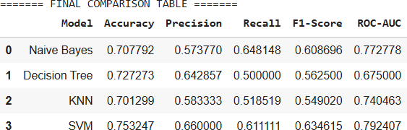

import numpy as np import pandas as pd import seaborn as sns
import matplotlib.pyplot as plt

# 8. PLOT CONFUSION MATRICES
plt.figure(figsize=(12, 10))
for i, (name, cm) in enumerate(conf_matrices.items(), 1): plt.subplot(2, 2, i)
sns.heatmap(cm, annot=True, fmt="d", cmap="Blues", xticklabels=['Pred 0','Pred 1'],
yticklabels=['True 0','True 1']) plt.title(f"{name} - Confusion Matrix") plt.xlabel("Predicted") plt.ylabel("Actual")
plt.tight_layout() plt.show()
# 9. PLOT ROC CURVES
plt.figure(figsize=(8,6))
for name, (fpr, tpr, auc_roc) in roc_curves.items(): plt.plot(fpr, tpr, label=f"{name} (AUC={auc_roc:.3f})")

plt.plot([0,1], [0,1], 'k--', label="Random") plt.xlabel("False Positive Rate") plt.ylabel("True Positive Rate") plt.title("ROC Curves for All Models") plt.legend()
plt.grid(True) plt.show()

# ---------------- 10. PLOT PRECISION–RECALL CURVES ----------------
plt.figure(figsize=(8,6))
for name, (recall_vals, precision_vals, auc_pr) in pr_curves.items(): plt.plot(recall_vals, precision_vals, label=f"{name}
(AUC={auc_pr:.3f})")

plt.xlabel("Recall") plt.ylabel("Precision")
plt.title("Precision–Recall Curves for All Models") plt.legend()
plt.grid(True) plt.show()

# 11. BAR PLOT OF METRICS
metrics_to_plot = ["Accuracy", "Precision", "Recall", "F1-Score", "ROC- AUC"]

plt.figure(figsize=(10,6)) x = np.arange(len(models)) bar_width = 0.15

for i, metric in enumerate(metrics_to_plot):
plt.bar(x + i*bar_width, results_df[metric], width=bar_width, label=metric)

plt.xticks(x + bar_width*2, results_df["Model"]) plt.ylabel("Score")
plt.title("Model Performance Comparison") plt.ylim(0, 1.05)
plt.legend() plt.tight_layout() plt.show()

Output Plot:
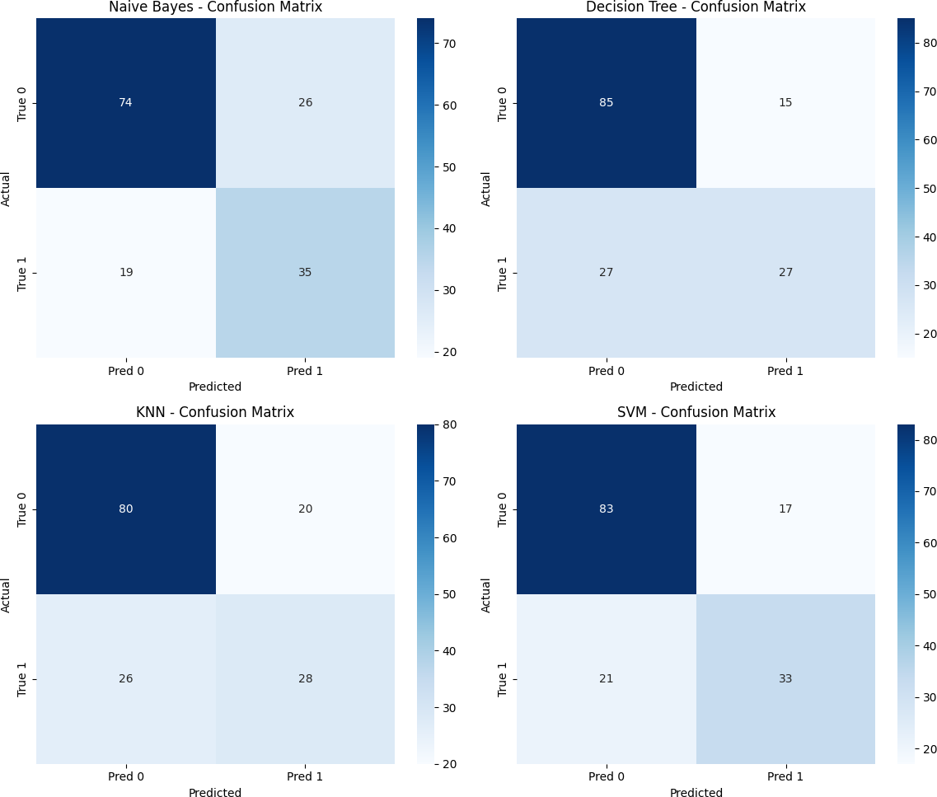

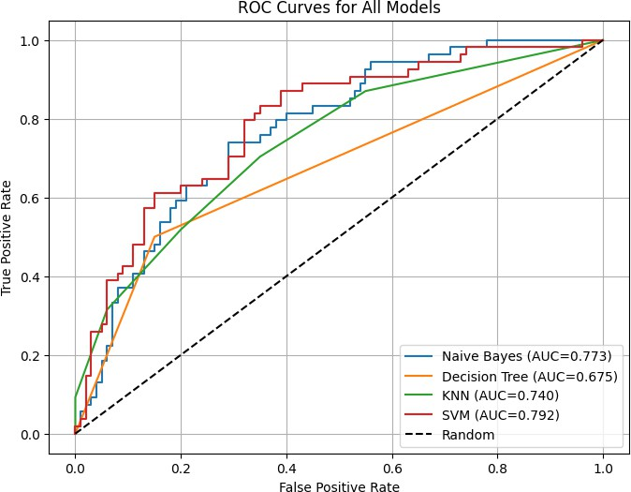

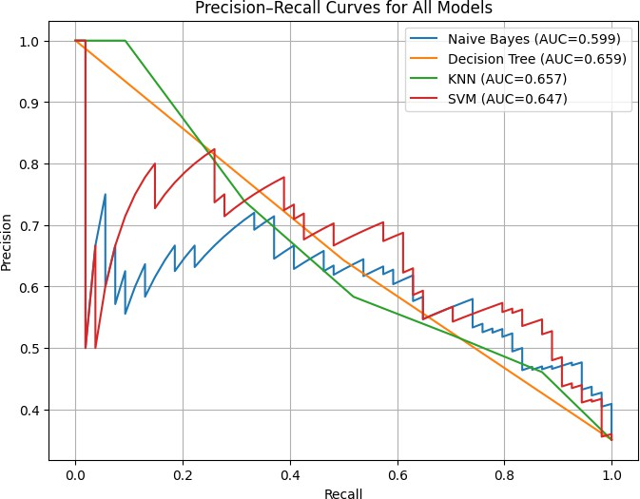

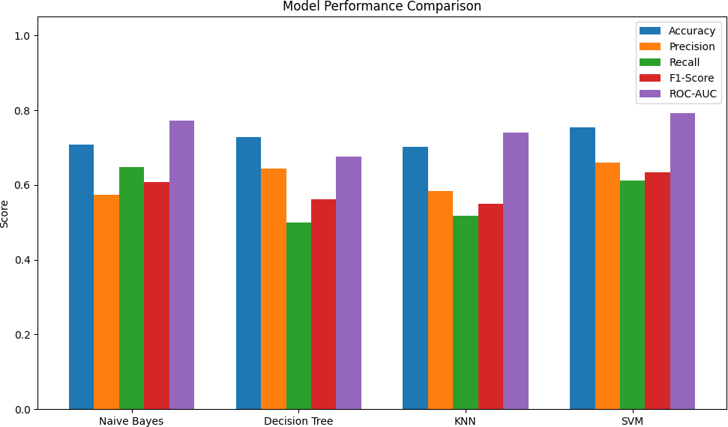

PRECAUTIONS:

- Ensure the dataset is properly preprocessed by handling missing values, duplicates, and outliers before training the models.
- Normalize or standardize the features, especially for algorithms sensitive to scale such as KNN and SVM.
- Use an appropriate train-test split or cross-validation to avoid biased evaluation and overfitting.
- Tune hyperparameters (e.g., number of neighbors in KNN, kernel type in SVM) for optimal model performance rather than using default values.

RESULT:

Expt. No: 07 Date:

AIM: Train Clustering with the K-Means algorithm using suitable data set.

Objectives

  - To apply the K-Means clustering algorithm on a suitable dataset to group similar data points based on feature similarity.
  - To visualize and interpret the clustering results to understand the structure and relationships within the dataset.
  - To evaluate the effectiveness of K-Means clustering based on intra-cluster similarity and inter-cluster separation.

Required Software

  - Google Colab or Anaconda

Theory and Background

K-Means is an unsupervised machine learning algorithm used for clustering data into groups based on similarity. Unlike classification algorithms, it does not use labeled data. Instead, it identifies patterns by grouping data points so that points within the same cluster are more similar to each other than to those in other clusters.

The algorithm works by selecting K initial cluster centroids and then performing two main steps iteratively:

- Assignment Step: Each data point is assigned to the nearest centroid based on a distance metric (commonly Euclidean distance).
- Update Step: The centroids are recalculated as the mean of all points assigned to each cluster.

This process continues until the centroids stabilize or the maximum number of iterations is reached.

K-Means is computationally efficient and works well for large datasets, but it is sensitive to the initial choice of K and may converge to a local minimum.

Procedure:

  - Import necessary libraries and load a suitable dataset for clustering.
  - Preprocess the data (e.g., handle missing values and scale features if required).
  - Apply the K-Means algorithm by specifying the number of clusters and fitting the model to the data.
  - Analyze and visualize the clustering results using cluster labels and plots to interpret groupings.

Program:

import pandas as pd # for loading and handling dataset
import numpy as np # for numerical operations import matplotlib.pyplot as plt # for plotting graphs import seaborn as sns # for visualizations

from sklearn.preprocessing import StandardScaler # to scale features from sklearn.cluster import KMeans # K-Means algorithm
from sklearn.decomposition import PCA # for 2D visualization

%matplotlib inline # allows charts to appear in notebook
sns.set_style("whitegrid") # formatting style for plots
plt.rcParams["figure.figsize"] = (8,5) # default figure size

df = pd.read_csv("D:\Python\spotify.csv\spotify.csv") # load dataset from uploaded file
print("Dataset shape:", df.shape) # print number of rows/columns
display(df.head()) # show first 5 rows

# Common Spotify audio features used for clustering candidate_features = [
'danceability','energy','loudness','speechiness','acousticness', 'instrumentalness','liveness','valence','tempo','duration_ms','popu
larity'
]

# Keep only the features that exist in the dataset
features = [col for col in candidate_features if col in df.columns] # If none of these exist, use all numeric columns

if not features:
features = df.select_dtypes(include=[np.number]).columns.tolist() print("Using features:", features)
# Extract selected columns as X
X = df[features]

# Replace missing values with median
X = X.fillna(X.median())

Output:
Using features: ['danceability', 'energy', 'loudness', 'speechiness', 'acousticness', 'instrumentalness', 'liveness', 'valence', 'tempo', 'duration_ms']

scaler = StandardScaler() # create scaler object X_scaled = scaler.fit_transform(X) # scale data (important for K- Means)

k = 3 # set number of clusters (choose any value)
kmeans = KMeans(n_clusters=k, random_state=42, n_init=10) # create K-
Means model
kmeans.fit(X_scaled) # train the model on scaled data
labels = kmeans.labels_ # get cluster number for each row

# Add cluster labels to original dataset df['cluster'] = labels

print("\nCluster counts:") print(df['cluster'].value_counts())

Output:

Cluster counts:
cluster
0 15122
2 11606
1 6105
Name: count, dtype: int64

pca = PCA(n_components=2) # reduce data to 2 dimensions X_pca = pca.fit_transform(X_scaled) # transform scaled data to PCA space

df_pca = pd.DataFrame(X_pca, columns=['PC1','PC2']) # create PCA DataFrame
df_pca['cluster'] = labels # add cluster labels

# Plot PCA scatter with clusters plt.figure(figsize=(8,6))
sns.scatterplot(data=df_pca, x='PC1', y='PC2', hue='cluster', palette='tab10', s=60)
plt.title("K-Means Clustering Visualization (PCA 2D)") plt.show()

Output Plot:
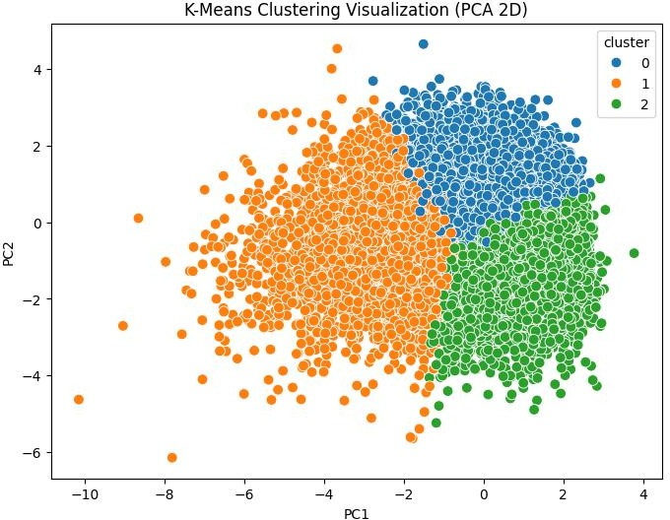

centers = kmeans.cluster_centers_ # get scaled cluster centers
centers_original_scale = scaler.inverse_transform(centers) # convert back to original units

cluster_centers_df = pd.DataFrame(centers_original_scale, columns=features)
print("\nCluster Centers (original scale):") display(cluster_centers_df)

Output:

Cluster Centers (original scale):
 | Danceabili  ty | Energy | Loudnes  s | Speechine  ss | Acousticne  ss | Instrumentaln  ess | Livenes  s | Valenc  e | Tempo | Duration_M  s
0 | 0.742678 | 0.71430  1 | - 6.236852 | 0.134056 | 0.146844 | 0.023574 | 0.16731  5 | 0.65179  5 | 115.9769  06 | 218444.9927  31
1 | 0.617237 | 0.44643  0 | - 10.39407  9 | 0.090240 | 0.464094 | 0.130996 | 0.15724  4 | 0.40141  7 | 113.2423  84 | 228255.9646  54
2 | 0.559996 | 0.81112  4 | - 5.412099 | 0.080701 | 0.060269 | 0.140240 | 0.23739  5 | 0.38368  9 | 131.3130  96 | 234108.6323  24

PRECAUTIONS:

- Choose an appropriate number of clusters (K value) using methods like the Elbow Method or Silhouette Score to avoid under- or over-clustering.

- Standardize or normalize the dataset, especially when features have different scales, as K- Means relies on distance calculations.

- Remove noise and outliers beforehand, as K-Means is sensitive to extreme values which can distort cluster centroids.

RESULT:

Expt. No: 08 Date:

AIM: Write a program to implement Classifying handwritten digits.

Objectives

  - To implement a machine learning model to classify handwritten digit images from a dataset such as MNIST or Scikit-learn’s digits dataset.
  - To train and evaluate classifiers (e.g., Logistic Regression, KNN, or SVM) for accurate recognition of digits.
  - To measure model performance using metrics like accuracy, confusion matrix, precision, recall, and F1-score.
  - To visualize sample predictions and understand model behavior on handwritten digit images.

Required Software

  - Google Colab or Anaconda

Theory and Background:

Handwritten digit classification is a fundamental machine learning task where the goal is to automatically recognize digits (0–9) from images. The MNIST dataset is widely used for this purpose, containing thousands of labeled 28×28 pixel grayscale digit images. Each image is converted into numerical features that can be processed by machine-learning models. Algorithms such as Logistic Regression, SVM, KNN, Decision Trees, or Neural Networks learn patterns in pixel intensities to distinguish between digits. Before training, the images are normalized to improve learning accuracy. The trained model is then evaluated using metrics such as accuracy and confusion matrix. This experiment demonstrates how machine learning can accurately interpret handwritten digits through supervised learning techniques.
Procedure:

  - Open Jupyter Notebook and create a new Python3 notebook for the experiment.
  - Import necessary libraries such as NumPy, Pandas, Matplotlib, Seaborn, and machine learning models.
  - Load the handwritten digit dataset (MNIST or your uploaded dataset) and view sample images to understand the data.
  - Preprocess the data by normalizing pixel values and converting images into suitable numerical feature vectors.

  - Split the dataset into training and testing sets to evaluate model performance.
  - Train a suitable classifier (Logistic Regression, SVM, KNN, or Neural Network) on the training data and predict on the test data.
  - Evaluate the model using accuracy, confusion matrix, and classification report, and display sample predictions.

Program:

import numpy as np import pandas as pd
from matplotlib import pyplot as plt

import pandas as pd # for loading and handling dataset

import numpy as np # for numerical operations import matplotlib.pyplot as plt # for plotting graphs import seaborn as sns # for visualizations dataset = pd.read_csv("train_data.csv")
dataset.head()

Output:

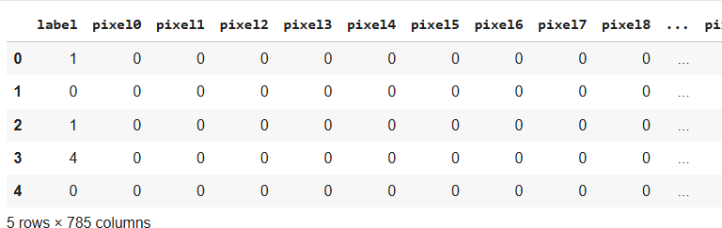

# Plotting images
a = np.random.random((10,10)) plt.figure()
plt.imshow(a, cmap='gray') plt.show()

Output Plot:
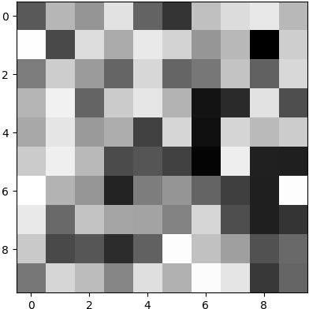

data = dataset.values[:5000] data.shape
(5000, 785)
X, y = data[:,1:], data[:, 0] # Plotting digit
im = X[4997].reshape((28,28)) plt.figure()
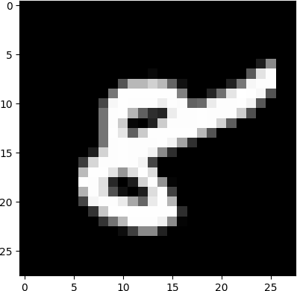
plt.imshow(im, cmap='gray') plt.show()

split = int(X.shape[0] * 0.80)
X_train, X_test, y_train, y_test = X[:split], X[split:], y[:split], y[split:]
print(X_train.shape, y_train.shape) print(X_test.shape, y_test.shape) print(y_train)
print(y_test)

Output:
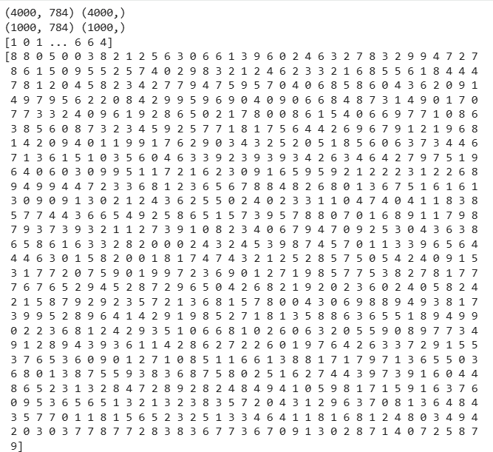

def knn(X_train, y_train, test_point, k=5):
distances = [] # Contains list of tuples (distance, label for data_point, label in zip(X_train, y_train):
distances.append((euclidean(test_point, data_point), label)) # for i in range(X_train.shape[0]):
# data_point = X_train[i]
# label = y_train[i]

sorted_distances = sorted(distances, key=lambda x: x[0]) k_nearest_neighbors = np.array(sorted_distances[:k])
freq = np.unique(k_nearest_neighbors[:,1], return_counts=True) labels, counts = freq
majority_vote = labels[counts.argmax()] return majority_vote

def euclidean(p1, p2):
return np.sqrt(np.sum((p1-p2)**2)) euclidean(np.array([1,2,3]), np.array([4,5,6]))

def calculate_accuracy(X_test, y_test, X_train, y_train, k=5): predictions = []
for test_point in X_test:
pred_label = knn(X_train, y_train, test_point, k) predictions.append(pred_label)

predictions = np.array(predictions)

accuracy = (predictions == y_test).sum() / y_test.shape[0] return accuracy

calculate_accuracy(X_test, y_test, X_train, y_train, k=5)

test_df = pd.read_csv(r"D:\Python\test_data\test_data.csv")
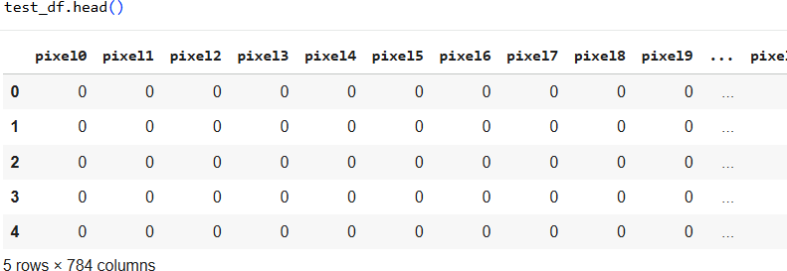

test_data = test_df.values test_images = test_data[:10] test_images.shape

for test in test_images:
im = test.reshape((28,28)) plt.figure()
plt.imshow(im, cmap='gray') plt.show()
print("Label:", knn(X_train, y_train, test))

Output Plot:

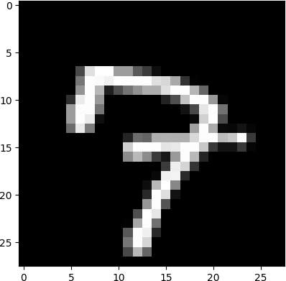

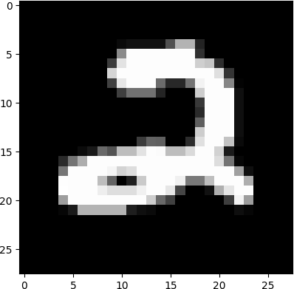
Label: 2.0

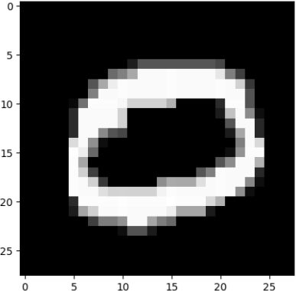
Label: 0.0

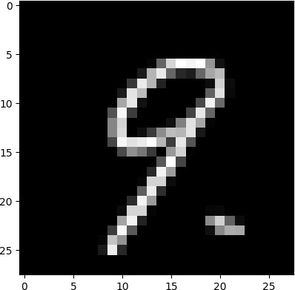
Label: 9.0

PRECAUTIONS:
Label: 7.0
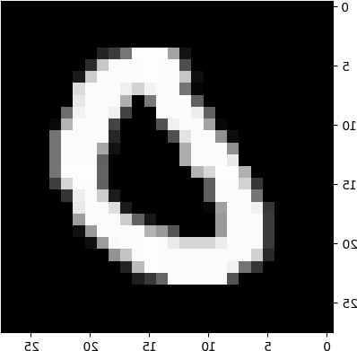
Label: 0.0

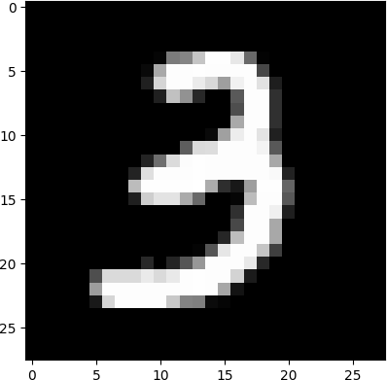
Label: 3.0

- Ensure correct splitting of training and testing datasets to avoid data leakage.
- Avoid using the entire dataset for training without a test set, as it prevents unbiased evaluation.

RESULT:

Expt. No: 09 Date:

AIM: Write a program to Classify characters in natural images.

Objectives

  - To design and implement a deep learning model using a pre-trained InceptionV3 architecture for accurate classification of characters from natural images under varying lighting, texture, and background conditions.
  - To apply transfer learning and data augmentation techniques to enhance model generalization, evaluate classification accuracy, and analyze performance using training–validation metrics and visualizations.

Required Software

  - Google Colab or Anaconda

Theory and Background

Character classification in natural images is a challenging computer-vision problem due to variations in lighting, shadows, background clutter, and differences in font style and orientation. Traditional machine-learning approaches struggle with such variations, but modern deep learning models, especially convolution-based architectures, excel at extracting hierarchical visual features. InceptionV3, a deep convolutional model trained on millions of images (ImageNet), uses multi-scale convolutions inside “Inception modules” to capture fine details such as edges, curves, and shapes of characters. Using transfer learning, the pre-trained InceptionV3 model provides strong feature extraction even for small datasets, while only the final classification layers are retrained for the new task. Data augmentation further improves model robustness. This combination makes InceptionV3 a powerful and efficient method for classifying characters in natural images with high accuracy.
PROCEDURE:

  - Prepare the dataset by organizing character images into separate folders (one folder per class) under a common directory for training and validation.
  - Load the dataset in Jupyter Notebook using image_dataset_from_directory() and verify samples by visualizing a few images.
  - Preprocess the images by resizing them to InceptionV3’s input size (299×299),
normalizing pixel values, and applying data augmentation such as rotation and zoom.

  - Load the pre-trained InceptionV3 model with include_top=False to use it as a feature extractor while freezing its convolutional layers.
  - Add a custom classification head using layers such as GlobalAveragePooling, Dense, Dropout, and a final Softmax layer to match the number of character classes.
  - Compile the model using an optimizer (Adam), a suitable loss function (categorical cross-entropy), and monitor performance metrics such as accuracy.
  - Train and evaluate the model on the dataset, fine-tune top layers of InceptionV3 if necessary, generate a confusion matrix, and interpret final accuracy for performance analysis.

Program:

import os
import numpy as np import tensorflow as tf
import matplotlib.pyplot as plt

# Correct imports for image loading & augmentation
from tensorflow.keras.preprocessing.image import ImageDataGenerator, img_to_array, load_img

from PIL import Image
from sklearn.utils import shuffle from random import randint

# Callbacks and pre-trained model imports
from tensorflow.keras.callbacks import ReduceLROnPlateau
from tensorflow.keras.applications.inception_v3 import InceptionV3 print("Setup Complete!")

Images, Labels = get_images(r"D:\Python\seg_train\seg_train") import os
print(os.listdir(r"D:\Python\seg_train")) print(os.listdir(r"D:\Python\seg_train\seg_train"))

Output:
['seg_train']

['buildings', 'forest', 'glacier', 'mountain', 'sea', 'street'] import os, cv2
def get_images_debug(directory):

Images = [] Labels = [] label_map = {
"buildings": 0,
"forest": 1,
"glacier": 2,
"mountain": 3,
"sea": 4,
"street": 5
}
counts = {}
for class_name in sorted(os.listdir(directory)): class_path = os.path.join(directory, class_name) if not os.path.isdir(class_path):
continue
label = label_map.get(class_name, None) if label is None:
print("Skipping unknown folder:", class_name) continue
files = [f for f in os.listdir(class_path) if f.lower().endswith(('.jpg','.jpeg','.png'))]
counts[class_name] = len(files) for fname in files:
fp = os.path.join(class_path, fname) img = cv2.imread(fp)
if img is None:
print("Failed to read:", fp) continue
img = cv2.resize(img, (150,150)) Images.append(img) Labels.append(label)
print("Per-class counts:", counts) return Images, Labels

Images, Labels = get_images_debug(r"D:\Python\seg_train\seg_train") print("Total loaded:", len(Images))
[ ]

Output:
Per-class counts: {'buildings': 2191, 'forest': 2271, 'glacier': 2404,
'mountain': 2512, 'sea': 2274, 'street': 2382}
Total loaded: 14034

f,ax = plt.subplots(5,5) f.subplots_adjust(0,0,3,3) for i in range(0,5,1):
for j in range(0,5,1):
rnd_number = randint(0,len(Images)) ax[i,j].imshow(Images[rnd_number]) ax[i,j].set_title(get_classlabel(Labels[rnd_number])) ax[i,j].axis('off')

Output Plot:
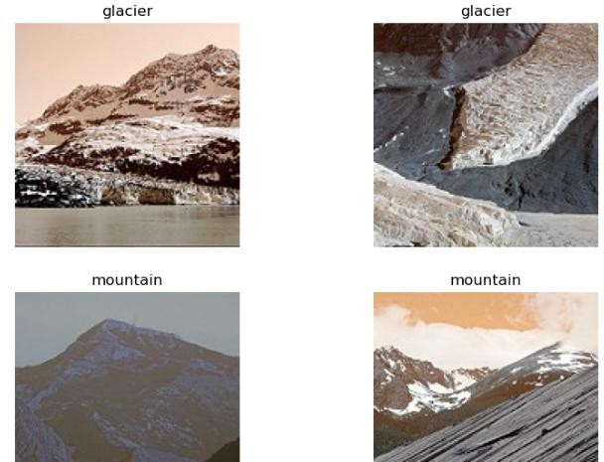
train_DIR = r"D:\Python\seg_train\seg_train" train_datagen = ImageDataGenerator( rescale = 1.0/255,
width_shift_range=0.2, height_shift_range=0.2, zoom_range=0.2, vertical_flip=True, fill_mode='nearest')

train_generator = train_datagen.flow_from_directory(train_DIR,
batch_size=32, class_mode='categor

ical',

150))

test_DIR = r"D:\Python\seg_test\seg_test"

target_size=(150,

validation_datagen = ImageDataGenerator(rescale = 1.0/255)

validation_generator = validation_datagen.flow_from_directory(test_DIR,
batch_size=128, class_mode='categor

ical',

150))

Output:
Found 14034 images belonging to 6 classes. Found 3000 images belonging to 6 classes.

target_size=(150,

inceptionV3 = InceptionV3(include_top= False, input_shape=(150,150,3))

for layer in inceptionV3.layers: layer.trainable = False

last_layer = inceptionV3.get_layer('mixed9') last_output = last_layer.output # tensor

print("last layer tensor shape:", last_output.shape)

Output:
last layer tensor shape: (None, 3, 3, 2048)

x = tf.keras.layers.Flatten()(last_output)
x = tf.keras.layers.Dense(units = 1024, activation = tf.nn.relu)(x) x = tf.keras.layers.Dropout(0.2)(x)
x = tf.keras.layers.Dense (6, activation = tf.nn.softmax)(x) model = tf.keras.Model( inceptionV3.input, x)
learning_rate_reduction = ReduceLROnPlateau(monitor='val_acc',
patience=1, verbose=1, factor=0.25, min_lr=0.000003)

model.compile(loss = 'categorical_crossentropy', optimizer= tf.keras.optimizers.Adam(), metrics=['acc'])

model.summary()

Output:
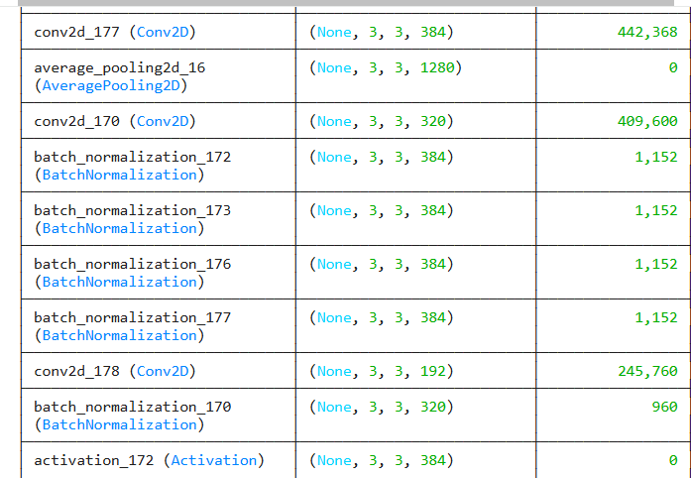
Total params: 34,604,262 (132.00 MB)
Trainable params: 18,881,542 (72.03 MB)
Non-trainable params: 15,722,720 (59.98 MB)

history = model.fit(train_generator,
epochs = 10,
verbose = 1,
validation_data = validation_generator, callbacks=[learning_rate_reduction])

Output
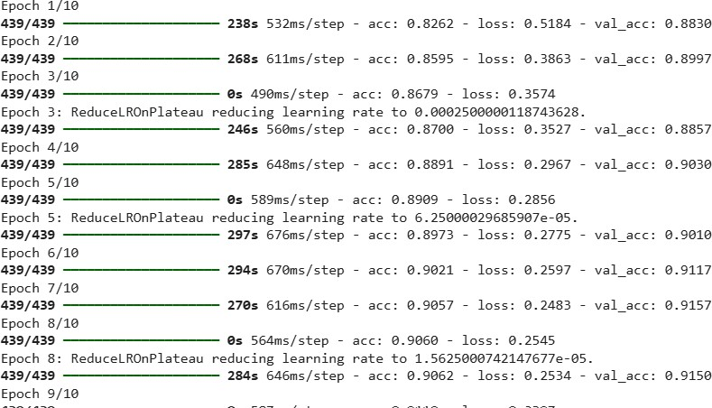

: %matplotlib inline
acc = history.history['acc'] val_acc = history.history['val_acc'] loss = history.history['loss']
val_loss = history.history['val_loss'] epochs = range(len(acc))
plt.plot(epochs, acc, 'r', label='Training accuracy') plt.plot(epochs, val_acc, 'b', label='Validation accuracy') plt.title('Training and validation accuracy')
plt.legend() plt.figure()

plt.plot(epochs, loss, 'r', label='Training Loss') plt.plot(epochs, val_loss, 'b', label='Validation Loss') plt.title('Training and validation loss')
plt.legend() plt.show()

Output Plot:
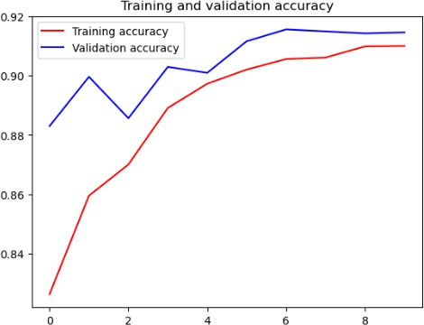

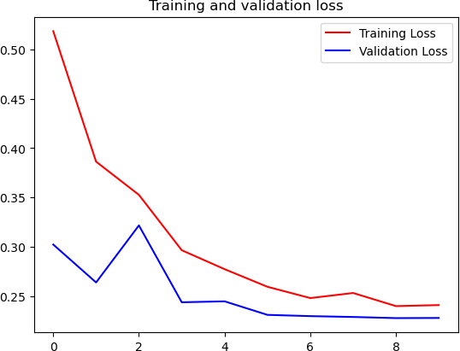

import numpy as np
from keras.preprocessing import image

file_path = r"D:\Python\seg_pred\seg_pred\2326.jpg"

test_image = image.load_img(file_path, target_size = (150, 150)) plt.imshow(test_image)
test_image = image.img_to_array(test_image) test_image = np.expand_dims(test_image, axis = 0) result = model.predict(test_image)

classes=train_generator.class_indices

classes=['buildings','forest','glacier','mountain','sea','street'] print("Prediction for this image is :",classes[np.argmax(result)])

Output:
1/1 ━━━━━━━━━━━━━━━━━━━━ 0s 76ms/step Prediction for this image is : sea

PRECAUTIONS:

- Shuffle and split data correctly to prevent biased learning.
- Use appropriate model complexity; too large models may increase training time and memory usage.
- Validate model using a separate validation set to monitor training progress.

RESULT:

Expt. No: 10 Date:

AIM: Training Bagging, Boosting, Random Forest, with scikit-learn.

Objectives

  - To understand and implement ensemble learning techniques: Bagging, Boosting, and Random Forest using scikit-learn.
  - To train and test the models on a suitable dataset and compare their performance.
  - To evaluate the classifiers using accuracy, precision, recall, F1-score, and confusion matrix.
  - To analyze how ensemble learning improves model performance and reduces variance or bias compared to individual models.

Required Software

  - Google Colab or Anaconda

Theory and Background:

Bagging and Boosting are ensemble learning methods that combine multiple weak learners to build a stronger, more accurate model. Bagging (Bootstrap Aggregating) trains several models independently using different random subsets of the training data created via bootstrapping. It reduces variance and prevents overfitting; Random Forest is a popular extension of Bagging that builds many decision trees with random feature selection. Boosting, on the other hand, trains models sequentially, where each new model focuses more on correcting errors made by previous models. Algorithms like AdaBoost and Gradient Boosting improve bias and create highly accurate models by giving more weight to misclassified instances. While Bagging reduces variance, Boosting reduces both bias and variance, resulting in improved performance on complex datasets. Together, these methods form the foundation of modern ensemble classifiers widely used in real-world applications.
PROCEDURE:

  - Load the dataset and preprocess it by handling missing values, encoding labels, and identifying feature and target columns.
  - Split the dataset into training and testing sets to evaluate ensemble models fairly.
  - Implement Bagging, usually with a Decision Tree base estimator, and train multiple bootstrapped models independently.

  - Train a Random Forest classifier using multiple decision trees created by random feature selection and bootstrapped samples.
  - Implement Boosting using algorithms such as AdaBoost or Gradient Boosting where models are trained sequentially, emphasizing misclassified samples at each stage.
  - Predict on test data using each ensemble model and compute evaluation metrics such as accuracy, precision, recall, F1-score, and confusion matrix.
  - Compare the performance of Bagging, Boosting, and Random Forest to determine which ensemble method performs best on the dataset.

Program:

# Random Forest with Pipeline:
from sklearn.datasets import load_iris import pandas as pd
from sklearn.model_selection import train_test_split from sklearn.preprocessing import LabelEncoder
from sklearn.tree import DecisionTreeClassifier
from sklearn.metrics import accuracy_score, classification_report

# Load CSV file
df = pd.read_csv(r"D:\Python\Iris.csv") print(df.head())

# Drop ID column (not a feature) df = df.drop("Id", axis=1)

# Features (all numeric columns)
X = df.iloc[:, :-1] # SepalLengthCm ... PetalWidthCm

# Target (Species)
y = df.iloc[:, -1] # Species

# Encode species names to numbers le = LabelEncoder()
y = le.fit_transform(y)

# Train-test split
X_train, X_test, y_train, y_test = train_test_split( X, y, test_size=0.3, random_state=42
)

from sklearn.ensemble import RandomForestClassifier

rf = RandomForestClassifier(n_estimators=100, random_state=42) rf.fit(X_train, y_train)

import matplotlib.pyplot as plt

# Retrieve feature importances importances = rf.feature_importances_

# Feature names feature_names = X.columns

# Plot plt.figure(figsize=(10, 6))
plt.barh(feature_names, importances, color='teal') plt.xlabel('Feature Importance') plt.ylabel('Features')
plt.title('Random Forest Feature Importance (Iris Dataset)') plt.show()

Output
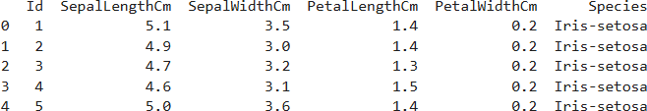
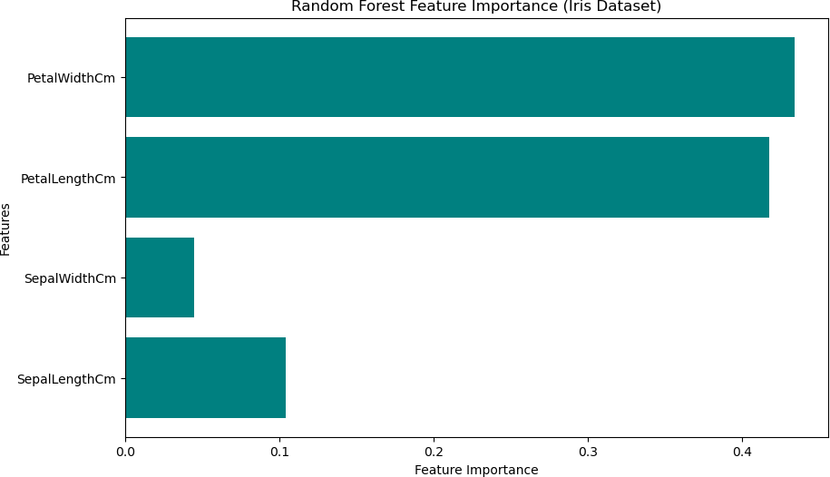

from sklearn.metrics import classification_report

# Predict on test data y_pred = rf.predict(X_test)

# Print Classification Report print("Classification Report:\n")
print(classification_report(y_test, y_pred, target_names=le.classes_))

Output:
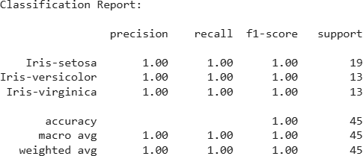

# Create a Bagging classifier pipeline using Decision Trees as base estimators
bagging_pipeline = Pipeline([
('scaler', StandardScaler()), # Optional: Standardize features ('bagging', RandomForestClassifier(n_estimators=100,
random_state=42, max_features=None))
])

# Fit the model to the training data bagging_pipeline.fit(X_train, y_train)

# Make predictions on the test data y_pred_bagging = bagging_pipeline.predict(X_test)

# Calculate accuracy
accuracy_bagging = accuracy_score(y_test, y_pred_bagging) print(f"Bagging Test Accuracy: {accuracy_bagging:.2f}")

bagging_pipeline.named_steps['bagging']
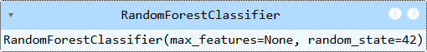
import matplotlib.pyplot as plt

# Retrieve variable importance scores importances =
bagging_pipeline.named_steps['bagging'].feature_importances_

# Get feature names # Feature names
feature_names = X.columns

# Plot variable importances plt.figure(figsize=(10, 6)) plt.barh(range(len(importances)), importances, tick_label=feature_names)
plt.xlabel('Feature Importance') plt.ylabel('Features') plt.title('Bagging Variable Importance') plt.show()

Output Plot:
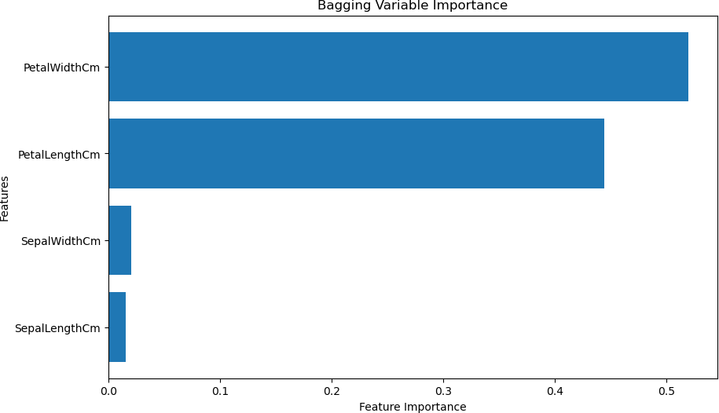

# Boosting with Pipeline:
from sklearn.ensemble import AdaBoostClassifier

# Create an AdaBoost classifier pipeline using Decision Trees as base estimators
boosting_pipeline = Pipeline([
('scaler', StandardScaler()), # Optional: Standardize features ('boosting', AdaBoostClassifier(n_estimators=100, random_state=42))
])

# Fit the model to the training data boosting_pipeline.fit(X_train, y_train)

# Make predictions on the test data y_pred_boosting = boosting_pipeline.predict(X_test)

# Calculate accuracy
accuracy_boosting = accuracy_score(y_test, y_pred_boosting) print(f"Boosting Accuracy: {accuracy_boosting:.2f}")
Output: Boosting Accuracy: 1.00

import matplotlib.pyplot as plt

# Retrieve variable importance scores importances =
boosting_pipeline.named_steps['boosting'].feature_importances_

# Get feature names feature_names = X.columns

# Plot variable importances plt.figure(figsize=(10, 6)) plt.barh(range(len(importances)), importances, tick_label=feature_names)
plt.xlabel('Feature Importance') plt.ylabel('Features') plt.title('AdaBoost(Boosting) Variable Importance') plt.show()

Output Plot:
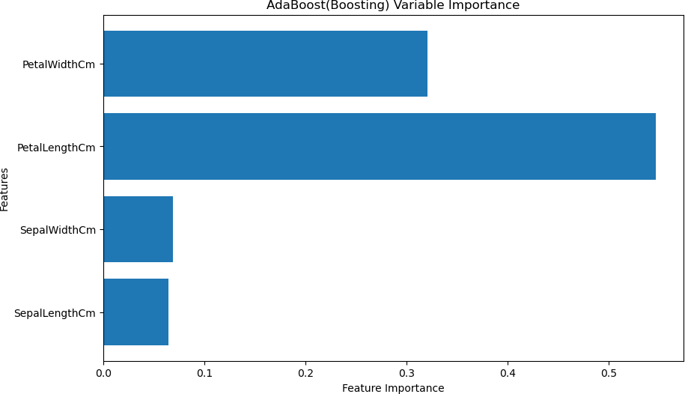

PRECAUTIONS:

- Clean and preprocess data before training.

- Use proper train-test split or cross-validation.

RESULT:

