The Rate Assumption Is the Story: Electrification Cost Impact Across Eight Rate Models
WhyWatt technical report — DRAFT for manual editing Prepared 2026-09-09 · Data snapshot: tests/validation/rate_model_impact.json (Phase 6 WS1), regenerated after the gas rate projection was put on a consistent real 2024$ basis (see docs/rate_projection_gas_provenance.md).
Draft status. This is a working draft assembled from the committed impact snapshot and the project’s rate-projection guide. Prose marked [EDITOR NOTE] flags a decision or a number to confirm before this goes to an audience. Charts are generated by scripts/build_impact_report_charts.py; the rate-curve figure is the same one served with the in-app methodology guide.

1. Introduction — why the rate projection is the analysis
When a homeowner asks “will electrifying save me money?”, the honest first answer is a question back: at what future energy prices? The cost of an electrification journey is dominated not by the appliances but by two decades of energy bills, and those bills depend on how the price of electricity and gas moves between now and mid-century. Get the rate path wrong and every downstream number — payback, lifetime savings, the whole recommendation — is wrong with it.
The uncomfortable truth is that no one can hand you a single correct future rate. The major institutions that publish rate outlooks do not agree, and they are not supposed to:
- US EIA (Energy Information Administration) publishes the neutral, federal reference. Its Annual Energy Outlook keeps both electricity and gas roughly flat in real terms nationally, and roughly flat even for the Pacific region — because the federal reference case does not model California’s electrification-driven decline of the gas system.
- The California Energy Commission (CEC) publishes the state’s own official forecast. Its 2025 IEPR keeps California electricity near-flat in real terms, but shows gas rates climbing steeply for the customers who remain — the “death spiral” — with the severity depending on a policy choice about how the state recovers the cost of a shrinking gas system.
- E3 (Energy + Environmental Economics), the firm that builds California’s Avoided Cost Calculator, published the foundational gas death-spiral study; its managed high-electrification path is an independent high case.
- PG&E’s own published tariffs are the ground-truth starting point — today’s E-1 electric and G-1 gas rates — that every projection must be anchored to.
The single most important message of this report is therefore not a number but a shape: the near-term, mid-term, and long-term rate outlook is genuinely uncertain, and that uncertainty cannot honestly be collapsed to one percentage-per-year. Near-term California rate pressure (wildfire cost recovery, grid upgrades) behaves nothing like the long-term picture (a cleaner, cheaper generation supply and, for gas, a shrinking customer base). A defensible tool has to show a range built from named sources — and then show how the electrification verdict holds up across that range. That is exactly what the rest of this report does.

2. Rate projection — sources and method
This section summarizes the project’s living methodology guide, docs/help/rate_projection_guide.md (§R1–R3, §R8). The math lives in docs/Energy_Rate_Projection_Spec.md.

2.1 What the projection does (§R1)
The projection builds the price side of the future bill: a schedule of dollars-per-kWh and dollars-per-therm for every year and month out to 2050. It is deliberately framed as a projection under stated assumptions, not a prediction. Rather than one mystery number, it lays out a low, a central, and a high path — each anchored to today’s real PG&E rate and grown using published government and expert forecasts — so the reasoning is visible instead of hidden.

2.2 A growing rate is a function, not a single percentage (§R2)
Older tools escalate prices by one fixed percentage a year, forever. WhyWatt instead grows the rate in segments — a near-term rate, a mid-term rate, and a long-term rate — with the curve bending at the horizons the official forecasts themselves use (around 2030 and 2045). This captures the fact that the rate of increase itself changes over time: near-term wildfire and grid pressure is not the same force as the long-term supply picture.

2.3 How one year’s rate is built (§R3)
A California retail rate is not the cost of energy plus a markup. WhyWatt builds each year’s rate by adding two pieces:
- Marginal cost — the true cost of one more unit of energy at that hour (a few cents/kWh), taken from the state’s official Avoided Cost Calculator (ACC 2024, built by E3).
- Residual — everything else the utility must recover: wildfire mitigation, existing poles and wires, legacy contracts, public programs. This is the majority of the bill.
The two are added, not multiplied, and that choice drives the whole result. The residual behaves like a large fixed pot of cost (the revenue requirement) divided across all the energy sold:
residual rate ≈ revenue requirement ÷ energy sold
Two things move it — the revenue requirement rising, and the amount of energy sold changing:
- Electricity: sales are growing (EVs and heat pumps sell more kWh), and that growth roughly cancels the rising revenue requirement — so electric rates stay about flat after inflation.
- Gas: sales are shrinking (homes leave gas), so the same fixed cost lands on fewer therms and the rate climbs.
Same arithmetic, opposite direction — which is precisely why electricity and gas pull apart over time.

2.4 The sources, in one place (§R8)
Input | Source | Role in the model
Marginal cost (elec & gas) | CPUC ACC 2024 (built by E3), harvested at climate zone CZ4 | Sets the “one more unit” piece; shows the bill marginal cost is nearly flat
Electricity central line | CEC 2025 IEPR electricity rate workbook (PG&E residential, tn=268239) | Drives the WhyWatt electricity scenarios (real-flat ~36¢/kWh 2024$)
Gas death-spiral cases | CEC 2025 IEPR gas rate workbook (tn=264063, PG&E Res sheet, col H “Delivered Price”; Planning-Area + extreme case; real 2024$) | Drives the WhyWatt gas scenarios and the CEC extreme benchmark
Independent high case | E3 (2020) “Retail Gas in California’s Low-Carbon Future” | Second, independent gas-spiral benchmark
Neutral anchor | US EIA national average + AEO Pacific | Federal reference lines; the recommended default anchor
Base-year anchor & backcast | PG&E published tariffs (E-1, G-1, 2018→2025) | Sets today’s rate; checks the model retraces recent history
Nominal↔real bridge | CEC 2023 IEPR GDP deflator (~2.2%/yr) | The single inflation series used across all sources
A note on dollar basis. The rate curves in Section 3 (Figure 1 and its table) are shown in real 2024$ — inflation removed with the CEC GDP deflator — because that is the basis the CEC anchors are published in, so every source compares fairly. The cumulative bill totals in Section 4 are nominal dollars (what actually appears on a bill, summed over the horizon), which is why they run larger; the model computes those nominal, and the same deflator can convert them to real if wanted. Both are labelled where they appear.

3. Rate projection — results, in plain terms
The figure below plots every selectable rate model, both fuels, 2025–2050 (gas on a log scale).
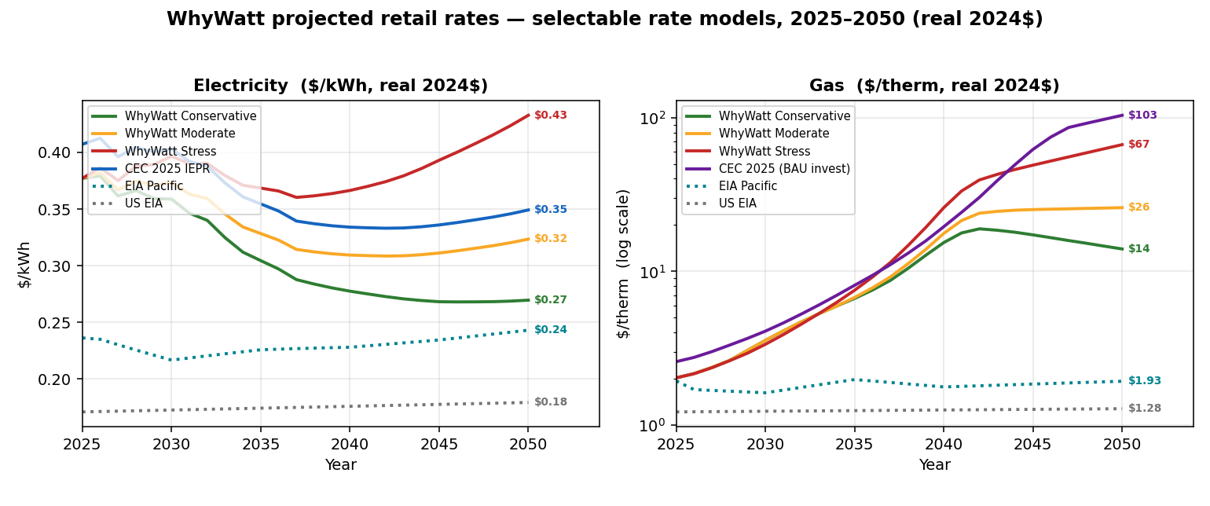
Projected retail rates for every selectable rate model, electricity and gas, 2025–2050
Figure 1. Projected retail rate for every selectable rate model — the three WhyWatt scenarios plus the CEC and EIA reference lines — both fuels, 2025–2050 (gas log scale), in real 2024$ (inflation removed); each line labelled with its 2050 value. Anchored to the PG&E E-1/G-1 tariff. Generated from whywatt_rate_projection.json by scripts/build_guide_charts.py.
In plain terms — electricity stays modest; only gas spirals. All the electricity lines sit in a narrow band and stay roughly flat in real terms across every model. The gas lines fan out dramatically. That divergence is the entire economic engine of electrification: you are moving load off the fuel whose price is climbing and onto the fuel whose price is stable.
How far gas rises is a policy choice, not physics. Using the CEC’s own gas study (PG&E residential, today ≈ $2.08/therm), the projected 2050 gas rates — in real 2024$ — are:
Line | 2050 gas rate | What it represents
US EIA national | ~$1.3 | federal reference — no CA death spiral modeled
EIA AEO Pacific | ~$1.9 | federal reference, our region — still roughly flat
E3 (2020) | ~$7.8 | E3’s managed high-electrification path
WhyWatt Conservative | ~$14 | CEC managed decline (“pruning” gas spend)
WhyWatt Moderate (default) | ~$26 | CEC steadier recovery (“front-load”)
WhyWatt Stress | ~$67 | CEC business-as-usual spending (“flat”)
CEC extreme | ~$103 | CEC fast electrification + business-as-usual spending (~50×)
(All real 2024$. In nominal dollars each gas figure is ~1.7× larger by 2050 — e.g. Moderate ≈ $46/therm nominal — which is the basis the Section 4 bill totals are summed in.)
The federal (EIA) lines stay near today’s rate because they don’t assume California’s gas transition happens; the CEC cases show what does happen to remaining gas customers when it does.
The anchor thesis (why the default is the neutral EIA average). When a conversation drifts into “but rates could do anything,” anchor it: run the analysis at the conservative US EIA national average (electricity ~18¢/kWh, gas ~$1.25/therm — about half of California’s rates). As Section 4 shows, even at those modest national rates, electrification plus solar still comes out ahead in California. A homeowner’s actual California costs will be higher — which only strengthens the case — but anchoring to the neutral federal number keeps the argument defensible and sidesteps “California is a special case” skepticism.

4. Impact scenarios
We ran five electrification configurations, each priced under eight rate models — two legacy baselines (flat CAGR and ACC), the three WhyWatt scenarios, the CEC death-spiral case, and the two EIA reference lines. In every chart below, the bar is the 20-year (or 30-year) net savings from electrifying, defined as do-nothing − journey: green means the journey costs less than staying on gas; red means it costs more. The same house and the same choices are held fixed within each chart — only the rate assumption changes.
The snapshot deliberately exercises non-default projection paths (it is a validation snapshot, not the golden run). Reference: tests/validation/rate_model_impact.md. All dollar figures in this section are nominal cumulative operating bills — annual bills summed over the horizon, as they’d appear — not the real 2024$ rate levels of Section 3.

4.0 How savings and payback are defined (from the code)
These definitions are taken directly from the model’s canonical cockpit extraction (_verdict_numbers in src/ui/sim.py, reading the "Opex Delta" reporter in src/model.py and cumulative_opex in src/journey.py). Two facts up front:
- cumulative_opex is operating energy cost only — the sum of each device-slot’s yearly energy bill, net of solar savings. It does not include equipment install/capital costs (those are tracked separately as capex_events/capex_by_year), and it does not include any social/health/carbon adder.
- Let bill_B(t) and bill_J(t) be the do-nothing and journey cumulative operating bills through simulation year t. The model’s headline delta is
- Δ(t) = bill_B(t) − bill_J(t) (the "Opex Delta" reporter; positive ⇒ the journey is cheaper to run)
- The Net savings (Δopex) bars in every chart are Δ(T) at the final year T.
Payback year — without social cost (this is the value in the snapshot). The reported payback_year is the first simulation year t (1-indexed) at which Δ(t) first turns strictly positive, else — (never):
delta_vals = df["Opex Delta"].values # cumulative bill_B(t) − bill_J(t), per year
payback_yr = next((i + 1 for i, d in enumerate(delta_vals) if d > 0), None)
Because it is defined on the operating-bill delta, it counts only energy bills — never install capital, never social cost. And because Δ(t) is not guaranteed to be monotonic, an early payback can later reverse: the cumulative bill delta can cross zero, go positive, then fall back negative. That is exactly what happens in the full-electrification cases under flat rates below — the cheap early appliance swaps put the journey marginally ahead by year 2, but the later heat-pump and water-heater swaps, expensive to run at a flat ~$0.386/kWh with no rising gas price to escape, pull the cumulative delta back underwater by year 20. So a reported payback_year = 2 alongside a negative final Δopex means “paid back early, then reversed” — a transient payback, not a durable one. (This is a genuine artifact of reporting a single payback year for a non-monotonic curve; consider surfacing “durable payback” — the last crossing — alongside it.)
Net social cost avoided (reported as a horizon total, not a payback). For each year the model values the avoided externality of burning less gas and gasoline:
social_X(t) = gas_therms_X(t) × total_social_rate + gasoline_gallons_X(t) × gasoline_externality_rate
where total_social_rate (climate + health, per therm) comes from SocialCostConfig. The reported net_social_cost_avoided is the sum over all years of social_B(t) − social_J(t) — the total societal cost the journey avoids over the horizon. It is added on top of the bill story, not folded into Δopex.
Payback year — with social cost (derived; not currently in the snapshot). If the avoided social cost is credited as a benefit, payback is the first year t where the combined cumulative position turns positive:
first t with Δ(t) + Σ₍s≤t₎ [ social_B(s) − social_J(s) ] > 0
Because each year’s social term is ≥ 0 (electrifying always burns less gas/gasoline than doing nothing), the with-social payback is always ≤ the bill-only payback — crediting society’s avoided cost can only bring payback forward, never push it later. [EDITOR NOTE] The tool today reports the bill-only payback and the social total separately; the combined series above is not yet a field in the snapshot. If a with-social payback is wanted in this report, add that cumulative series to the cockpit extraction (or compute it from the per-year Social Total reporters) rather than inferring it by hand.

4.1 HVAC (2027) + Water Heater (2029) only — the partial journey
The lightest journey: swap the furnace/AC for a heat pump in 2027 and the water heater in 2029, and nothing else. Peak load 78 A → panel status yellow. 20-year horizon.
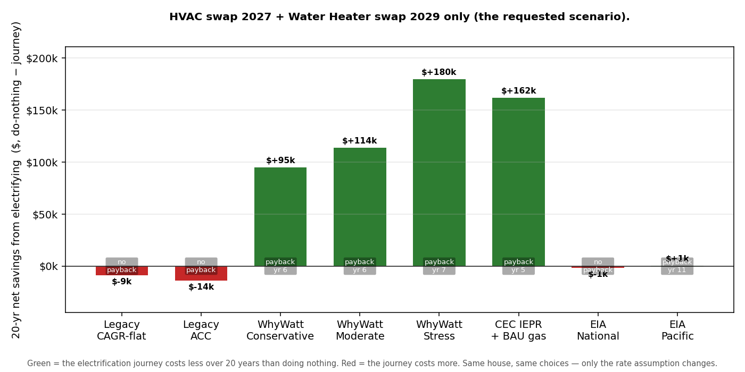
Net savings by rate model — HVAC 2027 + WH 2029
Key finding. This is the scenario where the rate assumption changes the verdict, not just the size of the win. Under the flat-rate legacy and EIA models the partial journey is roughly break-even to mildly negative (−$14k to +$1k, no clean payback except EIA Pacific’s marginal year-11 crossing). But the moment gas is allowed to rise along any CEC-grounded path, the same two swaps save $95k–$180k over 20 years (payback in years 5–7). The do-nothing baseline is what moves: from $132k under flat rates to $313k under Stress. A partial electrification’s case is made or broken entirely by the gas-rate outlook.

4.2 Full electrification (HVAC + WH + dryer + cooktop + EV), 200 A panel
The complete journey on an adequate service. Peak load 119 A → panel status green. 20-year horizon.
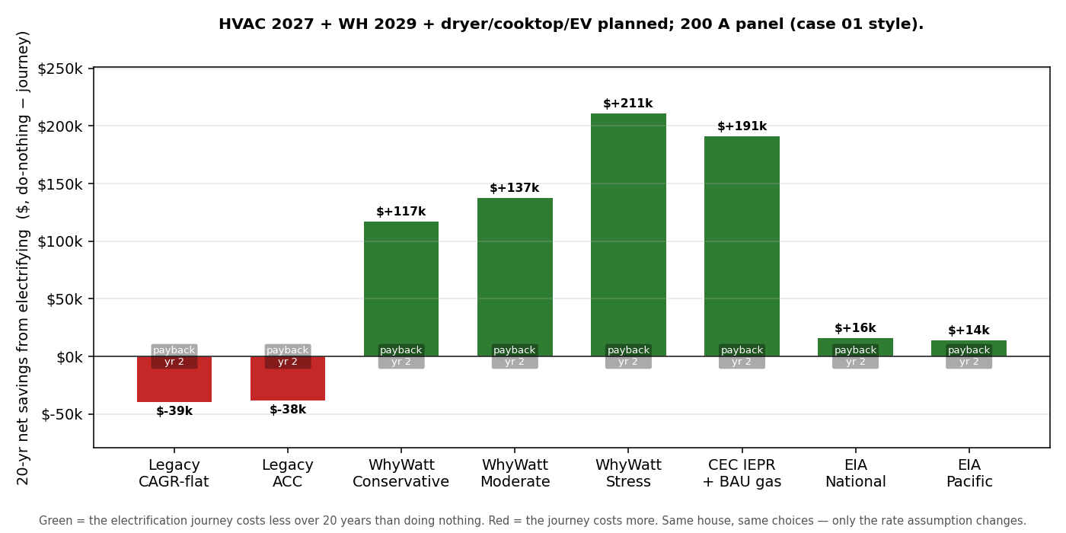
Net savings by rate model — full electrification, 200 A
Key finding. Adding the EV and the remaining appliances roughly doubles the avoided social cost (from ~$20k to ~$42k) and, under every gas-rising model, drives net savings to $117k–$211k. Under the flat-rate legacy models the operating-bill delta is slightly negative (−$38k to −$39k), because the EV adds electric load that flat rates never reward — yet the model still reports a year-2 payback across the board. Per §4.0 this is a transient payback: the cheap early appliance swaps put the journey briefly ahead, then the later heat-pump/WH swaps pull the cumulative bill delta back negative by year 20 (payback year 2, negative final Δopex = “paid back early, then reversed”). Even the neutral EIA national and Pacific anchors turn positive here (+$16k / +$14k). Full electrification is a clear win under every California-grounded rate model and is at worst break-even-to-positive under the neutral federal anchor.

4.3 Full electrification + rooftop solar (NEM3) — the headline
The same full journey with rooftop solar added. Peak load 119 A → panel status green. 20-year horizon.
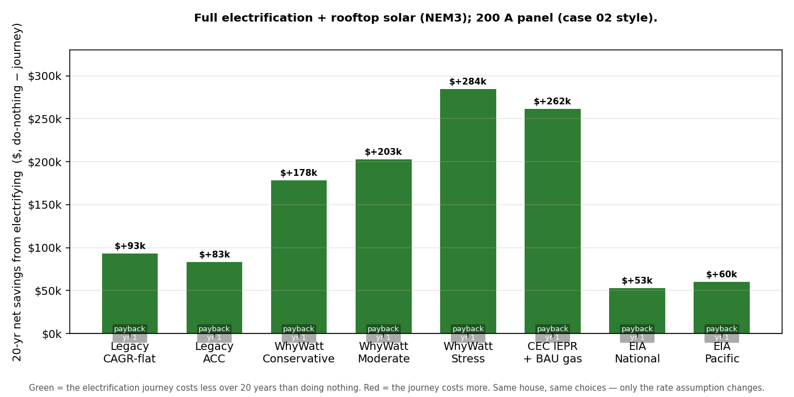
Net savings by rate model — full electrification + solar
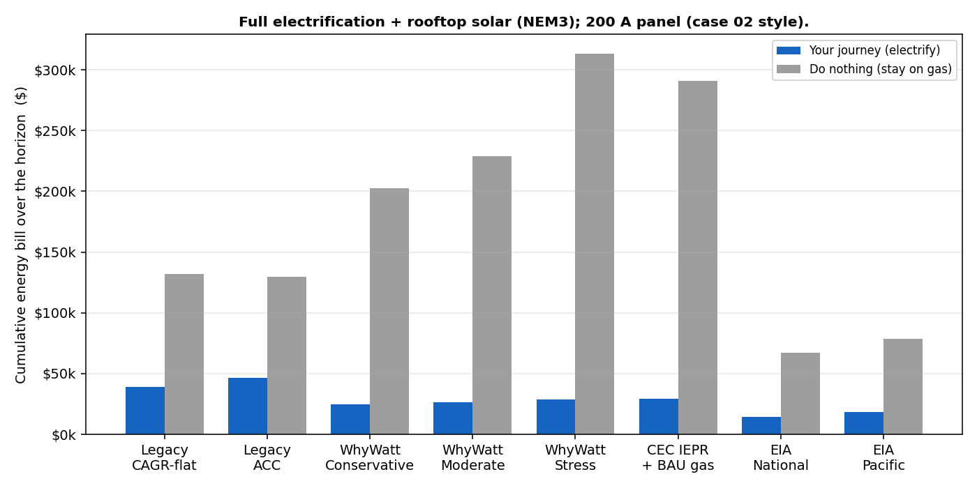
Cumulative bills, journey vs do-nothing — full electrification + solar
Key finding — this is the report’s punchline. With solar, the journey wins under every single rate model, without exception, including the most conservative flat-rate legacy case (+$93k) and both neutral EIA anchors (+$53k national, +$60k Pacific). Payback is year 1 everywhere. The journey’s cumulative bill collapses to $14k–$46k while do-nothing runs $67k–$313k (Figure, lower panel). This is the concrete backing for the anchor thesis in Section 3: you do not need to believe California’s gas death spiral for electrification-plus-solar to pay — it pays even at flat national rates.

4.4 Full electrification on a 100 A service — the panel-upgrade trigger
Identical to 4.2 in every dollar, but on an undersized 100 A service. Peak load 119 A → panel status red.
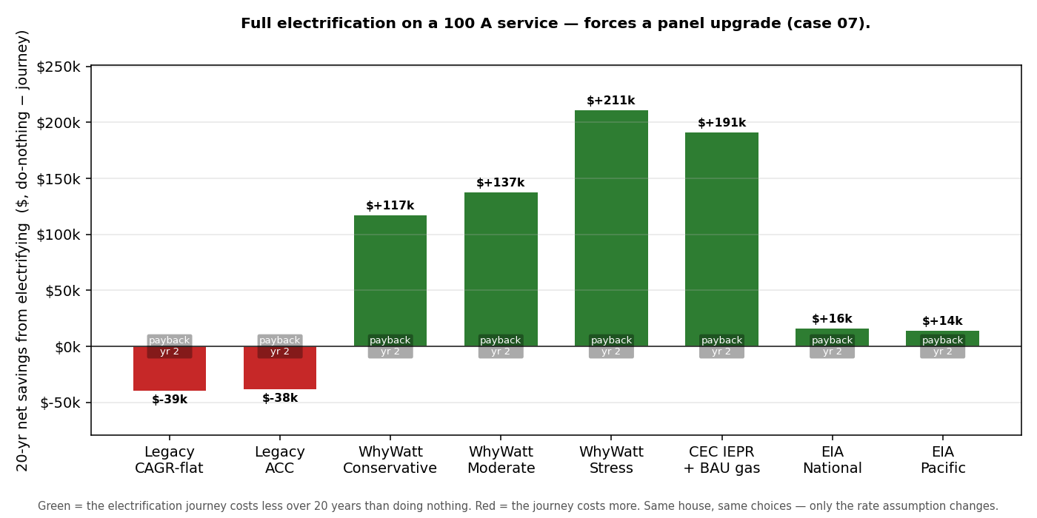
Net savings by rate model — full electrification, 100 A (panel upgrade)
Key finding. The operating economics are identical to the 200 A case — the rate models don’t know about the panel, because peak load is a function of use, not price. What changes is the red panel status: a 100 A service forces a panel upgrade, a one-time capital cost and a feasibility flag that the operating-bill figures here do not include. The takeaway for advocates is to separate the two conversations: the long-run bill story is unchanged, but this household has an up-front hurdle to plan and finance. [EDITOR NOTE] Consider adding the panel-upgrade capital cost explicitly so this scenario’s total-cost story differs from 4.2 as it should.

4.5 HVAC + WH only, over a 30-year horizon — time amplifies the spiral
The same partial journey as 4.1, extended to 30 years (the projection holds flat past 2050). Peak load 78 A → panel status yellow.
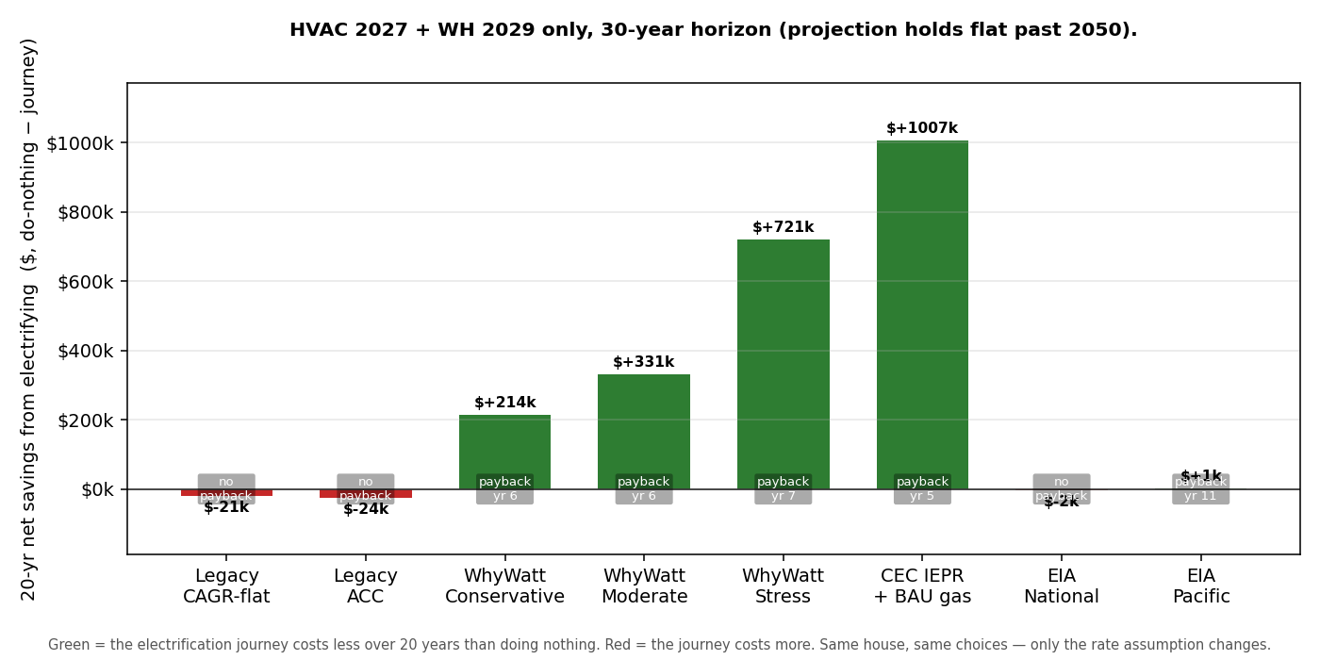
Net savings by rate model — HVAC + WH, 30-year horizon
Key finding. Lengthening the horizon does not change the direction of any result but hugely amplifies its magnitude wherever gas rises. Do-nothing under Stress balloons to $1.02M and under the CEC extreme to $1.34M, pushing net savings to $721k and $1.01M respectively — while the flat-rate models stay near break-even, exactly as at 20 years. The longer the horizon, the more the scenario choice dominates the outcome — which is the strongest possible argument for showing a range rather than a single rate.

5. Conclusion
Across five electrification configurations and eight rate models, one pattern holds:
- The rate assumption, not the hardware, decides the answer for partial journeys. HVAC + water heater alone is break-even under flat rates and a $95k–$180k winner under any California-grounded gas outlook. You cannot answer “should I electrify?” without first choosing a rate story — which is why WhyWatt refuses to ship a single mystery percentage.
- Full electrification is robust. Under every California-grounded model it saves $117k–$211k over 20 years, and even at the neutral federal anchor it is break-even to positive.
- Solar makes the answer unanimous. With rooftop solar, electrification wins under every rate model tested — flat, federal, or spiraling — with year-1 payback. This is the defensible headline: the recommendation survives the most skeptical, non-California rate assumption available.
- Horizon and panel are separate axes. A longer horizon amplifies the gas-rate divergence (30-year savings reach ~$0.7M–$1.0M under the stress and CEC cases); an undersized panel adds a one-time capital hurdle that leaves the long-run bill story unchanged.
The overarching message is the one Section 1 opened with: the future rate cannot honestly be a single number, so the tool’s job is to show the range and demonstrate that the electrification case holds across it. For the conservative, sceptic-proof version of that case, anchor to the neutral US EIA average and add solar — the answer is still yes.

Appendix — reproduce the figures:
.venv/Scripts/python.exe scripts/build_guide_charts.py # Figure 1 (rate curves)
.venv/Scripts/python.exe scripts/build_impact_report_charts.py # Section 4 bar charts
Underlying data: tests/validation/rate_model_impact.json and ...md.

