AWS 1st Assignment

Assignment-1

Connect and disconnect with login Access

* What happens when you login a non-existent users or username?
  + Provide Screenshot and What you understand, explain in short brief?

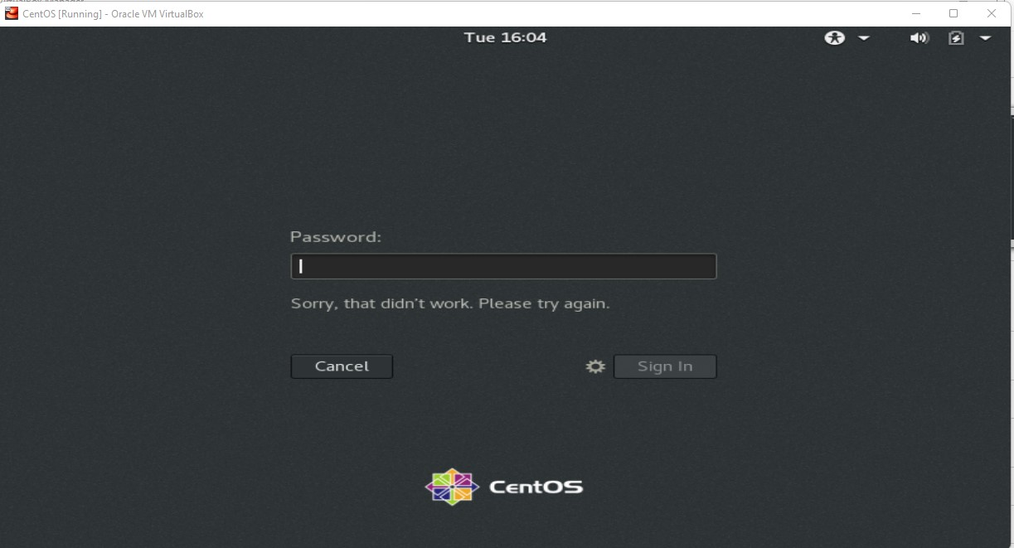

Explanation: As I haven’t added the user , CentOS is not recognizing the username and password I entered.

It’s throwing the error Sorry, that didn’t work. Please try again.

Assignment-2

Password changing

* Login into your account and then change password?
  + Change your password into ***IneuR0n#42*** and hit the **Enter** key
    - Explain what happen and give screenshot?
  + Try again to change password but use like password ***1234*** or ***abcd***
    - Explain what happen and give screenshot?
  + Try again to change password but now don’t use any password just hit **Enter** key
    - Explain what happen and give screenshot?

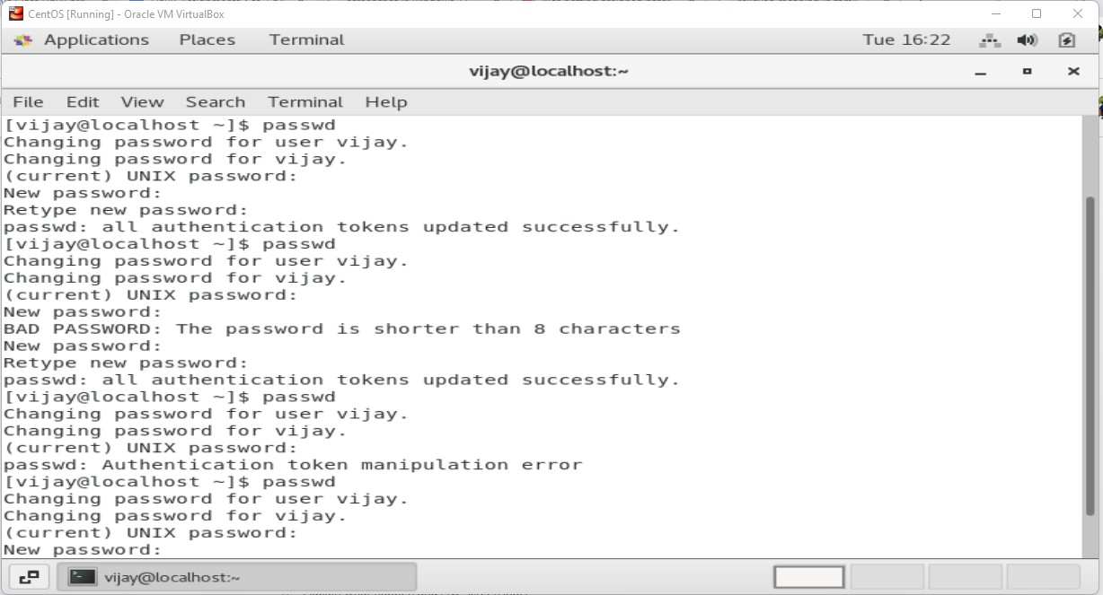

Exp

1. Changed the password using the **passwd** command and got all authentication tokens updated successfully.
2. Tried using 1234 while using the password as the min required length of the password is 8 characters, but it is throwing error.

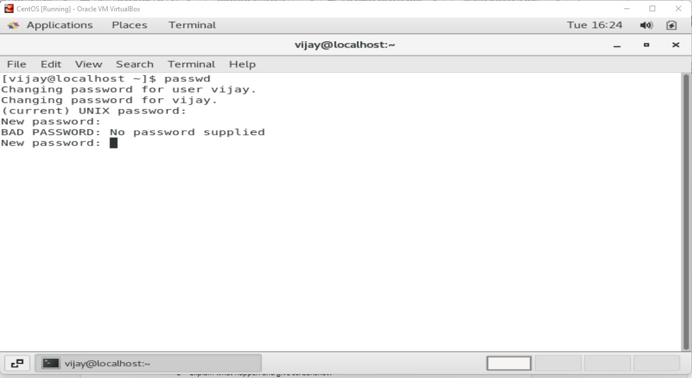

1. Tried to change the password by leaving it blank it throws error as

**No password supplied.**

Assignment-3

Working with Directories

* Enter the command **cd /** and then **ls** and then hit **Enter** key
  + Take screenshot and explain what output we got?
* Enter the command now **cd /home** and then hit **Enter** key
  + Do **ls,** provide screenshot and explain what is **/home** directory used for?
* Enter **cd ..** and hit **Enter** key [ *Note: here we have space after cd then use double dot*]
  + Check what happen and give screenshot?
* Now enter **cd /var/www/html** and then type **cd** and hit **Enter** key
  + Explain what happen and give screenshot?
* Now type **cd /root** and then hit **Enter** key
  + Do **ls,** check any output we have on screen if yes then take screenshot?

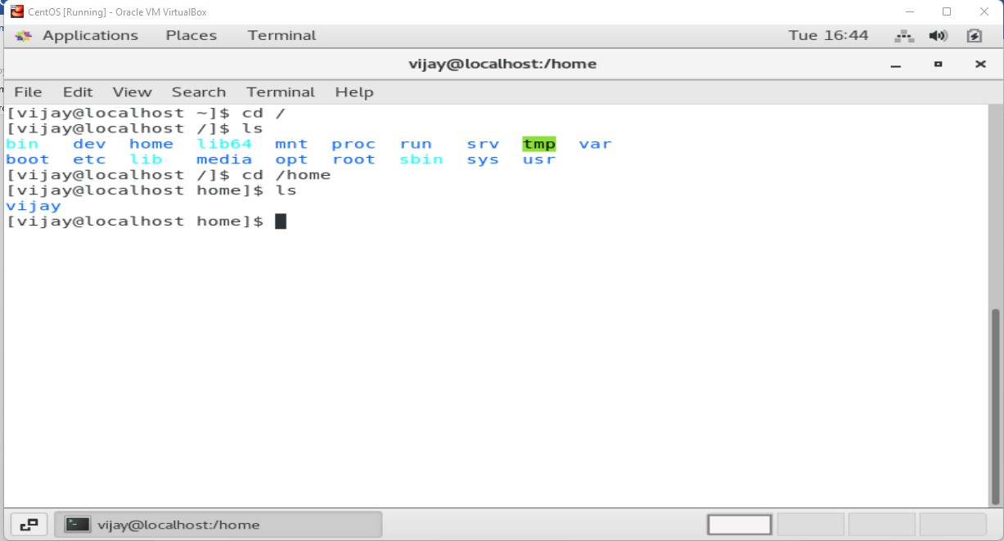

1. While giving **cd /** , the directory changed from the home directory (~)the to root directory(/) **ls** command gave the list of available folders in the directory.
2. While using **cd /home** command it get us inside the home folder , after that **ls** command gives us the list of available folder in the home directory.
3. **cd ..** command gets us out of the current folder.

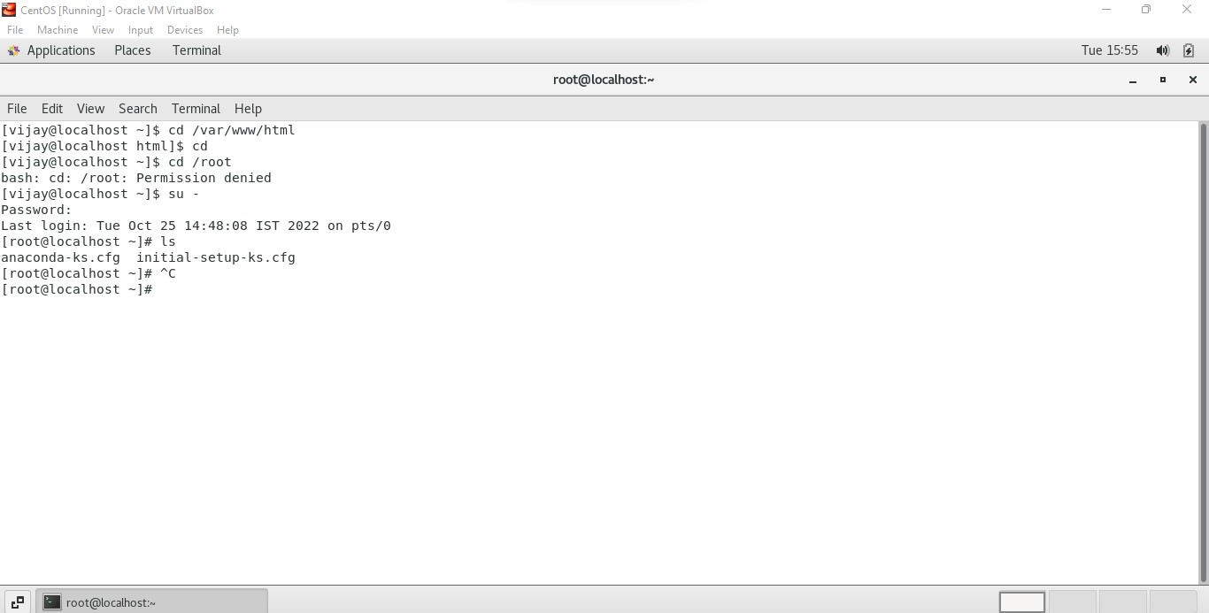

1. **cd /var/www/html** command get us into html folder.
2. **Cd /root** requires admin permission **,** when it is given **ls** listed the folders inside it

Assignment-4

Working with File Listing

* Go to **cd /etc** and type **ls**
  + Take screenshot and explain what files you have seeing?
  + Take screenshot and explain what different output you found compare to previous command you used?
* Then type **ls -al** and hit **Enter** key
  + Take screenshot and explain what new file or directory you found?
* Then use **ls -i** and hit **Enter** key
  + Now see what different output its shows and take screenshot?
* Then use **ls –help** and see other options about **ls** command
  + Explore it and try with other attribute we can use with **ls** command

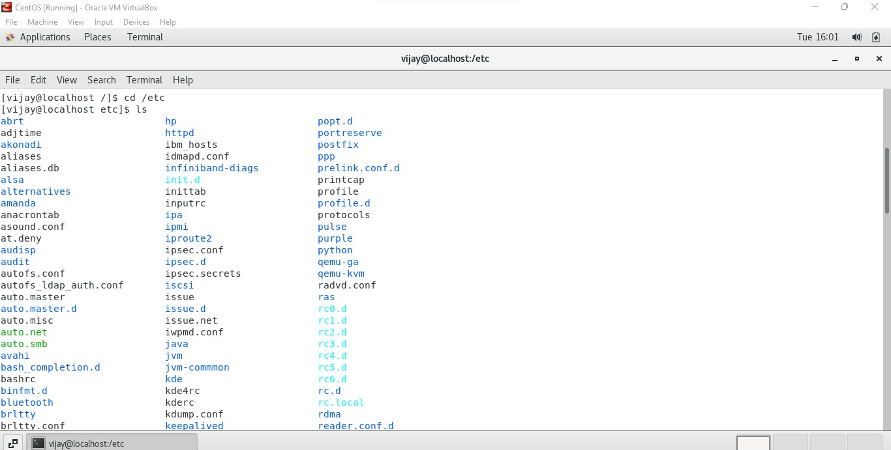

**Explanation.**

* 1. We can able to see multiple file with various type of extensions such as .db,.conf ,.d etc.
  2. The previous command has only .cfg ie config files while in this folder we have many files like .db .d etc

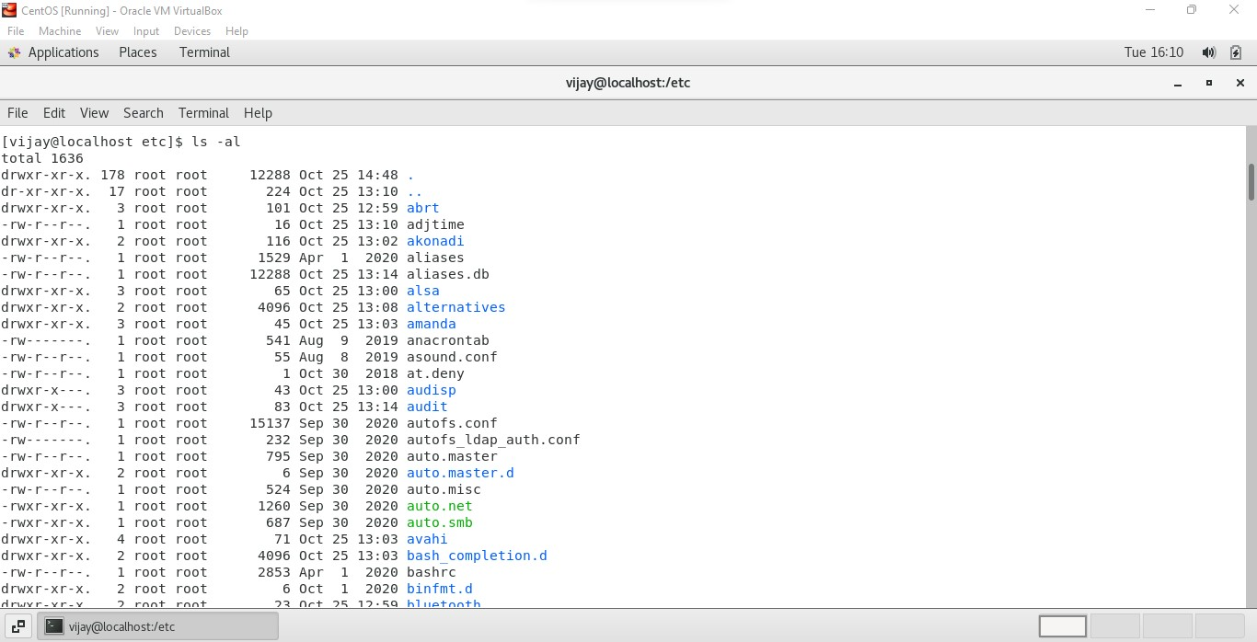

* 1. **ls -al** command gives the permission each life has.

**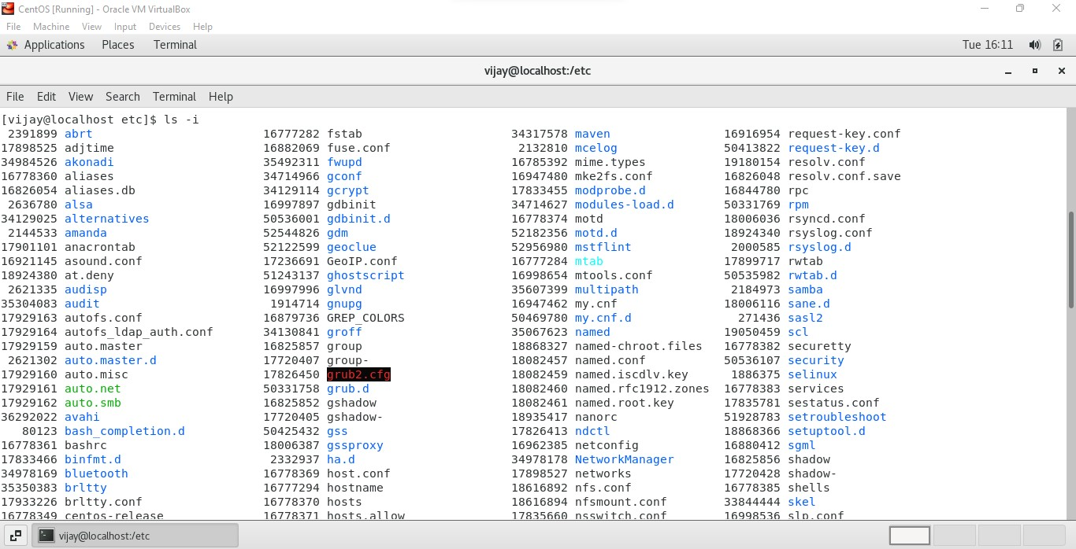  
4. Ls -i** gives us the index number of each file.

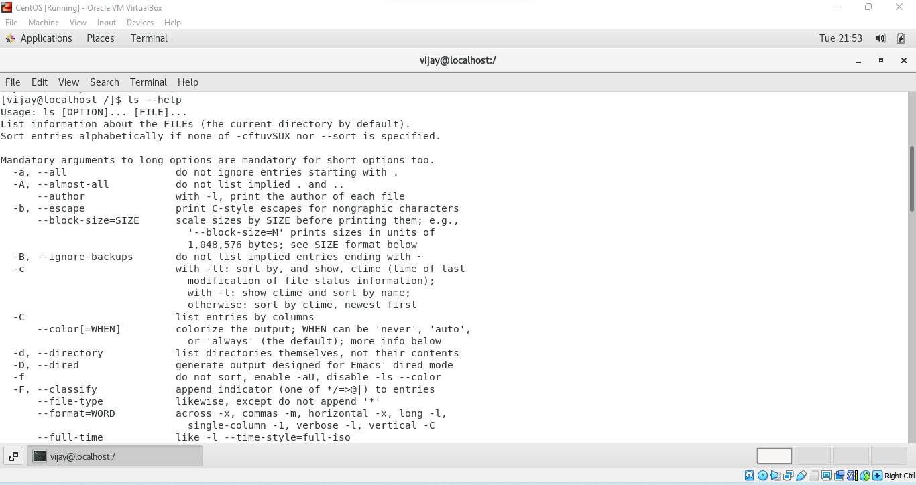

1. **ls –help** gives us the explanation of each option available in ls to access files and directories.

Assignment-5

Know where you are and where you working

*Here we use* ***pwd, cd and ls*** *as combine task to understand where you working on terminal and how you can switch from one directory to another one.*

* Open terminal after restart the linux
  + Check which location you working, type **pwd** and take screenshot
* Now use **cd /var** and hit **Enter** key
  + Do **ls,** and see what output comes, give screenshot?
* Do explore other help options of each command to learn more other things we can do with these commands

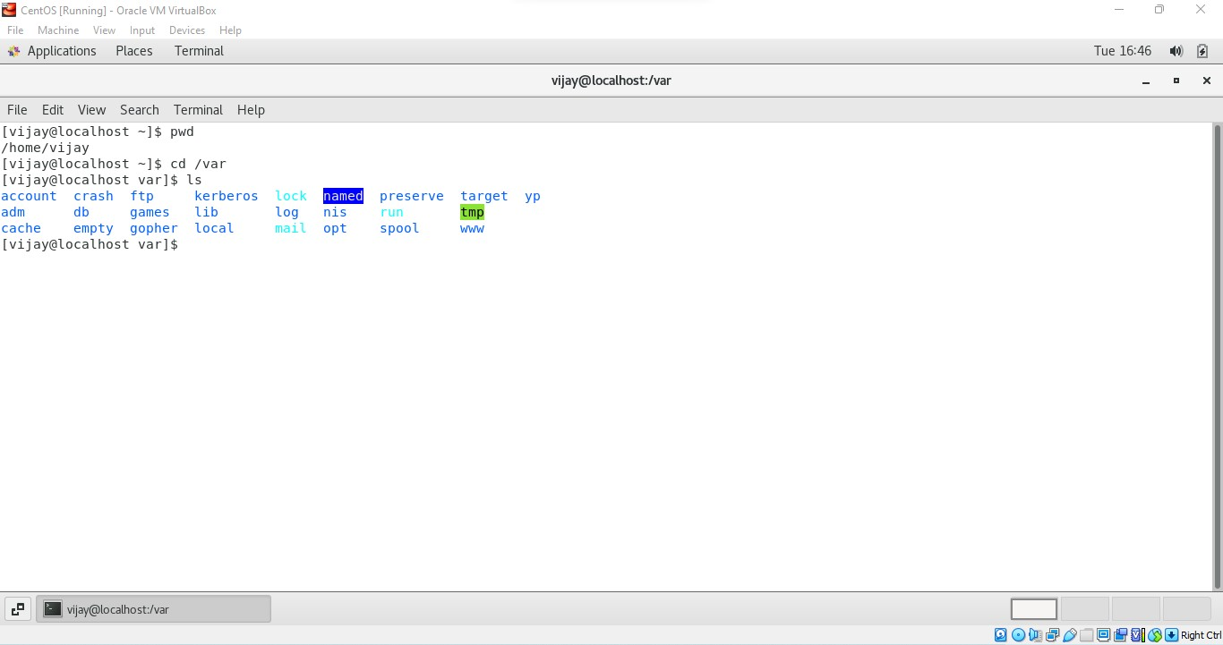

* + 1. **pwd** command gives my current folder I am working on.
    2. **Cd /var then ls** gives us the sub directory of other directories.

**Some of the other commands are**

* + 1. **ls -a -** will not ignore entries start with .(dot)
    2. **ls -**d – list all directories.