**Linux Assignment 2**

Assignment

Part-3

Playing with files

1. Create a file like nano file1.txt o Edit some data and then save the file

2. Now we will copy date from file1 to new file2 o cp file1.txt file2.txt

Then see the output of file2.txt, cat file2.txt o Give screenshot.

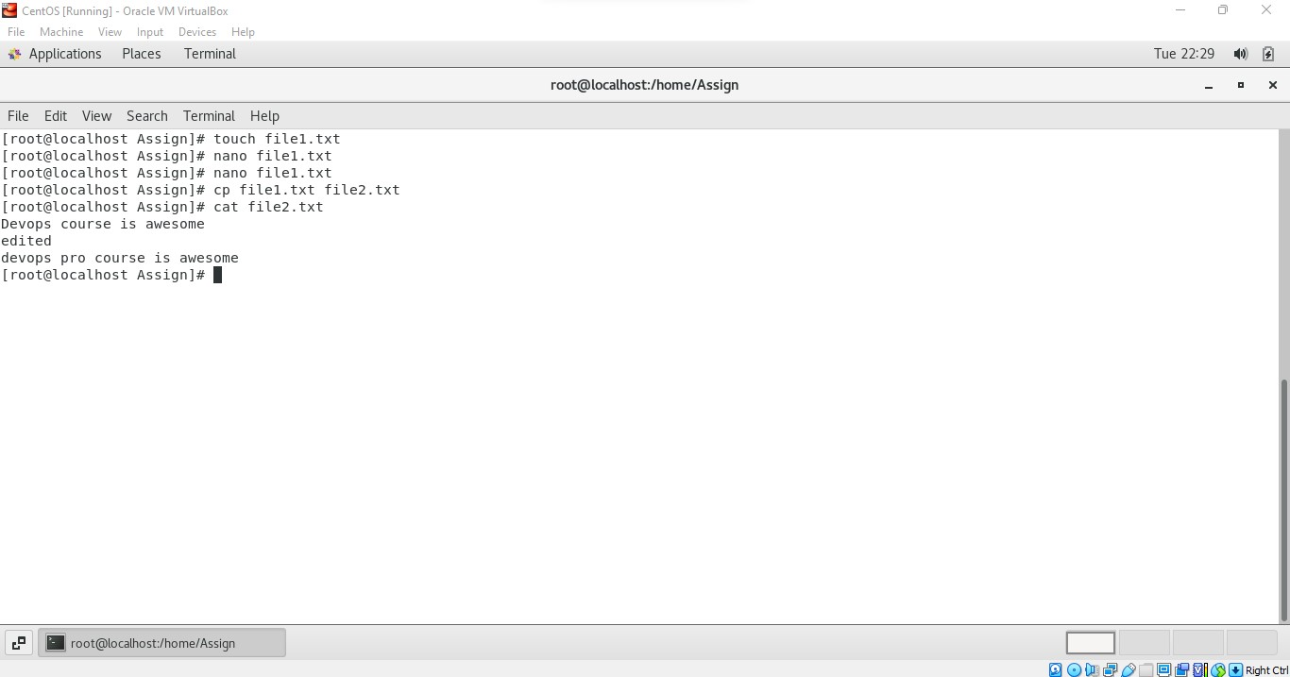

Explanation:

1. Created new file using touch file1.txt , even nano file1.txt will also create new file and opens it.

After entering the content of the file we have to give ctrl+x to save the file.

Again nano file1.txt will open the file in editor we can do alterations and save it

1. Cp file1.txt file2.txt will copy the content of file1 to file2 , here the file2 will be created automatically we don’t need to create it separately.
2. Cat file2.txt will out the content of that file.

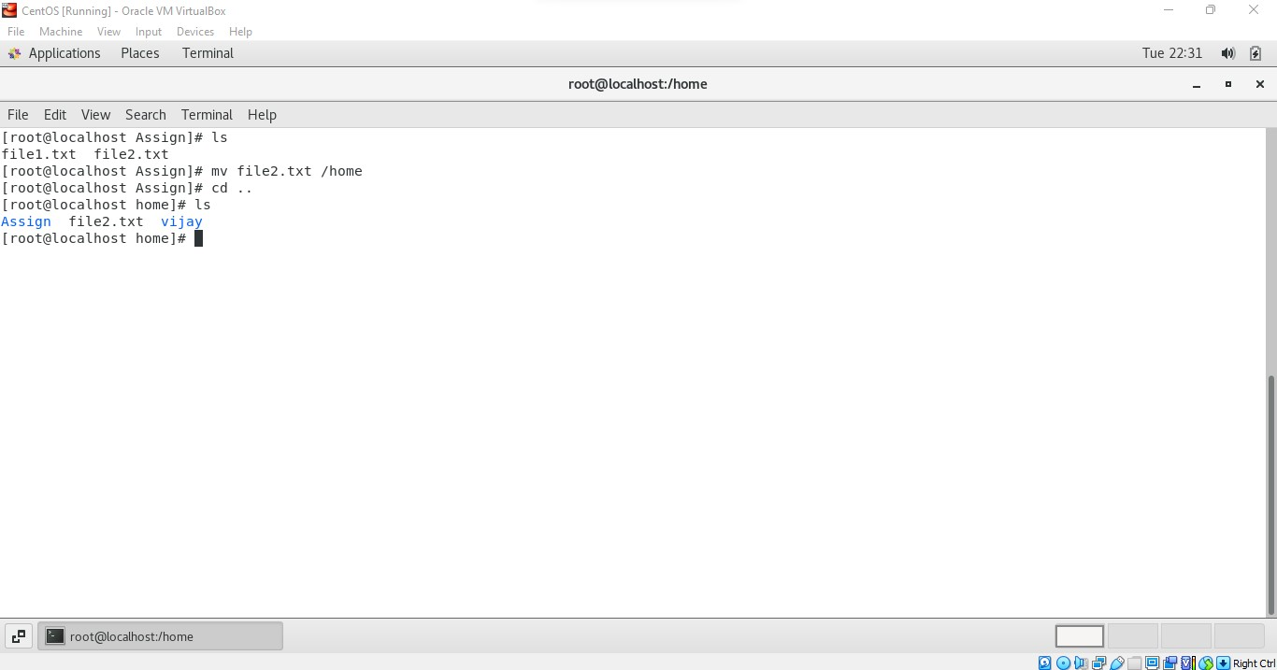  
Here the command **mv file2.txt /home** is moving the file from Assign directory to home directory.

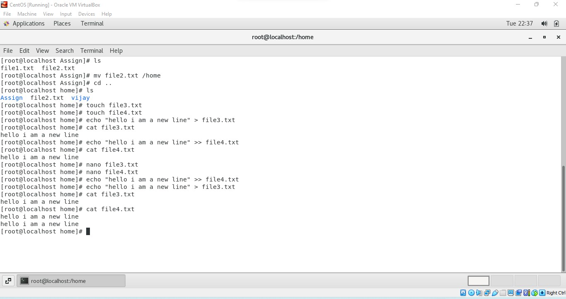

First I have created file3.txt and file4.txt using touch command then

the echo “hello I am a new line” > file3.txt write hello I am a new line in file3.txt

the echo “hello I am a new line” >> file4.txt write hello I am a new line in file4.txt

the key difference between > and >> is

> - Will rewrite the entire file by overwriting the previous content in the file.

>> - Will append the content to the file without affecting the previous content of the file.

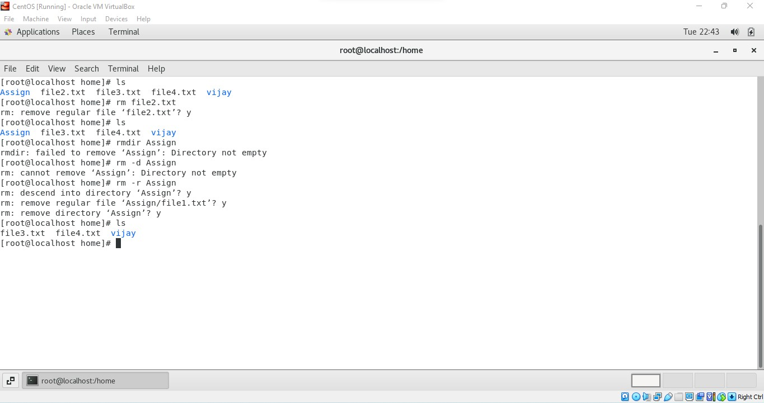

Here the command

rm file2.txt removes the file from the directory.

rmdir Assign - denies to remove the directory because it has files in it rmdir cant remove the directory with file.

To remove the directory with files we need to use command

**rm -r directory name**

**rm -r Assign** removed the Assign directory**.**