# Lab 6 Proxy Design pattern

## Screen 1

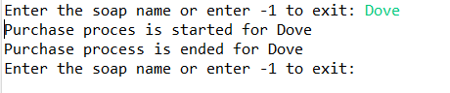

## Screen 2

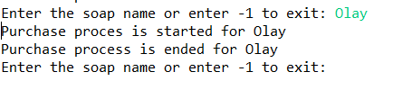

## Screen 3

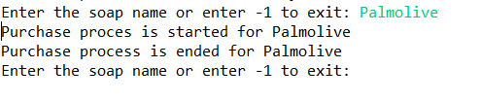

## Screen 4

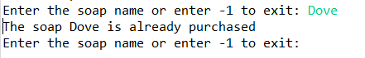

## Screen 5

