LAB 6.5 - ArrayList & LinkedList
Submitted by: _______________________
Date: _______________________
──────────────────────────────────────────────────
Q1. Shopping Cart using ArrayList
Write a program to create a shopping cart. User can add items and remove purchased items using ArrayList.
CODE:
import java.util.*;

public class ShoppingCart {
public static void main(String[] args) {
Scanner sc = new Scanner(System.in);
ArrayList<String> cart = new ArrayList<>();
int choice;

do {
System.out.println("\n===== SHOPPING CART =====");
System.out.println("1. Add Product");
System.out.println("2. Remove Product");
System.out.println("3. View Cart");
System.out.println("4. Checkout & Exit");
System.out.print("Enter choice: ");
choice = sc.nextInt(); sc.nextLine();

switch (choice) {
case 1:
System.out.print("Enter product name: ");
String p = sc.nextLine();
cart.add(p);
System.out.println(p + " added."); break;
case 2:
System.out.print("Enter product to remove: ");
String r = sc.nextLine();
if (cart.remove(r))
System.out.println(r + " removed.");
else System.out.println("Not found."); break;
case 3:
if (cart.isEmpty())
System.out.println("Cart empty.");
else for (int i = 0; i < cart.size(); i++)
System.out.println((i+1) + ". " + cart.get(i));
break;
case 4:
if (!cart.isEmpty()) {
System.out.println("\nPurchased:");
for (String x : cart)
System.out.println("- " + x);
cart.clear();
}
System.out.println("Thank you!"); break;
}
} while (choice != 4);
sc.close();
}
}
OUTPUT:
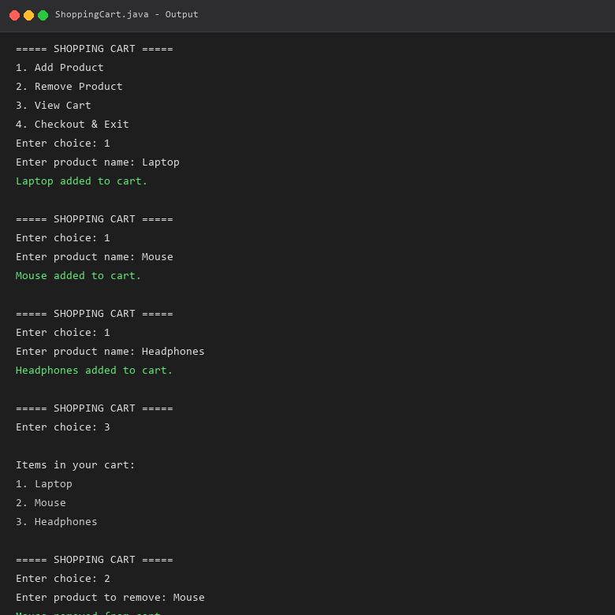
──────────────────────────────────────────────────
Q2. Music Playlist using ArrayList
Write a program to manage a music playlist. Songs can be added and removed from the list.
CODE:
import java.util.*;

public class PlaylistManager {
public static void main(String[] args) {
Scanner sc = new Scanner(System.in);
ArrayList<String> playlist = new ArrayList<>();
int choice;

do {
System.out.println("\n===== MUSIC PLAYLIST =====");
System.out.println("1. Add Song");
System.out.println("2. Remove Song");
System.out.println("3. View Playlist");
System.out.println("4. Exit");
System.out.print("Enter choice: ");
choice = sc.nextInt(); sc.nextLine();

switch (choice) {
case 1:
System.out.print("Enter song: ");
String song = sc.nextLine();
playlist.add(song);
System.out.println("\"" + song + "\" added."); break;
case 2:
if (playlist.isEmpty())
System.out.println("Empty.");
else {
System.out.print("Remove song: ");
String s = sc.nextLine();
if (playlist.remove(s))
System.out.println("\"" + s + "\" removed.");
else System.out.println("Not found.");
} break;
case 3:
if (playlist.isEmpty())
System.out.println("Empty.");
else {
System.out.println("\nPlaylist (" + playlist.size() + "):");
for (int i = 0; i < playlist.size(); i++)
System.out.println((i+1) + ". " + playlist.get(i));
} break;
case 4:
System.out.println("Goodbye!"); break;
}
} while (choice != 4);
sc.close();
}
}
OUTPUT:
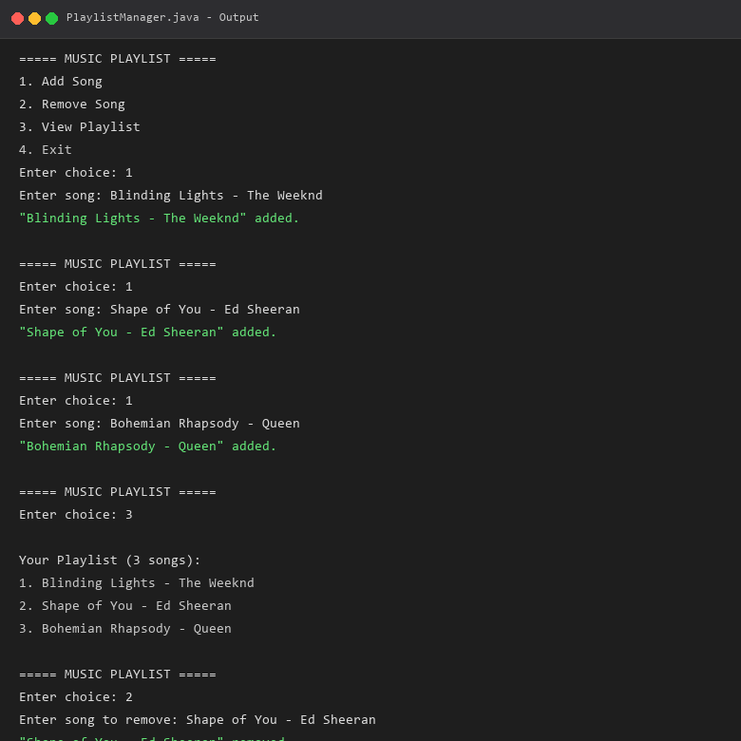
──────────────────────────────────────────────────
Q3. Browser History using LinkedList
Write a program to implement browser history navigation using LinkedList. Simulate visiting pages and going back.
CODE:
import java.util.*;

public class BrowserHistory {
public static void main(String[] args) {
LinkedList<String> history = new LinkedList<>();

history.add("google.com");
history.add("youtube.com");
history.add("gmail.com");
history.add("github.com");
System.out.println("History: " + history);

history.removeLast();
System.out.println("After back: " + history);

history.add("stackoverflow.com");
System.out.println("After visit: " + history);

history.removeLast();
System.out.println("After back: " + history);

history.add("reddit.com");
System.out.println("After visit: " + history);

System.out.println("Current: " + history.getLast());
}
}
OUTPUT:
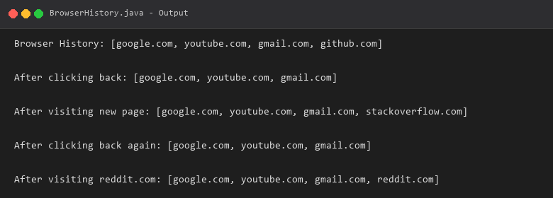
──────────────────────────────────────────────────
Q4. Train Reservation Waiting List using LinkedList
Write a program to implement a train waiting list system (FIFO) using LinkedList to manage passengers waiting for seat allocation.
CODE:
import java.util.*;

public class TrainWaitingList {
public static void main(String[] args) {
LinkedList<String> queue = new LinkedList<>();
Scanner sc = new Scanner(System.in);
int choice;

do {
System.out.println("\n===== TRAIN WAITING LIST =====");
System.out.println("1. Add Passenger");
System.out.println("2. Allocate Seat");
System.out.println("3. View List");
System.out.println("4. Check Size");
System.out.println("5. Exit");
System.out.print("Enter choice: ");
choice = sc.nextInt(); sc.nextLine();

switch (choice) {
case 1:
System.out.print("Name: ");
String name = sc.nextLine();
queue.addLast(name);
System.out.println(name + " added."); break;
case 2:
if (queue.isEmpty())
System.out.println("No passengers.");
else
System.out.println("Allocated: " + queue.removeFirst());
break;
case 3:
if (queue.isEmpty())
System.out.println("Empty.");
else for (int i = 0; i < queue.size(); i++)
System.out.println((i+1) + ". " + queue.get(i));
break;
case 4:
System.out.println("Waiting: " + queue.size()); break;
case 5:
System.out.println("Exiting..."); break;
}
} while (choice != 5);
sc.close();
}
}
OUTPUT:
