Array Programs
Q1. Find Second Largest and Third Minimum from Array
Write a program to accept array elements from the user and find the second largest and third minimum element.
CODE:
import java.util.*;

public class Array_SecondLargestThirdMin {
public static void main(String[] args) {
Scanner sc = new Scanner(System.in);
System.out.print("Enter number of elements: ");
int n = sc.nextInt();
int arr[] = new int[n];
System.out.println("Enter " + n + " numbers:");
for (int i = 0; i < n; i++) arr[i] = sc.nextInt();

// Bubble sort
for (int i = 0; i < n - 1; i++)
for (int j = 0; j < n - 1 - i; j++)
if (arr[j] > arr[j + 1]) {
int t = arr[j];
arr[j] = arr[j + 1];
arr[j + 1] = t;
}

System.out.println("Sorted: " + Arrays.toString(arr));
System.out.println("Second largest: " + arr[n - 2]);
System.out.println("Third minimum: " + arr[2]);
sc.close();
}
}
OUTPUT:
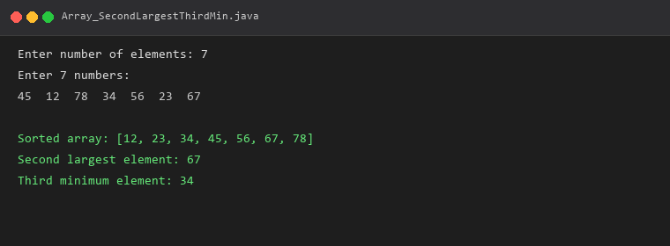
──────────────────────────────────────────────────
Q2. Remove Duplicate Elements from an Array
Write a program to remove duplicate elements from an array and display the unique elements.
CODE:
import java.util.*;

public class Array_RemoveDuplicates {
public static void main(String[] args) {
Scanner sc = new Scanner(System.in);
System.out.print("Enter number of elements: ");
int n = sc.nextInt();
int arr[] = new int[n];
System.out.println("Enter " + n + " numbers:");
for (int i = 0; i < n; i++) arr[i] = sc.nextInt();

ArrayList<Integer> list = new ArrayList<>();
for (int i = 0; i < n; i++)
if (!list.contains(arr[i]))
list.add(arr[i]);

System.out.println("After removing duplicates: " + list);
sc.close();
}
}
OUTPUT:
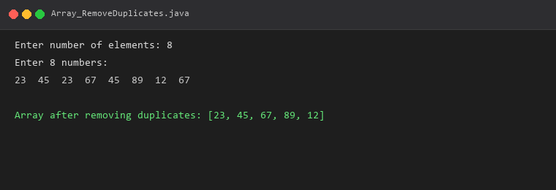
──────────────────────────────────────────────────
Q3. Find Average of Array Elements
Write a program to accept array elements from the user and calculate the average.
CODE:
import java.util.*;

public class Array_Average {
public static void main(String[] args) {
Scanner sc = new Scanner(System.in);
System.out.print("Enter number of elements: ");
int n = sc.nextInt();
int arr[] = new int[n];
System.out.println("Enter " + n + " numbers:");
for (int i = 0; i < n; i++) arr[i] = sc.nextInt();

int sum = 0;
for (int i = 0; i < n; i++) sum += arr[i];

double avg = (double) sum / n;
System.out.println("Sum = " + sum);
System.out.println("Average = " + avg);
sc.close();
}
}
OUTPUT:
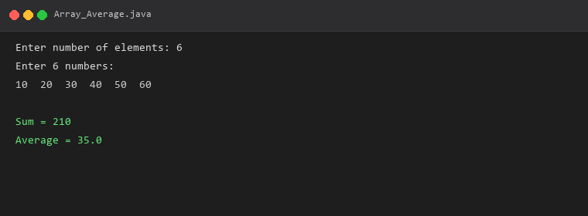
──────────────────────────────────────────────────
Q4. Find Maximum Element from an Array
Write a program to accept array elements from the user and find the maximum element.
CODE:
import java.util.*;

public class Array_MaxElement {
public static void main(String[] args) {
Scanner sc = new Scanner(System.in);
System.out.print("Enter number of elements: ");
int n = sc.nextInt();
int arr[] = new int[n];
System.out.println("Enter " + n + " numbers:");
for (int i = 0; i < n; i++) arr[i] = sc.nextInt();

int max = arr[0];
for (int i = 1; i < n; i++)
if (arr[i] > max) max = arr[i];

System.out.println("Maximum element: " + max);
sc.close();
}
}
OUTPUT:
